Australian Capital Territory
Heritage (Decision about Registration of the
Canberra Baptist Church Precinct, Kingston)
Notice 2009 (No 1)*
Notifiable Instrument NI2009—405
made under the
Heritage Act 2004 s42 Notice of decision about registration

- Revocation
This instrument replaces NI 2008 – 302.

- Name of instrument
This instrument is the Heritage (Decision about Registration for the Canberra Baptist Church Precinct, Kingston) Notice 2009 (No 1).

- Registration details of the place
Registration details of the place are at Attachment A: Register entry for Canberra Baptist Church Precinct, Kingston.

- Reason for decision
The ACT Heritage Council has decided that the Canberra Baptist Church Precinct, Kingston meets one or more of the heritage significance criteria at section 10 of the Heritage Act 2004. The register entry is at Attachment A.

- Date of Registration
20 August 2009.

…………………………..

Gerhard Zatschler
Secretary
ACT Heritage Council
GPO Box 158
Canberra ACT 2601
20 August 2009

AUSTRALIAN CAPITAL TERRITORY

HERITAGE REGISTER
(Registration Details)

Place No: 104

For the purposes of s. 41 of the Heritage Act 2004, an entry to the heritage register has been prepared by the ACT Heritage Council for the following place:

- CANBERRA BAPTIST CHURCH PRECINCT, KINGSTON

DATE OF REGISTRATION

Notified: 20 August 2009 Notifiable Instrument: 2009 -

Copies of the Register Entry are available for inspection at the ACT Heritage Unit. For further information please contact:

The Secretary
ACT Heritage Council
GPO Box 158, Canberra, ACT 2601

Telephone: 132281 Facsimile: (02) 6207 2229

IDENTIFICATION OF THE PLACE

- Canberra Baptist Church Precinct, 11 Currie Crescent, Section 23, Block 1, Suburb of Kingston, ACT

STATEMENT OF HERITAGE SIGNIFICANCE

The Canberra Baptist Church building in Kingston is significant as the first Baptist Church in the Territory and only the second permanent church constructed after the gazettal of the then Federal Capital Territory. The church has played a significant part in the establishment of the Baptist denomination in Canberra.

The church is a fine example of the Inter-War Gothic style and its internal and external integrity add to this significance. As one of a group of four churches constructed in this style in the ACT between 1927 and 1938, it has associational and aesthetic significance. The setting is significant as a mature example of early Canberra landscape principles of placing buildings within a landscape.

The building was a symbol for the Baptist Church in Australia in the late 1920s and 1930s, and is significant because its construction was paid for by national fund raising within the denomination. This demonstrates the drive by a number of denominations to establish a presence in the national capital despite the economic hardships of the Depression at the time.

The building is associated with a number of individuals who were significant figures in local, state or national affairs. These include Dr A J Waldock, Rev F P McMaster, Gough Whitlam, A C Joyce.

The remnant communities of native grasses along the Telopea Park edge of the site near the Tennis Court are particularly rare within the developed urban areas of South Canberra.

FEATURES INTRINSIC TO HERITAGE SIGNIFICANCE

The physical features of the Canberra Baptist Church Precinct, Kingston, that particularly reflect its heritage significance are:
- The Church building as a definable individual element on the site
- The existing symmetrical east façade
- The regular fenestration articulation and vertical emphasis of the facades.
- Castellated parapets to entry and rear wings.
- The gothic style represented by the planning and detail of the building
- The building’s landscape setting
- The axial relationship of the church and the Currie Crescent link to Giles Street.
- The original (1929) internal details generally including woodwork and plaster detail of the church nave, including the pulpit and sanctuary chairs and tables the exposed roof trusses, the Greening Room including doors and door hardware, light fittings, windows skirtings and exposed roof trusses.
- The stained glass windows.
- The prominence of the building on the southern half of the site.
- The remnant native grasses.
- Open park setting of buildings within a landscape.

This heritage listing has considered only the Canberra Baptist Church building within its landscape setting. Therefore other buildings on the site are not noted here as features intrinsic to the heritage significance. However the other buildings within the curtilage may have heritage significance which will become apparent on further investigation and may later be registered within their own right.

APPLICABLE HERITAGE GUIDELINES

The Heritage Guidelines adopted under s27 of the Heritage Act 2004 are applicable to the conservation of the Canberra Baptist Church Precinct, Kingston.

The guiding conservation objective is that the Canberra Baptist Church Precinct, Kingston, shall be conserved and appropriately managed in a manner respecting its heritage significance and the features intrinsic to that heritage significance, and consistent with a sympathetic and viable use or uses. A conservation management plan (CMP) would help to guide conservation and future use. Any works that have a potential impact on significant fabric (and/or other heritage values) which are necessary prior to the development of a CMP shall be guided by a professionally documented interim assessment and conservation policy relevant to that area or component (i.e. a Statement of Heritage Effects - SHE).

Any guidelines developed by Heritage Council under the Heritage Act 2004 that apply to the management of Natural Values will apply to this place. In the interim, the Heritage Council will consider any impact on Natural Values on the basis of the information provided.

REASON FOR PROVISIONAL REGISTRATION

The Canberra Baptist Church Precinct, Kingston, has been assessed against the heritage significance criteria and been found to have heritage significance against 6 of the heritage criteria under the ACT Heritage Act.

ASSESSMENT AGAINST THE HERITAGE SIGNIFICANCE CRITERIA

Pursuant to s.10 of the Heritage Act 2004, a place or object has heritage significance if it satisfies one or more of the following criteria:

- it exhibits outstanding design or aesthetic qualities valued by the community or a cultural group;

The building has aesthetic value as a fine example of the Inter-War Gothic style. The high-level integrity of the exterior contributes to its significance.

The church building has a strong axial relationship from Currie Crescent through to Giles Street. Its relationship to the manse is representative of Dr Waldock’s Grand Scheme which saw four buildings symmetrically placed on the site, all addressing Currie Crescent. In addition, the site exhibits a group of buildings within a landscape setting of trees and shrubs in keeping with early Canberra landscape development principles.

The interior is substantially intact and exhibits high-quality decorative timber and plasterwork in the nave of the church and the Greening room. The stained-glass windows in the nave exhibit a high degree of artistic merit in the quality of workmanship and detail of the designs.

The site has aesthetic significance as a mature example of early Canberra landscape principles of placing buildings within a landscape.

- it is highly valued by the community or a cultural group for reasons of strong or special religious, spiritual, cultural, educational or social associations;

The building is significant as the first Baptist Church in the ACT and construction resulted from a national fundraising campaign which strengthens its social value. It was also the base from which later Baptist congregations including North Canberra and Dickson were established.

The building has social significance to the broader community and is one of the first churches in the ACT and symbolises the energy and enthusiasm which surrounded the establishment of the National Capital.

- it is a rare or unique example of its kind, or is rare or unique in its comparative intactness

Remnants of the native grassland landscape which existed before Canberra was developed, remains along the Telopea Park edge of the site near the tennis court. This native grassland comprises of kangaroo grass (Themeda australis) and redleg grass (Bothriocholoa macra). Similar grasslands can be found throughout old Canberra on areas where the land has never been disturbed and are considered by botanists to be an invaluable resource and a part of Canberra’s history.

- it is a notable example of a kind of place or object and demonstrates the main characteristics of that kind

The building is one of only four examples displaying some characteristics of the Inter-War Gothic style churches in the ACT (Reid Uniting, St Andrew’s Forrest, St Paul’s Griffith).

- it has strong or special associations with a person, group, event, development or cultural phase in local or national history

The church was the second permanent church built after the establishment of the ACT and the first church (following establishment of the ACT) in South Canberra. As such, it is associated with the early development of the Territory and played an important role in early Canberra Baptist community. The church still performs a significant role in the Baptist denomination’s Ministry to the ACT.

A number of people associated with the church through its history have made significant contributions to the church and or community at local, state or national level. These include Dr A J Waldock, Ref F P McMaster and A C Joyce.

- it has provided, or is likely to provide, information that will contribute significantly to a wider understanding of the natural or cultural history of the ACT because of its use or potential use as a research site or object, teaching site or object, type locality or benchmark site

The site has the potential to reveal information related to the rare remnant native grassland which is of interest to landscape historians in relation to the pre-development of the ACT.

The following criteria were found not to be applicable: (a), (c), (e), (i), (k), (l).

SUMMARY OF THE PLACE’S
HISTORY AND PHYSICAL DESCRIPTION

History
The Canberra Baptist Church, Kingston, was the first Baptist Church constructed in the ACT. Constructed in 1929, on one of the designated ‘Cathedral’ sites offered by the Federal Capital Commission, the church was the second permanent church built in the Territory. Sydney architect F W Peplow was commissioned to prepare plans. The contract for construction was let to R E Midson and the foundation stones for the church and manse were laid on 21 March 1928. The church was dedicated for public worship on 24 February 1929.

The driving force behind the establishment of a Baptist Church in the Territory was Reverend Dr A J Waldock who ran a national fund raising campaign to finance the construction of an appropriate church building. However, despite all of his energies, the campaign fell short of its target and the building budget was made up with a bank loan.

In 1952 a former Government hostel (hut) was purchased to accommodate needs of the church activities. The hut still remains west of the Church Hall and is used by a non-church group with agreement from the church. The hut provided only temporary relief to the accommodation problem and in 1959, Sydney architects, Booker and Wilson were engaged to design a new hall building with kitchen and stage facilities. The new building was opened on 14 April 1962, and cost £14,747. The hall was dedicated to the memory of Rev Dr Waldock. The hall was extended in 1974, the design prepared by local architect Anthony Cooper.

Description
The Canberra Baptist Church Precinct, Kingston, is located on a large semi circular site bounded to the east by Currie Crescent and to the west by Telopea Park East, in the suburb of Kingston. The church building is prominent on the southern half of the site.

Four buildings are located on the site:
- A face red brick church and separate manse of a similar construction date.
- A 1970s face brick Church Hall, and
- A weatherboard clad former hostel building now used by a non-church group with agreement from the church.

The Canberra Baptist Church, Kingston is designed in the Inter-War Gothic style. Construction is red-face brickwork with horizontal bands of contrast in black-brown bricks. The building is a basic cruciform shape in plan, with the functions of each area of the building being defined externally by its massing.

Behind the nave section of the Church, the Baptistery and large meeting room are contained within a lower section of pitched roof which extends on the same axis of the main roof. To the north and south of these are located vestry and small service rooms, expressed as projecting wings to the sides of the main building axis. The wings have flat roofs concealed behind a castellated parapet similar to that of the vestry and small service rooms.

The top of the entry walls is a castellated parapet. The entry door location is reflected in the parapet by a steeply pitched gable element, highlighted by a white painted concrete moulding. The feature of the entry walls is the buttressing at the corners and either side of the main doorway. Buttressing is also featured in the side and front elevations of the nave of the church building. A key feature is the regular fenestration articulation and vertical emphasis of the façades, and symmetry of the east façade.

The church and entry windows are steel framed with stained glass in the side walls of the sanctuary area and stained glass the front and entry wall windows. Two of the original windows with diagonal wired glass have been replaced with stained-glass winders in memory of former ministers/members of the Church. Mesh security grilles have been installed over all of the stained-glass windows. Windows in the rear wings, Greening and basement rooms of the building are double hung sash timber framed units, generally larger than the sanctuary. All windows in these areas are clear glazed.

Gothic styled stained glass windows are grouped in pairs on the south and north wall of the nave. The windows are highlighted with a plaster label mould, which runs continuously along the wall near the head of the windows. The windows are dedicated to former ministers and members. At the base of each window is an inward opening sash.

The floor of the nave is stained tongue and grooved timber. The aisles, front section before the sanctuary and the sanctuary and choir areas have been carpeted in red. The nave ceiling is fibrous plaster and is divided into structural bays by the large section finely detailed roof trusses. The ceiling bays are further defined by ornate plaster mouldings. The roof trusses are buttressed off the side walls and sit on a rendered plinth. Original pendant lights illuminate the nave. The lamping of the lights has been upgraded since construction. Additional task spotlights have been introduced on two trusses. Ceiling fans have also been introduced and are suspended from the roof trusses.

The sanctuary sits below a large arched opening in the western wall. The sanctuary layout is a 1989 design but retains original pulpit, ministers’ chairs and communion table. A baptistery with ceramic tiled pool is located behind the sanctuary. Either side of the sanctuary, timber panelled doors lead to corridors serving rooms at the rear of the Church.

A doorway in the north wall of the south passage opens into the James Greening room, a large meeting room located directly behind the sanctuary. The Greening room is detailed and finished similar to the vestries. The principle variance is that a suspended ceiling has been installed below the original moulded and panelled plaster ceiling. The room contains a large face brick fireplace on the east wall. A heater has been installed into the hearth.

Landscape
The overall impression of the landscape is one of mature trees in keeping with the period of the suburb’s development. Dominant species of trees include Monterey Pines (Pinus radiate)and Eucalypts. The pines appear to be the oldest plantings on the site and is estimated that they were planted c1930. Blue gums have been used near the manse and to a lesser extent at the northern end of the site. Eucalypt Grove near the tennis court contains three species of tree (Eucalyptus mannifera, Eucalyptus bridgesiana and Eucalyptus cinerea).

There is a pin oak tree located between the church and the hall, which is considered to be an important landscape tree on the site. It is an excellent specimen in good condition. It has significance from the social viewpoint as it provides a canopy when morning teas are served in this space.

There are shrub beds associated with the buildings. There is a memorial pink rose is planted in the front planter bed to the memory of Professor Gordon Reid AG.

Remnants of the native grassland landscape which existed before Canberra was developed remain along the Telopea Park edge of the site near the tennis court. This native grassland comprises of kangaroo grass (Themeda australis) and redleg grass (Bothriochloa macra) and was once the habitat of the Golden Sun Moth (recent evidence of its presence is lacking). Similar grasslands can be found throughout old Canberra on areas where the land has never been disturbed.

References

Cox Architects and Planners August 1997 Canberra Baptist Church, Conservation Plan.

Hughes R W 2004 Recalling with Gratitude – the Memorials of the Canberra Baptist Church, Canberra Baptist Church, February.

Metcalf, Andrew 2003 Canberra Architecture, The Watermark Press, Sydney, p 106.

Robb, R K (ed) 1979 Fifty Capital Years – A History of the foundation of Baptist Witness in the ACT, Summit Press, ACT.

PHOTOGRAPHS AND PLANS

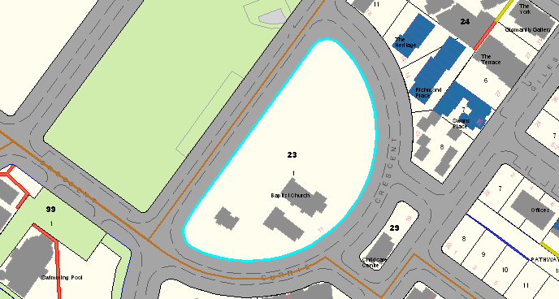

Figure 1. Location of Kingston Baptist Church, Kingston

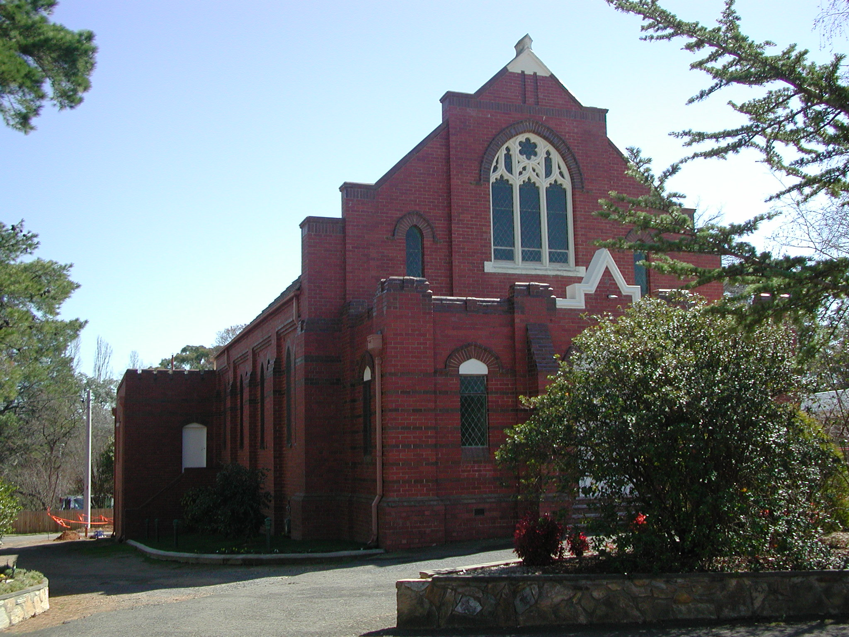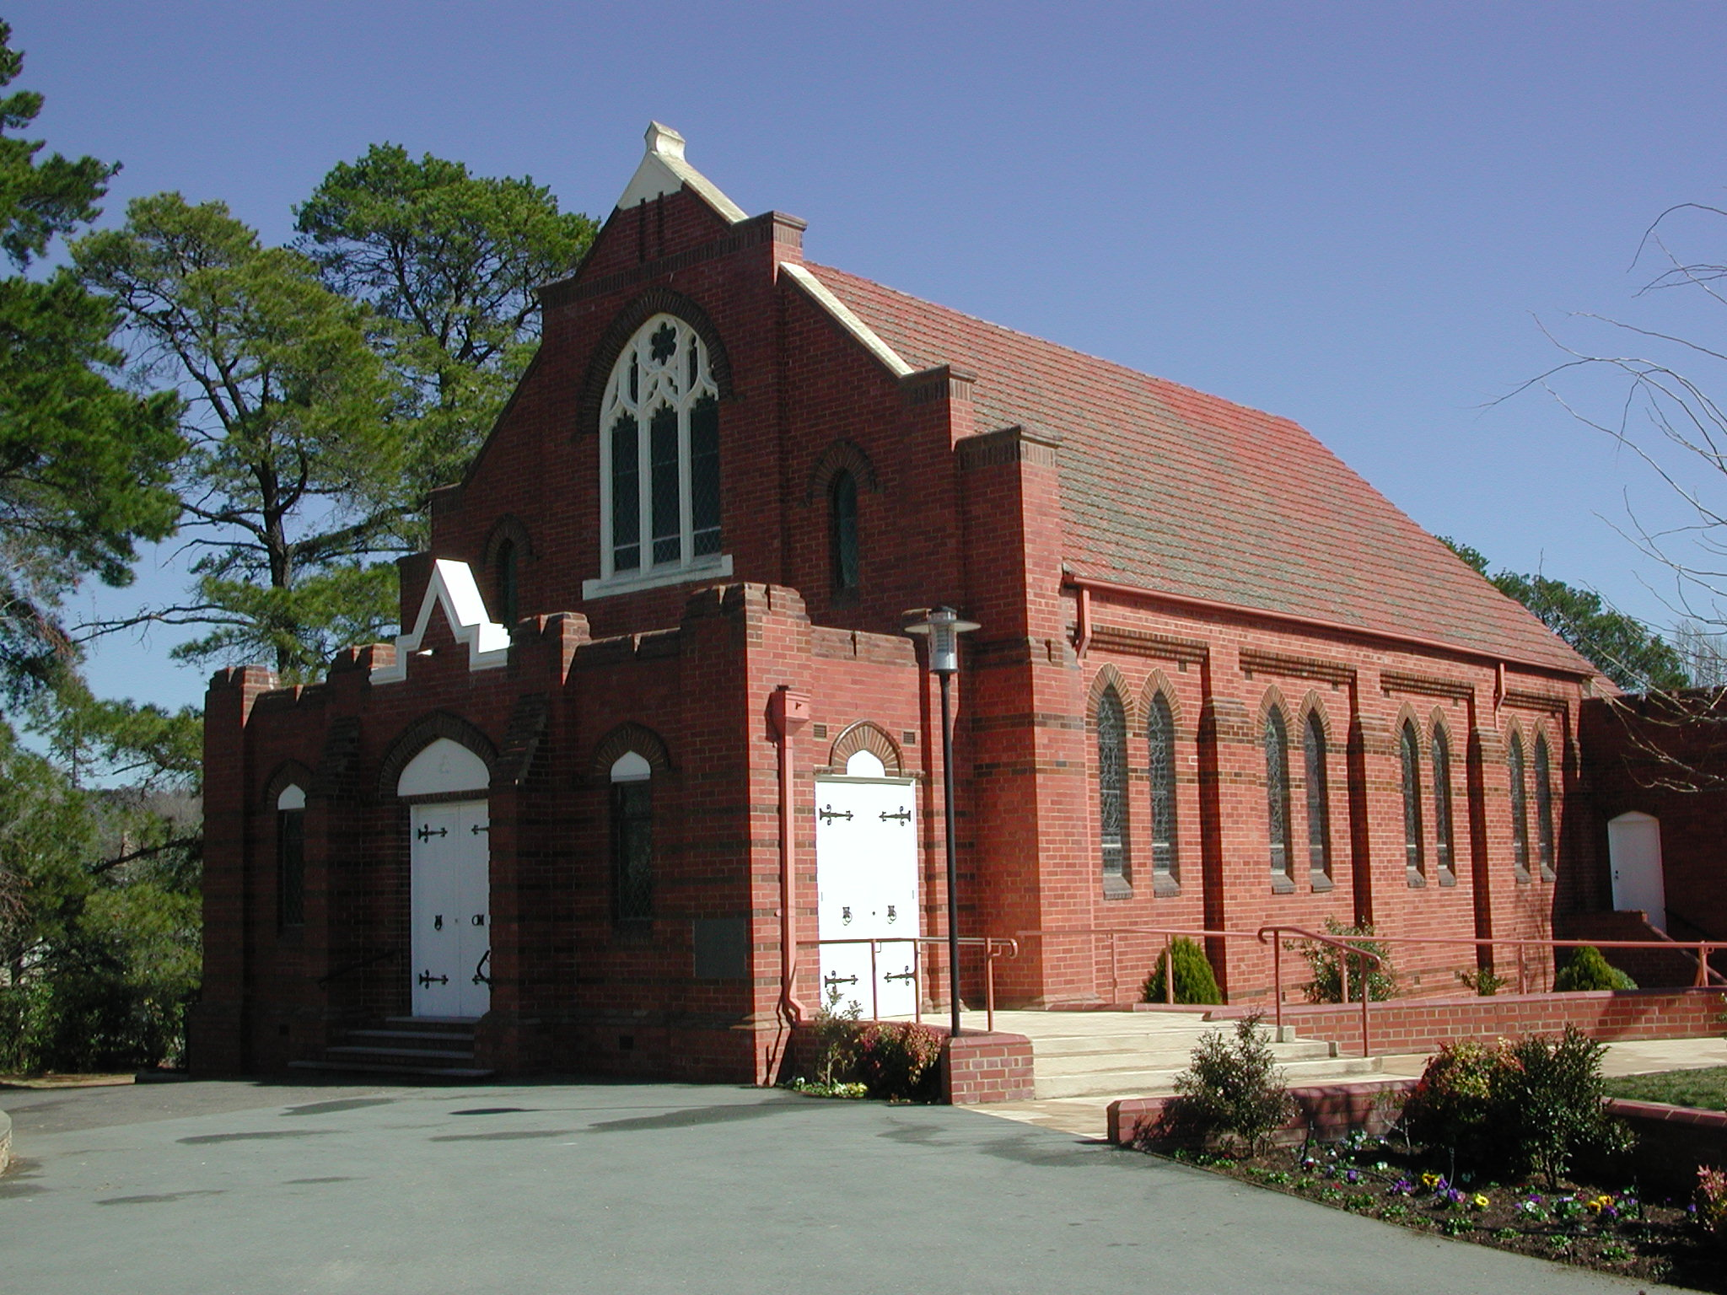

Figure 2. Church Entrance (1987) Figure 3. View of Church from Currie Cres (1987)
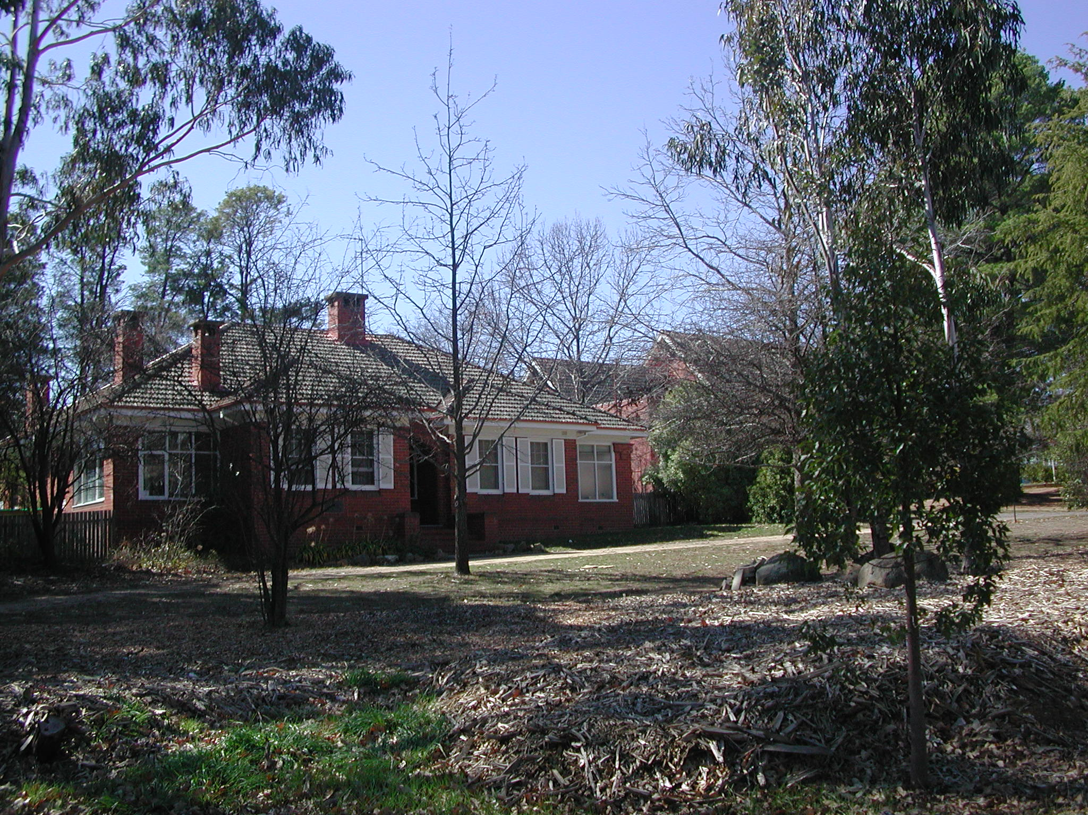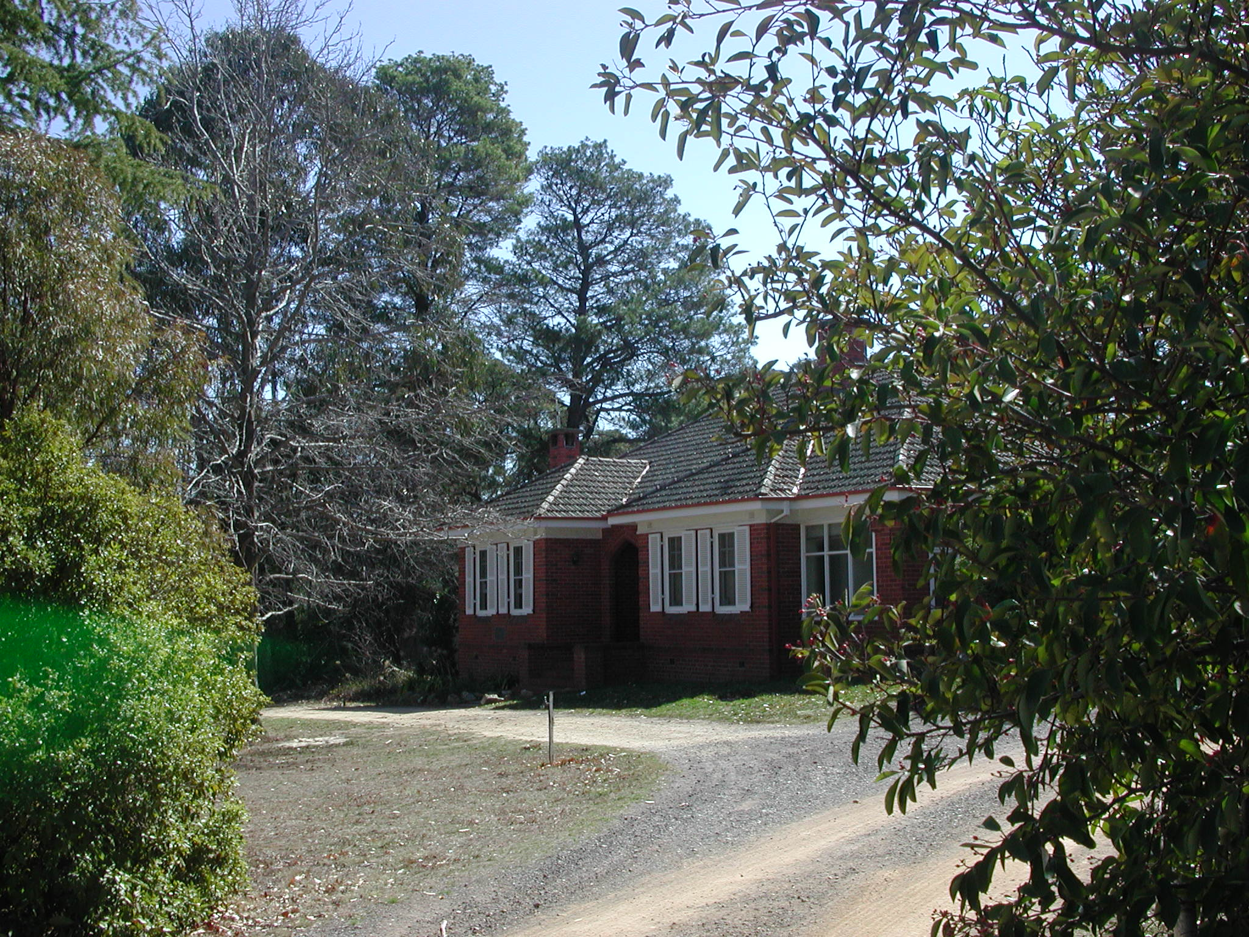
Figure 4. Church Manse – Front (1987) Figure 5. Church Manse – Rear (1987)

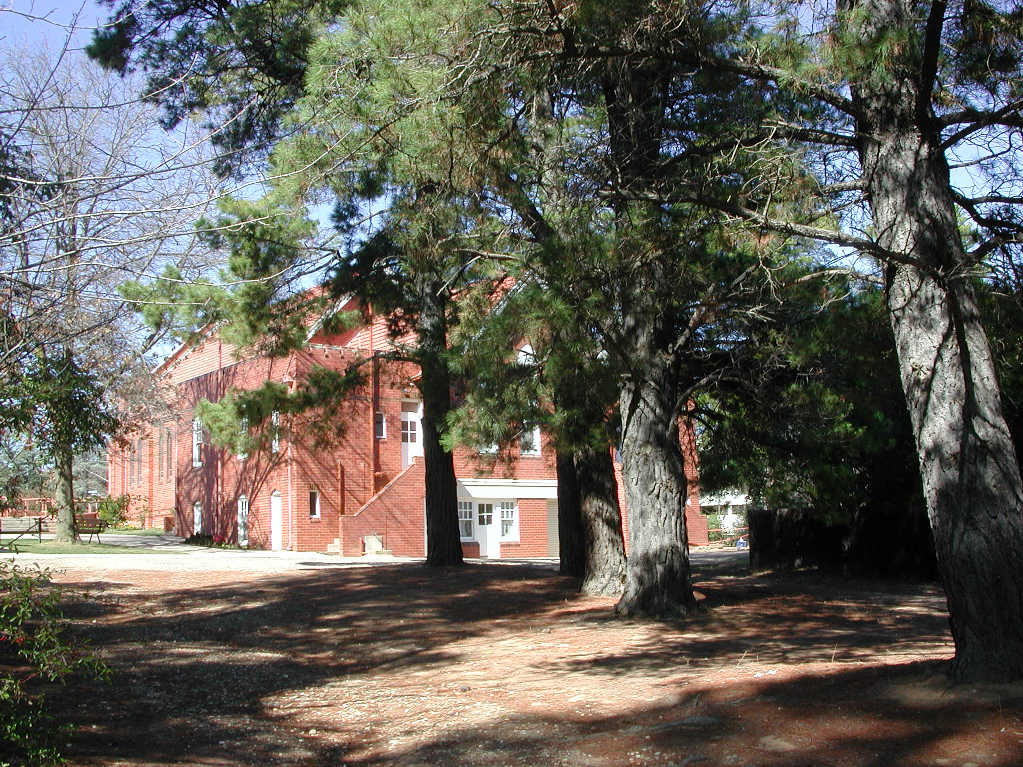
Figure 6. Rear of Church (1987)

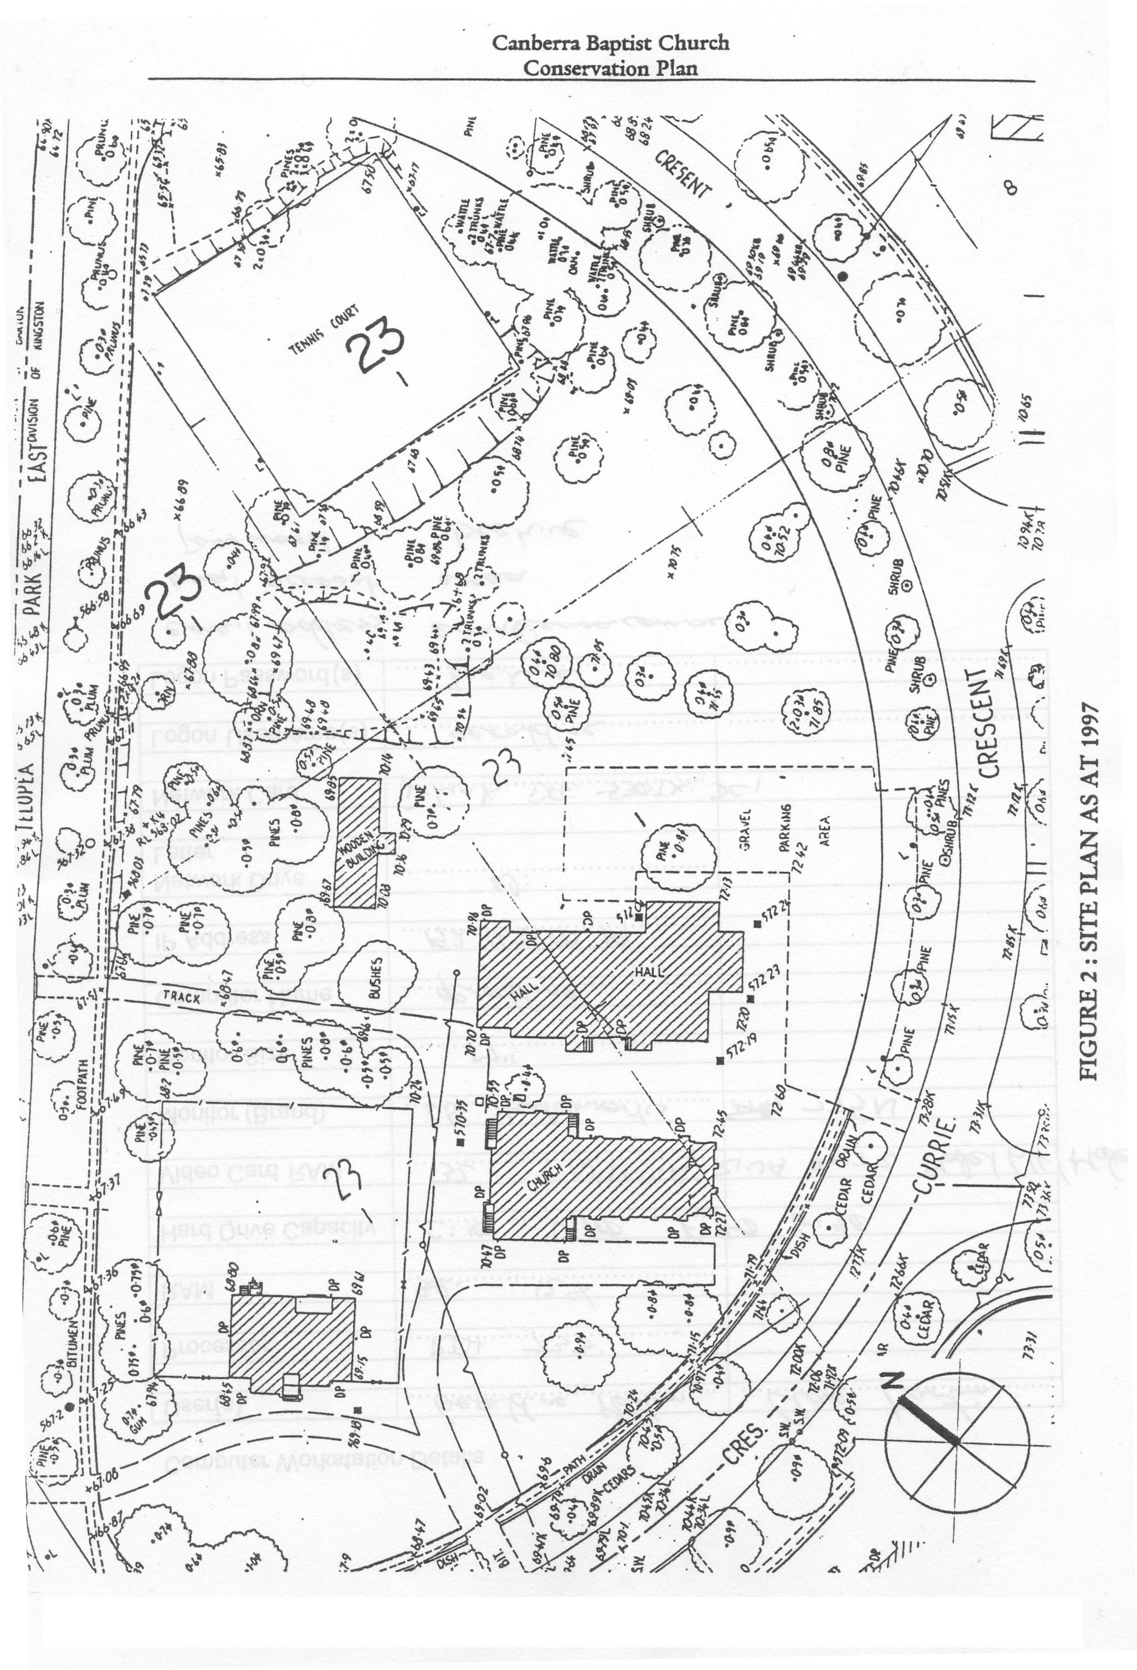

Figure 2. Site plan as at 1997, Cox 1997

