Australian Capital Territory

Planning and Development (Technical Amendment—Realignment of designated area boundary and rezone future urban area – Molonglo) Plan Variation 2010

Notifiable instrument NI2010 — 219
Technical Amendment No 2010-08
made under the
Planning and Development Act 2007, section 89 (Making technical amendments)

This Technical Amendment commences on 7 May 2010.

Technical Amendment Number 2010-08 to the Territory Plan has been approved by the Planning and Land Authority.

Kelvin Walsh
Delegate of Planning and Land Authority

3 May 2010

Planning & Development Act 2007

Proposed
Technical Amendment
to the Territory Plan

2010-08

Realignment of designated area boundary and rezone future urban area on
the Territory Plan map – Molonglo and
Structure Plan – Molonglo and North Weston

May 2010

Table of Contents

1. INTRODUCTION 1
Outline of the process 1
2. EXPLANATORY STATEMENT 2
Background 2
Proposed Changes and Reasons 2
3. TECHNICAL AMENDMENT 4

- INTRODUCTION

Outline of the process
The Commonwealth’s Australian Capital Territory (Planning and Land Management) Act 1988 allows for the Legislative Assembly to make laws to establish a Territory Planning Authority and for that Authority to prepare and administer a Territory Plan.
The Planning and Development Act 2007 (the Act) establishes the ACT Planning and Land Authority (ACTPLA) as the Authority which prepares and administers the Territory Plan, including continually reviewing and proposing amendments as necessary.
The technical amendment to the Territory Plan is prepared in accordance with the following two sections of the Act.
- section 95(1), a rezoning within a future urban area is a technical amendment that is consistent with the principles and policies in the structure plan for the area. Limited consultation is required for technical amendments made under section 95
- section 87(e), a variation may be undertaken to bring the territory plan in line with the national capital plan. No consultation is required for this type of variation
Following the release of the variation 2010-08 under section 90 of the Act, submissions from the public were invited for the part of this variation undertaken under section 95(1).
At the conclusion of the limited consultation period, any representations are considered by the ACT Planning and Land Authority (the Authority). In this instance no public submissions were received. The Authority then determines a day when the code variation is to commence by way of a commencement notice.
- EXPLANATORY STATEMENT

Background
The future urban area for Molonglo on the Territory Plan map does not accurately reflect the boundary line shown on the National Capital Plan (see Figure 1).
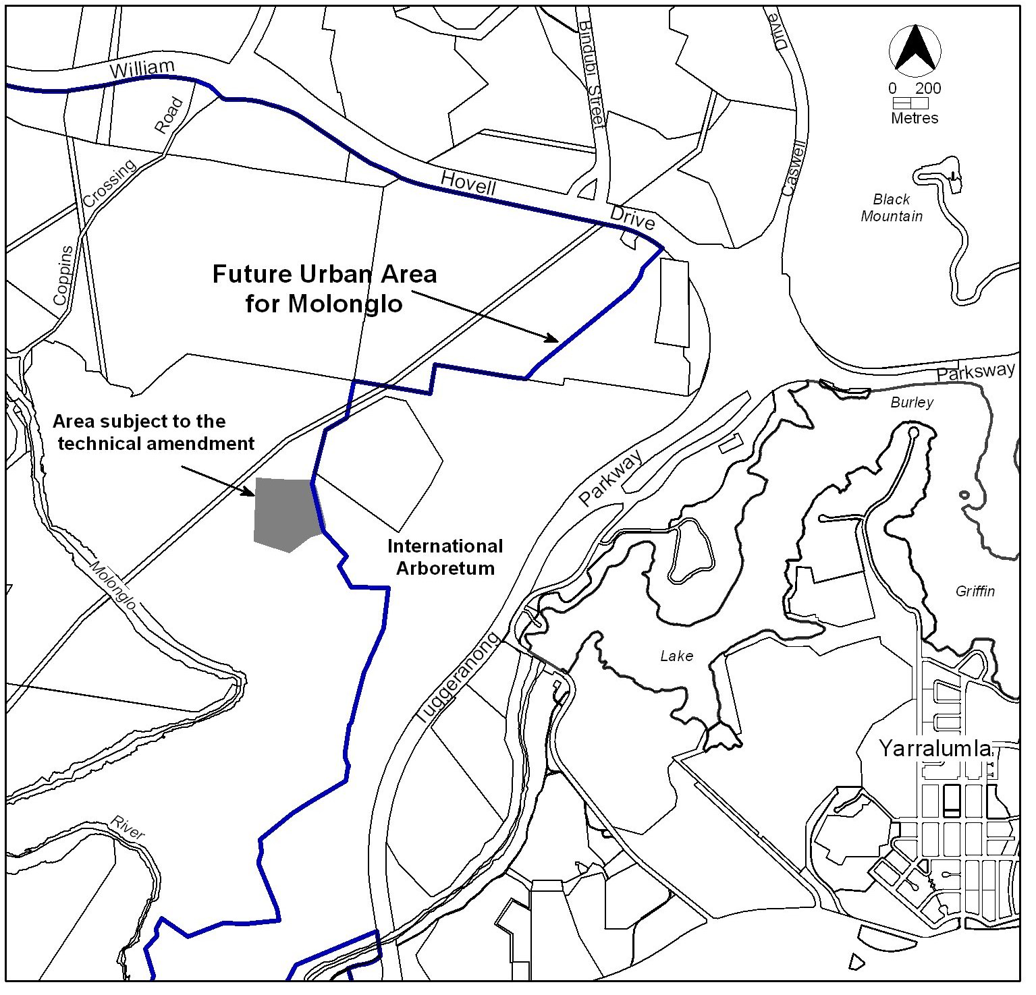
Figure 1: Boundary of Future Urban Area for Molonglo in Canberra central adjacent to designated land covering the International Arboretum.

Proposed Changes and Reasons
- Change to the boundary of the designated area alignment as shown on the Territory Plan map—Molonglo—Item 1

The boundary of the designated area is currently not shown in its correct alignment on the Territory Plan. Designated areas are under the control of the National Capital Authority as indicated in the National Capital Plan. The Territory Plan needs to be amended to show the correct boundary alignment. This change is made under section 87(e) of the Planning and Development Act 2007.

- Rezoning of future urban area shown on the Territory Plan map—Molonglo—Item 1

The area that is currently shown incorrectly on the map as designated area needs to be zoned and a future urban area overlay applied. The area currently zoned transport and services TSZ2 services is to be moved to provide a more appropriate location for the development of services. The site is intended to be developed as a substation to enable power to be provided to suburbs within the Molonglo future urban area. This change is made under section 95(1) of the Planning and Development Act 2007.
It should be noted, however, that as this area will retain a future urban area overlay, that the zoning of this land may undergo further changes as a result of future detailed planning. The final zoning of the land will be considered as a part of the estate development planning process and be set at the time of future urban area uplift.

- Revision of Figure 1 showing future urban area in Molonglo and North Weston Structure Plan—Item 2

Figure 1 in the Structure Plan for Molonglo and North Weston is to be revised to show the correct boundary alignment of designated areas in the Territory Plan. This change is made under section 87(e) of the Planning and Development Act 2007.
- TECHNICAL AMENDMENT

Variation to Territory Plan map
- Territory Plan map – Molonglo

Substitute the ‘Area subject to the technical amendment’ in Figure 2 with the ‘Area subject to the technical amendment’ in Figure 3.

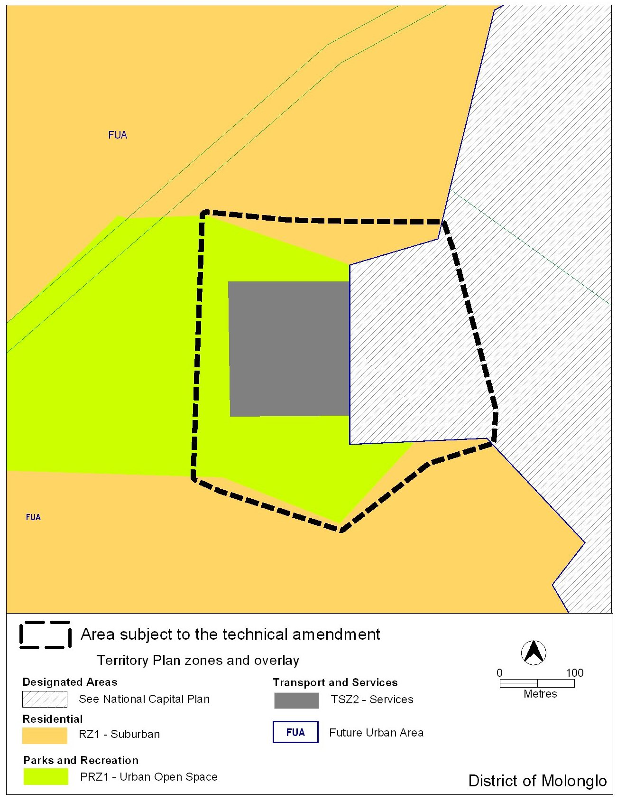
Figure 2: Current Territory Plan map showing area subject to the technical amendment

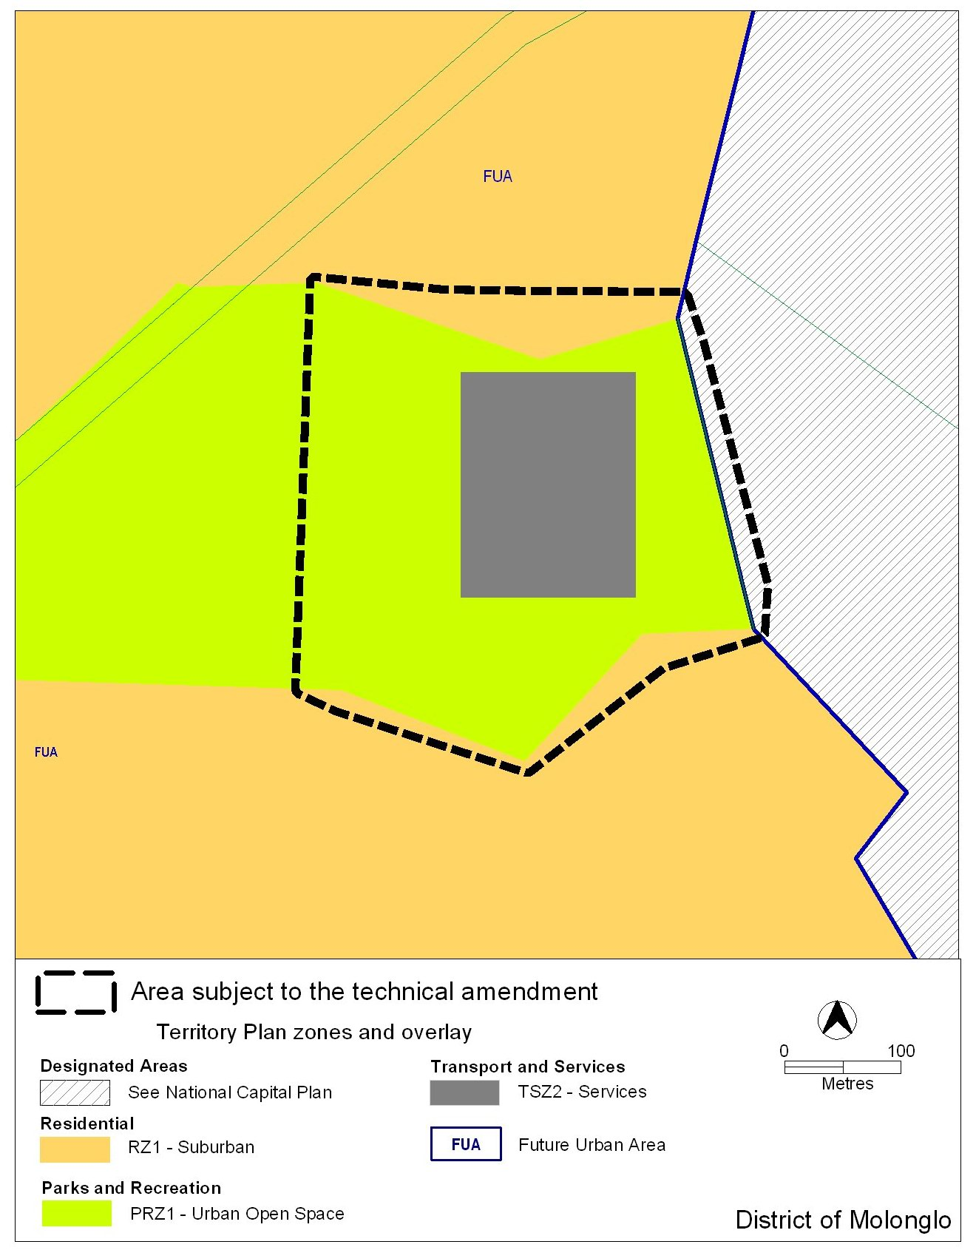
Figure 3: Proposed map showing land use zones in the future urban areas of Molonglo

Variation to Structure Plan Molonglo and North Weston
- Structure Plan Molonglo and North Weston, 3. Prohibited Development, Figure 1 Future Urban Area at the commencement of the Molonglo and North Weston Structure Plan

Substitute the current Figure 1 with the following

Figure 1 Area subject to structure plan
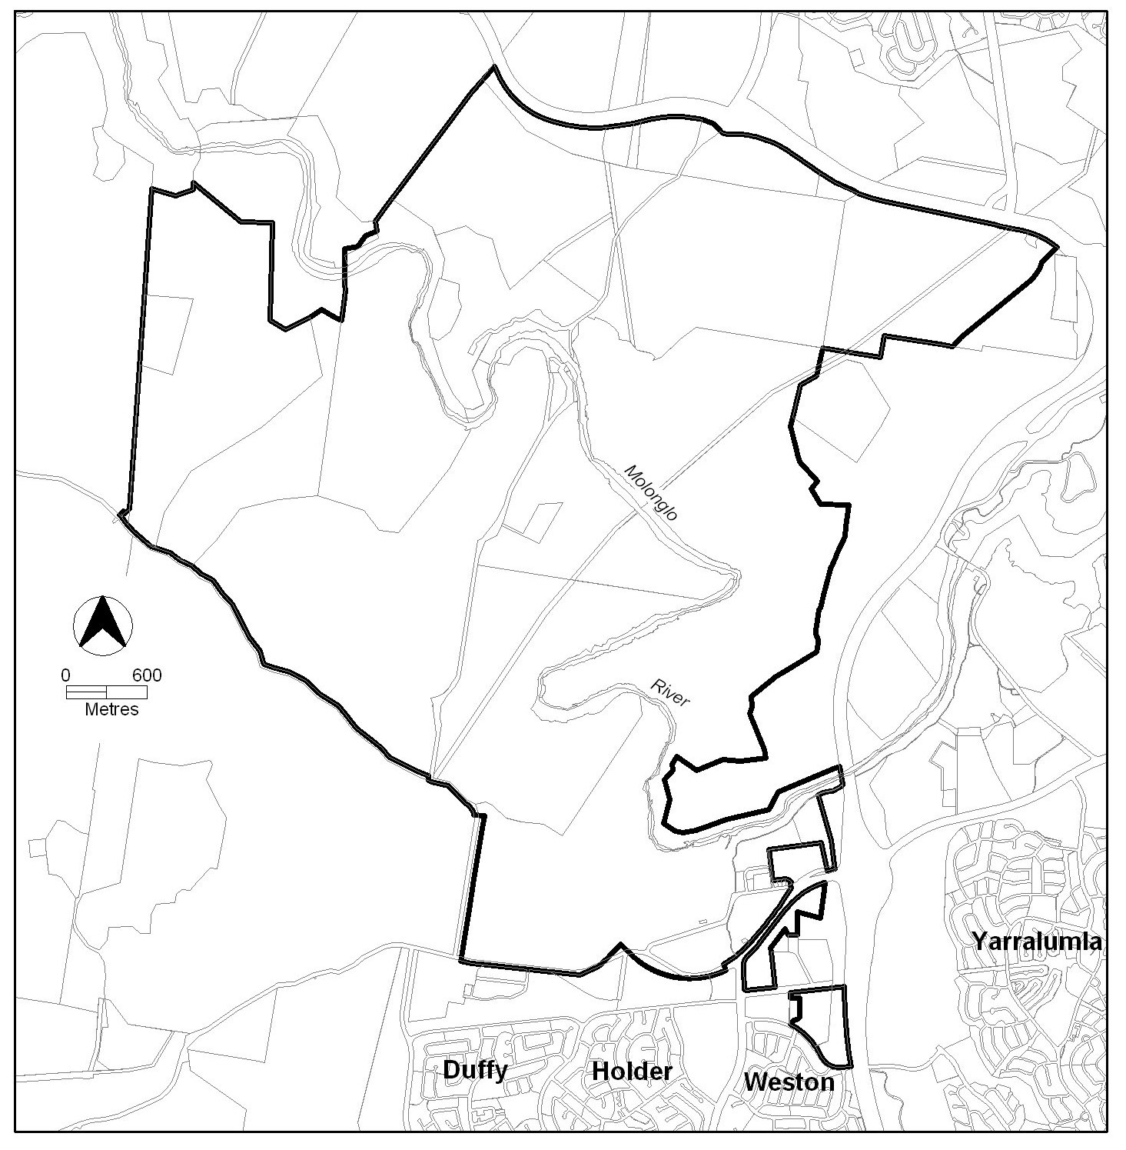

Interpretation service
