Australian Capital Territory

Heritage (Decision about Registration of the Giralang Primary School Complex, Giralang) Notice 2010 -

**Notifiable Instrument NI 2010—596**

made under the

*Heritage Act 2004* section 42 Notice of Decision about Registration

1. **Revocation**

This instrument replaces NI 2010 – 328

1. **Name of instrument**This instrument is the Heritage (Decision about Registration for Giralang Primary School Complex, Giralang) Notice 2010 -
2. **Registration details of the place**

Registration details of the place are at Attachment A: Register entry for the Giralang Primary School Complex, Giralang.

1. **Reason for decision**

The ACT Heritage Council has decided that the Giralang Primary School Complex, Giralang meets one or more of the heritage significance criteria at s 10 of the *Heritage Act 2004*. The register entry is at Attachment A.

1. **Date of Registration**21 October 2010

**Gerhard Zatschler  
Secretary  
ACT Heritage Council**

**21 October 2010**

|  |  |
| --- | --- |
|  | **AUSTRALIAN CAPITAL TERRITORY**  **HERITAGE REGISTER**  **(Registration Details)**  **Place No:** |

For the purposes of s. 41 of the *Heritage Act 2004*, an entry to the heritage register has been prepared by the ACT Heritage Council for the following place:

**Giralang Primary School Complex, Giralang**

Giralang Primary School

Block 4 Section 80 Giralang

Child Health Clinic

Block 5 Section 80 Giralang

Giralang Pre-School

Block 2 Section 80 Giralang

**DATE OF REGISTRATION**

Notified: 21 October 2010 Notifiable Instrument: 2010 -

Copies of the Register Entry are available for inspection at the ACT Heritage Unit. For further information please contact:

The Secretary

ACT Heritage Council

GPO Box 158, Canberra, ACT 2601

Telephone: 13 22 81 Facsimile: (02) 6207 2229

**IDENTIFICATION OF THE PLACE**

* **Giralang Primary & Infants School, Hall, Child Health Clinic and Pre-School complex, Blocks 2, 4 and 5 Section 80, Giralang**

**STATEMENT OF HERITAGE SIGNIFICANCE**

The Giralang Primary School Complex comprising the Primary School, Child Health Clinic and Pre-School, has exceptional heritage value arising from its outstanding design by prominent Canberra architect Enrico Taglietti. The complex retains strong associations with Taglietti who played a significant role in Canberra’s cultural history as one of the most significant architects to practice in Canberra. The Giralang complex is both one of his major works (acknowledged as such by himself and others) and one of his early commissions from the National Capital Development Commission which helped to establish his working career in Canberra.

The design exhibits exceptional creativity which was highly innovative in Canberra at the time of construction. As well as innovative fully open plan teaching areas the internal features of the school included innovative extensively glazed teachers’ offices next to class areas. The school complex is an important example of the Late Twentieth-Century Organic Style of architecture and in its aesthetics it epitomizes the design principles of that style with the exterior free massing expressing internal functions. It is of special interest because it is one of the earliest Canberra buildings in this modern ideal.

The Giralang Primary and Infants School also has high heritage significance for its historic association with the development of education in Canberra. It is a particularly well-preserved example of a 1970’s educational and community facilities demonstrating the philosophy of open-plan primary education dating from the time when the ACT education authority was inspired by developments of open learning. The architectural design exhibits this philosophy through its interconnected, totally open-plan, and flexible multi-use teaching areas with courtyards and framed vistas between teaching areas and out to playgrounds.

The Giralang Primary School Complex also demonstrates the innovative decision by the ACT education authority and NCDC planners to build schools with facilities which could be used extensively by community groups outside school hours. The school was one of the first examples of this approach and included school assembly hall and board room which were also available for community use. The adjacent Child Health Centre is also important as evidence of the ACT’s community child health policy at the time.

The spacious park setting of the complex is distinctive of the modern style and the planning intentions of both the education authorities and the planning authorities of the time. The setting and the architecture combine to produce a precinct of integrity, illustrative of modern architecture and can provide information that will contribute to the understanding of architectural and cultural history of the ACT and for teacher education as the benchmark primary school for totally open learning.

**FEATURES INTRINSIC TO THE HERITAGE SIGNIFICANCE OF THE PLACE**

The features intrinsic to the heritage significance of the place and which require conservation comprise:

* The built fabric of the complex as originally constructed and finished to house the primary, infants and kindergarten teachingareas, library, assembly hall, canteen, staff, pre-school and child health clinic.
* The sculptural forms, free asymmetrical massing and complex angular geometry of the buildings; horizontal roof planes, timber lined eaves combined with the steep pitched roof forms of the major spaces, deep horizontal and sculptured metal fascias, down pipes and tubs; steel-framed structure; face cement-brick walls; bush-hammered concrete; fenestration; clear-finished timber joinery internally; open planning; arrangement of floor and ceiling levels and walls; varied ceiling heights (including original raked ceiling to the Assembly Hall, internal courtyards; original finishes and detailing; and the original colour scheme including blue carpet, red metalwork and yellow storm water pipes.
* The site plan where the buildings are like sculptural forms set in an open landscaped setting, including the original scale, form and fabric. The open park-like character of the grounds and playing fields around the school, their landscaping and planting.

**APPLICABLE HERITAGE GUIDELINES**

The Heritage Guidelines adopted under s27 of the *Heritage Act* 2004 are applicable to the conservation of Giralang Primary School Complex comprising the Primary School, Child Health Clinic and Pre-School.

The guiding conservation objective is that the Giralang Primary School Complex shall be conserved and appropriated managed in a manner respecting its heritage significance and the features intrinsic to that heritage significance, and consistent with a sympathetic and viable use or uses. In the absence of a Conservation Management Plan any works that have a potential impact on significant fabric (and / or other heritage values) shall be guided by a professionally documented assessment and conservation policy relevant to that area or component (i.e. a Statement of Heritage Effects – SHE).

**REASON FOR REGISTRATION**

Giralang Primary School Complex, Blocks 2, 4 and 5, Section 80, Giralang, has been assessed against the heritage significance criteria and been found to have heritage significance when assessed against five criteria under the *Heritage Act 2004.*

**ASSESSMENT AGAINST THE HERITAGE SIGNIFICANCE CRITERIA**

In assessing the nomination for this place, the Council considered:

• The nomination by the RAIA (ACT Chapter) of the Giralang Primary & Infants School, Hall, Child Health Clinic and Pre-School Complex in May 1996.

• Inspections of the complex by ACT Heritage Council members in June and August 2006, February 2010 and by architectural consultants July 2009.

Pursuant to s.10 of the *Heritage Act 2004,*a place or object has heritage significance if it satisfies one or more of the following criteria. Significance has been determined by research as accessed in the references below. Future research may alter the findings of this assessment.

**(a) it demonstrates a high degree of technical or creative achievement (or both), by showing qualities of innovation, discovery, invention or an exceptionally fine level of application of existing techniques or approaches**

The highly innovative and creative achievement of architect Enrico Taglietti is apparent in his design of an inter-related group of buildings in the Giralang Primary School Complex. The Primary/Infant School provides five interconnected totally open-plan teaching areas for pupils carefully composed to stimulate their learning. Open plan learning was a new philosophy at that time and previously schools had had individual classrooms. Other innovative features include teachers’ offices with extensive glazing to allow supervision of the class areas, and a designated school board room for school and community use–the first in any Canberra school. The Giralang Primary School Assembly Hall also demonstrates the innovative decision by the ACT education authority and NCDC planners to build schools with facilities which could be used extensively by community groups outside school hours.

The Giralang Primary School Complex was awarded the RAIA ACT Chapter Canberra Medallion in 1977, the most prestigious award in Canberra for architectural excellence. It was later awarded the RAIA ACT Chapter Twenty Five Year Award in 2001.

The place meets the threshold for heritage listing in relation to this criterion.

**(b) it exhibits outstanding design or aesthetic qualities valued by the community or a cultural group**

The Giralang Primary School Complex exhibits outstanding design qualities and is an important example of the Late Twentieth-Century Organic Style of architecture in Canberra, and epitomizes the design principles of that style. The more dramatic and spectacular aspects of organic architecture such as the complex angular geometry which complements nature, horizontal roof plane, and highlight windows are demonstrated to great effect.

Internally there is a successful flow of space from the entrance down the natural slope of the land, upwards as the low ceilings blend into raked ceilings under the pitched roofs and horizontally where the walls are angled across the rectangular grid of the plan. The resulting variety of spaces and shapes provide distinctive aesthetic quality in the interior areas. The creation of courtyards and framed vistas between teaching areas and out to playgrounds adds to these aesthetic qualities and their appreciation by the school and local community.

The internal cement brick walls and the bush-hammered concrete balcony, in their original unpainted condition; the internal timber joinery, when it had a natural finish; and the original colour scheme had considerable aesthetic value. Although depleted by the treatment of these elements, that value could be recovered with appropriate restoration.

The exterior of the complex is the result of free massing expressing functions naturally. It has considerable design quality, due in particular to the angular geometry of the larger elements which rise above the horizontal roof planes. The lower roofs satisfactorily link the components of the complex and their downpipes provide rhythm to the composition, enhanced by the regular spacing of projecting dwarf walls.

The open suburban park setting of the complex adds to its aesthetic value.

The place meets the threshold for heritage listing in relation to this criterion

**(c) it is important as evidence of a distinctive way of life, taste, tradition, religion, land use, custom, process, design or function that is no longer practised, is in danger of being lost or is of exceptional interest**

Giralang Primary School layout demonstrates the innovative and distinctive educational approach of open plan schooling introduced in the early 1970s to Canberra schools by the ACT Education Department. It demonstrates how flexible, multi-purpose spaces, both large and small, could be arranged to enable teachers to work in teams to cater for the individual needs of students of various ages and learning capacities. Before the design and construction of Giralang Primary School, semi open-plan schools were built in the ACT, beginning with Flynn Primary in 1973, but by the late 1970s the experiment was discredited and fully open-plan schools were no longer built. Giralang remains as the prime exemplar of this educational philosophy.

The Child Health Centre is important as evidence of the ACT’s community health policy at the time it was built, of general practitioners operating from government surgeries located in government-owned neighbourhood health centre, a system also unique in Australia. This health program ceased in the late 1990s.

The place meets the threshold for heritage listing in relation to this criterion.

**(d) it is highly valued by the community or a cultural group for reasons of strong or special religious, spiritual, cultural, educational or social associations**

The Giralang Primary School Complex is clearly valued by its local community for the amenities and services it provides. Some may also value its historic, architectural and aesthetic qualities, and for the modernist character the complex provides to the suburb, but this has not yet been tested in an objective way. At the time when the school was under threat of closure there was much public support for the school, but this focused as much on its function as on its form. Since the school has been retained there has been far less public evidence of widespread local community attachment to the place. Further testing and analysis would be necessary to substantiate social value heritage significance for the Giralang Primary School Complex.

The place does not meet the threshold for heritage listing in relation to this criterion.

**(f) it is a rare or unique example of its kind, or is rare or unique in its comparative intactness**

The Giralang Primary School complex is an unusual example of a comparatively intact and cohesive group of buildings erected at the same time that incorporates facilities for children from pre-school to primary ages and was designed by the one architect in the same architectural style. However these qualities contribute to its creative, aesthetic and historic heritage values rather than being intrinsically of heritage value in their own right.

There are four public schools designed by Enrico Taglietti in Canberra. The former Flynn Primary School, also designed by Taglietti, has several aspects of the open plan philosophy of school learning in its architectural design, and the Giralang complex is not unique in that respect.

The place does not meet the threshold for heritage listing in relation to this criterion.

**(h) it has strong or special associations with a person, group, event, development or cultural phase in local or national history**

The association of Giralang Primary School with a particular phase in the development of education in the ACT is strong. It was purpose designed in the era of the Whitlam Labor Government, when the ACT education authority was inspired by developments in the United Kingdom, particularly open learning and close relationships between schools and their communities.

The complex is important for its strong association with the architect Enrico Taglietti, who played and still plays a significant role in Canberra’s cultural history. He is one of the most acclaimed architects to practice in Canberra and the Giralang is a major work which established his early career. Both Taglietti and others acknowledge the Giralang complex as being a seminal design in his portfolio. The Giralang Primary School Complex has strong and special association with Enrico Taglietti.

The Giralang Primary School Complex also has some associations with John Griffin, Principal in 1988 and who was innovative in introducing computer education as a new teaching subject and introduced the use of information technology in school administration. John Griffin was also a pioneer of School Based Financial Management, which he developed successfully at Giralang, and which is now used throughout the ACT. However there is no evidence that he was influenced by the architectural environment at Giralang in these undertakings and he may well have introduced these measures if he had been Principal at another school. The association with John Griffin is not of heritage value.

The place meets the threshold for heritage listing in relation to this criterion.

**(i) It is significant for understanding the evolution of natural landscapes, including significant geological features, landforms, biota or natural processes**

Not applicable.

**(j) it has provided, or is likely to provide, information that will contribute significantly to a wider understanding of the natural or cultural history of the ACT because of its use or potential use as a research site or object, teaching site or object, type locality or benchmark site**

The Giralang Primary School Complex is such a good example of its architectural style and depiction of a particular educational philosophy, and also so intact, that it can provide information that can contribute to the understanding of architectural history by students and the general public. The complex can also provide information that will contribute to the cultural history of the ACT for teacher education and research as the benchmark primary school for totally open learning.

The place meets the threshold for heritage listing in relation to this criterion.

**SUMMARY OF THE PLACE**

**HISTORY AND PHYSICAL DESCRIPTION**

**Description**

Giralang is a northern suburb of Belconnen and its local Public Primary School is located roughly the centre of the suburb, surrounded on three sides by the Giralang District Playing Fields. The suburb, characterised by Radburn-style planning with houses facing parklands, has in general enabled pedestrian routes for children to travel from home to the local school which opens directly onto the unfenced playgrounds, with established trees, and ovals.

Externally, the buildings of the school complex have grey cement brick walls and the roofs are metal deck with wide white-painted metal fascias to the flat roof areas. Throughout the buildings the metalwork (windows, doors, light fittings and exposed steel posts) is painted red. Prominent vertical square hollow metal pipes are attached to the fascias acting as downpipe spitters, emptying into concrete bowls. They give a vertical rhythm to the facades that contrasts with the strong horizontal form of the white metal fascias. Adjacent to almost all downpipes along the front of the school and the assembly hall are regularly-spaced projecting cement brick dwarf walls.

The Pre-School is located to the west of the school and is constructed in the same aesthetic and similar materials to the primary school building. There are spaces for noisy and quiet learning activities, resting, toilets, staff, kitchen and storage. The walls are of unpainted cement bricks. Some walls project on the south side and on the north side into the playground. They have geometric profiles similar to those of the dwarf walls at the front of the school. The flat roof is relieved by two light towers rising above internal learning space. Flat roofs have deep fascias painted blue and natural-finished timber-boarded soffits.

The Child Health Clinic is located to the north east of the school and is constructed in the same materials as the school and retains the original colour scheme to the exterior. It too has a flat roof with a generous overhang, deep fascias and timber-boarded soffits. There are also projecting cement brick dwarf walls complementing those at the front of the school directly opposite.

The plan of the Primary and Infant Schools and Assembly Hall is based on a cruciform shape with interconnecting teaching areas under one roof. The centre of this cruciform plan is the library as the heart of the school, surrounded by the open plan classrooms on three sides and an internal landscaped courtyard on the fourth side. Additional internal courtyards are cut into the plan to provide natural light and to enhance the feeling of openness. The overall whole is a balanced distribution of forms and spaces about a centre point and organised along secondary axes, some of which incorporate ramped pathways.

The cruciform plan of the school is expanded at the internal corners where the rooms extend out in plan with 55-degree external walls. This planning is reminiscent of that of American architect Frank Lloyd Wright in his later years when he used 60-degree grids to form the basis of his designs. Here the whole planning grid is on a square module and these 50 degree walls are planned in a 2:3 (X:Y) angle cut across the grid.

The principal’s office, staff room, boardroom and administration office are located off the northern entry, at the top of the “Y” axis of the cruciform plan. The floor plan steps down the site with a circulation ramp leading from the administration wing down towards the large central landscaped internal courtyard in front of the library. The wide passage splits in two directions to enter the teaching areas either side of the courtyard and library. Restricted views into the courtyard are provided through porthole windows from the passage and teaching areas. Further open ramps either side of the library provide continuity between teaching areas. Each teaching area has separate withdrawal rooms, wet areas and teachers’ offices providing for large and for small teaching groups and varied activities. The teaching areas open out onto the playground and smaller courtyards, some landscaped and others paved. The teaching areas are all linked through the open planning.

There are a small number of raised levels to the southern end of the school with special activities on the upper levels and wet areas below. There are two mini stepped theatres, one of which is associated with the kindergarten. These are also used as separate private teaching areas. The teachers’ offices have extensive glazing to allow supervision of the whole area.

The kindergarten is to the west on the “X” axis and is slightly separated from the adjoining class areas and the central library. The kindergarten has its own north east facing, partly enclosed grassed playground, however, due to the limited number of teachers, the kindergarten children now play with the older children in the combined playground to the south and this area is used as an outdoor teaching facility. The kindergarten area has been adapted for use by the Pre-School relocated there in 2007.

To the east along the “X” axis the Assembly (Communal) Hall is excised from the plan and is located away from the classrooms, with the canteen, connected via a wide enclosed passage. The plan and form of the hall shares a common shape with the primary and infants school yet is a clearly articulated separate form that expresses its dual function: it was planned to be used, along with the canteen, during school hours as well as an out of hours as a community facility, for the residents of Giralang. It is still used in this way and

has its own separate entry lobby for out of hours use. The hall proscenium arch is quite low, in scale with the young performers. A false ceiling has been installed, to reduce heating costs, which detracts from the understanding of the original space with its high raked ceiling and full-length highlight windows.

The school canteen is located in the wide link foyer between the class areas and the assembly hall enabling it to also be used out of hours with the assembly hall during functions. During the school day the children can approach the canteen off the link foyer through separate glazed doors from the southern playground.

The central location of the library forms the learning ‘heart’ of the school with access provided from two sides. The dynamic space has a raked ceiling, with highlight windows, over half of the floor area. The bulkhead and vertical surface of the highlight wall are timber lined. To the north the full width glazing, with timber lining below the sill, allows a view out over the large internal courtyard while to the south the library steps up a half flight to an intimate mezzanine space that cantilevers out over the southern open plan class areas with a bush-hammered in situ concrete walled ‘balcony’. This area was originally an intimate reading area but is now used as the computer lab. Below the mezzanine, down a half level, is the librarian’s office and teacher resource store. The librarian’s office has extensive glazing to allow supervision of the main area of the library.

To the south of the library there is an important spatial relationship where the ceiling rises to its greatest height along the open plan teaching spaces. Externally this space is expressed as a similar shape to the Assembly Hall structure. Internally the vista extends along an exceptional three-dimensional space where the sculptured masonry walls and library cantilevered concrete ‘balcony’ combine to frame vistas that at their ends extend on out to the playgrounds through vertical windows at the angled perimeter walls.

A secondary visual axis extends across the southern teaching areas and the two internal courtyards where there are ‘porthole’ windows in all the walls which provide a vista from one side of the playground through the building to the other side of the playground.

The school is constructed in a steel frame on a six-metre module. The internal walls are cement brick. The school colours are yellow and blue, these prime colours being part of the original design. Internally, the carpet was blue and some carpet appears to be original. Much of the original internal timber joinery is intact and has a natural finish. The boardroom and staff room have highlight windows and raked ceilings. The internal masonry walls are sculptured, including part circular forms, and combined with the varying ceiling levels; create a complexity of form and architectural interest of outstanding and dramatic affect.

The large landscaped courtyard located between the administration area and the library is paved with ceramic tiles designed by the children as a Bicentenary project in 1988. The courtyard trees and large stormwater ‘bowls’ are also important landscape design elements. In the foundations below the tiles is a time capsule placed by the children at the time of laying the tiles.

The complex has clear architectural indicators of the Late Twentieth-Century Organic Style (1960- ): free massing expressing functions naturally; complex angular geometry; horizontal roof planes; highlight windows. In the two parallel streams of modern architecture, the ‘functional’ attracted followers of Le Corbusier, while the ‘organic’ appealed to architects such as Taglietti. The authors of the authoritative study *Identifying Australian Architecture* noted “the more dramatic and spectacular aspects of organic architecture were to be seen in the idiosyncratic designs of Enrico Taglietti.” This is seen to great effect in the Giralang complex.

**History**

The Giralang Primary School Complex was designed by Enrico Taglietti in 1974-75 1 for the National Capital Development Commission (NCDC), construction being completed in 1976.

Residential settlements such as Giralang were an integral part of the creation and planning of Canberra. The growth of Canberra in the latter half of the 20th century resulted in the development of the “Y Plan” by the NCDC. The new suburbs designed by the NCDC were often based on ‘Radburn’ planning, with the segregation of traffic and pedestrians; with parkland or nature reserves linking the residential blocks with shops and schools, often passing under or bridging the roads.

In 1974 the ACT established its own education system separate from that of NSW. It was founded on community involvement and a school-based curriculum and the new policy was for open plan classrooms in preference to the previous single classrooms and associated traditional education philosophy.

The design brief for the school let by the Commonwealth Department of Education stated that the school was to be open plan to facilitate the new philosophy of open plan education from Britain and the USA where learning was in flexible, multi-purpose spaces that enabled teachers to work in teams to cater for the individual needs of students. Local Canberra architect Enrico Taglietti won the design brief. Construction of the complex commenced in June, 1976, by ACT Builders (interstate) Pty Ltd, and was completed in December of the same year, at a cost of $1, 800, 00.

The Child Health Clinic was included as part of the original NCDC brief and it housed a Resident Salaried Medical Doctor, two dental nurses and a Community Nurse. The provision of “bulk-billing” salaried neighbourhood doctors practising from government surgeries located in government-owned neighbourhood health centres was an important community health policy in the ACT that was unique in Australia. This program was ended and many of the centres hastily demolished under the Carnell Liberal Government of the late 1990’s. A private medical practitioner now rents the clinic

The Pre-School attached was a semi-autonomous body; the building being under the control of the Principal and the administration being under the control of the Pre-School Authorities. The Pre-School function was relocated into the main Primary School building in early 2008 and the Pre-School premises transferred from the Department of Education to TAMS.

**Condition**

The primary and infants school, pre-school, hall and health centre are well maintained and in good condition. There are minor internal alterations to some areas. Ceilings have been replaced and in most areas the original face brick walls have been painted. Most wet area joinery has been replaced with Laminex veneered units. Some of the original light tan coloured acoustic ceiling panels have been replaced with new white panels, some in new two way exposed suspension systems, in places concealing the original raked ceilings. The raked ceiling of the assembly hall has been concealed by a flat suspended ceiling system, which detracts from the understanding of the original space. The original cylindrical suspended light fittings in teaching areas have been replaced by spheres. A partition wall has been installed which partially divides the large teaching area at the southern end of the school, and the originally unpainted bush-hammered in situ concrete balcony to the library upper mezzanine has been painted white.

Externally, downpipes, originally painted yellow, have been painted white and retro-fitted services have partially obscured the original architectural aesthetic. Timber-boarded box-like elements which originally projected from the apexes of the splayed gables have been removed.

**REFERENCES**

Enrico Taglietti, Final Sketch plans “Giralang Primary & Pre School for NCDC”

RAIA 1982, *Canberra An Architectural Guide To Australia’s Capital*

Richard Apperly Robert Irving Peter Reynolds 1989, *Identifying Australian Architecture Styles and Terms from 1788 to the Present*, Angus and Robertson.

AR The Architectural Review Vol. CLXIV No. 979 Sept. 1978.

Jennifer Taylor, 1990, *Australian Architecture Since 1960*, RAIA 1990

Paul Reid 2002, *Canberra following Griffin: a Design History of Australia’s National Capital*, National Archives of Australia.

Di Herbert. A Brief History of Giralang Primary School.

Ed. Gerd Hatje. *Encyclopaedia of modern architecture*, Thames and Hudson, London, 1965.

Ken Charlton, 2007, *The Contribution of Enrico Taglietti to Canberra’s Architecture*, RAIA (ACT).

RAIA ACT Chapter RSTCA Citation on Giralang Primary School

**IMAGES AND MAPS**

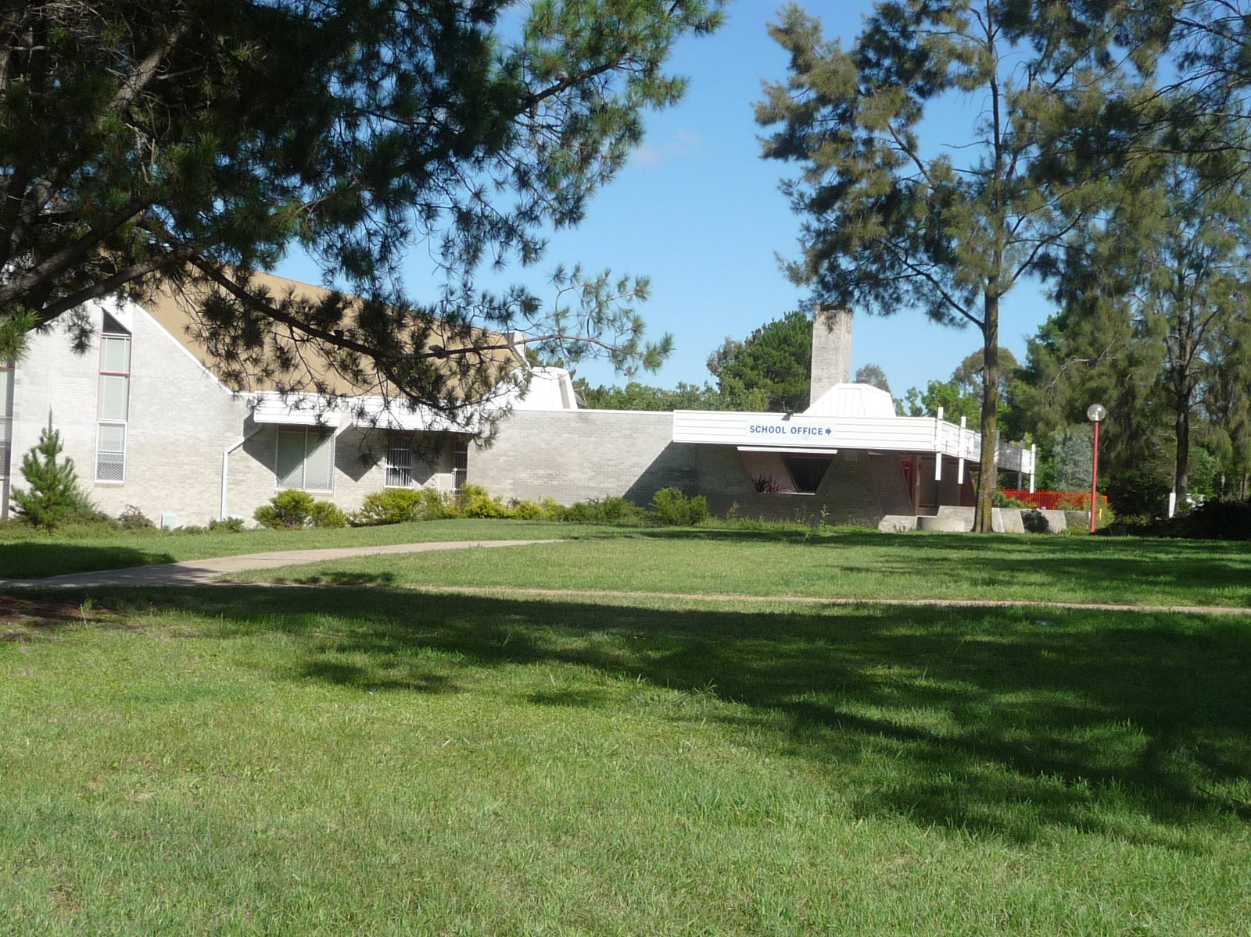

Giralang Primary School, Giralang (Photo: ACT Heritage 2010)

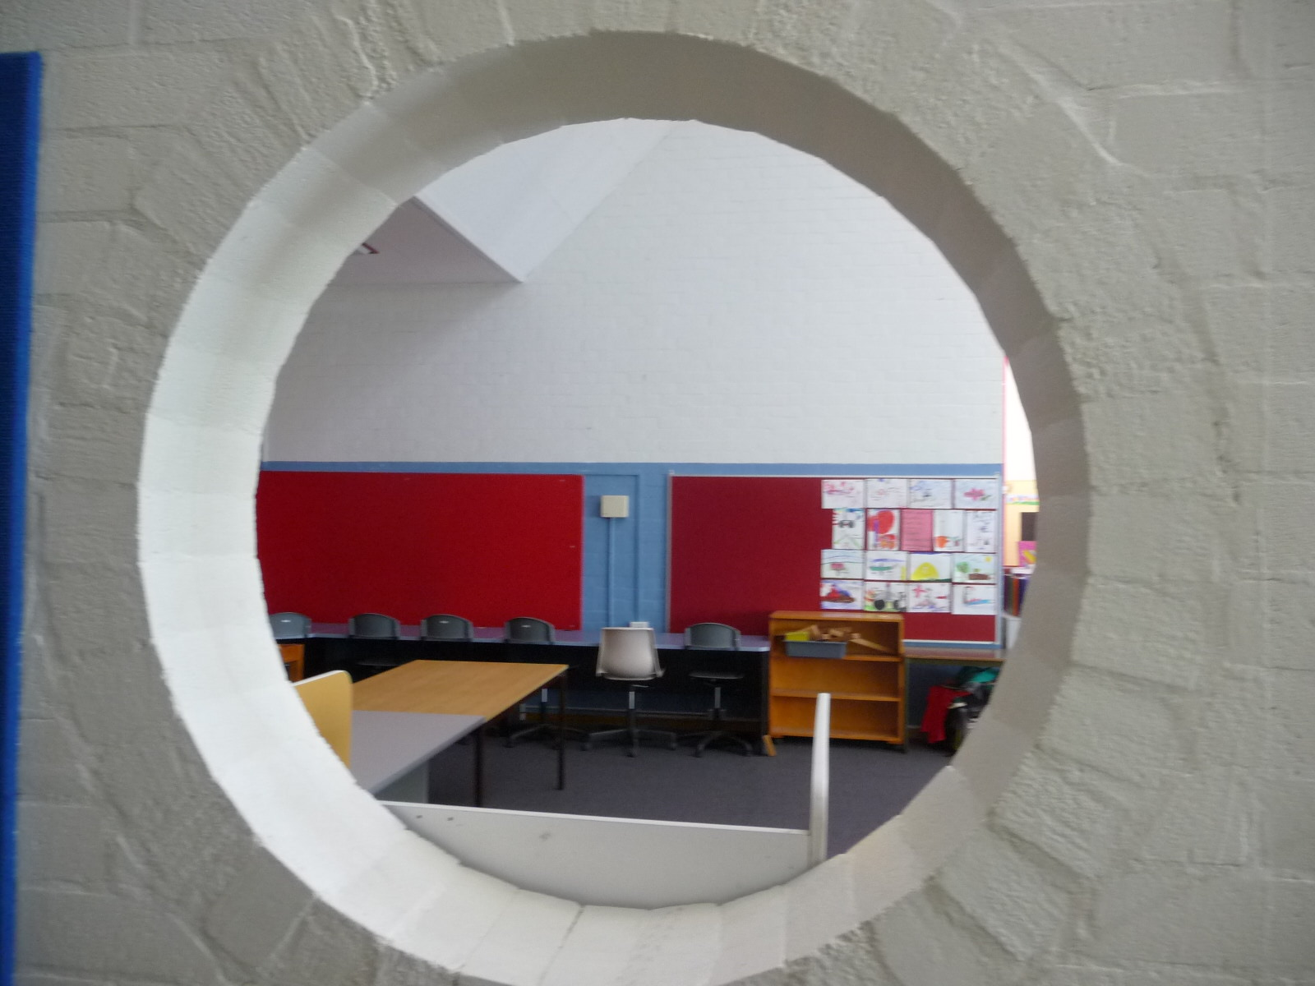

Giralang Primary School, interior of classroom (Photo: ACT Heritage 2010)

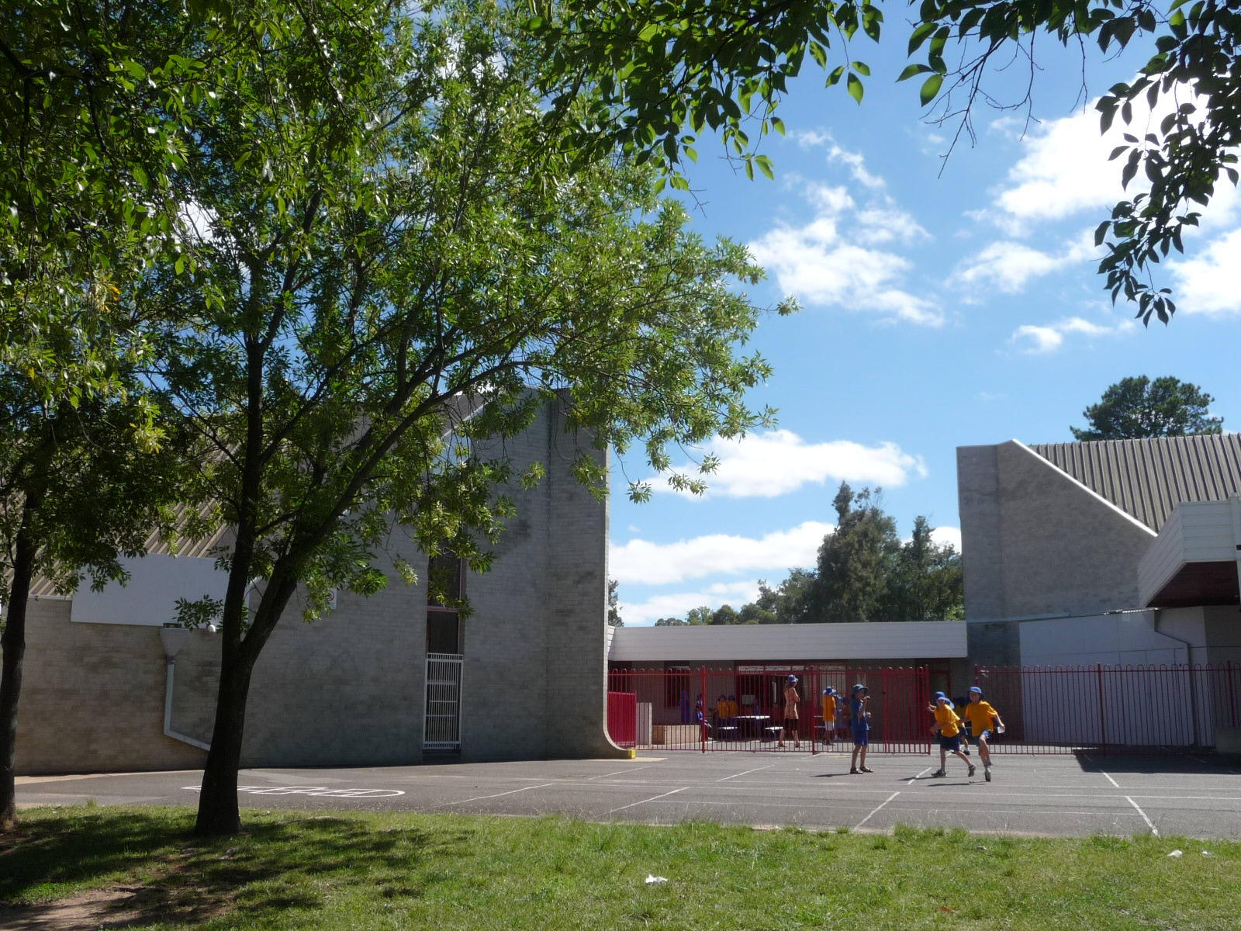

Giralang Primary School ,Giralang (Photo: ACT Heritage 2010)

**Location of Giralang Primary School Complex**



Giralang Primary School, Giralang (Source ACTmap i)



Giralang Primary School, Giralang indicating building footprint (Source: *Canberra By Suburbs*)

**Plan of Giralang Primary School and Health Centre**

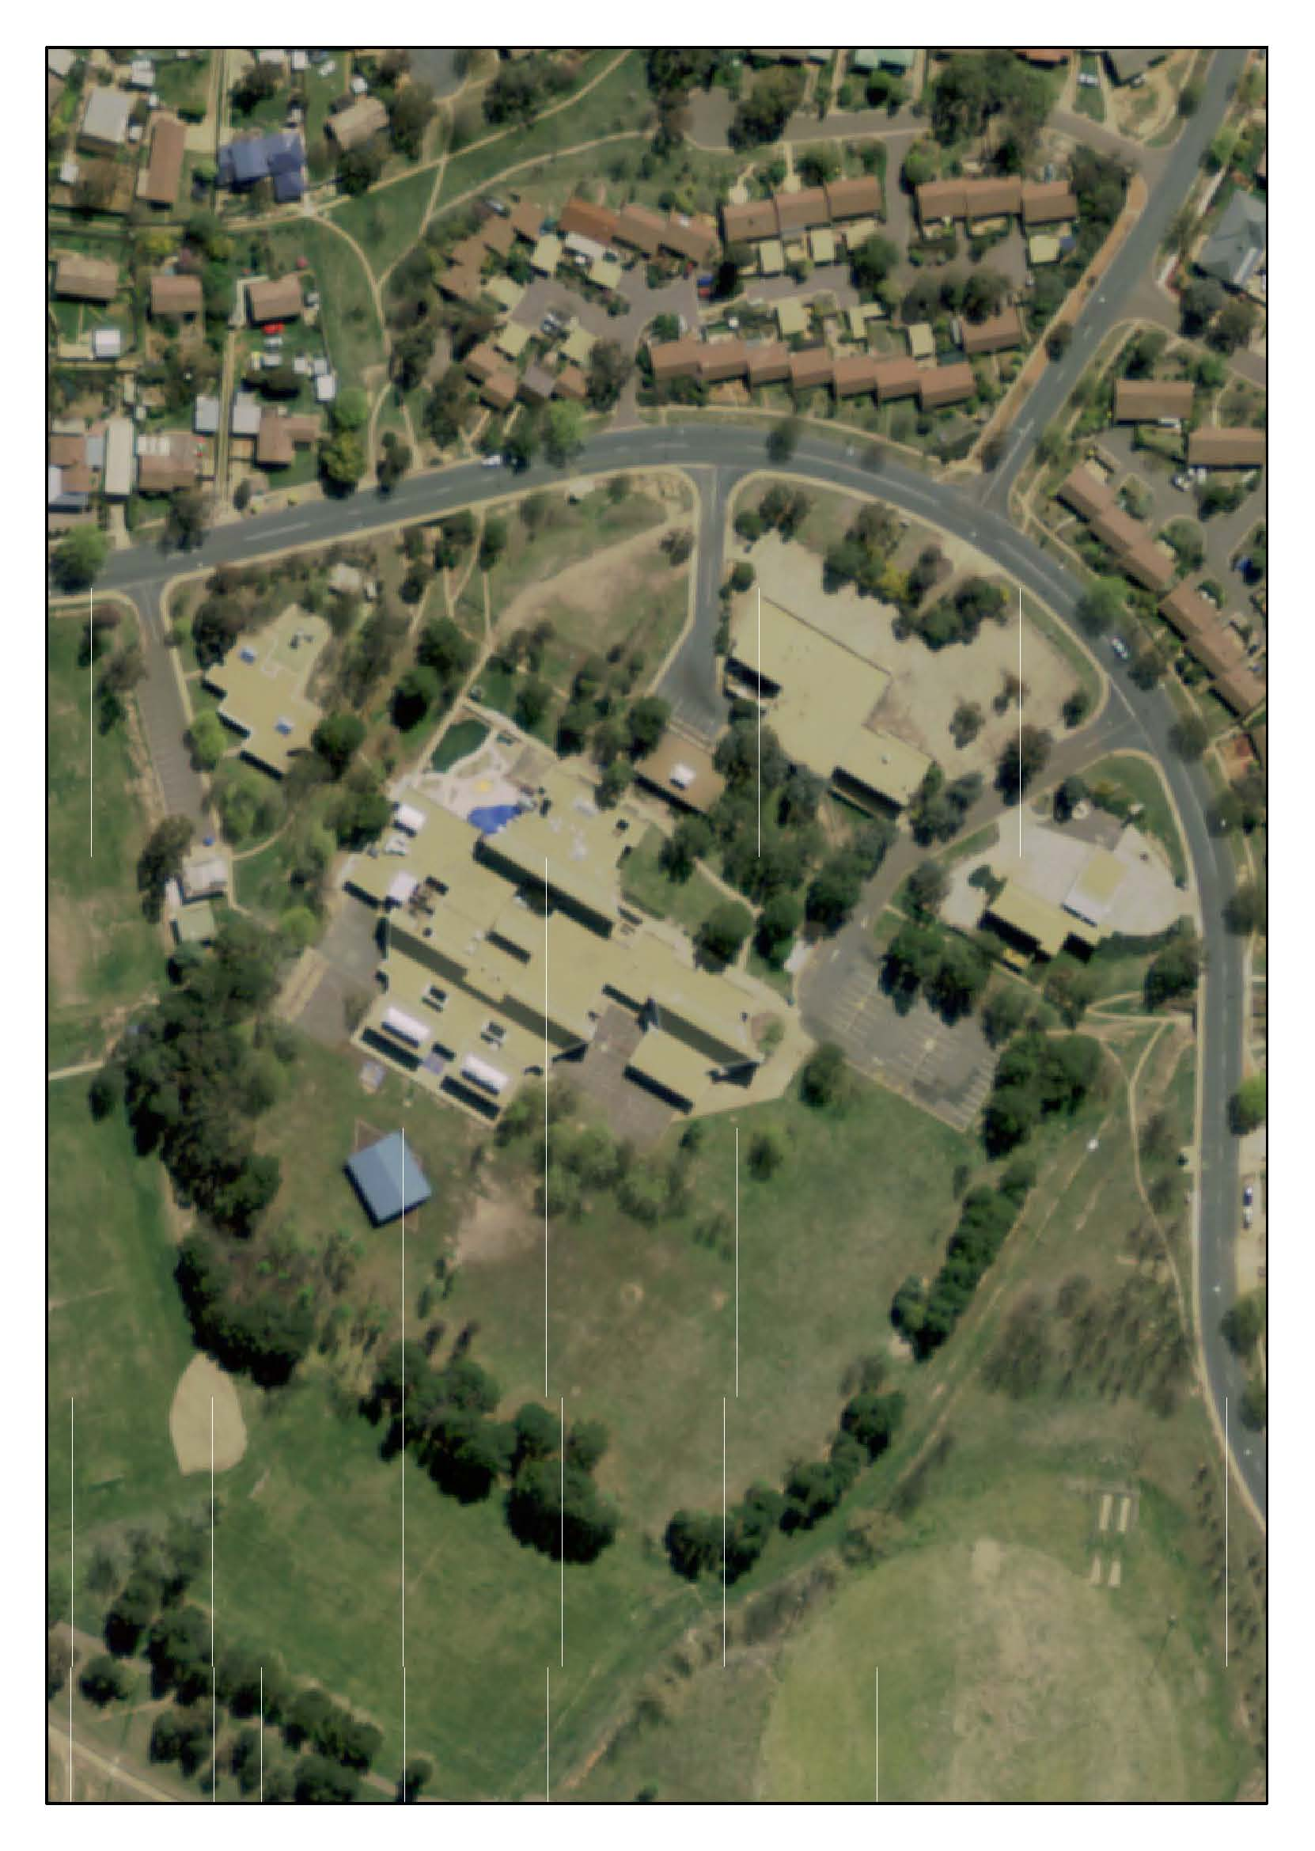

Giralang Primary School Complex showing extent of mature landscaping across the site. (Source ArcGIS 2008)