Australian Capital Territory

Planning and Development (Technical Amendment — (Changes to Flemington Road corridor concept plan, non urban zones development code and group centres development code) Plan Variation 2010
Notifiable instrument NI2010—601
Technical Amendment No 2010-23
made under the
Planning and Development Act 2007, section 89 (Making technical amendments)

This technical amendment commences on 29 October 2010.

Technical amendment number 2010-23 to the Territory Plan has been approved by the Planning and Land Authority.

Kelvin Walsh
Delegate of Planning and Land Authority

22 October 2010

Planning & Development Act 2007

Technical Amendment
to the Territory Plan

Variation 2010-23

Code changes to Flemington Road corridor concept plan, non-urban zones development code and group centres development code

October 2010

Table of Contents

1. INTRODUCTION 2
Outline of the process 2
2. EXPLANATORY STATEMENT 3
Changes and Reasons 3
3. TECHNICAL AMENDMENT 6
3.1 Code Amendment 6

INTRODUCTION

Outline of the process
The Commonwealth’s Australian Capital Territory (Planning and Land Management) Act 1988 allows for the Legislative Assembly to make laws to establish a Territory Planning Authority and for that Authority to prepare and administer a territory plan.
The Planning and Development Act 2007 (the Act) establishes the ACT Planning and Land Authority as the Authority which prepares and administers the territory plan, including continually reviewing and proposing amendments as necessary.
Technical amendments to the territory plan are prepared in accordance with the Act. This technical amendment has been prepared in accordance with the following two sections of the Act:
A code variation (section 87(b) of the Act) is a technical amendment that
- would only change a code; and
- is consistent with the policy purpose and policy framework of the code; and
- is not an error variation.
A variation under section 87(g) of the Act is a technical amendment that clarifies the language in the territory plan, provided it does not change the substance of the plan.

Following the release of the variation under section 90 of the Act, submissions from the public are invited. At the conclusion of the limited consultation period, any representations are considered by the ACT Planning and Land Authority (the Authority). The Authority then determines a day when the code variation is to commence by way of a commencement notice.

EXPLANATORY STATEMENT

Changes and Reasons
A Group centres development code - clarification of intent of rule R12 (item 1)

The current wording of rule R12 states that a 300m² gross floor area (GFA) restriction applies per shop in the CZ2 business zone where physically contiguous with development in the CZ1 zone. However it does not specify whether this refers to the building or the land being physically contiguous. This amendment clarifies that where the land is physically contiguous then this rule applies.

B Non urban zones development code - introduction of restriction on location of residential care accommodation in broadacre areas (items 2 and 3)

Land use controls for residential care accommodation in the non urban zones NUZ1 broadacre zone have been tightened to ensure residential care accommodation is only permissible in this zone where there is a demonstrated need for the development to be outside of the urban area. The reasons for a broadacre location for residential care accommodation will need to be made on health or community safety grounds.

C Restructure and changes to Flemington Road corridor concept plan (items 4 - 14)

- Amendment to study area to include small portion of undeveloped land in Franklin (items 4 and 14)

The area that is covered by the concept plan has been increased to include a small portion of undeveloped land in Franklin, north of Tomasetti Crescent and Section 4. This portion of land is zoned in the Territory Plan as RZ4 medium density residential zone and is approximately 2ha in area. This area is proposed to be subdivided concurrently with land adjacent to Flemington Road. To ensure an integrated planning outcome, the portion of land has been added into the concept plan. The revised study area is described and graphically represented in Section 2.2.

With the inclusion of a small portion of land in Franklin into the study area, the study area map in the appendices of the concept plan has been amended.

- Relocation of provisions relating to dwelling numbers into Part B of concept plan (item 5-7)

The provisions relating to dwelling numbers are located within Section 2.4.13 of the concept plan. The provisions have been relocated to Part B (Subdivision) of the Development Control Requirements (see rule R2 and criterion C2) so that dwellings numbers can now be formally considered as part of an estate development plan (EDP) development application (DA). A new criterion has also been added to ensure that traffic related matters are taken into account where additional dwellings over 1225 are proposed through the EDP (see criterion C2(c)).

As a result of the relocation of the provisions for dwelling numbers to rule R2 and criterion C2, item numbers will be chronologically renumbered.

- Introduction of new rule requiring reporting of total dwelling numbers (item 7)

A new rule (R2A) has been introduced requiring information regarding the total number of dwellings proposed/permissible within the Flemington Road corridor to be included in EDP DAs. This is to ensure that EDP DAs are considered within the context of the total dwelling number proposed within the corridor.

- Appropriate identification of building heights for part Franklin (item 8)

With the inclusion of the small portion of undeveloped land in Franklin into the concept plan, building heights for this area needed to be appropriately identified. Accordingly, the Territory Plan building height provisions relating to RZ4 medium density residential zone have been applied (see R11A). Otherwise the concept plan building height provisions relating to residential RZ4 medium density zone will apply and through criteria the building height could increase to four storeys. This increased height is considered inappropriate for this location.

- Introduction of maximum front setback provisions for intersections (item 9)

A new provision has been added to introduce a maximum front setback for development located at the intersections of Flemington Road / Nullarbor Avenue and Flemington Road / Mapleton Avenue. When the original concept plan was translated into the rules and criteria format, only a minimum setback was identified (being 3m). A new rule mandating a maximum front setback of 7m has been introduced for development fronting these intersections (R16A). This is to ensure that the intent of the concept plan for development to address the intersections is met.

- Requirement for traffic assessment for increased dwelling numbers (item 10)

A new provision has been added requiring a traffic assessment to be undertaken where an increase in the number of dwellings permitted by a crown lease is proposed (R19A). This is to ensure that the dwelling increase does not have any detrimental effect on the traffic network.

- Amendment to CZ4 local centre commercial gross floor area (GFA) provisions (item 11)

The commercial CZ4 local centre commercial GFA provisions have been amended in response to a review of possible commercial demand (R20). The proposed changes increase the commercial GFA at Flemington Road and Nullarbor Avenue intersection and introduce a maximum supermarket size. The minimum commercial requirement at the Flemington Road and Mapleton Avenue intersection has been deleted. In this way, the commercial needs at the Flemington Road and Mapleton Avenue intersection can be determined in the future as part of future land releases, taking into account commercial activities in the wider catchment. The previous criterion (C20) that may permit an increase in the commercial gross floor area has been deleted. Accordingly, R20 is a mandatory rule.

- Clarification that deep root planting zones are not required at major intersections and the introduction of deep root planting zones adjacent to walkways (items 12-13)

The current provisions relating to deep root planting zones within blocks could be interpreted as being required at the intersections of Flemington Road and Nullarbor Avenue and Flemington Road, and Mapleton Avenue (Manning Clarke Crescent). To clarify the situation, a note to R29 has been added specifying that deep root planting zones are not required at the major intersections. This will ensure that development addresses the intersections, as intended.

A new provision requiring deep root planting within blocks adjacent to walkways has been added (R30A). This landscaping requirement will reinforce the entry to the walkways and improve public amenity.

TECHNICAL AMENDMENT
    - Code Amendment

Variation to group centres development code
- Part A(2) – Group Centres – CZ2 Business Zone, Element 1 Restrictions on use, Item 1.2 Shops, R12

Substitute b) with the following

- 300m² per shop where the land is physically contiguous with the CZ1 zone; or

Variation to non-urban zones development code

- Part A – Zone Specific Controls, Part A(1) – NUZ1 – Broadacre Zone, Element 1: Restrictions on Use

Substitute

Intent:
  - To provide opportunities for residential care accommodation where such facilities should be isolated from urban areas
  - To provide an appropriate level of on-site services for residential care accommodation in rural settings

- Part A – Zone Specific Controls, Part A(1) – NUZ1 – Broadacre Zone, Element 1: Restrictions on Use, Item 1.1 Residential Care Accommodation

Insert a new criterion

There is no applicable rule. | C2A  Residential care accommodation meets all of the following:  - demonstrates need for an environment isolated from urban areas  - need for isolated facilities must be for demonstrated health or community safety reasons  - the reasons are to be contained in a report endorsed by a suitably qualified medical professional who has expertise regarding the conditions proposed to be treated on-site.
Variation to Flemington Road corridor concept plan

- 2.2 Site

Substitute

The study area covers the Flemington Road corridor from immediately south of Well Station Drive up to the alignment of Sapling Street (Old Well Station Track) (see Figure 1). It includes a 65.1 metre wide road corridor (reducing to 62.3 metres at transit nodes), and development sections flanking the road on the eastern and western sides. The study area also includes land north of Tomasetti Crescent and Section 4 in Franklin. The length of the study area is approximately 2 kilometres.

The section of Flemington Road comprising the study area generally dissects the residential estates of Harrison and its associated community facilities to the east and Franklin to the west.

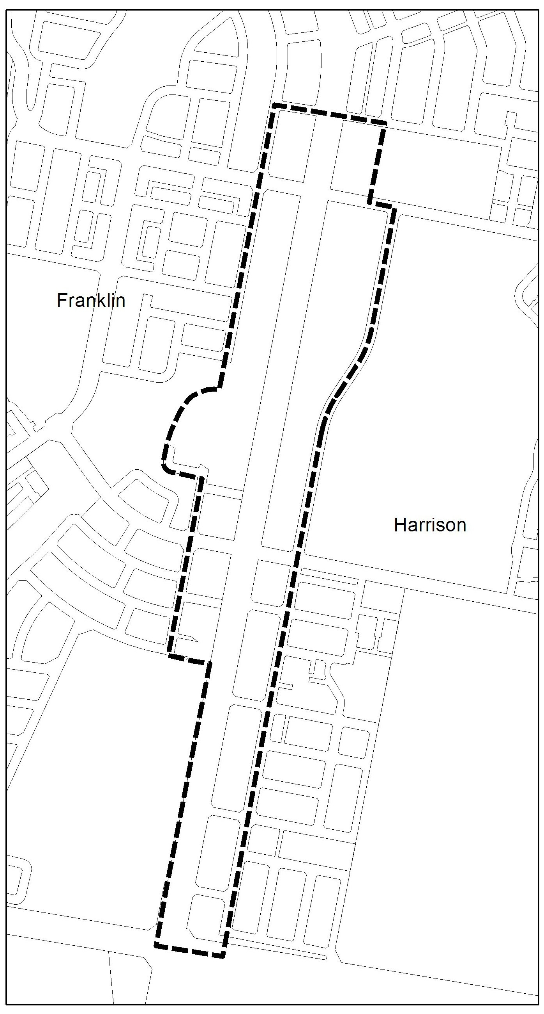

Figure 1 – Flemington Road Corridor Concept Plan Study Area

- 2.4 Indicative Development Plan – Primary Elements

Omit

2.4.13 Land Program

- 3.0 Development Control Requirements, Part A – Land Use

Renumber

R2 to R1
C2 to C1

- 3.0 Development Control Requirements, Part B – Subdivision

a) Insert

Rules | Criteria
1. Dwelling Numbers
R2  The maximum number of dwellings within the Flemington Road corridor concept plan area is 1225 dwellings. | C2  An increase in the number of dwellings specified in R2 may be considered where all of the following can be demonstrated:  - a range of different dwelling types and sizes are provided to cater for changing demographics and improved housing affordability  - additional dwellings minimise detrimental impacts on the character of adjacent residential zones in Franklin and Harrison and community facility zones in Harrison by limiting overshadowing, maximising access to sunlight and ensuring that the height, scale, setbacks and built form establish an appropriate visual streetscape character and separation  - a traffic assessment that assesses the impacts of the total number of dwellings permissible in the Corridor (as referred to at R2A) on the road network and provides recommendations to ensure that the estate development plan development application will not result in a detrimental impact to traffic flow within the corridor.
R2A  The estate development plan development application (EDP DA) submission includes drawings and information that nominate the total number of dwellings permissible within the Flemington Road corridor concept plan area.  The total number of dwellings permissible is to comprise:  - the number of dwellings permissible that have been approved through all previous EDP DAs  - the number of dwellings permissible through any current EDP DA or amendment to an EDP DA approval  - the number of dwellings permissible in proposed future subdivision stages within the corridor, if any  - number of dwellings permissible subsequent to any variation to the Crown lease for a block within the corridor approved in accordance with R19A. | This is a mandatory requirement. There is no applicable criterion.

b) Renumber subsequent items accordingly

- 3.0 Development Control Requirements, Part C – Buildings and Structures, 1. Building Heights and Form

Insert
R11A  For development within the residential RZ4 medium density zone located immediately north of Tomasetti Crescent and Section 4 Franklin, the maximum building height does not exceed 3 storeys. An attic and/or basement may be permitted in addition to 3 storeys. | This is a mandatory requirement. There is no applicable criterion.

- 3.0 Development Control Requirements, Part C – Buildings and Structures, 2. Setbacks

Insert
R16A  For development adjacent to the intersections of Nullarbor Avenue/ Flemington Road, Flemington Road / Mapleton Avenue (Manning Clarke Crescent), the maximum front setback is 7 metres for a minimum length of 40 metres measured from the block corner (as if there were no corner splay) along both road frontages. | This is a mandatory requirement. There is no applicable criterion.

- 3.0 Development Control Requirements, Part C – Buildings and Structures

- Insert Item 3 and associated rule

Rules | Criteria
3. Increase in the Number of Dwellings Permitted by a Crown Lease
R19A  If an increase in the maximum number of dwellings permitted on a block is proposed through a variation to the Crown lease, the applicant is required to undertake a traffic assessment to demonstrate that the additional permissible dwellings will not have a detrimental impact on traffic flow within the road network. The traffic assessment is also to take into consideration the total number of dwellings permissible within the Flemington Road corridor concept plan area, as referred to at R2A. | This is a mandatory requirement. There is no applicable criterion.

- Renumber subsequent items accordingly

- 3.0 Development Control Requirements, Part C – Buildings and Structures, 4. Commercial Gross Floor Area, R20

Substitute
R20  Development in commercial CZ4 local centre zones meets all of the following:  - at the Flemington Road and Nullarbor Avenue intersection, the total combined gross floor area for the following uses:  - SHOP  - restaurant  - NON RETAIL COMMERCIAL USE  is not less that 700 square metres and not more than 2000 square metres and PROVIDED THAT the total combined gross floor area for supermarket does not exceed 1500 square metres  - at the Flemington Road and Manning Clark Crescent intersection, the total combined gross floor area for the following uses:  - SHOP  - restaurant  - NON RETAIL COMMERCIAL USE  is not more than 1100 square metres. | This is a mandatory requirement. There is no applicable criterion.

- 3.0 Development Control Requirements, Part C – Buildings and Structures, 12. Deep Root Planting Zones

Substitute
R29  All development in commercial CZ5 mixed use and RZ4 medium density residential zones fronting Flemington Road, Christina Stead Street, Clare Burton Circuit, Henry Kendall Street, Wimmera Street and King Canyon Street incorporates deep root planting zones capable of supporting large trees (semi-mature stock with a minimum mature height of 5m) within the front setback.  Note - Deep root planting zones within blocks are not required adjacent to the intersections of Flemington Road and Mapleton Avenue (Manning Clark Crescent), Flemington Road and Nullarbor Avenue, and Flemington Road and Well Station Drive. | This is a mandatory requirement. There is no applicable criterion.
- 3.0 Development Control Requirements, Part C – Buildings and Structures, 12. Deep Root Planting Zones

Insert
R30A  A 12m x 12m deep root planting zone is to be provided within the block at each corner that is adjacent to a pedestrian walkway and be planted with large trees (semi-mature stock with a minimum mature height of 5m). | C30A  An alternative landscaped treatment may be considered provided that the treatment addresses all of the following:  - marks and reinforces the entry to the adjacent walkway  - shortens the walkway’s perceived length  - improves the public amenity of the walkway.

- Concept Plan Drawings, Flemington Road Concept Plan Study Area

Substitute
Flemington Road Corridor Concept Plan Study Area

Interpretation service

