Australian Capital Territory

Planning and Development (Draft Variation No 310) Consultation Notice 2011

Removal of specified restrictions on use at Turner section 47 and part 63 and North of Macarthur and Wakefield Avenues (RZ4 Medium Density Residential Zone)
Notifiable instrument NI 2011—222
Made under the
Planning and Development Act 2007, section 63 (Public consultation—notification) and section 64 (Public consultation—notice of interim effect etc)

Draft Variation No. 310 to the Territory Plan (see Annexure A) proposes to remove specified building height and plot ratio limitations applying to the RZ4 medium density residential zones north of Macarthur Avenue and Wakefield Avenue, North Canberra, under the Residential Zones – Multi Unit Housing Development Code (rule R21). The draft variation also proposes to remove the prohibition on redevelopment of Turner Section 47 and Turner Section 63 Blocks 12-21, in the Inner North Precinct Code.

You can get copies of draft variation documents:
- online at www.actpla.act.gov.au (note free internet access is available at ACT public libraries)
- at ACTPLA’s customer service centre, 16 Challis Street, Dickson during business hours.
Written comments from the public are invited by COB Tuesday 21 June 2011.
Comments should include reference to the draft variation, a return postal address, and be addressed Territory Plan Variation Unit, Development Policy Section

Comments can be:
- emailed to terrplan@act.gov.au
- mailed to ACTPLA, GPO Box 1908, Canberra, ACT 2601
- delivered to ACTPLA’s customer service centre at the above address

Comments received will be made available for public inspection (unless exempted under section 411 of the Act) for a period of no less than 15 business days at ACTPLA’s customer service centre in Dickson the day after the closing date for submissions and on ACTPLA’s website 10 business days after the closing date for submissions.

The draft variation does not have interim effect and therefore section 65 of the Planning and Development Act 2007 does not apply. The current Territory Plan will continue to apply while the variation remains in draft form.

Neil Savery
Chief Planning Executive
ACT Planning and Land Authority
03 May 2011

Planning & Development Act 2007

Draft Variation to the
Territory Plan
Number 310

Removal of restrictions on use at
Turner section 47 and part 63
and
North of Macarthur and Wakefield Avenues
(RZ4 Medium Density Residential Zone)

May 2011

Contents
1. INTRODUCTION 1
1.1 Summary of the proposal 1
1.2 Outline of the process 1
1.3 This document 2
1.4 Public consultation 2
2. EXPLANATORY STATEMENT 3
2.1 Background 3
2.2 Current Territory Plan provisions 4
2.2.1 Residential Zones—Multi Unit Housing Development Code 4
2.2.2 Inner North Precinct Code 5
2.3 Proposed changes 7
2.3.1 Changes to the Residential Zones—Multi Unit Housing Development Code (item 1) 7
2.3.2 Changes to the Inner North Precinct Code (item 2) 7
2.4 Reasons for the proposed draft variation 7
2.5 Planning Context 7
2.5.1 National Capital Plan 7
2.5.2 Territory Plan 7
2.5.3 Planning Strategy for the ACT 8
2.6 Interim effect 9
2.7 Consultation with government agencies 9
3. DRAFT VARIATION 11

- INTRODUCTION
  - Summary of the proposal
The purpose of this draft variation is to implement the Government’s response to several recommendations of the Legislative Assembly’s Standing Committee on Planning, Public Works and Territory and Municipal Services Report No. 9, released on 17 February 2011. Firstly it is proposed to remove building height and plot ratio limitations applying to the RZ4 medium density residential zones north of Macarthur Avenue and Wakefield Avenue, North Canberra, under the Residential Zones—Multi Unit Housing Development Code (rule R21). Secondly, the draft variation proposes to remove the prohibition on redevelopment of Turner Section 47 and Turner Section 63 Blocks 12-21, under the Inner North Precinct Code.
  - Outline of the process
The Commonwealth’s Australian Capital Territory (Planning and Land Management) Act 1988 allows for the Legislative Assembly to make laws to establish a Territory Planning Authority and for that Authority to prepare and administer a Territory Plan. The Planning and Development Act 2007 (the Act) establishes the ACT Planning and Land Authority (ACTPLA) as the Authority which prepares and administers the Territory Plan, including continually reviewing and proposing amendments as necessary.
The Territory Plan is comprised of the written statement and a map. The written statement contains a number of parts, namely Governance; Strategic Directions; Zones; Precinct Codes; General Codes; Overlays; Definitions; Structure Plans, Concept Plans and Development Codes for Future Urban Areas.
The Territory Plan Map graphically represents the applicable land use zones (under the categories of Residential, Commercial, Industrial, Community Facility, Urban Parks and Recreation, Transport and Services and Non Urban), precincts and overlays. The zone, precinct and overlay requirements are detailed in the volumes of the Territory Plan.
Draft variations to the Territory Plan are prepared in accordance with the Act. Following the release of the draft variation under section 63 of the Act, submissions from the public are invited. At the conclusion of the consultation period the ACTPLA submits a report on consultation and a recommended final variation to the Minister for Planning for approval. The Minister has the discretion to determine if referral to the Legislative Assembly Standing Committee on Planning, Public Works and Territory and Municipal Services is warranted prior to approval, depending on the nature and significance of the proposal. If the draft variation is referred to the Committee by the Minister or otherwise, the Minister must consider the findings of the Committee before deciding whether to approve the draft variation. If the Minister approves the variation, the variation and associated documents will be tabled in the Legislative Assembly. Unless disallowed by the Legislative Assembly within five sitting days, the variation commences on a day nominated by the Minister.

  - This document
This document contains the background information in relation to the proposed variation. It comprises the following parts:
- Part 1 - This introduction.
- Part 2 - An explanatory statement, which gives reasons for the proposed variation and describes its effect.
- Part 3 - The draft variation, which details the proposed changes to the Territory Plan.
  - Public consultation
Comments from the public are invited on the draft variation. Subject to consideration of responses received, ACTPLA proposes to submit this draft variation to the Minister for Planning in accordance with the Act.
The documents relating to this draft variation may be obtained from
- online at www.actpla.act.gov.au/territory plan
(note that free internet access is available at ACT public libraries)
- at ACTPLA’s customer service centre, 16 Challis Street, Dickson,
Monday to Friday between 8:30am and 4:30pm

Written comments from the public are invited by COB Tuesday 21 June 2011.

Comments should include reference to the draft variation, a return postal address, and be addressed Territory Plan Variation Unit, Development Policy Section

Comments can be:
- emailed to terrplan@act.gov.au
- mailed to ACTPLA, GPO Box 1908, Canberra, ACT 2601
- delivered to ACTPLA’s customer service centre at the above address

Comments received will be made available for public inspection (unless exempted under section 411 of the Act) for a period of no less than 15 business days at ACTPLA’s customer service centre in Dickson the day after the closing date for submissions and on ACTPLA’s website 10 business days after the closing date for submissions.

- EXPLANATORY STATEMENT
  - Background
The inquiry into RZ3 and RZ4 Residential Redevelopment Policies – Inner North Canberra was referred to the Legislative Assembly’s Standing Committee on Planning, Public Works and Territory and Municipal Services by the ACT Legislative Assembly on 25 June 2009 for inquiry and report. It was proposed by the Minister for Planning, Mr Andrew Barr MLA, in order to consider whether current planning policies, including those contained within the Inner North Precinct Code, remain appropriate in light of issues such as climate change and population growth.
On 17 February 2011, the standing committee released report No. 9 on its inquiry into RZ3 and RZ4 Residential Redevelopment Policies – Inner North Canberra.
The first of its 15 recommendations are:
Recommendation 1
The Committee recommends that Rule 21, restricting development in RZ4 zones north of Macarthur Avenue and Wakefield Avenue, be removed from the Residential Zones—Multi Unit Housing Development Code.
Recommendation 2
The Committee recommends that Rule 44, restricting use on Blocks 12-21, Section 63 Turner should be removed from the Inner North Precinct Code.
Recommendation 3
The Committee recommends that Rule 44, restricting use on Section 47 Turner should be removed from the Inner North Precinct Code.
Under recommendation 1, development in the RZ4 medium density residential zone in the area specified would be subject to the same rules that apply to development elsewhere in this zone, ie. a building height of 3 rather than 2 storeys, and a plot ratio of 80% rather than 65%.
Under recommendations 2 and 3, redevelopment beyond minor additions and alterations to existing buildings would be possible on the land specified, subject to the prevailing RZ3 urban residential zone, and relevant codes (including other provisions of the Inner North Precinct Code).

Recommendations 5, 6 and 7 are currently being considered in the context of other pending variations to the Territory Plan. The standing committee’s other recommendations do not involve variations to the Territory Plan.

The Government agreed with a number of the standing committee’s recommendations including recommendations 1, 2 and 3.

  - Current Territory Plan provisions
    - Residential Zones—Multi Unit Housing Development Code
The current provisions affecting RZ4 medium density residential land north of Macarthur Avenue and Wakefield Avenue are found in Residential Zones— Multi Unit Housing Development Code, part A(4) section 2.1 – Restrictions on Use – Staging of Development – Inner North Canberra, which includes rule R21, see Figure 1 and Map 1 below.

Figure 1 – Extract from Residential Zones—Multi Unit Housing Development Code

Rules | Criteria
2.1 Restrictions on Use – Staging of Development – Inner North Canberra
R21  )  Development of land in the RZ4 zones of O’Connor, Dickson and Lyneham, north of Macarthur Avenue and Wakefield Avenue, is restricted in height to 2 storeys and a maximum plot ratio of 65%, until 23.5 hectares of residential blocks in the RZ4 zones of O’Connor, Turner and Braddon north of Cooyong Street and Donaldson Streets has been developed for multi-unit housing. | C21  )  This is a mandatory requirement. There is no applicable criterion.

Map 1 – RZ4 zones north of Macarthur Avenue and Wakefield Avenue

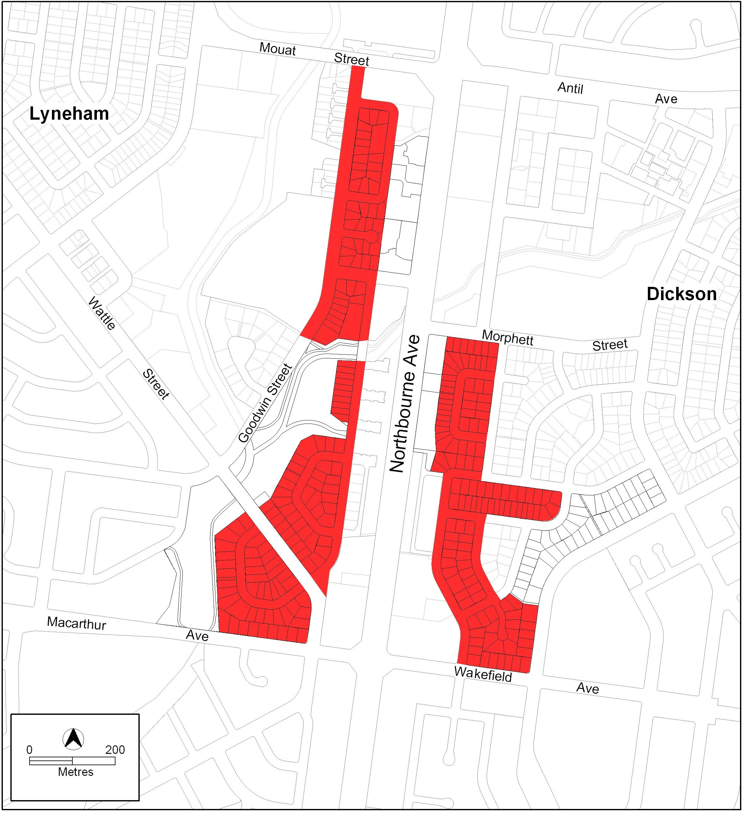

    - Inner North Precinct Code
The current provisions affecting certain land in Turner are found in Inner North Precinct Code part C(5), element 1 (which includes rule 44), see Figure 2 and Map 2.

Figure 2 – Extract from Inner North Precinct Code
Part C(4) – Turner
Element 1: Restrictions on Use
Intent:
)
a) To protect the existing residential amenity of neighbouring lessees

Rules | Criteria
1.1 Residential
R44  )  Redevelopment is not permitted on Turner Section 47 and Section 63 Blocks 12-21. | C44  )  Minor additions or alterations, which do not result in a significant change to the scale and/or character of the dwelling may be permitted.

Map 2 – Turner Section 47 and Section 63 Blocks 12-21
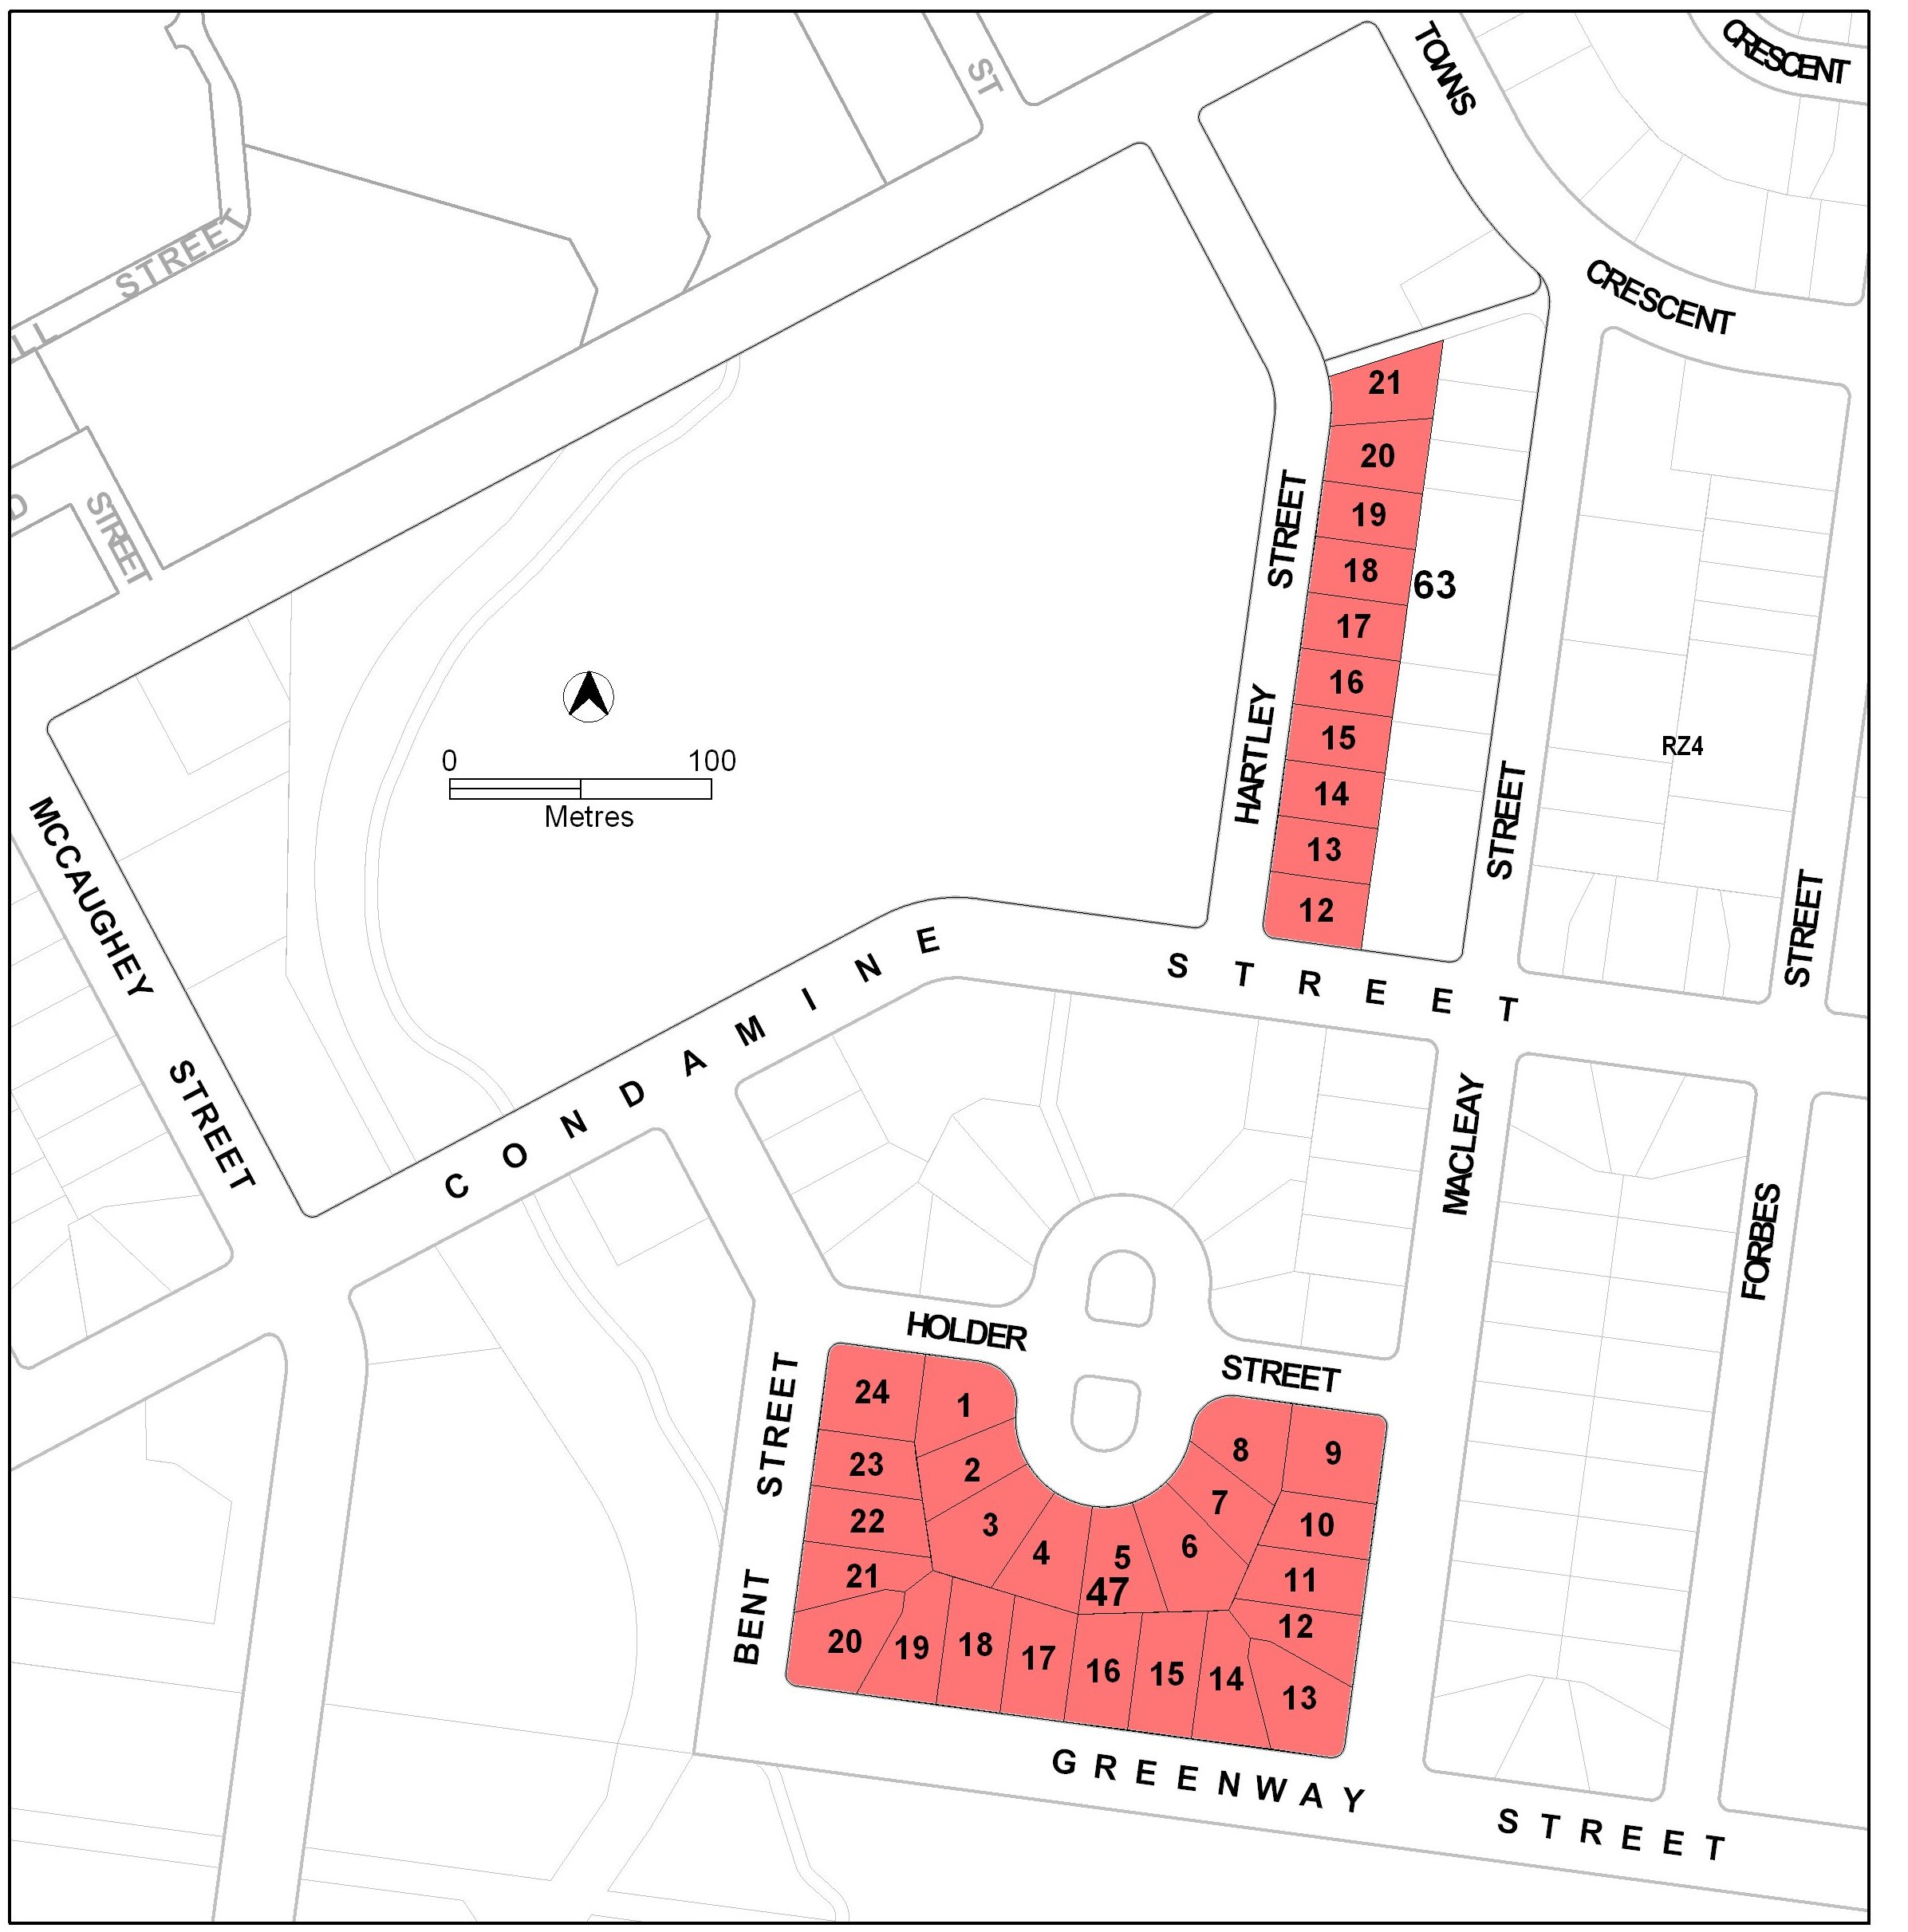

  - Proposed changes
Reasons for the proposed changes are outlined in section 2.1 under the heading of background above.
    - Changes to the Residential Zones—Multi Unit Housing Development Code (item 1)
It is proposed to delete part A(4) section 2.1 – Restrictions on Use – Staging of Development – Inner North Canberra, which includes rule R21.
    - Changes to the Inner North Precinct Code (item 2)
It is proposed to delete from the Inner North Precinct Code part C(5) element 1, which includes rule 44.

  - Reasons for the proposed draft variation
This draft variation responds to recommendations of the Legislative Assembly’s Standing Committee on Planning, Public Works and Territory and Municipal Services following its inquiry into RZ3 and RZ4 Residential Redevelopment Policies – Inner North Canberra, as outlined in section 2.1 above.

  - Planning Context
    - National Capital Plan
The Australian Capital Territory (Planning and Land Management) Act 1988 established the National Capital Authority (NCA) with two of its functions being to prepare and administer a National Capital Plan (NCP) and to keep the NCP under constant review and to propose amendments to it when necessary.
The NCP, which was published in the Commonwealth Gazette on 21 January 1990 is required to ensure that Canberra and the Territory are planned and developed in accordance with their national significance. The Planning and Land Management Act 1988 also required that the Territory Plan is not inconsistent with the NCP.

    - Territory Plan
The proposal is consistent with the Territory Plan’s Statement of Strategic Directions in terms of social sustainability, and spatial planning and urban design principles, especially principle numbers 2.5 and 2.6 for urban areas as follows:

2.5 A wide range of housing types will be permitted in identified residential areas close to commercial centres and some major transport routes to increase choice; maximise opportunities for affordable housing; and secure some intensification of development consistent with maintaining residential amenity. Outside of these areas, planning policies will protect the typically low density, garden city character of Canberra’s suburban areas.
2.6 Higher density development will be encouraged within and near major centres, and in other suitable locations that are well served by public transport.

    - Planning Strategy for the ACT
      - The Canberra Spatial Plan
The Canberra Spatial Plan outlines the strategic direction for growth to achieve social, environmental and economic sustainability for Canberra. Through the introduction of the proposed codes the following objectives of the plan (Spatial Plan p17) will be advanced:
- provide opportunities for a diverse range of housing for the full range of household types and lifestyle preferences
- facilitate a high quality built environment

      - Time to talk – Canberra 2030
In December 2010 the outcomes report from Time to talk – Canberra 2030 was released. Six key messages emerged from community engagement. They are concerned with:
- population growth and demography
- management of water and energy
- housing diversity
- integrating transport and land use
- a compact city and quality urban environment
- Canberra’s role in the region.

This draft variation is consistent with the messages concerned with housing diversity and the facilitation of a compact city, by allowing the development potential of the land in question to be fully realised, consistent with the Territory Plan.

  - Interim effect
The draft variation does not have interim effect and therefore section 65 of the Act does not apply. The current Territory Plan will continue to apply while the variation remains in draft form.

  - Consultation with government agencies
ACTPLA is required to, in preparing a draft variation under section 61(b) consult with each of the following in relation to the proposed draft variation
- the national capital authority
- the conservator of flora and fauna
- the environment protection authority
- the heritage council
- if the draft variation would, if made, be likely to affect unleased land or leased public land – each custodian for the land likely to be affected

National Capital Authority

The NCA provided the following comments on 12 April 2011.
The NCA has no objection to DV310 proceeding.

Response
Noted

Conservator of Flora and Fauna

The Conservator of Flora and Fauna made the following comments on
14 April 2011.

While recognising that increased density of the RZ3 and RZ4 zones is important to aspects of sustainability, the removal of Rule 21 in zones north of Macarthur Avenue and the removal of Rule 44 from Blocks 12-21 Section 63 and Section 47 Turner, are likely to have less than optimal outcomes for urban biodiversity, as well as increased heat island impacts as increasing the plot ratio to 80% will likely result in the removal of significant areas of urban vegetation.

Response
The implementation of this variation will effectively increase the maximum plot ratio from 65% to 80%, but this is not likely to result in a loss of urban vegetation. In fact it is likely to reduce vegetation loss by encouraging the employment of basement rather than surface car parking. An increase in plot ratio, when coupled with an increase in maximum building height from 2 to 3 storeys, will make no substantial difference to the amount of the site covered by buildings or impervious surfaces. It is expected that the additional floor space will be taken up in the third storey rather than in additional site coverage. The prospect of additional dwellings on the site will also increase the likelihood of basement car parking, thus further increasing the prospects of vegetation retention and additional planting. It should also be noted that all buildings must meet the same boundary setback and building envelope controls regardless of the maximum permitted plot ratio.
In relation to the blocks identified in Turner, the removal of the current moratorium will allow these blocks to be developed under the current RZ3 zone, in common with many other blocks in this suburb. The maximum plot ratio is 65% and building height limited to 2 storeys. It is true that removing the moratorium has the potential to increase the site coverage of these blocks when and if they are redeveloped for multi unit housing. But the provision of additional housing in this central location will bring its own sustainability benefits in the context of a compact city. It should also be noted that multi unit housing must comply with boundary setback provisions that allow for tree retention and additional planting where practicable. Proposals must also comply with the Tree Protection Act, where applicable.

Environment Protection Authority

The Environment Protection Authority provided the following comments on 12 April 2011

There are no issues for the Environment Protection Authority.

Response
Noted

Heritage Council

The Heritage Council provided the following comments on 12 April 2011.
The Council considers that the proposed variation 310 is unlikely to generate any detrimental heritage impacts, especially on adjacent sites such as the Northbourne Housing Precinct which is currently being considered for registration.
Overall the Council does not raise any objections to (the proposed draft variation).
Response
Noted.

- DRAFT VARIATION
The Territory Plan is varied as follows.

Variation to residential zones—multi unit housing development code
1. Part A – Zone Specific Controls, Part A(4) – RZ4 – Medium Density Residential Zone, Element 2: Building and Site Controls

Omit
2.1 Restrictions on Use – Staging of Development – Inner North Canberra including Rule R21

Variation to inner north precinct code
2. Part C(5) – Turner

Omit
Element 1: Restrictions on Use including Intent, 1.1 Residential and Rule R44 and Criterion C44

Interpretation service
