Australian Capital Territory

Planning and Development (Technical Amendment—Forde) Plan Variation 2011 (No 2)*

Notifiable instrument NI2011— 309
Technical Amendment No 2011-24
made under the
Planning and Development Act 2007, section 89 (Making technical amendments) (s96 land ceases to be in future urban area)

This plan variation commences on the day after it is notified.

Variation No 2011-24 to the Territory Plan has been approved by the Planning and Land Authority.

Annexure A, B and C - The maps specify that the land identified may be used for the purposes indicated on these maps.

Annexure D - Introduces Forde Precinct Code to section 10 of the Territory Plan.

The variations specify that the land identified on the maps of annexure A, B, C and D being land within the Division of Forde, may be used for the purposes indicated in the annexure.

Neil Savery
Planning and Land Authority

Date: 20 June 2011
THIS IS PAGE ONE OF ANNEXURE A
TO NOTIFIABLE INSTRUMENT NI2011 – 309

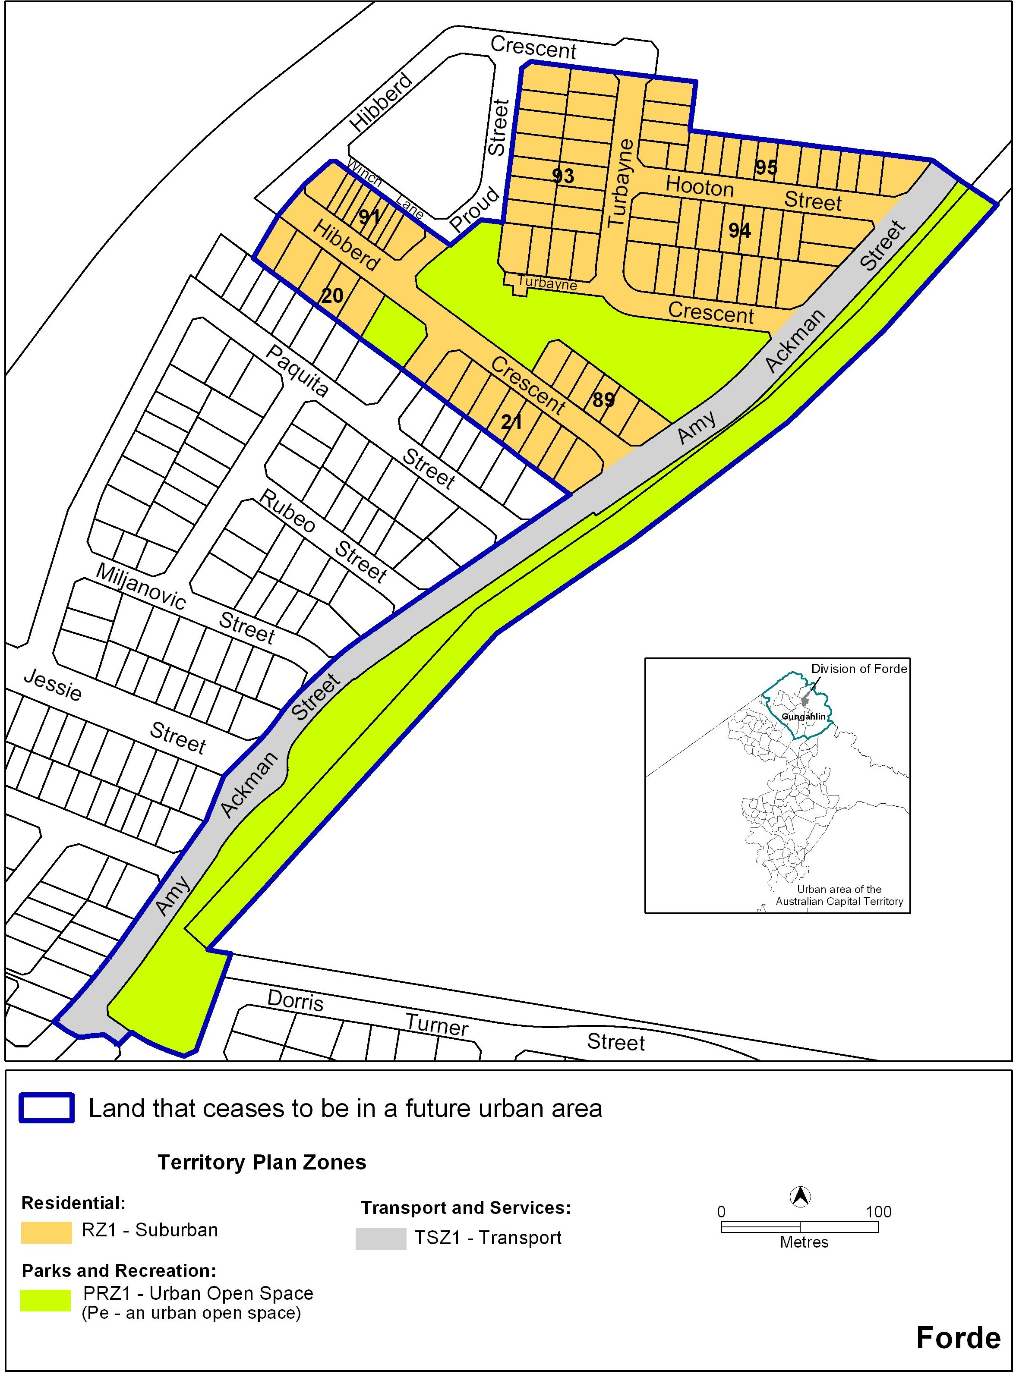

Neil Savery
Planning and Land Authority
Date: 20 June 2011

THIS IS PAGE ONE OF ANNEXURE B
TO NOTIFIABLE INSTRUMENT NI2011 – 309

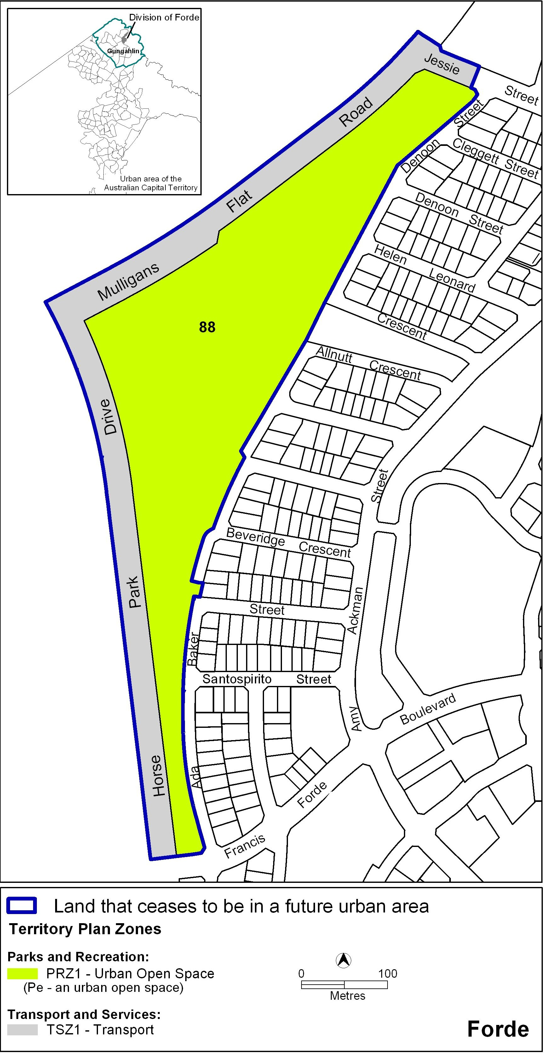

Neil Savery
Planning and Land Authority
Date: 20 June 2011

THIS IS PAGE ONE OF ANNEXURE C
TO NOTIFIABLE INSTRUMENT NI2011 – 309

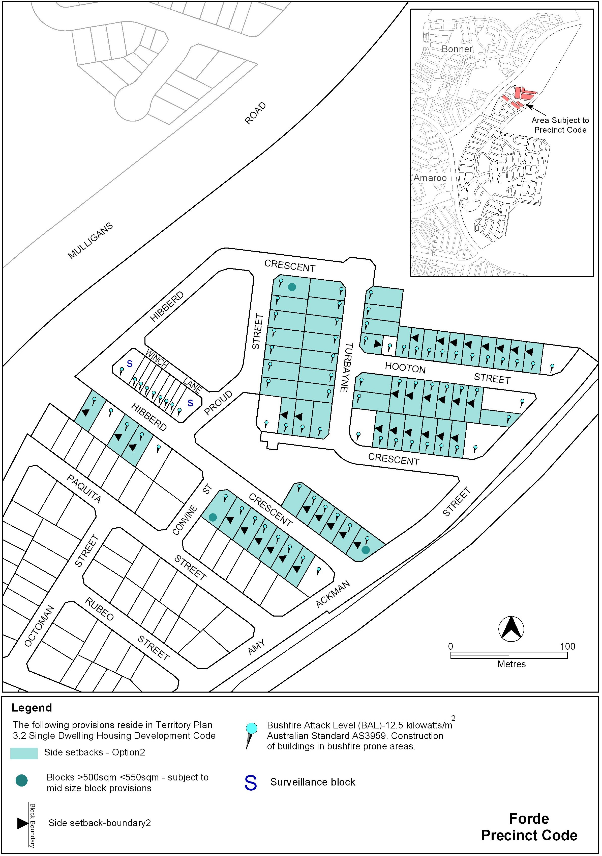

Neil Savery
Planning and Land Authority
Date: 20 June 2011

THIS IS PAGE ONE OF ANNEXURE D
TO NOTIFIABLE INSTRUMENT NI2011 – 309

Forde Precinct Code
Covering the Division of Forde

Introduction

Name
The name of this code is the Forde Precinct Code.

Application
This Precinct Code applies to the suburb of Forde. The code identifies individual blocks or areas to which specific provisions apply as defined in the legend of the map attached.

Where more than one type of Code applies to a development, the order of precedence when there is inconsistency of provisions between Codes, as defined by the Act, is Precinct Code, then Development Code, and then General Code.

Purpose of code
Codes provide additional planning, design and environmental controls to support the zone objectives and assessable uses in the Development Tables.
The Codes are used by the Authority to assess development applications. The Codes therefore also provide guidance to intending applicants in designing their developments and preparing their development applications.

Further information
Please refer also to the Forde Concept Plan for other relevant or applicable planning provisions.

Forde Precinct Code

