Australian Capital Territory

Planning and Development (Technical Amendment—Franklin) Plan Variation 2011 (No 1)*

Notifiable instrument NI2011—42
Technical Amendment No 2011-01
made under the
Planning and Development Act 2007, section 89 (Making technical amendments) (s96 land ceases to be in future urban area)

This plan variation commences on the day after it is notified.

Variation No 2011-01 to the Territory Plan has been approved by the Planning and Land Authority

The variation specifies that the land identified on the map at Annexure A being land within the Division of Franklin, may be used for the purposes indicated in the Annexure.

Neil Savery
Planning and Land Authority
Date: 3 February 2011
THIS IS PAGE ONE OF ANNEXURE A
TO NOTIFIABLE INSTRUMENT NI2011 –42

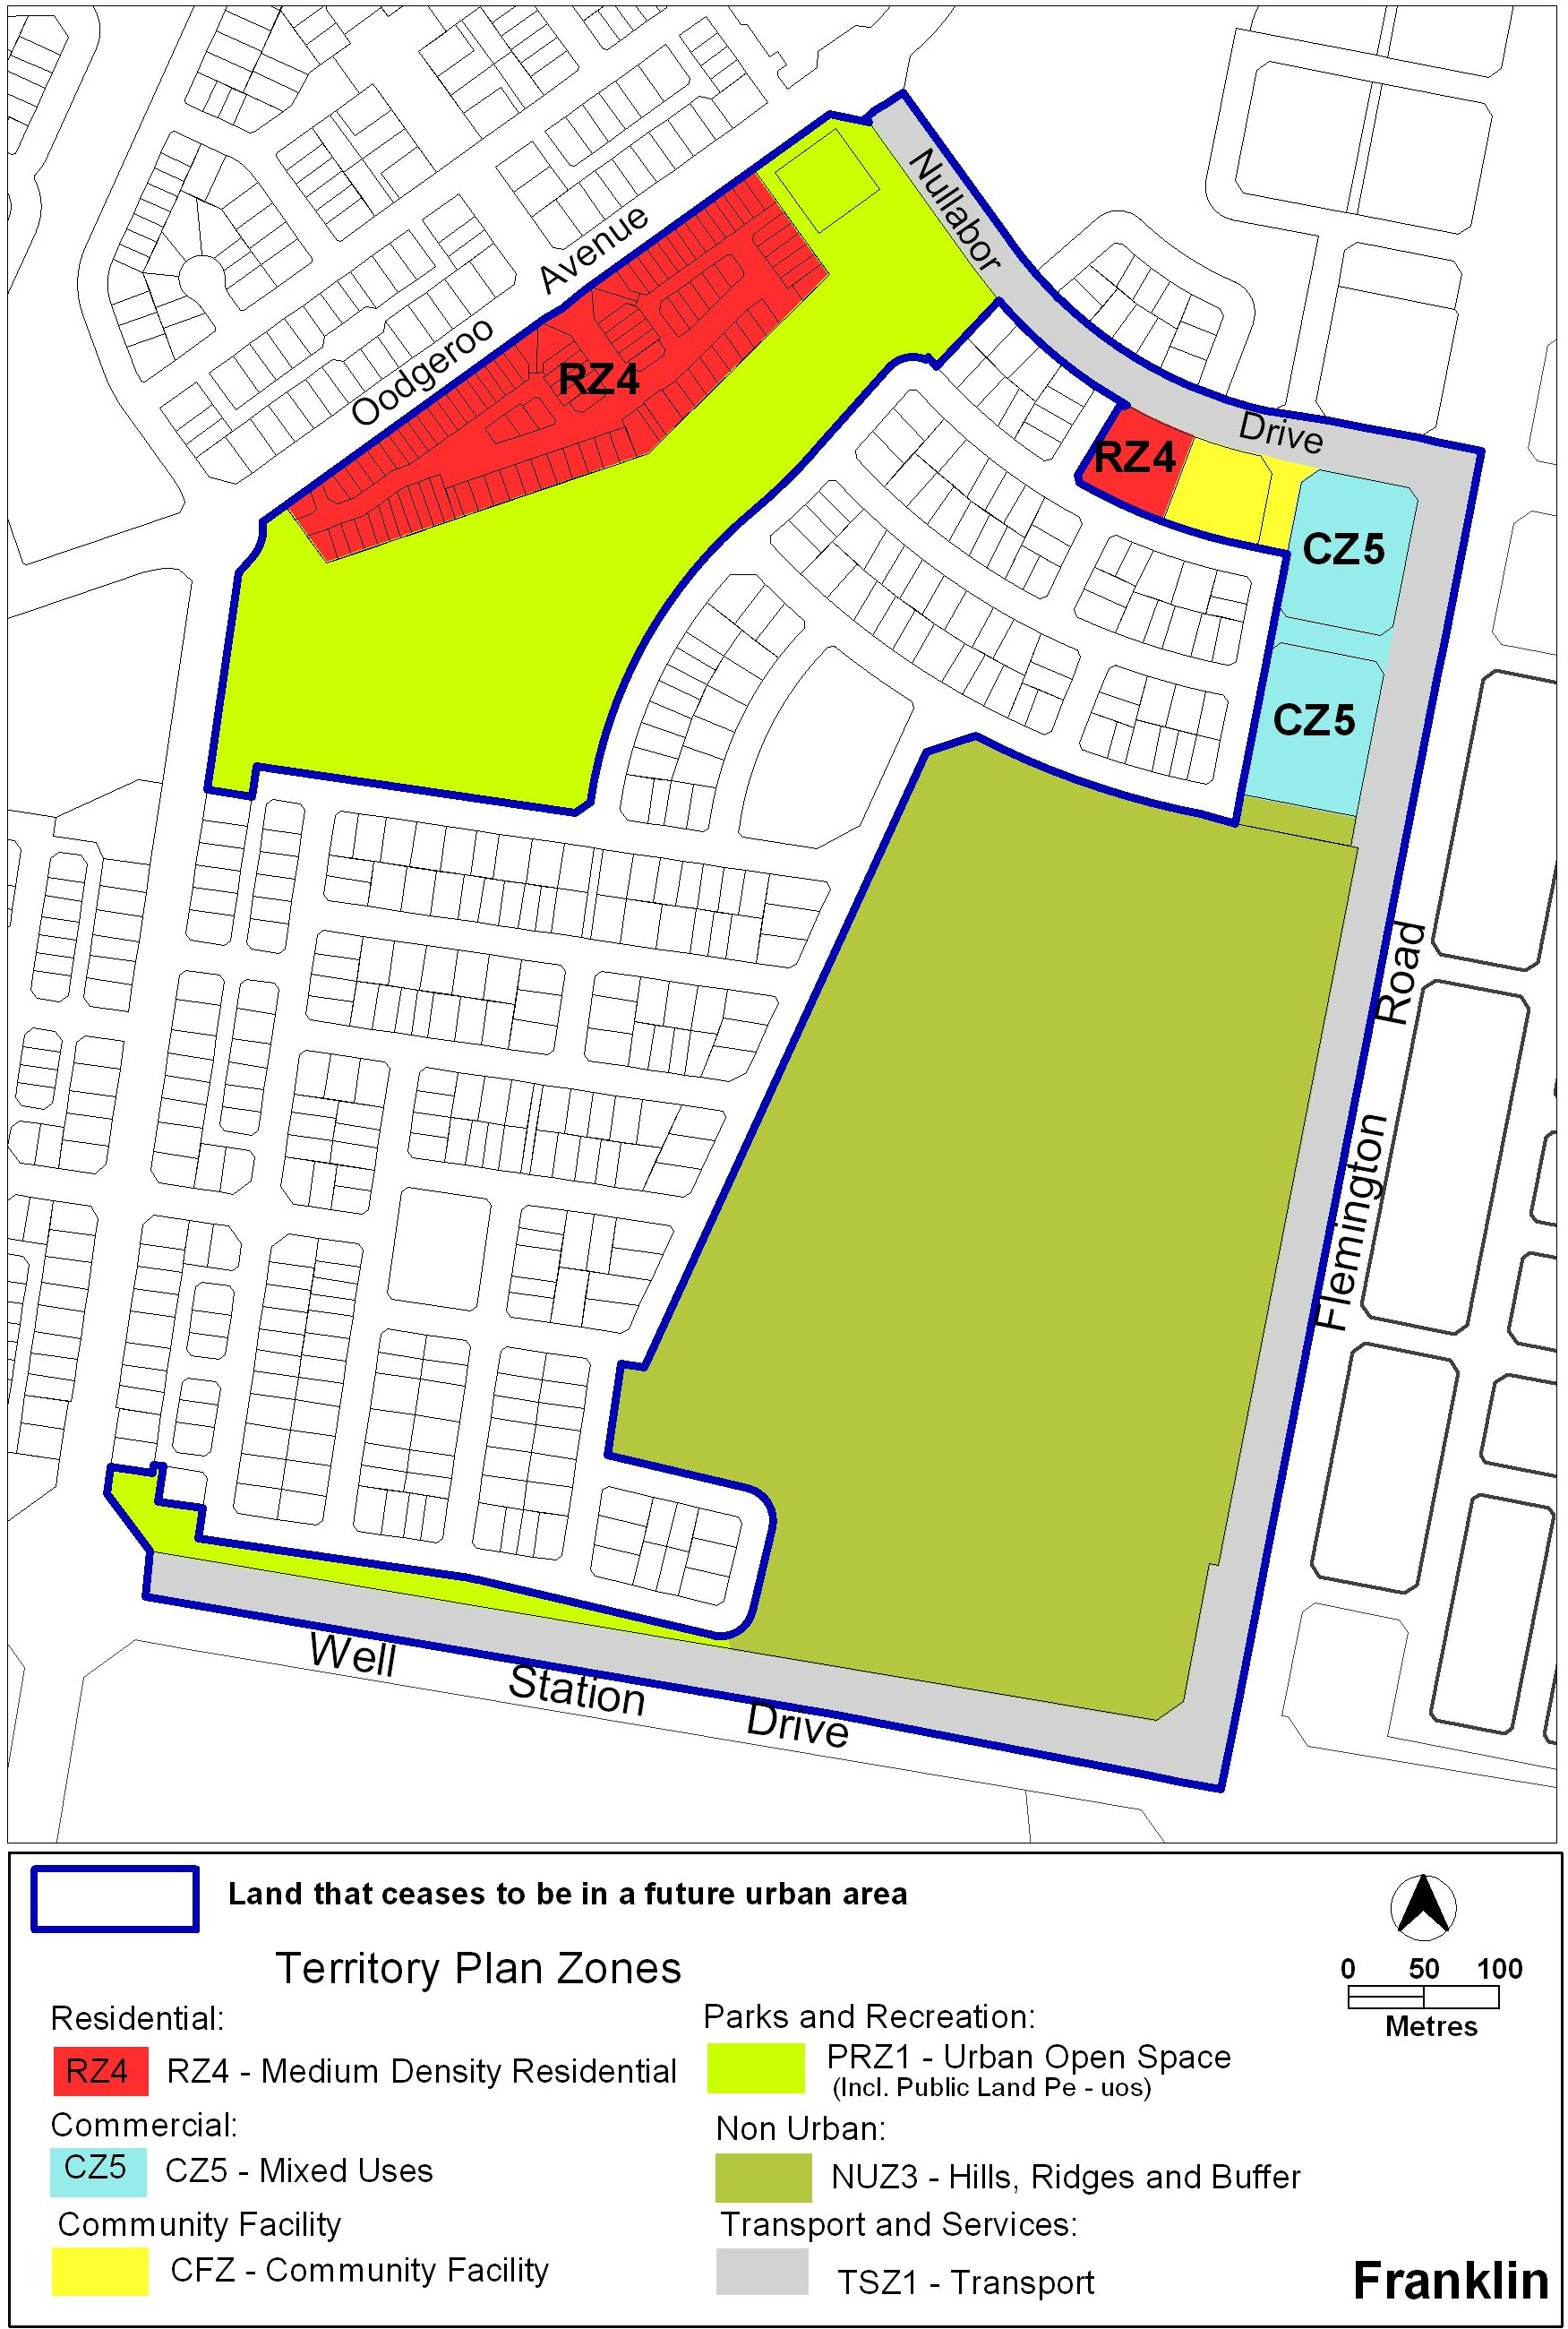

Neil Savery
Planning and Land Authority
Date: 3 February 2011

