Australian Capital Territory
Road Transport (Public Passenger Services) Information to be Displayed in Taxis Approval 2011 (No 2)

Notifiable Instrument NI 2011-524
made under the
Road Transport (Public Passenger Services) Regulation 2002, s102 (2) (Information to be displayed in Taxis)

1. Name of instrument

This instrument is the Road Transport (Public Passenger Services) Information to be displayed in Taxis Approval 2011 (No 2).

2. Commencement

This instrument commences on 25 August 2011.

3. Approval

I approve the information to be displayed in a taxi affiliated with Aerial Capital Group Pty Limited as specified in Schedule 1 of this instrument.

4. Revocation

I revoke Notifiable Instrument NI 2003-225 dated 26 June 2003.

Kerry Bell
Delegate of the Road Transport Authority
25 August 2011

THIS IS PAGE 1 OF SCHEDULE 1 TO THE INSTRUMENT MADE UNDER s102 OF THE ROAD TRANSPORT (PUBLIC PASSENGER SERVICES) REGULATION 2002 ON THE 25 DAY OF AUGUST 2011

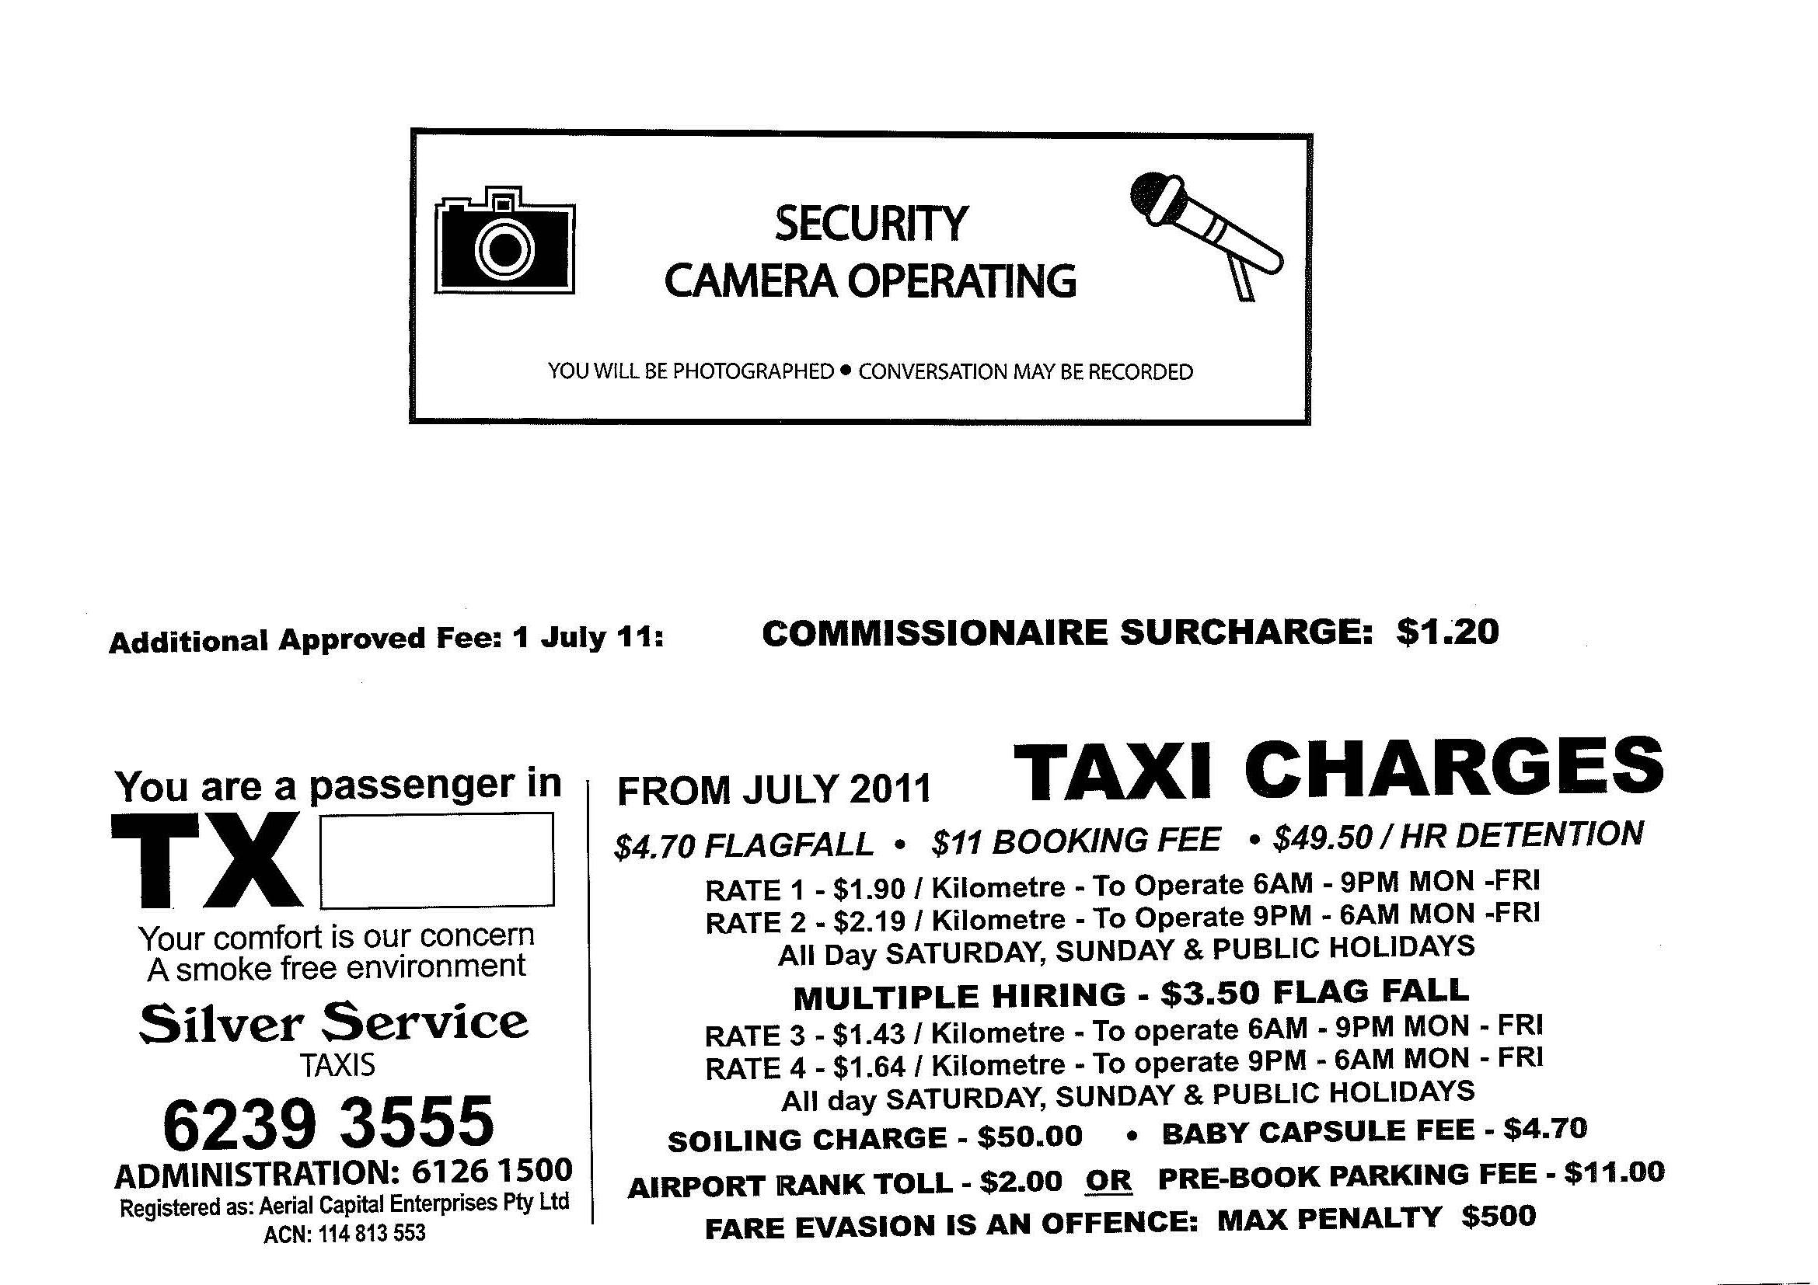

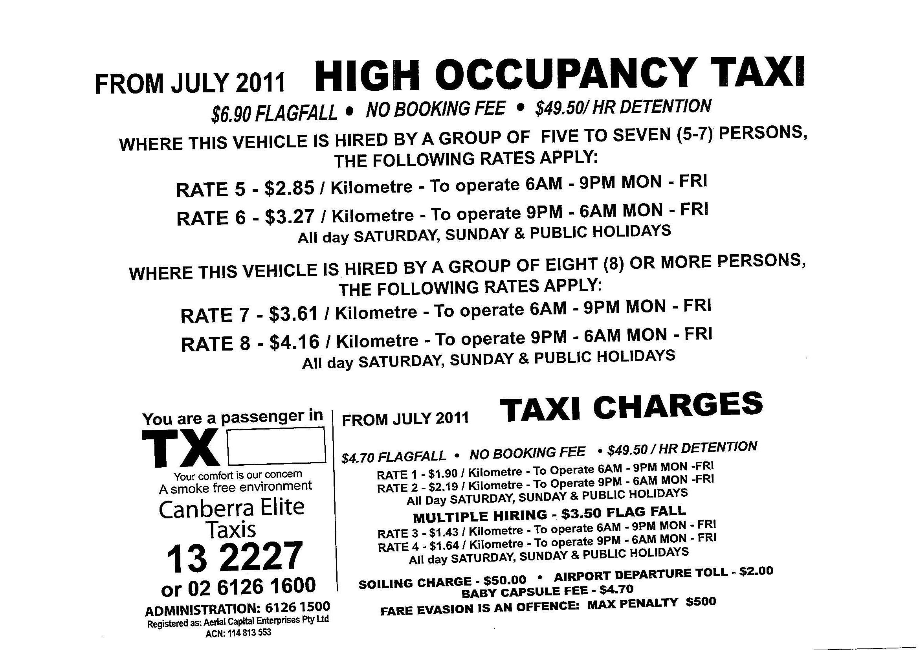

THIS IS PAGE 2 OF SCHEDULE 1 TO THE INSTRUMENT MADE UNDER s102 OF THE ROAD TRANSPORT (PUBLIC PASSENGER SERVICES) REGULATION 2002 ON THE 25 DAY OF AUGUST 2011

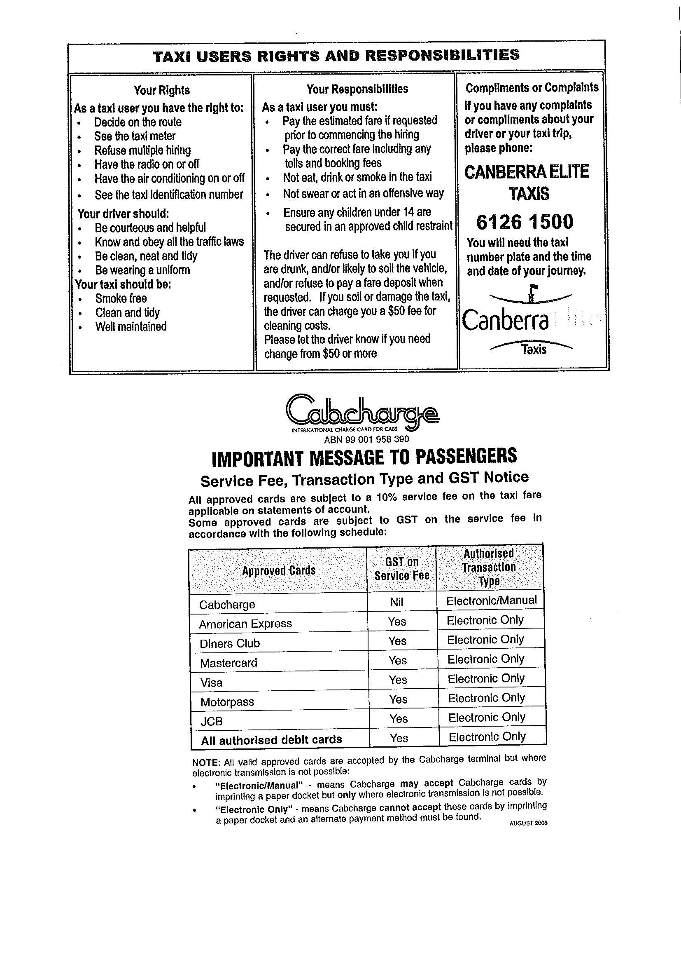

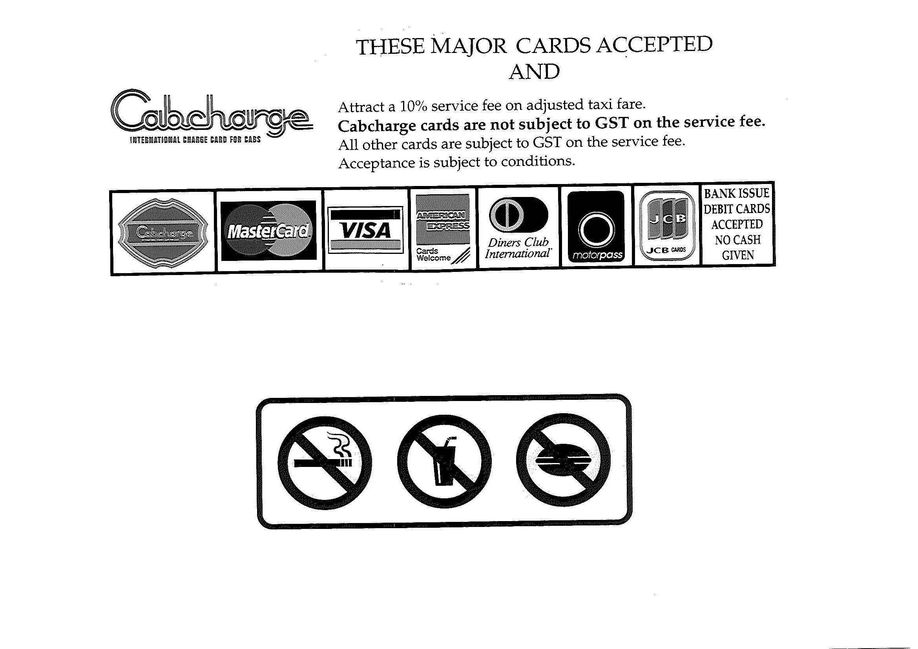
THIS IS PAGE 3 OF SCHEDULE 1 TO THE INSTRUMENT MADE UNDER s102 OF THE ROAD TRANSPORT (PUBLIC PASSENGER SERVICES) REGULATION 2002 ON THE 25 DAY OF AUGUST 2011

THIS IS PAGE 4 OF SCHEDULE 1 TO THE INSTRUMENT MADE UNDER s102 OF THE ROAD TRANSPORT (PUBLIC PASSENGER SERVICES) REGULATION 2002 ON THE 25 DAY OF AUGUST 2011

