Australian Capital Territory
Road Transport (Public Passenger Services) Taxi Network Livery Approval 2011 (No 3)

Notifiable Instrument NI 2011 - 567
made under the
Road Transport (Public Passenger Services) Regulation 2002, s107 (Taxi Network Livery)

1. Name of instrument

This instrument is the Road Transport (Public Passenger Services) Taxi Network Livery Approval 2011 (No 3).

2. Commencement

This instrument commences on 23 September 2011.

3. Approval

I approve the taxi network livery for Aerial Capital Group Ltd specified in Schedule 1 of this instrument.

Kerry Bell
Delegate of the Road Transport Authority
23 September 2011

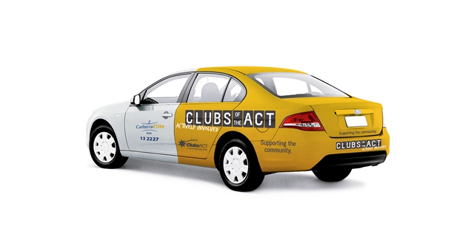

.............
Initials

