Australian Capital Territory

Planning and Development (Technical Amendment— Code and clarification changes to various development codes, general codes, definitions and concept plans) Plan Variation 2011 (No 2)*
Notifiable instrument 2011—589
Technical Amendment No 2011-23
made under the
Planning and Development Act 2007, section 89 (Making technical amendments)

This Technical Amendment commences on Friday 07 October 2011.

Technical Amendment Number 2011-23 to the Territory Plan has been approved by the Planning and Land Authority

Ben Ponton
Delegate of Planning and Land Authority

4 October 2011

Planning and
Land Authority

Planning & Development Act 2007

Technical Amendment
to the Territory Plan Variation 2011-23

Code and clarification technical amendment, including changes to development codes, general codes, definitions and concept plans

October 2011

Table of Contents

1. INTRODUCTION 2
Outline of the process 2
2. EXPLANATORY STATEMENT 3
Proposed changes, reasons, and compliance with the Planning and Development Act 2007 3
2.1 Code variations 3
2.2 Clarification variations 9
3. TECHNICAL AMENDMENT 11
3.1 Code Amendments 11
3.2 Clarification Amendments 16

INTRODUCTION

Outline of the process
The Commonwealth’s Australian Capital Territory (Planning and Land Management) Act 1988 allows for the Legislative Assembly to make laws to establish a Territory Planning Authority and for that Authority to prepare and administer a territory plan.
The Planning and Development Act 2007 (the Act) establishes the ACT Planning and Land Authority as the Authority which prepares and administers the territory plan, including continually reviewing and proposing amendments as necessary.
Technical amendments to the territory plan are prepared in accordance with the Act. This technical amendment has been prepared in accordance with the following two sections of the Act:
A code variation (section 87(b) of the Act) is a technical amendment that
- would only change a code; and
- is consistent with the policy purpose and policy framework of the code; and
- is not an error variation.

A variation under section 87(g) of the Act is a technical amendment that clarifies the language in the territory plan, provided it does not change the substance of the plan.

Following the release of the variation under section 90 of the Act, submissions from the public were invited. At the conclusion of the limited consultation period, any representations are considered by the ACT Planning and Land Authority (the Authority). The Authority then determines a day when the code variation commences by way of a commencement notice.

EXPLANATORY STATEMENT

Proposed changes, reasons, and compliance with the Planning and Development Act 2007
    - Code variations
- Single dwelling housing development code –clarification of setbacks to chamfer lines on corner blocks (item 1)

Part C(1) of the single dwelling housing development code applies to development applications for single dwelling housing in all residential zones, except where provided for by Parts C(2), C(3) or C(4).

Table 1 explains front street setbacks and provides exceptions for corner blocks with an accompanying note for explanatory purposes. However currently there are no specific setback provisions for situations where chamfers (or corner cut-offs) occur within residential corner blocks. Chamfers are usually found at the corner of a block at the junction of streets.

A note is added to the table to clarify that the setback to the chamfer line should be the lesser of the two front setbacks in the case of corner blocks where there is more than one setback requirement, unless the length of the chamfer is less than the length of the additional front boundary in which case the greater of the two setbacks will apply.

Section of Act | Statement of compliance with Act
s87(b) a variation (a code variation) that -
(i) would only change a code; and | Only amends a table in the single dwelling housing development code to include requirements for setbacks to chamfer lines on corner blocks
(ii) is consistent with the policy purpose and policy framework of the code; and | The purpose of the code is to provide additional planning, design and environmental controls to support the zone objectives and assessable uses in the Development Tables. The amendment is considered to be consistent with the purpose of the residential single dwelling housing development code.  The amendment makes no changes and does not affect the application of the residential zone objectives that provide a framework for the particular provisions contained in the code. The change is consistent with the objectives for the residential zones.
(iii) is not an error variation | Is not a formal error

- Changes to requirements for consideration of neighbourhood plans in various codes (items 3 – 5)

These changes to requirements for consideration of neighbourhood plans were previously undertaken in TA2009-26, however references to three relevant codes were omitted. This amendment makes changes to these requirements in the remaining codes.

Criteria contained in some of the residential and commercial codes require a proponent, when preparing a development application, to demonstrate responses to the key strategies and actions of any relevant neighbourhood plan, where one exists. In relation to the requirement to respond to ‘actions’, it is not considered relevant for proponents to address actions which are beyond their scope or control and require review or action by another entity or government organisation. On this basis the words ‘and actions’ are removed from both of the aforementioned criteria as this requirement is not within the proponent’s control.

Section of Act | Statement of compliance with Act
s87(b) a variation (a code variation) that -
(i) would only change a code; and | Only amends a table in various codes to remove the words “and actions”.
(ii) is consistent with the policy purpose and policy framework of the code; and | The codes require a proponent, when preparing a development application, to demonstrate responses to the key strategies and actions of any relevant neighbourhood plan, where one exists. In relation to the requirement to respond to ‘actions’, it is not considered relevant for proponents to address actions which are beyond their scope or control and require review or action by another entity or government organisation.  The amendment makes no changes and does not affect the application of the objectives that provide a framework for the particular provisions contained in the code. The change is consistent with the objectives for the zones.
(iii) is not an error variation | Is not a formal error

- Group centres development code – changing a figure to reflect previous rezoning (item 2)

This technical amendment replaces a figure (Figure A6 Dickson Group Centre Zones) in the group centres development code to reflect a boundary rezoning change undertaken in TA2011-10.

Part Block 19 Section 30 was rezoned to CZ1 commercial. The new figure includes the current zoning codes.

Section of Act | Statement of compliance with Act
s87(b) a variation (a code variation) that -
(i) would only change a code; and | Only changes a reference figure in the group centres development code.
(ii) is consistent with the policy purpose and policy framework of the code; and | The change replaces a figure containing superseded zoning information.  The changes are consistent with the policy framework of the code.
(iii) is not an error variation | Is not a formal error

- Parking and vehicular access general code – change to the requirements for tandem parking spaces in multi unit residential apartment developments (item 6)

This technical amendment changes the tandem parking requirements under Section 2.8 of the parking and vehicular access general code. The current requirements constrain the provision of tandem parking to 10% of the total residential parking for two or more bedroom units. However, on constrained sites there are benefits to allowing more significant levels of tandem parking and it could reasonably be permitted on a larger scale than presently allowed under Section 2.8. Section 2.8 is changed by increasing the percentage of tandem parking spaces which may be permitted without the separate agreement of ACT government authorities for individual development applications to 50% of dwellings with two or more bedrooms in a development.

Section of Act | Statement of compliance with Act
s87(b) a variation (a code variation) that -
(i) would only change a code; and | Only changes section 2.8 in the parking and vehicular access general code relating to tandem parking spaces in multi unit residential apartment developments.
(ii) is consistent with the policy purpose and policy framework of the code; and | The purpose of the code is to ensure that development achieves the relevant objectives of the Territory Plan and will be used by the Authority in the assessment of development applications involving development, redevelopment and lease variations. The code specifies vehicular access and parking requirements for development.  The change increases the percentage of tandem parking spaces for multi unit residential apartment developments which may be permitted without agreement of ACT government authorities.
(iii) is not an error variation | Is not a formal error

- Parking and vehicular access general code – changes to parking provision for multi-unit developments in residential zones (item 7)

This technical amendment changes the on-site parking provision rate in the parking and vehicular access general code, to differentiate between two-bedroom and three-bedroom residences in multi-unit developments, including single or detached dwellings within an integrated multi-unit development. These changes are made because of problems with management of parking spaces in basements and on-site where there are multi-unit dwellings. The concept of ‘shared’ spaces for two-bedroom units creates management problems for body corporates and for the allocation of spaces for residents. It is not possible to allocate the ‘shared’ spaces under unit titling legislation and these become ‘free’ spaces for use by anyone who is aware of their availability. Allocation of all parking spaces for use by residents is the most effective way of dealing with the issue. Residential visitor spaces are not included in the changes and these will still remain the responsibility of body corporate in terms of management.

Section of Act | Statement of compliance with Act
s87(b) a variation (a code variation) that -
(i) would only change a code; and | Only changes section 3.5 in the parking and vehicular access general code relating to the on-site parking provision rate for two and three bedroom residences, including detached residences in multi-unit developments.
(ii) is consistent with the policy purpose and policy framework of the code; and | The purpose of the code is to ensure that development achieves the relevant objectives of the Territory Plan and will be used by the Authority in the assessment of development applications involving development, redevelopment and lease variations. The code specifies vehicular access and parking requirements for development.  The changes allocate all parking spaces provided in two and three bedroom residences, including apartments, attached houses and detached houses in multi-unit residential developments for use by residents.
(iii) is not an error variation | Is not a formal error

- Lawson South concept plan – changes to include a criterion to provide limited flexibility for assessing minimum dwelling numbers (item 8)

Part B 3 – Dwelling Yield of the Lawson South concept plan is amended by introducing a criterion to provide for the consideration in certain circumstances, of a reduced dwelling number. In this way, dwelling numbers and densities can be reviewed in response to detailed investigations and subdivision design taking into account site specific factors such as topography and the electrical infrastructure including the zone substation and high voltage electrical transmission lines. This is consistent with the intent of the concept plan to guide the design of the estate development plan, which is used to assess the estate development plan development application. The amended criterion places the onus on the proponent to demonstrate that densities are maximised with an efficient subdivision layout in the event that a reduced dwelling number is proposed.

Section of Act | Statement of compliance with Act
s87(b) a variation (a code variation) that -
(i) would only change a code; and | Only changes the Lawson South concept plan, which is a precinct code for the purposes of Section 93 of the Planning and Development Act 2007.
(ii) is consistent with the policy purpose and policy framework of the code; and | The Section 93 of the Planning and Development Act 2007 states that a concept plan guides:  (i) preparation and assessment of development in future  urban areas to which the concept plan relates; and  (ii) assessment of development when the land ceases to be in a  future urban area.  The changes add provisions to the concept plan to provide for the consideration of a dwelling number below the current rule for a specified minimum number of units, where certain requirements can be demonstrated.  The changes are consistent with the policy framework of the code.
(iii) is not an error variation | Is not a formal error

    - Clarification variations

- Definitions – clarification of the meaning of outdoor recreation facility (item 9a)

This technical amendment clarifies that a community garden fits within the definition of outdoor recreation facility by inserting the term into the common terminology column. Community gardens are a popular form of community based outdoor recreational activity in the ACT and are managed by a community group for the production of edible vegetables and fruit for personal use. The term ‘community garden’ is not currently a defined term in the Territory Plan, but is considered to fit within the outdoor recreation facility definition.

Section of Act | Statement of compliance with Act
s87(g) a variation to clarify the language in the territory plan if it does not change the substance of the plan | The addition to the list of common terminology under the outdoor recreation facility clarifies that a community garden is included in the definition.

- Definitions – clarification of the term community garden (item 9b)

In association with item G above a definition for the term community garden is included in the Territory Plan - Definitions of Terms section. The term ‘community garden’ is considered to fit within the outdoor recreation facility definition. Inserting a definition in the Definitions of Terms section further clarifies the term when assessing an application for development of community gardens.

Section of Act | Statement of compliance with Act
s87(g) a variation to clarify the language in the territory plan if it does not change the substance of the plan | The addition of a definition for the term “community garden” is intended to provide greater clarity as to what constitutes a community garden.

- Definitions – clarification of the meaning of power generation station (item 10)

This technical amendment clarifies the language within the definition of power generation station, improves its workability and confirms that it is intended to include electrical generation based on renewable energy sources on sites that would principally be assessed for a MAJOR UTILITY INSTALLATION. The current definition of a power generation station in the Territory Plan is based on fuel sources (coal, gas, etc.) involving the delivery, processing and production of by-products; this would not be the case for stationary power generating processes (e.g. photovoltaic panels). The definition is amended to include renewable energy technologies.

Section of Act | Statement of compliance with Act
s87(g) a variation to clarify the language in the territory plan if it does not change the substance of the plan | The change to the definition of power generation station is intended to clarify the original intent of the provision through clearer wording of the definition and providing greater clarity as to what constitutes a power generation station.

- Lawson South Concept Plan – clarification of the location of precincts in the code (item 11)

A note is included to clarify the location of the Lawson South Concept Plan development precincts indicated in Figure 3 of the concept plan.

Section of Act | Statement of compliance with Act
s87(g) a variation to clarify the language in the territory plan if it does not change the substance of the plan | The changes only clarify the language used and do not change the substance of the plan. The addition of the table will assist in clarifying the development precincts indicated in Figure 3 of the concept plan.

TECHNICAL AMENDMENT
    - Code Amendments

Variation to Residential Zones – Single Dwelling Housing Development Code
- Part C – Development Type Controls, Part C(1) – Single Dwelling Housing, Element 2: Building and Site Controls, Table 1: Front Street Setback (Refer Figures C1-3)

Substitute ‘Notes’ with the following

Notes:
- The minimum setbacks for corner blocks apply only to the street frontage nominated. Setbacks to any other street frontage are to comply with the minimum requirements stated in the respective columns for blocks in subdivisions approved post or pre 18 October 1993. If street frontages on corner blocks are of equal length, the minimum setbacks only apply to one street frontage.
- Chamfers are ordinarily found at the corner of a block at the junction of streets. Chamfers may be included in the secondary street frontage, but only if the length of the chamfer is less than the length of the front boundary.

Variation to Group Centres Development Code
- Part A – Group Centres – Overview, Group Centres – Canberra Central, Figure A6 Dickson Group Centre Zones

Substitute with

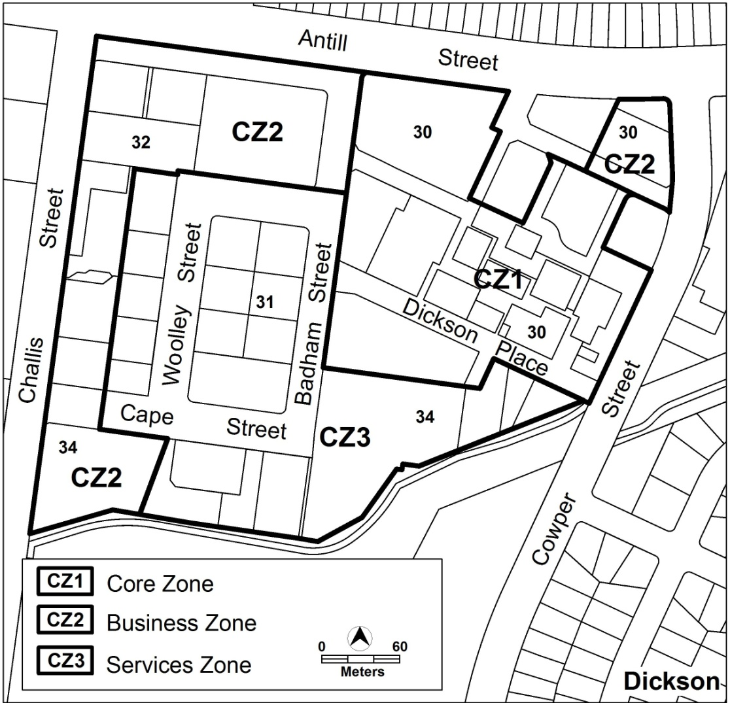

Variation to CZ2 Office Areas Outside Centres Development Code
- At CZ2 office areas outside centres development code, part B general development controls, element 5 amenity, 5.4 neighbourhood plans, criterion C26

Substitute criterion C26 with

Where a Neighbourhood Plan exists, development demonstrates a response to the key strategies of the relevant Neighbourhood Plan.

Variation to CZ6 Leisure and Accommodation Zone Development Code
- At leisure and accommodation zone development code, part B general development controls, element 5 amenity, 5.4 neighbourhood plans, criterion C28

Substitute criterion C28 with

Where a Neighbourhood Plan exists, development demonstrates a response to the key strategies of the relevant Neighbourhood Plan.

Variation to Parks and Recreation Zone Development Code
- At parks and recreation zone development code, part B general development controls, element 5 amenity, 5.4 neighbourhood plans, criterion C30

Substitute criterion C30 with

Where a Neighbourhood Plan exists, development demonstrates a response to the key strategies of the relevant Neighbourhood Plan.

Variation to Parking and Vehicular Access General Code
- Section 2. General Design and Vehicular Access Requirements, 2.8 Tandem parking in multi unit residential apartment developments

Substitute wording in the first and second paragraph of section 2.8 as underlined below

b) the proportion of tandem parking spaces does not exceed 50% of the number of dwellings with two (2) or more bedrooms.
If the proportion of tandem parking spaces exceeds 50% of the number of dwellings with two (2) or more bedrooms, it is subject to an individual assessment and is referred to the Transport Planning and Strategy Section in the Environment and Sustainable Development Directorate for advice.

- Section 3. Parking and vehicular access, 3.1.5 Schedules of parking provision rates for residential zones

Substitute wording in section 3.1.5 Schedule 1 – Residential zones for Apartment, Attached house and Detached house as indicated below

Development Parking provision rates for residential zones
Apartment One (1) parking space per single bedroom dwelling;
and
A minimum average provision of 1.5 spaces per two bedroom
dwelling, provided that each two bedroom dwelling is allocated a
minimum of one (1) parking space and each two (2) bedroom
dwelling is allocated no more than two (2) parking spaces;
or
Two (2) parking spaces per two bedroom dwelling;
and
Two (2) parking spaces for each dwelling with three or more
bedrooms;
plus
One (1) visitor space per four (4) dwellings or part thereof
where a complex comprises four (4) or more dwellings
Attached house One (1) parking space per single bedroom dwelling;
and
A minimum average provision of 1.5 spaces per two bedroom
dwelling, provided that each two bedroom dwelling is allocated a
minimum of one (1) parking space and each two (2) bedroom
dwelling is allocated no more than two (2) parking spaces;
or
Two (2) parking spaces per two bedroom dwelling;
and
Two (2) parking spaces for each dwelling with three or more
bedrooms;
plus
One (1) visitor space per four (4) dwellings or part thereof
where a complex comprises four (4) or more dwellings
Detached house As per above, except that, for two (2) bedroom dwellings only, a
minimum average provision of 1.5 spaces per dwelling, provided that
each two (2) bedroom dwelling is to be allocated a minimum of one
- parking space and no two (2) bedroom dwelling is to be allocated
- more than two (2) parking spaces;
plus
One (1) visitor space per four (4) dwellings or part thereof where a
complex comprises four (4) or more dwellings
Note: if there is only one (1) detached two (2) bedroomed dwelling in
a development, then two (2) parking spaces are required

Variation to Lawson South Precinct Code
- Part B – Subdivision – 2. Dwelling Yield

Substitute with

Rules | Criteria
2. Dwelling Yield
R6  The estate provides a range of housing types, densities and block sizes with a maximum total dwelling yield of 1850 in accordance with Figure 3, and all of the following:  a) in Precinct A, dwelling yield is between 350 and 550  b) in Precinct B, dwelling yield is between 400 and 600  c) in precinct C, the maximum dwelling yield is the maximum total dwelling yield of the estate less the dwelling yield proposed in Precincts A and B. | C6  A greater dwelling yield than that specified may be considered where all of the following can be  demonstrated:  a) that there is sufficient capacity in the infrastructure, services and the local and arterial road networks  b) that a range of dwelling types and densities are provided to accommodate varying lifestyle, housing needs and choice to cater for changing demographics and improving housing affordability.  A reduced dwelling yield than that specified may be considered where all the following can be demonstrated:  a) that the resultant density for the estate is maximised to reflect its proximity to the Belconnen Town Centre, major employment, the University of Canberra, high public amenity areas, and public transport  b) that all available developable land within the estate has been efficiently utilised  c) that the impacts, including those on the amount of land take and dwelling yields, of the electrical infrastructure (zone substation and high voltage powerlines) on the subdivision have been minimised through detailed investigations.  Note: Alternative design solutions to minimise and attenuate the impacts of the electrical infrastructure may be possible.

    - Clarification Amendments

Variation to Definitions
- Part A – Definitions of Development

- In the column labelled ‘Some Common Terminology’ associated with the development definition for ‘Outdoor recreation facility’, add ‘Community garden’ below ‘BMX track’.

- Insert wording underlined below into the definition of ‘power generation station’ in the development column

Power generation station means equipment and associated buildings constructed for the generation of electricity utilising gas, coal, renewable energy technology or other fuel sources.

- Part B – Definitions of Terms

Insert the following definition below the definition for “Communal open space”

Community garden means the use of land for the cultivation of produce primarily for personal use by those people undertaking the gardening, including demonstration gardening or other environmental activities which encourage the involvement of schools, youth groups and citizens in gardening activities.

Variation to Lawson South Precinct Code

- Part B – Subdivision, Heading

Substitute with

Part B - Subdivision
Note:
- This part should be read in conjunction with other relevant codes
- Precincts referred to in this part are development precincts shown in Figure 3 and are subject to criteria
3) The precincts shown in Figure 3 are indicative only and are defined as:
a) Precinct A is located between Lake Ginninderra foreshore and west of the main collector road entering the estate from the intersection of Aikman Drive and Ginninderra Drive. The precinct also includes a small portion of land located north east of College Creek
b) Precinct B is located east of the main collector road entering the estate from the intersection of Aikman Drive and Ginninderra Drive, west of College Creek and north of Ginninderra Drive
c) Precinct C is all the remaining land located east of College Creek (with the exemption of the small parcel of land in the north western corner, which forms part of Precinct A) and west of Baldwin Drive.

Interpretation service

