Australian Capital Territory
Heritage (Decision about Provisional Registration of the site of General Legge’s House, Cranleigh, Latham) Notice 2011
Notifiable Instrument NI2011−643
made under the
Heritage Act 2004 s34 Notice of decision about Provisional Registration

- Name of instrument
This instrument is the Heritage (Decision about Provisional Registration of the site of General Legge’s House, Cranleigh, Latham) Notice 2011*

- Commencement
This instrument commences on the day after notification.

- Notice of Decision
Pursuant to Section 32 of the Heritage Act 2004 the ACT Heritage Council has decided not to provisionally register the site of General Legge’s House Site, Cranleigh at Latham to the ACT Heritage Register.

…………………………….

Mr Gerhard Zatschler

Secretary

ACT Heritage Council

GPO Box 158

Canberra ACT 2601

20 October 2011

STATEMENT OF REASONS

DECISION NOT TO PROVISIONALLY REGISTER
THE SITE OF GENERAL LEGGE’S HOUSE, CRANLEIGH
(Blocks 1 and 2, Section 69, Latham ACT)
IN THE ACT HERITAGE REGISTER

Background

The site of General Legge’s house, Cranleigh, at Latham was nominated to the ACT Heritage Register some time ago. In 1999, a plaque was installed at the site, commemorating General Legge.

The house site is located on open reserve land, with many mature trees.

At Council Meeting #39 on 20 October 2011 the ACT Heritage Council endorsed a Statement of Reasons which does not find the site of General Legge’s House, Cranleigh eligible for provisional registration.

Assessment
The Council’s assessment against the criteria specified in s.10 of the Heritage Act 2004 is as follows.

In assessing the nomination for Cranleigh, the Council considered:

- The material referenced below; and
- A site visit by Heritage Unit staff on Thursday 16 June 2011.

Criterion (a) it demonstrates a high degree of technical or creative achievement (or both), by showing qualities of innovation, discovery, invention or an exceptionally fine level of application of existing techniques or approaches
The site of General-Legge’s homestead, Cranleigh, does not meet this criterion.

Criterion (b) it exhibits outstanding design or aesthetic qualities valued by the community or a cultural group
The site of General-Legge’s homestead, Cranleigh, does not meet this criterion.

Criterion (c) it is important as evidence of a distinctive way of life, taste, tradition, religion, land use, custom, process, design or function that is no longer practiced, is in danger of being lost or is of exceptional interest
The site of General-Legge’s homestead, Cranleigh, is related to land-use in the area at the time of the early development of Canberra. Much of the focus at this time was on the development of the new suburbs of Braddon, Ainslie, Kingston and Griffith and the civic centre. Other land-uses were related to rural soldier settler leases including those of Belconnen Farm and Callum Brae.

At the time of establishment of the Federal Capital Territory, rural properties were compulsorily resumed by the Government, and leased back to rural tenants. Cranleigh is one such place which operated as a rural lease within the newly formed capital. Other places include the earlier farms of Horse Park, Canberra Park, Elm Grove and Belconnen Farm.

Given the lack of remaining evidence at the site of Cranleigh, when compared with other rural properties of this time, this place cannot be considered to be ‘important as evidence’ of this land use.

The site of General-Legge’s homestead, Cranleigh, does not meet this criterion.

Criterion (d) it is highly valued by the community or a cultural group for reasons of strong or special religious, spiritual, cultural, educational or social associations
No information has been provided to suggest that the site of General-Legge’s homestead, Cranleigh, is highly valued by the community or a cultural group.

There is no evidence before Council to indicate that the place meets this criterion.

Criterion (e) it is significant to the ACT because of its importance as part of local Aboriginal tradition
The site of General-Legge’s homestead, Cranleigh, does not meet this criterion.

Criterion (f) it is a rare or unique example of its kind, or is rare or unique in its comparative intactness
The site of General-Legge’s homestead, Cranleigh, does not meet this criterion.

Criterion (g) it is a notable example of a kind of place or object and demonstrates the main characteristics of that kind.
The site of General-Legge’s homestead, Cranleigh, does not meet this criterion.

Criterion (h) it has strong or special associations with a person, group, event, development or cultural phase in local or national history
Heritage Council assessment:
The site of General Legge’s homestead, Cranleigh in Latham has an association with Lieutenant-General James Gordon Legge, a prominent figure in Australia’s military history.

Following Legge’s retirement from the Army in 1922 Cranleigh was his place of residence until 1947.

However, this association cannot be considered strong or special, given the lack of remaining evidence to support and demonstrate the association. Although the trees on the block were planted by Legge, this is not considered a strong or special association. Further, Legge’s association with the place is not related to the reasons for which he is a prominent figure through his career with the Australian Army.

The site of General-Legge’s homestead, Cranleigh, does not meet this criterion.

Criterion (i) it is significant for understanding the evolution of natural landscapes, including significant geological features, landforms, biota or natural processes
The site of General-Legge’s homestead, Cranleigh, does not meet this criterion.

Criterion (j) it has provided, or is likely to provide, information that will contribute significantly to a wider understanding of the natural or cultural history of the ACT because of its use or potential use as a research site or object, teaching site or object, type locality or benchmark site
The site of General-Legge’s homestead, Cranleigh, does not meet this criterion.

Criterion (k) for a place—it exhibits unusual richness, diversity or significant transitions of flora, fauna or natural landscapes and their elements
The site of General-Legge’s homestead, Cranleigh, does not meet this criterion.

Criterion (l) for a place—it is a significant ecological community, habitat or locality for any of the following:
(i) the life cycle of native species;
(ii) rare, threatened or uncommon species;
(iii) species at the limits of their natural range;
(iv) distinct occurrences of species
The site of General-Legge’s homestead, Cranleigh, does not meet this criterion.

HISTORY

The Cranleigh homestead was built by, and was the home of Lieutenant-General James Gordon Legge after his retirement. Legge was a key figure in the development of the Australian Army and a commander of Australian troops in the African War, and in World War I at Gallipoli, Ypres and the Somme. Legge was also a commandant of the Royal Military College, Duntroon. Following his retirement from the Army in 1922 Cranleigh was his residence until 1947.

Legge had an impressive military career, climbing through the ranks from a lieutenant in 1892 to the positions of Major General in 1915 and 1920, followed by the position of commandant of the Royal Military College of Duntroon, also in 1920. He made a significant contribution to Australia’s military forces, including leading a division at the Western Front in France in 1916 and assisting with Kitchener’s Defence Scheme in 1909.

Perhaps Legge’s most enduring contribution to Australia’s military history was during his assistance to Kitchener in 1909, and the subsequent establishment of the military training institution of Duntroon. Kitchener’s Defence Scheme has been said to really have been Legge’s Defence Scheme, given the work he undertook.

Legge’s military career

James Gordon Legge was born in 1863 in London and came to Sydney with his family in 1878. He first joined the military forces of the 3rd New South Wales Infantry regiment as a lieutenant in 1885. He soon joined the permanent staff with the rank of captain, taking up the appointment in 1894. Soon after he became ‘adjutant of the 2nd Infantry Regiment and applied himself to critically examining Australian defence arrangements’ (ADB, 2011).

In 1896 Legge married Annie Frances Ferguson in Sydney.

In 1899 Legge was appointed to command an infantry company in the South African Boer War and was an intelligence officer in Cape Colony in 1901-1902 before returning to Sydney in 1902. Upon his return, Legge held many prominent positions including deputy assistant adjutant general with rank of major (1904) and assistant adjutant general and chief staff officer (1905). In 1909 Legge was promoted substantively to lieutenant-colonel. The work of Field Marshal Lord Kitchener was heavily reliant on the work of Legge (ADB, 2011). ‘The week after Legge's death, in September 1947, (the official war historian) Dr. C. E. YV. Bean published an article in the Sydney Morning Herald in which he noted the fact that the early defence system was usually known as the 'Kitchener scheme . . . But [it] was basically Legge's' (Mordike, 1984: 8).

Legge was an ardent advocate of universal military training, in opposition to other military personnel at the time who tended to follow the conservative British model of opposition to compulsory conscription.

But, ‘Legge was also sympathetic to wider nationalist aspirations and in 1910 he was to remind the then Labour Minister of Defence, Senator George Pearce, that it was most necessary to adapt military policy to Australian conditions ' where the methods of a Regular Army have to be modified to suit one composed of citizens’ (Mordike, 1984: 5). As a result, in 1907 he commenced full-time work on Deakin's military scheme, being directly responsible to the Minister.

‘Legge continued to be involved with the training scheme until early 1911, including the brief period from November 1908 to June 1909 when the Fisher Labor Government was in office. His work was the basis of the amendments incorporated into the Defence Act in 1909 and, as well as introducing plans for universal military training, the amendments proposed the establishment of a military college for training professional officers to fill appointments as administrative and instructional staff in the scheme’ (Mordike, 1984: 5).

It was not the first time a military college had been proposed for Australia, but, until it had been decided to introduce universal training, there simply was not a sufficient requirement for officers to justify its establishment (Mordike, 1984: 5).

Prime Minister for the third time since 1903, Alfred Deakin formally invited the retiring Imperial Commander-in-Chief in India, Field Marshal Viscount Kitchener of Khartoum, to visit Australia. Deakin explained that the object of the invitation was to have Kitchener ' inspect our . . . [military] . . . forces and fixed defences in order to advise this Government upon the best means of developing and perfecting the land defence of the country . . . [so that] . . . we should have much more confidence in completing our schemes’ (Mordike, 1984: 5).

However, Kitchener’s proposal that nearly all cadets be full-fee paying students resulted in some debate, with concerns that only the sons of wealthy families would be able to enter. An article in the Sydney Worker publication stated ‘a basic essential of the foundation of a citizen army is equality of opportunity, with office for merit alone. Kitchener's scheme ignores this, and is therefore undemocratic and unacceptable to Australia' (Mordike, 1984: 11). Subsequently, a new Government was formed, abolishing the idea of fees, and proceeded with the establishment of the training college.

Kitchener’s Defence Scheme resulted in many amendments to the Defence Act in 1911, including the establishment of the military training institution of Duntroon.

His Defence Scheme also resulted in providing the legislative framework for the Australian Armed Forces, bringing them from the separate administration of the former colonies of Australia into a composite force under the command of the Commonwealth Government.

In 1912 Legge was appointed as Australia’s representative on the Imperial General Staff in London. Also in this year he was appointed C.M.G. ‘He was returning home when war was declared and arrived in Melbourne after preparations had begun under Bridges for the dispatch of a force for active service in Europe. He immediately assumed responsibility for raising a smaller contingent, the Australian Naval and Military Expeditionary Force, and a second Australian Imperial Force (AIF) contingent and reinforcements’ (ADB, 2011).

In 1915 the commander of the AIF, Bridges, was fatally wounded in action with the 1st Australian Division. Legge was appointed to succeed him. On reaching Gallipoli he was promoted Major General and assumed command of the 1st Division though only retained this position for a month before returning to Egypt to form the 2nd Division.

Legge’s Division was responsible for a section of the Western Front in France. The 2nd Division’s attack in August 1916 was a success. Legge returned to Australia in 1917 and his AIF appointment ended soon after. He then took up roles including inspector general of the Australian Military Forces, and became involved in the second conscription referendum. In 1920 Legge again became Major General and relinquished the post of CGS to become commandant of the Royal Military College, Duntroon. In 1922 Legge was retrenched for financial reasons and retired with the honorary rank of lieutenant-general.

Legge’s decision to retire in the then newly formed Federal Capital Territory is unusual, with few other senior army officials ever having retired in the ACT.

It is unclear exactly why Legge chose to retire in the ACT at this time, with family in Melbourne and Sydney. He chose a rural block far away from the construction activity of the civic area and the early suburbs which were being built for public servants.

At the time he chose his property Cranleigh, the Kingston Power House had been constructed, as well as the Yarralumla Brickworks and the Kingston-Civic railway line. Plans were well afoot to develop the nation’s capital.

Legge’s decision to retire in the ACT in the early 1920s occurred at the time that the city of Canberra was forming. It had been declared the Federal Capital Territory in 1913. The Federal Capital Advisory Committee (FCAC) was appointed in 1921 to facilitate the move to Canberra of Parliament and the central staff of each department. In 1922 the FCAC built its first houses in Braddon, Kingston and Yarralumla. In 1925 the Federal Capital Commission (FCC) replaced the FCAC and the decision was made to move a larger number of public servants from Melbourne to Canberra.

Legge’s enforced return to civil life before reaching the prescribed retiring age deprived Legge of a military pension. For this reason, with the assistance of the soldier settlement scheme, he took up 400 acres of land in Weetangera (now Belconnen) and turned to pig-farming. He named the property ‘Cranleigh Farm’ after his school in England and his former home in Sydney.

Soldier Settlement contextual history

In 1915 the Federal Government implemented the Soldier Settlement Scheme to encourage voluntary recruitment, to provide employment for returned servicemen and to increase post-war primary production. The scheme can be summarised as:
- the Commonwealth Government would supply loan funds to the States and Territories for a maximum £500 per soldier settler (later increased to £625);
- the States and Territories would make land available for sale to returned soldiers and would administer the scheme;
- There would be an initial period of low interest charges to settlers;
- The settlers would be paid sustenance during the establishment period; and
- The State would organise training facilities for settlers with no farming experience (Navin Officer, 2001: 6).

In 1919 land was made available in the FCT for settlement of returned Australian soldiers as a repatriation scheme. As happened elsewhere throughout Australia, large landholdings were resumed by the government and subdivided for closer settlement including for soldier settlement. In the FCT, this land included areas at Yarralumla (including ‘Belconnen’), Duntroon, Lanyon, Tuggeranong and Charnwood (Pfanner, 1999: 11).

Life on most of the soldier settlement leases appears to have been difficult. Most of the settlers had little capital and many had no previous farming experience (Navin Officer, 2001: 6).

In general terms, the Soldier Settler Schemes across Australia were considered to have failed. This is due to a number of factors, including ‘small non-viable blocks on poor land which were unsuitable for farming, over-capitalisation due to the high price of stock and equipment, lack of previous farming experience, a fall in farm commodity prices in the critical years between 1920 and 1924 when soldier settlers were trying to establish their properties, and continued decline in the rural sector from 1924 and throughout the Depression’ (Navin Officer, 2001: 6).

In the ACT, a greater flexibility in the leasehold system enabled struggling lessees to transfer or consolidate their leases, thereby saving the scheme in the ACT from total failure. Most of these leases were eventually resumed for the development of Canberra (Navin Officer, 2001: 7).

Cranleigh

By 1923 cottages for a manager and workmen were being built at Cranleigh, farm machinery including a tractor had been purchased and a concrete weir across the Ginninderra Creek was under construction (Coulthard-Clark, 1987).

Legge envisaged a substantial piggery being constructed on Cranleigh Farm with provisions for a bacon factory. By 1929 he had installed 20 pens and a watering system for the pigs and had brought in Berkshire and Poland-China varieties to breed. Unfortunately the piggery proved unprofitable due to a number of factors, including the farm’s isolation and Legge’s inexperience in this area (Gillespie, 1992: 179-181).

At the time of Legge’s occupation of the land, a railway line was proposed from Canberra to Yass, passing across the northern corner of Legge’s property. It is thought that he was counting on the railway line to assist in the transportation of his pigs. The decision not to build the railway is cited as another reason for the failure of Legge’s piggery farm.

Legge then turned his hand to potato farming at Cranleigh, putting 80 hectares under cultivation. However, again Legge failed in this venture following two years of drought. Despite this, Legge and his wife persisted with the property for 25 years, leaving only when health forced them to do so (Gillespie, 1992: 181).

Soon after taking over the lease of the farm, Legge began the construction of an unusual residence. The style he adopted was said to have been derived from houses he had seen in India early in his military career. In its external appearance the house was square with a flat roof resembling a fort or block house construction. It was built of concrete blocks moulded on site with sand from Ginninderra Creek. Internally there was a central verandah courtyard surrounded by ten rooms with each room having an entrance to the courtyard. The house was completed in 1923.

Legge lived in this home till ill health forced him to move to Melbourne to live with his son in 1947. His wife had left three years before, due to her own ill health and had lived in Melbourne and then Sydney under the care of family members. Legge received news of his wife’s death in September 1947 while he was ill with bronco-pneumonia in a private hospital. He died little more than a fortnight later on 18 September aged 84.

After his death all his papers were destroyed on his previous instructions by his manager. The house was closed up. Furniture and other contents of the house not wanted by the family were disposed of in two sales with the results that General Legge’s personal effects entered many Canberra homes.

After Legge’s death the house was sold to Jack Sheperd and Dixon. Shepherd and Dixon sold the concrete blocks of the house and demolished the house in the early 1950s, leaving only the foundations.

By 1953 the homestead was virtually derelict and was sold to the owner of the neighbouring property. The house was dismantled and the concrete blocks eventually ended up as paving stones on a nearby property. The foundations of the house remained within the grove of pines as the northern suburbs of Canberra developed to consume much of the property. In 1986 the foundations were cleared away and no trace of the house remained. The only indications of Legge’s presence are the pine trees and the remaining orchard in what is left of the Cranleigh property.

A nearby school in the suburb of Holt bears the name ‘Cranleigh’ and a minor road in the grounds of Duntroon bears Legge’s name.

Other ACT places associated with Legge
There are few other places in the ACT associated with Legge, as most of his military career was spent in Sydney and Melbourne, as well as overseas. The exact date of Legge’s arrival in Canberra is unknown, but is likely to have been circa 1920 when he became Commandant of the Royal Military College of Duntroon.

The most notable place in Canberra associated with Legge is the Duntroon Military College. This place is considered to have a stronger and more special association with Legge, as it is directly related to his career with the Australian armed service, and is directly related to one of the reasons for which he is a prominent figure within Australia’s history.

An assessment has not been undertaken to determine the significance of Legge’s association with Duntroon, though it is considered without doubt as having a greater degree of association than Cranleigh for the reasons noted above.

A portrait of Legge, by Harry Bromilow Harrison, hangs on loan from the Australian War Memorial at Duntroon.

DESCRIPTION

The home of General James Gordon Legge was constructed on the site of Block 1, Section 69 Latham in 1922. The house was demolished in 1951 and building remains were cleared from the site in 1986 to form an urban park. Wind break plantings, planted by Legge, remain on the site, and a memorial plaque was installed in 1999.

The site of Cranleigh is part of Canberra’s open space urban park system. The rows of pine trees confer a sense of stateliness and tranquillity to the site.

The park is dominated by pine trees planted by Legge. He planted the trees to surround the homestead and orchard grounds which stood approximately in the centre of the existing park. Approximately 161 living pines remain in multiple rows which delineate the borders of the park on the north, south and west sides. There are many vacant spaces within the rows, indicating the previous existence of more trees than those which exist today.

A grove of fruit trees in the northern half of the park are the remains of an orchard planted by Legge. The trees were planted in three or four rows. Approximately 20 trees remain.

Physical condition and integrity

The site of the Cranleigh homestead has a low level of integrity, with no above ground features of the homestead. However, mature plantings planted by Legge remain at the site.

SITE PLAN AND IMAGES

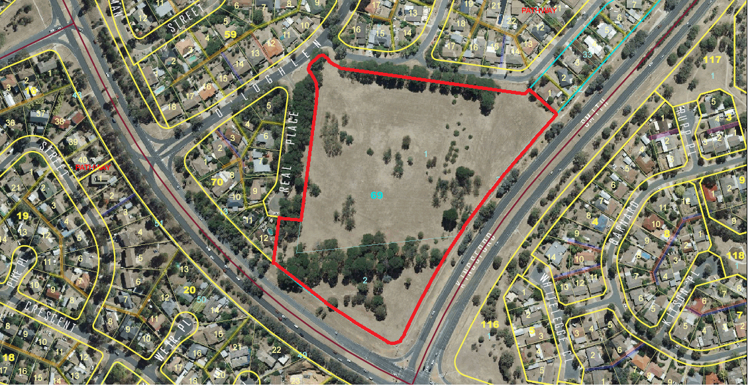
Site boundary as defined by solid red line

Images taken 16 June 2011

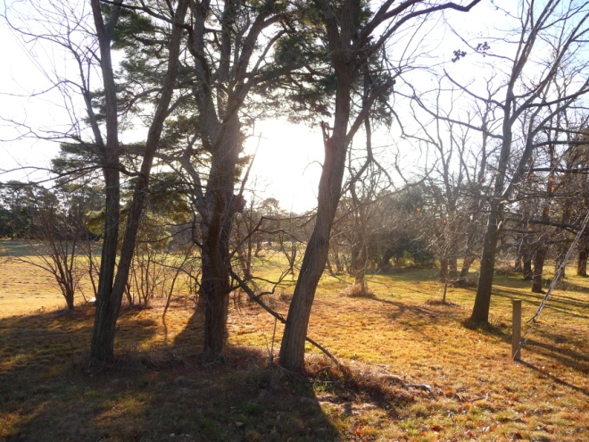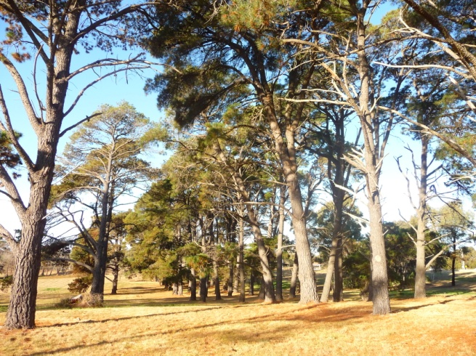

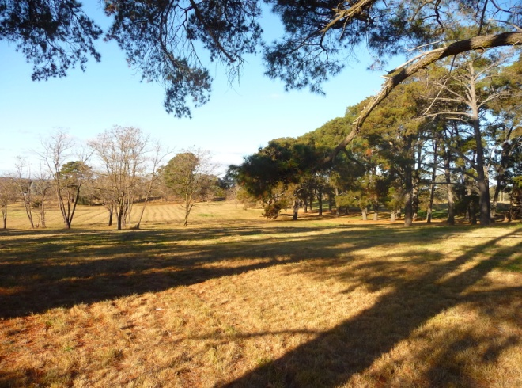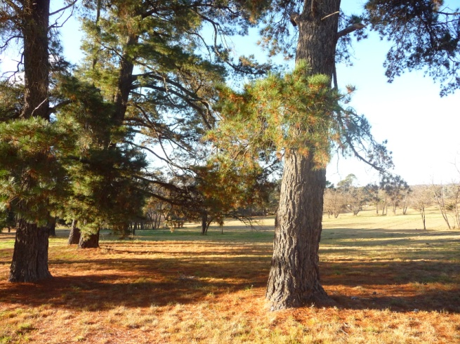

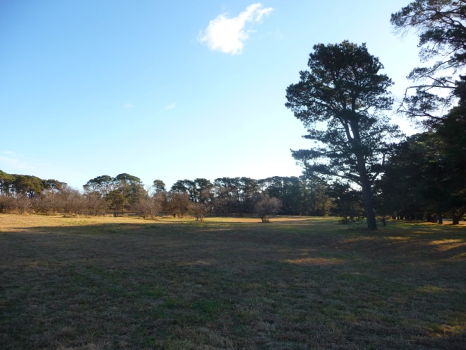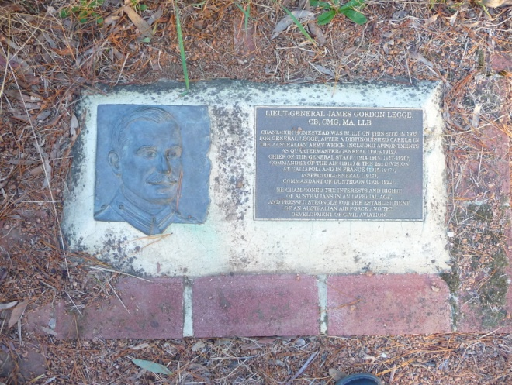

References

Australian Dictionary of Biography (ADB) – Online Edition, ‘Legge, James Gordon (1863 - 1947)’, author - C. D. Coulthard-Clark, date accessed 15 June 2011.

Coulthard-Clark, C.D, 1987, ‘General Legge at Weetangera’, Canberra Historical Journal, New Series No. 19, pp9-13.

Coulthard-Clark, C.D., 1988a, ‘General Legge at Weetangera: A Postscript’, Canberra Historical Journal, New Series No. 22, pp.53-54.

Cuolthard-Clark, C.D, 1988b, No Australian Need Apply. The Troubled Career of Lieutenant-General Gordon Legge, Allen and Unwin, Sydney.

Gillespie, L., 1992: Ginninderra Forerunner to Canberra, Lyall Gillespie, Campbell ACT.

Mordike, J.L., 1984, ‘Lord Kitchener’s Memorandum on the Defence of Australia, 1910: The Implications for Australia’s Military Forces’, in Defence Force Journal, May/June 1984, Australian Government Publishing Service, Canberra.

Navin Officer Heritage Consultants, 2001, A Comparative Assessment of the Cultural Heritage Values of Surviving Soldier Settlement Properties within the ACT. Report to Purdon Associates Pty Ltd.

Pfanner, S. 1996, Soldier settlement subdivisions in the Federal Capital Territory after WWI. Canberra Historical Journal 37: 25-34, March 1996. Canberra & District Historical Society.

Pfanner, S. 1999, A History of Soldier Settlement in the Federal Capital Territory after the First World War. Unpublished report to ACT Heritage Unit.

Conclusion

The site of General Legge’s homestead, Cranleigh, is marked by rows of mature trees, and an orchard. General Legge was a prominent figure in the Australian Army, during World War I, and for his involvement with the Kitchener Scheme which saw the establishment of the Duntroon Military College.

While of some historic interest, the site of General Legge’s homestead, Cranleigh, does not meet any of the criteria for registration under the Heritage Act 2004.

Legge’s association with the place is not strong. There is little physical fabric remaining to evidence Legge’s time here. Further, the association dates from a time subsequent to his significant achievements within Australia’s history and is unrelated to the reasons for which he is a prominent person. Although Legge planted the trees at the site himself, this alone does not provide enough evidence of a strong or special association.

This Statement of Reasons provides an assessment of the site of General Legge’s homestead, Cranleigh and finds that the place does not meet any of the criteria of the Heritage Act 2004.

Gerhard Zatschler (Secretary)
ACT Heritage Council

20 October 2011

