Australian Capital Territory

Planning and Development (Technical Amendment—Weston) Plan Variation 2011 (No 2)*

Notifiable instrument NI2011—731
Technical Amendment No 2011-35
made under the
Planning and Development Act 2007, section 89 (Making technical amendments) (s96 land ceases to be in future urban area)

This plan variation commences on the day after it is notified.

Variation No 2011-35 to the Territory Plan has been approved by the Planning and Land Authority

Annexure A – specifies the zones that apply to the area shown on the map.

Annexure B – amends the Weston Precinct Code at section 10 of the Territory Plan.

Ben Ponton
Delegate of ACT Planning and Land Authority
Date: 23 November 2011

THIS IS PAGE ONE OF ANNEXURE A
TO NOTIFIABLE INSTRUMENT NI2011 – 731

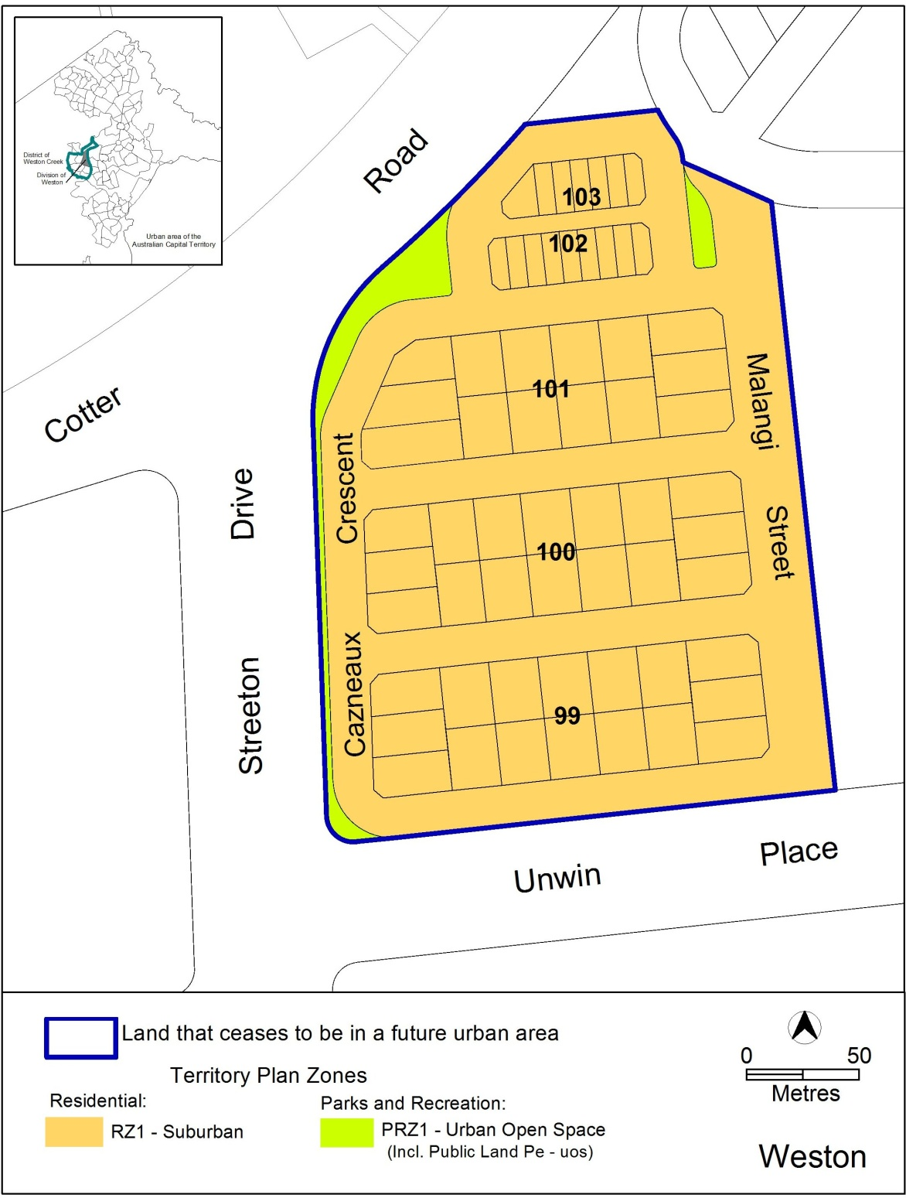

Ben Ponton
Delegate of ACT Planning and Land Authority
Date: 23 November 2011

THIS IS PAGE ONE OF ANNEXURE B
TO NOTIFIABLE INSTRUMENT NI2011 – 731

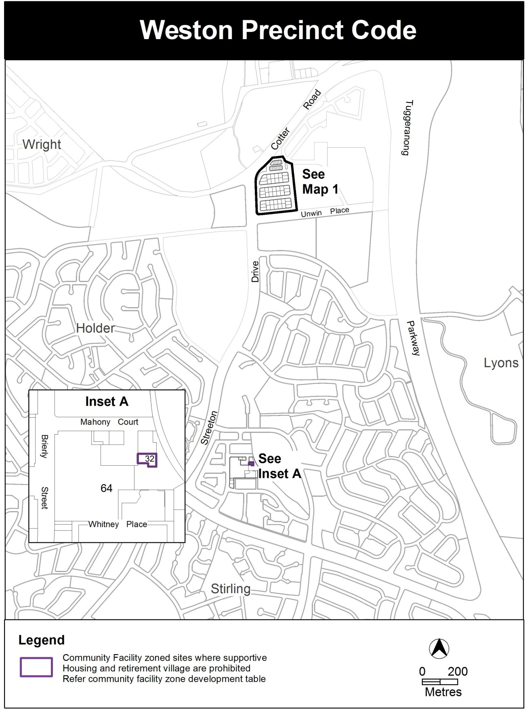

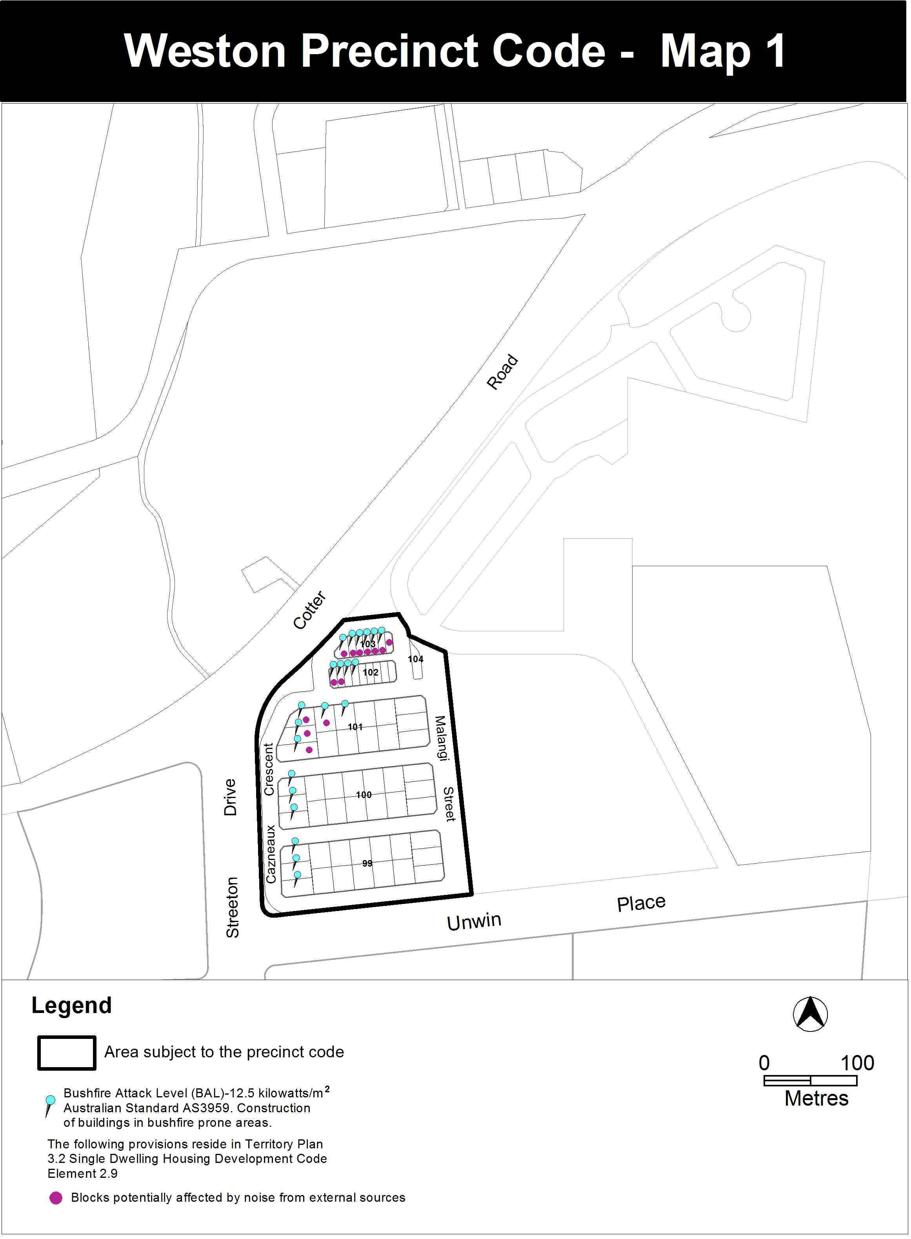

Ben Ponton
Delegate of ACT Planning and Land Authority
Date: 23 November 2011

