Australian Capital Territory
Work Health and Safety (How to Manage Work Health and Safety Risks) Code of Practice 2011*
Notifiable instrument NI2011–749
made under the
Work Health and Safety Act 2011, section 274 (Approved Codes of Practice)

1 Name of instrument
This instrument is the Work Health and Safety (How to Manage Work Health and Safety Risks) Code of Practice 2011.
2 Commencement
This instrument commences on 1 January 2012.
3 Code of Practice Approval
Under section 274 of the Work Health and Safety Act 2011 (the Act), and being satisfied that this code of practice was developed in accordance with the process described in s274 (2) of the Act, I approve the ACT Work Health and Safety (How to Manage Work Health and Safety Risks) Code of Practice 2011.

Dr Chris Bourke
Minister for Industrial Relations
15 December 2011

HOW TO MANAGE
WORK HEALTH AND SAFETY RISKS

Code of Practice

ISBN 978-0-642-33301-8 [PDF]
ISBN 978-0-642-33302-5 [RTF]

Creative Commons
Except for the Safe Work Australia logo, this copyright work is licensed under a Creative Commons Attribution-Noncommercial 3.0 Australia licence. To view a copy of this licence, visit
http://creativecommons.org/licenses/by-nc/3.0/au/
In essence, you are free to copy, communicate and adapt the work for non commercial purposes,
as long as you attribute the work to Safe Work Australia and abide by the other licence terms.
Table of Contents
FOREWORD 4
1. INTRODUCTION 5
1.1 Who has responsibility for managing work health and safety risks? 5
1.2 The meaning of key terms 5
1.3 What is involved in managing risks? 6
1.4 When should a risk management approach be used? 8
2. STEP 1 – HOW TO IDENTIFY HAZARDS 9
2.1 How to find hazards 9
3. STEP 2 – HOW TO ASSESS RISKS 11
3.1 When should a risk assessment be carried out? 11
3.2 How to do a risk assessment 11
4. STEP 3 – HOW TO CONTROL RISKS 15
4.1 The hierarchy of risk control 15
4.2 How to develop and implement control options 17
4.3 How to ensure that controls remain effective 18
5. STEP 4 – HOW TO REVIEW CONTROLS 20
6. KEEPING RECORDS 21
APPENDIX A – Assessing how things go wrong 22
APPENDIX B – Risk REGISTER 23
APPENDIX C – case studies 24

FOREWORD
This Code of Practice on how to manage work health and safety risks is an approved code of practice under section 274 of the Work Health and Safety Act (the WHS Act).
An approved code of practice is a practical guide to achieving the standards of health, safety and welfare required under the WHS Act and the Work Health and Safety Regulations (the WHS Regulations).
A code of practice applies to anyone who has a duty of care in the circumstances described in the code. In most cases, following an approved code of practice would achieve compliance with the health and safety duties in the WHS Act, in relation to the subject matter of the code. Like regulations, codes of practice deal with particular issues and do not cover all hazards or risks that may arise. The health and safety duties require duty holders to consider all risks associated with work, not only those for which regulations and codes of practice exist.
Codes of practice are admissible in court proceedings under the WHS Act and Regulations. Courts may regard a code of practice as evidence of what is known about a hazard, risk or control and may rely on the code in determining what is reasonably practicable in the circumstances to which the code relates.
Compliance with the WHS Act and Regulations may be achieved by following another method, such as a technical or an industry standard, if it provides an equivalent or higher standard of work health and safety than the code.
An inspector may refer to an approved code of practice when issuing an improvement or prohibition notice.
This Code of Practice has been developed by Safe Work Australia as a model code of practice under the Council of Australian Governments’ Inter-Governmental Agreement for Regulatory and Operational Reform in Occupational Health and Safety for adoption by the Commonwealth, state and territory governments.
A draft of this Code of Practice was released for public consultation on 7 December 2010 and was endorsed by the Workplace Relations Ministers’ Council on 10 August 2011.

SCOPE AND APPLICATION
This Code provides practical guidance for persons who have duties under the WHS Act and Regulations to manage risks to health and safety. The duty is placed on persons conducting a business or undertaking, including employers, self-employed, principal contractors, persons with management or control of a workplace, designers, manufacturers, importers and suppliers of plant, substances or structures that are used for work.
This Code applies to all types of work and all workplaces covered by the WHS Act. Other approved codes of practice should be referenced for guidance on managing the risk of specific hazards.
How to use this Code of Practice
In providing guidance, the word ‘should’ is used in this Code to indicate a recommended course of action, while ‘may’ is used to indicate an optional course of action.
This Code also includes various references to sections of the WHS Act and to regulations which set out the legal requirements. These references are not exhaustive. The words ‘must’, ‘requires’ or ‘mandatory’ indicate that a legal requirement exists and must be complied with.

1. INTRODUCTION

1.1 Who has responsibility for managing work health and safety risks?
The WHS Act and Regulations require persons who have a duty to ensure health and safety to ‘manage risks’ by eliminating health and safety risks so far as is reasonably practicable, and if it is not reasonably practicable to do so, to minimise those risks so far as is reasonably practicable.
Persons conducting a business or undertaking will have health and safety duties to manage risks if they:
- engage workers to undertake work for them, or if they direct or influence work carried out by workers
- may put other people at risk from the conduct of their business or undertaking
- manage or control the workplace or fixtures, fittings or plant at the workplace
- design, manufacture, import or supply plant, substances or structures for use at a workplace
- install, construct or commission plant or structures at a workplace.
Deciding what is ‘reasonably practicable’ to protect people from harm requires taking into account and weighing up all relevant matters, including:
- the likelihood of the hazard or risk concerned occurring
- the degree of harm that might result from the hazard or risk
- knowledge about the hazard or risk, and ways of eliminating or minimising the risk
- the availability and suitability of ways to eliminate or minimise the risk, and
- after assessing the extent of the risk and the available ways of eliminating or minimising the risk, the cost associated with available ways of eliminating or minimising the risk, including whether the cost is grossly disproportionate to the risk.
The process of managing risk described in this Code will help you decide what is reasonably practicable in particular situations so that you can meet your duty of care under the WHS laws.
Officers (for example company directors) must exercise due diligence to ensure that the business or undertaking complies with the WHS Act and Regulations. This includes taking reasonable steps to:
- gain an understanding of the hazards and risks associated with the operations of the business or undertaking
- ensure that the business or undertaking has and uses appropriate resources and processes to eliminate or minimise risks to health and safety.
A person can have more than one duty and more than one person can have the same duty at the same time.

1.2 The meaning of key terms
Hazard means a situation or thing that has the potential to harm a person. Hazards at work may include: noisy machinery, a moving forklift, chemicals, electricity, working at heights, a repetitive job, bullying and violence at the workplace.
Risk is the possibility that harm (death, injury or illness) might occur when exposed to a hazard.
Risk control means taking action to eliminate health and safety risks so far as is reasonably practicable, and if that is not possible, minimising the risks so far as is reasonably practicable. Eliminating a hazard will also eliminate any risks associated with that hazard.

1.3 What is involved in managing risks?
Management commitment
Effective risk management starts with a commitment to health and safety from those who operate and manage the business or undertaking. You also need the involvement and cooperation of your workers, and if you show your workers that you are serious about health and safety they are more likely to follow your lead.
To demonstrate your commitment, you should:
- get involved in health and safety issues
- invest time and money in health and safety
- ensure health and safety responsibilities are clearly understood.
A step-by-step process
A safe and healthy workplace does not happen by chance or guesswork. You have to think about what could go wrong at your workplace and what the consequences could be. Then you must do whatever you can (in other words, whatever is ‘reasonably practicable’) to eliminate or minimise health and safety risks arising from your business or undertaking.
This process is known as risk management and involves the four steps set out in this Code (see Figure 1 below):
- identify hazards – find out what could cause harm
- assess risks if necessary – understand the nature of the harm that could be caused by the hazard, how serious the harm could be and the likelihood of it happening
- control risks – implement the most effective control measure that is reasonably practicable in the circumstances
- review control measures to ensure they are working as planned.
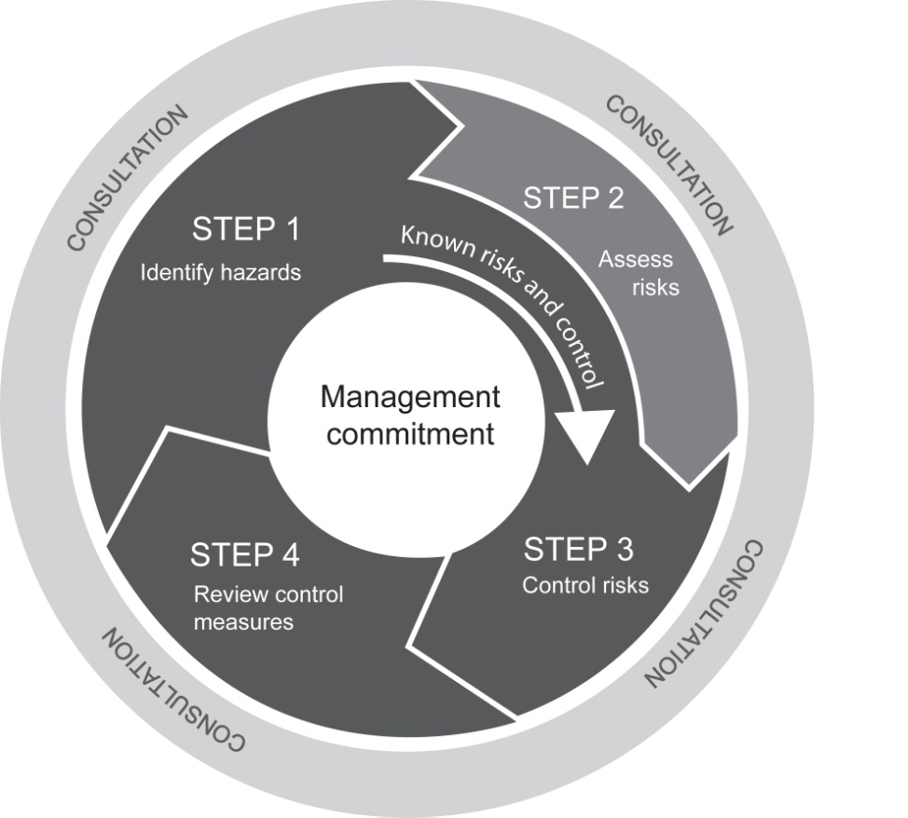
Figure 1: The risk management process
Many hazards and their associated risks are well known and have well established and accepted control measures. In these situations, the second step to formally assess the risk is unnecessary. If, after identifying a hazard, you already know the risk and how to control it effectively, you may simply implement the controls.
Risk management is a proactive process that helps you respond to change and facilitate continuous improvement in your business. It should be planned, systematic and cover all reasonably foreseeable hazards and associated risks.
Consulting your workers
Section 47: The WHS Act requires that you consult, so far as is reasonably practicable, with workers who carry out work for you who are (or are likely to be) directly affected by a work health and safety matter.
Section 48: If the workers are represented by a health and safety representative, the consultation must involve that representative.
Consultation involves sharing of information, giving workers a reasonable opportunity to express views and taking those views into account before making decisions on health and safety matters.
Consultation with workers and their health and safety representatives is required at each step of the risk management process. By drawing on the experience, knowledge and ideas of your workers you are more likely to identify all hazards and choose effective control measures.
You should encourage your workers to report any hazards and health and safety problems immediately so that risks can be managed before an incident occurs.
If you have a health and safety committee, you should engage the committee in the risk management process as well.
Consulting, co-operating and co-ordinating activities with other duty holders
Section 46: The WHS Act requires that you consult, co-operate and co-ordinate activities with all other persons who have a work health or safety duty in relation to the same matter, so far as is reasonably practicable.
Sometimes you may share responsibility for a health and safety matter with other business operators who are involved in the same activities or who share the same workplace. For example, if you engage on-hire workers as part of your workforce you share a duty of care to these workers with the business that provides them. In these situations, you must discuss the hazards and risks associated with the work and what precautions will be taken with the on-hire firm.
Never assume that someone else is taking care of a health and safety matter. Find out who is doing what and work together with other duty holders in a co-operative and co-ordinated way so that all risks are eliminated or minimised as far as reasonably practicable.
When entering into contracts you should communicate your safety requirements and policies, review the job to be undertaken, discuss any safety issues that may arise and how they will be dealt with. Remember that you cannot transfer your responsibilities to another person.
Further guidance on consultation is available in the Code of Practice: Work Health and Safety Consultation, Co-operation and Co-ordination.

1.4 When should a risk management approach be used?
Managing work health and safety risks is an ongoing process that is triggered when any changes affect your work activities. You should work through the steps in this Code when:
- starting a new business or purchasing a business
- changing work practices, procedures or the work environment
- purchasing new or used equipment or using new substances
- planning to improve productivity or reduce costs
- new information about workplace risks becomes available
- responding to workplace incidents (even if they have caused no injury)
- responding to concerns raised by workers, health and safety representatives or others at the workplace
- required by the WHS regulations for specific hazards
It is also important to use the risk management approach when designing and planning products, processes or places used for work, because it is often easier and more effective to eliminate hazards before they are introduced into a workplace by incorporating safety features at the design stage.

2. STEP 1 – HOW TO IDENTIFY HAZARDS

Identifying hazards in the workplace involves finding things and situations that could potentially cause harm to people. Hazards generally arise from the following aspects of work and their interaction:
- physical work environment
- equipment, materials and substances used
- work tasks and how they are performed
- work design and management
Table 1 below lists some common types of workplace hazards. Some hazards are part of the work process, such as mechanical hazards, noise or toxic properties of substances. Other hazards result from equipment or machine failures and misuse, chemical spills and structural failures.
A piece of plant, substance or a work process may have many different hazards. Each of these hazards needs to be identified. For example, a production line may have dangerous moving parts, noise, hazards associated with manual tasks and psychological hazards due to the pace of work.
Table 1: Examples of common hazards
Hazard | Potential harm
Manual tasks | Overexertion or repetitive movement can cause muscular strain
Gravity | Falling objects, falls, slips and trips of people can cause fractures, bruises, lacerations, dislocations, concussion, permanent injuries or death
Electricity | Potential ignition source.  Exposure to live electrical wires can cause shock, burns or death from electrocution
Machinery and equipment | Being hit by moving vehicles, or being caught by moving parts of machinery can cause fractures, bruises, lacerations, dislocations, permanent injuries or death
Hazardous chemicals | Chemicals (such as acids, hydrocarbons, heavy metals) and dusts (such as asbestos and silica) can cause respiratory illnesses, cancers or dermatitis
Extreme temperatures | Heat can cause burns, heat stroke or fatigue  Cold can cause hypothermia or frost bite
Noise | Exposure to loud noise can cause permanent hearing damage
Radiation | Ultra violet, welding arc flashes, micro waves and lasers can cause burns, cancer or blindness
Biological | Micro-organisms can cause hepatitis, legionnaires’  disease, Q fever, HIV/AIDS or allergies
Psychosocial hazards | Effects of work-related stress, bullying, violence and work-related fatigue

2.1 How to find hazards
Inspect the workplace
Regularly walking around the workplace and observing how things are done can help you predict what could or might go wrong. Look at how people actually work, how plant and equipment is used, what chemicals are around and what they are used for, what safe or unsafe work practices exist as well as the general state of housekeeping.
Things to look out for include the following:
- Does the work environment enable workers to carry out work without risks to health and safety (for example, space for unobstructed movement, adequate ventilation, lighting)?
- How suitable are the tools and equipment for the task and how well are they maintained?
- Have any changes occurred in the workplace which may affect health and safety?
Hazards are not always obvious. Some hazards can affect health over a long period of time or may result in stress (such as bullying) or fatigue (such as shiftwork). Also think about hazards that you may bring into your workplace as new, used or hired goods (for example, worn insulation on a hired welding set).
As you walk around, you may spot straightforward problems and action should be taken on these immediately, for example cleaning up a spill. If you find a situation where there is immediate or significant danger to people, move those persons to a safer location first and attend to the hazard urgently.
Make a list of all the hazards you can find, including the ones you know are already being dealt with, to ensure that nothing is missed. You may use a checklist designed to suit your workplace to help you find and make a note of hazards.
Consult your workers
Ask your workers about any health and safety problems they have encountered in doing their work and any near misses or incidents that have not been reported.
Worker surveys may also be undertaken to obtain information about matters such as workplace bullying, as well as muscular aches and pains that can signal potential hazards.
Review available information
Information and advice about hazards and risks relevant to particular industries and types of work is available from regulators, industry associations, unions, technical specialists and safety consultants.
Manufacturers and suppliers can also provide information about hazards and safety precautions for specific substances (safety data sheets), plant or processes (instruction manuals).
Analyse your records of health monitoring, workplace incidents, near misses, worker complaints, sick leave and the results of any inspections and investigations to identify hazards. If someone has been hurt doing a particular task, then a hazard exists that could hurt someone else. These incidents need to be investigated to find the hazard that caused the injury or illness.

3. STEP 2 – HOW TO ASSESS RISKS
A risk assessment involves considering what could happen if someone is exposed to a hazard and the likelihood of it happening. A risk assessment can help you determine:
- how severe a risk is
- whether any existing control measures are effective
- what action you should take to control the risk
- how urgently the action needs to be taken.
A risk assessment can be undertaken with varying degrees of detail depending on the type of hazards and the information, data and resources that you have available. It can be as simple as a discussion with your workers or involve specific risk analysis tools and techniques recommended by safety professionals.

3.1 When should a risk assessment be carried out?
A risk assessment should be done when:
- there is uncertainty about how a hazard may result in injury or illness
- the work activity involves a number of different hazards and there is a lack of understanding about how the hazards may interact with each other to produce new or greater risks
- changes at the workplace occur that may impact on the effectiveness of control measures.
A risk assessment is mandatory under the WHS Regulations for high risk activities such as entry into confined spaces, diving work and live electrical work.
Some hazards that have exposure standards, such as noise and airborne contaminants, may require scientific testing or measurement by a competent person to accurately assess the risk and to check that the relevant exposure standard is not being exceeded (for example, by using noise meters to measure noise levels and using gas detectors to analyse oxygen levels in confined spaces).
A risk assessment is not necessary in the following situations:
- Legislation requires some hazards or risks to be controlled in a specific way – these requirements must be complied with.
- A code of practice or other guidance sets out a way of controlling a hazard or risk that is applicable to your situation and you choose to use the recommended controls. In these instances, the guidance can be followed.
- There are well-known and effective controls that are in use in the particular industry, that are suited to the circumstances in your workplace. These controls can simply be implemented.

3.2 How to do a risk assessment
All hazards have the potential to cause different types and severities of harm, ranging from minor discomfort to a serious injury or death.
For example, heavy liquefied petroleum gas (LPG) cylinders can cause muscular strain when they are handled manually. However, if the cylinder is damaged causing gas to leak which is then ignited, a fire could result in serious burns. If that leak occurs in a store room or similar enclosed space, it could result in an explosion that could destroy the building and kill or injure anyone nearby. Each of the outcomes involves a different type of harm with a range of severities, and each has a different likelihood of occurrence.
Work out how severe the harm could be
To estimate the severity of harm that could result from each hazard you should consider the following questions:
- What type of harm could occur (e.g. muscular strain, fatigue, burns, laceration)? How severe is the harm? Could the hazard cause death, serious injuries, illness or only minor injuries requiring first aid?
- What factors could influence the severity of harm that occurs? For example, the distance someone might fall or the concentration of a particular substance will determine the level of harm that is possible. The harm may occur immediately something goes wrong (e.g. injury from a fall) or it may take time for it to become apparent (e.g. illness from long-term exposure to a substance).
- How many people are exposed to the hazard and how many could be harmed in and outside your workplace? For example, a mobile crane collapse on a busy construction site has the potential to kill or injure a large number of people.
- Could one failure lead to other failures? For example, could the failure of your electrical supply make any control measures that rely on electricity ineffective?
- Could a small event escalate to a much larger event with more serious consequences? For example, a minor fire can get out of control quickly in the presence of large amounts of combustible materials.

Work out how hazards may cause harm
In most cases, incidents occur as a result of a chain of events and a failure of one or more links in that chain. If one or more of the events can be stopped or changed, the risk may be eliminated or reduced.
One way of working out the chain of events is to determine the starting point where things begin to go wrong and then consider: ‘If this happens, what may happen next?’ This will provide a list of events that sooner or later cause harm. See the case study in Appendix A.
In thinking about how each hazard may cause harm, you should consider:
- the effectiveness of existing control measures and whether they control all types of harm,
- how work is actually done, rather than relying on written manuals and procedures
- infrequent or abnormal situations, as well as how things are normally meant to occur.
Consider maintenance and cleaning, as well as breakdowns of equipment and failures of health and safety controls.

Work out the likelihood of harm occurring
The likelihood that someone will be harmed can be estimated by considering the following:
- How often is the task done? Does this make the harm more or less likely?
- How often are people near the hazard? How close do people get to it?
- Has it ever happened before, either in your workplace or somewhere else? How often?
Table 2 contains further questions that can help you estimate likelihood.
You can rate the likelihood as one of the following:
- Certain to occur - expected to occur in most circumstances
- Very likely - will probably occur in most circumstances
- Possible – might occur occasionally
- Unlikely – could happen at some time
- Rare – may happen only in exceptional circumstances

The level of risk will increase as the likelihood of harm and its severity increases.
Table 2
Questions to ask in  determining likelihood | Explanation and examples
How often are people exposed to the hazard? | A hazard may exist all of the time or it may only exist occasionally. The more often a hazard is present, the greater the likelihood it will result in harm.  For example:  - Meshing gears in an enclosed gearbox can cause crushing only if the gearbox is open during maintenance, and therefore the potential for harm will not occur very often.  - Continuously lifting heavy boxes has the potential to cause harm whenever the work is done.
How long might people be exposed to the hazard? | The longer that someone is exposed to a hazard, the greater the likelihood that harm may result.  For example:  The longer a person is exposed to noisy work, the more likely it is that they will suffer hearing loss.
How effective are current controls in reducing risk? | In most cases the risks being assessed will already be subject to some control measures. The likelihood of harm resulting from the risk will depend upon how adequate and effective the current measures are.  For example:  Traffic management controls have been implemented in a warehouse to separate moving forklifts from pedestrians by using signs and painted lines on the floor. These controls may need to be upgraded to include physical barriers.
Could any changes in your organisation increase the likelihood? | The demand for goods or services in many organisations varies throughout the year. Changes in demand may be seasonal, depend on environmental conditions or be affected by market fluctuations that are driven by a range of events. Meeting increased demand may cause unusual loads on people, plant and equipment and systems of work. Failures may be more likely.  For example:  Inner city restaurants and bistros are very busy in the period prior to Christmas, placing extra demands on kitchen and serving staff. The increase in volume of food to be prepared and serving a larger number of patrons increases the potential for human error and the likelihood of harm.
Are hazards more likely to cause harm because of the working environment? | Examples of situations where the risk of injury or illness may become more likely:  - Environmental conditions change. For example, work performed in high temperatures in a confined space increases the potential for mistakes because workers become fatigued more quickly; wet conditions make walkways and other things slippery.  - People are required to work quickly. The rate at which work is done (e.g. number of repetitions) can over-stress a person’s body or make it more likely that mistakes will be made.  - There is insufficient light or poor ventilation.
Could the way people act and behave affect the likelihood of a hazard causing harm? | The possibility that people may make mistakes, misuse items, become distracted or panic in particular situations needs to be taken into account. The effects of fatigue or stress may make it more likely that harm will occur.
Do the differences between individuals in the workplace make it more likely for harm to occur? | People with disabilities may be more likely to suffer harm if the workplace or process is not designed for their needs.  New or young workers may be more likely to suffer harm because of inexperience.  People who do not normally work at the workplace will have less knowledge than employees who normally work there, and may be more likely to suffer harm. These people include contractors, visitors or members of the public.

4. STEP 3 – HOW TO CONTROL RISKS
The most important step in managing risks involves eliminating them so far as is reasonably practicable, or if that is not possible, minimising the risks so far as is reasonably practicable.
In deciding how to control risks you must consult your workers and their representatives who will be directly affected by this decision. Their experience will help you choose appropriate control measures and their involvement will increase the level of acceptance of any changes that may be needed to the way they do their job.
There are many ways to control risks. Some control measures are more effective than others.
You must consider various control options and choose the control that most effectively eliminates the hazard or minimises the risk in the circumstances. This may involve a single control measure or a combination of different controls that together provide the highest level of protection that is reasonably practicable.
Some problems can be fixed easily and should be done straight away, while others will need more effort and planning to resolve. Of those requiring more effort, you should prioritise areas for action, focusing first on those hazards with the highest level of risk.

4.1 The hierarchy of risk control
The ways of controlling risks are ranked from the highest level of protection and reliability to the lowest as shown in Figure 2. This ranking is known as the hierarchy of risk control. The WHS Regulations require duty holders to work through this hierarchy when managing risk under the WHS Regulations.

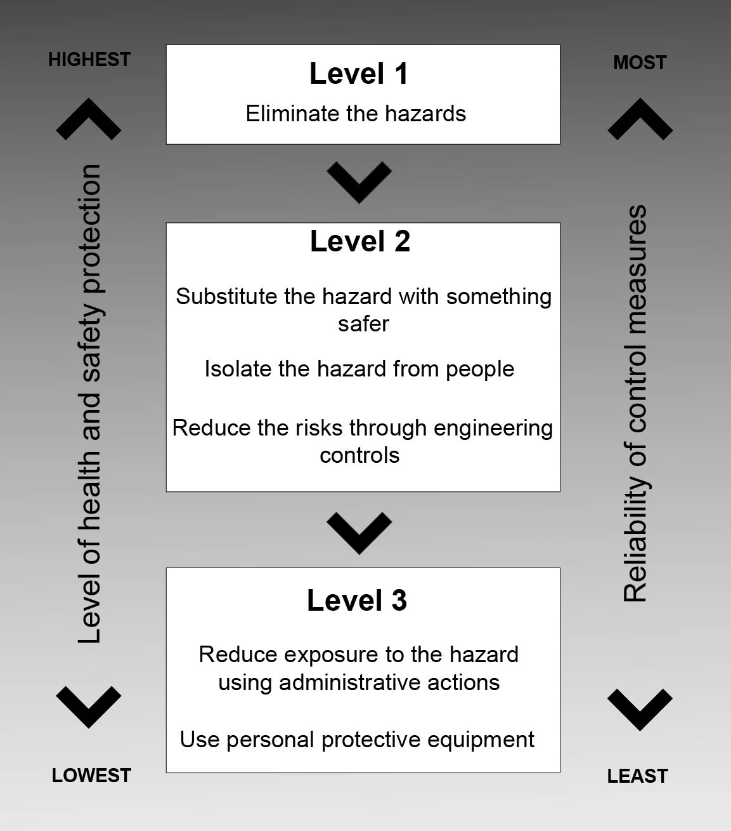
Figure 2: The hierarchy of risk control
You must always aim to eliminate a hazard, which is the most effective control. If this is not reasonably practicable, you must minimise the risk by working through the other alternatives in the hierarchy.

Level 1 control measures
The most effective control measure involves eliminating the hazard and associated risk. The best way to do this is by, firstly, not introducing the hazard into the workplace. For example, you can eliminate the risk of a fall from height by doing the work at ground level.
Eliminating hazards is often cheaper and more practical to achieve at the design or planning stage of a product, process or place used for work. In these early phases, there is greater scope to design out hazards or incorporate risk control measures that are compatible with the original design and functional requirements. For example, a noisy machine could be designed and built to produce as little noise as possible, which is more effective than providing workers with personal hearing protectors.
You can also eliminate risks by removing the hazard completely, for example, by removing trip hazards on the floor or disposing of unwanted chemicals.
It may not be possible to eliminate a hazard if doing so means that you cannot make the end product or deliver the service. If you cannot eliminate the hazard, then eliminate as many of the risks associated with the hazard as possible.

Level 2 control measures
If it is not reasonably practicable to eliminate the hazards and associated risks, you should minimise the risks using one or more of the following approaches:
- Substitute the hazard with something safer
For instance, replace solvent-based paints with water-based ones.
- Isolate the hazard from people
This involves physically separating the source of harm from people by distance or using barriers. For instance, install guard rails around exposed edges and holes in floors; use remote control systems to operate machinery; store chemicals in a fume cabinet.
- Use engineering controls
An engineering control is a control measure that is physical in nature, including a mechanical device or process. For instance, use mechanical devices such as trolleys or hoists to move heavy loads; place guards around moving parts of machinery; install residual current devices (electrical safety switches); set work rates on a production line to reduce fatigue.

Level 3 control measures
These control measures do not control the hazard at the source. They rely on human behaviour and supervision, and used on their own, tend to be least effective in minimising risks. Two approaches to reduce risk in this way are:
- Use administrative controls
Administrative controls are work methods or procedures that are designed to minimise exposure to a hazard. For instance, develop procedures on how to operate machinery safely, limit exposure time to a hazardous task, use signs to warn people of a hazard.
- Use personal protective equipment (PPE)
Examples of PPE include ear muffs, respirators, face masks, hard hats, gloves, aprons and protective eyewear. PPE limits exposure to the harmful effects of a hazard but only if workers wear and use the PPE correctly.
Administrative controls and PPE should only be used:
- when there are no other practical control measures available (as a last resort)
- as an interim measure until a more effective way of controlling the risk can be used
- to supplement higher level control measures (as a back-up).

Regulation 44-47: The WHS Regulations include specific requirements if PPE is to be used at the workplace, including that the equipment is:
- selected to minimise risk to health and safety
- suitable for the nature of the work and any hazard associated with the work
- a suitable size and fit and reasonably comfortable for the person wearing it
- maintained, repaired or replaced so it continues to minimise the risk
- used or worn by the worker, so far as is reasonably practicable.
A worker must, so far as reasonably able, wear the PPE in accordance with any information, training or reasonable instruction.

4.2 How to develop and implement control options
Information about suitable controls for many common hazards and risks can be obtained from:
- codes of practice and guidance material
- manufacturers and suppliers of plant, substances and equipment used in your workplace
- industry associations and unions.
In some cases, published information will provide guidance on the whole work process. In other cases, the guidance may relate to individual items of plant or how to safely use specific substances. You may use the recommended control options if they suit your situation and eliminate or minimise the risk.

Developing specific control measures
You may need to develop specific control measures if the available information is not relevant to the hazards and risks or circumstances at your workplace. This can be done by referring to the chain of events that were recorded during the risk assessment.
For each of the events in the sequence, ask: “What can be done to stop or change the event occurring?” An example of this approach is shown in Appendix A.
Working through the events in the sequence will give you ideas about all possible ways to eliminate or minimise the risk. There may be more than one solution for each of the events. The control option you choose should be:
- one that provides the highest level of protection for people and is the most reliable – that is, controls located towards the top of the hierarchy in Figure 2.
- available – that is, it can be purchased, made to suit or be put in place.
- suitable for the circumstance in your workplace – that is, it will work properly given the workplace conditions, work process and your workers.
Where the hazard or risk has the potential to cause death, serious injury or illness, more emphasis should be given to those controls that eliminate or reduce the level of harm, than those that reduce the likelihood of harm occurring.
Make sure that your chosen solution does not introduce new hazards.

Cost of control measures
All risks can be controlled and it is always possible to do something, such as stopping the activity or providing instructions to those exposed to the risk. There will normally be a number of different options between these two extremes. Cost (in terms of time and effort as well as money) is just one factor to consider when determining the best control option.
The cost of controlling a risk may be taken into account in determining what is reasonably practicable, but cannot be used as a reason for doing nothing.
The greater the likelihood of a hazard occurring and/or the greater the harm that would result if the hazard or risk did occur, the less weight should be given to the cost of controlling the hazard or risk.
If two control measures provide the same levels of protection and are equally reliable, you can adopt the least expensive option.
Cost cannot be used as a reason for adopting controls that rely exclusively on changing people’s behaviour or actions when there are more effective controls available that can change the risk through substitution, engineering or isolation.

Implementing controls
The control measures that you put into operation will usually require changes to the way work is carried out due to new or modified equipment or processes, new or different chemicals or new personal protective equipment. In these situations, it is usually necessary to support the control measures with:
- Work procedures
Develop a safe work procedure that describes the task, identifies the hazards and documents how the task is to be performed to minimise the risks.
- Training, instruction and information
Train your workers in the work procedure to ensure that they are able to perform the task safely. Training should require workers to demonstrate that they are competent in performing the task according to the procedure. It is insufficient to simply give a worker the procedure and ask them to acknowledge that they understand and are able to perform it. Training, instruction and information must be provided in a form that can be understood by all workers.
Information and instruction may also need to be provided to others who enter the workplace, such as customers or visitors.
- Supervision
The level of supervision required will depend on the level of risk and the experience of the workers involved. High levels of supervision are necessary where inexperienced workers are expected to follow new procedures or carry out difficult and critical tasks.

You may prepare a risk register that identifies the hazards, what action needs to be taken, who will be responsible for taking the action and by when. An example is provided at Appendix B.

4.3 How to ensure that controls remain effective
The following actions may help you monitor the control measures you have implemented and ensure that they remain effective:
- Accountability for health and safety – Accountability should be clearly allocated to ensure procedures are followed and maintained. Managers and supervisors should be provided with the authority and resources to implement and maintain control measures effectively.
- Maintenance of plant and equipment – This will involve regular inspection and testing, repair or replacement of damaged or worn plant and equipment. It includes checking that any control measures are suitable for the nature and duration of work, are set up and used correctly.
- Up-to-date training and competency – Control measures, particularly lower level controls, depend on all workers and supervisors having the appropriate competencies to do the job safely. Training should be provided to maintain competencies and to ensure new workers are capable of working safely.
- Up-to-date hazard information – Information about hazards, such as plant and substances, may be updated by manufacturers and suppliers and should be checked to make sure controls are still relevant. New technology may provide more effective solutions than were previously available. Changes to operating conditions or the way activities are carried out may also mean that control measures need to be updated.
- Regular review and consultation – Control measures are more effective where there is regular review of work procedures and consultation with your workers and their representatives.

5. STEP 4 – HOW TO REVIEW CONTROLS
The control measures that you put in place should be reviewed regularly to make sure they work as planned. Don’t wait until something goes wrong.
There are certain situations where you must review your control measures under the WHS Regulations and, if necessary, revise them. A review is required:
- when the control measure is not effective in controlling the risk
- before a change at the workplace that is likely to give rise to a new or different health and safety risk that the control measure may not effectively control
- if a new hazard or risk is identified
- if the results of consultation indicate that a review is necessary
- if a health and safety representative requests a review.
You may use the same methods as in the initial hazard identification step to check controls. Consult your workers and their health and safety representatives and consider the following questions:
- Are the control measures working effectively in both their design and operation?
- Have the control measures introduced new problems?
- Have all hazards been identified?
- Have new work methods, new equipment or chemicals made the job safer?
- Are safety procedures being followed?
- Has instruction and training provided to workers on how to work safely been successful?
- Are workers actively involved in identifying hazards and possible control measures? Are they openly raising health and safety concerns and reporting problems promptly?
- Is the frequency and severity of health and safety incidents reducing over time?
- If new legislation or new information becomes available, does it indicate current controls may no longer be the most effective?
If problems are found, go back through the risk management steps, review your information and make further decisions about risk control. Priority for review should be based on the seriousness of the risk. Control measures for serious risks should be reviewed more frequently.
Quality assurance processes may be used if you design, manufacture or supply products used for work to check that the product effectively minimises health and safety risks. Obtain feedback from users of the product to determine whether any improvements can be made to make it safer.
Case studies demonstrating how to manage work health and safety risks in consultation with workers are at Appendix C.

6. KEEPING RECORDS
Keeping records of the risk management process demonstrates potential compliance with the WHS Act and Regulations. It also helps when undertaking subsequent risk assessments.
Keeping records of the risk management process has the following benefits. It:
- allows you to demonstrate how decisions about controlling risks were made
- assists in targeting training at key hazards
- provides a basis for preparing safe work procedures
- allows you to more easily review risks following any changes to legislation or business activities
- demonstrates to others (regulators, investors, shareholders, customers) that work health and safety risks are being managed.
The detail and extent of recording will depend on the size of your workplace and the potential for major work health and safety issues. It is useful to keep information on:
- the identified hazards, assessed risks and chosen control measures (including any hazard checklists, worksheets and assessment tools used in working through the risk management process)
- how and when the control measures were implemented, monitored and reviewed
- who you consulted with
- relevant training records
- any plans for changes.
There are specific record-keeping requirements in the WHS Regulations for some hazards, such as hazardous chemicals. If such hazards have been identified at your workplace, you must keep the relevant records for the time specified.
You should ensure that everyone in your workplace is aware of record-keeping requirements, including which records are accessible and where they are kept.

APPENDIX A – Assessing how things go wrong

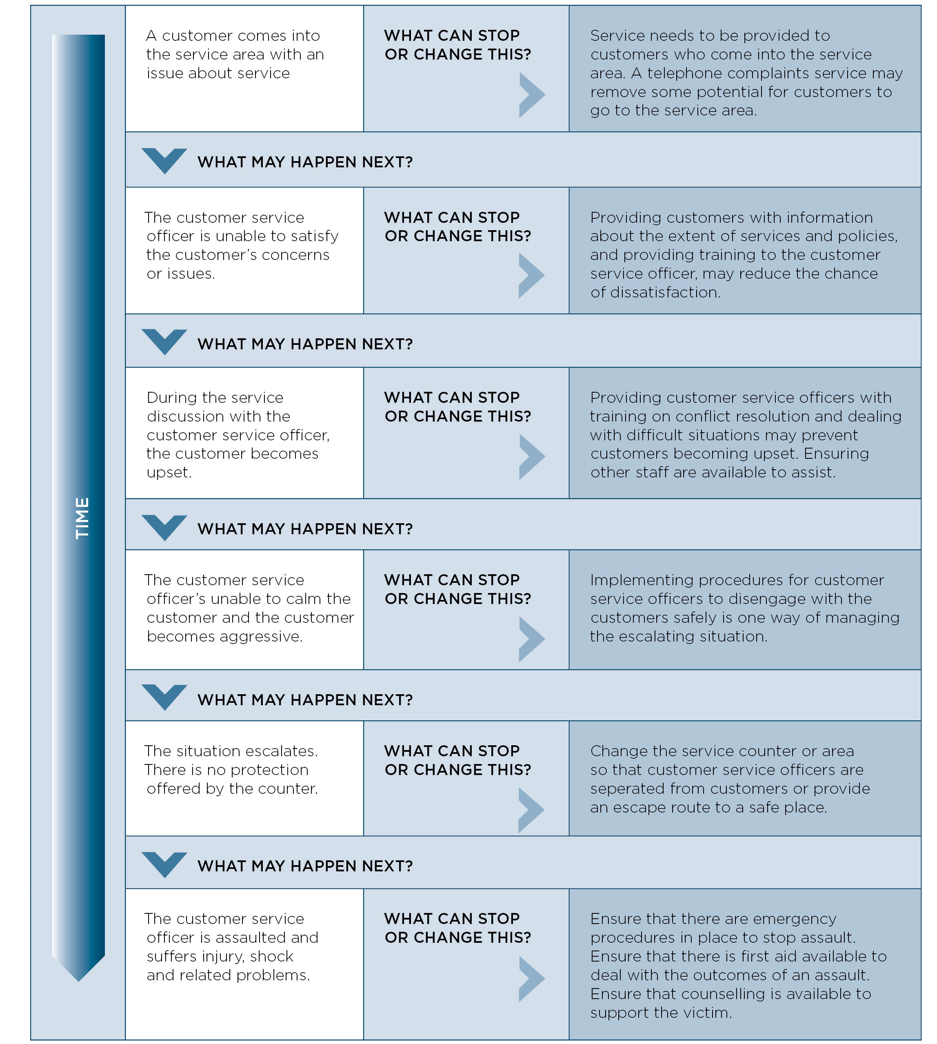

APPENDIX B – Risk REGISTER
Location: |  |  |  |  | Date:
Hazard | What is the harm that the hazard could cause? | What is the likelihood that the harm would occur? | What is the level of risk? | How effective are the current controls? | What further controls are required? | How will the controls be implemented?
 |  |  |  |  |  | Action by | Due Date | When Completed

APPENDIX C – case studies

Case Study 1:
Two years ago, the Burbs Municipal Council implemented a number of written health and safety procedures used to train workers how to carry out particular tasks safely. As these procedures had not been reviewed since their implementation, the Safety Manager (SM) implemented a new approach to not only review these procedures but also promote health and safety more widely across the organisation by encouraging staff involvement and co-operation.

To do this, the SM established and facilitated safety workshops each Friday for an hour where a team would review a particular task and its procedures to identify hazards, assess risks and options to control these. The team included management, council workers, the respective health and safety representative and any contractors engaged to carry out the work.

The SM’s approach was to facilitate the workshops but then hand this role over to the relevant team supervisor, who would then facilitate future meetings to review other tasks conducted by the workers. The written health and safety procedures were not used in the workshops as the SM wanted to learn more about the hazards, risks and controls from the workers without prompting. However, any changes discussed and agreed during the meeting would be included in the revised written safety procedures.

The first safety workshop was conducted in the Parks and Gardens Branch and involved management, workers, their health and safety representatives and a representative from the maintenance shop that supplied the Parks and Gardens Branch with a variety of vehicles and equipment.

Safety workshop – 20 August 2010
Team | Parks and Gardens Branch
Task being reviewed | Cleaning of the toilets in the council’s parks
Description of task | Undertaken by two workers each Monday morning in a Council truck who would clean the eight toilet blocks across the municipality
What does the task involve? | At the depot:  - Load the truck with the compressor and pressure hose along with cleaning chemicals and materials
At the park:
- Open toilet block
- Clean toilets
- Unload compressor and pressure hose, place them in toilet block and attach to tap, turn on compressor and hose walls and floors
- Put compressor and pressure hose along with cleaning gear back on truck
- Dry out toilet block floor by sweeping
- Leave park and go to next one

In order to gather advice and information from the team, the SM asked the following questions and shared the responses by writing them on a whiteboard or butchers paper:

 | What hazards are encountered when doing the task? | What risks do these pose to the health and safety? | How are these hazards and risks controlled?
Plant | - Truck  - Compressor and pressure hose | - Truck - faulty truck could cause accident and cause injuries to workers and others  - Compressor and pressure hose - faulty fuel line in compressor could cause burns and injuries through fire or explosion | - Truck and compressor have maintenance schedule  - Checklist for visual inspection for all plant before it leaves depot  - Reporting and tagging system for all defective plant
Manual Handling | - Loading and unloading the compressor  - Carrying the compressor to and from the toilet block | - Heavy load can cause sprains, strains, back injuries or fractures and cuts if dropped on foot | - Compressor has handles fitted to assist in lifting and carrying  - Two persons required to lift and carry compressor  - Only workers who have been trained able to lift and carry compressor
Chemical | - Cleaning agents used to clean toilets and basins | - Skin irritation, rashes and illness caused by exposure to chemicals and their vapours in confined space | - Only non-toxic cleaning agents used  - Gloves provided to avoid skin contact
Noise | - Operating the compressor in a closed space with hard surfaces | - Hearing loss from prolonged exposure to the noise levels generated by the compressor | - Hearing protection provided for wearing when hosing out the toilet block
Slips, trips and falls | - Wet floor when hosing out the toilet block. | - Cuts and bruises caused by slipping on wet surface | - Safety boots were provided that had slip-resistant soles

Many staff present at the workshop indicated it was a waste of time as everything discussed was covered by the health and safety procedure, which they knew backwards. The SM acknowledged this concern but then asked the team whether the way the task was being conducted could be changed to improve health and safety.
One staff member raised concerns about lugging the compressor around 16 times every Monday morning and that doing this tempted them to call in sick. The SM was curious about this and asked why it was necessary to take the compressor off the truck and place it in the toilet. The workers explained that the length of the hose on the pressure spray was short and could only be operated with the compressor in the toilet block.

After hearing this, the representative from the maintenance shop who supplied the compressor mentioned that he could attach a 10-metre hose to the compressor, which would mean the compressor would not have to be taken off the truck. The team agreed this was a good idea and would eliminate the manual handling risks associated with lifting and carrying the compressor. The SM asked what other impacts this would have. The team agreed this would also reduce the noise as the compressor would now be outside the toilet block, but that there could be new risks associated with handling and storing a 10-metre long hose. The team agreed to trial the new hose. It was then installed with a hose handling system.

Following the workshop, the SM asked the supervisor to ensure the modifications were made within two weeks and to revise the procedures and have them checked by the health and safety representative and workers.

Case Study 2:
Jane Smith has been working at the local grocery store for the last 12 months. She had recently taken on a new role as the bakery supervisor and was eager to review the work activities and safety procedures. In preparing for the review, Jane considered how she would conduct the review and who she should speak with.

As a first step, Jane identified the different activities and tasks that were carried out by the workers. These included:
- preparing a number of different products such as bread, cakes, slices and doughnuts
- cleaning items used in product preparation
- general housekeeping.

The next step was to analyse what was involved with each activity. Jane spent three mornings that week with the four bakers who worked in the bakery department. She talked to them about the work activities and what they thought could be changed to improve the safety of the workplace. One of the bakers had been working in the store for over 10 years, whilst another had been working for over 25 years. The other two bakers were apprentices and had only been working with the store for around six months.

From these discussions, Jane identified a number of key tasks the bakers carried out every day when preparing the baked products:
- moving the ingredients from their storage locations to the area of use
- mixing the ingredients together using specialised mixers
- transferring the mixture to the container for baking
- putting them in the oven and removing them from the oven
- slicing and decorating
- packaging the products.

During an inspection of the bakery, Jane and the bakers identified a number of hazards, including the following:
- the doughnut mixer was not guarded and the mixing bowl could be accessed when the machine was operating
- the concrete floors were slippery in the mixing room and flour was spilt where the bakers walked
- low lighting in the food preparation area
- there was narrow access and restricted movement in the storage area where the flour bags were kept.

Jane and the bakers discussed the risks associated with each of the hazards and what could be done to control these risks. In relation to the unguarded mixer, one of the bakers suggested purchasing or hiring a new model with an interlocking guard. After considering the ideas of the bakers, Jane completed the following risk register:

XYZ Grocery Store Pty Ltd
Work area: Bakery department
Form completed by: Jane Smith (Bakery supervisor)
Date form completed: 05/11/2010
Hazard identification
Hazard: Doughnut mixer not guarded and mixing bowl can be accessed when machine is operating.

Risk Assessment
What is the harm the hazard could cause: The person operating the mixer could be injured by the moving parts if their hand slipped in while the machine was operating. Hand could be cut or could even lose a finger.
What is the likelihood of this happening: This machine is used several times a day. Two of the workers have not been working in the bakery for a long time and are not very experienced in using the equipment.
Persons at risk: All four bakers who operate the machine.
Existing control measure: Staff follow policy and operating instructions to use the mixer safely – not very effective because it relies on staff keeping hands away from the dangerous parts.
Consequence: Serious injuries
Likelihood: Very likely
Outcome: High risk - the mixer must not be used again until the risk has been controlled.
Control measures
Possible control options:
- Elimination – Eliminating the use of the mixer completely will mean the business cannot continue to sell baked products as the dough cannot be mixed. Business revenue will suffer.
- Substitution – Use of the mixer could be substituted by hand mixing the dough. One day’s production will be lost in the change over. This method can only be considered an interim option as it is not sustainable for more than a day or two with present staff. However, part time staff could be hired to mix the dough. Business income would be reduced and impact on revenue. Alternatively, the mixer could be replaced by purchasing a new, safer machine with a built-in guard.
- Engineering – The mixer could be modified by adding an interlocking guard. A mixer could be hired for the period the old mixer is in for repairs. One day’s production will be lost in this option. The modifications are estimated to cost $1600. Other costs included are: one day lost in production plus hire of substitute machine for approximately 10 days and transport. Estimated cost is less than $6000.
- Administrative or PPE – All staff told to keep hands away from the mixing bowl while it is in use. Only the more experienced bakers are to operate the mixer.

Preferred control option: Purchase a new mixer, which would not cost much more than having the old one modified. Mixing to be done by hand while waiting for replacement mixer to arrive. The costs involved are outweighed by worker safety and this option eliminates the risk of injury.
Implementation
Associated activities | Resources required | Person(s) responsible | Sign off and date
New mixer to be purchased. Mixing to be done by hand while waiting for new mixer. May require staff working more hours | Less than $6000 | Jane Smith – Bakery supervisor | J Smith 9/11/10
Develop new work procedures  Provide training to bakers on using the new machine | 3 hours | Jane Smith – Bakery supervisor | J Smith 20/12/10

Review
Scheduled review date: 31 January 2011
Are the control measures in place?
- Yes – the new machine has an interlocking guard and bakers have been provided with training on how to use the machine in accordance with the manufacturer’s instructions.
Are the controls eliminating or minimising the risk?
- Yes – the interlocking guard prevents people from putting their hand in the mixing bowl.
Are there any new problems with the risk?
- No.

Jane repeated these steps for each hazard that she identified. The review of the work activities and the implemented control measures improved the safety in the bakery department at the grocery store.

