Australian Capital Territory

Planning and Development (Technical Amendment—District of Molonglo Valley) Plan Variation 2012 (No 1)

Notifiable instrument NI2012—162
Technical Amendment No 2012—16
made under the
Planning and Development Act 2007, section 89 (Making technical amendments) s87 (e) (a variation required to bring the territory plan into line with the national capital plan)

This plan variation commences on the day after it is notified.

Variation No 2012—16 to the Territory Plan has been approved by the Planning and Land Authority.

Variation to the Territory Plan
The Territory Plan map is varied as indicated in Annexure A to bring the zone into line with the National Capital Plan.

Ben Ponton
Delegate of ACT Planning and Land Authority
Date: 25 March 2012

THIS IS PAGE ONE OF ANNEXURE A
TO NOTIFIABLE INSTRUMENT NI2012–162

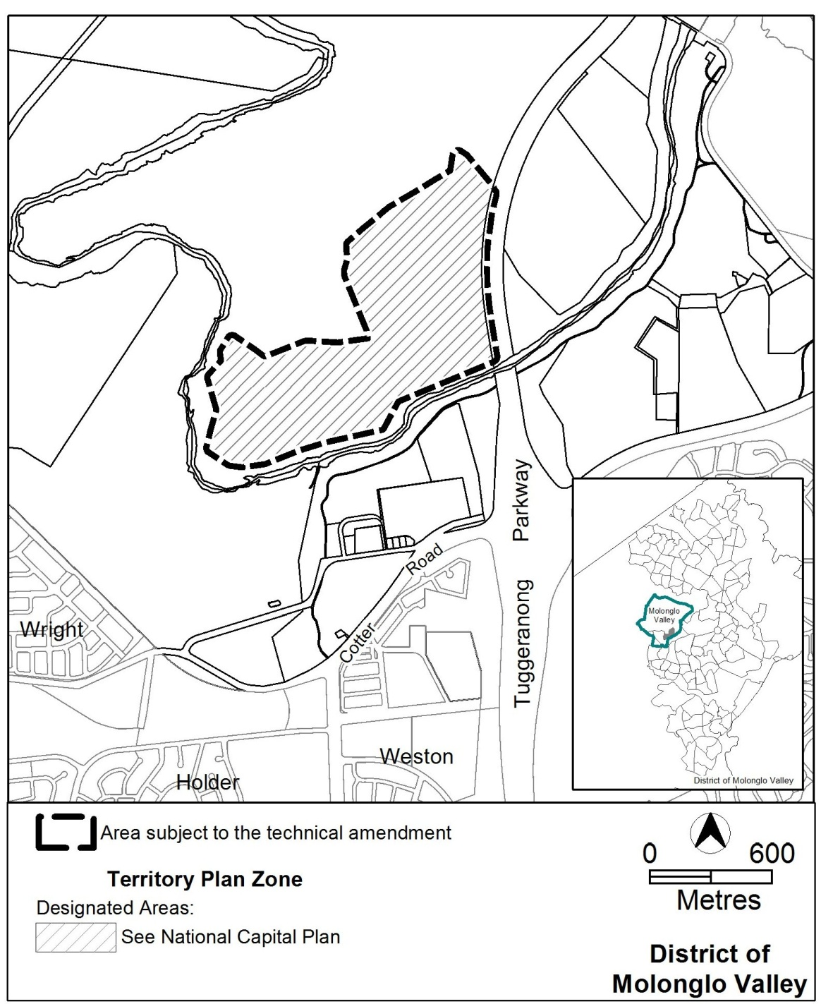

Ben Ponton
Delegate of ACT Planning and Land Authority
Date: 25 March 2012

