Australian Capital Territory

Planning and Development (Plan Variation No 313) Notice 2012*
Notifiable Instrument NI2012-287
made under the
Planning and Development Act 2007, section 76(3)

1 Name of instrument
This instrument is the Planning and Development (Plan Variation No 313) Notice 2012.

2 Plan Variation 313
On 29 May 2012, the Minister for the Environment and Sustainable Development approved a draft of the attached plan variation to the Territory Plan (Annexure A) under s 76 (3).

Ben Ponton
Delegate of the Planning and Land Authority
3 June 2012

Planning and Development Act 2007

Variation to the
Territory Plan 313

Calvary Hospital Car Parking
Bruce section 110 block 1 (part)
- Change of zoning from non urban NUZ3 hills, ridges and buffer zone to community facility zone

Table of Contents
1. EXPLANATORY STATEMENT 2
1.1 Background 2
1.2 Summary of the proposal 2
1.3 The National Capital Plan 2
1.4 Site Description 3
1.5 Current Territory Plan provisions 4
1.6 Changes to the Territory Plan 5
1.7 Consultation on the exhibited draft variation 5
1.8 Revisions to the exhibited draft variation 5
2. VARIATION 6
2.1 Variation to the Territory Plan Map 6

- EXPLANATORY STATEMENT
  - Background

In 2004 Calvary Health Care ACT commenced formal assessments of both existing and future requirements for car parking facilities at the Calvary Hospital. It was found that the demand for parking exceeded supply and more spaces would be required to accommodate future development of the site. To address this problem, a number of options were proposed which included off-site locations for provision of car parking facilities.

Calvary Health Care ACT subsequently prepared a planning study to consider the merits of a proposed variation to the Territory Plan to rezone a small portion of adjoining land on the northern boundary of the Hospital. It is estimated that this area can accommodate approximately 100 car spaces.

The site to be rezoned comprises an area of approximately 4,335m² and is currently zoned non urban NUZ3 hills, ridges and buffer. A car park is more appropriately located in the community facility zone, hence the rezoning.

The site is currently unleased Territory land. The ACT Government has agreed to the direct sale of this land to Calvary Health Care Pty Ltd, subject to the outcome of the draft variation.

  - Summary of the proposal

The variation changes the zone of the land from the non urban NUZ3 hills, ridges and buffer to the CFZ community facility zone to recognise the role of the site for car parking purposes for Calvary Hospital and other on-site uses.

  - The National Capital Plan

The Australian Capital Territory (Planning and Land Management) Act 1988 established the National Capital Authority (NCA) with two of its functions being to prepare and administer a National Capital Plan (NCP) and to keep the NCP under constant review and to propose amendments to it when necessary.
The NCP, which was published in the Commonwealth Gazette on 21 January 1990 is required to ensure that Canberra and the Territory are planned and developed in accordance with their national significance. The Planning and Land Management Act 1988 also required that the Territory Plan is not inconsistent with the NCP.

  - Site Description

The site to be rezoned is located at Bruce section 110 block 1 (part) (Figure 1.1).

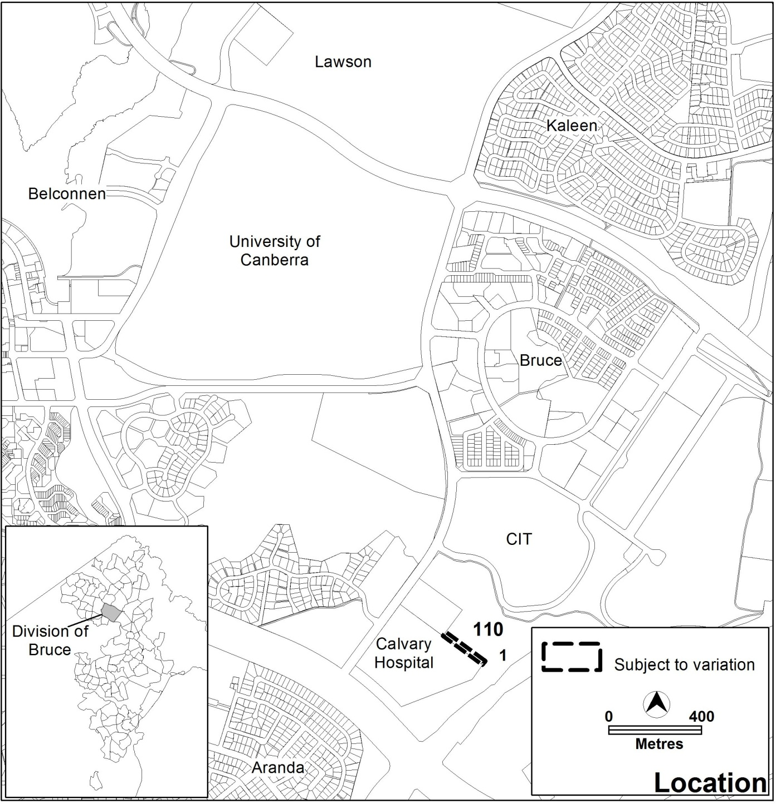
Figure 1.1 Site location

  - Current Territory Plan provisions
The Territory Plan Map zones for the area that are subject to this variation is shown in Figure 1.2.
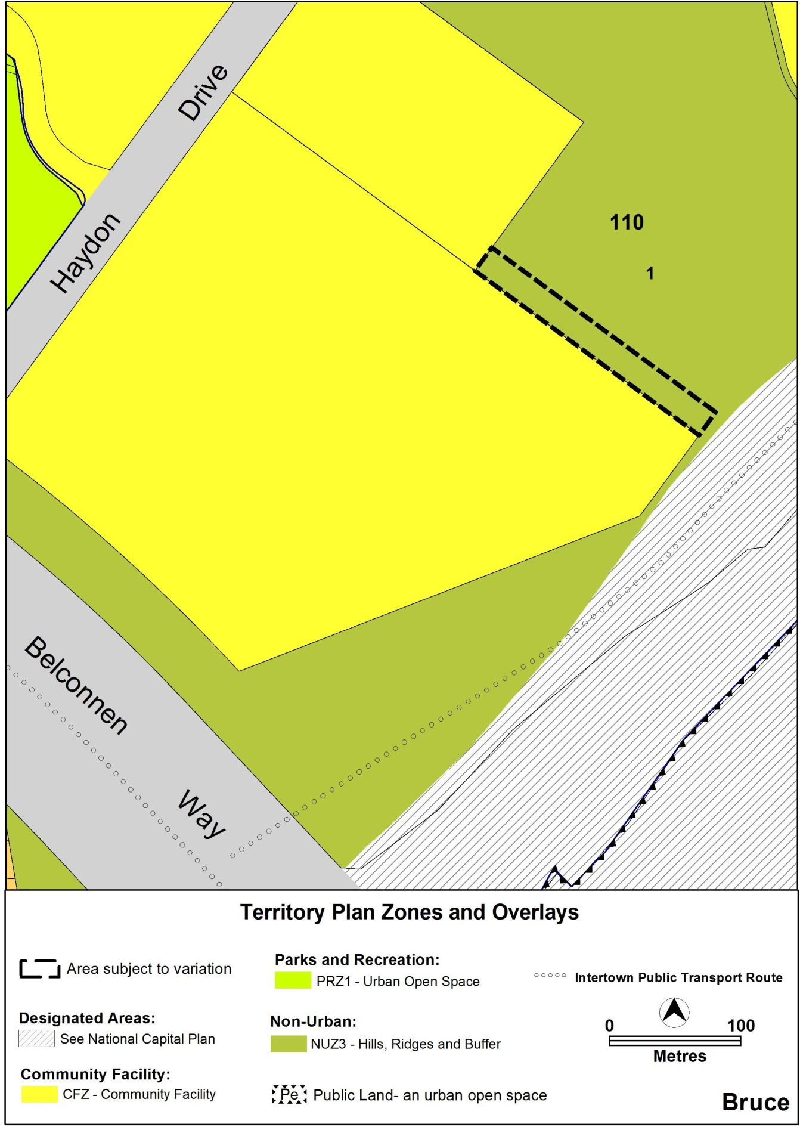

Figure 1.2 Territory Plan Zones Map

  - Changes to the Territory Plan
The changes to the Territory Plan Map are indicated in Figure 2.1 at Part 2 of this document and consist of removing Bruce section 110, block 1 (part) from the non-urban NUZ3 hills, ridges and buffer zone and including it in the community facility zone.

  - Consultation on the exhibited draft variation
Variation 313 was released for public comment on 2 March 2012 and a consultation notice under section 63 of the Planning and Development Act was placed on the ACT Legislation Register on 1 March 2012 and a notice published in The Canberra Times on 3 March 2012 and in The Chronicle on 6 March 2012.
Written comments were invited by 16 April 2012 and a total of one written submission was received from the public as a result of the consultation process.

Main issues raised by submitters relate to:
- Overwhelming support (evidenced by the attached petition with over 1,200 signatures) for the proposal to provide more car parking at
Calvary Hospital

- Protection of adjoining bushland

These issues were noted in the ‘Report on Consultation’ that was prepared by ESDD under s 69 (2) of the P&D Act in conjunction with this variation document submitted to the Minister.
  - Revisions to the exhibited draft variation
After analysis of the comments received during the draft variation consultation period, no changes were made to the exhibited draft variation.

- VARIATION
  - Variation to the Territory Plan Map
The Territory Plan map for Bruce, section 110 block 1 (part) is varied for the area subject to the variation as shown in Figure 2.1:
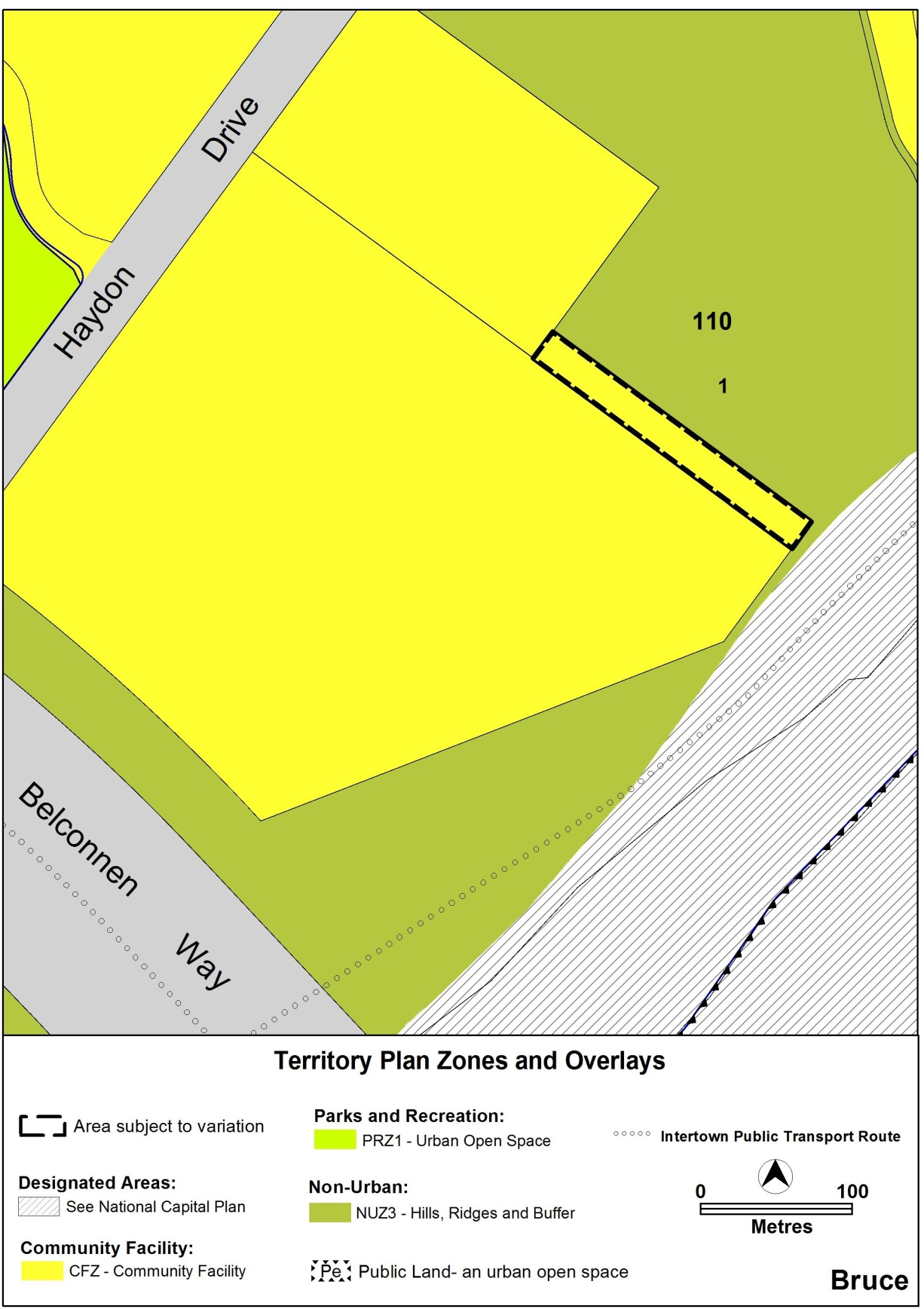

Figure 2.1 Proposed Territory Plan Zones Map

Interpretation service
