Australian Capital Territory

Planning and Development (Plan Variation No 312) Notice 2012
Notifiable Instrument NI2012-366
made under the
Planning and Development Act 2007, section 76(3)

1 Name of instrument
This instrument is the Planning and Development
(Plan Variation No 312) Notice 2012.

2 Plan Variation 312
On 6 July 2012, the Minister for Environment and Sustainable Development approved the attached variation to the Territory Plan under s 76 (3).

Ben Ponton
Delegate of the Planning and Land Authority
11 July 2012

Planning and Development Act 2007

Variation to the
Territory Plan
312

Hume West Industrial Estate
Hume section 30 blocks 1 to 8
Change of zoning from IZ1 general industrial zone, to IZ2 industrial mixed use zone

Final variation prepared under s76 of the
Planning and Development Act 2007

This page is intentionally blank.

Contents
1. EXPLANATORY STATEMENT 1
1.1 Background 1
1.2 Summary of the Proposal 1
1.3 The National Capital Plan 1
1.4 Site Description 2
1.5 Current Territory Plan Provisions 3
1.6 Changes to the Territory Plan 4
1.7 Consultation on the Draft Variation 4
1.8 Revisions to the Draft Variation Recommended to the Minister 4
2. VARIATION 5
2.1 Variation to the Territory Plan Map 5

This page is intentionally blank.

- EXPLANATORY STATEMENT
  - Background
The Estate Development Plan development application was approved in 2010 for the Hume West Industrial Estate. The estate development plan sets out the subdivision layout for a total of 35 blocks, with a mix of small, medium and large blocks ranging in size from 1264m² to 3.2 hectares. The site is currently zoned as IZ1 general industrial zone. The location for a potential industrial service centre (hub) within the estate was identified to meet the convenience retailing, community use and service needs of the local workforce, with the potential to include future retail uses, cafes and small scale offices. These uses are generally not permitted in the industrial IZ1 general industrial zone.

The Land Development Agency (LDA) of the ACT Government Economic Development Directorate (EDD) prepared a planning study to consider the merits of a proposed variation to the Territory Plan to rezone a small portion of the Hume West Industrial Estate. The rezoning comprises eight blocks from IZ1 general industrial to IZ2 mixed use industrial to accommodate industry-associated retailing, services and other commercial uses to support general industrial uses at the south-western end of Hume without jeopardising the overall supply of industrial land.

  - Summary of the Proposal
The variation changes the zone of the land from the IZ1 general industrial zone to IZ2 mixed use industrial zone to accommodate industry-associated retailing, services and other commercial uses to support the general industrial uses.

  - The National Capital Plan
The Australian Capital Territory (Planning and Land Management) Act 1988 established the National Capital Authority (NCA) with two of its functions being to prepare and administer a National Capital Plan (NCP) and to keep the NCP under constant review and to propose amendments to it when necessary.

The NCP, which was published in the Commonwealth Gazette on 21 January 1990 is required to ensure that Canberra and the Territory are planned and developed in accordance with their national significance. The Planning and Land Management Act 1988 also required that the Territory Plan is not inconsistent with the NCP.

In accordance with section 10 of the Australian Capital Territory (Planning and Land Management) Act 1988, the National Capital Plan defines the planning principles and policies for Canberra and the Territory, for giving effect to the object of the NCP and sets out the general policies to be implemented throughout the Territory, including the range and nature of permitted land uses.

It also sets out the detailed conditions of planning, design and development for areas that have special significance to the National Capital known as designated areas and identifies special requirements for the development of some other areas.

  - Site Description
The site for rezoning is located at Tralee Street, Hume West Industrial Estate, Hume, section 30, comprising blocks 1 to 8 (Figure 1). Hume West Industrial Estate is located at the south-western end of the existing Hume industrial area, between the Monaro Highway and the NSW/ACT border.

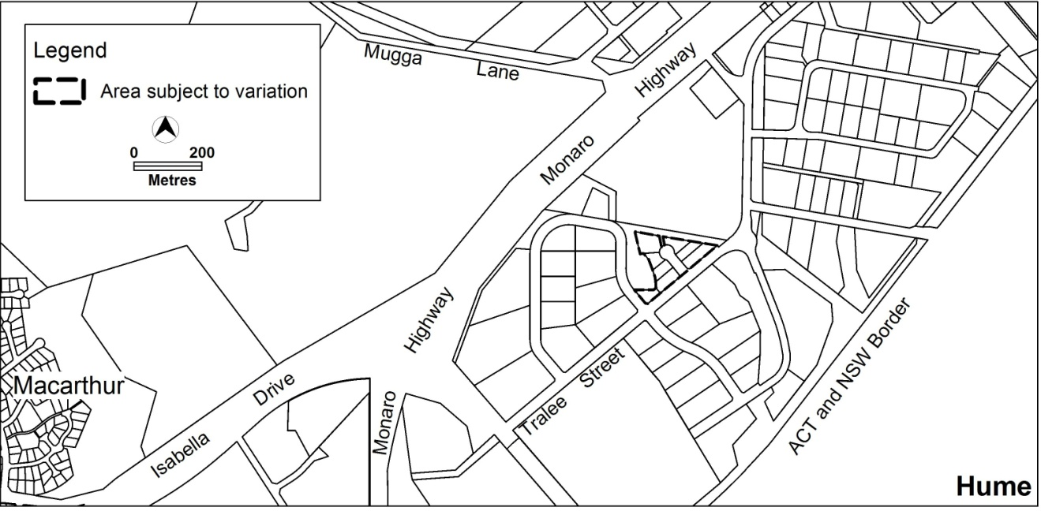

Figure 1 Site Plan

  - Current Territory Plan Provisions
The Territory Plan Map zone for the area subject to this variation is shown in Figure 2

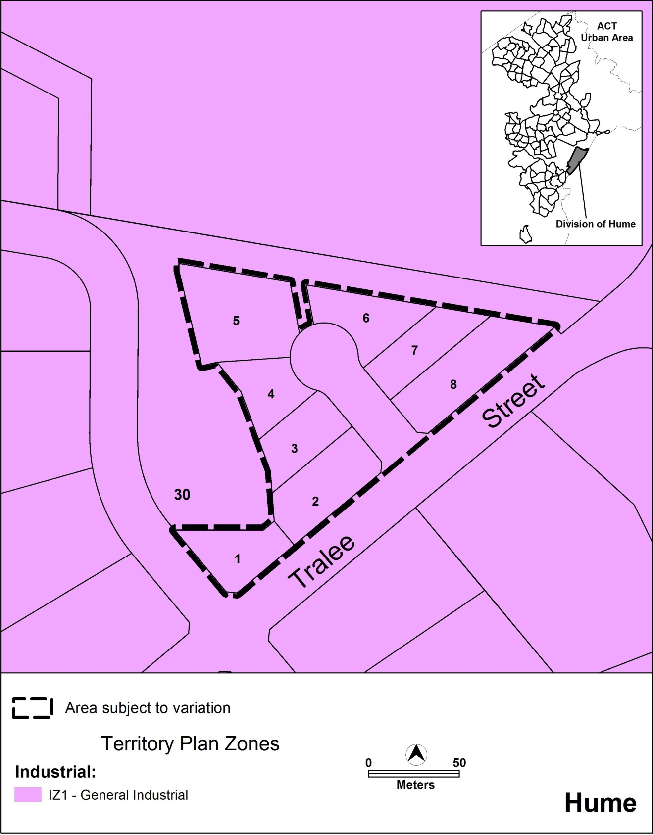

Figure 2 Territory Plan Zones Map

  - Changes to the Territory Plan
The changes to the Territory Plan Map are detailed in section 2 of this document.

  - Consultation on the Draft Variation
Draft variation 312 was released for public comment between 9 March 2012 and 23 April 2012. A consultation notice under section 63 of the Planning and Development Act 2007 was placed on the ACT Legislation Register on 8 March 2012. A consultation notice was published in the Canberra Times on 10 March 2012 and in the Chronicle on 13 March 2012.
Only one written submission (late) was received from the public as a result of the consultation process. The submission was from Queanbeyan City Council and raised the following issues:

- Queanbeyan City Council not being advised of the draft variation
- the draft variation is unnecessary / premature
- insufficient consideration of cross-border issues
- insufficient consideration of the Council’s Residential and Economic Strategy 2031
- the rezoning being inconsistent with the hierarchy of commercial centres
- the proposed rezoning will set a precedent
The above issues were considered and are detailed in a report on consultation. No changes were made as a result of consultation. The outcomes of consultation were considered by the Minister responsible for planning prior to approval of this variation.
  - Revisions to the Draft Variation Recommended to the Minister
No changes were made to the draft variation recommended to the Minister.

- VARIATION
  - Variation to the Territory Plan Map
The Territory Plan map is varied as indicated in Figure 3.

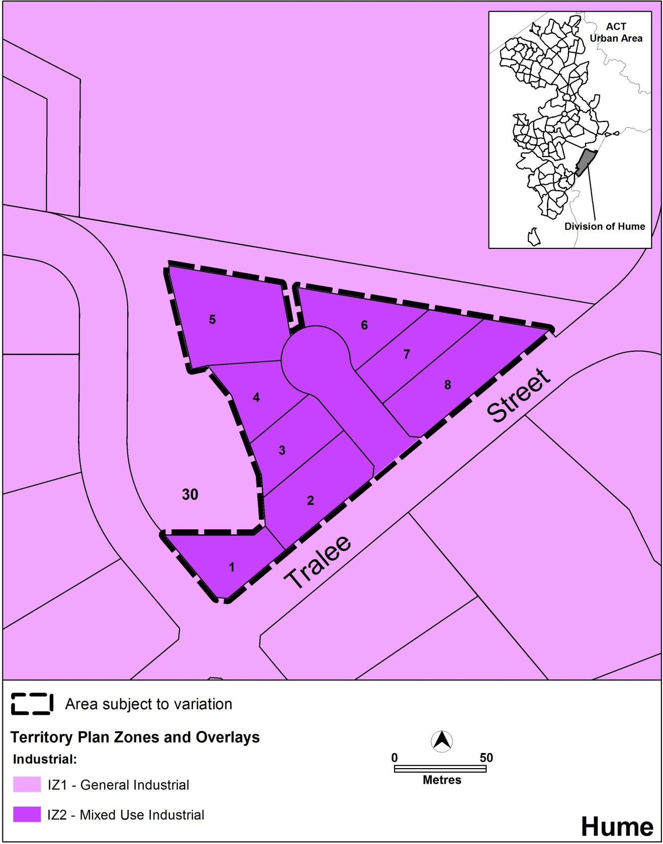

Figure 3 Territory Plan Map

Interpretation service
