Australian Capital Territory
Planning and Development (Draft Variation No 311) Consultation Notice 2012

Dickson Group Centre – Introduction of a Precinct Code and Zone Changes
Notifiable instrument NI2012—390
made under the
Planning and Development Act 2007, section 63 (Public consultation - notification) and section 64 (Public consultation – notice of interim effect etc)

Draft Variation Number 311 to the Territory Plan (see Annexure A) Dickson Group Centre proposes to change the development controls at Dickson shopping centre and to rezone part of a car park next to the Tradies Club in Dickson for use as a park. The revised provisions will be included in a stand-alone precinct code for the centre and some consequential changes to provisions in the group centres development code are proposed to remove potential confusion on what provision applies.
The draft variation is available online at www.act.gov.au/draftvariations until the closing date for written comments and background documents are available at www.act.gov.au/dickson.
Printed copies of the draft variation (this document) and background documents are available for inspection and purchase at the Environment and Sustainable Development Customer Service Centre 16 Challis Street Dickson weekdays (except public holidays) between 8:30am and 4:30pm. Please call 6207 1923 to arrange a copy for purchase.
Written comments from the public are invited by COB Monday 10 September 2012.
Comments should include reference to the draft variation, your name and contact details and be addressed to Territory Plan Variation Unit.
Comments can be:
- emailed to terrplan@act.gov.au
- mailed to Territory Plan Comments, GPO Box 1908, Canberra, ACT 2601
- delivered to ESDD’s Customer Service Centre at the above address
Comments received will be made available 10 working days after the closing date. The comments will be available for no less than 15 working days at ESDD’s customer service centre in Dickson and on ESDD’s website.
Comments made available will include personal contact details unless excluded under section 411 or 412 of the Planning and Development Act 2007 (the Act). A request for exclusion under this section must be in writing, clearly identifying what you are seeking to exclude and how the request satisfies the exclusion criteria.
Effect of the draft variation
Section 65 of the Act applies to the draft variation. This means that, in addition to the Territory Plan, the provisions of the draft variation apply to development applications lodged on or after 27 July 2012. The draft variation is part of the Territory Plan for a period of up to one year from 27 July 2012 unless the draft variation is commenced, is withdrawn or rejected by the Legislative Assembly. During this period, the ACT Government must not do or approve anything that would be inconsistent with the Territory Plan.

Ben Ponton
Delegate of the ACT Planning and Land Authority

25 July 2012

Planning and Development Act 2007

Draft
Variation to the
Territory Plan
311

Dickson Group Centre –Introduction of a Precinct Code and Zone Changes

July 2012

Draft variation for public consultation prepared under s60 of the Planning and Development Act 2007

This page is intentionally blank.

Contents

1. INTRODUCTION 1
1.1 Summary of the Proposal 1
1.2 Outline of the process 1
1.3 This document 2
1.4 Public Consultation 2
1.5 Further Information 2
2. EXPLANATORY STATEMENT 3
2.1 Background 3
2.2 Site Description 4
2.3 Current Territory Plan Provisions 5
2.4 Proposed Changes 6
2.4.1 Proposed Changes to the Territory Plan Map 6
2.4.2 Proposed Changes to Territory Plan 6
2.5 Reasons for the Proposed Draft Variation 6
2.6 Planning Context 7
2.6.1 National Capital Plan 7
2.6.2 Territory Plan 7
2.6.3 Strategic Planning Context 8
2.7 Interim Effect 10
2.8 Consultation with Government Agencies 10
3. DRAFT VARIATION 15
3.1 Variation to the Territory Plan Map 15
3.2 Variation to the Territory Plan 16

Figures
Figure 1 Dickson Group Centre 4
Figure 2 Existing zones for Dickson Group Centre 5
Figure 3 Proposed zones for Dickson Group Centre 15

This page is intentionally blank.

- INTRODUCTION
  - Summary of the Proposal
The draft variation proposes to implement the findings of the Dickson centre master plan, which was prepared by the ACT Government in consultation with the Canberra community from mid 2009 to late 2010. The ACT Government endorsed the plan in May 2011 and work began on changes to the Territory Plan to achieve the main findings of the master plan. Draft Variation 311 (DV311) Dickson Group Centre establishes a precinct code for the group centre to guide future development in a manner consistent with the master plan and propose rezoning of part of the carpark adjoining The Tradies club for use as a park. Minor resultant changes are proposed to the group centres development code.
  - Outline of the process
The Commonwealth’s Australian Capital Territory (Planning and Land Management) Act 1988 allows for the Legislative Assembly to make laws to establish a Territory Planning Authority and for that Authority to prepare and administer a Territory Plan. The Planning and Development Act 2007 (the Act) establishes the ACT Planning and Land Authority (ACTPLA) as the Authority which prepares and administers the Territory Plan, including continually reviewing and proposing amendments as necessary. The functions of ACTPLA are administered by the Environment and Sustainable Development Directorate (ESDD).
The Territory Plan is comprised of the written statement and a map. The written statement contains a number of parts, namely governance; strategic directions; zones (including objectives and development tables and zone or centre development codes); precinct codes; general codes; overlays; definitions; structure plans, concept plans and development codes for future urban areas.
The Territory Plan Map graphically represents the applicable land use zones (under the categories of residential, commercial, industrial, community facility, urban parks and recreation, transport and services and non urban), precincts and overlays. The zone, precinct and overlay requirements are detailed in the volumes of the Territory Plan.
Draft variations to the Territory Plan are prepared in accordance with the Act. Following the release of the draft variation under section 63 of the Act, submissions from the public are invited. At the conclusion of the consultation period the ESDD submits a report on consultation and a recommended final variation to the Minister responsible for planning for approval. The Minister has the discretion to determine if referral to the Legislative Assembly standing committee responsible for planning is warranted prior to approval, depending on the nature and significance of the proposal. If the draft variation is referred to the committee by the Minister or otherwise, the Minister must consider the findings of the Committee before deciding whether to approve the draft variation. If the Minister approves the variation, the variation and associated documents will be tabled in the Legislative Assembly. Unless disallowed by the Legislative Assembly within five sitting days, the variation commences on a day nominated by the Minister.
  - This document
This document contains the background information in relation to the proposed variation. It comprises the following parts
Part 1 - This Introduction
Part 2 - An Explanatory Statement, which gives reasons for the proposed variation and describes its effect
Part 3 - The Draft Variation, which details the precise changes to the Territory Plan that are proposed

  - Public Consultation
Written comments from the public are invited by COB Monday 10 September 2012.
Comments should include reference to the draft variation, your name and contact details, and be addressed to the Territory Plan Variation Unit.
Comments can be:
- emailed to terrplan@act.gov.au
- mailed to Territory Plan Comments, GPO Box 1908, Canberra, ACT 2601
- delivered to ESDD’s Customer Service Centre 16 Challis Street, Dickson weekdays (except public holidays) between 8:30am and 4:30pm Please call 6207 1923 to arrange a copy for purchase

Comments received will be made available 10 working days after the closing date. The comments will be available for no less than 15 working days at ESDD’s customer service centre in Dickson and on ESDD’s website.
Comments made available will include personal contact details unless excluded under section 411 or 412 of the Planning and Development Act 2007. A request for exclusion under this section must be in writing, clearly identifying what you are seeking to exclude and how the request satisfies the exclusion criteria.

  - Further Information
The draft variation, and background documents will be available online at www.act.gov.au/draftvariations.
Printed copies of the draft variation (this document) and background documents are available for inspection and purchase at the Environment and Sustainable Development Customer Service Centre 16 Challis Street Dickson from Monday to Friday (except public holidays) between 8:30am and 4:30pm. Please call 6207 1923 to arrange a copy for purchase.

- EXPLANATORY STATEMENT
  - Background
The draft variation proposes to implement the findings of the Dickson centre master plan, which was prepared by the ACT Government in consultation with the Canberra community from mid 2009 to late 2010. The master plan has been informed by the recommendations of the Dickson centre urban planning and design framework, which was prepared by the ACT Planning and Land Authority in response to issues raised by residents, businesses and other parties with interests in Dickson during consultations as part of the Dickson centre planning study. The Dickson centre master plan can be found on the Environment and Sustainable Directorate’s (ESDD) website at www.act.gov.au/dickson.
The following changes to the Territory Plan were required to implement key findings of the Dickson centre master plan:
- establishment of a precinct code that would include planning controls on land use, design and siting of buildings, parking and amenity to guide future development at the centre
- change the current zone of an existing, sealed surface level car park to make provision for a park
The rezoning and precinct code makes provision for the following:
- development of active uses (including retail and entertainment) at the ground floor level fronting the northern east to west pedestrian connection
- maintain active uses (including restaurants and entertainment) at the ground floor level in Woolley Street
- ensures future development respects the centre’s existing geometry
- development of new road and laneway connections
- new pedestrian connections across the centre by increasing development rights for affected blocks if the pedestrian connections are provided as part of any future redevelopment
- enhance major view corridors and vistas through establishing new setbacks on various blocks
- increases to the height of buildings in many areas while protecting the scale and character of key precincts
- residential development on land adjoining pedestrian routes to increase passive surveillance

  - Site Description
The Dickson group centre is one of the largest and most diverse group centres in Canberra. It is recognised as a social hub and the convenience retail centre for north Canberra as well as a destination of metropolitan significance for dining and entertainment activities. The centre is characterised by its diversity, the unique form of the retail core and its multicultural atmosphere. Dickson group centre is located in inner north Canberra adjacent to Antill Street, approximately 4 km north of the Civic centre (Post Office to Post Office, by road) and 4 km south of the industrial area of Mitchell (see Figure 1).
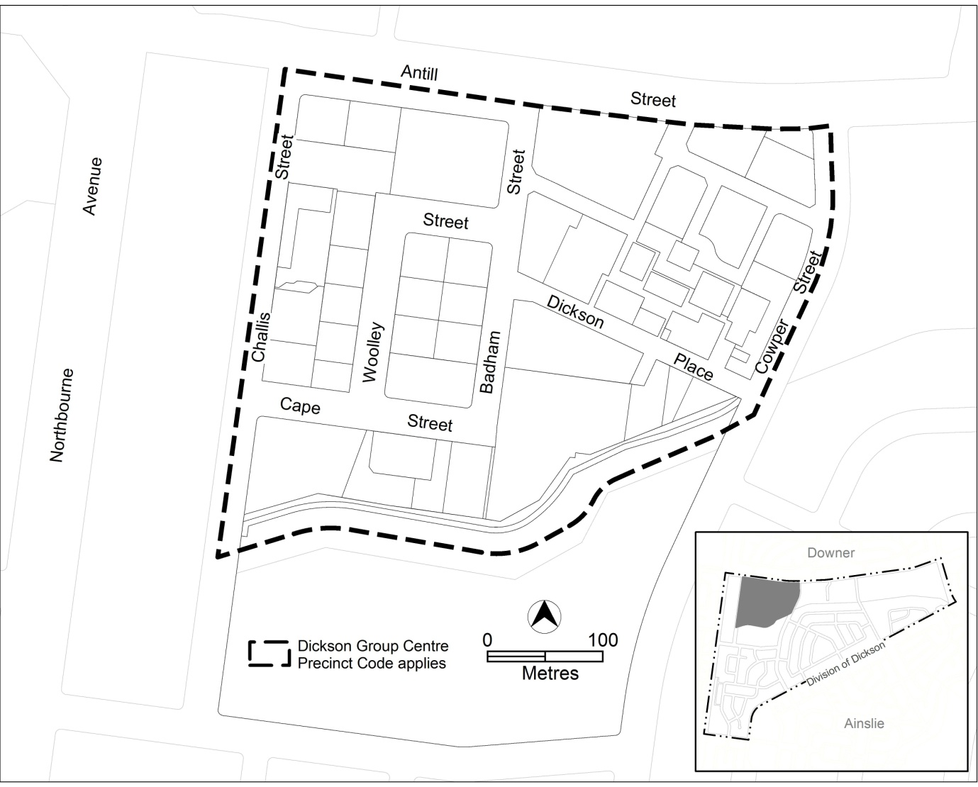
Figure 1 Dickson Group Centre

  - Current Territory Plan Provisions
The Dickson group centre comprises a mixture of commercial zones including CZ1 core, CZ2 business and CZ3 services (refer to figure 2). Part of section 30 has a Community Facility zone and part of section 34 along the southern boundary of the group centre has a Parks and Recreation PRZ1 Urban Open Space zone.
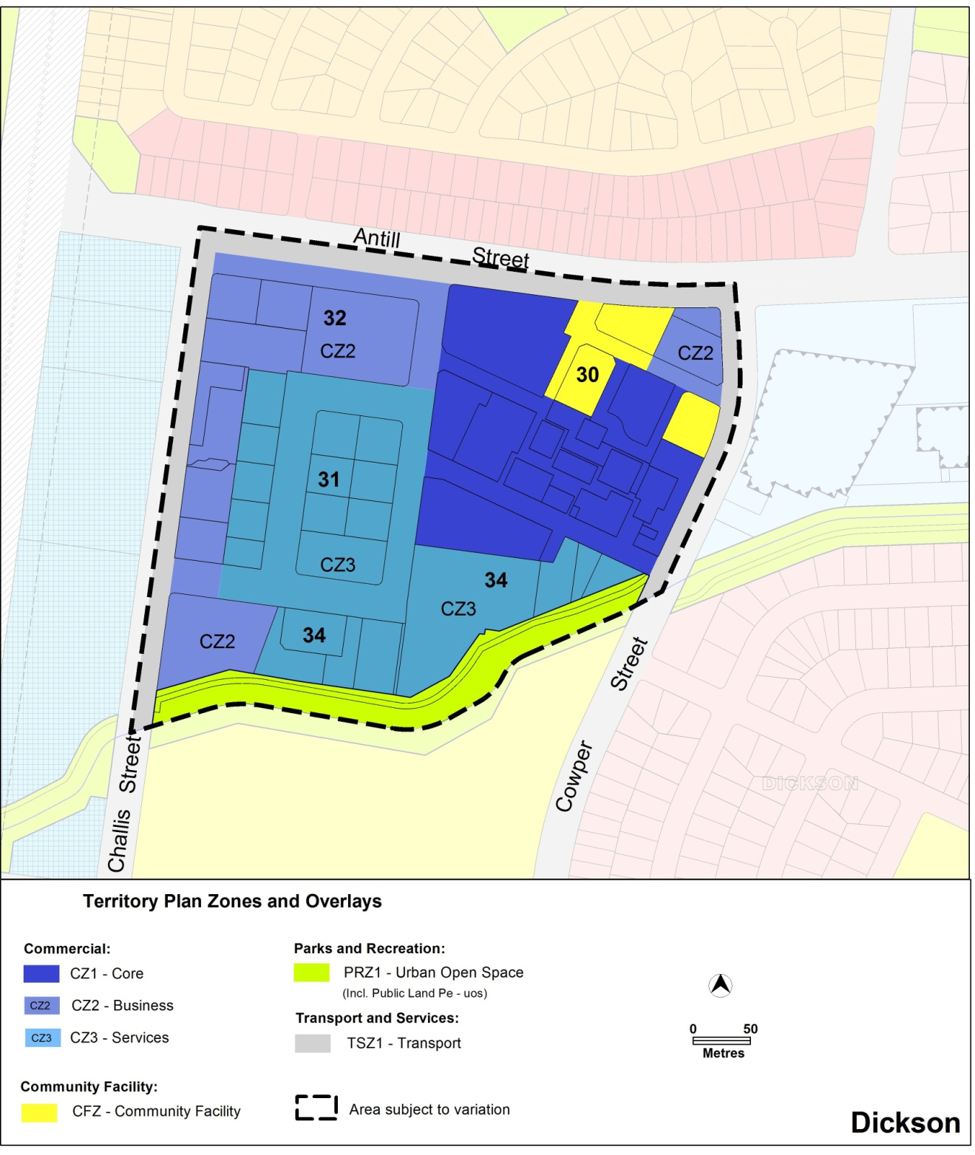
Figure 2 Existing zones for Dickson Group Centre

Development on land with a commercial zone is currently subject to provisions in the Group Centres Development Code of the Territory Plan. Additional controls for certain development are included in separate development codes. For instance, residential development at the group centre would be assessed against provisions in the multi unit housing development code.

  - Proposed Changes
    - Proposed Changes to the Territory Plan Map
The proposed changes to the Territory Plan map are indicated in Figure 3 and involve changing the zoning on block 20 section 34 Dickson from CZ1 core zone to PRZ1 urban open space zone at the corner of Badham Street and Dickson Place to allow development of a park and the zone on the remaining part of block 20 is to be commercial CZ3 services
The draft variation map indicates the proposed zone boundaries as accurately as possible but may be subject to adjustments following detailed surveys.
    - Proposed Changes to Territory Plan
The proposed changes to the Territory Plan written statement are outlined in detail in part 3 of this draft variation, and involve changes to the group centres development code, and the introduction of the Dickson centre precinct code.

  - Reasons for the Proposed Draft Variation
The draft variation proposes to make changes to the Territory Plan that will guide future development at Dickson group centre in a manner consistent with the Dickson centre master plan. The master plan is available on ESDD’s website at www.act.gov.au/dickson.

  - Planning Context

    - National Capital Plan
The Australian Capital Territory (Planning and Land Management) Act 1988 established the National Capital Authority (NCA) with two of its functions being to prepare and administer a National Capital Plan (NCP) and to keep the NCP under constant review and to propose amendments to it when necessary.
The NCP, which was published in the Commonwealth Gazette on 21 January 1990, is required to ensure that Canberra and the Territory are planned and developed in accordance with their national significance. The Australian Capital Territory (Planning and Land Management) Act 1988 also required that the Territory Plan is not inconsistent with the NCP.

    - Territory Plan
The proposal is consistent with the Statement of Strategic Directions in the Territory Plan particularly the principles of economic sustainability, social sustainability and spatial planning and urban design principles for urban areas.

In relation to economic sustainability (principle 1.12)

The overall intent of the proposed precinct code is to enable the Dickson Centre to revitalise and respond to the pressures for change. The built form theme proposes the intensification of development in the centre which will facilitate an increase in economic activity.

In relation to social sustainability (principle 1.22)

The proposal involves enhancing the public realm and includes requirements for the application of principles of crime prevention through environmental design.

In relation to planning for urban areas (principles 2.3, 2.6 and 2.7)

The proposed precinct code is consistent with these principles by
- strengthening and enhancing the existing retail core of the centre
- encouraging higher density development within the group centre
- improving the ability of people to move around easily, safely and comfortably by maximising permeability and encouraging walkability

In relation to urban design (principle 2.14)

The proposed rezoning of part of section 34 to PRZ1 is consistent with this principle, by creating an urban open space to be used as a public park. The proposed precinct code will also improve amenity through emphasising quality design of open space and the public realm.

    - Strategic Planning Context
Spatial Plan
The Spatial Plan outlines the strategic direction for growth to achieve social, environmental and economic sustainability for Canberra. Draft variation 311 is consistent with the Spatial Plan as it involves:
- containing growth within 15kms of the Civic to reduce sprawl and protect biodiversity
- encouraging residential intensification within a 7.5 kilometre radius of the Civic to provide a range of housing close to employment and services
- locating new residential areas close to employment and public transport routes

The Spatial Plan proposes that up to 50 per cent of future urban growth will be located close to existing major employment areas and existing services and facilities. Furthermore, the Spatial Plan implementation framework identifies the Dickson Centre as an area for short term residential intensification.

Transport Plans
Various transport plans have identified Dickson as a key location on Canberra’s public transport network. The Sustainable Transport Plan 2004 confirmed the establishment of an inter-town public transport corridor along Northbourne Avenue for the provision of fast and frequent services. The Public Transport Strategic Network Plan 2009 identified a site in Challis Street Dickson for the location of an on-street bus station. The Transport for Canberra: transport for a sustainable city 2012 – 2031 plan, which replaced the 2004 Sustainable Transport Plan, highlights the important relationship between land use and transport in achieving a more sustainable transport system for Canberra. It confirmed the need for a new bus station at Dickson.

The proposed development meets the broad objectives of the Sustainable Transport Plan by providing
- improved pedestrian linkages within the group centre,
- increasing pedestrian permeability to and from the surrounding neighbourhoods
- improving public transport facilities within the centre

The proposal meets the specific requirements of the Public Transport Strategic Network Plan by
- considering the proposed bus station in terms of the overall design of the group centre
- providing for pedestrian linkages to and from the proposed bus station

The proposal meets the following objectives of the Transport for Canberra 2012-2031 plan:
- Public Transport objectives - by supporting the frequent public transport network by improving pedestrian linkages to and from Northbourne Avenue.
- Active Travel objectives - by providing for quality pedestrian paths and linkages to and from the proposed bus station, including active frontages on buildings fronting major pedestrian routes for increased safety and visibility.
- Roads, Transport, Vehicles and Freight objectives - by maintaining the levels of existing car parking in the centre, and by accommodating the needs for additional car parking resulting from increased demand due to increased density.
- Managing Travel Demand objectives - by encouraging higher density development in the centre to ultimately contribute to a more compact city through an integration of transport and land use planning.

ACT Planning Strategy
The draft variation is consistent with the objectives and principles of the ACT Planning Strategy. The strategy builds on the outcomes from the 2004 Canberra Spatial Plan and responds to the changes in the Australian Capital Territory’s economic, demographic and environmental circumstances as well as the community’s values.
DV311 is consistent with the following principles in the Planning Strategy:
Town centres and the transport corridors that connect them will be the focus for increasing residential density in the city
The town, group and local centres will be the focus of community life, offering a range of services, job opportunities and the chance to live close to work
Canberra will have more diverse urban environments that fulfil a range of lifestyle expectations and support a growing, changing population. There will be greater clarity about the quality, location and type of development possible
The community’s changing needs will be recognised and there will be greater choice in housing types and where people can live sustainably, with increased affordability
It will be easy to get around Canberra, to access services and to participate and socialise in the community. Districts and neighbourhoods will be safe and have a network of pathways leading to public parks, squares and community facilities
A regional approach will be taken to protect biodiversity, manage natural resources, retain agriculturally productive land, and invest in services and infrastructure to make the Capital region more prosperous and sustainable
Canberra will have a more diverse, knowledge economy, and be an important centre providing a range of services and opportunities to a prosperous region
Innovation and enterprise will be encouraged with more affordable opportunities for businesses and community services to locate in group and local centres

  - Interim Effect
Section 65 of the Planning and Development Act 2007 applies to the draft variation. This means that, in addition to the Territory Plan, the provisions of the draft variation apply to development applications lodged on or after 27 July 2012. The draft variation is part of the Territory Plan for a period of up to one year from 27 July 2012 unless the draft variation is commenced, is withdrawn or rejected by the Legislative Assembly. During this period, the ACT Government must not do or approve anything that would be inconsistent with the Territory Plan.

  - Consultation with Government Agencies
The ESDD is required to, in preparing a draft variation under section 61(b) consult with each of the following in relation to the proposed draft variation
- the national capital authority
- the conservator of flora and fauna
- the environment protection authority
- the heritage council
- if the draft variation would, if made, be likely to affect unleased land or leased public land – each custodian for the land likely to be affected
Details on the consultations are included below.

National Capital Authority
The National Capital Authority provided the following comments on 17 April 2012:
Consideration should be given to allowing greater flexibility in the location of future pedestrian routes, particularly the proposed route between Woolley and Challis Streets. This may be pertinent as the design of the bus station between Challis Street and Northbourne Avenue is progressed. Pedestrian routes between the bus station and the core of the Dickson Group Centre should be as legible and direct as possible as a bus station at this location is at some distance from the core retail area of the centre.
The National Capital Authority has no objection to Draft Variation 311 proceeding to the next stage of consultation.

Response
Noted.

Conservator of Flora and Fauna
The Conservator made the following comments on 3 April 2012:
I note that provision is being made for an area of urban open space on the corner of Badham Street and Dickson Place. The provision of urban open space is supported. s. 316 of the Planning and Development Act 2007 requires that an area of public land must be managed in accordance with (a) the management objectives applying to the area; and (b) any plan of management for the area. The relevant plan of management for this area of open space is the Inner Canberra's Urban Parks and Sportsgrounds Plan of Management. Page 11 refers to the new area of urban open space as a 'town park'. The Plan of Management contains specific requirements for town parks and lists Glebe Park and City Hill specifically as the only town parks within Inner Canberra. It is recommended that you liaise with City Services, Territory and Municipal Services to determine the relevant park type for this location to ensure management will comply with the Plan of Management.

Response
Noted. References to a town park in the precinct code have been changed to park.

Environment Protection Authority
The Environment Protection Authority provided the following comments on
17 April 2012:
Draft Variation 311 details that a new Precinct Code will introduce site specific controls to specific land use and design details which will guide development in the Dickson group centre. Dickson has had an ongoing history of noise complaints associated with incompatible land uses. These issues were identified in the Dickson Centre Urban Planning and Design Framework August 2010 including some initial suggested solutions. The Precinct Code should expand on the issues raised in the Framework to address noise issues relating to mixed use development. The current Commercial Zones Policy Review as well as the current review of the Environment Protection Act 1997 and Regulations will assist with the development of the Precinct Code in detailing appropriate planning, design and noise mitigation measures and practices to ensure appropriate amenity for the increased residential use in the area.

Response
Noted. A provision, requiring the preparation of a noise management plan for residential development, has been included at rule R18 of the precinct code.

ACT Heritage Council
The ACT Heritage Council provided the following comments on 20 April 2012:
The Dickson Library is within the Dickson group centre and is a registered place on the ACT Heritage register. The heritage values identified in the Dickson Library guidelines are maintained, in part, with this draft variation to the Territory Plan. However, the proposed height controls for the buildings surrounding the Dickson Library will change the scale of the area and is a concern. The height of the buildings in the immediate area surrounding the Dickson Library should be sympathetic in scale. The setting of the place that enables its scale and form to be appreciated including the open form of the urban setting from all four sides is one of the features intrinsic to the heritage significance of the Dickson Library. The Council understands the opportunities presented by the draft variation to update the Dickson group centre. However, the rule concerning height (R20) and controls under Pat1 A, 2.4 Building Design within the draft precinct code does not address the significance of the scale of the library. Any new development in the Dickson centre must respect the heritage values of the Dickson Library and have minimal impacts on its significance. A limitation on building heights within a distance of the library site may resolve this concern. For example, the height of the buildings where directly adjacent to the library could be stepped with a maximum of one-two storeys. The height could then increase at a reasonable distance from the library as per Rule 20. Consequently, the Heritage Council does not find draft variation 311 acceptable in its current form. It is recommended that it be revised to accommodate specific controls to retain the features intrinsic to the significance of the Dickson Library.

Additional comments from the ACT Heritage Council were received on 6 June 2012:

The Council is satisfied that the amendments proposed, and listed below will provide adequate curtilage to provide for the urban setting of the Dickson Library, allowing it to be viewed from all four sides.
- 12m separation of the boundaries of new blocks to the north from the existing north boundary of the library.
- 17m separation of the boundaries of new blocks to the south from the existing south boundary of the library.
- 11m separation of the boundaries of new blocks to the east from the existing east boundary of the library.
- 10m separation of the boundaries of new blocks to the west from the existing west boundary of the library.

Subject to these amendments being included in the amended DV311, the ACT Heritage Council has no further objections to DV311.

Response
Noted. The precinct code has been revised to provide a buffer area around the Dickson library (refer to figure 7) where no new buildings may be developed.

Land Custodian
The Territory and Municipal Services Directorate provided the following comments on 19 April 2012:
TAMS supports the document being released for public consultation. However, there are concerns that the new area of Urban Open Space (UOP) is being referred to as a Town Park. Dickson is a Group Centre in accordance with the Plan of Management for Inner North Region and TAMS does not support a Town Park in a Group Centre. A Town Park has specific requirements managed and maintained to high standards. Town Parks usually have mown and irrigated grass, paving, sculptures, furniture, shrub or flower beds, adjacent to and serving the main town centres. They have intensive use and may host special events. It is also questionable whether the proposed area for PRZ1 would probably be of a suitable size for a Town Park.

Response
Noted. As noted in response to the Conservator’s comments above, references to a town park in the precinct code have been replaced by park.

This page is intentionally blank.

- DRAFT VARIATION
  - Variation to the Territory Plan Map
The Territory Plan map is varied as indicated in Figure 3.

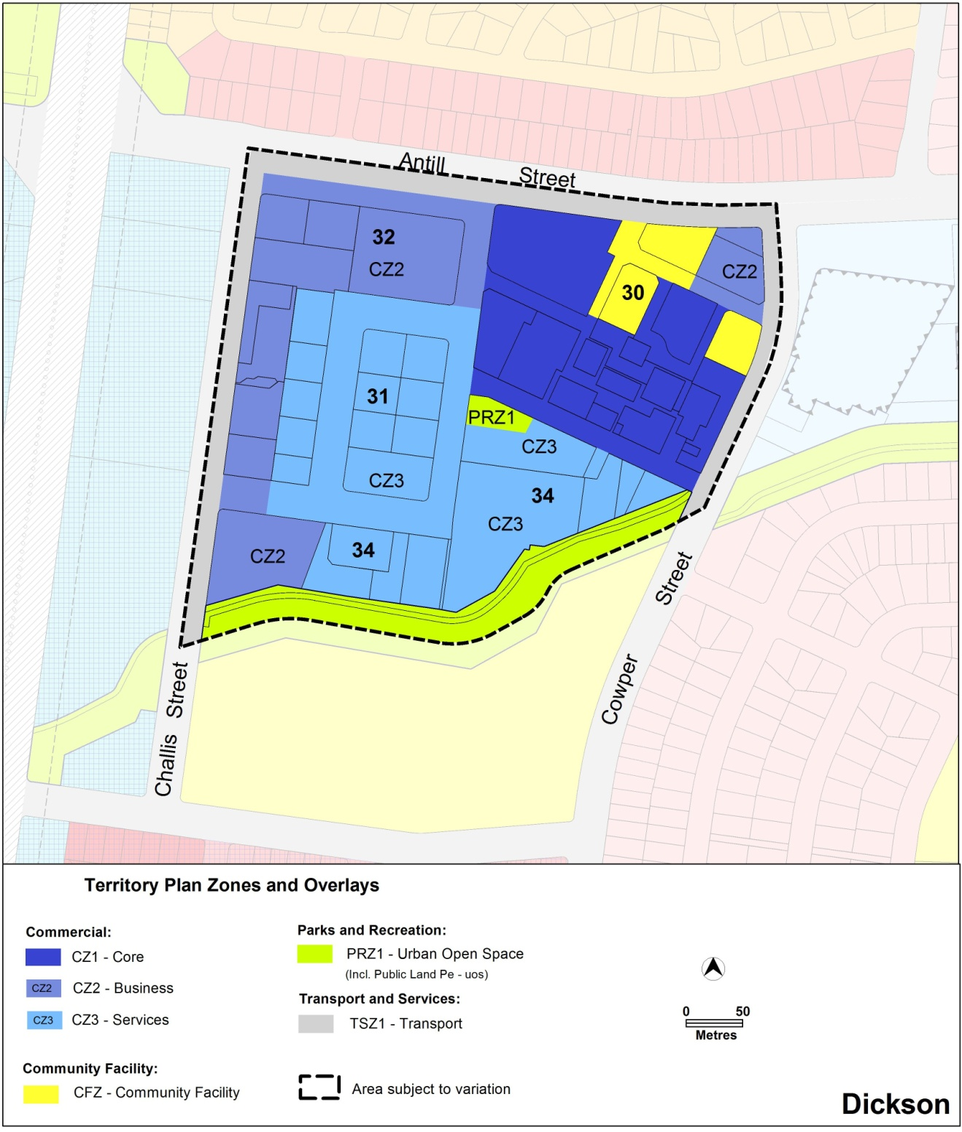
Figure 3 Proposed zones for Dickson Group Centre

  - Variation to the Territory Plan
The Territory Plan is varied as follows.

Variation to Group Centres Development Code
- Part A – Centres and Zone specific Controls, Part A Group centres – Overview, Group Centres – Canberra Central, Figure A6 Dickson Group Centre

Substitute with the following
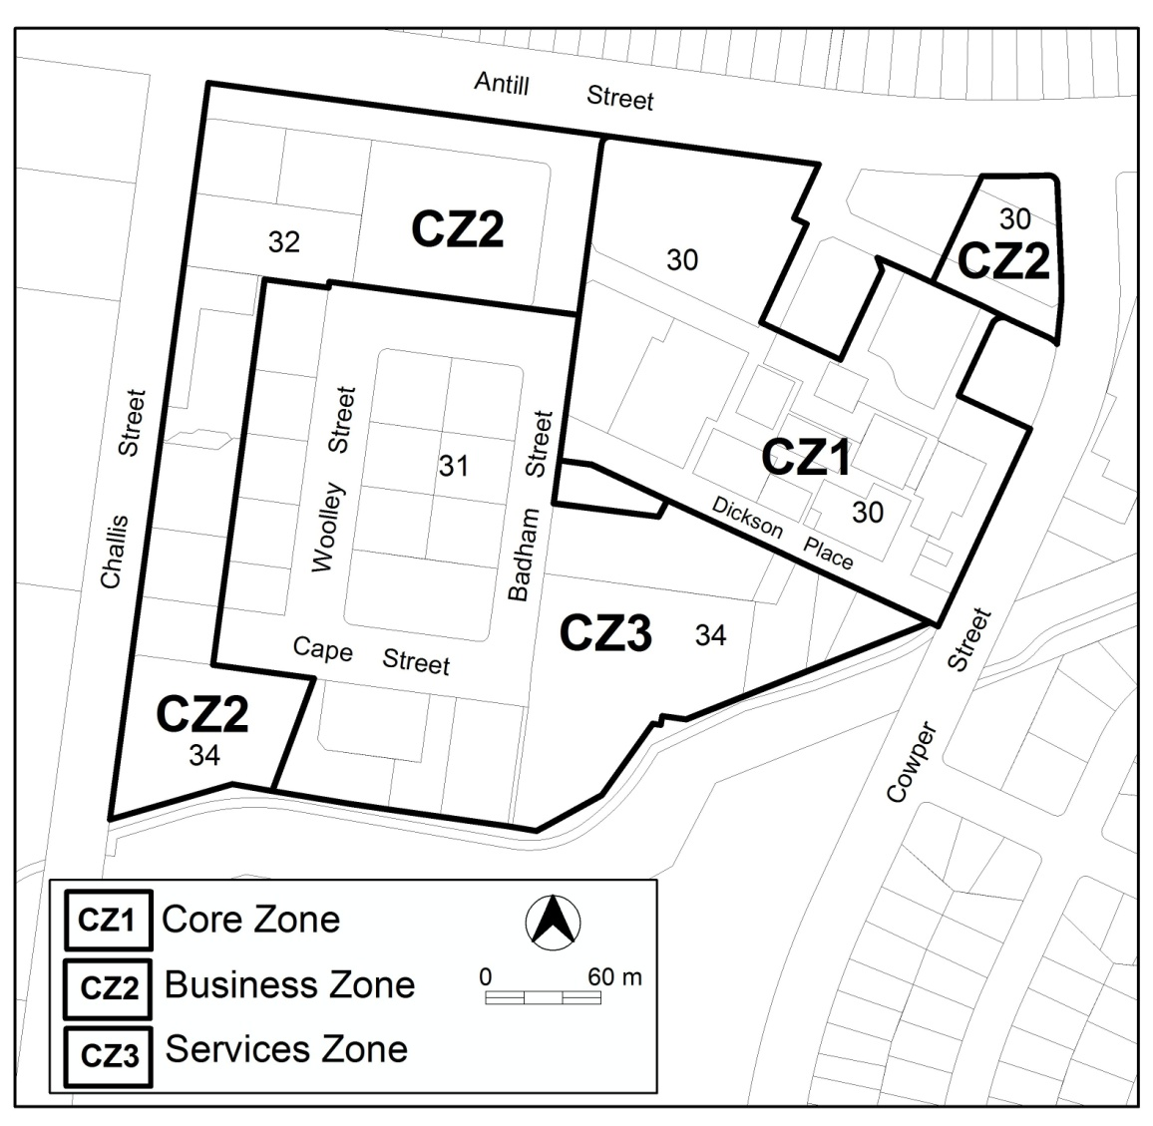

- Part A – Centres and Zone specific Controls, Part A(1) Group centres, CZ1 Core zone, Section 1.2, rule R3

Omit
- offices in Dickson: 4000 m² per lease

- Part A – Centres and Zone specific Controls, Part A(1) Group centres, CZ1 Core zone, section 2.3 Dickson

Omit section 2.3

- Part A – Centres and Zone specific Controls, Part A(2), Section 1.3, rule R13

Omit
- offices in Dickson: 4000 m² per lease

- Part A – Centres and Zone specific Controls, Part A(2) Group centres – CZ2 Business zone, Section 2.3 Dickson Section 32

Omit section 2.3

- Part A – Centres and Zone specific Controls, Part A(3) Group centres - CZ3 Services zone, Section 1.2, rule R24

Omit
- office in Dickson: 4000 m² per lease

- Part B – General Development Controls, Element 1 - Restrictions on Use Figure B6 Dickson Group Centre

Omit figure

Variation to Precinct Codes
- 10.2 Other Precinct Codes

Insert Dickson Group Centre Precinct Code (Attachment A)

Interpretation service
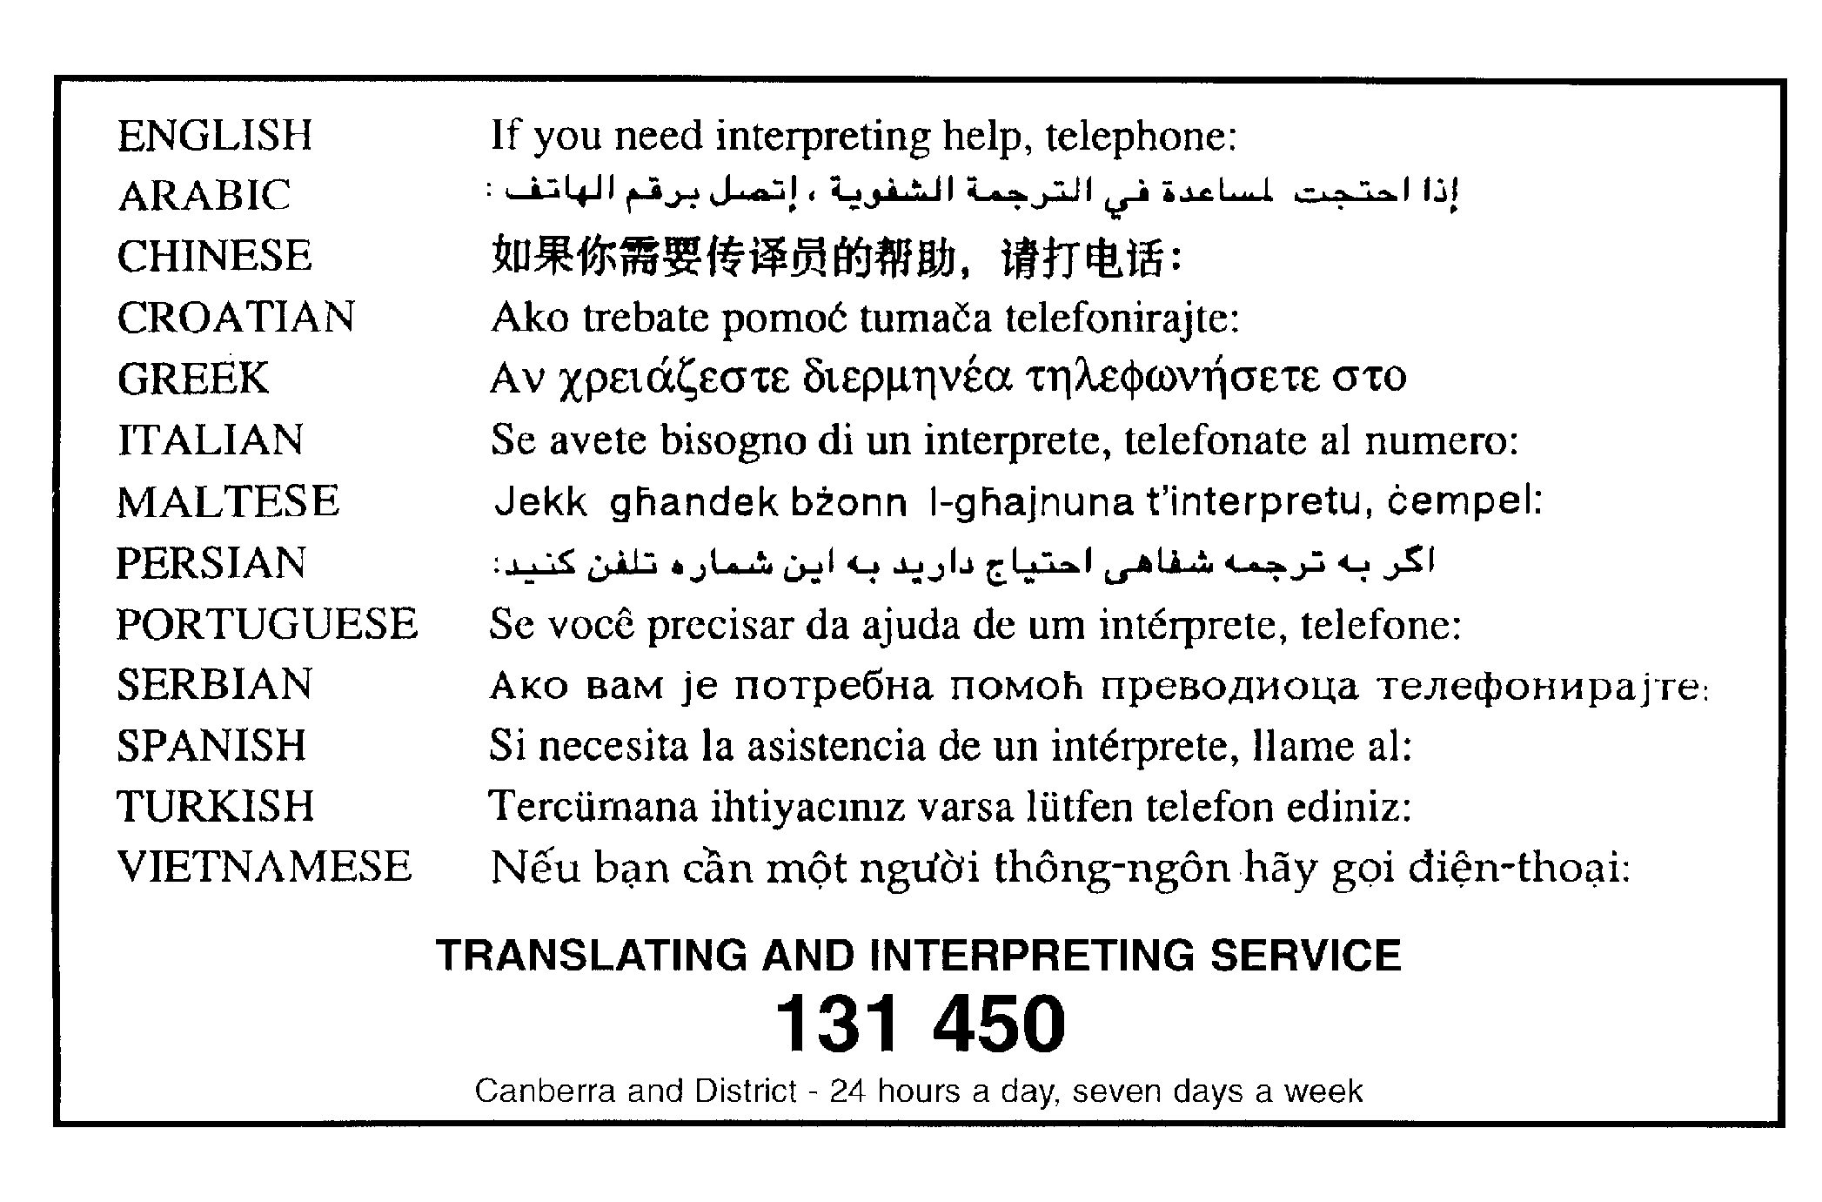

Dickson Group Centre Precinct Code

This page is intentionally blank.

Contents
Introduction 1
Part A – General controls 4
Element 1: Use 4
1.1 Residential use restriction 4
Element 2: Building 4
2.1 Redevelopment and/or subdivision 4
2.2 Pedestrian routes 5
2.3 Building design 7
2.4 Awnings 7
2.5 Plot ratio 7
2.6 Setback 8
2.7 Active frontage 10
Element 3: Access and parking 11
3.1 Street works 11
3.2 Development on nominated car parking areas 12
Element 4: Amenity 12
4.1 Landscaping 12
4.2 Residential use – noise management plan 12
Part B – Area specific controls 13
Area B(1) Main retail area 14
Element 5: Use 14
5.1 Ground floor use restrictions 14
5.2 Office – floor area limit 14
Element 6: Building 15
6.1 Height of building 15
6.2 Setback 15
6.3 Restriction on driveway access to Antill Street 15
Part B(2) – Business and services area 17
Element 7: Use 17
7.1 Ground floor use restrictions 17
7.2 Residential use – ground floor 17
7.3 Office – floor area limit 17
Element 8: Building 19
8.1 Redevelopment and/or subdivision 19
8.2 Building design 20
8.3 Height of building 20

List of Figures
Figure 1 Dickson Group Centre 1
Figure 2 Roadway pattern 4
Figure 3 Roads, car parks and pedestrian routes 6
Figure 4 Active frontages 9
Figure 5 Major view corridors and vistas 11
Figure 6 Dickson centre sub precincts 13
Figure 7 Building heights in area B(1) 16
Figure 8 Building heights in the Business and services area 18
Figure 9 Woolley Street 21
Figure 10 Badham Street 21
Figure 11 Antill Street road reserve 22
Figure 12 Cape Street extension 22
Figure 13 Laneway along north-south view corridor 23

This page is intentionally blank.

Introduction
Name
The name of this code is the Dickson Group Centre precinct code.
Application
This precinct code applies to blocks and parcels in the Dickson Group Centre as shown in figure 1.
Figure 1 Dickson Group Centre
Site description
Dickson group centre is one of the largest and most diverse group centres in Canberra. It is a social hub and the convenience retail centre for north Canberra as well as a destination of metropolitan significance for dining and entertainment activities. The centre is characterised by its diversity, the unique form of the retail core and its multicultural atmosphere. Dickson group centre is located in inner north Canberra adjacent to Antill Street, approximately 4 km north of the Civic centre (Post Office to Post Office, by road) and 4 km south of the industrial area of Mitchell.
Purpose
This code provides additional planning, design and environmental controls for specific areas or blocks and may also contain references to provisions in other codes.
The intent of the development controls is to implement the Dickson Centre master plan by providing the opportunity for development of the following:
- a diverse mix of uses to support the centre’s growth
- both public and private sector investment to enhance the attractiveness of the centre and meet the needs of its catchment population
- a more attractive place throughout the day and evening
- additional and increased diversity in business activities that enhances its role as a metropolitan destination for dining/entertainment
- an increase in housing supply in the centre
- a significant mixed use node that supports public transport infrastructure and use
In conjunction with other relevant codes it will be used by the Authority to assess development applications and offer guidance to intending applicants in designing development proposals and preparing development applications.
Structure
This precinct code has two parts:
Part A – General controls
Part B – Area specific controls
Each element has one or more rules, each having an associated criterion (unless the rule is mandatory). A rule provides quantitative, or definitive, controls, while criteria are chiefly qualitative in nature.
In some instances rules are mandatory. Such rules are accompanied by the words “This is a mandatory requirement. There is no applicable criterion”. Non-compliance with a mandatory rule will result in the refusal of the development application. Conversely, the words “There is no applicable rule” are found where only a criterion is applicable. Where both rule and criterion apply, compliance with the rule is deemed to satisfy the particular requirement. Provided the relevant criterion can be met, strict compliance with the rule is not required.
Code hierarchy
Under the P&D Act, where more than one type of code applies to a development and there is inconsistency between provisions, the order of precedence is: precinct code, development code, and general code.
If more than one precinct code applies to the site, the most recent precinct code takes precedence to the extent of any inconsistency.
Definitions
Defined terms, references to legislation and references to other documents are italicised.
Definitions of terms used in this code are listed in the Territory Plan or, for terms applicable only to this code, associated with the respective rule.
Acronyms
Authority Planning and Land Authority within the ACT Environment and Sustainable Development Directorate
EPA ACT Environment Protection Authority
ESA ACT Emergency Services Agency
ESDD ACT Environment and Sustainable Development Directorate
NCA National Capital Authority
P&D Act Planning and Development Act 2007
TAMS ACT Territory and Municipal Services Directorate

Part A – General controls
This part contains general controls that are applicable to all development subject to this precinct code. Part B, which contains additional area-specific controls, also applies.
- Use
Rules | Criteria
  - Residential use restriction
Residential use is prohibited on ground floor level unless otherwise specified in this code.  Refer to item 7.3 Residential use – ground floor and Figure 8. | This is a mandatory requirement. There is no applicable criterion.

- Building
Rules | Criteria
  - Redevelopment and/or subdivision
There is no applicable rule. | Redevelopment, including subdivision, is consistent with the existing distinctive roadway pattern of the centre shown in Figure 2.

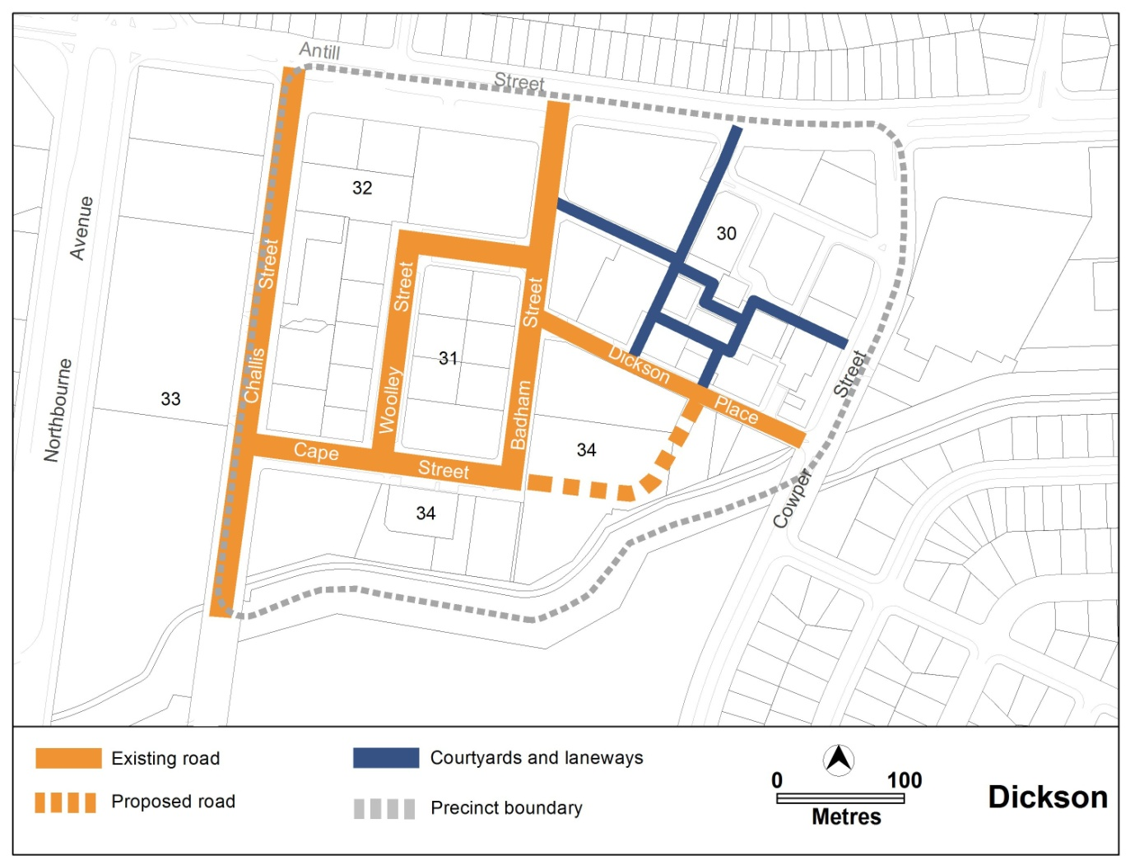
Figure 2 Roadway pattern
Rules | Criteria
  - Pedestrian routes
Redevelopment and/or subdivision will:  - retain and improve the existing major pedestrian routes  - provide the proposed major pedestrian routes and pedestrian trans-section routes  at the locations shown in figure 3 | Redevelopment and/or subdivision are consistent with the pattern of existing and proposed pedestrian routes and pedestrian trans-section routes at the locations shown in figure 3.
New pedestrian trans-section routes have a minimum width of 4m. | The width and scale of new pedestrian trans-section routes reflect their function and location.
This rule applies to pedestrian routes, including new trans-section routes, shown in figure 3.  Pedestrian routes and pedestrian trans-section routes comply with all of the following:  - signage at each end identifying the connection provided  - ongoing public access  - AS 1158.3.1 pedestrian lighting  - AS 1428.1 design for access and mobility | Pedestrian routes and/or pedestrian trans-section routes achieve all of the following:  - reasonable public access  - reasonable public safety  - reasonable information signage  - reasonable access for people with disability
There is no applicable rule. | This criterion applies where a pedestrian trans-section route from street to street shown in Figure 3 is not achievable.  Partial pedestrian trans-section routes (halfway through the section) achieves all of the following  - completion of the trans-section connection is enabled when adjoining sites are developed/redeveloped  - are adjoined by building frontages that are suitable for active uses  - provide for pedestrian access to adjacent buildings  - provision for adequate lighting  - signage at the entrance identifying access to the adjacent building(s)
Note: Changes and/or alterations to the existing pedestrian route, including the design of new pedestrian or pedestrian trans-section routes, are required to be endorsed by TAMS. TAMS will endorse the plan if it complies with the relevant TAMS standards. TAMS may endorse departures from these standards.

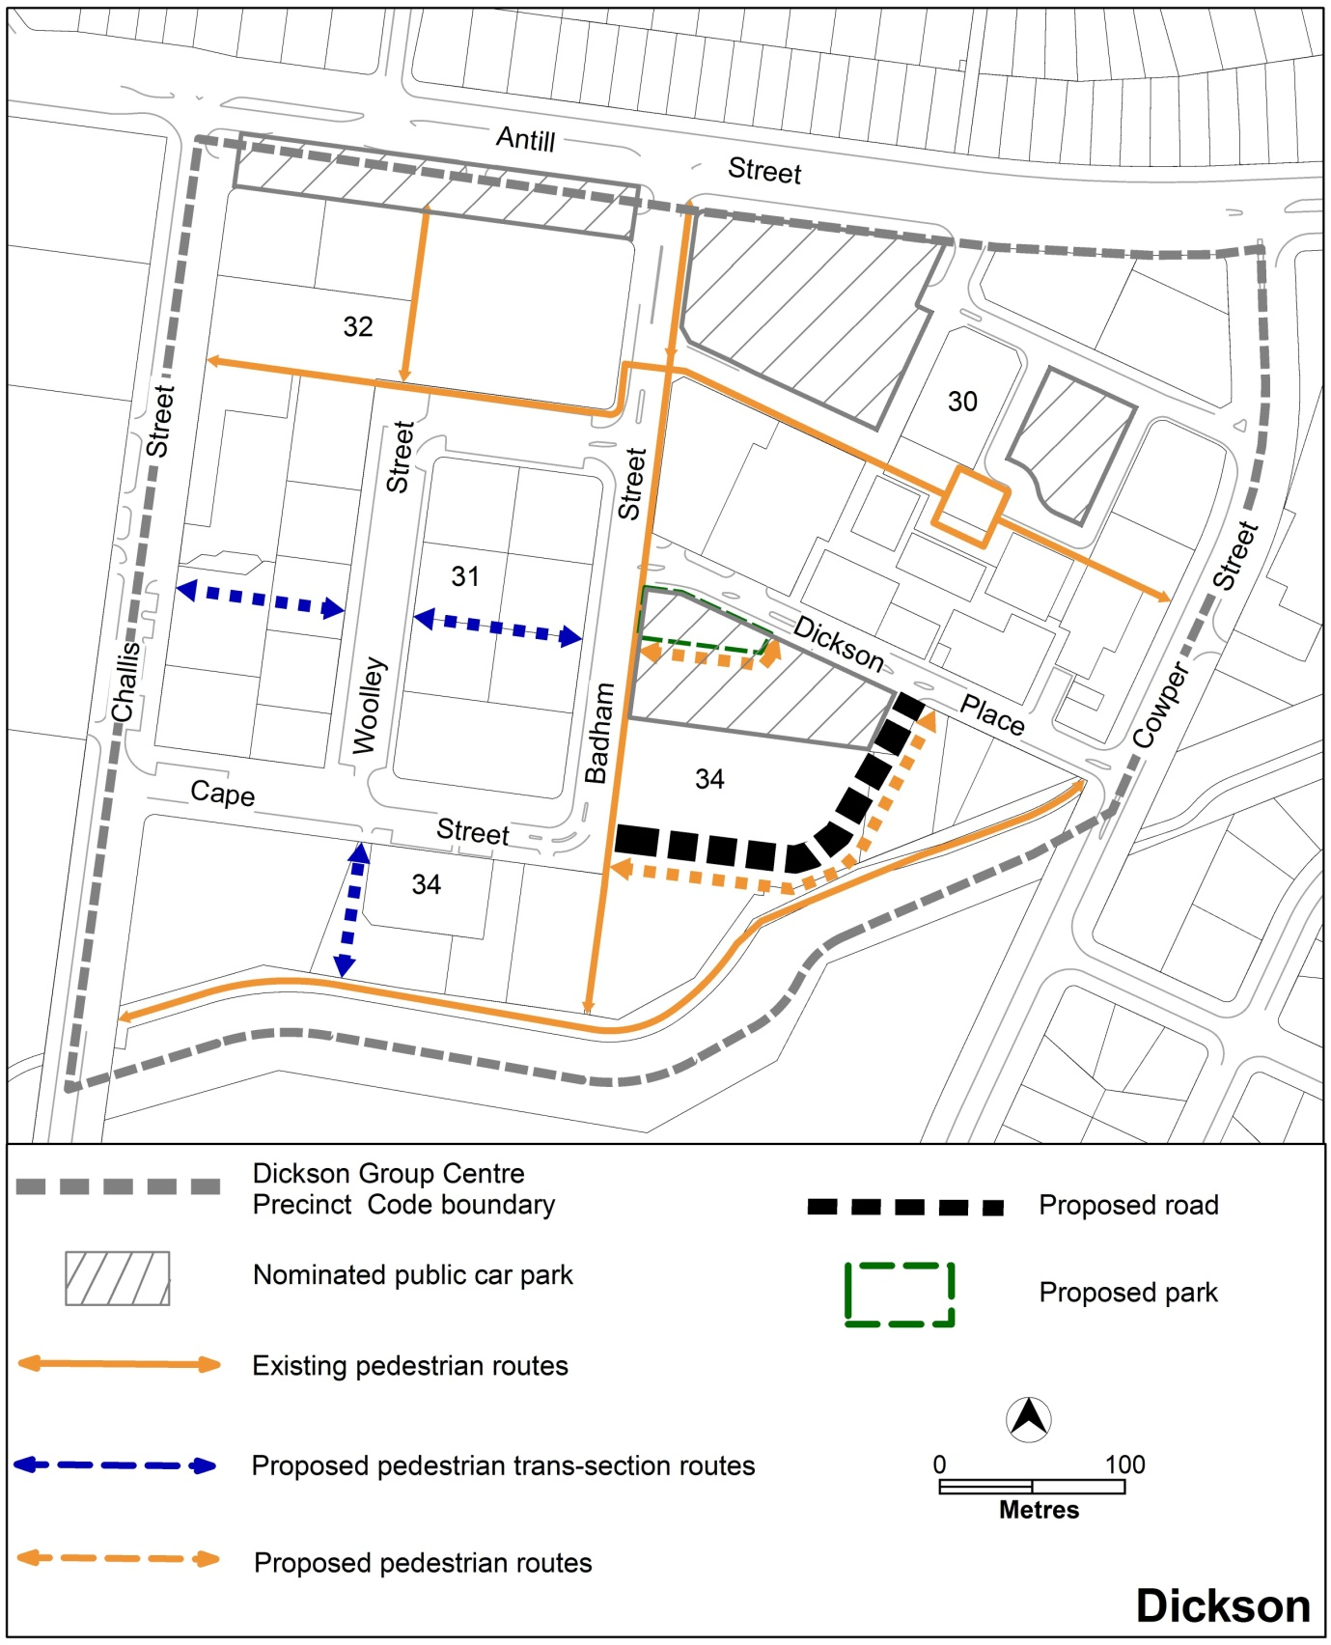
Figure 3 Roads, car parks and pedestrian routes

Rules | Criteria
  - Building design
The minimum ground floor level floor to ceiling height is 3.6m. | Ground floor level of buildings is adaptable for retail and service trades uses.
There is no applicable rule. | Building design achieves all of the following:  - corner buildings contain focal points providing architectural interest and variety to the building design  - entrances to common areas for residential use provide strong visual connection to the street and ensure a high level of surveillance  - driveways and pedestrian entrances to the site are visible from the block boundary  - west-facing facades incorporate sun shading into building designs  - consistency with the desired character
  - Awnings
This rule applies to building with frontages to primary active areas shown in figure 4.  Awnings comply with all of the following:  - cantilevered awnings for the full extent of the building frontage  - awnings are to be a minimum of 3m in cantilever width  - awnings are to be a minimum height of 3m above finished pavement or ground level of the verge  - awnings are to be integrated into the building design at the first floor level | This is a mandatory requirement. There is no applicable criterion.
  - Plot ratio
There is no applicable rule. | Plot ratios achieve consistency with desired character.
  - Setback
Buildings are built to the front boundary except for the following:  - where alternative setbacks are established by existing adjacent development, in which case setbacks are consistent with the intended design themes of the area  - minor setbacks in building alignment may be permitted to provide small spaces for active uses along pedestrian routes shown in figure 3  - at the locations shown in figure 8, where setbacks are required for the laneway connection from the corner of Badham and Cape Streets to the urban open space corridor at the centre’s southern boundary | Building setbacks and alignment achieve consistency with the desired character.

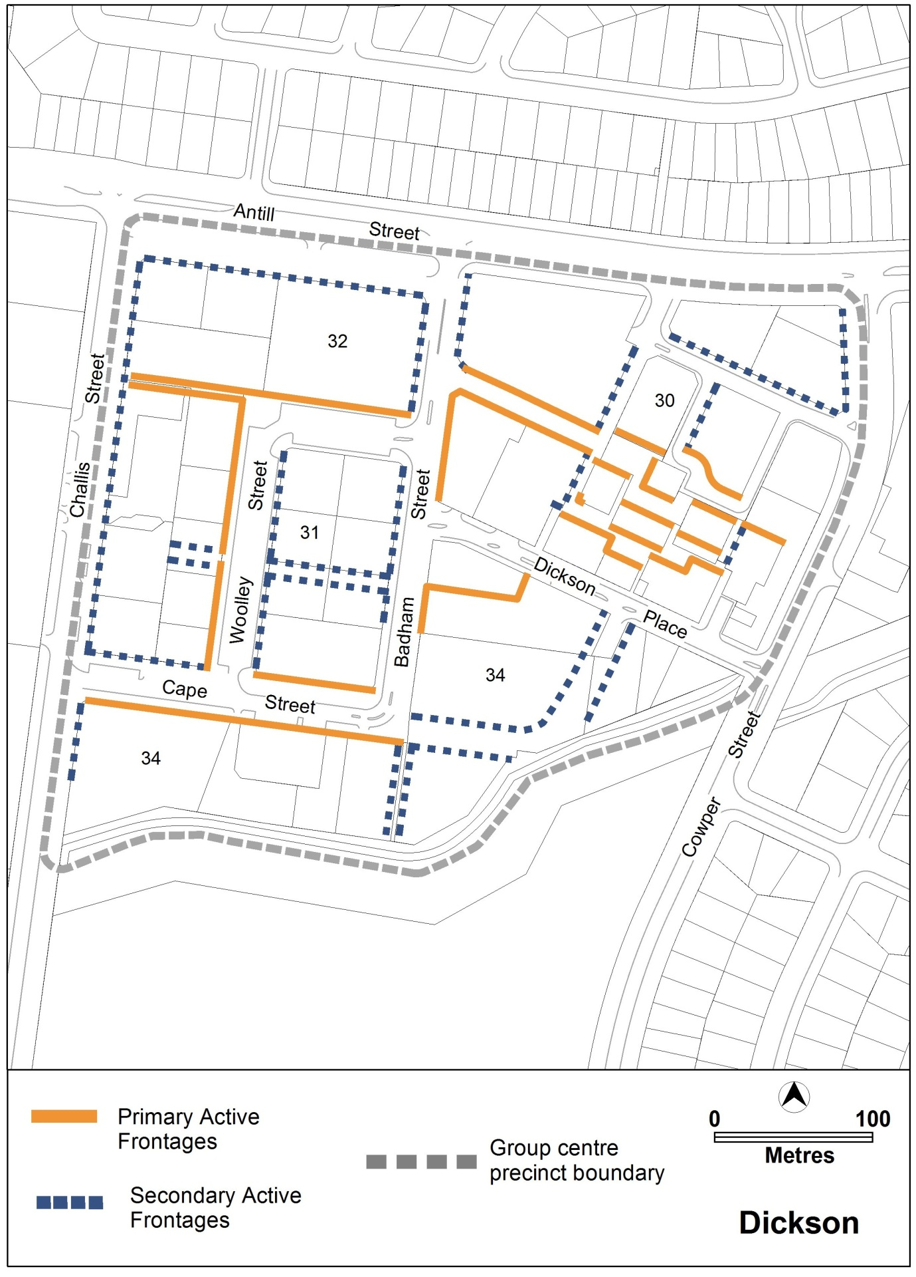
Figure 4 Active frontages

Rules | Criteria
  - Active frontage
For buildings located along primary active frontage areas identified in figure 4, frontages and building design complies with all of the following:  - buildings incorporate clear display windows and/or shop fronts at the ground floor level  - buildings incorporate direct pedestrian access at grade with the verge level for access and egress for persons with disabilities  - tenancies at ground floor level that occupy more than a total of 20m of the street frontage present as more than one tenancy  Any small areas of walls without windows contain display windows, showcases and/or public art, with a maximum of 30% blank frontage per tenancy. | This is a mandatory requirement. There is no applicable criterion.
For buildings located along secondary active frontage areas identified in figure 4, frontages and building design complies with all of the following:  - buildings incorporate clear display windows and shop fronts at the ground floor level  - buildings incorporate direct pedestrian access at grade with the verge level for access and egress for persons with disabilities | For buildings located along secondary active frontage areas identified in figure 4, development at ground floor level achieves all of the following:  - is adaptable for shops  - where building access is provided, direct pedestrian access at street level
There is no applicable rule. | Extensive lengths of blank facades, open structured car parks, loading docks, substations and other service infrastructure are not located along primary active frontage areas, and do not dominate secondary active frontage areas, as indicated in figure 4.

- Access and parking
Rules | Criteria
  - Street works
This rule applies to kerb and other associated road structures along:  - eastern side of Badham Street  - east-west section of Woolley Street  - Antill Street road reserve  achieve all of the following:  - a minimum setback of 5m to the block boundary  - provision of a landscaped area that will form part of the public realm and satisfies C17 | The kerb and other associated road structures achieve all of the following:  - north-south and east-west views and vistas, as shown in figure 5, are not obstructed  - provision of a landscaped area that will form part of the public realm and satisfies C17
Note: Appendix A illustrates the kerb setbacks on Badham and Woolley streets and the Antill Street road reserve.

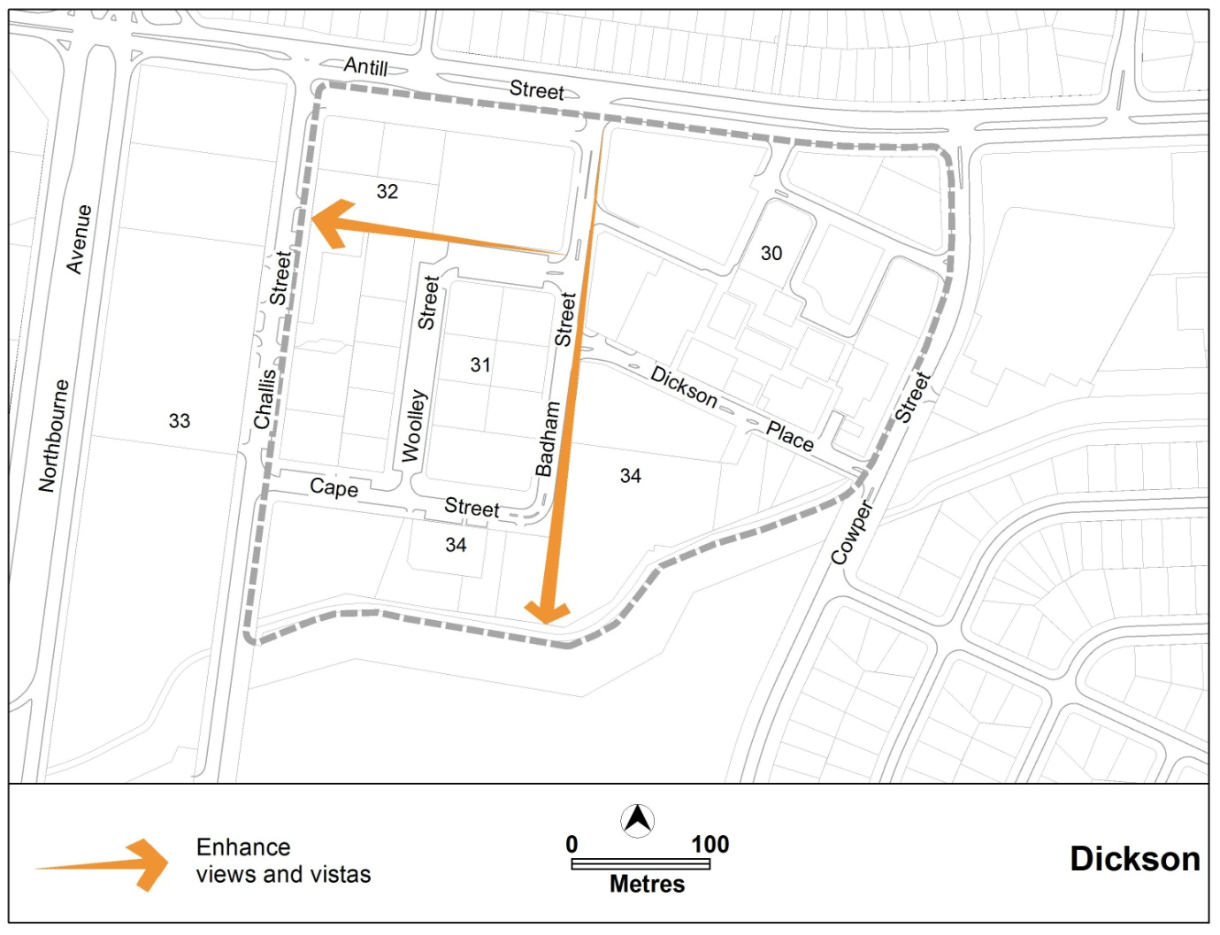
Figure 5 Major view corridors and vistas

Rules | Criteria
  - Development on nominated car parking areas
This rule applies to the areas identified as existing public car parks in figure 3.  Development complies with all of the following:  - retains the existing level of car parking  - accommodates onsite any additional demand for car parking that is generated by the development  - ensures that car parking remains available for public access  - complies with the Parking and vehicular access general code in the Territory Plan | Development achieves all of the following:  - in accordance with the Parking and vehicular access general code, there is enough car parking for the needs of the centre as a whole  - the development does not adversely affect the overall function of the centre in terms of economic, social, traffic and parking and urban design impacts

- Amenity
Rules | Criteria
  - Landscaping
There is no applicable rule. | Landscaping associated with capital works, building setbacks, kerb setbacks and pedestrian routes achieves all of the following:  - quality space for pedestrians  - provision for on-site infiltration of stormwater run-off  - quality landscaping
Note: The landscaping design is to be endorsed by TAMS. TAMS will endorse the design if it complies with the relevant TAMS standards. TAMS may endorse departures.
  - Residential use – noise management plan
Where residential uses are applied for, a noise management plan must be prepared by a suitably qualified acoustic consultant and endorsed by the relevant authority.  The noise management plan must detail the design, siting and construction methods, which will be used to achieve the satisfactory recommended design sound level for residential buildings specified in AS/NZS 2107 recommended design sound levels and reverberation times for building interiors as amended from time to time. | This is a mandatory requirement. There is no applicable criterion.

Part B – Area specific controls
This part contains additional rules and criteria to those in part A. To remove any doubt, the provisions in this part apply to development in the indicated areas. Where there is any inconsistency between parts A and B, the latter shall prevail to the extent of any consistency.

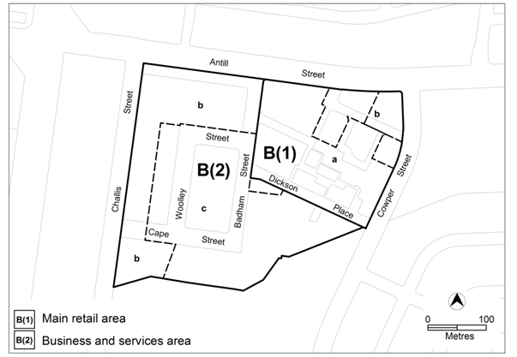
Figure 6 Dickson centre sub precincts

Area B(1) Main retail area
This part applies to blocks and parcels identified in area B(1) shown on figure 6.
- Use
Rules | Criteria
  - Ground floor use restrictions
Only the following uses are permitted on the ground floor level of buildings in area a in B(1) shown in figure 6  - business agency  - club  - COMMUNITY USE  - drink establishment  - financial establishment  - hotel  - indoor entertainment facility  - indoor recreation facility  - public agency  - restaurant  - SHOP | This is a mandatory requirement. There is no applicable criterion.
  - Office – floor area limit
This rule applies to areas a and b in B(1) shown in figure 6.  The maximum gross floor area (GFA) for office in is 4000m² per lease. | This is a mandatory requirement. There is no applicable criterion.

- Building
Rules | Criteria
  - Height of building
The maximum height of building in B(1) as shown in figure 7 is the lesser of one of the following:  - 12m above the datum ground level  - RL587  provided buildings do not overshadow the public realm beyond the shadow cast by a notional 9m fence on boundaries to the public realm. | This is a mandatory requirement. There is no applicable criterion.
Note: The height of the notional fence is measured from datum ground level.
The maximum height of buildings, including rooftop plant, on land in area a in B(1) fronting Antill Street at the location shown in figure 7 is 23m above the datum ground level. | This is a mandatory requirement. There is no applicable criterion.
  - Setback
No new buildings are allowed within the ‘library buffer area’ shown in figure 7. | This is a mandatory requirement. There is no applicable criterion.
Note: This rule does not apply to basements below ground level.
  - Restriction on driveway access to Antill Street
Driveway access or egress to Antill Street is not permitted. | This is a mandatory requirement. There is no applicable criterion.

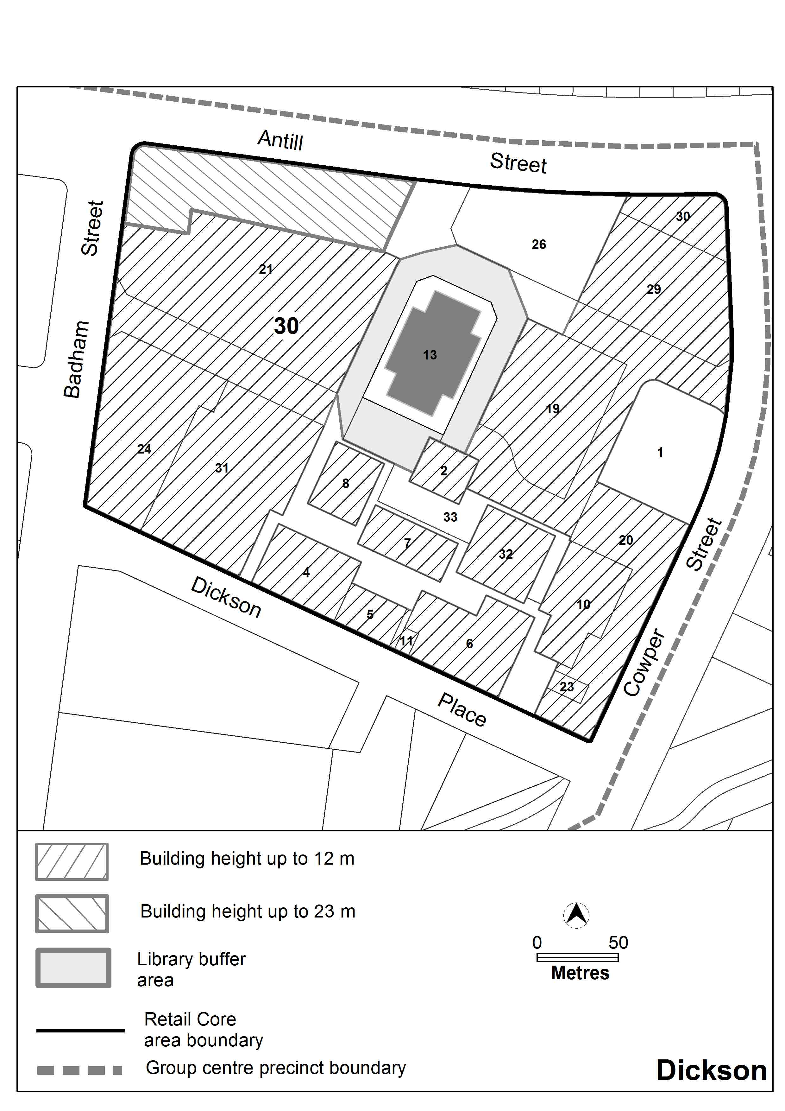
Figure 7 Building heights in area B(1)

Part B(2) – Business and services area
This part applies to blocks and parcels identified in area B shown on figure 6.
- Use
Rules | Criteria
  - Ground floor use restrictions
This rule applies to buildings facing the following areas:  - Woolley Street  - Badham Street  - laneway between Badham Street and the urban open space corridor along the centre’s southern boundary  only the following uses are permitted at the ground floor level  - club  - drink establishment  - hotel  - indoor entertainment facility  - indoor recreation facility  - restaurant  - SHOP | Buildings incorporate uses on the ground floor that generate activity in the public space.
  - Residential use – ground floor
There is no applicable rule. | This criterion applies to area a in figure 8.  Restrictions on residential use at the ground floor level specified in the group centres development code and at R1 of this code do not apply.
There is no applicable rule. | Residential use on ground floor level at area a in figure 8 is designed to comply with the provisions of Australian Standard AS4299 Adaptable housing and the Access and Mobility General Code.
  - Office – floor area limit
This rule applies to land shown in areas b and c in figure 6.  The gross floor area for office in each lease complies with all of the following:  - maximum total area of 4000m²  - maximum at ground level of 1500m² | This is a mandatory requirement. There is no applicable criterion.

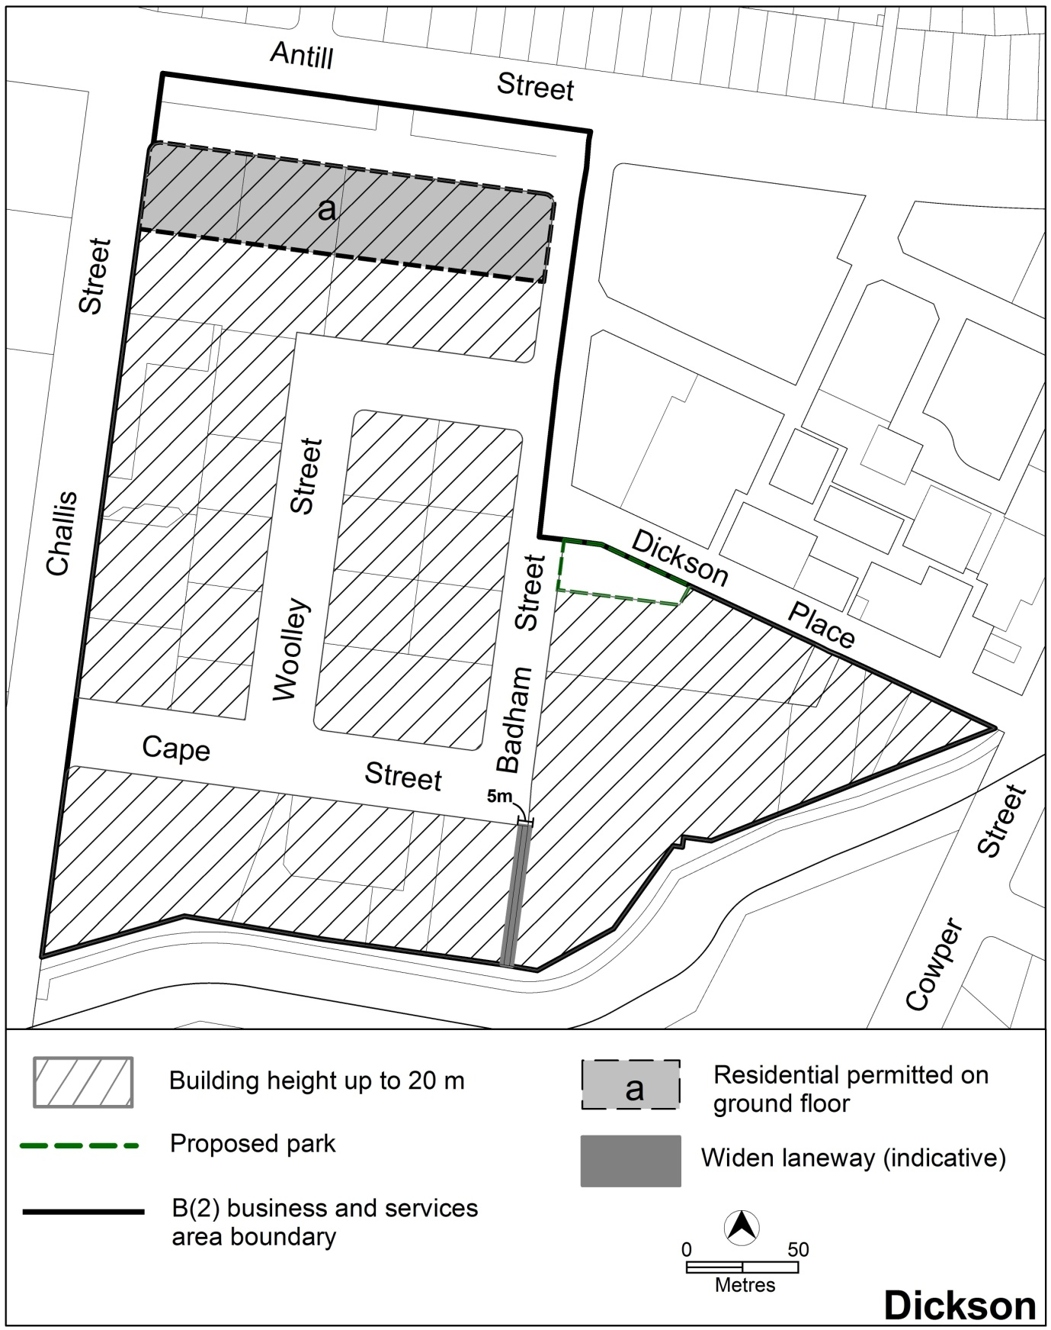
Figure 8 Building heights in the Business and services area

- Building
Rules | Criteria
  - Redevelopment and/or subdivision
Redevelopment and/or subdivision of part section 34 fronting Badham Street and Dickson Place that exceeds two storeys incorporates the ‘proposed road’ at the location shown in Figures 3 and 10. | Redevelopment and/or subdivision that exceeds two storeys is consistent with the pattern of proposed roads at the location shown in Figures 3 and 10.
Note: Street designs are endorsed by TAMS. In making its assessment, TAMS will consider whether the proposed street design achieves both (i) provision of street function and facilities and (ii) accommodation of future traffic growth
Redevelopment and/or subdivision of part of section 34 on the corners of Badham Street and Dickson Place achieves all of the following:  - provides for an area of land no less than 1300m² on the corner of Badham Street and Dickson Place, to be developed as a public park  - park boundaries line up with the proposed pedestrian trans-section route from Woolley Street to Badham street on the west of the park site, and to the existing pedestrian route between blocks 31 and 4, Section 30 to the north of the site, as identified in Figure 3 | This is a mandatory requirement. There is no applicable criterion.
Note: Public park designs must be endorsed by TAMS
Redevelopment and/or subdivision of part of section 34 at the locations shown in figure 8 provide for an expanded laneway between the corner of Badham and Cape streets and the urban open space corridor along the centre’s southern boundary. Laneway location and dimensions are indicated in figures 8 and 13. | This is a mandatory requirement. There is no applicable criterion.
Note: Any changes and/or alterations to existing outdoor pedestrian laneway design must be approved by TAMS.
Appendix A - Figure 14 illustrates the intended setbacks of buildings facing the laneway.
  - Building design
Buildings facing the laneway between Badham Street and the urban open space corridor along the centre’s southern boundary shown in figure 8 have clear windows facing the lane. | This is a mandatory requirement. There is no applicable criterion.
  - Height of building
This rule applies to the parcels shown in figure 8.  The maximum height of building, including any rooftop plant, is the lowest of the following:  - 20m above the datum ground level  - RL595 | This is a mandatory requirement. There is no applicable criterion.

Appendix A: Indicative cross sections

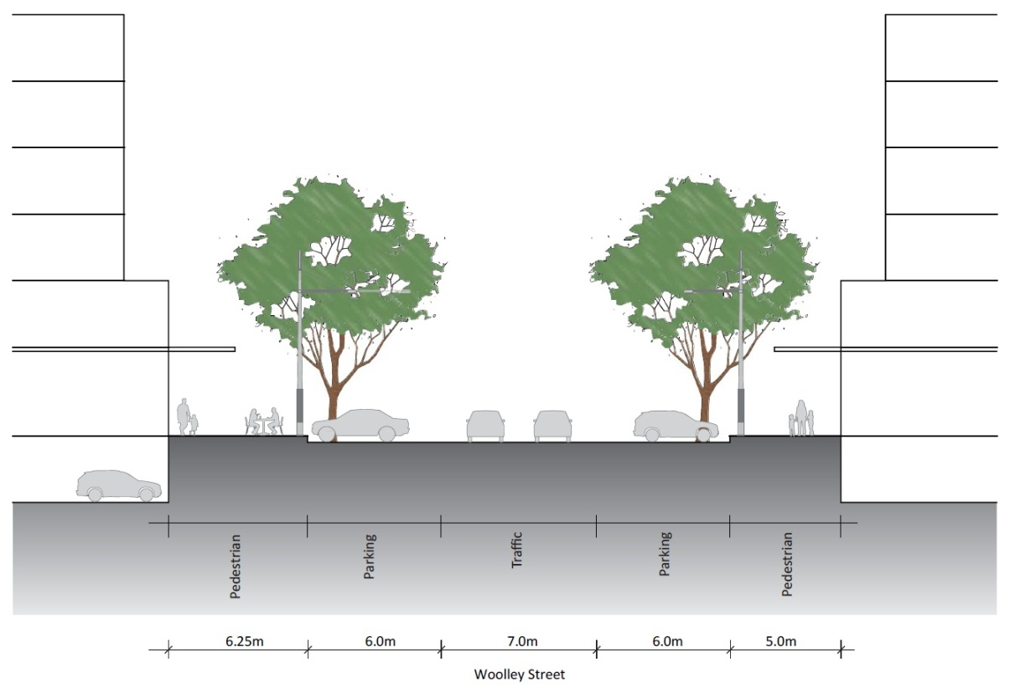
Figure 9 Woolley Street

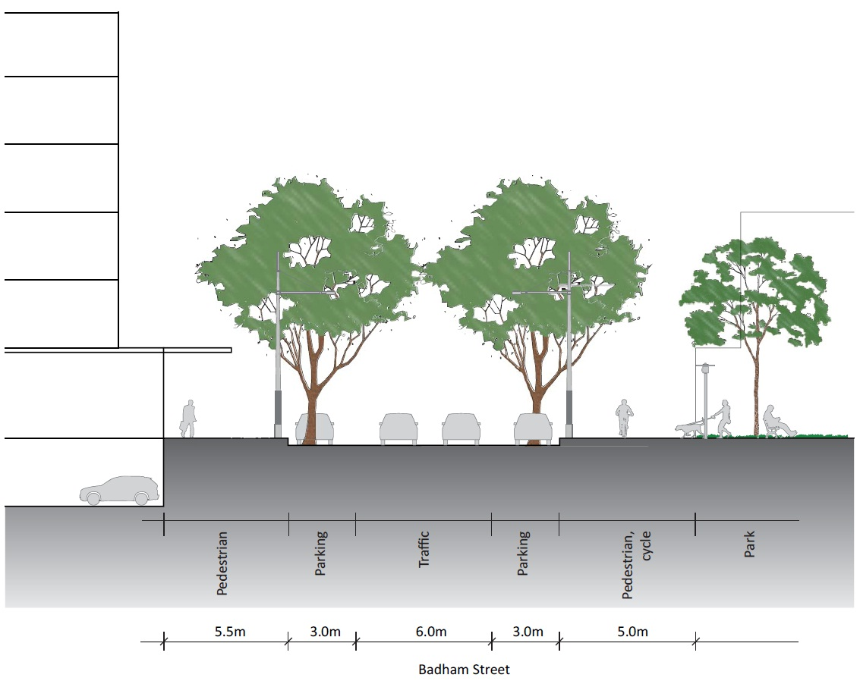
Figure 10 Badham Street
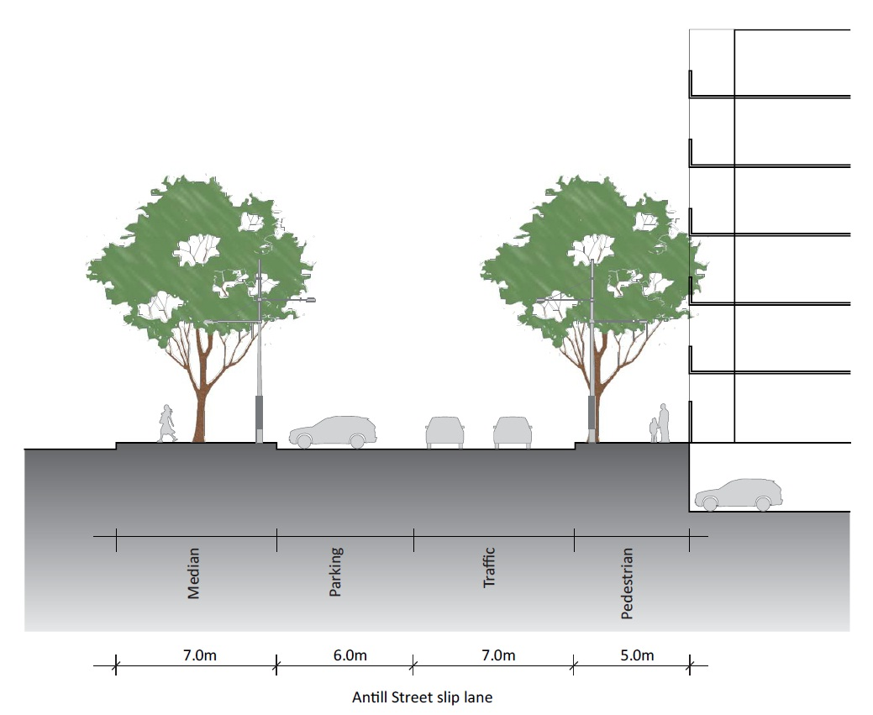
Figure 11 Antill Street road reserve

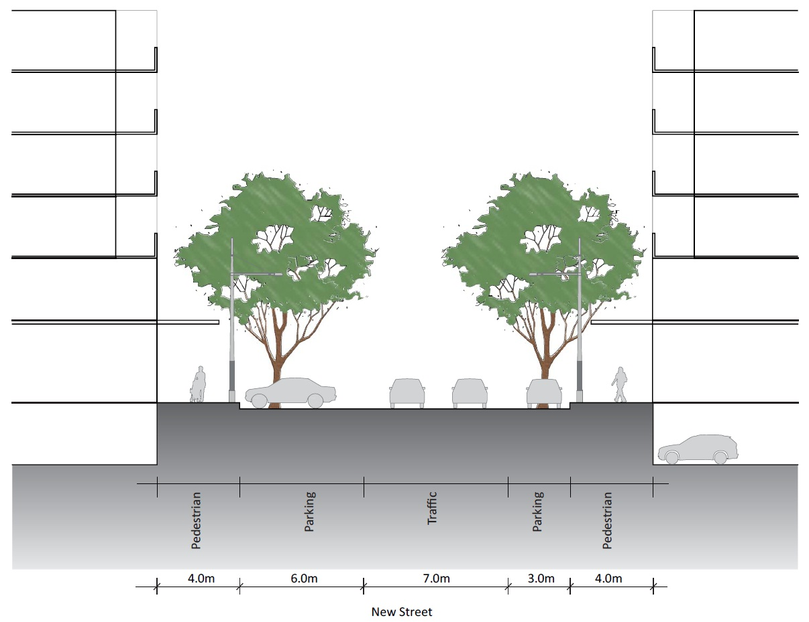
Figure 12 Cape Street extension
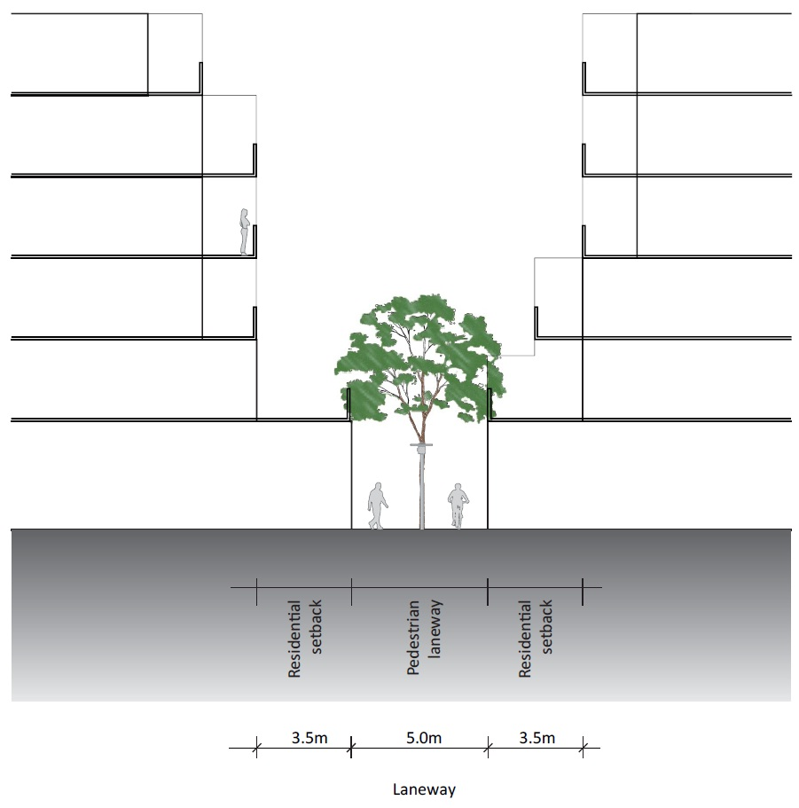
Figure 13 Laneway along north-south view corridor

