Australian Capital Territory

Planning and Development (Technical Amendment—Code and clarification amendment) Plan Variation 2012 (No 3)*
Notifiable instrument NI2012—411
Technical Amendment No 2012-24
made under the
Planning and Development Act 2007, section 89 (Making technical amendments)

This Technical Amendment commences on 10 August 2012.

Technical Amendment Number 2012-24 to the Territory Plan has been approved by the Planning and Land Authority.

Ben Ponton
Delegate of Planning and Land Authority

8 August 2012
This page is intentionally blank

Planning & Development Act 2007

Technical Amendment
to the Territory Plan
Variation 2012-24

Rezoning of land within the future urban area on the Territory Plan map - Molonglo

August 2012

Table of Contents

1. INTRODUCTION 1
Outline of the process 1
2. EXPLANATORY STATEMENT 2
Proposed changes, reasons and compliance with the Planning and Development Act 2007 2
3. TECHNICAL AMENDMENT 7
3.1 S95 Amendment 7

INTRODUCTION

Outline of the process
The Commonwealth’s Australian Capital Territory (Planning and Land Management) Act 1988 allows for the Legislative Assembly to make laws to establish a Territory Planning Authority and for that Authority to prepare and administer a territory plan.
The Planning and Development Act 2007 (the Act) establishes the ACT Planning and Land Authority as the Authority which prepares and administers the territory plan, including continually reviewing and proposing amendments as necessary. The responsibilities of the ACT Planning and Land Authority are administered by the Environment and Sustainable Development Directorate (ESDD).
Technical amendments to the territory plan are prepared in accordance with the Act. This technical amendment has been prepared in accordance with the following section of the Act:
- A variation under section 95(1) of the Act is a rezoning within a future urban area, and is a technical amendment that is consistent with the principles and policies in the structure plan for the area. Limited consultation is required for technical amendments made under section 95.

Following the release of the variation under section 90 of the Act, submissions from the public are invited. At the conclusion of the limited consultation period, any representations are considered by the ACT Planning and Land Authority (the Authority). The Authority then determines a day when the code variation is to commence by way of a commencement notice.

EXPLANATORY STATEMENT

Proposed changes, reasons and compliance with the Planning and Development Act 2007
- Rezoning of land within the future urban area shown on the Territory Plan map – Molonglo - Stage 2 (item 1)
A draft planning and design framework (PDF) technical report for the whole of Molonglo Valley stage 2 was completed in July 2011. The three stages of Molonglo are identified in Figure 1 below.

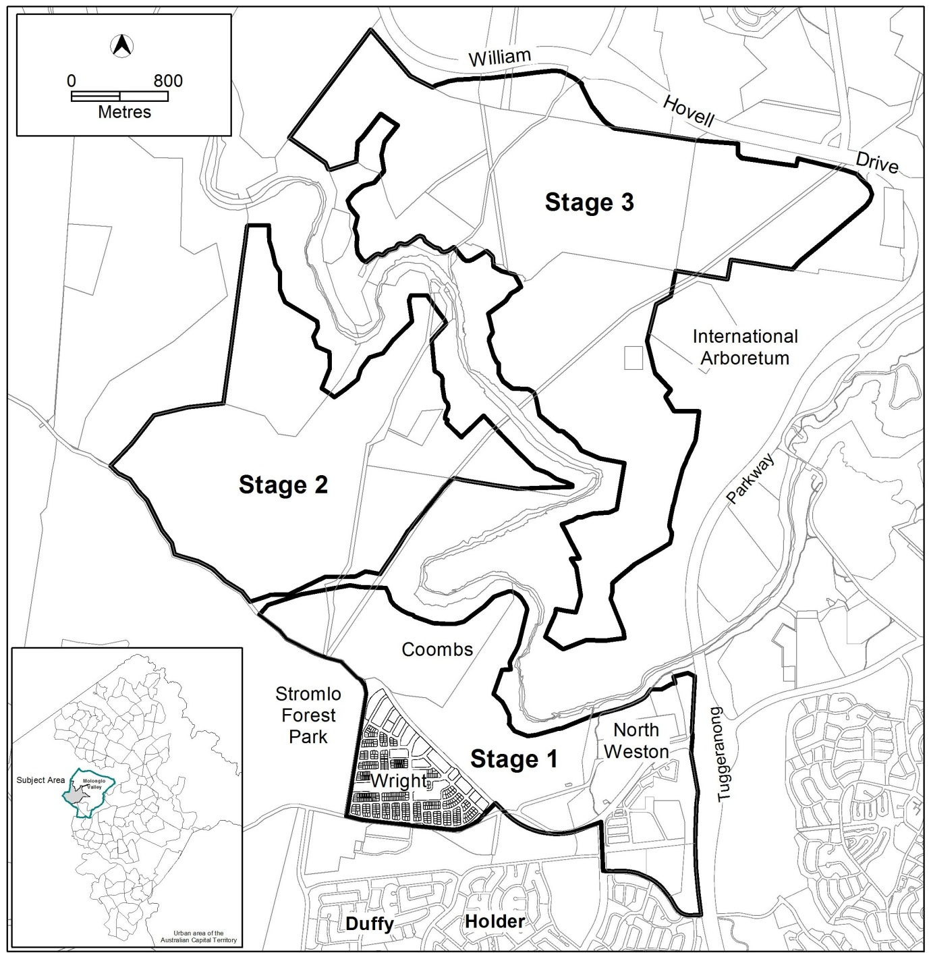

Figure 1: Stages of Molonglo location map

The PDF was approved by the ESDD Chief Planning Executive on 17 April 2012. Accordingly this technical amendment reflects the indicative locations of the major roads and land uses for Molonglo Valley stage 2 as described by the approved PDF.

The changes arising from the PDF are described in detail in Table 1 of this technical amendment. However, the key changes include the following:
- The realignment of the north-south arterial road and associated bridge crossing of the Molonglo River to protect medium to high quality pink-tailed worm lizard habitat in the river corridor, as a requirement of the Molonglo Valley Plan for the Protection of Matters of National Environmental Significance (September 2011).
- The group centre in stage 2 has been relocated to a more elevated and central site within the district which will enable better connections to surrounding residential areas.
Molonglo Stage 2 will retain its future urban area overlay in the Territory Plan. This will enable zones to be further refined as a result of more detailed planning for the Molonglo District, including an estate development planning process. Ultimately, the zoning of the land will be finalised at the time of the uplift of the future urban area overlay under section 96 of the Act.

Section of the Act | Statement of compliance with the Act
S95(1) a variation (a rezoning of FUA variation) that -
(i) would only rezone part of a FUA; and | This technical amendment only proposes to rezone land that is within the future urban area overlay of the Territory Plan map.
(ii) is consistent with the Structure plan for the FUA | The proposed amendment is considered to be consistent with the purpose of the Structure Plan for Molonglo and North Weston as identified in the assessment contained in Table 1 below.

Table 1 – Compliance of the proposed technical amendment with the Molonglo structure plan within the Territory Plan:
Proposed change | Structure plan (clauses referenced) | Compliance with the structure plan
North - south arterial road. | 41. Major roads will be located on the less steep land. | The topography of Molonglo Valley stage 2 is relatively steep, with over half of the site having slopes greater than 10%. The proposed alignment is on slopes that are generally less than 10%.
 | 75. North South arterial to connect Coulter Drive and or Bindubi Street to Cotter Road in the south. | The proposed alignment does not affect these connections.
PRZ1 north south corridor widened, expanded and linked through a local centre. | 36. Urban development will be generally in accordance with the zones applying to the future urban area shown on the Territory Plan map. | The proposed open space corridor is intended to be a pedestrian open space network linking the surrounding residential areas with a local centre and a school. It has therefore been altered on the Territory Plan map to better serve this purpose.
CZ5 has been removed and replaced with mostly RZ4 and some PRZ1. | 36. Urban development will be generally in accordance with the zones applying to the future urban area shown on the Territory Plan map. | It is proposed to use a mix of zones to achieve a mix of development rather than utilising the CZ5 zone. Therefore the same outcomes can be achieved.
 | 52. (d) residential mixed uses to be located near the major and minor group centres and in areas of high amenity. | As above.
 | 88. Commercial uses, generally of a non retail nature, may be located within the CZ5 zone to the north east of the group centre, at the edge of the Molonglo River corridor. These uses may be associated with river corridor activities and/or residential development. | As above.
The two indicative local centres have been replaced with one (1) local centre in a more central location. | 12. Commercial and retail activities will be concentrated in centres and other planned nodes well serviced by public transport to ensure an efficient pattern of development and high levels of accessibility. | The two local centres are currently identified as dots on the Territory Plan map. This means they are indicative only. More detailed planning has identified the need for only one local centre in stage 2. This local centre is proposed to be located more centrally than the two indicative centres on the existing map. In this central location, the local centre will be more accessible and well serviced by public transport.
 | 13. The group and local centres will be located on major roads and will have good pedestrian and vehicular access. | As above, noting also that the open space corridor now provides a pedestrian link through the community facility CF zoned land to the `proposed local centre.
 | 36. Urban development will be generally in accordance with the zones applying to the future urban area shown on the Territory Plan map. | As above, noting also that the Structure Plan does not stipulate the number of local centres to be provided.
 | 89. Local centres providing for convenience shopping are to be located throughout the development area at key focal points having good pedestrian and vehicular access. Local centres will be located generally in accordance with the Territory Plan map. | As above.
The CZ1 group centre is generally in the same location but is now centred on a more elevated site. | 12. Commercial and retail activities will be concentrated in centres and other planned nodes well serviced by public transport to ensure an efficient pattern of development and high levels of accessibility. | The site for the group centre is proposed at the junction of the north–south and east–west arterial roads and as such is situated to be highly accessible to surrounding areas and will be readily serviced by public transport.
 | 13. The group and local centres will be located on major roads and will have good pedestrian and vehicular access. | As above.
 | 84. A large group centre is to be located on elevated land at junction of the north-south and east-west arterials. | As above. The group centre remains at the junction of the major north-south and east-west roads.
The four indicative Community Facility locations (2 large, 2 small) have been replaced by three large areas of Community Facility zonings. | 5. Community Facility sites will be located close to public transport and generally in places where. For reasons of public safety, people already have a cause to congregate, particularly at shopping centres and schools. | One site is adjacent to the local centre and another is adjacent to the group centre. The third site is adjacent to the major north- south arterial road.
The two RZ3 circles have been removed. | 2. Provisions will be made for a range of housing types, densities and affordability, to meet changes in household and community needs and encourage the formation of a diverse community. | A mix of residential zones is proposed to achieve the outcomes of the Structure Plan including the residential RZ1 suburban, RZ4 medium density and RZ5 high density zones.
 | 36. Urban development will be generally in accordance with the zones applying to the future urban area shown on the Territory Plan map. | As above.
Two large areas of RZ4 have been introduced (in addition to the RZ4 which replaces the CZ5). | 2. Provisions will be made for a range of housing types, densities and affordability, to meet changes in household and community needs and encourage the formation of a diverse community. | As above.
 | 3. Higher density development will be encouraged within and near major centres, and in other suitable locations well served by public transport, maximising accessibility to services, facilities and employment. | One RZ4 zone is located in proximity to the group centre and the local centre. The other is on a proposed future public transport loop linking the local centre with group centre.
 | 11. Higher density will be generally located near areas of higher amenity and public transport routes. | As above, noting that the second RZ4 area, to the north is in an area of high amenity close to the Molonglo River corridor.
 | 36. Urban development will be generally in accordance with the zones applying to the future urban area shown on the Territory Plan map. | A mix of residential zones is proposed to achieve the outcomes of the Structure Plan including the residential RZ1 suburban, RZ4 medium density and RZ5 high density zones.
 | 52. (a) suburban scale housing is to be the dominant housing type. | Residential RZ1 suburban is still the largest zoned area.
 | 52. (c) Medium density housing, which may include a higher built form is to be located on land near major transport routes, commercial centres, at activity nodes and in locations with higher amenity such as near the proposed pond on Weston Creek, adjacent to the Molonglo River Corridor and other substantial public open spaces. | As stated above, one RZ4 is located in proximity to the group centre and the local centre. The other is on a proposed future public transport loop linking the local centre with group centre. The second RZ4 area, to the north is in an area of high amenity close to the Molonglo River corridor.
The RZ5 ribbon has been replaced with extensive areas of RZ5. | 2. Provisions will be made for a range of housing types, densities and affordability, to meet changes in household and community needs and encourage the formation of a diverse community. | A mix of residential zones is proposed to achieve the outcomes of the Structure Plan including the residential RZ1 suburban, RZ4 medium density and RZ5 high density zones.
 | 3. Higher density development will be encouraged within and near major centres, and in other suitable locations well served by public transport, maximising accessibility to services, facilities and employment. | The RZ5 high density residential zoning is located in proximity to the group centre and the proposed local centre. It is also located on the major north-south and proposed east-west arterial roads.
 | 11. Higher density will be generally located near areas of higher amenity and public transport routes. | As above.
 | 36. Urban development will be generally in accordance with the zones applying to the future urban area shown on the Territory Plan map. | A mix of residential zones is proposed to achieve the outcomes of the Structure Plan including the residential RZ1 suburban, RZ4 medium density and RZ5 high density zones.
 | 52. (a) suburban scale housing is to be the dominant housing type. | Residential RZ1 suburban is still the largest zoned area.

TECHNICAL AMENDMENT
    - S95 Amendment

Variation to the Territory Plan map
- Territory Plan map - Molonglo

Substitute the ‘Area subject to the technical amendment’ in Figure 2 with the ‘Area subject to the technical amendment’ in Figure 3

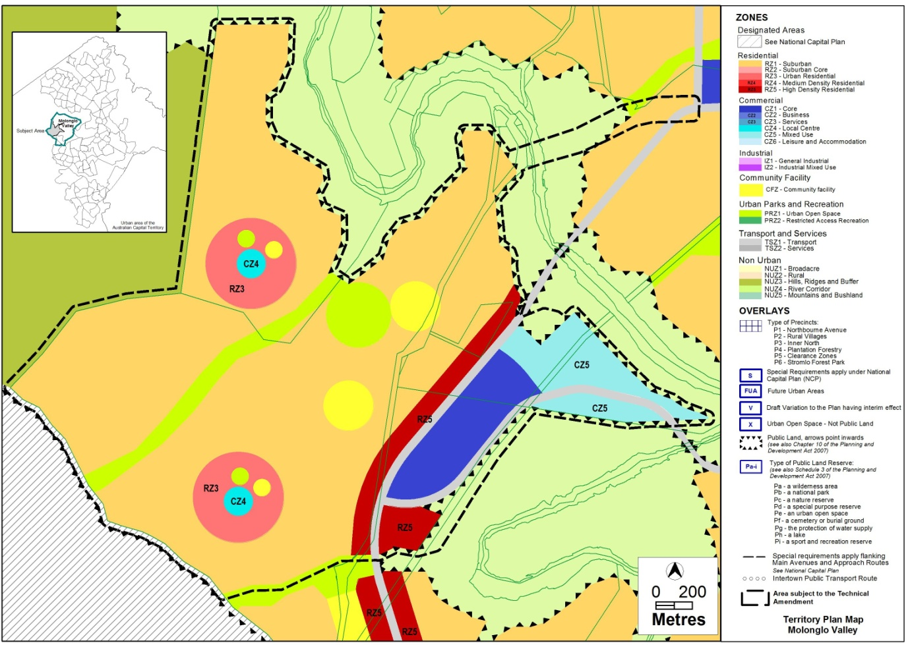
Figure 2: Current Territory Plan map showing the area subject to the technical amendment.

.

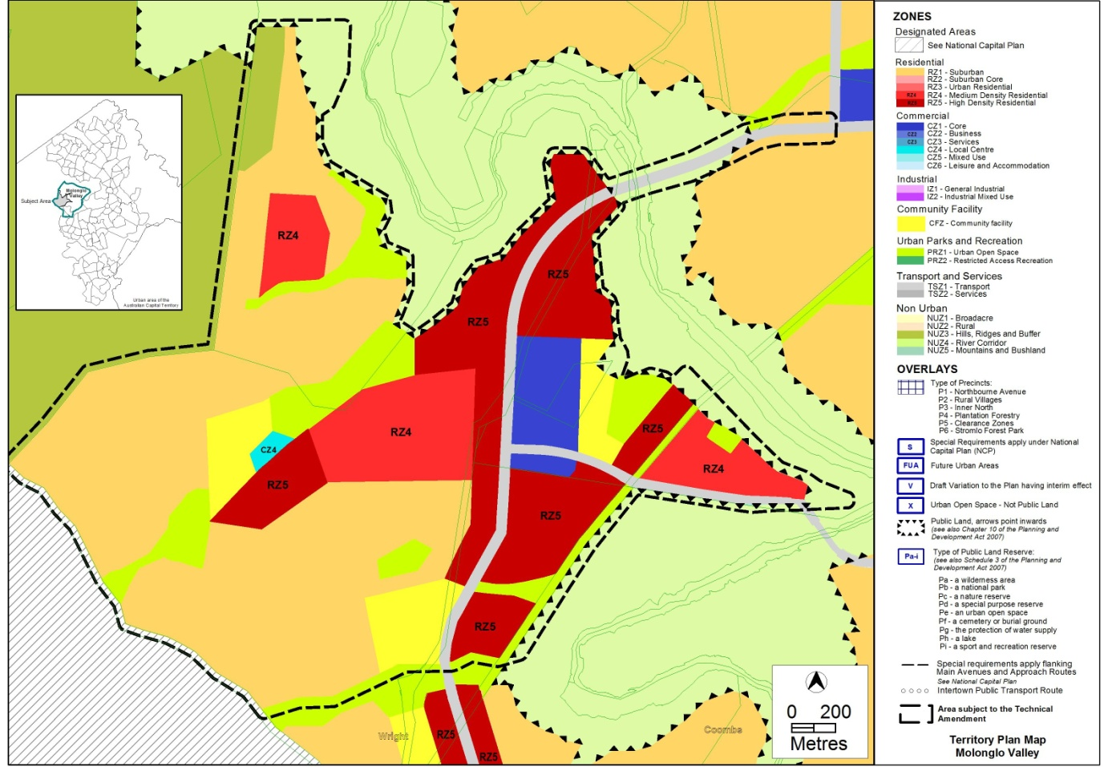
Figure 3: Proposed map showing land use zones in the future urban areas of Molonglo stage 2.

Interpretation service
