Australian Capital Territory

Heritage (Revocation of Provisional Registration and Decision about Provisional Registration of Lower Molonglo Geological Site, Stromlo) Notice 2012

**Notifiable Instrument NI 2012—472**

made under the

*Heritage Act 2004* section 34 Notice of decision about provisional registration

1. **Revocation**This instrument revokes the ACT Heritage Council decision of 24 June 2010 – NI 2010—336 *(Decision about Provisional Registration for Lower Molonglo Geological Site).*
2. **Name of instrument**This instrument is the Heritage *(Revocation of Provisional Registration and Decision about Provisional Registration of Lower Molonglo Geological Site, Stromlo) Notice 2012.*
3. **Registration details of the place**

On 6 September 2012 the ACT Heritage Council decided to provisionally register the Lower Molonglo Geological Site, Stromlo to the ACT Heritage Register. Registration details of the place are at Attachment A: Provisional Register entry for Lower Molonglo Geological Site, Stromlo.

1. **Reason for decision**

The statutory time period for deciding whether to register the Lower Molonglo Geological Site, Stromlo in accordance with Council’s decision of 24 June 2010 (NI 2010—336) lapsed as Council had not yet made a decision on its final registration.

The Council is satisfied that the Lower Molonglo Geological Site, Stromlo may have heritage significance as defined in section 10 of the *Heritage Act 2004* (heritage significance criteria), and has recommenced the registration process by re-provisionally registering the place. The provisional register entry is at Attachment A.

1. **Date of Provisional Registration**6 September 2012
2. **Indication of council's intention**

The Council intends to decide whether to register the place under Division 6.2 within 5 months of provisional registration.

1. **Public consultation period**

The Council invites public comment by Wednesday 10 October 2012 on the provisional registration of the Lower Molonglo Geological Site, Stromlo to:

The Secretary

ACT Heritage Council

GPO Box 158

CANBERRA ACT 2601

**Jennifer O’Connell  
A/g Secretary  
ACT Heritage Council**

**6 September 2012**

|  |  |
| --- | --- |
|  | **AUSTRALIAN CAPITAL TERRITORY**  **HERITAGE REGISTER**  **(Provisional Registration Details)** |

For the purposes of s. 33 of the *Heritage Act 2004*, an entry to the heritage register has been prepared by the ACT Heritage Council for the following place:

**Lower Molonglo Geological Site, Stromlo**

**DATE OF PROVISIONAL REGISTRATION**

6 September 2012 Notifiable Instrument: 2012—472

**PERIOD OF EFFECT OF PROVISIONAL REGISTRATION**

Start Date: 6 September 2012 End Date: 6 February 2013

**Extended Period (if applicable) Start Date** ________ **End Date** _______

Copies of the Register Entry are available for inspection at the ACT Heritage Unit. For further information please contact:

The Secretary

ACT Heritage Council

GPO Box 158, Canberra, ACT 2601

Telephone: 13 22 81 Facsimile: (02) 6207 2229

**IDENTIFICATION OF THE PLACE**

**Lower Molonglo Geological Site, Stromlo** Part Blocks 1020, 1576, 168 Belconnen; Part Blocks 45, 403, 482 District of Stromlo

The site (also known as Coppins Crossing, fossiliferous limestone and shale) is in two sections, at the top of the river banks and adjacent flats on both sides of the Lower Molonglo River, approximately 3 km downstream from Coppins Crossing (see Map 3).

**STATEMENT OF HERITAGE SIGNIFICANCE**

This statement refers to the Heritage Significance of the place as required in s12(d) of the *Heritage Act 2004*.

The Lower Molonglo Geological Site, Stromlo is a significant outcrop of limestone that contains evidence of a rich and diverse array of marine fossils, including corals, trilobites, brachiopods, gastropods and ostracods, including some species first described from specimens from this site. It is one of the best-known and richest Middle Silurian faunal assemblages in eastern Australia, dating from 425 million BP. The outcrop is of value in dating similarly aged rocks elsewhere in the region.

**FEATURES INTRINSIC TO THE HERITAGE SIGNIFICANCE OF THE PLACE**

The physical features of the Lower Molonglo Geological Site that particularly reflect its heritage significance are:

The outcrops of fossil bearing limestone and shale/siltstone. The just-visible outcrops are manifestations of a continuous feature, and the underground sectors between the outcrops are equally significant.

The limestone rocks contain a range of marine fossils, including corals, trilobites, brachiopods, gastropods and ostracods.

**APPLICABLE HERITAGE GUIDELINES**

Heritage Guidelines adopted under s25 of the *Heritage Act* 2004 are applicable to the conservation of the Lower Molonglo Geological Site.

The guiding conservation objective is that the Lower Molonglo Geological Site, shall be conserved and appropriately managed in a manner respecting its heritage significance and the features intrinsic to that heritage significance, and consistent with a sympathetic and viable use or uses. Any works that have a potential impact on significant fabric (and / or other heritage values) shall be guided by a professionally documented assessment and conservation policy relevant to that area or component (i.e. a Statement of Heritage Effects – SHE).

**REASON FOR PROVISIONAL REGISTRATION**

The Lower Molonglo Geological Site has been assessed against the heritage significance criteria and been found to have heritage significance when assessed against four criteria under the *Heritage Act* 2004 including (f), (g), (i) and (j).

**ASSESSMENT AGAINST THE HERITAGE SIGNIFICANCE CRITERIA**

Pursuant to s.10 of the *Heritage Act 2004,*a place or object has heritage significance if it satisfies one or more of the following criteria. Significance has been determined by research as accessed in the references below. Future research may alter the findings of this assessment.

1. **It demonstrates a high degree of technical or creative achievement (or both), by showing qualities of innovation, discovery, invention or an exceptionally fine level of application of existing techniques or approaches.**

The Lower Molonglo Geological Site, Stromlo does not meet this criterion.

1. **It exhibits outstanding design or aesthetic qualities valued by the community or a cultural group.**

The Lower Molonglo Geological Site, Stromlo does not meet this criterion.

1. **It is important as evidence of a distinctive way of life, taste, tradition, religion, land use, custom, process, design or function that is no longer practised, is in danger of being lost or is of exceptional interest.**

The Lower Molonglo Geological Site, Stromlo does not meet this criterion.

1. **It is highly valued by the community or a cultural group for reasons of strong or special religious, spiritual, cultural, educational or social associations**

The Lower Molonglo Geological Site, Stromlo does not meet this criterion.

1. **It is significant to the ACT because of its importance as part of local Aboriginal tradition.**

The Lower Molonglo Geological Site, Stromlo does not meet this criterion.

1. **it is a rare or unique example of its kind, or is rare or unique in its comparative intactness**

The site is regionally unique in the number of type species and genera of Middle Silurian animals which have been described from it.

**(g) it is a notable example of a kind of place or object and demonstrates the main characteristics of that kind**

The site is a notable example of a Middle Silurian faunal assemblage and has been described as containing “probably the best documented fossil fauna from the Wenlockian (Middle Silurian) of eastern Australia” (Owen 1987).

1. **It has strong or special associations with a person, group, event, development, or cultural phase in local or national history.**

The Lower Molonglo Geological Site, Stromlo does not meet his criterion.

1. **it is significant for understanding the evolution of natural landscapes, including significant geological features, landforms, biota or natural processes**

The site is regarded as a benchmark for dating rocks of similar age in the region, an essential stage in understanding the evolution of landscapes.

**(j) it has provided, or is likely to provide, information that will contribute significantly to a wider understanding of the natural or cultural history of the ACT because of its use or potential use as a research site or object, teaching site or object, type locality or benchmark site.**

The site is valuable as a type locality for three genera and fourteen species of trilobites, and two genera and ‘several’ brachiopod species (Owen 1987), thus giving the site significance as a teaching and research opportunity.

1. **for a place – it exhibits unusual richness, diversity or significant transitions of flora, fauna or natural landscapes and their elements.**

The Lower Molonglo Geological Site, Stromlo does not meet this criterion.

**(l) for a place- it is a significant ecological community, habitat or locality for any of the following:**

**(i) the life cycle of a native species:**

**(ii) rare, threatened or uncommon species;**

**(iii) species at the limits of their natural range;**

**(iv) distinct occurrences of species**

The Lower Molonglo Geological Site, Stromlo does not meet this criterion.

**SUMMARY OF THE PLACE**

**HISTORY AND PHYSICAL DESCRIPTION**

The site, in two sections, is at the top of the riverbanks and adjacent flats on both sides of the Molonglo River (see Map 3). The section north and east of the river is defined by a series of conspicuous dark grey fossil-bearing limestone outcrops. This section is approximately 1.2 km from north to south and 300m east to west. In addition there are smaller fossil-bearing shale and siltstone outcrops south of the river; this area is of approximately the same width as the larger one, and some 700m north to south. A depiction of the location of the visible outcrops is indicated at Map 1 which has been adapted from Owen (1978).

Within the Wenlochian Walker Volcanics (of the Middle Silurian, i.e. around 425 million years BP) at the site are exposures of fossil-bearing limestone and shale of similar age. The limestone in particular is conspicuous, forming large dark grey blocks on the valley slope below the 550 metre contour above, and east and north of, the Molonglo River. In situ, the 3-5 metre thick limestone layer is topped by up to 4 metres of shale.

To the south of the river are smaller shale outcrops. Both sedimentary rock types have rich and diverse marine fossils, including corals, trilobites, brachiopods, gastropods and ostracods. Study of these fossils in the early 1980s revealed five new genera, and many new species, of trilobites and brachiopods. This makes it one of the best-known and richest Middle Silurian faunal assemblages in eastern Australia. It is thus also of value in dating similarly aged rocks elsewhere in the region.

**non-statutory background information**

There has been some disturbance in the past, from grazing-associated erosion, and from roadworks and (backfilled) trenching for a sewage line outfall trench, but in general the site is in good condition.

The site is well known to and highly significant to geologists as well as palaeontological societies. (Chatterton, 1980 and Henderson, 1981) The site was included in the Sites of Significance list compiled by NCDC (1998 p47) and its values described by the Geological Society of Australia (Owen 1978).

**REFERENCES**

Chatterton, B.D.E. and Campbell, K.S.W. 1980. Silurian Trilobites from near Canberra and some related forms from the Yass Basin. *Palaeontographica Abteilung* A. 167, 77-119. Pls 1-16.

Henderson, G.A.M. 1981. Geology of Canberra, Queanbeyan and environs. Notes to accompany the 1980 geological map. Australian Government Publishing Service, Canberra.

NCDC 1988*. Sites of Significance in the ACT*. Vol 6 Stromlo and Uriarra Areas. Technical Paper No. 56 National Capital Development Commission, Canberra, ACT, Australia.

Owen, M. 1978 Geological Monuments in the Australian Capital Territory. Report prepared by the Territories Division of the Geological Society of Australia for the Australian Heritage Commission.

**MAPS** **AND IMAGES**

**Appendix A:** ***Site numbers refer to Map 1.***

***Site 1.*** *Major limestone outcrop at   
350 16' 35.5"S 1490 01' 14.5"E, 545 metres asl.*

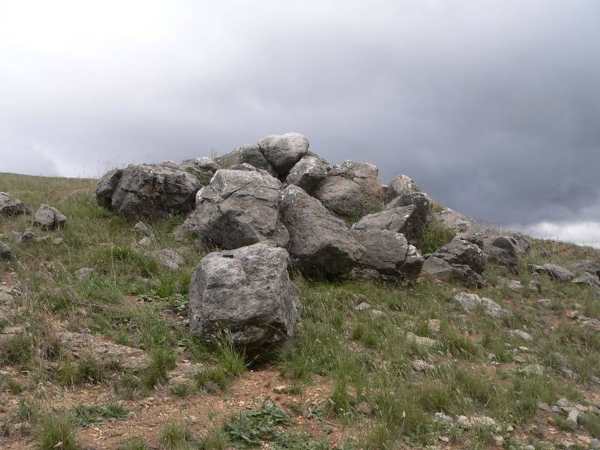

***Site 3.*** *Limestone block above river at   
350 16' 31.5"S 1490 01' 09"E, 515 metres asl.*

***Site 5.*** *Limestone above river at   
350 16' 28.5"S 1490 01' 09.5"E, 520 metres asl.*

***Site 2.*** *Limestone block above river at   
350 16' 36"S 1490 01' 09"E, 515 metres asl.*

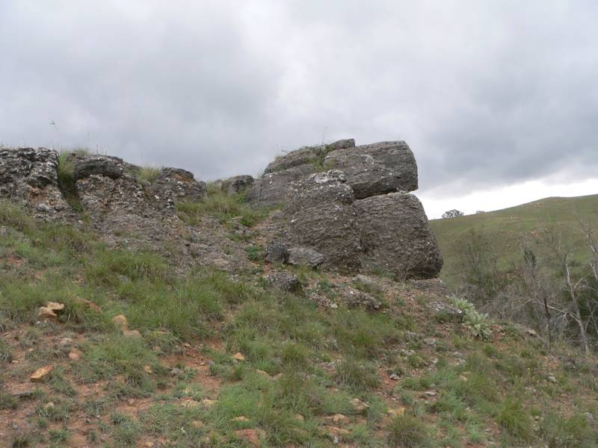

***Site 4.*** *Surface shale, looking south towards Site 1,  
350 16' 32"S 1490 01' 12"E, 530 metres asl.*

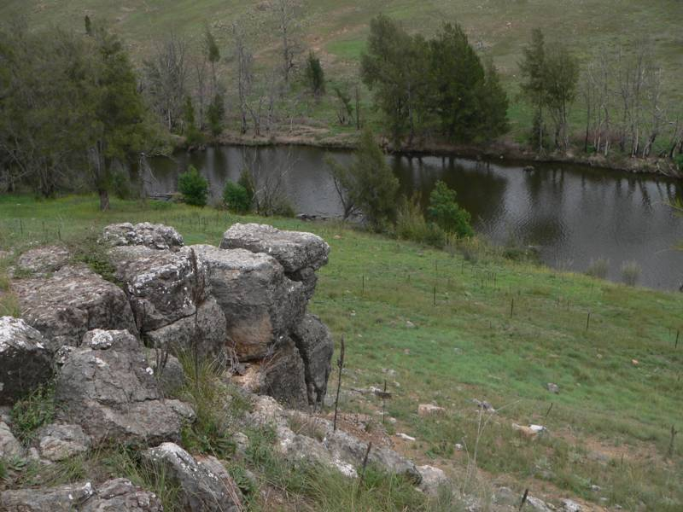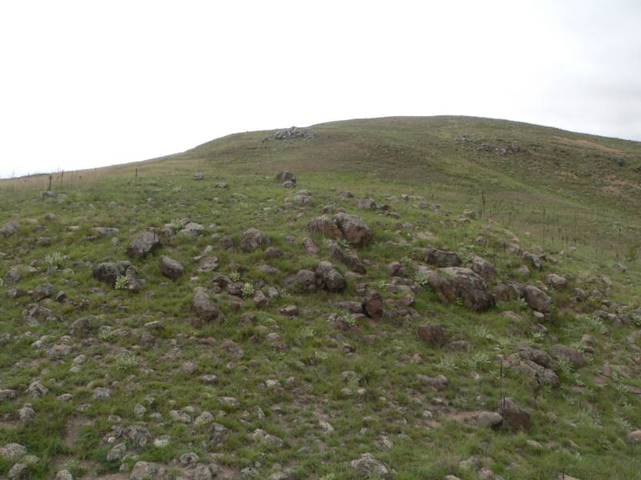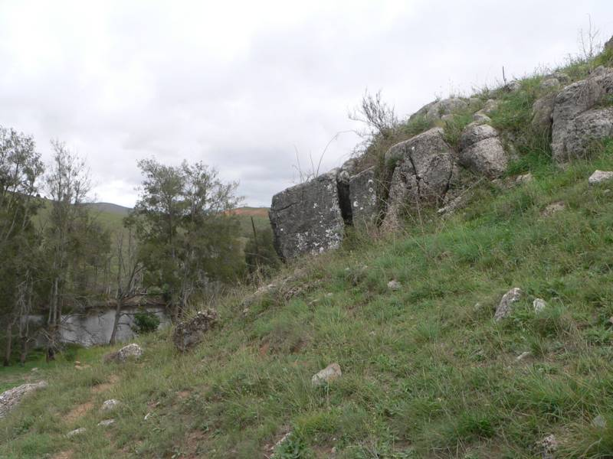

***Site 6.*** *Granite streamline at  
350 16' 24.5"S 1490 01' 11"E, 520 metres asl.*

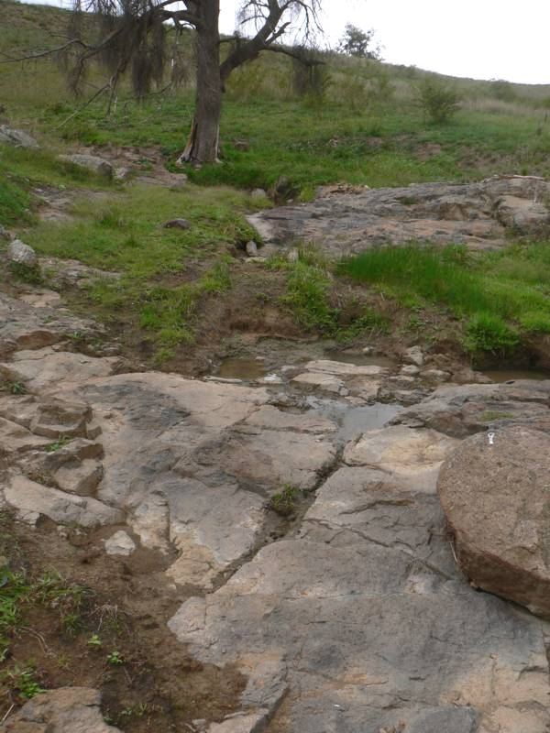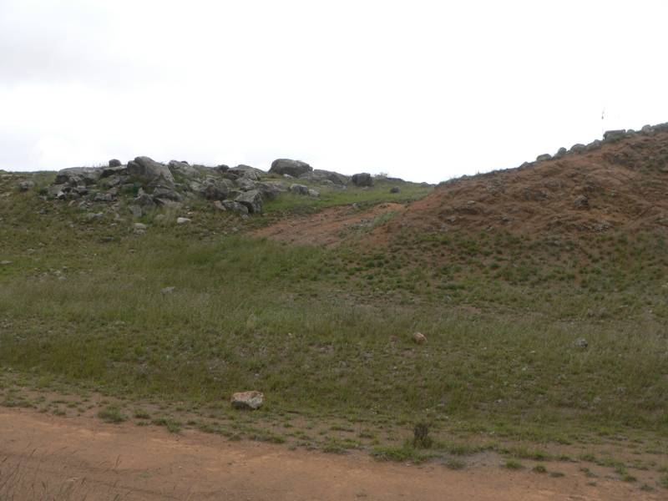

***Site 7.*** *Limestone on left, shale on right, looking east;  
350 16' 15.5"S 1490 01' 06.5"E, 535 metres asl.*

**MAP 1. Geological Features**

**From NCDC 1988. Numbers refer to Sites identified in photos above.**

**MAP 2. Location of Site**



**MAP 3 Lower Molonglo Geological Site Showing Registered Area**

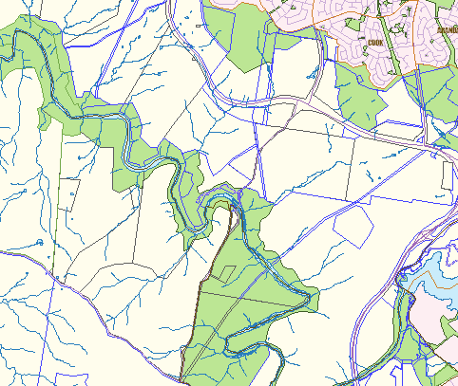

**area shown in map 1**

**Molonglo River**

**Coppins Crossing**

