Australian Capital Territory

Heritage (Decision about Registration of Hill Station, Hume) Notice 2012

**Notifiable Instrument NI2012—540**

made under the

*Heritage Act 2004* section 42 Notice of Decision about Registration

1. **Revocation**

This instrument replaces NI 2012 —283.

1. **Name of instrument**This instrument is the *Heritage (Decision about Registration of   
   Hill Station, Hume) Notice 2012.*
2. **Registration details of the place**

Registration details of the place are at Attachment A: Register entry for   
Hill Station, Hume.

1. **Reason for decision**

The ACT Heritage Council has decided that Hill Station, Hume meets one or more of the heritage significance criteria at s 10 of the *Heritage Act 2004*.   
The register entry is at Attachment A.

1. **Date of Registration**18 October 2012

**Jennifer O’Connell  
A/g Secretary** (as delegate for) **ACT Heritage Council**

**18 October 2012**

|  |  |
| --- | --- |
|  | **AUSTRALIAN CAPITAL TERRITORY**  **HERITAGE REGISTER**  **(Registration Details)** |

For the purposes of s. 41 of the *Heritage Act 2004*, an entry to the heritage register has been prepared by the ACT Heritage Council for the following place:

Hill Station, Hume

Block 5 Section 5 Hume, ACT

**DATE OF REGISTRATION**

18 October 2012 Notifiable Instrument: 2012—540

Copies of the Register Entry are available for inspection at the ACT Heritage Unit. For further information please contact:

The Secretary

ACT Heritage Council

GPO Box 158, Canberra, ACT 2601

Telephone: 13 22 81 Facsimile: (02) 6207 2229

**IDENTIFICATION OF THE PLACE**

* Hill Station Block 5 Section 5 Suburb Hume, ACT

**STATEMENT OF HERITAGE SIGNIFICANCE**

Hill Station is important as an early homestead complex, parts of which date from 1862, which displays evidence of a nineteenth century rural lifestyle as well as a rare construction technique (pise). Hill Station has a strong association with the early settlement period of the Australian Capital Territory. The complex presents an example of the size of dwellings and ways of domestic life of the European settlers who first took up residence in the area which was to become the ACT.

Hill Station displays several differing construction techniques used in nineteenth and early twentieth century rural Australia. In particular the pisé (pisé de terre or rammed earth) method of construction was well suited to the south-east Australian climatic conditions and used mud, which was cheap and readily available to early settlers. The pisé cottage is one of the earliest pisé constructions in the ACT.

Hill Station, as an outstation of nearby Woden, has strong associations with the Campbell family of Duntroon, who established Woden and were a prominent family in the early development of pastoralism in the ACT. Since its acquisition by the Commonwealth, the Hill Station has been leased by several families including those of two former Government ministers; Sir David Fairbairn who held the defence portfolio for some years after the Second World War, and Sir Henry Gullett who held various portfolios including Vice President of the Executive Council. During their tenures, Hill Station hosted the visits of diplomats and foreign dignitaries during the early development of Canberra.

**OTHER RELATED PLACES**

* Woden Homestead
* Tralee Homestead
* Rose Cottage
* Couranga Homestead

**FEATURES INTRINSIC TO THE HERITAGE SIGNIFICANCE OF THE PLACE**

Features intrinsic to the heritage significance of the place which require conservation include:

## Individually identified buildings and structures including:

Pisé homestead (c. 1909) (excluding 1980s extensions)

Pisé homestead interiors, including floors, walls, ceilings, roof, windows, doors and timber verandah (excluding 1980s fitouts)

Service wing (servants’ quarters) including historic wall alignments and masonry fireplace

Slab cottage (1860s)

Meat house (c. 1909)

Garage (c. 1920) including the building form, existing galvanised and painted corrugated iron walls and roof, “bush timber” structural frame and the cellar and the raised floor above the cellar

1. Landscape features, including:

Trees dating before 1980

Garden setting

Stone wall on Sheppard Drive

The layout of the complex including the open spaces between:

* the garage and service wing (servants quarters)
* the service wing (Servants quarters) and the pisé homestead
* the garage, service wing and homestead as far as Sheppard Drive
* the front of the pisé homestead and the present carpark
* the pisé homestead, slab cottage and 1980s function room

|  |
| --- |
|  |

**APPLICABLE HERITAGE GUIDELINES:**

The ‘Heritage Guidelines: General Conservation Guidelines for Historic Heritage Places 2012’ adopted under s25 of the *Heritage Act* 2004 are applicable to the conservation of Hill Station.

The guiding conservation objective is that Hill Station shall continue to be conserved and appropriately managed in a manner respecting its heritage significance and the features intrinsic to that heritage significance, and consistent with a sympathetic and viable use or uses. Any works that have a potential impact on significant fabric (and / or other heritage values) shall be guided by a professionally documented assessment and conservation policy relevant to that area or component (i.e. a Statement of Heritage Effects – SHE). Any actions impacting on the significance of Hill Station are to be based on professional conservation planning.

**REASON FOR REGISTRATION**

Hill Station has been assessed against the heritage significance criteria and found to have significance when assessed against five criteria under the *Heritage Act 2004*, including (a), (c), (d), (f) and (j).

**ASSESSMENT AGAINST THE HERITAGE SIGNIFICANCE CRITERIA**

Pursuant to s. 10 of the Heritage Act 2004, a place or object has heritage significance if it satisfies one or more of the following criteria. Significance has been determined by research as accessed in the references below. Future research may alter the findings of this assessment.

1. it demonstrates a high degree of technical or creative achievement (or both), by showing qualities of innovation, discovery, invention or an exceptionally fine level of application of existing techniques or approaches;

Hill Station does not meet this criterion.

1. **it exhibits outstanding design or aesthetic qualities valued by the community or a cultural group;**

Hill Station does not meet this criterion.

1. **it is important as evidence of a distinctive way of life, taste, tradition, religion, land use, custom, process, design or function that is no longer practised, is in danger of being lost or is of exceptional interest;**

Hill Station is a vestigial part of the early grazing properties in the Tuggeranong Valley region of the ACT. Together with other nearby homesteads Woden, Tralee and Couranga and Rose Cottage and remnant stations it is a visible reminder of the building methods employed during the nineteenth and early twentieth centuries in rural Australia.

The Hill Station group presents an example of the size of dwellings and ways of domestic life of the European settlers who first took up residence in the area which was to become the ACT. The easy accessibility of these buildings is of benefit to casual visitors, and enables them to appreciate aspects of a lifestyle once prevalent in the ACT.

Although changes and additions to the buildings have occurred and the development of the Hume Industrial Estate has destroyed the rural setting of the Hill Station group it still retains a good deal of its original structural form. This is particularly evident in the cottage, which has had minimal changes.

As such, the Hill Station group retains a potential for present generations to gain an understanding of the lifestyle of those who lived on the rural properties in the ACT last century. As such it demonstrates a distinctive way of life, domestic rural living, which is rare and becoming rarer in the ACT and surrounding area, particularly as Canberra expands and the region is subdivided.

Hill Station meets this criterion.

1. **it is highly valued by the community or a cultural group for reasons of strong or special religious, spiritual, cultural, educational or social associations;**

Hill Station does not meet this criterion.

1. **it is significant to the ACT because of its importance as part of local Aboriginal tradition**

Hill Station does not meet this criterion.

1. **it is a rare or unique example of its kind, or is rare or unique in its comparative intactness**

The main pisé homestead on Hill Station is a rare example of its kind. The various methods of construction used in Hill Station were well suited to rural districts of late nineteenth and early twentieth century Australia. In particular the pisé de terre (or rammed earth) was well suited to the south-east Australian climatic conditions and used local soil, which was cheap and readily available to early settlers. The pisé built homestead is one of the earliest pisé constructions in the ACT. The nearby pisé-built Rose Cottage was built at a similar time. The pisé homestead is one of the few examples of an early settlers pisé building which until 2009 was publically accessible.

Pisé is becoming uncommon in the ACT and in the wider region, and is under threat from development, redundancy and erosion. As a pisé homestead, Hill Station is rare in its comparative intactness. Other examples of pise in the ACT include the Rock Valley and Nil Desperandum properties at Tidbinbilla.

Hill Station meets this criterion.

1. **it is a notable example of a kind of place or object and demonstrates the main characteristics of that kind**

Hill Station demonstrates the main characteristics of a 19th and early 20th century homestead group. Hill Station is of interest for the way it demonstrates contrasting forms of construction. Its multiple buildings and different construction styles are typical of the period.

As noted, the use of pisé in the main homestead reflects a time when early settlers made use of cheap and readily available local soil in construction. The slab cottage is of a style and construction technique indicative of the 19th century. These techniques are common to many 19th century Australian rural stations.

With features including a main homestead, various outbuildings and traditional plantings, Hill Station is a representative example of a rural station.

Hill Station meets this criterion.

1. **it has strong or special associations with a person, group, event, development or cultural phase in local or national history**

The period of initial European settlement and rural establishment places Hill Station (as an outstation for Woden Station) and surrounding district in the context with squatting, land tenure, primary industry, Federation in 1901, and the compulsory acquisition of lands by the Commonwealth Government for use in the development of the National Capital. It has a strong association with the development of pastoralism in the ACT area, as an outstation of nearby Woden.

Hill Station also has strong associations with the Campbell’s of Duntroon who established nearby Woden and were a prominent family in the early settlement of the Limestone Plains (now Canberra).

Since acquisition, Hill Station has been leased by several families including those of two former Government ministers. Sir David Fairbairn, who held the defence portfolio for some years after the Second World War, and Sir Henry Gullett who held various portfolios including Vice President of the Executive Council. During their tenancy, Hill Station hosted the visits of diplomats and foreign dignitaries during the early development of Canberra. During the 1950s, one important visitor to Hill Station was British philosopher Bertrand Russell.

Hill Station meets this criterion.

1. **it is significant for understanding the evolution of natural landscapes, including significant geological features, landforms, biota or natural processes.**

Hill Station does not meet this criterion.

1. **it has provided, or is likely to provide, information that will contribute significantly to a wider understanding of the natural or cultural history of the ACT because of its use or potential use as a research site or object, teaching site or object, type locality or benchmark site.**

Hill Station does not meet this criterion.

1. **for a place—it exhibits unusual richness, diversity or significant transitions of flora, fauna or natural landscapes and their elements**

Hill Station does not meet this criterion.

1. **for a place—it is a significant ecological community, habitat or locality for any of the following:**

(i) the life cycle of native species;

(ii) rare, threatened or uncommon species;

(iii) species at the limits of their natural range;

(iv) distinct occurrences of species.

Hill Station does not meet this criterion.

**SUMMARY OF THE PLACE**

**HISTORY AND PHYSICAL DESCRIPTION**

**HISTORY**

Hill Station was not originally a separate property, but part of nearby Woden Station. The first owner was probably Francis Mowatt. In 1837 Mowatt sold Woden including the current site of Hill Station to Dr James Fitzgerald Murray. A 1925 title search for the Commonwealth Surveyor General states that Hill Station, as part of portion 12 (2,560 acres), Parish of Queanbeyan, was granted to Dr James Fitzgerald Murray by Crown Grant dated 14th April 1828 (Memorandum to Commonwealth Surveyor General, 1925, Hill Station file, Australian Archives A1196/1). Bordering properties were owned by Robert Campbell Senior and G.T. Palmer. During his ownership Dr Murray leased a large part of his property to small settlers (Fitzhardinge, 1975: 13) and the slab cottage was most likely built by one of them. Pemberton Palmer, son of G.T.Palmer, was according to Schumack (Schumack,1967: 28) proprietor of the Jerrabomberra and Hill Plain estate, which may have included the present Hill Station, for some length of time prior to 1867.

There is some uncertainty over the sequence of ownership of Hill Station following Dr Murray's title. Following his death the property may have passed to Dr Murray's brother, Terrence Murray, who then sold Woden to Thomas Rutledge (Schumack, 1967: 47). Alternatively, Charles and Martin Byrne may have acquired Woden from Dr Murray in the 1860s and then sold it to Frederick Arthur Campbell (Watson, 1927: 1). By at least 1900 (Gillespie: 1988: 240) Hill Station was a separate entity from Woden Station and in the hands of the McDonald family of Uriarra. Surrounding properties were Woden to the north, Jerrabomberra to the east, and Rose Cottage and Wanniassa to the south-west.

The present homestead was most likely erected in 1909 by Gilbert Mclnnes for Alexander and Morton McDonald. In 1924 Hill Station, then at around 5,100 acres, was subdivided and four of the lots, including the site of the homestead, were sold to James Patrick Heaton of Gurrundah. James Heaton subsequently sold his four lots to Mrs Amy Halloran of Sydney in 1925. Mrs Halloran was the wife of Henry Halloran, a lawyer of Pitt Street. The property was known as Halloran Estate and Thomas Tyson was installed as lessee. The four lots of Halloran estate straddled the NSW and the ACT border. Soon after the sale the Commonwealth acquired the land within the ACT by compulsory order on 2nd April 1925. Tyson remained as the lessee. On 27th July a further one-half acre was leased to Canberra Freeholds Ltd. What profit was made, if any, by Mrs Halloran and Mr Heaton is not certain but letters from Mrs Halloran to the Commonwealth authorities indicate that she was not entirely pleased with the compensation price of 5,000 pounds given her (Australian Archives A196/410).

Since Commonwealth acquisition, Hill Station has been leased by several families, including those of two former Government ministers. Sir David Fairbairn, who held the defence portfolio for some years after the Second World War, and Sir Henry Gullett who held various portfolios including Vice President of the Executive Council. During their tenancy Hill Station hosted the visits of diplomats and foreign dignitaries during the early development of Canberra. Sir Henry Gullett, along with J. Fairbairn MP, Minister for Air and Civil Aviation, Brigadier G. Street MP Minister of State for Army Repatriation, the Chief of General Staff, Lt Gen Sir Brudenell White, and six others, were killed in an air crash on 13 August 1940 as the plane was circling Fairbairn Airport. The Air Disaster Memorial near Fairbairn Airport marks the place of the crash.

During the late 1970s, Hill Station was unoccupied and deteriorating. The then National Capital Development Commission attributed little importance to it and for a period marked the buildings for destruction to increase the size of the Hume Industrial Estate. The Australian Heritage Commission, however, valued the "somewhat quaint Hill Station melange of architectural styles" and "the historic value of the homestead in relation to the development of the district" (Latcham, undated: 10). The buildings were retained. Its rural setting has, however, largely been destroyed with the development of the Hume Industrial Estate which surrounds the homestead group. Hill Station served as a function and conference centre, and restaurant from the 1970s until its closure in 2009. In 2012 the buildings are vacant.

Pastoral Context

The Hill Station property was one of the many properties in the Canberra region established primarily for sheep and cattle grazing.

Soon after the establishment of the first European settlement at Sydney sheep grazing became the dominant economic activity of the new colony. Following quickly after the first exploratory expeditions the first sheep and cattle came to the Limestone Plains with stockmen possibly in 1823. Land holdings were eagerly sought in this new area that promised excellent sheep and cattle grazing. By 1831 wool exports from the colony had passed 2.5 million lbw and the area from Lake Bathurst to the Monaro grazed one-third of the total sheep and cattle (Lea-Scarlett, 1968: 24). The gently sloping terrains of the Tuggeranong Valley, crossed by the Murrumbidgee and a number of its tributaries were seen as prime sheep grazing lands and became the economic impetus for a number of settlements in the surrounding region. Hill Station was designated as first-class grazing lands well into the twentieth century (Australian Archives, series A196/410).

At first, most of the land owners were absentee landlords who held large tracts of the land and placed their overseers and convict labourers on their properties. Subsequent legislation and private sales, however, gradually broke up some of the large properties in the Canberra region into smaller holdings. By 1900 Hill Station was a separate grazing property having been previously attached to the larger Woden holding.

The period of initial European settlement and rural establishment places Hill Station (Woden Station) and surrounding district in the context with squatting, land tenure, primary industry, Federation in 1901, and the compulsory acquisition of lands by the Commonwealth Government for use in the development of the National Capital.

Although the term squatter was used as a term of contempt in England and America it had very different socioeconomic connotations within the frame work of Australia's land tenure history. From the 1830s in Australia the term signified a person who had gone out into the 'unoccupied' territories and had, with or without official government sanction, claimed an area of land by building a hut or depasturing sheep or cattle. The drive behind Australia's squatting period was economic made so by the high demand for raw wool in England and later in India. Australia had the land, the labour and the type of wool for creating a valuable export trade. To take advantage of this demand squatting became the practice for many of the existing land holders in New South Wales as the frontiers of the colony spread west. The Colonial Government had an official attitude against dispersion but later saw the impossibility of preventing squatting, but in turn stressed that the Crown should maintain its rights of ownership of land beyond the boundaries of settlement. A series of land acts were put in place some with little or no success - e.g. the 1836 Act in NSW making occupation beyond the settled limits illegal and punishable by fine and the later selection legislation laid down in Robertson's Land Acts in the 1860s. These Acts showed little consideration for the suitability of the land for agriculture and largely failed to control squatting. They resulted in 'dummying' by squatters who put up nominees to buy land for them and in 'peacocking', placing hired individuals on selected land to keep an eye on the property and manage the herds. This practice had a later form in 'Pitt Street Farming' where lawyers and commercial businessmen, acting individually, in partnership, or with proxies, bought rural properties and installed lessees with the sole intent of financial gain.

The Land Acts did try to create a group of yeoman farmers on small runs but instead intensified a bitter class war between the selectors and squatters. Some land holders were able to hold on to their large runs, particularly those with suitable high yielding lands. Other properties were broken up for selection. No socially acceptable system of land settlement was worked out until towards the middle of this century.

Since the First World War, and particularly after the Second World War, the use of legislative power to acquire land compulsorily (for example, acquisitions for residential and secondary industrial development) has provided a surer means of forcing the subdivision of large estates. Exercise of this power has, however, often resulted in dissatisfaction among the parties affected by resumption leading to protracted litigation. Hill Station was one of the properties that was compulsorily acquired by the Commonwealth Government to create an outlying industrial area away from the governmental, residential and business areas of the National Capital.

**DESCRIPTION**

The Hill Station group consists of buildings of varying ages and construction techniques. The earliest structure is a small slab cottage, dated to c1862, of a style and construction technique indicative of the nineteenth century. It may have been originally constructed elsewhere, dismantled and reassembled at the present site. The walls are low and constructed of slab timber with external stucco rendering. Windows are four-paned and the floor was originally of timber. The roof is of corrugated iron over a bush timber framework. The ceiling is wooden and may be a later addition. The structure is detached from the main homestead although it had been linked by a wooden pathway. In 1925 the property was assessed for improvements and the cottage was described as a 'garden shed' with 'slab walls, galvanised iron roof [with] hardwood floors on ground’ (National Archives of Australia, series A 1961 Item 410).

Since its construction, a number of changes have been made to the cottage. After 1925 the corrugated iron chimney, originally between the current windows on the north elevation, was removed and the internal fireplace filled in. A kitchenette extension was built on the south side of the building incorporating a brick chimney. The extension is of brick but rendered and painted to blend in to the original style. Sometime after 1925 the wooden floor boards were replaced with a floor of red Canberra Bricks.

The main homestead, built c1909, is a of pisé construction with galvanised iron roof and has been extended and renovated during the 1980s to include a restaurant. However, the original sections of the building are quite visible. The original homestead was in two sections linked by a walkway. The southern section (service wing) was used for servants quarters and contained laundry, scullery, kitchen and pantry rooms to serve the homestead. The northern section was the main living areas for the owners. It had four bedrooms separated by a passage way which led into the dining room. A verandah surrounded all sides and a small bath room was situated on the south-east corner. The 1925 schedule of improvements (Australian Archives, series A 1961 Item 410) described it as 'pisé walls plastered inside and out, steel ceilings, brick chimney [with a] verandah all round, iron roof, tallowwood floors.' The 'steel ceilings' are pressed metal with each room containing a different pattern. The structure of the original homestead remains relatively unchanged from the 1925 description.

In the 1980s restoration and extensions were done by the architect Peter Freeman. The extensions consisted of an extension leading from the east side of the main homestead section to be used as dining room and removing a section of the rear verandah area and construction of a small room which was used as an art gallery and now incorporates the kitchen and service area. When these additions were made, respect was given to the original fabric of the building and as little as possible was changed. For this work the architect was awarded The Canberra Medallion in 1984 for architectural merit by the Royal Australian Institute of Architects (RAIA), and was a finalist in The Lachlan Macquarie Award in 1984 for 'The most outstanding work of restoration or recycling of a building of architectural or historic value'(Latchman: 5).

A number of fittings of the homestead, however, have been changed. The homestead was empty for a period in the late 1970s awaiting a decision on its future from the then National Capital Development Commission. During this period vandals entered the building and caused damage to some of the original fittings. The front door was damaged and the present door is a replacement. Some modification to the wood panelling has been done to the fire place in the original living room. The tiles around the hearth of all fireplaces have been replaced with those of a modern Portuguese design similar to the originals.

The homestead is bounded by a stone wall on Sheppard Drive. The northern part of the wall is constructed of free-standing stone and is of recent age while the southern section is at least as old as the main building.

A small meat house built c1909 and garage built c.1920 make up the remaining group of structures. The meat house is a single-room, weather board construction with a corrugated iron pitched roof. Double windows on the north and south sides may be later additions to the original construction. The nearby garage (referred to as the 'stables') has cement rendered walls on the east and west sides with north and south walls of corrugated iron. The roof is corrugated iron pitched above the main doors along the north-south axis of the building. The original flooring has been replaced with red Canberra bricks in the eastern section and a raised wooden floor in the western section. A cellar now used for the storage of wine is located under the flooring. The building is in present use as an external dining room.

The Plan of Detail of Hill Station completed in 1925 (see Fig 6) shows pine trees and tennis court located in the field to the north of the homestead. These would have been removed with the development of the Hume Industrial Estate. The plan also provides detail of the trees and gardens on the property in 1925. A row of poplars and pines provided a boundary to the homestead grounds to the west along the present boundary of Sheppard Street. Gardens separated the poplars from the homestead. Pines formed a double semi-circular boundary for the gardens separating them from the northern field. The field immediately east of the homestead contained scattered 'Gums and Apple Trees' and a fenced vegetable garden. The vegetable garden now contains the residence of the current lessees. A 'closet' was located in the southern portion of the field. The adjoining eastern grazing field contained plum and almond trees along two boundaries and a 'fowl run' was located attached to its southern fenceline. Further slab constructed buildings were located in the fields to the south of the main homestead area but these were removed during the development of the Hume Industrial Estate. However, one of these buildings, a wood-slab, wire-netting structure remains.

A variety of construction methods have been used in the Hill Station group. Timber slab and pisé methods of standing wall construction were used extensively throughout Australia during the nineteenth century (Connah, 1988: 70) and were commonly used in the Canberra area. The pisé (pisé de terre or rammed earth) method of construction was introduced into the Tuggeranong region by Eusebio Ponsey, a South American, in 1874) (Gillespie, 1991: 156). The method was well suited to the south-east Australian climatic conditions and used mud, which was cheap and readily available to early settlers.' The use of corrugated iron in building, particularly roofing, first appears in Australia in the 1850s (Connah, 1988: 69), usually later in the more remote parts of the colonies where transportation links were relatively undeveloped. Pressed metal ceilings became popular in Australia during the last decade of the nineteenth century and remained popular until the 1920s. The manufacture of pressed metal for ceilings was done almost exclusively in Sydney by Wunderlich Ltd. The company ceased production in 1969(Connah: 1998, 142).

**Physical condition and integrity**

A site inspection was undertaken in 2012 to assess the physical condition and integrity of the Hill Station site. The site no longer operates as a restaurant, and has been abandoned for a number of years. The garden is very overgrown, and there has been considerable water damage to the homestead building and verandah. Cracks can be seen in the pisé walls, the bull-nosed verandah roof is buckled in several places and the guttering has not provided adequate drainage of rainwater. Water has pooled in corners of the verandah floor, and caused some rotting and the tongue and groove boards on the external verandahs are lifting.

Although this damage has occurred, the buildings retain a high degree of integrity, and the significant original features remain. With appropriate and sensitive restoration and conservation efforts, their condition may improve.

Interior

While Hill Station buildings were not physically accessible during the site visit, the homestead interiors can be seen through the windows. Water damage to the ceiling and floor can be seen in the 1980s extension. In the remainder of the main homestead, linen can still be seen on tables from the former restaurant. The ceilings, fireplaces, walls and floors appear intact.

**REFERENCES**

National Archives of Australia (ACT). M. Moriarty, *Field Book Valuation of B. Blundell's holdings. Angus Cameron's holdings, Hill Station (Halloran Estate) 1924-1925*, Series A740, Item 1943

National Archives of Australia (ACT) Federal Capital, Holding 410, Hill Station. Claim of Mrs A.G. Halloran, Series A 196 Item 410

Barrow, G. 1998 *Canberra’s Historic Houses – Dwellings and Ruins of the 19th Century*, Dagraja Press, Canberra

Connah, G. 1988 *The Archaeology of Australia's History*, Cambridge University Press, Cambridge.

Fitzhardinge, L.F., 1975, Old Canberra 1820-1900, Canberra

Garrett, R and Hyndes, D 1992 *The Heritage of the Australian Capital Territory*, Goanna Print, Canberra

Gillespie, L. 1988 *Canberra 1820-1913*, Australian Government Publishing Service, Canberra.

Lea-Scarlett, E. 1968, *Queanbeyan District and People* Queanbeyan Municipal Council, Queanbeyan.

Latcham, L. *Heritage Plan for Hill Station Homestead*, Hume, ACT, unpublished report, University of Canberra.

National Trust of Australia (ACT) Hill Station File.

Schumack, S. 1967 *Tales and Legends of Canberra Pioneers*, Australian National University Press, Canberra.

Watson, F. 1927, *A Brief History of Canberra*, F.C. Press.

**MAPS AND IMAGES**



Hill Station, boundary indicated by yellow line. Map is not to scale.

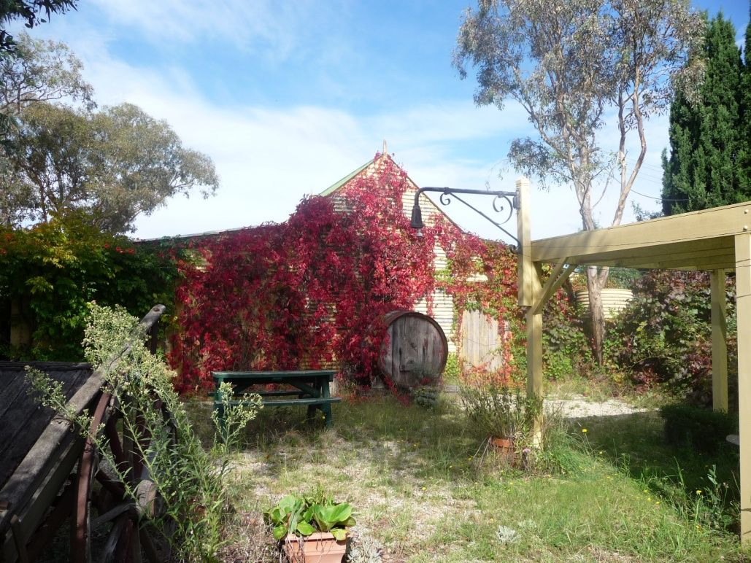

Fig 1: Garage c. 1920

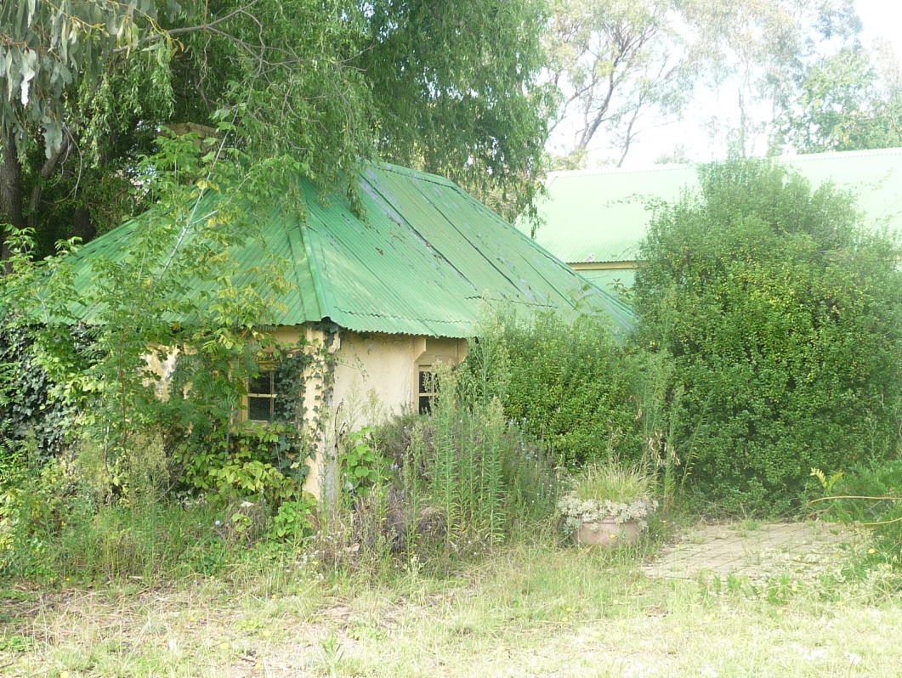

Fig 2: 1860s slab cottage

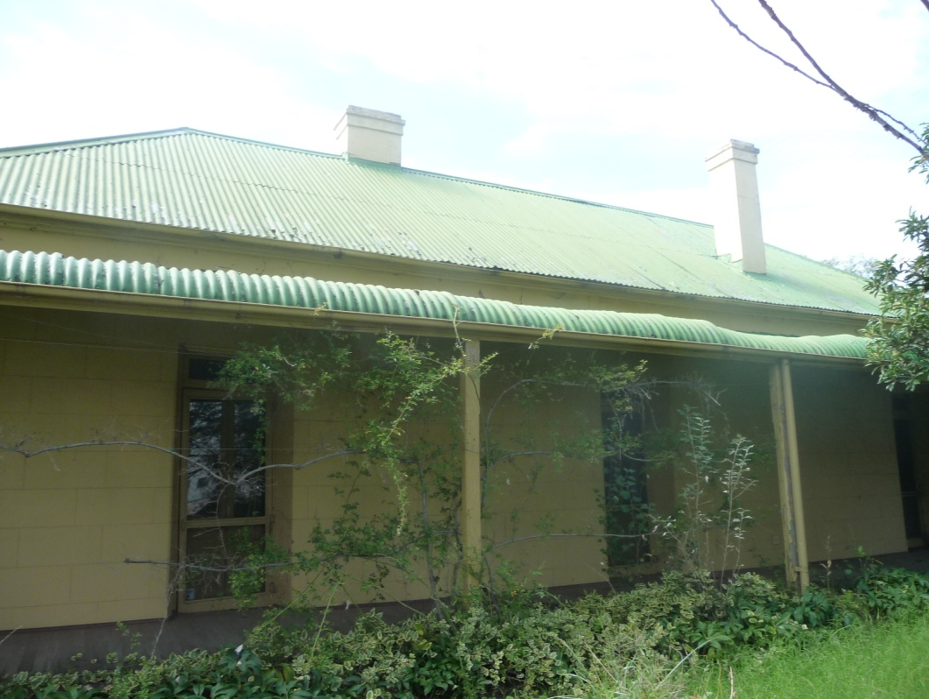

Fig 3: Pisé homestead with bull-nosed verandah, c 1909

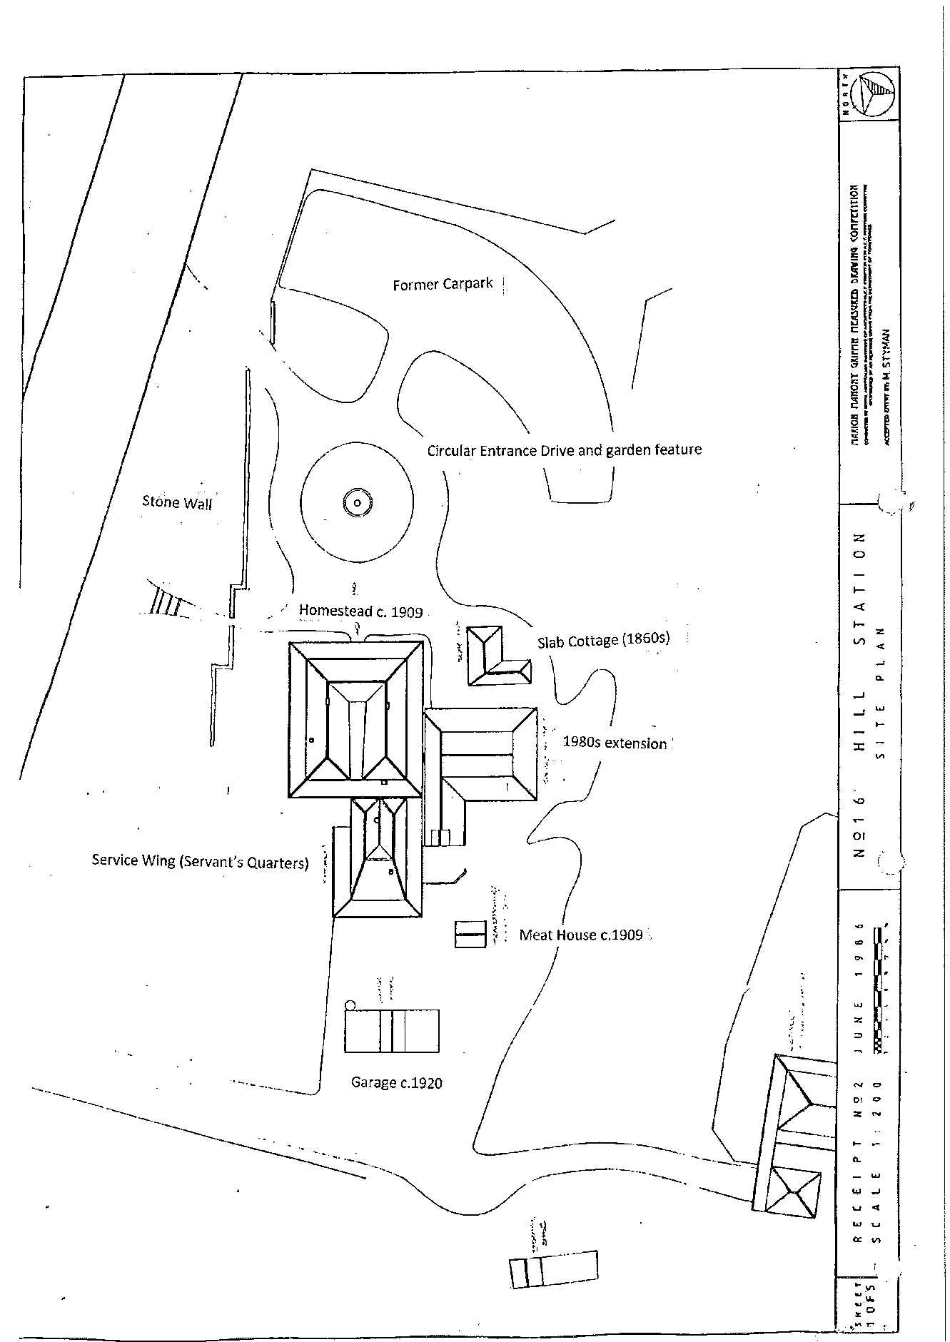

Annotated Site Plan of Hill Station including 1980s extension (Source: Marion Mahony Griffin Drawing Competition 1986)

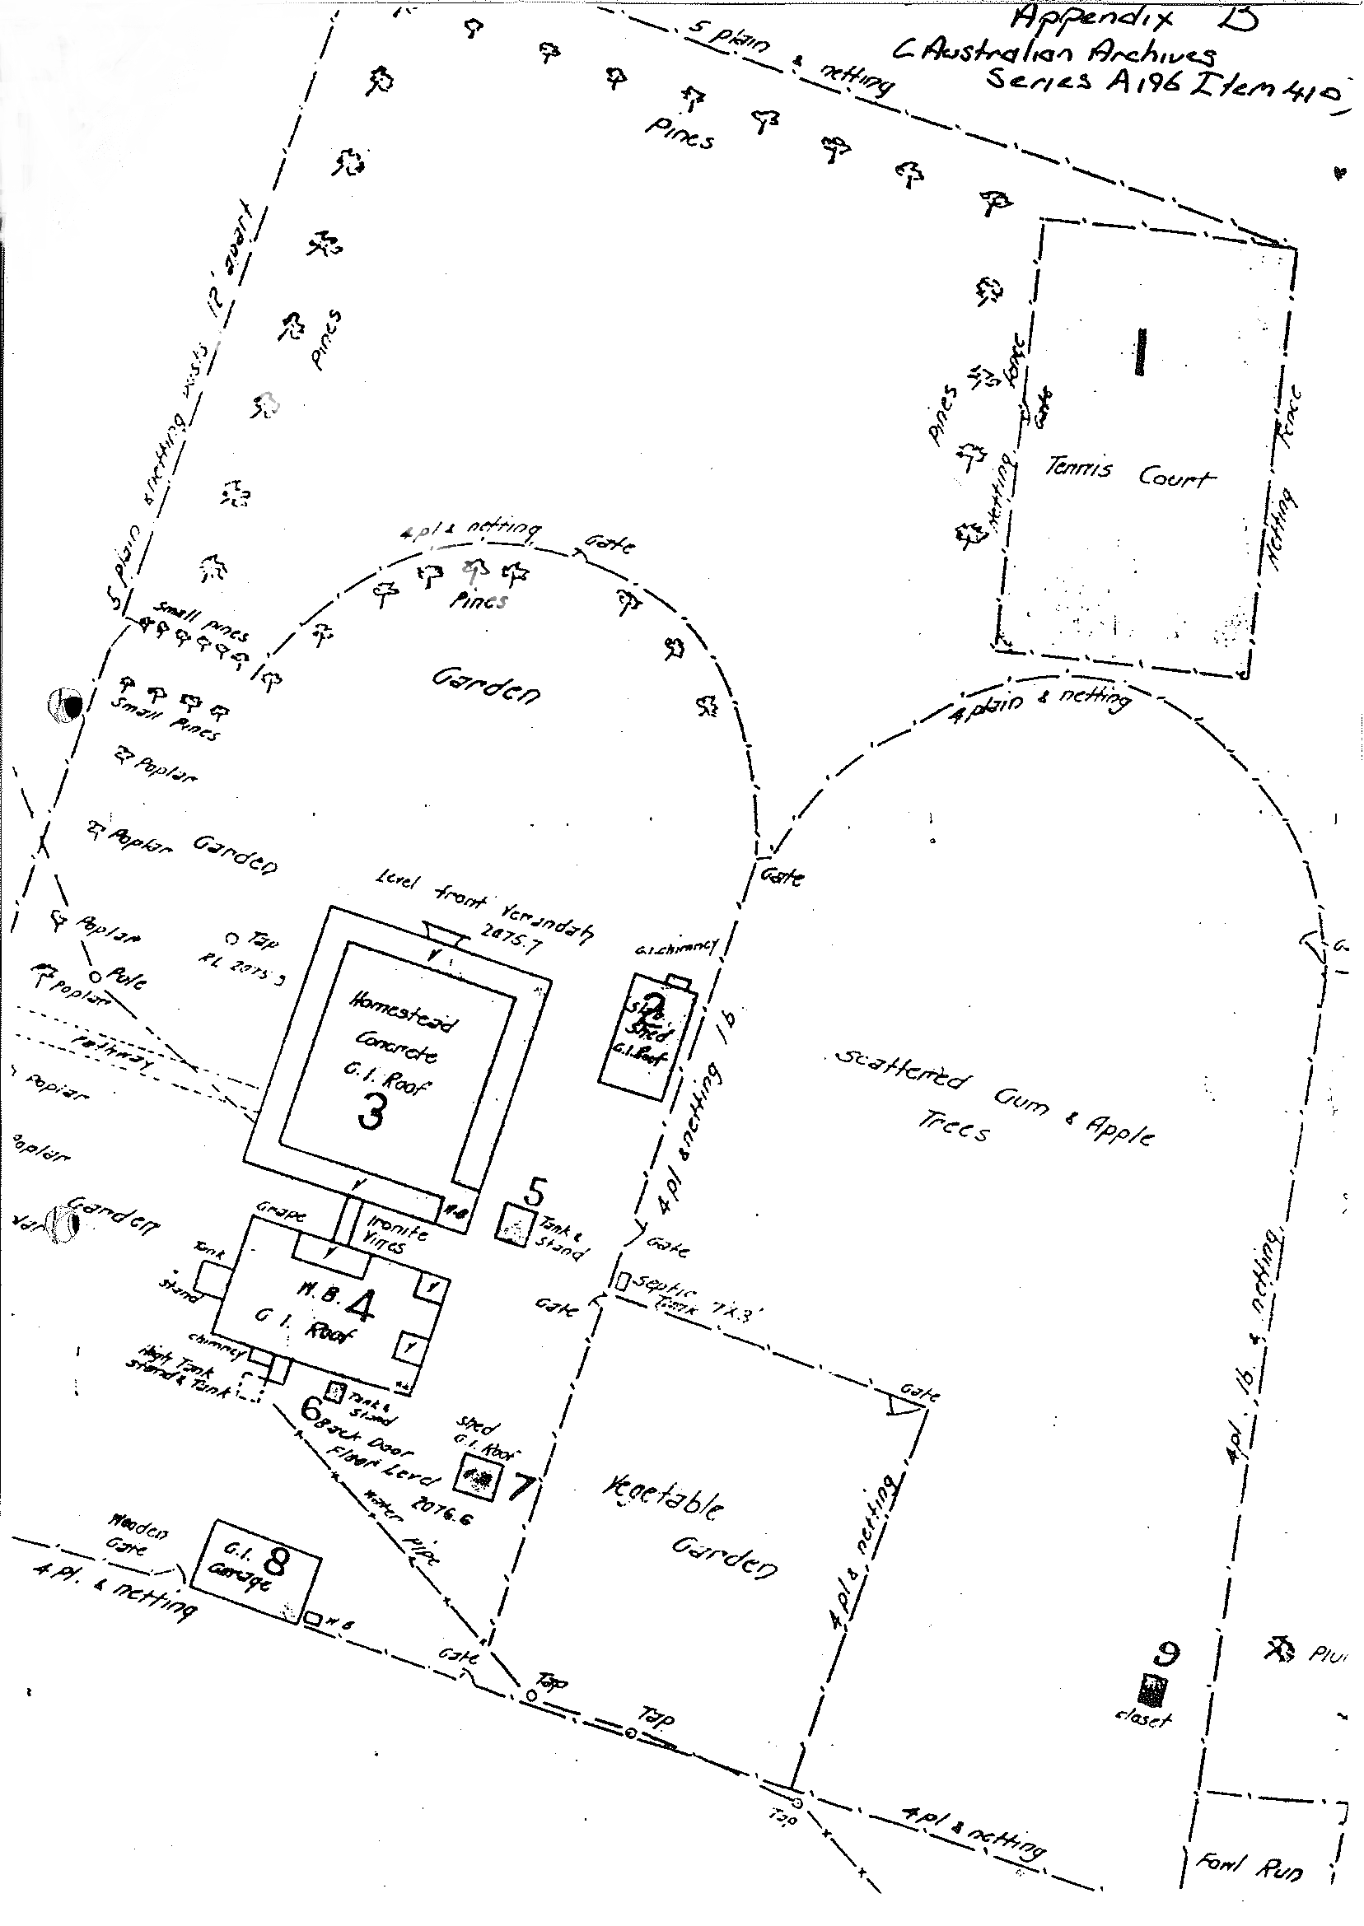

: Plan of Hill Station c. 1920s (Source: National Trust of Australia ACT))