Australian Capital Territory

Heritage (Decision about Registration of Woden Homestead and Environs, Hume) Notice 2012

**Notifiable Instrument NI2012—542**

made under the

*Heritage Act 2004* section 42 Notice of Decision about Registration

1. **Revocation**

This instrument replaces NI 2012 —284.

1. **Name of instrument**This instrument is the *Heritage (Decision about Registration of   
   Woden Homestead and Environs, Hume) Notice 2012.*
2. **Registration details of the place**

Registration details of the place are at Attachment A: Register entry for   
Woden Homestead and Environs, Hume.

1. **Reason for decision**

The ACT Heritage Council has decided that Woden Homestead and Environs, Hume meets one or more of the heritage significance criteria at s 10 of the *Heritage Act 2004*. The register entry is at Attachment A.

1. **Date of Registration**18 October 2012

**Jennifer O’Connell  
A/g Secretary** (as delegate for) **ACT Heritage Council**

**18 October 2012**

|  |  |
| --- | --- |
|  | **AUSTRALIAN CAPITAL TERRITORY**  **HERITAGE REGISTER**  **(Registration Details)** |

For the purposes of s. 41 of the *Heritage Act 2004*, an entry to the heritage register has been prepared by the ACT Heritage Council for the following place:

Woden Homestead & Environs, Hume

Blocks 7 & 8 (part) Section 17 Hume, ACT

**DATE OF REGISTRATION**

Notified: 18 October 2012 Notifiable Instrument: 2012—542

Copies of the Register Entry are available for inspection at the ACT Heritage Unit. For further information please contact:

The Secretary

ACT Heritage Council

GPO Box 158, Canberra, ACT 2601

Telephone: 13 22 81 Facsimile: (02) 6207 2229

**IDENTIFICATION OF THE PLACE**

* Woden Homestead & Environs Blocks 7 & 8 (part) Section 17 Hume, ACT

**STATEMENT OF HERITAGE SIGNIFICANCE**

This statement refers to the Heritage significance of the place as required in s12(d) of the *Heritage Act 2004*.

Woden Homestead & Environs, Hume is of heritage significance as important evidence of a way of life and design no longer practiced, as a notable example of a kind of place, and for strong and special associations with a cultural phase in the history of the ACT.

Woden Homestead and Environs is significant as one of the earliest rural properties on the Limestone Plains (now Canberra), and it includes the oldest remaining homestead (from 1832) that has been continuously occupied and managed as part of an agricultural enterprise.

Woden Homestead and Environs has a strong association with a number of key figures associated with early pastoral history in the ACT region such as Francis Mowatt (1832-1837),

Dr James Fitzgerald Murray (1837-1856) and the Campbell family (1871-1922). Between 1840 and 1852, it was the home of Mrs Anna Maria Bunn, author of the first novel published by a woman in Australia (1838).

The homestead contains a significant collection of documents and objects (including furniture) relating to the Campbell family and Canberra’s history.

Despite a severe bush fire in 1952, many important structures and plants survived in and around the grounds to enable understanding of the history of development of a rural property. These include surrounding gum trees, hedges and fences, rambling roses and a carriage loop with shrubs. Edna Walling, one of Australia’s leading landscape designers, redesigned the garden in 1952. The gardens are of importance as a largely intact example of her design style and the plant materials of the 1950s.

The location and setting of the property is an agricultural and rural landscape that forms a significant cultural landscape.

The surrounding grasslands are also of heritage significance. Natural Temperate Grasslands is listed as an Endangered Ecological Community under both Commonwealth and ACT legislation. Associated with the grasslands is an example of White Box – Yellow Gum – Blakely’s Red Gum Grassy Woodland and Derived Native Grassland community. This is listed as a Critically Endangered Ecological Community under Commonwealth legislation. The same community, described as Yellow Box – Red Gum Grassy Woodland is also listed as an Endangered Ecological Community under ACT legislation.

The natural interface between these two distinct communities is also of heritage significance. Additional heritage significance arises from the presence of two endangered species, the Grassland Earless Dragon, *Tympanocryptis pinguicolla*, and Golden Sun Moth, *Synemon plana* (Commonwelath and ACT legislation) as well as the Perunga Grasshopper, *Perunga ochracea* listed as Vulnerable (ACT Legislation) (ACT Government, 2005).

Pastoral management practices of the native grasslands in the north of the property have ensured the survival of endangered fauna including the Grassland Earless Dragon (*Tympanocryptis pinguicolla),* Golden Sun Moth (*Synemon plana*) and Perunga Grasshopper (*Perunga ochracea)* and their habitat, including examples of the endangered Natural Temperate Grassland community and the endangered Yellow Gum – Red Gum Grassy Woodland community.

The homestead, collection, gardens, cultural landscape and natural conservation values combine to make the property a significant rural property in the ACT and an important part of our heritage.

**OTHER RELATED PLACES**

* Hill Station, Hume

**FEATURES INTRINSIC TO THE HERITAGE SIGNIFICANCE OF THE PLACE**

Features intrinsic to the heritage significance of the place which require conservation include:

## Individually identified buildings and structures of cultural significance, specifically:

## The Homestead building (excluding 1974 extension);

The Homestead interiors, including architraves, skirtings, doors and windows (excluding post 1980 fit outs);

The old cattle yards (1950s);

The shed;

The stable (1890); and

The cottage (1930).

1. The Homestead Gardens, specifically:

The carriage Loop with shrubs, roses and trees from the 19th Century;

The Peppercorn trees east of house (19th Century);

The garden design layout of 1952 (by Edna Walling), with dry stone walls and plants;

The original Ships Tank and stand; and

The tennis court.

1. The agricultural rural landscape, including the following elements:

The cultural landscape to the north of the Homestead;

The individual mature Eucalyptus trees to the east and south of the Homestead;

The cultural landscape to the south and east as a ‘pastoral ideal’;

The cultural landscape to the west of the Homestead for open woodland;

The existing upper length of driveway as indicated on Map 2;

The fences and hedges;

The windmill; and

The archaeological sites (including the former track to Duntroon and sites of previous structures and gardens).

1. The natural grasslands and woodlands including the following elements:

The Natural Temperate Grasslands;

The Yellow Box – Red Gum Woodlands;

The interface between these grasslands and woodlands; and

The habitat of the Grassland Earless Dragon, Golden Sun Moth and Perunga Grasshopper.

|  |
| --- |
|  |

**APPLICABLE HERITAGE GUIDELINES**

The ‘Heritage Guidelines: General Conservation Guidelines for Historic Heritage Places 2012’ adopted under s25 of the *Heritage Act* 2004 are applicable to the conservation of the Woden Homestead & Environs.

The guiding conservation objective is that the Woden Homestead shall continue to be conserved and appropriately managed in a manner respecting its heritage significance and the features intrinsic to that heritage significance, and consistent with a sympathetic and viable use or uses. Any works that have a potential impact on significant fabric (and / or other heritage values) shall be guided by a professionally documented assessment and conservation policy relevant to that area or component (i.e. a Statement of Heritage Effects – SHE).

**REASON FOR REGISTRATION**

Woden Homestead & Environs, Hume, ACT has been assessed against the heritage significance criteria and been found to have heritage significance when assessed against five criteria under the ACT *Heritage Act 2004* including (c), (f), (g), (h) and (l).

**ASSESSMENT AGAINST THE HERITAGE SIGNIFICANCE CRITERIA**

Pursuant to s. 10 of the *Heritage Act 2004*, a place or object has heritage significance if it satisfies one or more of the following criteria. Significance has been determined by research as accessed in the references below. Further research may alter the findings of this assessment.

1. it demonstrates a high degree of technical or creative achievement (or both), by showing qualities of innovation, discovery, invention or an exceptionally fine level of application of existing techniques or approaches;

Woden Homestead & Environs does not meet this criterion.

1. **it exhibits outstanding design or aesthetic qualities valued by the community or a cultural group;**

Woden Homestead & Environs does not meet this criterion.

The house has evolved over many decades and has developed a certain aesthetic quality and charm manifested in old homes in a fine landscape setting. The garden retains essential components of the 1950s Edna Walling design and reinforces the aesthetic qualities of the Homestead. The redevelopment and extension of the gardens in the1990s by the Campbell’s are good examples of domestic landscape design combining plantsmanship and art.

However, there is no evidence that these outstanding aesthetic qualities are valued by the broader ACT community or a cultural group.

1. **it is important as evidence of a distinctive way of life, taste, tradition, religion, land use, custom, process, design or function that is no longer practised, is in danger of being lost or is of exceptional interest;**

Woden Homestead & Environs meets this criterion.

Woden Homestead is of exceptional interest as one of the oldest buildings in the ACT and is the oldest that has been continuously occupied. It has been part of an operating grazing property since 1832, which is longer than any other property in the ACT. It retains many important elements such as the homestead, garden, outbuildings, windmill and evidence of earlier tracks. As such it demonstrates a distinctive way of life, domestic rural living, which is becoming increasingly uncommon in the ACT and surrounding area, particularly as Canberra expands and the region is subdivided.

1. **it is highly valued by the community or a cultural group for reasons of strong or special religious, spiritual, cultural, educational or social associations;**

Woden Homestead & Environs does not meet this criterion.

1. **it is significant to the ACT because of its importance as part of local Aboriginal tradition**

Woden Homestead & Environs does not meet this criterion.

1. **it is a rare or unique example of its kind, or is rare or unique in its comparative intactness**

Woden Homestead & Environs meets this criterion.

Woden Homestead is one of the oldest buildings in the ACT, and is rare in its comparative intactness and high integrity. Duntroon House (1832), Duntroon Dairy (1832), The Oaks (1836), Lanyon (c1830s), Mugga Mugga (c1838), Tuggeranong Barn (c1840) are the only other extant structures pre 1850 in the ACT and there are few others in the region. The other pre 1850s buildings (eg. St Johns 1845) are not part of a homestead complex or are now archaeological sites such as Palmerville, Moores and Canberry Stations.

Woden Homestead is the only homestead of the ones listed which has been continuously occupied from the 1830s and part of an operating farm. Lanyon Homestead has not been occupied or the buildings around the homestead used for farm purposes since the 1970s although the other parts of the farm have been continuously used. The other properties have changed uses and purposes over the decades and most have had the associated farm land affected by urban development.

Woden Homestead & Environs is a focal point from the ACT border on Tharwa Drive, the main road south from Queanbeyan.

The native grassland paddocks north of the Homestead are an example of a landscape type and floral community that once was common within the ACT but is now, through urbanisation, increasingly uncommon.

1. **it is a notable example of a kind of place or object and demonstrates the main characteristics of that kind**

Woden Homestead & Environs meets this criterion.

Woden Homestead & Environs is a notable example of a 19th century Australian rural cultural landscape, with a homestead, garden and broader landscape with outbuildings and structures. The property retains the main characteristics of its kind. Woden features the original homestead building with additions, numerous outbuildings, yards, an established garden and landscape setting around the Homestead.

Woden Homestead is also notable for being the oldest homestead in the ACT to be continuously occupied and is still part of an operating farm. The owners continue to run sheep on the property. Its different construction styles demonstrate the development and different phases of occupation as a continuing rural property since its earliest European settlement.

The structures are typical of the period with the use of rendered stone walls, lath and plaster ceilings, timber shingles and cedar internal joinery followed by rendered brick walls and corrugated metal roofs. They have undergone a number of changes at various times with details and materials changing. As such they are representative of the periods of construction rather than illustrating any particular technical merit.

1. **it has strong or special associations with a person, group, event, development or cultural phase in local or national history**

Woden Homestead & Environs meets this criterion.

Woden Homestead & Environs has been associated with a number of people who have played a significant part in ACT history. This includes the Campbell family who established Duntroon, and played a primary role in the first European settlement of the Limestone Plains. Prominent members of the Campbell family have included Frederick and Catherine, Arthur and Elizabeth and more recently, Charles and Martha. Other important people associated with the property from the earlier phases includeFrancis Mowatt (1832-1837) and Dr James Fitzgerald Murray (1837-1856).

Mrs Anna Maria Bunn, author of the first novel published by a woman in Australia, lived at Woden Homestead and the sketches and notes of her son, John William Buckle Bunn, have been important in providing a rich detail of life at Woden in the 1840s.

The Woden Homestead setting and outbuildings were destroyed by fire in 1952. Edna Walling, one of Australia’s most renowned landscape designers of the Inter War period, redesigned the garden in 1952. These grounds contribute to the aesthetic appeal of the house. Many prominent friends of Arthur and Elizabeth Campbell planted ceremonial trees in the garden at Woden, including Sir Robert and Dame Pattie Menzies, Lady Casey, Field Marshal Sir William and Lady Slim, Lord Dunrossil and Field Marshal Sir Gerald Templar. While of interest these associations are not regarded as strong and special.

Woden Homestead and Environs provides strong evidence of over a century of development in the Limestone Plains. The diaries and sketches produced by John Buckle Bunn have provided a detailed insight into life at Woden in the 1840s. While of interest, this association is not strong or special.

1. **it is significant for understanding the evolution of natural landscapes, including significant geological features, landforms, biota or natural processes.**

Woden Homestead & Environs does not meet this criterion.

1. **it has provided, or is likely to provide, information that will contribute significantly to a wider understanding of the natural or cultural history of the ACT because of its use or potential use as a research site or object, teaching site or object, type locality or benchmark site.**

Woden Homestead & Environs does not meet this criterion.

Woden Homestead & Environs is of interest in what it provides about the rural history of Canberra without being a benchmark site. The collection of objects and furniture and its supporting information has the potential to provide a greater understanding of Canberra and Regional history. However as this collection is not publicly available, it is unlikely to provide information that will contribute significantly to a wider understanding of the natural and cultural history of the ACT.

1. **for a place—it exhibits unusual richness, diversity or significant transitions of flora, fauna or natural landscapes and their elements**

Woden Homestead & Environs does not meet this criterion.

1. **for a place—it is a significant ecological community, habitat or locality for any of the following:**

(i) the life cycle of native species;

(ii) rare, threatened or uncommon species;

(iii) species at the limits of their natural range;

(iv) distinct occurrences of species.

Woden Homestead & Environs meets this criterion.

Natural Temperate Grasslands is listed as an Endangered Ecological Community under both Commonwealth and ACT legislation. Associated with the grasslands is an example of White Box – Yellow Gum – Blakely’s Red Gum Grassy Woodland and Derived Native Grassland community. This is listed as a Critically Endangered Ecological Community under Commonwealth legislation. The same community, described as Yellow Box – Red Gum Grassy Woodland is also listed as an Endangered Ecological Community under ACT legislation.

The non-intensive agricultural management of the northern sector of the property has resulted in conservation of the endangered Natural Temperate Grassland community, which is the habitat of the endangered species the Grassland Earless Dragon (*Tympanocryptis pinguicolla)*, Golden Sun Moth (*Synemon plana*) and Perunga Grasshopper (*Perunga ochracea*). For the Grassland Earless Dragon, the Woden grassland community provides a significant habitat for this distinct occurrence of a species that is at the limit of its natural range. All extant populations of the Grassland Earless Dragon are extremely important for the survival of this taxon and its continuing life cycle.

The Grassland Earless Dragon, a species that is listed as endangered, has been identified in only two locations (Jerrabomberra Valley and Majura Valley) in the ACT including the Woden property, and one site near Queanbeyan in NSW. The lizards are generally found in treeless grassland habitats which have undergone minimal pasture improvement.

The non-intensive agricultural management of the central western sector of the property has also resulted in the conservation of the endangered Yellow Box – Red Gum Grassy Woodland ecological community.

**SUMMARY OF THE PLACE**

**HISTORY AND PHYSICAL DESCRIPTION**

HISTORY

The Ngunnawal Aboriginal people lived in the area of Canberra for thousands of years as hunter gatherers moving across the plains and into the mountain valleys in small groups to hunt and camp.

All this changed with Charles Throsby Smith, James Vaughan and Joseph Wild who first explored the area in 1820 and opened up the area for settlement.

In 1832 Francis Mowatt bought 2,560 acres and named the property Jerrabomberra and then erected a stone cottage with kitchen attached. The property was sold to Dr James Fitzgerald Murray in 1837. Murray renamed the property Woden, after the Norse god of wisdom, and expanded the cottage to a homestead. The Woden property originally included what is now Hill Station. While there is some uncertainty about the origins of Hill Station and its sequence of ownership, by at least 1900 it was a separate entity from Woden Station and in the hands of the McDonald family of Uriarra.

Murray’s widowed sister Anna Maria Bunn (author of the first novel published by a woman in Australia) and her son John William Buckle Bunn lived at Woden in 1840s. John Bunn’s journals and sketches contain detailed descriptions of life at Woden.

There is some uncertainty over the sequence of ownership of Woden following Dr Murray's title. Following his death the property may have passed to Dr Murray's brother, Terrence Murray, who then sold Woden to Thomas Rutledge (Schumack, 1967: 47). Alternatively, Charles and Martin Byrne may have acquired Woden from Dr Murray in the 1860s and then sold it to Frederick Arthur Campbell (Watson, 1927: 1). By at least 1900 Hill Station was a separate entity from Woden Station (Gillespie: 1988: 240).

In 1871 it was sold to George Campbell and became part of the Duntroon Estate. Initially it accommodated tenant farmers until Frederick Campbell and wife Edith Catherine moved there in 1890 and undertook alterations to the house.

After the selection of Canberra as the National Capital, Woden was acquired by the Commonwealth Government, reduced to 1,220 acres, and the Campbells leased the property until 1922. It was then transferred to their son Arthur and further alterations were undertaken.

Bushfires in 1952 destroyed the setting and outbuildings and as a result the gardens were redesigned by Edna Walling.

After the death of Arthur and Elizabeth in 1966 and 1971, their son Charles Campbell and wife Martha moved to Woden in 1972. Extensions and renovations followed. The 1980s saw further development of the garden.

DESCRIPTION

Woden Homestead and Environs encompass an area of approximately 500 hectares, which includes the main homestead of brick and stone, garage, stables, stockyards, hayshed, two dams, small weatherboard cottage and other minor structures.

The Homestead is U shaped around a courtyard with interconnecting enclosed verandahs. The southern wing, the earliest section, includes bedrooms, living room and study plus a cellar. The west wing, which is the converted coach house and dairy, is now a dining room, kitchen and bathroom. The north wing includes a laundry, office and guest facilities.

The southern section of the house consists of stone and hand-made brick walls. A galvanised iron skillion roof covers the verandah and continues around this section of the house. Above this is a galvanised iron hipped roof at an angle of approximately 35 degrees. A gable-ended portico is located at the front entrance of the house. It has a northerly aspect and overlooks an attractive central courtyard. This part of the house is the oldest portion dating back to 1832. The verandah had a Baltic pine floor from c1890, which is now hardwood.

The central gallery that connects the two sections of the building is made primarily of brick with painted timber framed windows covering the entire eastern wall, and a galvanised iron skillion roof.

The northern section of the house displays two distinctive architectural styles. The second bathroom and laundry have brick and stone walls with concrete floors and a galvanised iron skillion roof. The guestroom is the latest addition to the house and has a castellated **/** parapet form concealing the corrugated metal roof.

The building’s exterior has recently been painted using a traditional limewash technique to the colour of the original paintwork using earth-brown wash for the walls with white trim.

The Homestead is in excellent condition and is well maintained.

Internal finishes vary with floors mainly timber although wet areas and the 1974 section are concrete. Walls are mainly rendered with a number wallpapered over. Ceilings vary from timber boards, lath and plaster, fibro cement, asbestos cement, plaster and plasterboard, reflecting the period they were installed.

Internal details (architraves, skirtings, doors and windows) are mainly stained timber (mostly cedar) but some are painted. These also reflect a range of details associated with their period of construction or alteration.

The homestead precinct comprising buildings, structures and the intervening spaces are established on the eastern side of an unnamed hill that is part of the Mt Mugga Mugga formation. The homestead is located among the canopy of the retained native Yellow Box – Red Gum grassy woodland. This endangered vegetation community transitions down the slope into the pastoral landscape created by the settlers to the east and south of the homestead. Grazing paddocks on either side of the driveway contain remnant specimens including Yellow Box, *Eucalyptus melliodora*, Apple Box, *Eucalyptus bridgesiana,* and Blakely’s Red Gum, *Eucalyptus blakelyi.*

The stewardship of the Campbell family has resulted in the conservation of garden elements that remain from the earliest times. The garden surrounding the homestead can be classified into three distinct periods that relate to the events and the eras of the place.

Pre 1950s the original modest grounds, developed over time

1950s following the bushfires, redesign by Edna Walling in 1952

1990s following building renovations, redesign by the Campbell’s of the entry areas and continuing development of walled flower beds and garden on the western hill slope.

The Woden woodlands and grasslands are examples of natural vegetation that has evolved as a result of natural processes. In 2012 they represent a residual area of the original grassland/woodland landscape that was once part of a grassy woodland mosaic covering much of south-eastern Australia and locally referred to as ‘the limestone plains’. The grasslands/woodlands are in reasonably good condition.

The interface between the Woden grasslands and woodlands exhibits a significant transition zone, or ecotone, showing the natural interface that existed prior to European settlement. There are only a few such natural representatives of the woodland/grassland ecotone left in the ACT due to urban development in the valleys and lower slopes.

The surrounding Natural Temperate Grasslands is listed as an Endangered Ecological Community under both Commonwealth and ACT legislation. Associated with the grasslands is an example of White Box – Yellow Gum – Blakely’s Red Gum Grassy Woodland and Derived Native Grassland community. This is listed as a Critically Endangered Ecological Community under Commonwealth legislation. The same community, described as Yellow Box – Red Gum Grassy Woodland is also listed as an Endangered Ecological Community under ACT legislation.

There is also present a natural interface between these two distinct communities that is of heritage significance. The grasslands/woodlands provide habitat for two endangered species, the Grassland Earless Dragon, *Tympanocryptis pinguicolla*, and Golden Sun Moth, *Synemon plana* (Commonwelath and ACT legislation) as well as the Perunga Grasshopper, *Perunga ochracea* listed as Vulnerable (ACT Legislation) (ACT Government , 2005).

Ecological surveys conducted in the area have identified it as a key habitat for the Grassland Earless Dragon, Golden Sun Moth and Perunga Grasshopper that have each been listed as a threatened species under either of both Commonwealth and ACT.

The apparent extent of decline of the Grassland Earless Dragon and its grassland habitat indicates that all extant populations are extremely important for the survival of the taxon. All relevant state and territory conservation agencies have reflected this by placing the species in categories of very high conservation concern. All currently known and subsequently discovered populations should be considered in conservation strategies for this species. The Woden grassland is one of the key research sites used by threatened species ecologists to monitor populations of this species and to learn about its ecological requirements as part of the essential information required for recovery actions.

**REFERENCES**

ACT Government, 2005 *A Vision Splendid of the Grassy Plains Extended: ACT Lowland Native Grassland Conservation Strategy*. Action Plan No. 28 (Arts heritage and Environment, Canberra).

Heritage Unit *Preliminary Draft Citation c 1995*

Barrow, Graeme, *Canberra Historic Houses – Dwellings and Ruins of the 19th Century,* Dogroja Press, Canberra, 1998

Bunn, J.W. Journal kept at “Woden”, 1844-8. Mitchell Library, State Library NSW. Reference MLSS841 & MLSS871.

Bunn, M.A. *The Lonely Pioneer; William Bunn, Diarist 1830-1901.* 2002-07-24

Bunn, M.A. *The Woden Journals of J.W.Bunn.* (in preparation, 2002)

Campbell, C.A. Personal communications of 30 August and 2 October, 2001.

Campbell, C.A. and M.D., *Woden – A Select Chronology and Statement of Historical and Cultural Significance*, unpublished. Copy obtained 2001.

Campbell, C.A. and M.D., *Woden – a small unpublished folded A4 leaflet, which provides some information on the homestead. C*opy obtained 2001.

Cantlon, Maurice, *Homestead of Southern NSW 1830-1900,* Queensbury Hill Press 1981

Fitzgerald, Alan, *Historic Canberra 1825-1945 A Pictorial Record*, AGPS 1977

Fitzgerald, Alan, *Canberra in Two Centuries: A Pictorial History,* Clareville Press, Torrens ACT 1987

Garnet, Rodney and Danielle Hyndes (ed), *The Heritage of the Australian Capital Territory,* National Trust of Australia (ACT), 1992

Gillespie, L. *Canberra 1820-1913*. Australian Government Publishing Service, Canberra 1991

Healdix, E. *The Outbuildings of Woden Property Jerrabomberra ACT*, drawings from ACT Heritage file (1981?)

Lane, T. and Serle, J. *Australians at Home : A Documentary History of Australian Domestic Interiors from 1788 to 1914.* Oxford University press, Melbourne, p 73 1990

Martin, E and Associates. *Woden Homestead, ACT. Heritage Assessment.* Report for the Heritage Unit, Environment ACT. 2002

National Capital Development Commission *Sites of Significance in the ACT; Majura, Kowen and Associated Areas.* Technical Paper, No.56 Vol.5, National Capital Development Commission, Canberra 1988

Osborne, W.S. Kukolic, K., Davis, M.S and Blackburn, R. (1993) “Recent Records of the Earless Dragon *Tympanocryptis pinguicolla* in the Canberra Region and a Description of its Habitat. *Herpetofauna.* No.23 pp.16-24.

Sharp, S. “Lowland Native Grasslands in the ACT: Survey of the Sites and Assessment of the Conservation Status, Habitat and Management Requirements for the Species of Concern”. *Conservation Series Report* No.6 ACT Parks and Conservation Service, 1993

Shumack, S.  *Tales and Legends of Canberra Pioneers.* Australian University Press, Canberra, 1977

Wilson, G, *Murray of Yarralumla,* Oxford University Press, Melbourne, 1968

Wright, W. *Canberra*. Library of Australian History, North Sydney, 1977

**MAPS AND IMAGES**



MAP 1

Woden Homestead and Environs outlined in yellow. Map is not to scale

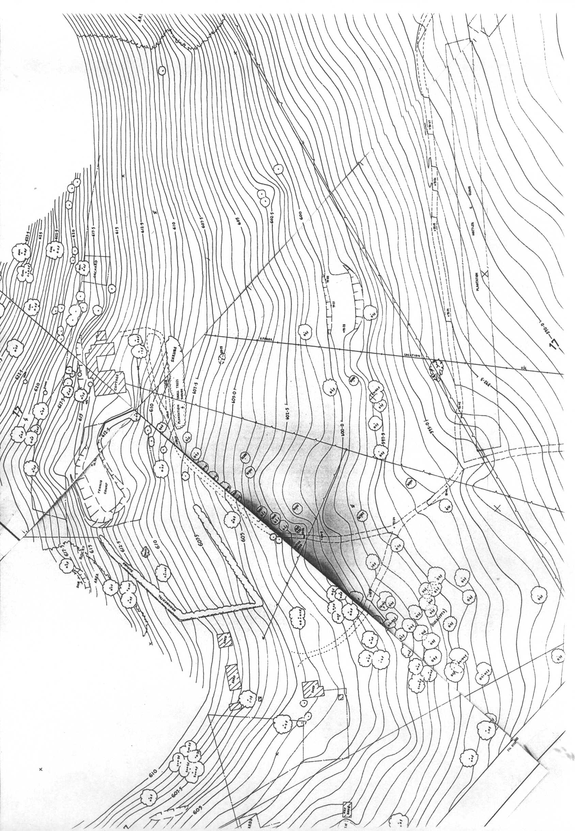

MAP 2

1980 Site survey of Woden indicating existing features including Homestead buildings, entrance driveway and original carriage loop, and significant plantings (Source: ACTPLA Plan Room)

|  |
| --- |
| Figure 15 Current Plan with phases of development |
|  |

Current Plan indicating phases of development of Woden Homestead (Source: Eric Martin & Associates)

|  |
| --- |
| DSCN0526 |
|  |

Fig 1: Front Verandah, Woden Homestead (Source: Eric Martin & Associates)

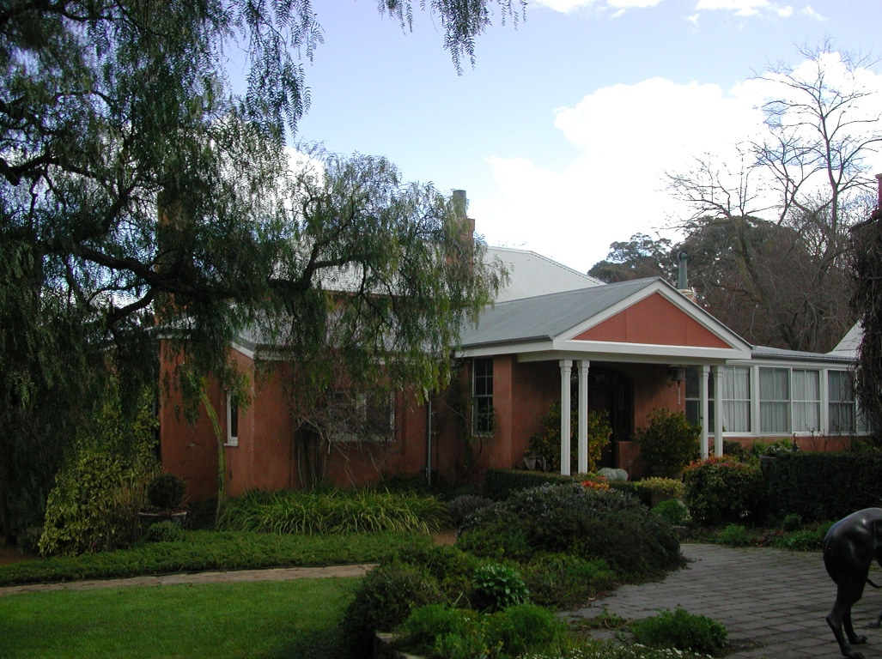

Fig 2: Oldest portion of Homestead, dating back to 1832 (Source: Eric Martin & Associates)