Australian Capital Territory

Planning and Development (Technical Amendment—Forde) Plan Variation 2012 (No 2)*

Notifiable instrument NI2012—87
Technical Amendment No 2012-09
made under the
Planning and Development Act 2007, section 89 (Making technical amendments) (s96 land ceases to be in future urban area)

This plan variation commences on the day after it is notified.

Variation No 2012-09 to the Territory Plan has been approved by the Planning and Land Authority.

Variation to the Territory Plan
The Territory Plan map is varied as indicated in Annexure A to identify the zones that apply to the land ceasing to be in a future urban area.

Variation to the Forde Precinct Code
Substitute page 1 and insert page 4 in the Forde Precinct Code at Annexure B to incorporate ongoing block specific provisions for the area.

Ben Ponton
Delegate of ACT Planning and Land Authority
21 February 2012
THIS IS PAGE ONE OF ANNEXURE A
TO NOTIFIABLE INSTRUMENT NI2012–87

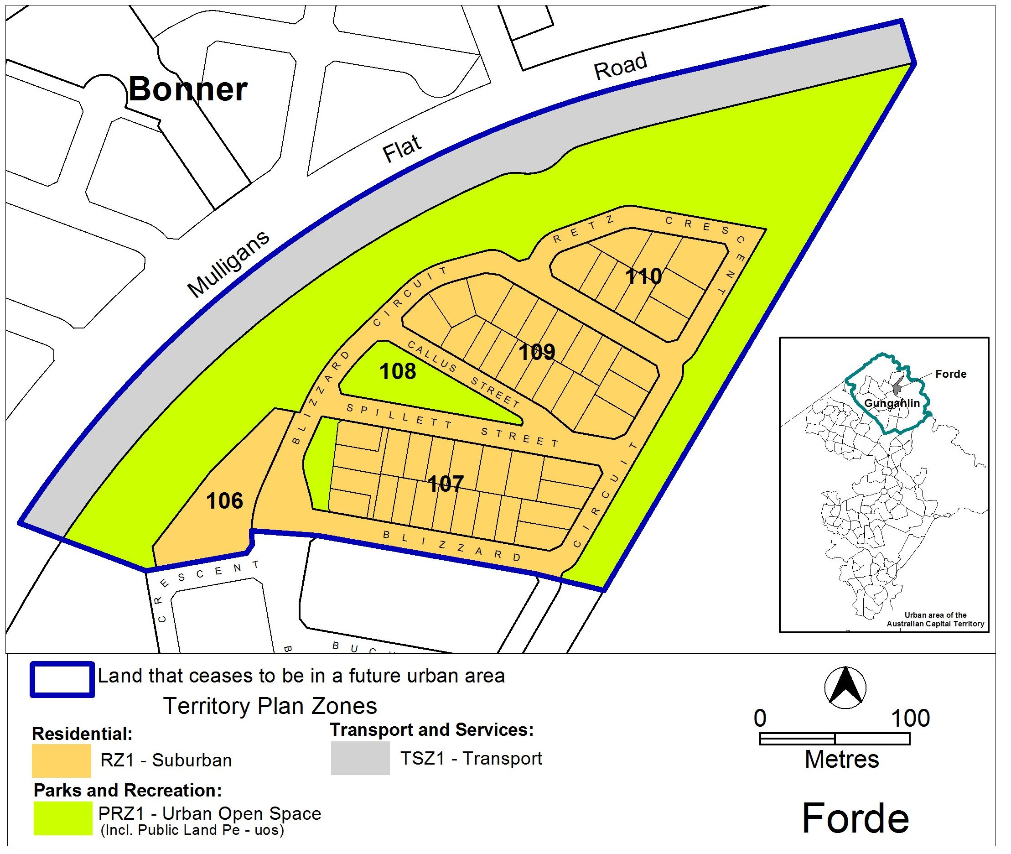

Ben Ponton
Delegate of ACT Planning and Land Authority
21 February 2012

THIS IS PAGE ONE OF ANNEXURE B
TO NOTIFIABLE INSTRUMENT NI2012–87

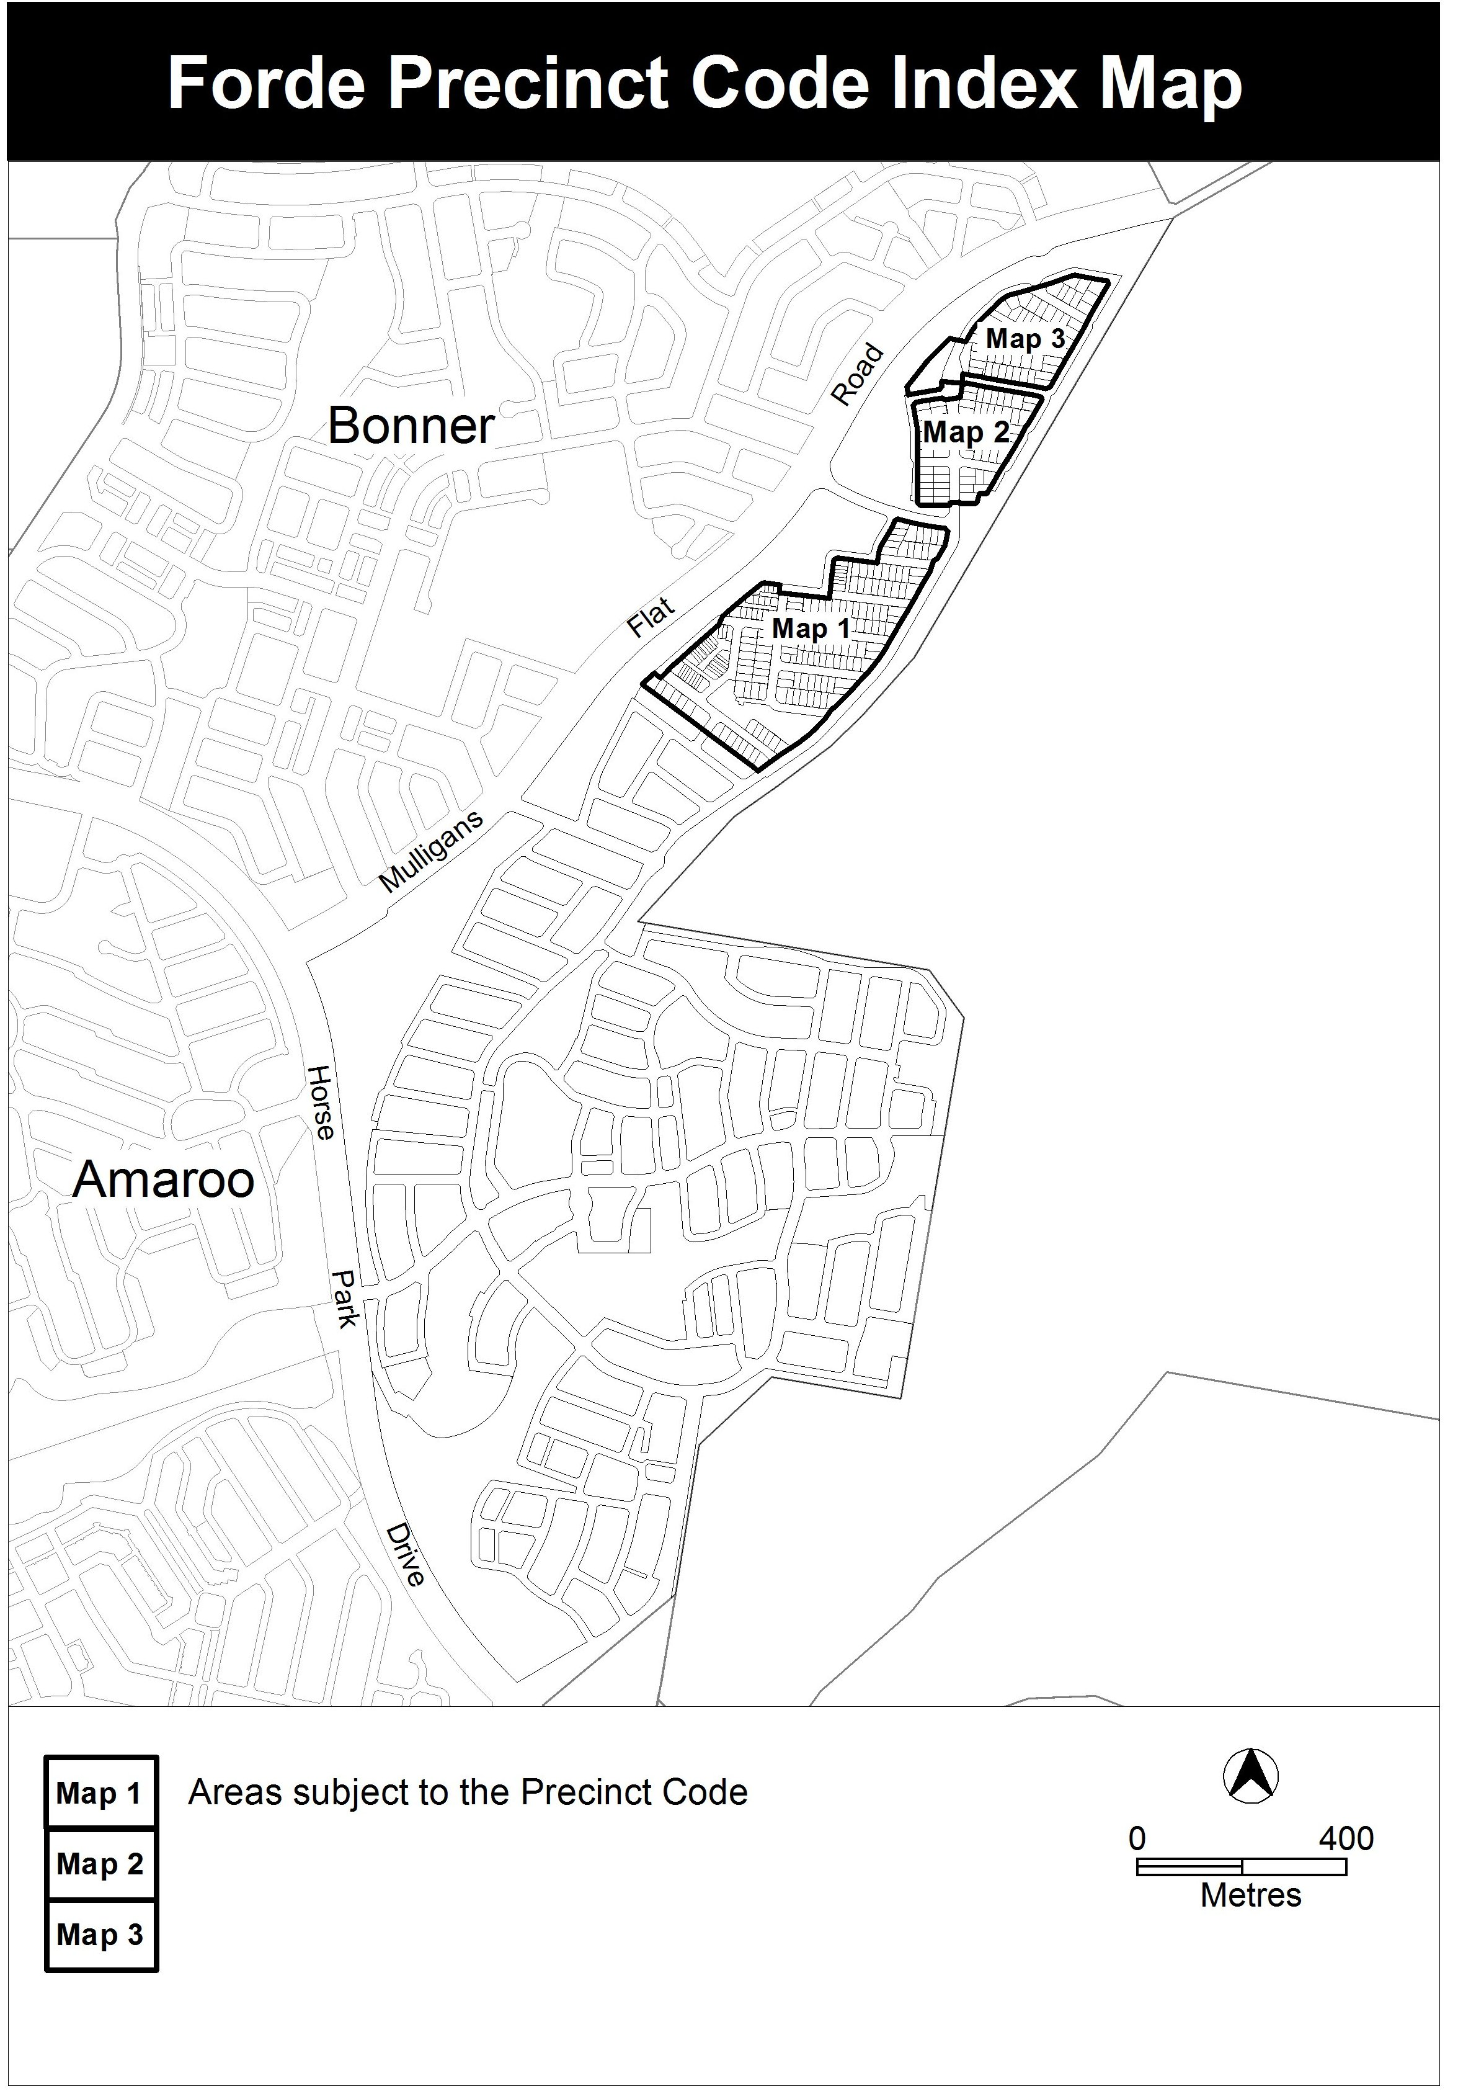

Ben Ponton
Delegate of ACT Planning and Land Authority
21 February 2012

THIS IS PAGE TWO OF ANNEXURE B
TO NOTIFIABLE INSTRUMENT NI2012–87

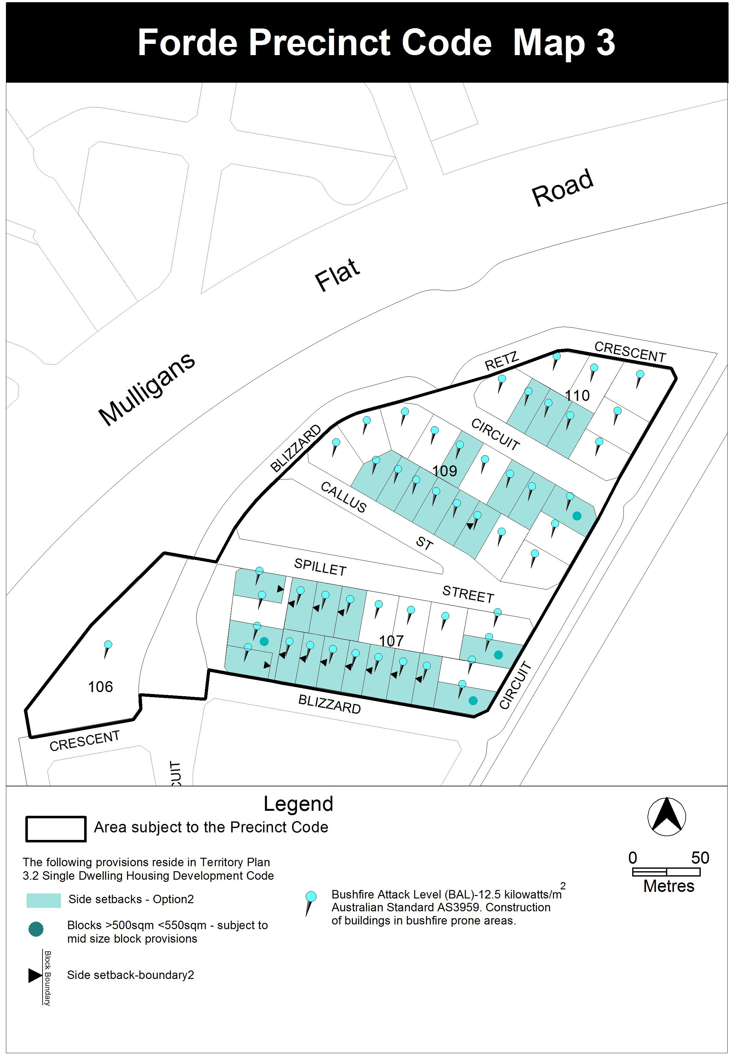

Ben Ponton
Delegate of ACT Planning and Land Authority
21 February 2012

