Australian Capital Territory

Planning and Development (Plan Variation No 315) Notice 2013

Notifiable Instrument NI2013-112

made under the

Planning and Development Act 2007, section 76(3)

**1 Name of instrument**

This instrument is the *Planning and Development (Plan Variation No 315) Notice 2013.\**

**2 Plan Variation 315**

On 27 February 2013, the Minister for Environment and Sustainable Development approved the attached plan variation to the Territory Plan ***(Attachment A)*** under s 76 (3).

Jim Corrigan

Delegate of the Planning and Land Authority

6 March 2013

**ANNEXURE A**

*Planning and Development Act 2007*

Variation to the   
Territory Plan  
315

**Aranda Ambulance and Fire Station** Aranda section 1 part block 24 and blocks 17–19

Establishment of emergency services facility as additional merit track development for various blocks in Aranda, introduction of an Aranda precinct code and removal of the public land reserve status from part of the block

Final variation prepared under s76 of the

*Planning and Development Act 2007*

This page is intentionally blank.

Contents

1. EXPLANATORY STATEMENT 2

1.1 Background 2

1.2 Summary of the proposal 2

1.3 The National Capital Plan 2

1.4 Site description 2

1.5 Current Territory Plan provisions 2

1.6 Changes to the Territory Plan 2

1.7 Consultation on the Draft Variation 2

1.8 Revisions to the Draft Variation Submitted to the Minister 2

2. VARIATION 2

2.1 Variation to the Territory Plan 2

Figures

Figure 1 Aerial image of site for proposed ambulance and fire station 2

Figure 2 Territory Plan map 2

This page is intentionally blank.

1. EXPLANATORY STATEMENT
   1. Background

As the ACT expands and the population grows, the ACT Emergency Services Agency (ESA) must ensure that its services are able to meet government benchmarks for emergency service response times and coverage. ESA has completed a Station Upgrade and Relocation Strategy and an Implementation Plan to determine where ambulance and fire stations should be located in the Territory for at least the next 20 years.

The current ambulance and fire stations in Lathlain Street, Belconnen have been operating in that location since the mid 1970’s but are no longer fit for purpose. The surrounding area has become heavily congested and physically constrained through various traffic control measures, which adversely impacts on emergency response. Also the size, layout and structure of the two existing sites do not meet the needs and requirements of contemporary emergency service facilities.

As part of the Station Upgrade and Relocation Strategy and Implementation Plan, the ESA engaged a UK based research organisation, which specialises in the application of analysis and modelling to support planning for emergency services, to undertake station location modelling and data analysis for the ACT. This exercise identified optimal areas for the location of emergency service facilities.

Based on the findings of the location modelling, the ESA undertook a comprehensive analysis of eight possible sites in the Belconnen area. One of the most important parameters for determining a suitable site for an emergency services facility is its proximity to a major arterial road. Being located close to or on a major arterial road facilitates speedy multidirectional egress. Other considerations included the suitability of the land (i.e. size, shape and topography) and the site constraints and opportunities (e.g. land availability, environmental issues, heritage, adjoining land uses, contamination and infrastructure).

Following the detailed analysis of the eight possible sites, in consultation between the ESA and various ACT Government agencies, it was concluded the Aranda site (refer ***Figure 1***) was the most suitable location for a co-located fire and ambulance station, based on a rigorously developed network plan which considered community response times.

It is intended that the Aranda facility will replace the existing stations for ambulance and fire in Lathlain Street Belconnen, which will be decommissioned.

The subject site is currently unleased Territory land. The custodian of the site is held partly by the Territory and Municipal Services Directorate (TAMS) and the Economic Development Directorate – Sport and Recreation. As a result of the variation being approved the affected land can be surveyed to determine new cadastral boundaries and property identifiers. This will allow responsibility for land management to be transferred to the ESA.

The Aranda site is covered by two zones, namely the transport and services TSZ1 transport zone and the parks and recreation PRZ1 urban open space zone. Under these zones, emergency service facility is prohibited. The variation to the Territory Plan has allowed the proposal to proceed upon this site.

* 1. Summary of the proposal

The variation enables the development of the Aranda ambulance and fire station on land that encompasses the road reserve in Bindubi Street and an area of urban open space which includes the Bardi Place car park. The Territory Plan has been varied to include *emergency services facility* as merit track development for the subject site, introduce planning controls through an Aranda precinct code to guide development of the land and remove the public land reserve status from part of the site so land management responsibilities can be transferred to the ESA.

While the variation allows development of the emergency services facility at this site, the existing list of permissible developments will be retained as no change in zone has been made to the land.

* 1. The National Capital Plan

The *Australian Capital Territory (Planning and Land Management) Act 1988* established the National Capital Authority (NCA) with two of its functions being to prepare and administer a National Capital Plan (the Plan) and to keep the NCP under constant review and to propose amendments to it when necessary.

The Plan, which was published in the Commonwealth Gazette on 21 January 1990, is required to ensure Canberra and the Territory are planned and developed in accordance with their national significance. The *Australian Capital Territory (Planning and Land Management) Act 1988* also requires the Territory Plan is not inconsistent with the Plan. The area covered by this variation is within urban areas identified in the Plan.

* 1. Site description

The subject site is located on Bindubi Street near the corner of Belconnen Way, Aranda (refer ***Figure 1***). The subject site is identified as part of block 24 and blocks 17–19 of section 1 Aranda. The total area of the subject site is comprised of approximately 6,750m² of unleased Territory land that includes the Bardi Place car park adjacent to the Aranda sports oval.

The final dimensions of the site will be determined by the detailed survey plan to establish the block.



Figure 1 Aerial image of site for proposed ambulance and fire station

* 1. Current Territory Plan provisions

The subject site has both a Transport and Services TSZ1 transport zone and a Parks and Recreation PRZ1 urban open space zone. Emergency services facility is listed as prohibited development in the development tables for both the TSZ1 transport zone and PRZ1 urban open space zone.

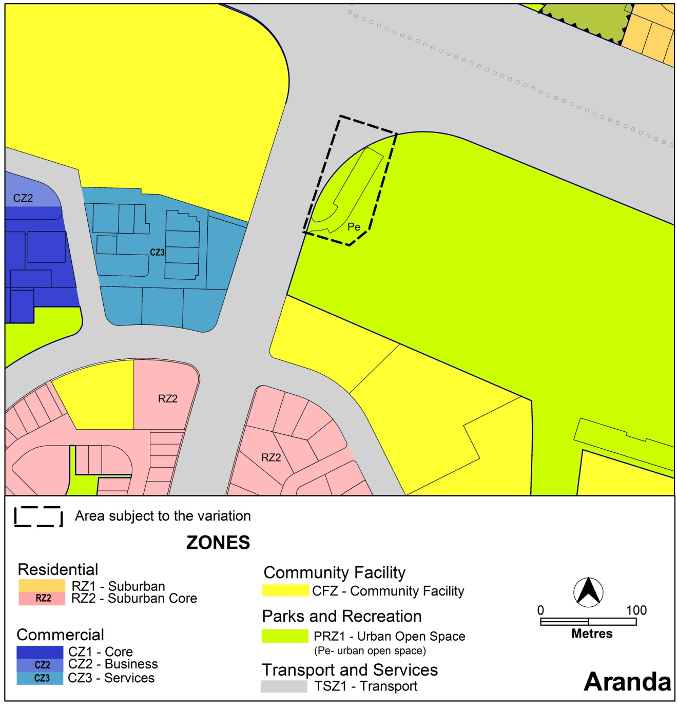

Figure 2 Current Territory Plan map

* 1. Changes to the Territory Plan

Detailed changes to the Territory Plan are noted in section 2 of this document.

As a result of a recent technical amendment to the Territory Plan which relocated site-specific provisions into suburb precinct maps and codes, it was necessary to revise the instructions on changes to the Territory Plan. The changes have resulted in the Aranda Precinct map being replaced with the Aranda Precinct map and code.

* 1. Consultation on the Draft Variation

Draft variation 315 (DV315) was released for public comment between Friday 20 July 2012 and Monday 3 September 2012. A consultation notice under section 63 of the *Planning and Development Act 2007* (P&D Act) was published in the ACT Legislation Register on Friday 20 July 2012 and in *The Canberra Times* on Saturday, 21 July 2012. A further notice was placed in the ACT Government Community Noticeboard printed in *The Canberra Times* on Saturday 4 August 2012. Full details of consultation activities are contained in the Report on Consultation for DV315.

A total of 14 written public submissions were received, which included submissions from the Aranda Residents Group and Friends of Aranda Bushland. Two submissions expressed support for the proposal.

Main issues raised by submitters included:

* loss of open space, recreational land and trees
* impacts upon traffic, road safety and parking
* noise generated by sirens
* consultation process
* visual amenity

Various submissions also commented on the site selection process and consultations undertaken by ESA, together with proximity to residential areas, additional protections for off-site trees, replacement of facilities and improvements to oval drainage.

The above issues were considered and are detailed in a report on consultation, which is available at **www.act.gov.au/recommendedvariations**. No changes were made following consideration of the consultation comments. The Minister will consider the outcomes of consultation prior to making a decision on this draft variation.

* 1. Revisions to the Draft Variation Submitted to the Minister

No changes were made to the draft variation recommended to the Minister.

1. VARIATION
   1. Variation to the Territory Plan

The Territory Plan is varied in all of the following ways:

Variation to the Aranda Precinct Map

1 Aranda precinct map

*Substitute with the following:*

Aranda Precinct Map and Code (at ***Attachment A***)

**Interpretation service**

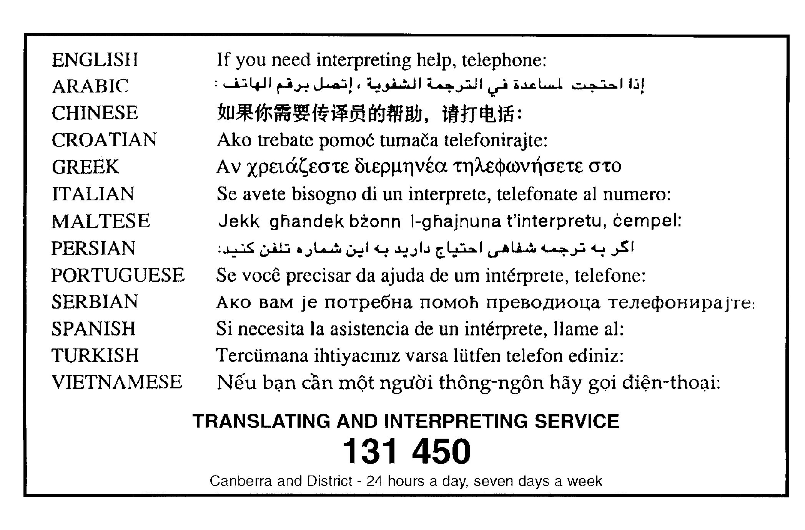

**ATTACHMENT A**

**Aranda Precinct Map and Code**

*This page is intentionally blank.*

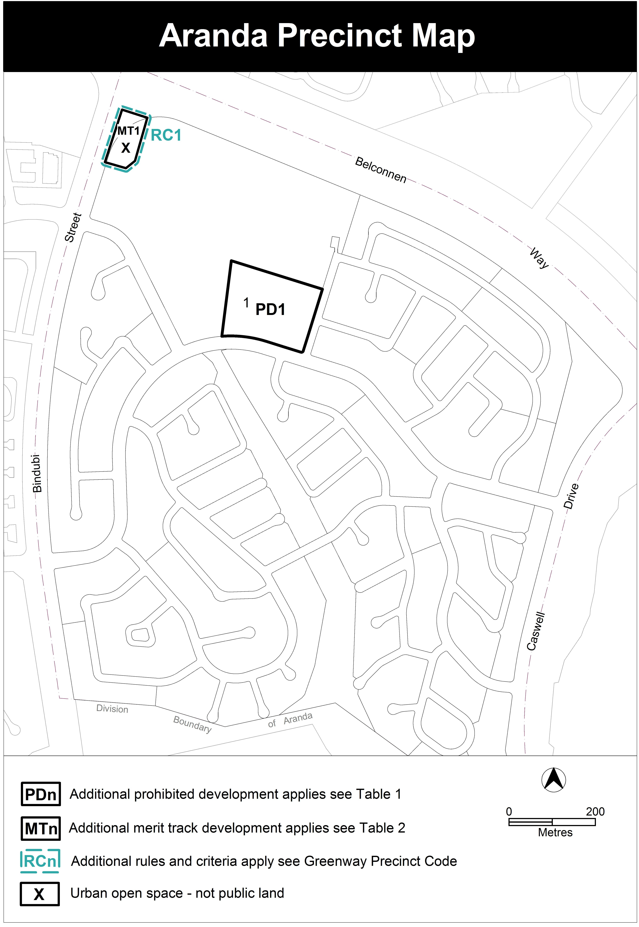

**Assessment Tracks**

The following tables identify the assessment tracks for additional prohibited development and additional merit track development for the blocks and parcels shown in the Aranda Precinct Map (identified as MTn or PDn). Development that is exempt from requiring development approval, other prohibited development and the minimum assessment track applicable to each development proposal are set out in the relevant zone development table.

The following table constitutes part of the relevant zone development table.

**Table 1 – Additional prohibited development**

|  |  |  |
| --- | --- | --- |
| **Additional prohibited development** | | |
| **Suburb precinct map label** | **Zone** | **Development** |
| PD1 | CFZ | *retirement village*  *supportive housing* |

**Table 2 – Additional merit track development**

|  |  |  |
| --- | --- | --- |
| **Additional merit track development that may be approved subject to assessment** | | |
| **Suburb precinct map label** | **Zone** | **Development** |
| MT1 | PRZ1  TSZ1 | *emergency services facility* |

**Aranda Precinct Code**

Contents

Introduction 2

Additional rules and criteria 2

RC1 – Aranda Ambulance and Fire Station 2

Element 1: Building 2

1.1 Height 2

1.2 Setback 2

1.3 Screening 2

*This page is intentionally blank.*

|  |
| --- |
| Introduction |

Name

The name of this code is **Aranda Precinct Code**.

Application

The code applies to the Division of Aranda.

Purpose

This code provides additional planning, design and environmental controls for specific areas or blocks and may also contain references to provisions in other codes.

In conjunction with other relevant codes it will be used by the *Authority* to assess development applications and offer guidance to intending applicants in designing developmentproposals and preparing development applications*.*

Structure

This code contains additional rules and/or criteria for particular blocks or parcels identified as areas RCn on the precinct map, to be read in conjunction with the relevant development code. It may also contain sub-parts.

Each element has one or more rules and, unless the respective rule is mandatory, each rule has an associated criterion. Rules provide quantitative, or definitive, controls. By contrast, criteria are chiefly qualitative in nature.

In some instances rules are mandatory. Such rules are accompanied by the words “This is a mandatory requirement. There is no applicable criterion.” Non-compliance with a mandatory rule will result in the refusal of the development application. Conversely, the words “There is no applicable rule” is found where a criterion only is applicable.

Code hierarchy

Under the *Planning and Development Act 2007*, where more than one type of code applies to a development, the order of precedence if there is inconsistency of provisions between codes is: precinct code, development code and general code.

If more than one precinct code applies to the site, the most recent precinct code takes precedence to the extent of any inconsistency.

Definitions

Defined terms, references to legislation and other documents are italicised.

Definitions of terms used in this code are listed in part 13 of the Territory Plan or, for terms applicable only to this code, associated with the respective rule.

Acronyms

ACTPLA Planning and Land Authority within the ACT Environment and Sustainable Development Directorate

EPA ACT Environment Protection Authority

ESA ACT Emergency Services Agency

ESDD ACT Environment and Sustainable Development Directorate

NCA National Capital Authority

P&D Act Planning and Development Act 2007

TAMS ACT Territory and Municipal Services Directorate

Additional rules and criteria

This part applies to blocks and parcels identified in the Aranda Precinct Map (RCn). It should be read in conjunction with the relevant zone development code and related codes.

RC1 – Aranda Ambulance and Fire Station

This part applies to blocks and parcels identified in area RC1 shown on the Aranda Precinct Map.

1. Building

| Rules | Criteria |
| --- | --- |
| * 1. Height | |
| 1. 1. The maximum *height of building*, excludingrooftopplant and equipment, is 9m. | 1. 1. Buildings achieve all of the following:       1. direct access from main pedestrian areas       2. avoid extensive lengths of blank walls unrelieved by doors, display windows or the like |
| * 1. Setback | |
| 1. nn   There is no applicable rule. | 1. 1. Setback achieves adequate sight lines for vehicles and pedestrians, especially near corners and intersections. |
| * 1. Screening | |
| 1. 1. Structures and plant and equipment situated on the roof are not visible from the street frontage or unleased Territory land unless exempt under *Planning and Development Act 2007*. This includes water tanks, solar energy devices, evaporative cooling or air conditioning devices, a radio mast or aerial, or a satellite dish. | 1. 1. Any structures and plant and equipment situated on or visible above the roofline does not significantly impact on the amenity of the streetscape or urban open space. |