Australian Capital Territory

Planning and Development (Plan Variation No 316) Notice 2013

Notifiable Instrument NI2013-114

made under the

Planning and Development Act 2007, section 76(3)

**1 Name of instrument**

This instrument is the *Planning and Development (Plan Variation No 316) Notice 2013.\**

**2 Plan Variation 316**

On 8 March 2013, the Minister for Environment and Sustainable Development approved the attached plan variation to the Territory Plan ***(Attachment A)*** under s 76 (3).

Jim Corrigan

Delegate of the Planning and Land Authority

8 March 2013

**ANNEXURE A**

*Planning and Development Act 2007*

Variation to the   
Territory Plan  
316

**Calwell / Conder Fire Station**

Establishment of emergency services facility as additional merit track development for a new parcel of land shown in the precinct maps for Calwell and Conder and amendments to the precinct codes for Calwell and Conder

This page is intentionally blank.

Contents

1. EXPLANATORY STATEMENT 1

1.1 Background 1

1.2 Summary of the proposal 2

1.3 National Capital Plan 2

1.4 Site description 3

1.5 Current Territory Plan provisions 4

1.6 Changes to the Territory Plan 5

1.7 Consultation on the Draft Variation 5

1.8 Revisions to the Draft Variation recommended to the Minister 6

2. VARIATION 7

2.1 Variation to the Territory Plan 7

Figures

Figure 1 Aerial image of site for proposed fire station 2

Figure 2 Territory Plan map 2

This page is intentionally blank.

1. EXPLANATORY STATEMENT
   1. Background

As the ACT expands and the population grows, the ACT Emergency Services Agency (ESA) must ensure that its services are able to meet government benchmarks for emergency service response times and coverage. To achieve this, the ESA recently completed a Station Upgrade and Relocation Strategy and an Implementation Plan to determine where ambulance and fire stations should be located in the Territory for at least the next 20 years.

As part of the Station Upgrade and Relocation Strategy and Implementation Plan, the ESA engaged a UK based research organisation, which specialises in the application of analysis and modelling to support planning for emergency services, to undertake station location modelling and data analysis for the ACT. This exercise identified optimal areas for the location of emergency service facilities.

Based on the findings of the location modelling, the ESA undertook a comprehensive analysis of three possible sites in the Tuggeranong area. One of the most important parameters for determining a suitable site for an emergency services facility is its proximity to a major arterial road. Being located close to or on a major arterial road facilitates speedy multidirectional egress which impacts on response times and coverage. Other considerations included response times and coverage, the suitability of the land (i.e. size, shape and topography) and the site constraints and opportunities (e.g. environmental issues, heritage, adjoining land uses, contamination and infrastructure).

Following the detailed analysis, the ESA concluded that the Calwell/Conder site is the most suitable location for a fire station based on a rigorously developed network plan which considered community response times.

It is proposed that the existing fire station on the corner of Reed and Scollay Streets, Greenway, will be used for a new ambulance station.

The subject site is currently unleased Territory land. The custodian of the site is the Territory and Municipal Services Directorate (TAMS). As a result of the variation being approved, the affected land can be surveyed to determine new cadastral boundaries and property identifiers. This allows responsibility for land management to be transferred to the ESA.

The Calwell/Conder site is zoned transport and services TSZ1 transport. Under this zone, emergency service facility is prohibited. The variation to the Territory Plan allows the proposal to proceed upon this site.

* 1. Summary of the proposal

The variation allows development of the Calwell / Conder fire station on land near the intersection of Tharwa Drive and Drakeford Drive by amending the Territory Plan to include *emergency services facility* as merit track development for the subject site and establishes planning controls in the precinct codes for Calwell and Conder to guide development of the land.

While the variation allows development of the emergency services facility at this site, the existing list of permissible developments has been retained as no change in zone has been made to the land.

* 1. National Capital Plan

The *Australian Capital Territory (Planning and Land Management) Act 1988* established the National Capital Authority (NCA) with two of its functions being to prepare and administer a National Capital Plan (the Plan) and to keep the NCP under constant review and to propose amendments to it when necessary.

The Plan, which was published in the Commonwealth Gazette on 21 January 1990, is required to ensure Canberra and the Territory are planned and developed in accordance with their national significance. The *Australian Capital Territory (Planning and Land Management) Act 1988* also requires the Territory Plan is not inconsistent with the Plan. The area covered by this variation is within urban areas identified in the Plan.

* 1. Site description

The subject land is located to the south-east of the intersection of Tharwa Drive and Drakeford Drive (refer ***Figure 1***). A new parcel of land will be required to be established within part of the road reserve. The total area of the parcel is approximately 7,000m² of unleased Territory land.

The final dimensions of the site will be determined by the detailed survey plan to allow the parcel of land to be established.



Figure 1 Aerial image of site for proposed fire station

* 1. Current Territory Plan provisions

The subject parcel is located on land within the TSZ1 transport zone.

Emergency services facility is among the list of prohibited development in the TSZ1 transport zone development table.

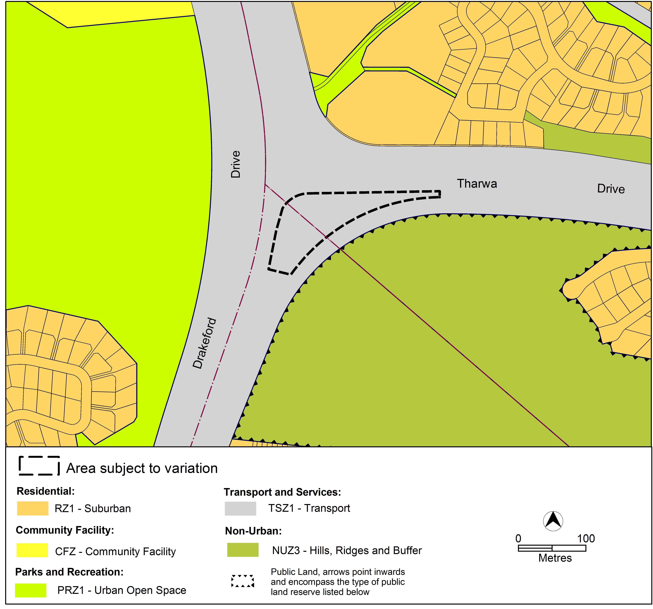

Figure 2 Territory Plan map

* 1. Changes to the Territory Plan

The changes to the Territory Plan are detailed in section 2 of this document.

Revisions were made to the form of the variation after a recent technical amendment to the Territory Plan which revised co-located site specific provisions in suburb precinct codes. The instructions in section 2 of this variation make all of the following changes to the Territory Plan:

1. identify the subject site as MT2 in precinct maps for both Calwell and Conder
2. add ‘emergency services facility’ to Table 2 – Additional merit track development of the precinct maps for both Calwell and Conder
3. include the additional rules and criteria for the subject site in the precinct codes for Calwell and Conder.
   1. Consultation on the Draft Variation

Draft variation 316 was released for public comment between Friday 20 July 2012 and Monday 3 September 2012. A consultation notice under section 63 of the *Planning and Development Act 2007* (P&D Act) was notified in the ACT Legislation Register on Friday 20 July 2012 and in *The Canberra Times* on Saturday 21 July 2012. A further notice was included in the ACT Government Community Noticeboard that published in *The Canberra Times* on Saturday 4 August 2012. Full details of consultation activities are contained in the Report on Consultation for DV316.

A total of three written submissions were received from individuals as a result of the consultation process. Two submissions indicated support for the proposal.

Main issues raised by submitters related to:

* justification for the proposal
* consideration of alternative sites, while supportive of the proposal

The above issues were considered and are detailed in a report on consultation. Changes to the draft variation were informed by issues raised by the Conservator of Flora and Fauna.

* 1. Revisions to the Draft Variation recommended to the Minister

No changes were made to the draft variation recommended to the Minister.

1. VARIATION
   1. Variation to the Territory Plan

The Territory Plan is varied in all of the following ways:

Variation to the Calwell Precinct Map and Code

1 Calwell precinct map

*Substitute with the following:*

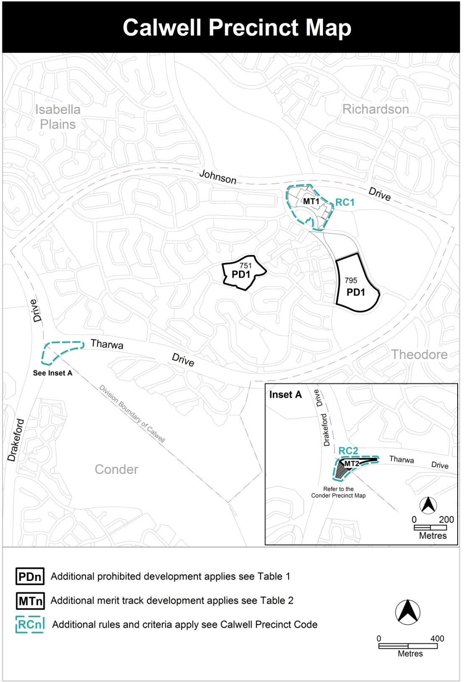

2 Calwell precinct map, Table 2 – Additional merit track development

*Insert the following:*

|  |  |  |
| --- | --- | --- |
| MT2 | TSZ1 | *emergency services facility* |

3 Calwell precinct code, RC1 – Calwell Group Centre, 2.1 Active frontages

*Insert the following:*

RC2 – Calwell / Conder Fire Station

This part applies to blocks and parcels identified in area RC2 shown on the Calwell Precinct Map.

1. Buildings

| Rules | Criteria |
| --- | --- |
| * 1. Height | |
| 1. 1. The maximum *height of building*, excludingrooftopplant and equipment, is 9m | 1. Nn     2. This is a mandatory requirement. There is no applicable criterion. |
| * 1. Setback | |
| 1. 2. There is no applicable rule. | 1. 1. Setback achieves adequate sight lines for vehicles and pedestrians, especially near the corners and intersections. |
| * 1. Screening | |
| 1. 1. Structures and plant and equipment situated on the roof are not visible from the street frontage or unleased Territory land unless exempt under *Planning and Development Act 2007*. This includes water tanks, solar energy devices, evaporative cooling or air conditioning devices, a radio mast or aerial, or a satellite dish. | 1. 1. Any structures and plant and equipment situated on or visible above the roofline does not significantly impact on the amenity of the streetscape or urban open space. |
| * 1. Environment | |
| 1. 1. Removal of native vegetation on unleased land in Calwell and Conder adjoining the site is to be endorsed by the Conservator of Flora and Fauna.   Note to applicant: In considering his or her decision, the Conservator has advised that plantings and regenerating saplings are to be retained, where possible, to maintain connectivity between Tuggeranong Hill Nature Reserve with areas in the Murrumbidgee River corridor reserve. Gaps of 100m or more in this connectivity are to be avoided. | 1. Nn     2. This is a mandatory requirement. There is no applicable criterion. |

Variation to the Conder Precinct Map and Code

1 Conder precinct map

*Substitute with the following:*

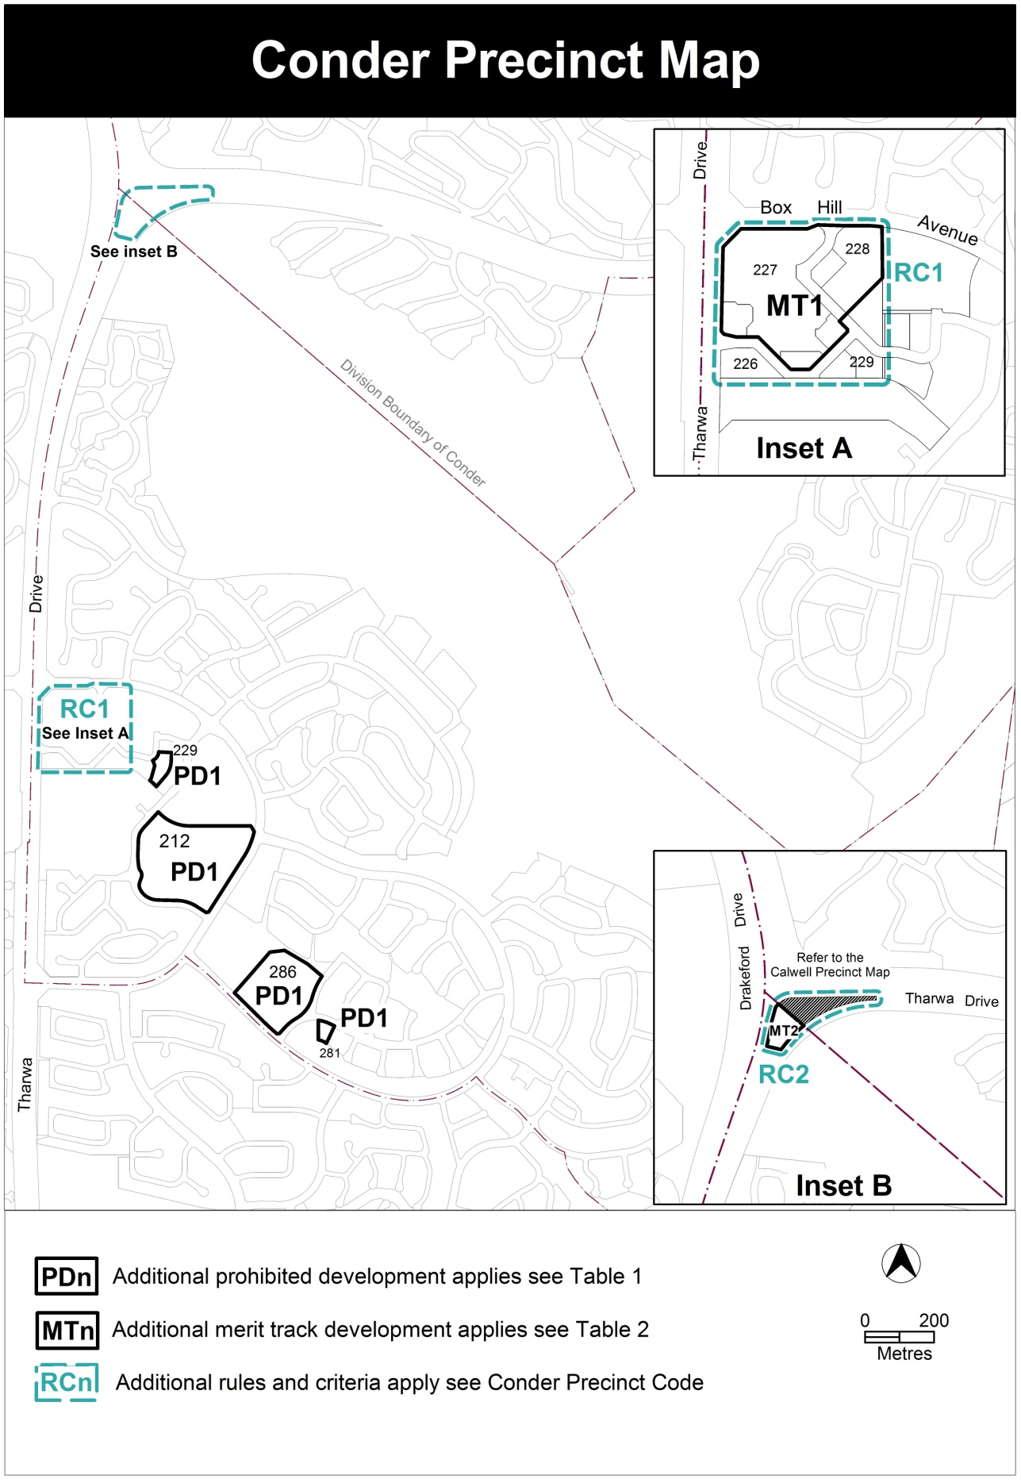

2 Conder precinct map, Table 2 – Additional merit track development

*Insert the following:*

|  |  |  |
| --- | --- | --- |
| MT2 | TSZ1 | *emergency services facility* |

3 Conder precinct code, RC1 – Conder Group Centre, 2.1 Active frontages

*Insert the following:*

RC2 – Calwell / Conder Fire Station

This part applies to blocks and parcels identified in area RC2 shown on the Calwell Precinct Map.

1. Buildings

| Rules | Criteria |
| --- | --- |
| * 1. Height | |
| 1. 1. The maximum *height of building*, excludingrooftopplant and equipment, is 9m | 1. Nn     2. This is a mandatory requirement. There is no applicable criterion. |
| * 1. Setback | |
| 1. 2. There is no applicable rule. | 1. 1. Setback achieves adequate sight lines for vehicles and pedestrians, especially near the corners and intersections. |
| * 1. Screening | |
| 1. 1. Structures and plant and equipment situated on the roof are not visible from the street frontage or unleased Territory land unless exempt under *Planning and Development Act 2007*. This includes water tanks, solar energy devices, evaporative cooling or air conditioning devices, a radio mast or aerial, or a satellite dish. | 1. 1. Any structures and plant and equipment situated on or visible above the roofline does not significantly impact on the amenity of the streetscape or urban open space. |
| * 1. Environment | |
| 1. 1. Removal of native vegetation on unleased land in Calwell and Conder adjoining the site is to be endorsed by the Conservator of Flora and Fauna.   Note to applicant: In considering his or her decision, the Conservator has advised that plantings and regenerating saplings are to be retained, where possible, to maintain connectivity between Tuggeranong Hill Nature Reserve with areas in the Murrumbidgee River corridor reserve. Gaps of 100m or more in this connectivity are to be avoided. | 1. Nn     2. This is a mandatory requirement. There is no applicable criterion. |

**Interpretation service**

