Australian Capital Territory

Planning and Development (Technical Amendment—Griffith) Plan Variation 2013 (No 1)

Notifiable Instrument NI2013—127
Technical Amendment No 2013—07
made under the
Planning and Development Act 2007, section 89 (Making technical amendments) s96A (Rezoning – boundary changes)

This plan variation commences on the day after it is notified.

Variation No 2013—07 to the Territory Plan has been approved by the Planning and Land Authority.

Variation to the Territory Plan
The variation specifies changes to zone boundaries as indicated in Annexure A to be consistent with the amendment to block boundaries and does not affect existing leasehold.

Jim Corrigan
Delegate of ACT Planning and Land Authority
19 March 2013

THIS IS PAGE ONE OF ANNEXURE A
TO NOTIFIABLE INSTRUMENT NI2013 – 127

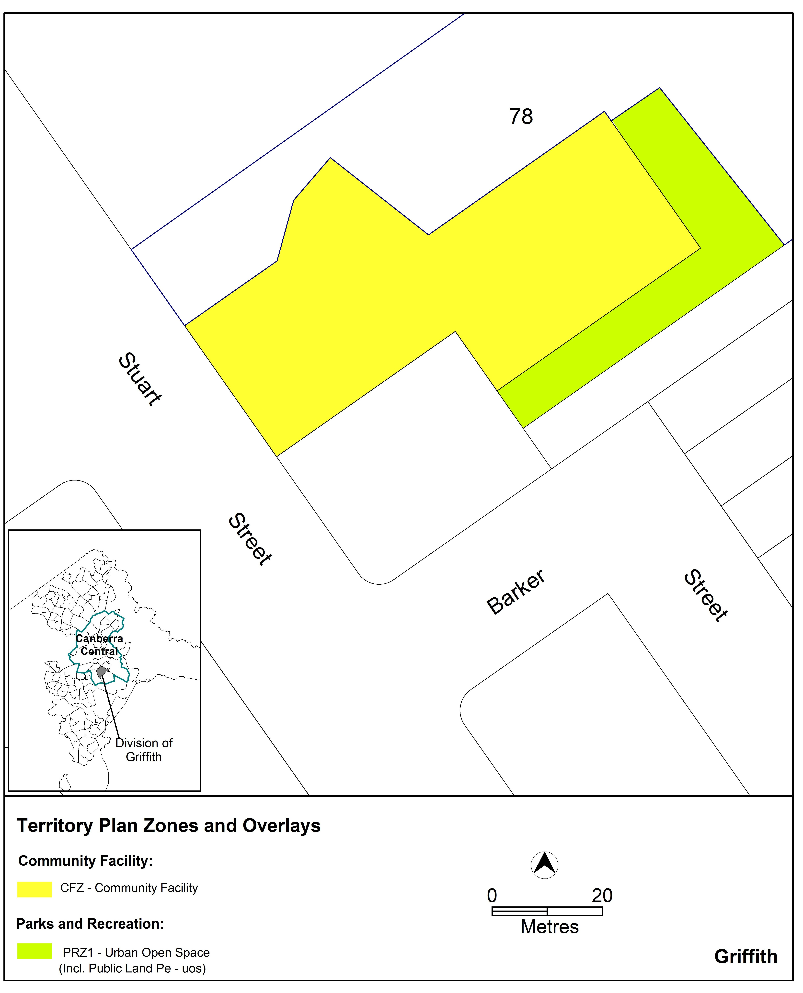

Jim Corrigan
Delegate of ACT Planning and Land Authority
19 March 2013

