Australian Capital Territory

Planning and Development (Draft Variation No 304) Consultation Notice 2013

Notifiable instrument NI2013—129
made under the

Planning and Development Act 2007, section 63 (Public consultation– notification) and section 64 (Public consultation – notice of interim effect etc)

Under the Planning and Development Act 2007, section 63(1), the planning and land authority, within the Environment and Sustainable Development Directorate (ESDD), has prepared Draft Variation No 304 (DV304) to the Territory Plan – Commercial Zones Development Code (see Annexure A).
The following changes are proposed:
- revising floor area provisions for shops in town centres and group centres
- introducing floor area provisions for shops in local centres and mixed use zones
- revising CZ4 local centres zone objectives
- realigning boundaries between commercial zones in some group centres
Written comments from the public are invited by COB Monday 6 May 2013.
The draft variation and background documents are available online at www.act.gov.au/draftvariations until the closing date for written comments.
Printed copies of the draft variation and background documents are available for inspection and purchase at the Environment and Sustainable Development Customer Service Centre, 16 Challis Street, Dickson, Monday to Friday (except public holidays) between 8:30am and 4:30pm. Please call 6207 1923 to arrange a copy for purchase.
Comments should include reference to the draft variation, your name and contact details, and be addressed to the Territory Plan Review Unit.
Comments can be:
- emailed to DV.Comments@act.gov.au
- mailed to Territory Plan Comments, GPO Box 158, Canberra, ACT 2601
- delivered to ESDD’s Customer Service Centre at the above address
Written comments will be made available (unless excluded) for public inspection for no less than 15 working days starting 10 working days after the closing date for comment. The comments will be available at ESDD’s customer service centre in Dickson and may be published on ESDD’s website.
Comments made available will include personal contact details unless excluded under section 411 or 412 of the Planning and Development Act 2007. A request for exclusion under these sections must be in writing, clearly identifying what you are seeking to exclude and how the request satisfies the exclusion criteria.
Effect of the draft variation
The following parts of DV304 have interim effect under section 65 of the Planning and Development Act 2007:
Draft Commercial Zones Development Code
- item 15.5 Shops – floor area, R51 and R52
- item 17.1 Shops – floor area, R56 and R57

Jim Corrigan
Delegate of the ACT Planning and Land Authority

20 March 2013

Planning and Land Authority

Draft Variation to the
Territory Plan 304

Commercial Zones Development Code:
Revise floor area provisions for shops in town centres, group centres and local centres.
Create floor area provisions for shops in mixed use zones.
Zone objectives:
Revise CZ4 local centres zone objectives.
Map:
Realign boundaries between commercial zones in some group centres.

March 2013

Public consultation version

Contents
1. INTRODUCTION 3
1.1 Purpose 3
1.2 The process 3
1.3 This document 4
1.4 Public Consultation 4
2. EXPLANATORY STATEMENT 5
2.1 Background 5
2.1.1 Review of the Territory Plan 5
2.1.2 Commercial zones policy review discussion paper 5
2.1.3 Technical amendment to the Territory Plan - TA2012-06 6
2.1.4 Supermarket Competition Policy 7
2.2 Commercial Zones Development Code 7
2.2.1 Floor area of shops 7
2.2.2 Local centres – consideration of impacts 12
2.3 CZ4 – Local Centre Zone objectives 12
2.4 Territory Plan map 13
2.4.1 Refine commercial zone boundaries at group centres 13
3. PLANNG CONTEXT 18
3.1 National Capital Plan 18
3.2 Territory Plan 18
3.3 ACT planning strategy 18
3.4 Interim effect 18
3.5 Consultation with government agencies 19
4. DRAFT VARIATION 21
4.1 Commercial Zones Development Code 21
4.2 CZ4 Objectives 21
4.3 Territory Plan Map 21

- INTRODUCTION
  - Purpose
The purpose of this draft variation is to modify the Commercial Zones Development Code to:
- introduce new limits on floor area for shops in local centres, group centres and mixed use zones (CZ5)
- introduce a new objective to the local centres zone (CZ4) to recognise the needs of people with mobility issues
- refine commercial zone boundaries at some group centres to better reflect current land use and development patterns.
  - The process
The Commonwealth’s Australian Capital Territory (Planning and Land Management) Act 1988 allows for the Legislative Assembly to make laws to establish a Territory Planning Authority and for that authority to prepare and administer a Territory Plan. The Planning and Development Act 2007 (the Act) establishes the ACT Planning and Land Authority to, among other things:
- prepare and administer the Territory Plan
- continually review the Territory Plan and proposed amendments as necessary.
The Territory Plan comprises a written statement and map. The written statement contains a number of parts, namely: governance, strategic directions, zones, precinct codes, general codes, overlays, definitions and structure plans, concept plans and development codes for future urban areas.
The Territory Plan Map graphically represents the applicable land use zones (under the categories of residential, commercial, industrial, community facility, urban parks and recreation, transport and services and non urban), precincts and overlays. The zone, precinct and overlay requirements are detailed in the Territory Plan.
Draft variations to the Territory Plan are prepared in accordance with the Act. Following the release of the draft variation under section 63 of the Act, submissions from the public are invited. At the conclusion of the consultation period the planning and land authority submits a report on consultation and a recommended final variation to the Minister for Planning for approval. The Minister may refer the draft variation to the Legislative Assembly’s Standing Committee on Planning, Public Works and Territory and Municipal Services, depending on the nature and significance of the proposal. If the draft variation is referred to the standing committee, the Minister must consider its findings before deciding whether to approve the draft variation. If the Minister approves the variation, it and associated documents are tabled in the Legislative Assembly. Unless disallowed by the Legislative Assembly within five sitting days, the variation commences on a day nominated by the Minister.
The Planning and Land Authority is currently within the Environment and Sustainable Development Directorate.

  - This document
This document contains the background information in relation to the proposed variation. It comprises the following sections:
Section 1 - This introduction.
Section 2 - An explanatory statement, which outlines the proposed changes to the Territory Plan and gives reasons for those changes.
Section 3 – Details of the draft variation taking the form of drafting instructions.

  - Public Consultation
Comments from the public are invited on the draft variation. Subject to consideration of responses received, the Planning and Land Authority proposes to submit this draft variation to the Minister for the Environment and Sustainable Development in accordance with the Act.
The documents relating to this draft variation may be obtained from
- www.act.gov.au/draftvariations
- ESDD Customer Service Centre, 16 Challis Street, Dickson between 8:30am and 4:30pm weekdays
Note that free internet access is available at all ACT Public Libraries.
Written comments from the public are invited on the draft variation by closing date: COB Monday 6 May 2013.
Comments should include reference to the draft variation and a return postal address.
Comments may be submitted to
- DV.Comments@act.gov.au
- Territory Plan Comments
GPO Box 158, Canberra ACT 2601
- ESDD customer service centre, 16 Challis Street, Dickson
Copies of all written comments received from the public will be made available for public inspection at the ESDD Customer Service Centre, Dickson for a period of not less than 15 working days after the closing date listed above.

- EXPLANATORY STATEMENT
  - Background

    - Review of the Territory Plan
On 31 March 2008 a restructured Territory Plan came into effect as part of the reform of the ACT planning system. In response to a commitment by the ACT government at the time, the Territory Plan was reformatted, but no significant policy changes were made.
In 2009 the planning authority commenced a general review of the policy content of the Territory Plan. The first step was a review of the community facility zone which culminated in the commencement of variation 302 in December 2011. This was followed by a review of provisions surrounding residential development, lease variations and estate development under draft variation 306 (DV306).
DV304 is the next step in the review. It focuses on policies applying to commercial zones, particularly local and group centres.

    - Commercial zones policy review discussion paper
Commercial zones policy review (phase 1) discussion paper was released to obtain feedback on various issues affecting development in commercial zones. These included the rezoning of land to allow development of new supermarkets, land use conflicts and provisions for social infrastructure. It also sought to assist in the development of policy responses, particularly in relation to group and local centres.
Public submissions on the discussion paper were invited from 6 May 2011 until 4 July 2011. A total of 49 comments were received including a petition. Apart from individual comments, submissions were received from Woolworths Ltd, Coles supermarkets, Supabarn and various IGA supermarkets, five centre landowners / developers, Housing Institute of Australia, Planning Institute of Australia, a planning consultant, five community groups or associations and ACT Greens.
The level of support for various policy changes in commercial zones that were canvassed in the discussion paper is summarised in table 1.

Table 1
Policy changes | Level of support reflected in public comments
 | strongly  supported | mildly  supported | equally divided | mildly  opposed | strongly  opposed
Widespread changes to the commercial zones
Reflect centres hierarchy in commercial zones
Zoning changes on a case-by-case basis
Expand the CZ1 core zone at centres [except where supported by a detailed planning study]
Limit supermarket size at local centres
Increase of SHOP size in CZ2 and CZ3 zones
Assess economic impact of significant supermarket developments on adjacent centres
Increase to building heights at centres
Revisions to night time economy (NTE) uses
Identification of housing precincts where
higher noise attenuation standards are needed
Submission of noise management plans for development of supermarkets and large shop
Location controls on night time economy venues
Requiring construction plans with lease variation applications for night time economy venues
Quotas on adaptable / universal standards for housing at centres [small number of submissions]
Target for the mix of bedroom numbers in housing at centres [small number of submissions]
Inclusion of social infrastructure targets

    - Technical amendment to the Territory Plan - TA2012-06
A precursor to DV304, technical amendment to the Territory Plan TA2012-06, commenced on 14 December 2012. It transferred all block specific provisions from development codes and zone development tables to suburb (divisional) precinct codes or district (largely rural) precinct codes. Co-locating these provisions in precinct codes, rather than being distributed throughout the Territory Plan, has advantages for proponents, assessors and the community. While some provisions were reworded for clarity, there was no change to the underlying policies.
This technical amendment also reconfigured most zone development tables to follow the format of the community facilities zone development table that was introduced through variation 302 to the Territory Plan in 2011. The new format acknowledges the role of leases in regulating land use and simplifies references to other relevant codes.
Following the pattern established by variation 302 (community facilities) and draft variation 306 (residential zones codes), the technical amendment TA2012-06 replaced five commercial zones development codes with a new Commercial Zones Development Code. The new code contains all relevant provisions other than the site specific provisions which were transferred instead to precinct codes. Whilst some provisions were re-worded for clarity and consistency, no new policies were introduced.

    - Supermarket Competition Policy
On 22 January 2010 the then Chief Minister released the ACT Supermarket Competition Policy Implementation Plan. This plan incorporates the ACT Government's response to the 15 recommendations of the Review of ACT Supermarket Competition Policy conducted by Mr John Martin, former Australian Competition and Consumer Commissioner. The Martin Review found that while there was reasonable supermarket competition in the ACT retail grocery market, there were benefits in providing competition and potentially supporting an alternative source of wholesale grocery supply.
While the plan’s focus is chiefly on the release of land for supermarket development, it also refers to possible changes to the Territory Plan (page 7):
The Planning and Land Authority is considering amendments to the Territory Plan to facilitate expansion of supermarkets in local centres to a level that is consistent with the role of those centres in the metropolitan retail structure and that takes account of factors such as scale and bulk of the Centre, supporting a good local amenity, access, traffic and car parking.
The Planning and Land Authority is monitoring Territory Plan policies to ensure that the full range of Government objectives are met in relation to accessibility, equity, public amenity and utilisation of existing infrastructure in local centres; and
The Planning and Land Authority is reviewing the ‘core’ and ‘secondary’ zones that currently apply in the Territory Plan for all group centres in Canberra, with a view to providing greater opportunities for additional supermarkets provided the existing cores are not detrimentally affected.
These investigations, with a focus on local and group centres, have informed this draft variation.

  - Commercial Zones Development Code
Planning controls for commercial zones are found in the Commercial Zones Development Codes. Area and site specific controls for commercial zones are also found in precinct codes, and override development codes where there is an inconsistency. For example, a precinct code may limit building height in a certain area to two storeys, despite a general three storey limit allowed under the Commercial Zone Development Code.
    - Floor area of shops
The intent of the proposed changes to floor area limits for shops in commercial zones is twofold. Firstly, to remove barriers to competition by allowing the development of small to medium sized shops (including supermarkets) in CZ2 and CZ3 zones. The second is to ensure that commercial development in local centres is consistent with the role of these centres and the established commercial centres hierarchy. As a general principle, development in local centres should not threaten the viability of nearby centres including group centres. This is to be accomplished by limiting the floor area of all shops including supermarkets in local centre CZ4 zones.
These changes will effectively limit the gross floor area of shops to 1,500m² in all commercial zones except CZ1 where the current provisions are retained, and in CZ6 where the nature and in some cases size of shops are limited to the sale of goods related to entertainment, accommodation or leisure.
These floor area limits will become the “default” provisions for commercial zones. Should the need to apply lower floor area restrictions, such provisions can be added to the relevant precinct code. For example, the master plan for Kingston recommends a 300m² GFA limit on shops in some areas. If endorsed, this restriction would be included in the Kingston Precinct Code through a variation to the Territory Plan. Under the code hierarchy established under the Act, precinct codes will always prevail over developments codes to the extent of any inconsistency.
Current and proposed gross floor area controls for shops (including supermarkets) are summarised in table 3.
A new term “net selling area” is proposed for use only in relation to CZ4 and CZ5:
Net selling area means that part of the gross floor area of a shop that is a) used for the display and sale of goods and b) is ordinarily accessible to the public.
The introduction of this new term is consistent with the select committee’s recommendation 11 (see section 2.1 above).

Both current and proposed provisions can be overridden by provisions in precinct codes. In most cases, however, a provision proposed for a precinct code that differs from a provision in the Commercial Zones Development Code can only be introduced through a full variation to the Territory Plan with the associated public consultation, approval by the Minister and scrutiny by the ACT Legislative Assembly.

Table 3 – Maximum floor area for shops
zone | current provision  (gross floor area) | proposed provision  (gross floor area)
town centres
CZ1 | not limited | not limited
CZ2 | 200m² with criterion | 1500m² for shops (including supermarkets) as a mandatory control
CZ3 | 200m² for a supermarket or a shop selling food (except for a produce market) as a mandatory control | 1500m² for shops selling food (including supermarkets but excluding produce markets) as a mandatory control
group centres
CZ1 | not limited | not limited
CZ2 | 100m² or 300m² where contiguous with CZ1 as a mandatory control | 1500m² for all shops (including supermarkets) as a mandatory control
CZ3 | 300m² per shop for supermarkets or shops selling food as a mandatory control; other shops unlimited as a mandatory control
local centres
CZ4 | not limited | 1500m² for all shops as a mandatory control;  A “net selling area” of 1000m² for shops selling food (including supermarkets) as a mandatory control.
mixed use zones
CZ5 | not limited | 1500m² for all shops as a mandatory control;  A “net selling area” of 1000m² for shops selling food (including supermarkets) as a mandatory control.

In Part B – Additional controls for town centres it is proposed to replace item 11.1:
Rules | Criteria
11.1 Shops – floor area limit – CZ2 and CZ3
R37  This rule applies CZ2.  The maximum gross floor area for a shop is 200m². | Shops are limited to a scale appropriate to providing convenience shopping and personal services for the local workforce and residents.
R37A  This rule applies CZ3.  The maximum gross floor area for a supermarket or a shop selling food (except for a produce market) is 200m². | This is a mandatory requirement. There is no applicable criterion.

with:
Rules | Criteria
11.1 Shops – floor area - CZ2
R37  This rule applies to CZ2.  The maximum gross floor area for shops (including supermarkets) is 1500m². | This is a mandatory requirement. There is no applicable criterion.
11.2 Shops – floor area – CZ3
R38  This rule applies to CZ3.  The maximum gross floor area for shops selling food (including supermarkets but excluding produce markets) is 1500m². | This is a mandatory requirement. There is no applicable criterion.

In Part C – Additional controls for group centres it is proposed to replace items 13.1 and 13.2:
Rules | Criteria
  - Shops – floor area limit - CZ2
R41  This rule applies to CZ2.  The maximum gross floor area for shops (including supermarkets) is:  - on land that is contiguous with CZ1 zone -300m²  - in all other cases - 100m². | This is a mandatory requirement. There is no applicable criterion.
  - Shops – floor area limit – CZ3
R42  This rule applies to CZ3.  The maximum gross floor area for a shop used or intended to be used as a supermarket is 300m². | This is a mandatory requirement. There is no applicable criterion.

with:
Rules | Criteria
13.1 Shops – floor area – CZ2
R41  This rule applies to CZ2.  The maximum gross floor area for shops (including supermarkets) is 1500m². | This is a mandatory requirement. There is no applicable criterion.
13.2 Shops – floor area – CZ3
R42  This rule applies to CZ3.  The maximum gross floor area for a shops selling food (including supermarkets) is 1500m². | This is a mandatory requirement. There is no applicable criterion.

In Part D – Additional controls for local centres it is proposed to insert item 15.6:
Rules | Criteria
15.6 Shops – floor area
R51  The maximum gross floor area for shops is 1500m². | This is a mandatory requirement. There is no applicable criterion.
R52  The maximum net selling area for shops selling food (including supermarkets) is 1000m².  For this rule:  Net selling area means that part of the gross floor area of a shop that is a) used for the display and sale of goods, and b) ordinarily accessible to the public. | This is a mandatory requirement. There is no applicable criterion.

In the new Part E – Additional controls for CZ5, it is proposed to insert the following:
Rules | Criteria
17.1 Shops – floor area
R56  The maximum gross floor area for shops is 1500m². | This is a mandatory requirement. There is no applicable criterion.
R57  The maximum net selling area for shops selling food (including supermarkets) is 1500m².  For this rule:  Net selling area means that part of the gross floor area of a shop that is a) used for the display and sale of goods, and b) ordinarily accessible to the public. | This is a mandatory requirement. There is no applicable criterion.

    - Local centres – consideration of impacts
The current Commercial Zones Development Code contains the following provision:
Rules | Criteria
15.1 Consideration of impacts
There is no applicable rule. | C48  A proposal to carry out development in a local centre must have regard to any significant adverse economic impact on other commercially viable local centres.

It is proposed to delete this provision because the proposed limit on the floor area of shops in local centres makes this redundant.

  - CZ4 – Local Centre Zone objectives
Currently, CZ4 local centre zone objectives are:
a) Provide for convenience retailing and other accessible, convenient shopping and community and business services to meet the daily needs of local residents
b) Provide opportunities for business investment and local employment
c) Ensure the mix of uses is appropriate to this level of the commercial hierarchy and enable centres to adapt to changing social and economic circumstances
d) Maintain and enhance local residential and environmental amenity through appropriate and sustainable urban design
e) Promote the establishment of a cultural and community identity that is representative of, and appropriate to, the place
Objective a) is proposed to be revised to include reference to people with mobility issues. This objective would act in concert with the current Access and mobility General Code which specifically applies to supermarkets:
    - Provide for convenience retailing and other accessible, convenient shopping and community and business services to meet the daily needs of local residents, particularly those with mobility issues.

These changes are consistent with the statement of strategic directions found in the Territory Plan.

  - Territory Plan map
    - Refine commercial zone boundaries at group centres
Currently the Territory Plan allocates CZ1, CZ2 and CZ3 to centres above local centres. Local centres are covered by CZ4.
It is proposed to refine the commercial zone boundaries at some group centres to reflect current land use and development patterns.

Jamison Group Centre-current
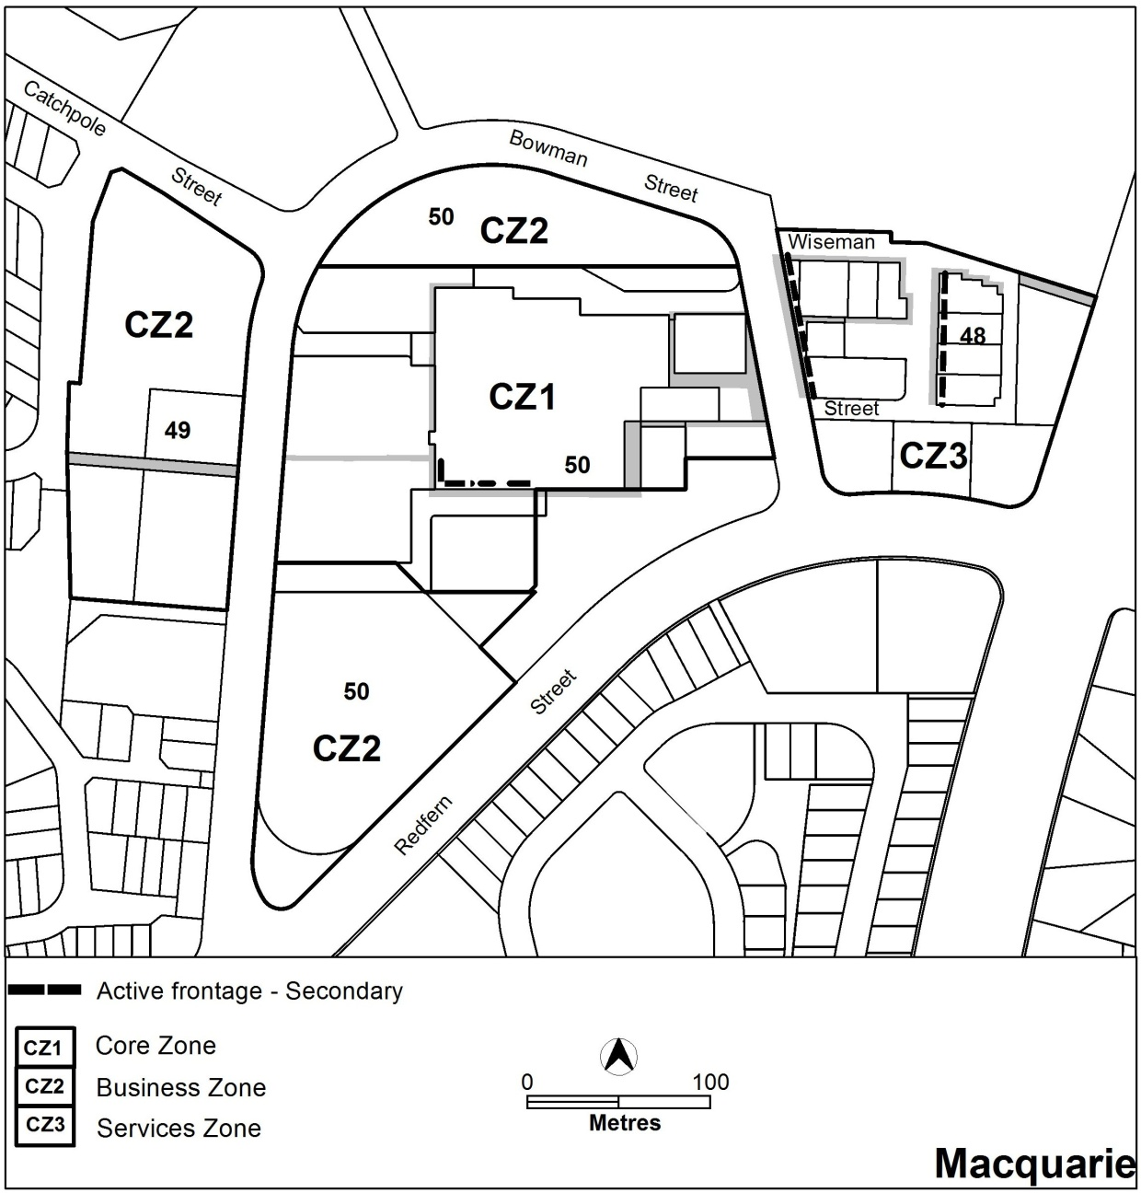

Jamison Group Centre-proposed
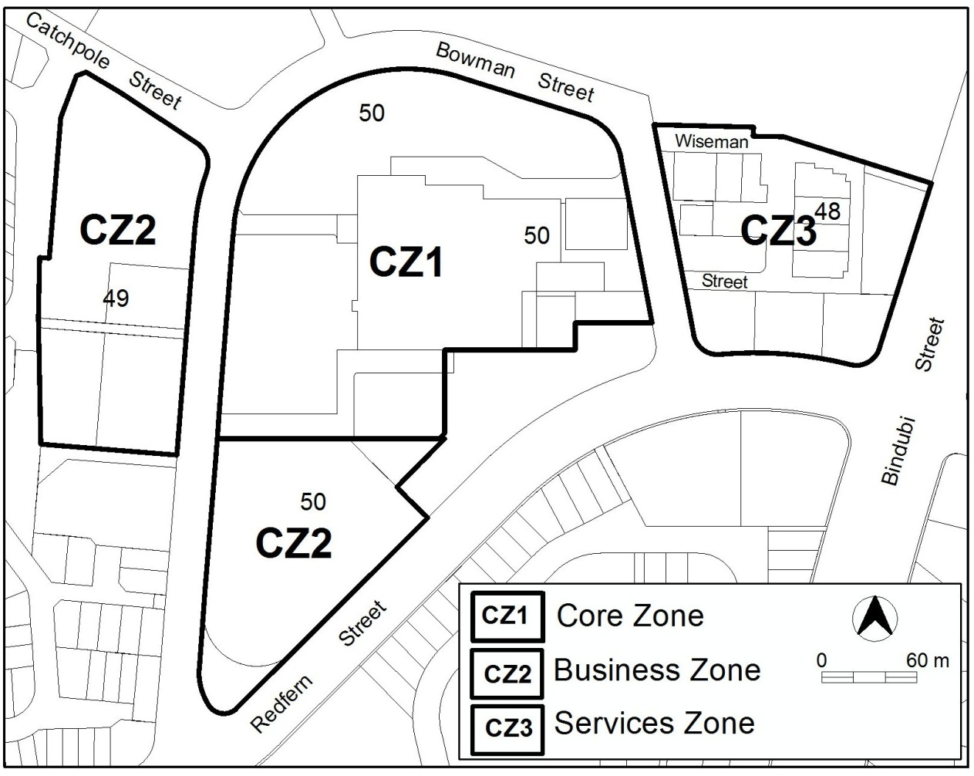

Kippax Group Centre – current
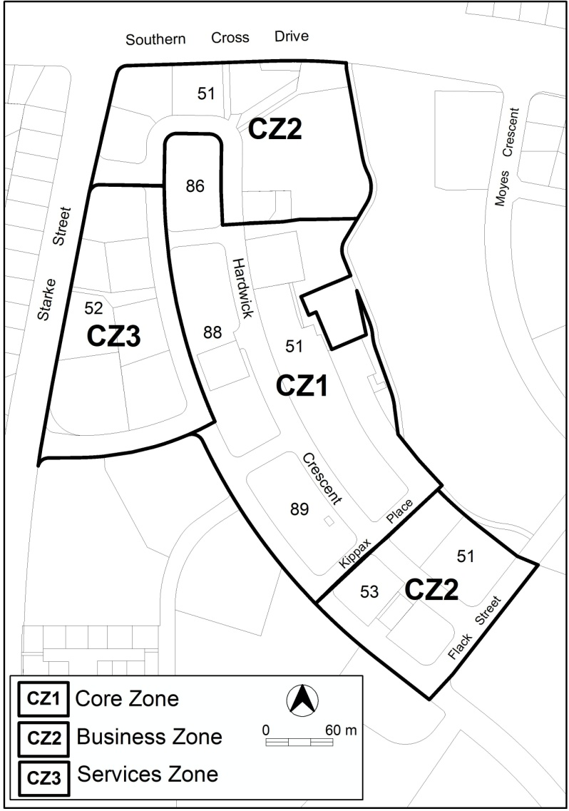

Kippax Group Centre – proposed
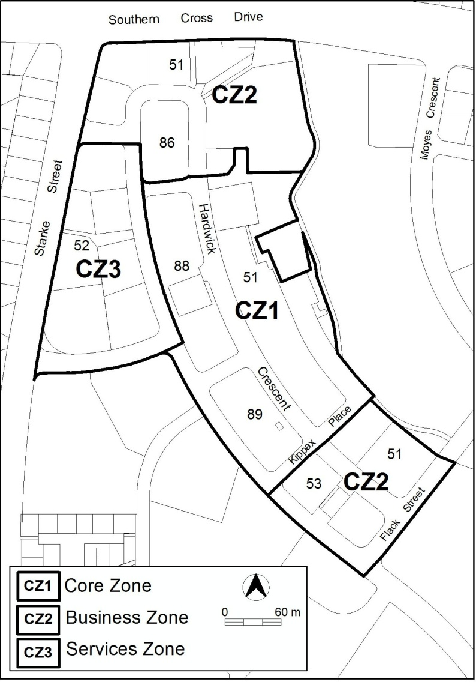

Wanniassa Group Centre – current
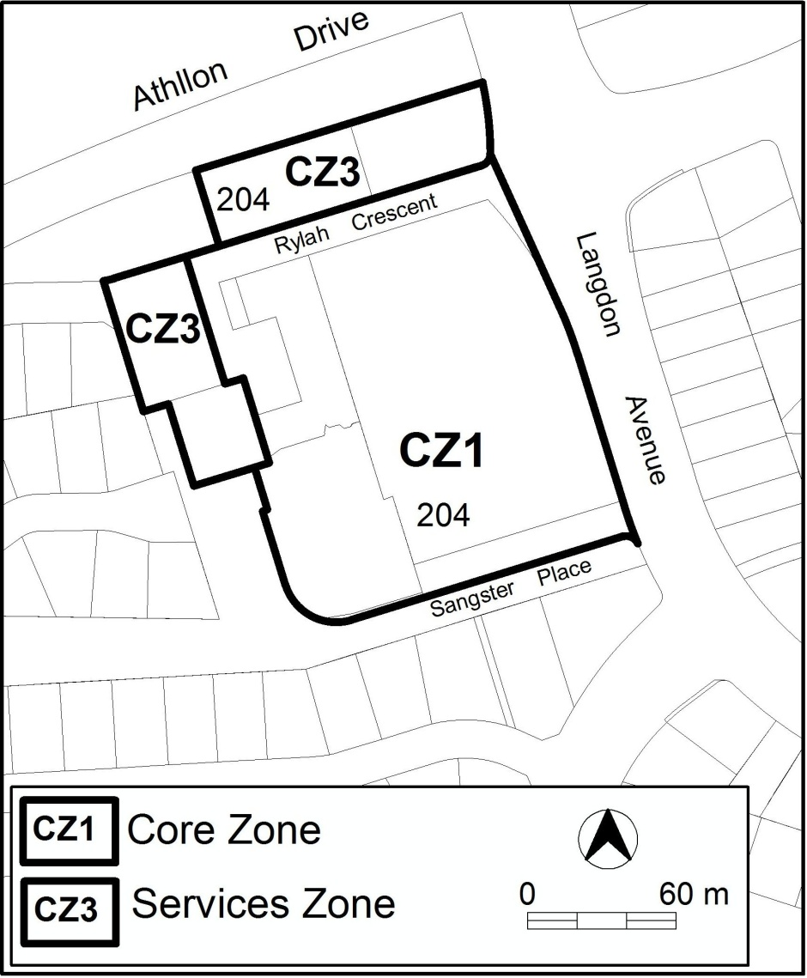

Wanniassa Group Centre – proposed
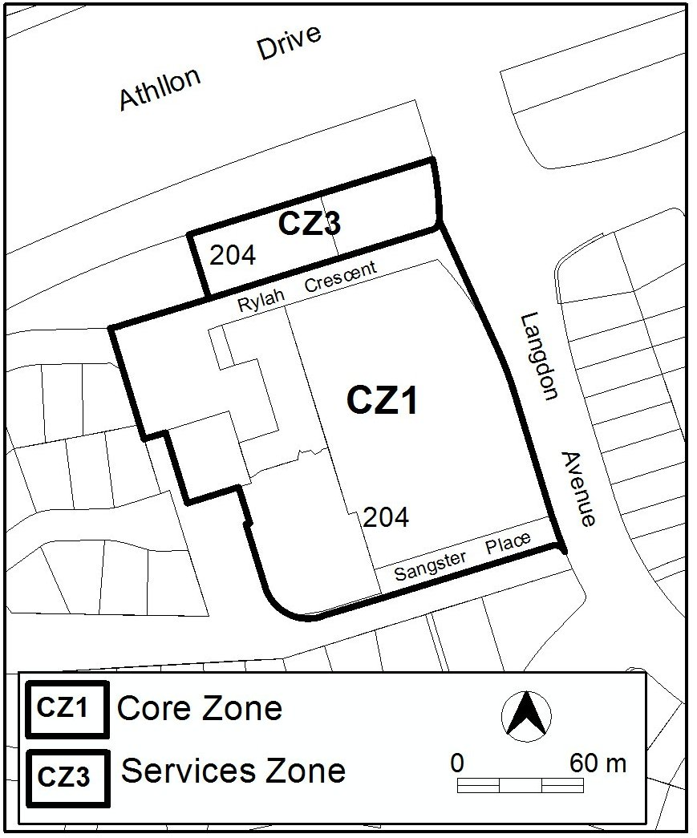

Mawson Group Centre – current
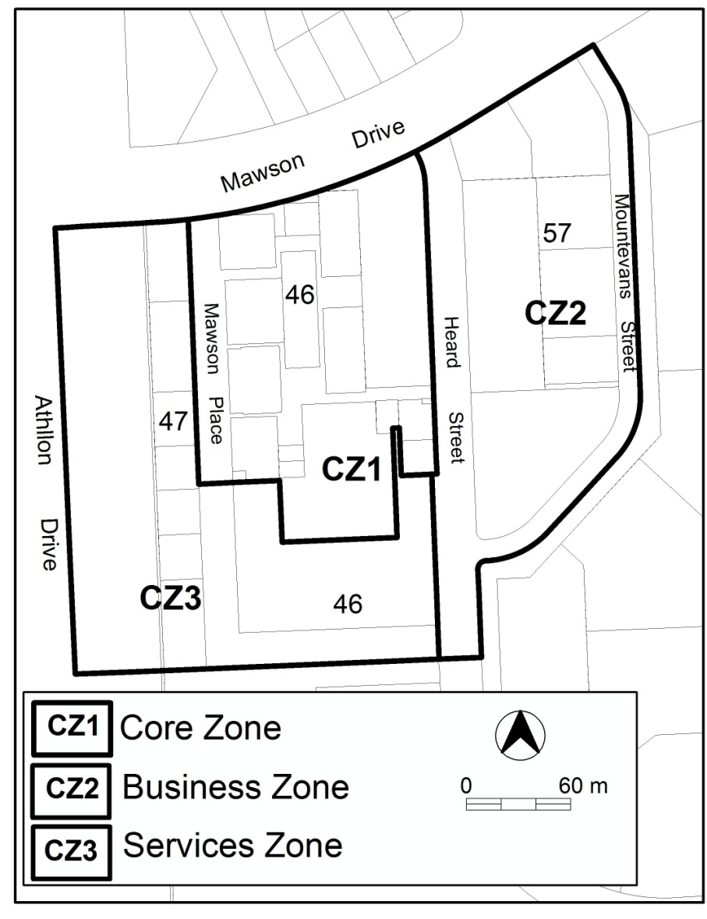
Mawson Group Centre – proposed
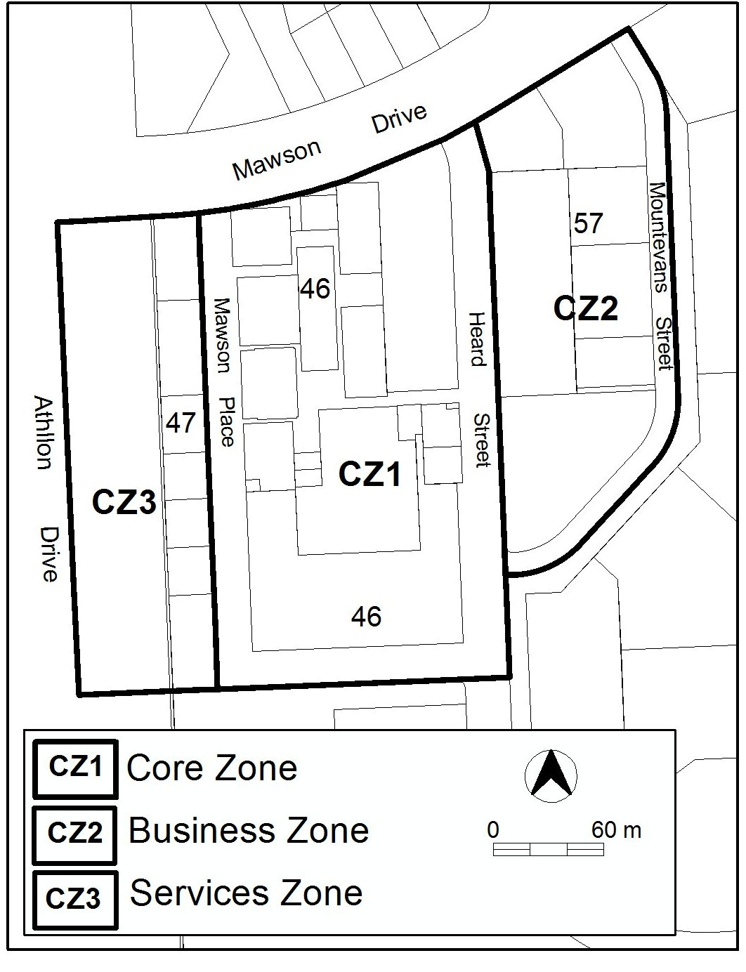

- PLANNG CONTEXT
  - National Capital Plan
The Commonwealth Australian Capital Territory (Planning and Land Management) Act 1988 established the National Capital Authority (NCA). Under this legislation the NCA is required to prepare a National Capital Plan (NCP), keep it under constant review, and propose amendments to it when necessary.
The NCP, which was published in the Commonwealth Gazette on 21 January 1990, seeks to ensure that Canberra and the Territory are planned and developed in accordance with their national significance. The Australian Capital Territory (Planning and Land Management) Act 1988 also provides that the Territory Plan cannot be inconsistent with the NCP.
  - Territory Plan
The proposal is consistent with the Territory Plan’s Statement of Strategic Directions in terms of environmental, economic and social sustainability, and spatial planning and urban design principles such as:
- reduce energy consumption by solar efficient siting and design of buildings
- support preferred pattern of development and efficient use of land.
  - ACT planning strategy
ACT planning strategy contains a number of strategies. Most relevant to this draft variation is:
Strategy 2: Renewing group and local centres as the hubs of community life and providing new opportunities for lifestyle choices.
By proposing to increase building heights at most local and group centres the draft variation is consistent with the implementation strategy recommended by the ACT planning strategy. This policy will encourage more housing development in these centres, thereby increasing housing choice and promoting more vibrant centres.
  - Interim effect
The following parts of this draft variation have interim effect, from date of the consultation notice (ie. on or about the date of release for public comment), but will not apply to development applications lodged before the date of public release.

Commercial Zones Development Code
- item 15.5 Shops – floor area, R51 and R52
- item 17.1 Shops – floor area, R56 and R57

The declaration of interim effect means that, after the date specified in the consultation notice, the identified provisions must be applied in the determination of a development application. In effect, if a draft provision with interim effect applies in a similar way to a current provision, the more onerous provision takes precedence.
Interim effect will end on the day the earliest of the following happens:
(i) the day the public availability notice under section 70 for the draft variation is notified in accordance with the Legislation Act
(ii) the day the draft variation, or the corresponding variation, is withdrawn under section 68 (1) (b) or section 76 (3) (b) (v)
(iii) 1 year after the date of the consultation notice.

  - Consultation with government agencies
When preparing a draft variation under section 61(b) the planning authority is required to consult with each of the following in relation to the proposed draft variation
- National Capital Authority
- Conservator of Flora and Fauna
- Environment Protection Authority
- Heritage Council
- if the draft variation would, if made, be likely to affect unleased land or leased public land – each custodian for the land likely to be affected

National Capital Authority
The NCA provided the following comments on 20 March 2013:

The National Capital Plan states that each town should have a centre acting as a focal point for higher order retail functions, commercial services, offices and community facilities. The National Capital Plan states that beyond these town centres 'the Territory Plan will provide for a range of lower order centres to meet the varying needs of residents'.

Draft Variation 304 is not inconsistent with these principles and policies of the National Capital Plan.

Response
Noted

Conservator of Flora and Fauna
The Conservator of Flora and Fauna made the following comments on 19 March 2013:

In accordance with Section 61(b) of the Planning and Development Act 2007, I advise that I have examined Draft Variation to the Territory Plan No. 304 Commercial Zones Development Code determined that there are no issues of concern with the proposed variation.

Response
Noted

Environment Protection Authority
The Environment Protection Authority provided the following comments on 21 March 2013:

Nil comment.

Response
Noted

Heritage Council
The Heritage Council provided the following comments on 20 March 2013:

I refer to your electronic mail dated 18 March 2013 in relation to the Draft Territory Plan Variation 304 seeking comments. It is noted that the purpose of the draft variation is to:
• Introduce new limits on floor area for shops in local and group centres;
• Introduce a new objective to the local centres zone (CZ4} to recognise the
needs of people with mobility issues; and
• Refine commercial zone boundaries at some group centres to better reflect current land use and development patterns.
In general, places on the ACT Heritage Register may have specific heritage controls which apply to new developments and those controls take precedence over any other planning requirements. Consequently, the Heritage Unit advises that the proposed variation 304 is unlikely to result in any detrimental heritage impacts. In the light of the above, the Heritage Unit would not raise any heritage concerns in relation to Territory Plan Variation 304.

Response
Noted
- DRAFT VARIATION
This section provides drafting instructions for the proposed changes to the Territory Plan as outlined in the previous section.

The Territory Plan is varied as follows.

  - Commercial Zones Development Code

Commercial Zones Development Code

substitute
the revised Commercial Zones Development Code at appendix A

  - CZ4 Objectives

CZ4 objectives

substitute
objective a) with
a) Provide for convenience retailing and other accessible, convenient shopping and community and business services to meet the daily needs of local residents, particularly those with mobility issues.

  - Territory Plan Map

Group centres

amend the map in the manner shown for the following group centres:

Jamison Group Centre
Kippax Group Centre

Wanniassa Group Centre

Mawson Group Centre

Interpretation service
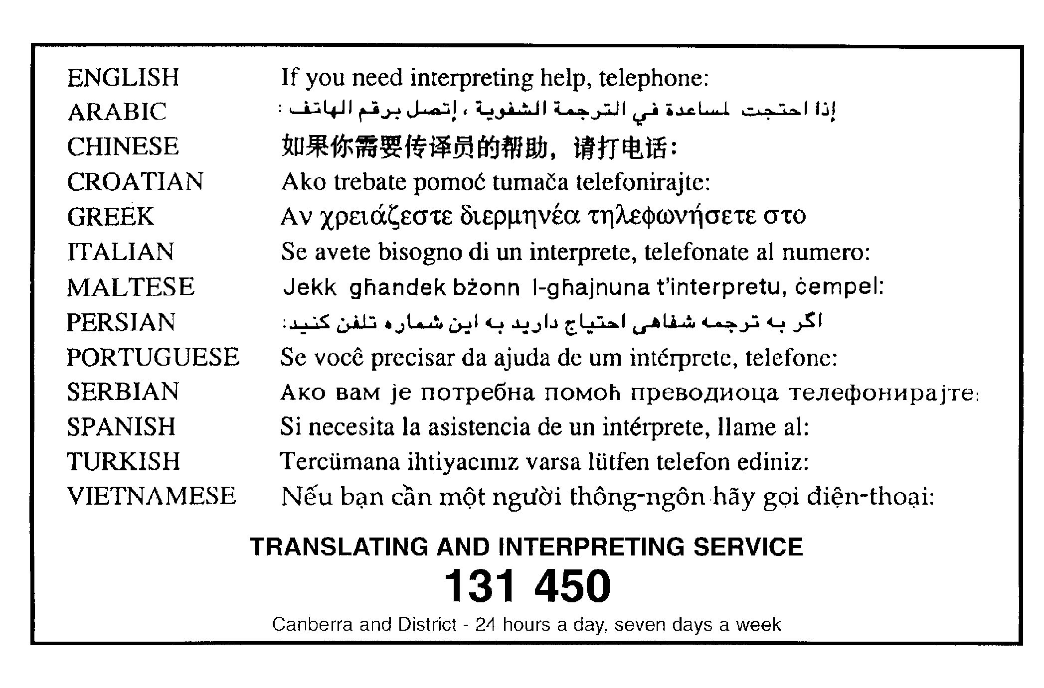

Appendix A

DRAFT
Commercial Zones
Development Code

This document incorporates the proposed changes outlined in section 2.2 of the DV304 explanatory document. Comments should be confined to the proposed changes.

March 2013

Contents
Part A – General controls 8
Element 1: Lease and development conditions 8
1.1 Approved lease and development conditions 8
Element 2: Use 9
2.1 Existing community and recreation sites 9
Element 3: Buildings 9
3.1 Building design and materials 9
3.2 Plant and structures 9
3.3 Car parking structures 9
3.4 Materials and finishes 10
3.5 Storage 10
3.6 Wind 10
3.7 Ventilation 11
3.8 Shopping arcades and malls – CZ3 11
3.9 Supportive housing and residential care accommodation 11
Element 4: Site 12
4.1 Landscaping 12
4.2 Lighting 12
4.3 Easements 13
Element 5: Access 13
5.1 Access 13
5.2 Traffic generation 13
5.3 Service access and delivery 13
Element 6: Noise 14
6.1 Potentially noisy uses 14
Element 7: Environment 15
7.1 Water sensitive urban design 15
7.2 Earthworks 16
7.3 Tree protection 16
7.4 Heritage 17
Element 8: Subdivision 17
8.1 Subdivision 17
Element 9: Demolition 18
9.1 Statement of endorsement 18
9.2 Hazardous materials survey 18
Element 10: Neighbourhood plans 19
10.1 Consideration 19
Part B – Additional controls for town centres 19
Element 11: Use 20
11.1 Shops – floor area – CZ2 20
11.2 Shops – floor area – CZ3 20
Element 12: Buildings 20
12.1 Materials and finishes 21
12.2 Number of storeys – CZ3 21
Part C – Additional controls for group centres 21
Element 13: Use 22
13.1 Shops – floor area – CZ2 22
13.2 Shops – floor area – CZ3 23
13.3 Offices – floor area limit 23
13.4 Residential use – ground floor – CZ1 23
Element 14: Buildings 23
14.1 Number of storeys 23
14.2 Plot ratio 24
Part D – Additional controls for local centres 24
Element 15: Use 25
15.1 Industrial trades 25
15.2 Redevelopment 25
15.3 Active frontages 25
15.4 Residential use 26
15.5 Shops – floor area 26
Element 16: Buildings 26
16.1 Height of buildings 27
16.2 Building design 27
16.3 Plot ratios 27
Part E – Additional controls for CZ5 28
Element 17: Buildings 28
17.1 Shops – floor area 28
Part F – Additional controls for CZ6 29
Element 18: Use 29
18.1 Shops 29
Element 19: Buildings 29
19.1 Number of storeys 29
19.2 Setbacks 29
Part G – Residential uses 30
Element 20: Residential development 30
20.1 Single dwelling housing 30
20.2 Multi unit housing 30
20.3 Residential care accommodation (where permitted) 30
Part H – Endorsement by government agencies (entities) 31
Element 21: Loading and unloading facilities 31
21.1 Goods 31
Element 22: Waste management 31
22.1 Management of construction waste 31
22.2 Post occupancy waste management 31
Element 23: Utilities 32
23.1 Utilities 32
Element 24: Environmental management 33
24.1 Erosion and sediment control 33
24.2 Contamination 33

Introduction
Name
The name of this code is Commercial Zones Development Code.
Application
This code applies to all development in the following zones:
CZ1 major centres core zone
CZ2 major centres business zone
CZ3 major centres services zone
CZ4 local centres zone
CZ5 mixed use zone
CZ6 leisure and accommodation zone.
National Capital Plan
Where a development is subject to special requirements under the National Capital Plan, or any relevant development control plan prepared under the National Capital Plan, the development must not be inconsistent with the special requirements or development control plan. Where any provision of this code is inconsistent with special requirements under the National Capital Plan, or any relevant development control plan prepared under the National Capital Plan, that provision has no effect.
Purpose
This code provides additional planning, design and environmental controls to support the objectives of the relevant zone.
It will be used by the Authority to assess development applications. It also offers guidance to applicants in designing development proposals and preparing development applications.
Structure
This code has a number of parts, each part a number of elements and each element one or more rules.
Each rule has an associated criterion (unless the rule is mandatory). Rules provide quantitative, or definitive, controls. In contrast, criteria are chiefly qualitative in nature.
In some instances rules are mandatory. Such rules are accompanied by the words “This is a mandatory requirement. There is no applicable criterion.” Non-compliance with a mandatory rule will result in the refusal of the development application. Conversely, the words “There is no applicable rule” is found where a criterion only is applicable.
Assessment tracks
Assessment track for a particular developments are specified in the relevant zone development table.
Proposals in the code track must comply with all rules relevant to the development.
Proposals in the merit track and impact track must comply with a rule or its associated criterion, unless the rule is mandatory (ie. it has no related criterion). Where a rule is fully met, no reference to the related criterion needs to be made. Where there is a departure from a rule, or where a criterion only applies, the onus is on the applicant to demonstrate that the relevant criterion is satisfied, through supporting drawings and/or written documentation. In addition, the applicant for proposals in the impact track must justify any non-compliance by reference to the Statement of Strategic Directions.
Code hierarchy
Under the Planning and Development Act 2007, where more than one type of code applies to a development and there is inconsistency between provisions, the order of precedence is: precinct code, development code, and general code.
Precinct codes
Precinct codes may contain additional provisions that apply to specified blocks. Precinct codes are found in part 10.
Definitions
Defined terms, references to legislation and other documents are italicised.
Definitions of terms used in this code are listed in part 13 of the Territory Plan or, for terms applicable only to this code, associated with the respective rule.
Acronyms
ACTPLA Planning and Land Authority within the ACT Environment and Sustainable Development Directorate
EPA ACT Environment Protection Authority
ESA Emergency Services Authority
ESDD ACT Environment and Sustainable Development Directorate
NCA National Capital Authority
P&D Act Planning and Development Act 2007
TAMS ACT Territory and Municipal Services Directorate

Relevant precinct codes, development codes and general codes
Suburb precinct codes will be relevant to development in Civic (City, Braddon and Turner), town centres and group centres. Precinct codes may also be relevant to local centres and out-of-centre commercial areas (eg. west Deakin). Precinct codes are located in section 10 of the Territory Plan
Development codes that may be relevant are marked Y in table 1.
Table 1 – Development codes applicable to development in commercial zones.
development/  use | this code | Residential Zones Development Code | Multi Unit Housing Development Code
ancillary use | Y
aquatic recreation facility | Y
boarding house | Y
car park | Y
caravan park/camping ground | Y
civic administration | Y
club | Y
COMMERCIAL ACCOMMODATION USE | Y
communications facility | Y
COMMUNITY USE | Y
consolidation | Y
craft workshop | Y
demolition | Y
drink establishment | Y
drive-in cinema | Y
emergency services facility | Y
freight transport facility | Y
funeral parlour | Y
group or organised camp | Y
guest house | Y
home business | Y
hotel | Y
indoor entertainment facility | Y
indoor recreation facility | Y
industrial trades | Y
light industry | Y
minor use | Y
motel | Y
municipal depot | Y
multi-unit housing | Y
NON RETAIL COMMERCIAL | Y
outdoor recreation facility | Y
overnight camping area | Y
parkland | Y
pedestrian plaza | Y
place of assembly | Y
plant and equipment hire establishment | Y
produce market | Y
public agency | Y
public transport facility | Y
relocatable unit | Y
recyclable materials collection | Y
RESIDENTIAL USE | Y | Y | Y
restaurant | Y
scientific research establishment | Y
serviced apartment | Y
service station | Y
SHOP | Y
store | Y
subdivision | Y
temporary use | Y
tourist facility | Y
tourist resort | Y
transport depot | Y
vehicle sales | Y
veterinary hospital | Y
warehouse | Y
zoological facility | Y

In addition to development codes and precinct codes, the following general codes may be relevant
Access and Mobility General Code
Bicycle Parking General Code
Communications Facilities and Associated Infrastructure General Code
Crime Prevention through Environmental Design General Code
Home Business General Code
Parking and Vehicular Access General Code
Planning for Bushfire Risk Management General Code
Residential Boundary Fences General Code
Signs General Code
Water Ways: Water Sensitive Urban Design General Code
General codes are located in part 11 of the Territory Plan.
Development must comply with the relevant codes (including other general codes that may not be listed above), subject to the code hierarchy outlined in the introduction to this code.

Part A – General controls
This part applies to all development in commercial zones.
Element 1: Lease and development conditions
Rules | Criteria
1.1 Approved lease and development conditions
R1  This rule applies to blocks affected by approved lease and development conditions that provide for one or more of the following matters:  a) plot ratio  b) building envelope  c) building height  d) front street setback  e) side setback  f) rear setback  g) building design  h) materials and finish  i) interface  j) vehicle access  k) parking  l) solar access  m) private open space  n) landscaping  o) water sensitive urban design.  Approved lease and development conditions for the matters listed above shall take precedence over the provisions of this code, but only to the extent of any inconsistency. | C1  The development meets the intent of any current, relevant lease and development conditions.  C3A, CZ5 DC

Element 2: Use
Intent:
a) To ensure that community and recreation facilities remain available to the community
Rules | Criteria
2.1 Existing community and recreation sites
R2  A development proposal does not reduce the range of community or recreation facilities available. | C2  A proposal that reduces the range of community or recreation facilities available demonstrates through a social impact assessment that there is enough land or sufficient other facilities in the locality to meet anticipated demand.

Element 3: Buildings
Rules | Criteria
3.1 Building design and materials
There is no applicable rule. | C3  Buildings achieve all of the following:  a) a contribution to the amenity and character of adjacent public spaces  b) interesting, functional and attractive facades that contribute positively to the streetscape and pedestrian experience  c) minimal reflected sunlight  d) articulated building forms.
There is no applicable rule. | C4  Buildings are of permanent construction.
3.2 Plant and structures
There is no applicable rule. | C5  Plant installations and service structures are integrated with the building design, so they are set back from the building facade and screened from public areas.
3.3 Car parking structures
There is no applicable rule. | C6  Car parking structures integrate with the built form of adjacent existing development.
3.4 Materials and finishes
There is no applicable rule. | C7  Building materials and finishes provide for visual expression and interest. Where extensive glass or solid wall facades are incorporated in buildings:  a) transparency is maximized  b) reflectivity is minimized  c) shadow profiles or visible joint detailing are included  d) visually interesting building elements are applied through the use of elements such as colour, articulation, materials selection, shadows or deep framing profiles.
3.5 Storage
R8  Outdoor storage areas comply with all of the following:  a) are located behind the building line  b) are screened from view from any road or other public area  c) do not encroach on car-parking areas, driveways, or landscape areas. | C8  Where the proposed use requires open areas for storage of goods and materials, adequate provision is included in the design and layout of the site for these areas, and they do not encroach on car parking, driveways or landscaped areas.
3.6 Wind
There is no applicable rule. | C9  This criterion applies to buildings with a height of building greater than 19m but less than 28m.  The wind patterns associated with the proposed building will not unreasonably reduce the safety and comfort of people in the public realm or other open spaces associated with the development, compared with a similar building on the site with a height of building of 19m.  Compliance with this criterion will be demonstrated by a wind assessment report prepared by a suitably qualified person.
R10  This rule applies to buildings with a height of building greater than 28m.  As a consequence of the proposed development wind speeds do not exceed the following:  a) adjacent main pedestrian areas and routes (as defined in the relevant precinct code) - 10m/s  b) all other adjacent streets and public places -  16 m/s.  Compliance with this rule is demonstrated by a wind assessment report prepared by a suitably qualified person. | C10  This is a mandatory requirement. There is no applicable criterion.
3.7 Ventilation
R11  This rule applies to buildings used or proposed to be used for one or more of the following:  a) food retail  b) restaurant.  All exhaust and ventilation systems are installed and operated to comply with Australian Standard AS1668.1 The Use of Ventilation and Air-conditioning in Buildings. | C11  This is a mandatory requirement. There is no applicable criterion.
3.8 Shopping arcades and malls – CZ3
R12  This rule applies to CZ3.  Internal shopping arcades or malls are not permitted. | C12  This is a mandatory requirement. There is no applicable criterion.
3.9 Supportive housing and residential care accommodation
R13  All dwellings for the purposes of supportive housing and/or residential care accommodation are designed to comply with the relevant parts of the Residential Zones – Multi Unit Housing Development Code and the relevant Australian Standard for Adaptable Housing. | C13  This is a mandatory requirement. There is no applicable criterion.

Element 4: Site
Rules | Criteria
4.1 Landscaping
There is no applicable rule. | C14  Landscaping associated with the development achieves all of the following:  a) response to site attributes, including streetscapes and landscapes of documented heritage significance  b) appropriate scale relative to the road reserve width and building bulk  c) vegetation types and landscaping styles which complement the streetscape  d) integration with parks, reserves and public transport corridors  e) minimal adverse effect on the structure of the proposed buildings or adjoining buildings  f) contribution to energy efficiency and amenity by providing substantial shade in summer, especially to west-facing windows and open car park areas, and admitting winter sunlight to outdoor and indoor living areas  g) minimal overlooking between buildings  h) satisfies utility maintenance requirements  i) minimises the risk of damage to aboveground and underground utilities  j) screens aboveground utilities  k) provides adequate sight lines for vehicles and pedestrians, especially near street corners and intersections  l) does not obscure or obstruct building entries, paths and driveways to reduce the actual or perceived personal safety and security.
There is no applicable rule. | C15  Tree planting in and around car parks provides shade and softens the visual impact of parking areas.
4.2 Lighting
R16  External lighting is provided to building frontages, to all pathways, roads, laneways and car-parking areas in accordance with Australian Standard AS1158.3.1 Pedestrian Lighting. | C16  This is a mandatory requirement. There is no applicable criterion.
R17  All external lighting provided is in accordance with Australian Standard AS4282 - Control of the Obtrusive Effects of Outdoor Lighting. | C17  Light spill is minimised.
4.3 Easements
R18  Buildings do not encroach over easements or rights of way. | C18  This is a mandatory requirement. There is no applicable criterion.

Element 5: Access
Intent:
a) To ensure safe and efficient access for vehicles and pedestrians
b) To ensure adequate parking facilities are provided

Rules | Criteria
5.1 Access
There is no applicable rule. | C19  Driveways and pedestrian entrances to the site are clearly visible from the front boundary.
R20  Loading docks or vehicular entries to buildings are not located on frontages to the street. | C20  Loading docks and vehicular entries do not dominate the street frontage or conflict with parking and pedestrian movements in front of the building.
5.2 Traffic generation
There is no applicable rule. | C21  The existing road network can accommodate the amount of traffic that is likely to be generated by the development.
5.3 Service access and delivery
R22  Goods loading and unloading facilities comply with all of the following:  a) are located within the site  b) allow for service vehicles to enter and leave the site in a forward direction.  Note: Loading, unloading and associated manoeuvring areas are in addition to minimum parking requirements. | C22  Facilities for the loading and unloading of goods achieve all of the following:  a) safe and efficient manoeuvring of service vehicles  b) does not unreasonably compromise the safety of pedestrians  c) does not unreasonably compromise traffic movement or the operation of any adjoining road, cycleway or pedestrian pathway  d) does not unreasonably affect on-street or off-street car parking  e) adequate provision for the manoeuvring of vehicles.

Element 6: Noise
Intent:
a) To promote a high level of amenity.

Rules | Criteria
6.1 Potentially noisy uses
R23  This rule applies to any of the following:  a) club  b) drink establishment  c) emergency services facility  d) hotel  e) indoor recreation facility  f) industry (except light industry)  g) indoor entertainment facility  h) outdoor recreation facility  i) restaurant.  Development complies with a noise management plan prepared by a suitably qualified person and endorsed by the Environment Protection Authority (EPA).  The noise management plan will detail the proposed design, siting and construction methods that will be employed to ensure compliance with the Noise Zone Standard as detailed in the EPA’s Noise Environment Protection Policy, January 2010, based on the estimated noise levels when the facility is in use.  Note: A condition of development approval may be imposed to ensure compliance with the endorsed noise management plan. | C23  This is a mandatory requirement. There is no applicable criterion.

Element 7: Environment
Intent:
a) To identify and mitigate potential onsite and offsite environmental impacts of development and incorporate alternative design options where necessary.
Rules | Criteria
7.1 Water sensitive urban design
R24  This rule applies to sites 5000m² or larger.  The average annual stormwater pollutant export is reduced for all of the following:  a) suspended solids by at least 60 per cent  b) total phosphorous by at least 45 per cent  c) total nitrogen by at least 40 per cent  compared with an urban catchment with no water quality management controls.  Note: Compliance with this rule is demonstrated by a water sensitive urban design outcomes plan endorsed by a suitably qualified person. | C24  This is a mandatory requirement. There is no applicable criterion.
R25  This rule applies to sites 2000m² or larger.  Stormwater management complies with one of the following:  a) the capacity of the existing pipe (minor) stormwater connection is not exceeded in  1-in-10 year storm event and the capacity of the existing major overland stormwater system is not exceeded in the 1-in-100 year storm event  b) the 1-in-5 year and 1-in-100 year stormwater peak run off does not exceed pre-development levels.  Note: Compliance with this rule is demonstrated by a water sensitive urban design outcomes plan endorsed by a suitably qualified person. | C25  This is a mandatory requirement. There is no applicable criterion.
R26  This rule applies to sites 2,000m² or larger.  Provision is made for one or more of the following:  a) the storage of stormwater equivalent to at least 1.4kl per 100m² of impervious area, and its release over a period of 1 to 3 days  b) runoff peak flow for the 3 month ARI storm to be no more than pre-development levels and release of captured flow over a period of 1 to 3 days.  Note: Compliance with this rule is demonstrated by a water sensitive urban design outcomes plan endorsed by a suitably qualified person. | C26  This is a mandatory requirement. There is no applicable criterion.
R27  Evidence is provided that shows the development achieves a minimum 40% reduction in mains water consumption compared to an equivalent development constructed in 2003 using the ACTPLA on-line assessment tool or another tool as included in the Water Ways: Water Sensitive Urban Design General Code. The 40% target is met without any reliance on landscaping measures to reduce consumption.  This requirement does not apply for extensions with an increase in the combined roof area, driveway, car manoeuvring areas and car parking areas of less than 25% of the original area. | C27  This is a mandatory requirement. There is no applicable criterion.
There is no applicable rule. | C28  Underground piping of natural stormwater overland flow paths is minimised.
7.2 Earthworks
There is no applicable rule. | C29  The extent of earthworks is minimised.
7.3 Tree protection
R30  This rule applies to a development that has one or more of the following characteristics:  a) requires groundwork within the tree protection zone of a protected tree  b) is likely to cause damage to or removal of any protected trees  c) is a declared site.  The authority shall refer the development application to the Conservator or Flora and Fauna.  Note 1: The authority will consider any advice from the Conservator or Flora and Fauna before determining the application.  Note 2: Protected tree and declared site are defined under the Tree Protection Act 2005. | C30  This is a mandatory requirement. There is no applicable criterion.
R31  Trees on development sites may be removed only with the prior agreement in writing of the Territory. | C31  Retained trees are protected and maintained during construction to the satisfaction of the Territory.
7.4 Heritage
R32  This rule applies to land containing places or objects registered or provisionally registered under section 41 of the Heritage Act 2004.  The authority shall refer a development application to the Heritage Council.  Note: The authority will consider any advice from the Heritage Council before determining the application. | C32  This is a mandatory requirement. There is no applicable criterion

Element 8: Subdivision
Rules | Criteria
8.1 Subdivision
R33  Subdivision is only permitted where all of the following are met:  a) the subdivision is part of a development application for another assessable development  b) it is demonstrated that any residual block can accommodate another assessable development designed in accordance with the relevant sections of this code. | C33  This is a mandatory requirement. There is no applicable criterion.

Element 9: Demolition
Rules | Criteria
9.1 Statement of endorsement
R34  The development application for demolition is accompanied by a statement of endorsement for utilities (including water, sewerage, stormwater, electricity and gas) in accordance with section 148 of the Planning and Development Act 2007 confirming all of the following:  a) all network infrastructure on or immediately adjacent the site has been identified on the plan  b) all potentially hazardous substances and conditions (associated with or resulting from the demolition process) that may constitute a risk to utility services have been identified  c) all required network disconnections have been identified and the disconnection works comply with utility requirements  d) all works associated with the demolition comply with and are in accordance with utility asset access and protection requirements. | C34  This is a mandatory requirement. There is no applicable criterion.
9.2 Hazardous materials survey
R35  This rule applies to one of the following:  a) the demolition of multi-unit housing (including garages and carports) for which a certificate of occupancy was issued prior to 1985  b) demolition of commercial or industrial premises for which a certificate of occupancy was issued before 2005.  Demolition is undertaken in accordance with hazardous materials survey (including an asbestos survey) endorsed by the Environment Protection Authority.  A hazardous materials survey includes, as a minimum, the identification of a disposal site for hazardous materials, including asbestos, that complies with one of the following:  a) is a licensed disposal facility in the ACT  b) another site outside the ACT.  If hazardous materials, including asbestos, are to be transported for disposal interstate, approval from the Environment Protection Authority prior to removal of material from the site.  An appropriately licensed contractor is engaged for the removal and transport of all hazardous materials (including asbestos) present at the site.  Note: If an endorsed hazardous materials survey is required but not provided, the application will be referred to the relevant agency in accordance with the requirements of the Planning and Development Act 2007. | C35  This is a mandatory requirement. There is no applicable criterion.

Element 10: Neighbourhood plans
Rules | Criteria
10.1 Consideration
There is no applicable rule. | C36  Where a Neighbourhood Plan exists, development demonstrates a response to the key strategies of the relevant Neighbourhood Plan.

Part B – Additional controls for town centres
This part applies to all development in town centres. Town centres are defined in the relevant precinct code.
Town centre | Relevant suburb precinct code
Belconnen | Belconnen, Bruce
Gungahlin | Gungahlin
Tuggeranong | Greenway
Woden | Phillip

Element 11: Use
Intent:
a) In CZ3 to provide for a range of conveniently located and relatively low rent service trades and commercial uses close to residential areas
b) In CZ3 to accommodate retail-related uses requiring large floor areas
c) To ensure that commercial development in CZ3 not undermine the function of CZ1 and CZ2.

11.1 Shops – floor area – CZ2
R37  This rule applies to CZ2.  The maximum gross floor area for shops (including supermarkets) is 1500m². | C37  This is a mandatory requirement. There is no applicable criterion.
11.2 Shops – floor area – CZ3
R38  This rule applies to CZ3.  The maximum gross floor area for shops selling food (including supermarkets but excluding produce markets) is 1500m². | C38  This is a mandatory requirement. There is no applicable criterion.

Element 12: Buildings
Intent:
a) To encourage a built form and scale of development that reinforces the town centre’s role as the main commercial focus for its district
b) To ensure that buildings are compatible with the built form, siting and scale of development in adjacent areas or the desired character of the area established within the Plan
c) To promote an attractive pedestrian environment
d) To ensure that the massing, scale, colours and materials used for buildings results in harmonious and a high quality urban design outcomes
e) To promote development that creates a diverse, lively and attractive character and provides an attractive and interlinked pedestrian environment
f) To ensure that the design of buildings reinforces the town centre’s role as the main commercial focus for its district and recognises the mixed services nature of CZ3.

Rules | Criteria
12.1 Materials and finishes
There is no applicable rule. | C39  Building colours and materials are consistent with existing development within the particular town centre.
12.2 Number of storeys – CZ3
R40  This rule applies to CZ3.  The maximum number of storeys is 2. | C40  Buildings achieve all of the following:  a) consistency with the desired character  b) reasonable solar access to dwellings on adjoining residential blocks and their associated private open space.

Part C – Additional controls for group centres
This part applies to the following group centres, as shown in the relevant precinct code.
Group centre | Relevant precinct code
Calwell | Calwell
Charnwood | Charnwood
Chisholm | Chisholm
Conder | Conder
Curtin | Curtin
Dickson | Dickson
Erindale | Wanniassa
Hawker | Hawker
Jamison | Macquarie
Kaleen | Kaleen
Kingston | Kingston
Kambah | Kambah
Kippax | Holt
Manuka | Griffith, Forrest
Mawson | Mawson
Wanniassa | Wanniassa
Weston | Weston

Element 13: Use
Intent:
a) To provide for and consolidate the major retail and service facilities of the centre within a convenient, safe and attractive pedestrian area
b) To encourage shop fronts and similar active frontages at street level and create a lively, vibrant character based around main pedestrian systems
c) To reinforce employment location strategies by limiting the size of offices in group centres
d) To ensure that commercial development in CZ3 does not undermine the function of CZ1 and CZ2
e) To ensure that community and recreation facilities remain available to the community
f) To ensure there is sufficient off-road parking to serve commercial centres
g) To provide opportunities for higher density residential development, while protecting existing commercial uses and the amenity of residents living in commercial zones.

Rules | Criteria
13.1 Shops – floor area – CZ2
R41  This rule applies to CZ2.  The maximum gross floor area for shops (including supermarkets) is 1500m². | C41  This is a mandatory requirement. There is no applicable criterion.
13.2 Shops – floor area – CZ3
R42  This rule applies to CZ3.  The maximum gross floor area for shops selling food (including supermarkets) is 1500m². | C42  This is a mandatory requirement. There is no applicable criterion.
13.3 Offices – floor area limit
R43  The maximum gross floor area for offices on any lease is 2000m². | C43  This is a mandatory requirement. There is no applicable criterion.
13.4 Residential use – ground floor – CZ1
R44  This rule applies to CZ1.  Residential use at the ground floor is not permitted. | C44  This is a mandatory requirement. There is no applicable criterion.

Element 14: Buildings
Intent:
a) To encourage a built form and scale of development that reflects the role of group centres as the main commercial focus for surrounding suburbs
b) To ensure that buildings are compatible with the built form, siting and scale of development in adjacent areas or the desired future character of the area established within the Plan.
c) To promote an attractive pedestrian environment.

Rules | Criteria
14.1 Number of storeys
R45  The maximum number of storeys is 2. | C45  Building comply with all of the following:  a) are compatible with the desired character  b) are appropriate to the scale and function of the use  c) minimise detrimental impacts, including overshadowing and excessive scale.
14.2 Plot ratio
R46  The maximum plot ratio is 100%. | C46  Buildings comply with all of the following:  a) are compatible with the desired character  b) are appropriate to the scale and function of the use  c) minimise detrimental impacts, including overshadowing and excessive scale.

Part D – Additional controls for local centres
This part applies to local centres. Local centres are defined by the CZ4 zone.
Element 15: Use
Intent:
a) To encourage shop fronts and similar active frontages at street level and create a lively, vibrant character based around main pedestrian systems
b) To ensure that convenience retailing and other services are readily available to the local community and compatible with nearby residential areas
c) To provide opportunities for higher density residential development, while protecting existing commercial uses and the amenity of residents living in commercial zones
d) To ensure impacts on other commercially viable local centres are considered.

Rules | Criteria
15.1 Industrial trades
There is no applicable rule. | C47  Industrial trades are restricted to the repair, maintenance (not including body building, panel beating and spray painting), sale and hire of electrical, mechanical or similar goods.
15.2 Redevelopment
There is no applicable rule. | C48  Residential development that results in a reduction in the total GFA provided for commercial/retail purposes by more than 50% may be approved only where one of the following is demonstrated to the satisfaction of the authority:  a) the whole centre is currently not commercially viable  b) the centre will remain commercially viable after the proposed development.  c) Compliance with this rule is demonstrated by a retail/commercial needs assessment prepared by a suitably qualified person.
15.3 Active frontages
R49  Only the following uses are provided in buildings at ground floor level on frontages to main pedestrian areas and routes:  a) business agencies  b) community activity centres  c) financial establishments  d) indoor entertainment facilities  e) indoor recreation facilities  f) public agencies  g) restaurants  h) shops. | C49  Buildings fronting main pedestrian areas and routes incorporate uses on the ground floor that generate activity in the public space, in a form that is consistent with the needs of the particular centre.
15.4 Residential use
R50  a) RESIDENTIAL USE is not located at ground floor level along streets where active frontages are required.  b) Redevelopment proposals retain at least the existing level of gross floor area provided for non-residential uses. | C50  Convenience retailing and other accessible, convenient shopping and community and business services are available to meet the needs of the local population.
15.5 Shops – floor area
R51  The maximum gross floor area for shops is 1500m². | C51  This is a mandatory requirement. There is no applicable criterion
R52  The maximum net selling area for shops selling food (including supermarkets) is 1000m².  For this rule:  Net selling area means that part of the gross floor area of a shop that is a) used for the display and sale of goods, and b) ordinarily accessible to the public. | C52  This is a mandatory requirement. There is no applicable criterion

Element 16: Buildings
Intent:
a) To encourage a built form and scale of development that reflects the centre’s role as a commercial and community focus for the local area
b) To ensure that buildings are compatible with the built form, siting and scale of development in adjacent areas or the desired future character of the area established within the Plan
c) To promote an attractive pedestrian environment
d) To ensure that development is compatible with, and does not adversely impact on, the environment
e) To ensure building design reinforces the local centre’s role and contributes to a diverse, lively and attractive character
f) To ensure that the massing, scale, colours and materials used for buildings results in harmonious and high quality urban design outcomes
g) To provide for buildings that promote a safe and accessible environment.

Rules | Criteria
16.1 Height of buildings
R53  The maximum number of storeys is 2. | C53  Buildings achieve all of the following:  a) consistency with the desired character  b) reasonable solar access to dwellings on adjoining residential blocks and their associated private open space.
16.2 Building design
There is no applicable rule. | C54  Development contributes to the amenity and character of the adjacent public spaces by achieving all of the following:  a) interesting, functional and attractive facades that contribute positively to the streetscape and the pedestrian experience  b) minimal visual impact of reflected sunlight  c) articulated building forms to compliment the desired character  integration of plant installations and service structures with the building design, so they are set back from the building facade and screened from public areas.
16.3 Plot ratios
There is no applicable rule. | C55  Buildings comply with all of the following:  a) are compatible with the desired character  b) are appropriate to the scale and function of the use  c) minimise detrimental impacts, including overshadowing and excessive scale.

Part E – Additional controls for CZ5
This part applies to CZ5 mixed use zone.
Element 17: Buildings
17.1 Shops – floor area
R56  The maximum gross floor area for shops is 1500m². | C56  This is a mandatory requirement. There is no applicable criterion
R57  The maximum net selling area for shops selling food (including supermarkets) is 1500m².  For this rule:  Net selling area means that part of the gross floor area of a shop that is a) used for the display and sale of goods, and b) ordinarily accessible to the public. | C57  This is a mandatory requirement. There is no applicable criterion

Part F – Additional controls for CZ6
This part applies to CZ6 leisure and accommodation zone.
Element 18: Use
Rules | Criteria
18.1 Shops
R58  Shops are permitted only where related to the sale of entertainment, accommodation and leisure goods such as specialty items or arts, crafts and souvenirs. | C58  Shops are appropriate to the primary function of the zone for tourist, recreation and leisure purposes.
R59  The maximum gross floor area for each shop is 250m².  This rule does not apply to shops selling predominantly one or more of the following:  a) arts  b) crafts  c) souvenirs. | C59  This is a mandatory requirement. There is no applicable criterion.

Element 19: Buildings
Rules | Criteria
19.1 Number of storeys
R60  The maximum number of storeys is 2. | C60  Buildings achieve all of the following:  a) consistency with the desired character  b) reasonable solar access to dwellings on adjoining residential blocks and their associated private open space.
19.2 Setbacks
R61  Minimum boundary setback is 6m.  Note:  This applies to front, side and rear boundaries. | C61  Buildings comply with all of the following:  a) are compatible with the desired character  b) are appropriate to the scale and function of the use  c) minimise detrimental impacts including overshadowing and excessive scale.

Part G – Residential uses
This part applies to residential development in commercial zones.
Element 20: Residential development
Intent:
a) To provide opportunities for higher density residential development, while protecting existing commercial uses and the amenity of residents living in commercial zones.

Rules | Criteria
20.1 Single dwelling housing
R62  Single dwelling housing complies with the Residential Zones - Single Dwelling Housing Development Code. | C62  This is a mandatory requirement. There is no applicable criterion.
20.2 Multi unit housing
R63  Multi unit housing complies with the Residential Zones – Multi Unit Housing Development Code. | C63  This is a mandatory requirement. There is no applicable criterion.
20.3 Residential care accommodation (where permitted)
R64  Residential care accommodation complies with the relevant parts of the Residential Zones Development Code. | C64  This is a mandatory requirement. There is no applicable criterion.

Part H – Endorsement by government agencies (entities)

This part applies to all development in commercial zones.
Intent:
a) To ensure, to the satisfaction of the relevant authority, provision of all necessary onsite services required for the construction and operation stages of the proposed use.

Element 21: Loading and unloading facilities
Rules | Criteria
21.1 Goods
R65  Goods loading and unloading facilities are endorsed by TAMS. | C65  This is a mandatory requirement. There is no applicable criterion.

Element 22: Waste management
Rules | Criteria
22.1 Management of construction waste
R66  This rule applies to development that is likely to generate more than 20m³ of waste comprising one or more of the following:  a) demolition waste  b) construction waste  c) excavation material.  The management of construction waste is to be endorsed by TAMS.  Notes:  1. TAMS will endorse waste facilities and management associated with the development if they comply with the current version of the Development Control Code for Best Practice Waste Management in the ACT.  2. TAMSD may endorse departures. | C66  This is a mandatory requirement. There is no applicable criterion.
22.2 Post occupancy waste management
R67  Post occupancy waste management facilities are to be endorsed by TAMS.  Note:  TAMS will endorse post occupancy waste management facilities where they are in accordance with the current version of the Development Control Code for Best Practice Waste Management in the ACT.  TAMS may endorse departures. | C67  This is a mandatory requirement. There is no applicable criterion.
R68  A statement of compliance from the relevant agency is provided, which confirms that the discharge (or potential discharge by accident or spillage) of non-domestic liquid waste to the sewerage or stormwater networks complies with utility standards and requirements. | C68  If a statement of compliance is not provided the application will be referred to the relevant agency in accordance with the requirements of the Planning and Development Act 2007.

Element 23: Utilities
Rules | Criteria
23.1 Utilities
R69  This rule applies to any proposed encroachment into a registered easement.  The proposed encroachment is approved in writing by the relevant service provider. | C69  This is a mandatory requirement. There is no applicable criterion.
R70  A statement of compliance from each relevant utility provider (for water, sewerage, electricity, stormwater and gas) is provided, which confirms that the location and nature of earthworks, utility connections, proposed buildings, pavements and landscape features comply with utility standards, access provisions and asset clearance zones.  Notes:  1. If there is no stormwater easement or Territory owned stormwater pipes located within the property boundary, a "Statement of Compliance" for stormwater from TAMSD (Asset Acceptance) is not required to be obtained  2. Where there is conflict between planning and utility requirements, the utility requirements take precedence over other codified or merit provisions  If a statement of compliance is not provided the application will be referred to the relevant agency in accordance with the requirements of the Planning and Development Act 2007. | C70  This is a mandatory requirement. There is no applicable criterion.
R71  All new permanent or long-term electricity supply lines are underground. | C71  This is a mandatory requirement. There is no applicable criterion.
R72  Subject to ACTEWAGL approval, all under cover areas drain to the sewer. | C72  This is a mandatory requirement. There is no applicable criterion.

Element 24: Environmental management
Rules |  | Criteria
24.1 Erosion and sediment control
R73  This rule applies to sites greater than 3000m².  Development complies with a sediment and erosion control concept plan endorsed by the Environment Protection Authority.  Supporting document:  A sediment and erosion control concept plan is prepared in accordance with the ACT EPA Environmental Protection Guidelines for Construction and Land Development in the ACT 2011.  Note:  A condition of development approval may be imposed to ensure compliance with this rule. | C73  This is a mandatory requirement. There is no applicable criterion.
24.2 Contamination
R74  This rule applies where an assessment by the proponent in accordance with the ACT Government Strategic Plan – Contaminated Sites Management 1995 and the ACT Environment Protection Policy 2000 identifies contamination within or adjacent to the development area, but does not apply if the Environment Protection Authority has provided written advice that there are no contaminated sites within or adjacent to the development area.  Development complies with an environmental site assessment report endorsed by Environment Protection Authority.  Supporting document: Environmental site assessment report endorsed by Environment Protection Authority  Note: A condition of development approval may be imposed to ensure compliance with the endorsed site assessment report. | C74  This is a mandatory requirement. There is no applicable criterion

