Australian Capital Territory

Planning and Development (Technical Amendment—code and clarification amendment) Plan Variation 2013 (No 1)

Notifiable Instrument NI2013—245
Technical Amendment No 2013—02
made under the
Planning and Development Act 2007, section 89 (Making technical amendments)

This technical amendment commences on the day after it is notified.

Variation No 2013—02 to the Territory Plan has been approved by the Planning and Land Authority.

Jim Corrigan
Delegate of the Planning and Land Authority
29 May 2013

Planning and Development Act 2007

Technical Amendment to the Territory Plan
Variation 2013 – 02

Amendments to various development codes, precinct codes and general codes

May 2013

Commencement version

Contents
1. INTRODUCTION 3
1.1 Purpose 3
1.2 Public consultation 3
1.3 National Capital Authority 4
1.4 Process 4
2. EXPLANATION 5
2.1 Non-urban Zones Development Code 5
2.2 Bonner Precinct Map and Code 6
2.3 Conder Precinct Map 8
2.4 Gungahlin Precinct Code 10
2.5 Parking and Vehicular Access General Code 13
2.6 Communications Facilities and Associated Infrastructure General Code 17
3. TECHNICAL AMENDMENT 20
3.1 Non-urban Zones Development Code 20
3.2 Bonner Precinct Map and Code 21
3.3 Conder Precinct Map 23
3.4 Gungahlin Precinct Code 24
3.5 Parking and Vehicular Access General Code 26
3.6 Communications Facilities and Associated Infrastructure General Code 28

- INTRODUCTION
  - Purpose

This technical amendment makes the following changes to the Territory Plan.

Non-urban Development Code
Clarify the rules relating to the Heritage Act 2004.

Bonner Precinct Code
Add ongoing bushfire provisions to certain sections of the Bonner precinct code.

Conder Precinct Map
Add supportive housing and retirement villages as prohibited development on community facility land. This area was misidentified and omitted under DV302.

Gungahlin Precinct Code
Change certain provisions in the Gungahlin precinct code for Block 4 Section 226 and Block 1 Section 232 on Gungahlin Place between Efkarpidis Street and The Valley Avenue.

Parking and Vehicular Access General Code
Change residential parking provision rates and locational requirements for major commercial centres.

Communications Facilities and Associated Infrastructure General Code
Clarify the intent of certain provisions.

  - Public consultation
Under section 88 of the Planning and Development Act 2007 (the Act) this type of technical amendment is subject to limited public consultation. The public was notified through a newspaper notice. At the conclusion of the limited consultation period, any representations are considered by the planning and land authority within the Environment and Sustainable Development Directorate (the Authority). The Authority then determines a day when the code variation is to commence by way of a commencement notice.

  - National Capital Authority
The National Capital Authority has been advised of this technical amendment, and made no objection.

  - Process
This technical amendment has been prepared in accordance with section 87 of the Planning and Development Act 2007 (the Act). Comments received from the public and the National Capital Authority were taken into account before the planning and land authority “made” the technical amendment under section 89 of the Act. The planning and land authority must now notify the public of its decision.
- EXPLANATION
  - Non-urban Zones Development Code
The current heritage provision in the Non-urban Zone Development Code is clarified to make reference to the Heritage Act 2004 and to update the provision to match recent changes to other codes.

Current provision:
Rules | Criteria
6.1 Heritage
R32  In accordance with section 148 of the Planning and Development Act 2007, applications for development on land or buildings subject to interim or full heritage registration are to be accompanied by advice from the Heritage Council stating that the development meets the requirements of the Heritage Act 2004. | C32  If advice from the Heritage Council is required, but not provided, then the application will be referred to the Heritage Council in accordance with the requirements of the Planning and Development Act 2007.

New provision:

Rules | Criteria
6.1 Heritage
R32  This rule applies to land containing places or objects registered or provisionally registered under Part 6 of the Heritage Act 2004. The authority shall refer a development application to the Heritage Council.  Note: The authority will consider any advice from the Heritage Council before determining the application. | This is a mandatory requirement. There is no applicable criterion.

Compliance with the Planning and Development Act 2007
Section | Statement
s87(g) a variation to clarify the language in the territory plan if it does not change the substance of the plan. | Compliant. This amendment clarifies the heritage rules referenced in the code, without changing their substance.

  - Bonner Precinct Map and Code
The current Bonner Precinct Map and Code does not reflect the latest bushfire provision advice received for Bonner Sections 89 and 90. The Land Development Agency has imposed the latest bushfire attack level (BAL) requirements in sale documents (specifically the Housing Development Guidelines) for Bonner Sections 89 and 90. The amendment harmonises the Territory Plan and the land sale documentation.

Current ongoing provision (OP3):

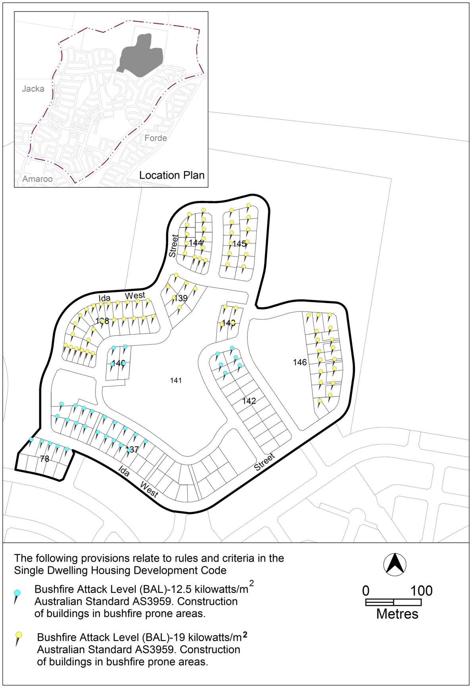
Figure 3

New ongoing provision (OP3):
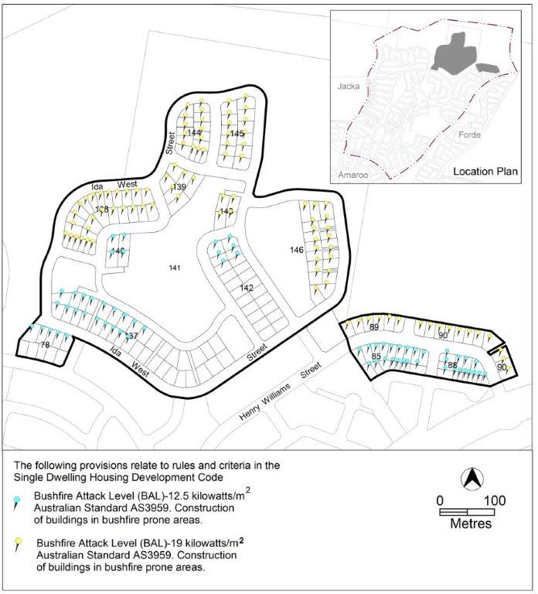
Figure 3

Compliance with the Planning and Development Act 2007
Section | Statement
s87(b) a variation (a code variation) that –  - would only change a code  - is consistent with the policy purpose and policy framework of the code; and  - is not an error variation. | Compliant. The changes add the latest bushfire provisions to the precinct codes, without changing the policy purpose of the code.

  - Conder Precinct Map
This technical amendment adds supportive housing and retirement villages as additional prohibited development on community facility zoned land on the Conder Precinct Map.

Current Conder Precinct Map:
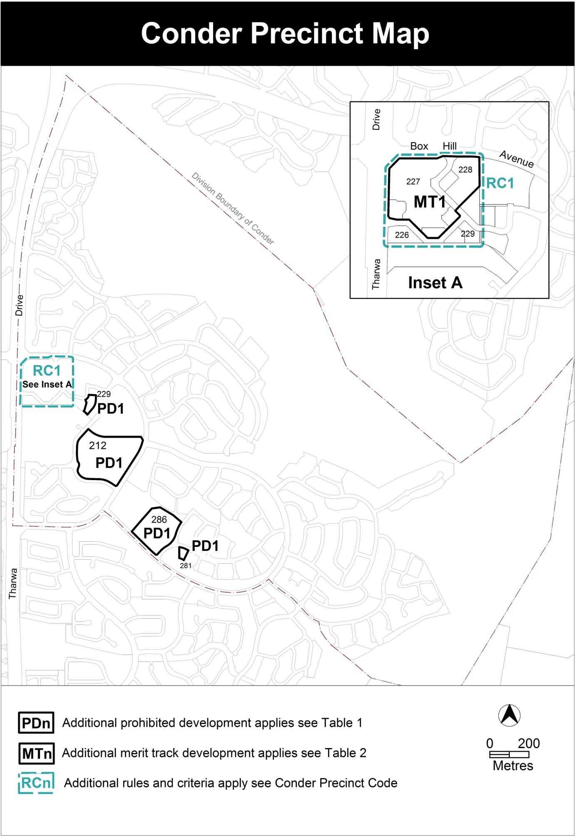

New Conder Precinct Map:
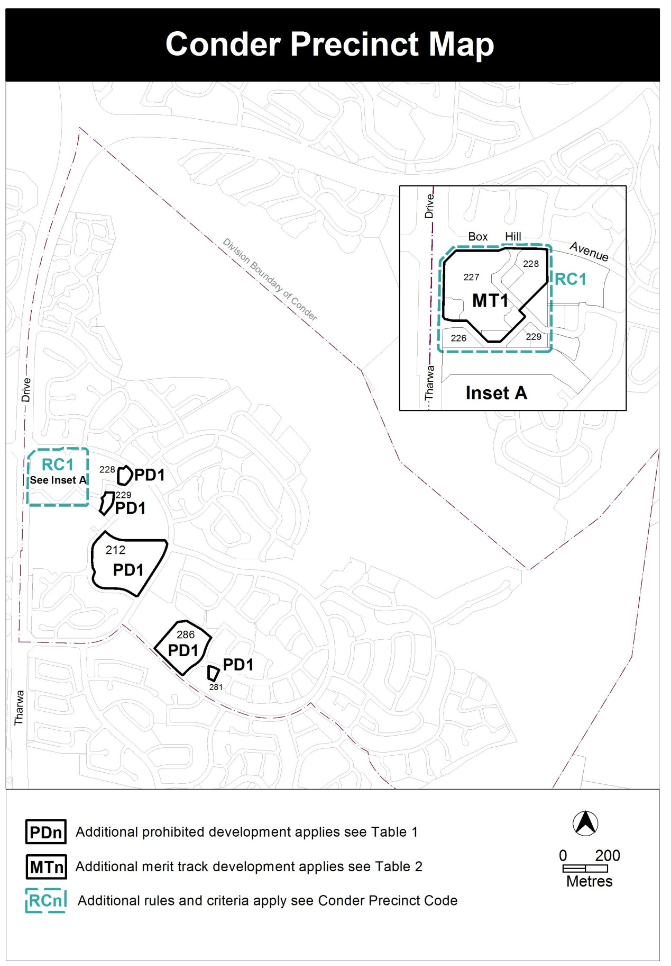

Compliance with the Planning and Development Act 2007
Section | Statement
s87(b) a variation (a code variation) that –  - would only change a code  - is consistent with the policy purpose and policy framework of the code; and  - is not an error variation. | Compliant. The change adds supportive housing and retirement villages as additional prohibited development, without changing the purpose of the code.

  - Gungahlin Precinct Code
Block 4 section 226 Gungahlin has been chosen as the site of the proposed ACT Government office building. It is zoned CZ1, and is situated in precinct 1B (retail code mixed use) of the Gungahlin Town Centre, as described in the Gungahlin Precinct Code. Certain issues have been identified that would hinder the development of office accommodation on this site. These include:
- A large regulated tree on the western edge of the site would make it impossible to adhere to the current Gungahlin precinct code’s awning provisions (rule 37).
- The proposed building design includes an entry forecourt with soft landscaped edge fronting Gungahlin Place. This would be inconsistent with the Gungahlin precinct code’s zero setback provision (rule and criterion 35).
The awning provisions in the Gungahlin Precinct Code are changed to accommodate regulated and/or registered trees.
The code is also amended to allow flexibility for setbacks on Section 226 and Block 1 Section 232 (on the western side of Gungahlin Place). The inclusion of Block 1 Section 232 will provide the opportunity for more consistent design outcomes for both sides of Gungahlin Place and ensure that the recommendations of the Gungahlin Planning Study will be achieved.

Current provisions:
Rules | Criteria
12.1 Building envelope and setbacks
R35  Buildings are joined at party walls and built to the front property boundary along main pedestrian areas and routes identified in figure 13. | C35  Buildings achieve all of the following:  - consistency with desired planning outcomes  - compatibility with adjacent development  Minor setbacks in building alignment may be permitted to provide small spaces for active uses.

13.2 Awnings
R37  Buildings must incorporate awnings that comply with all of the following:  - cantilevered awnings for the full extent of the building frontage along main pedestrian areas and routes identified in figure 13  - awnings are to be a minimum of 3m in cantilever width  - awnings are to be a minimum height of 3m above finished pavement or ground level of the verge  - awnings are to be integrated into the building design at the first floor level | This is a mandatory requirement. There is no applicable criterion.

New provisions:

Rules | Criteria
12.1 Building envelope and setbacks
R35  Buildings are joined at party walls and built to the front property boundary along main pedestrian areas and routes identified in figure 13.  This rule does not apply to the boundaries to Gungahlin Place of Section 226 Block 4 and Section 232 Block 1, Gungahlin. | C35  Buildings achieve all of the following:  - consistency with desired planning outcomes  - compatibility with adjacent development  Minor setbacks in building alignment may be permitted to provide small spaces for active uses.
There is no applicable rule. | C35A  This criterion applies to Section 226 Block 4 and Section 232 Block 1, Gungahlin, but does not apply to the Gozzard Street frontage or to the Hinder Street frontage.  Buildings achieve all of the following:  - consistency with desired planning outcomes  - compatibility with adjacent development  - corner treatment with articulation in the building facade at the corners of Gungahlin Place and Efkarpides Street  - where setbacks are proposed, reasonable space for active outdoor uses, the protection of any regulated trees, and the provisions of landscaping  - for outdoor spaces adjacent to Gungahlin Place, landscaping consistent with the landscaping in Gungahlin Place.  Note:  R35 and C35 still apply to the Gozzard Street frontage and to the Hinder Street frontage.

Rules | Criteria
13.2 Awnings
R37  Buildings with front boundary setbacks less than 2m incorporate awnings that comply with all of the following:  - cantilevered for the full extent of the building frontage along main pedestrian areas and routes identified in figure 13  - a minimum of 3m in cantilever width  - a minimum height of 3m above finished pavement or ground level of the verge  - integrated with the building design at the first floor level | This is a mandatory requirement. There is no applicable criterion.

Compliance with the Planning and Development Act 2007
Section | Statement
s87(b) a variation (a code variation) that –  - would only change a code  - is consistent with the policy purpose and policy framework of the code; and  - is not an error variation. | Compliant. The changes add more flexibility without changing the purpose of the code.

  - Parking and Vehicular Access General Code
    - Changes to locational requirements for commercial centres
This technical amendment changes some locational requirements for parking in major commercial centres, to ensure that spare capacity in residential streets adjoining major centres is not counted as available parking.

Current provisions:

3.2.4 Locational requirements

Commercial centre | Long stay parking | Short stay parking | Operational parking | Visitor parking
City centre | (i) CZ1 and CZ2 zones - on–site or in publicly available car parks up to1km distant  (ii) CZ3 zone - on-site and/or within 400m | (i) CZ1 and CZ2 zones – on site or within 400m  (ii) CZ3 zone - on-site and/or within 400m | On-site or immediately adjacent | (i) CZ1 and CZ2 zones – on site or within 400m  (ii) CZ3 zone – onsite and/or within 400m
Town centres | (i) Residential use – on site  (ii) Non residential use – on-site or within 1000m | Within 200m | On-site or immediately adjacent | Within 200m

New changes (underlined):

3.2.4 Locational requirements

Commercial centre | Long stay parking | Short stay parking | Operational parking | Visitor parking
City centre | (i) CZ1 and CZ2 zones - on–site or in publicly available car parks up to1km distant  (ii) CZ3 zone - on-site and/or within 400m, within the boundaries of the City Centre | (i) CZ1 and CZ2 zones – on site or within 400m  (ii) CZ3 zone - on-site and/or within 400m | On-site or immediately adjacent | (i) CZ1 and CZ2 zones – on site or within 400m  (ii) CZ3 zone – onsite and/or within 400m
Town centres | (i) Residential use – on site  (ii) Non residential use – on-site or within 1000m, within the boundaries of the Town centre | Within 200m | On-site or immediately adjacent | Within 200m

New note insertion below Locational requirements table
Note
Boundaries of commercial centres are defined in suburb precinct maps and codes.

    - Changes to parking provision rates for commercial centres
This technical amendment makes changes to residential parking provision rates in major commercial centres. The proposed changes for CZ2 zones in City and CZ1 and CZ2 zones in town centres are consistent with Transport for Canberra policies and actions. They also recognise that residents in major centres have access to a high level of services and amenities, including access to public transport, and the role of cycling and walking as significant alternative transport modes. The changes for CZ3 are consistent with work undertaken for Transport Planning in 2011 and with Transport for Canberra policies and actions.

Current provisions:
Schedule 2 – Parking provision rates for commercial zones
Development | City centre | Town centres | Group centres | Local centres | CZ2 zones outside centres and Northbourne Avenue precinct
RESIDENTIAL USE | CZ1 zone  No minimum requirement  CZ2 and CZ3 zones  As per residential zone schedule | As per Residential Zone Schedule

New changes (underlined):
Schedule 2 – Parking provision rates for commercial zones
Development | City centre | Town centres | Group centres | Local centres | CZ2 zones outside centres and Northbourne Avenue precinct
RESIDENTIAL USE | CZ1 and CZ2 zones  No minimum requirement  CZ2 and CZ3 zones  As per residential zone schedule  0.8 spaces per single bedroom unit  1.3 spaces per two bedroom unit  1.8 spaces per unit with three or more bedrooms | As per Residential Zone Schedule  CZ1 and CZ2 zones  No minimum requirement  CZ3 zones  0.8 spaces per single bedroom unit  1.3 spaces per two bedroom unit  1.8 spaces per unit with three or more bedrooms. | As per Residential Zone Schedule

Current provisions (note below Schedule 2 table):
Note
‘Spaces’ refer to ‘car parking spaces’ unless otherwise stated.

New provisions (notes below Schedule 2 table):
Notes
- Boundaries of commercial centres are defined in suburb precinct maps.
- Boundary of Northbourne Avenue precinct is defined in the Northbourne Avenue precinct code
- ‘Spaces’ refer to ‘car parking spaces’ unless otherwise stated.

Compliance with the Planning and Development Act 2007
Section | Statement
s87(b) a variation (a code variation) that –  - would only change a code  - is consistent with the policy purpose and policy framework of the code; and  - is not an error variation. | Compliant. These changes bring the code in line with Transport for Canberra policy. The purpose of the code stays the same.

  - Communications Facilities and Associated Infrastructure General Code

This technical amendment clarifies the provisions for new telecommunications towers and associated infrastructure. Telecommunications towers support a range of receiving and transmitting devices serving mobile telephony and data networks, radio, TV, emergency services and the like.

Telecommunications towers and associated access roads, reticulated services and buildings can have an adverse impact on environmental and cultural values, particularly in non-urban areas. For this reason the new provisions require referral of development applications to the ACT Conservator of Flora and Fauna in all non-urban zones and referral to the ACT Heritage Council for sites listed under the Heritage Act 2004.

The provisions focus on communications towers and the associated ground level infrastructure such as roads, electricity reticulation and buildings.

Current mandatory rules R17 and R18 severely limit the location of new towers and other facilities. This was not the approach of the pre-2008 Territory Plan (appendix VI to that plan) which provided more flexibility in the siting of communications facilities.

To restore this flexibility while ensuring that neither landscape, heritage or nature conservation values are jeopardised, new provisions are outlined below. The heading of part A(2) also changes to emphasize its application to a broad range of telecommunications towers, not just mobile phone towers.

The current rule 19 is deleted because its focus should be on communications towers rather than the relatively small sending and receiving devices attached thereto. Whilst the location of such devices on a tower is often disclosed in a development application, the subsequent attachment of additional devices is ordinarily exempt from development approval. This exemption also applies to the installation of sending and receiving devices on existing buildings and other structures. For this reason the heading to part A(2) item 2.2 is revised to exclude reference to towers.

New R17 requires a referral to be made to the ACT Conservator of Flora and Fauna of any application to erect a communications tower in the following zones:

- Parks and recreation zones – PRZ1, PRZ2
- Non-urban zones – NUZ1, NUZ2, NUZ3, NUZ4, NUZ5

A note to R17 refers to the revised provision in the Non-urban Zones Development Code (see section 2.1 above) that requires the referral of any application for development in land registered under the Heritage Act 2004 to the ACT Heritage Council for advice.

Headings in Part A(2)

Current heading:

Part A(2) – Mobile Phone Antenna(e), Towers and Associated Equipment

New heading:

Part A(2) – Telecommunications towers

Current heading:

2.2 Roof Mounted Antenna(e) and Towers

New heading:

2.2 Roof Mounted Antenna(e)

Provisions in Part A(2)

Current provisions:

Rules | Criteria
2.1 Design and siting
R17  Facilities and equipment are not located on sites of environmental, nature conservation or heritage significance. | This is a mandatory requirement. There is no applicable criterion.
R18  Facilities and equipment are sited in:  - Commercial, industrial or rural areas, transport and services corridors or low use open space locations; or  - Co-sited/ co-located with existing utility structures. | This is a mandatory requirement. There is no applicable criterion.
R19  Facilities and Equipment must be:  - Co-located on existing telecommunications towers; or  - On the roof of an existing building; or  - On the face of a building (panel antennae or similar facilities); or  - Attached to existing utility structures such as lighting columns. | This is a mandatory requirement. There is no applicable criterion.

New provisions:

Rules | Criteria
2.1 Environment
R17  This rule applies to land in the following zones:  Parks and recreation zones – PRZ1, PRZ2  Non-urban zones – NUZ1, NUZ2, NUZ3, NUZ4, NUZ5.  The authority shall refer a development application for a telecommunications tower to the Conservator of Flora and Fauna.  Notes:  1. The authority will consider any advice from the Conservator of Flora and Fauna before determining the application.  2. See rule 32 of the Non-urban Zones Development Code for development on sites registered under the Heritage Act 2004. | This is a mandatory requirement. There is no applicable criterion.
2.1A Telecommunications towers
There is no applicable rule. | C18  Telecommunications towers are erected only where there is no feasible alternative.  Compliance with this criterion is demonstrated by a report prepared by a suitably qualified person.
There is no applicable rule. | C19  Telecommunications towers are not visually intrusive to a significant extent when viewed from a public place.

Compliance with the Planning and Development Act 2007
Section | Statement
s87(g) a variation to clarify the language in the territory plan if it does not change the substance of the plan. | Compliant. The amendment clarifies the provisions for new telecommunications towers and associated infrastructure, without changing the substance of the coe.

- TECHNICAL AMENDMENT
  - Non-urban Zones Development Code
- Part B – General development controls, Element 6: Environment

substitute
Rules | Criteria
6.1 Heritage
R32  This rule applies to land containing places or objects registered or provisionally registered under Part 6 of the Heritage Act 2004. The authority shall refer a development application to the Heritage Council.  Note: The authority will consider any advice from the Heritage Council before determining the application. | This is a mandatory requirement. There is no applicable criterion.

  - Bonner Precinct Map and Code

- Bonner precinct map

substitute

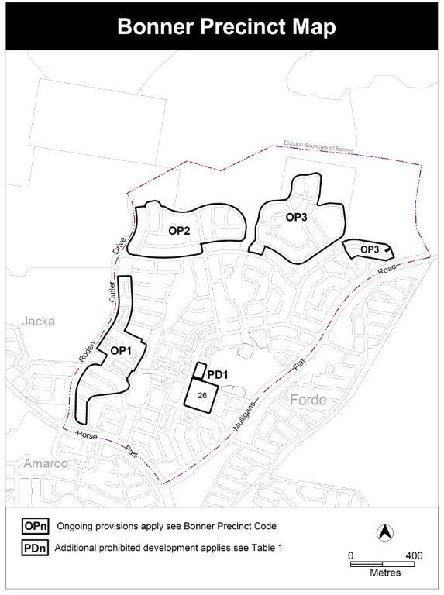

- Bonner Precinct Code, Figure 3

substitute

  - Conder Precinct Map
- Conder Precinct Map

substitute

  - Gungahlin Precinct Code
- Precinct 1b – Retail core mixed use, Element 12: Buildings, Section 12.1 Building envelope and setbacks

Substitute
Rules | Criteria
R35  Buildings are joined at party walls and built to the front property boundary along main pedestrian areas and routes identified in figure 13.  This rule does not apply to the boundaries to Gungahlin Place of Section 226 Block 4 and Section 232 Block 1, Gungahlin. | C35  Buildings achieve all of the following:  - consistency with desired planning outcomes  - compatibility with adjacent development  Minor setbacks in building alignment may be permitted to provide small spaces for active uses.

Insert
Rules | Criteria
There is no applicable rule. | C35A  This criterion applies to Section 226 Block 4 and Section 232 Block 1, Gungahlin, but does not apply to the Gozzard Street frontage and Hinder Street frontage.  Buildings achieve all of the following:  - consistency with desired planning outcomes  - compatibility with adjacent development  - corner treatment with articulation in the building facade at the corner of Gungahlin Place and Efkarpides Street  - where setbacks are proposed, reasonable space for active outdoor uses, the protection of any regulated trees, and the provisions of landscaping  - for outdoor spaces adjacent to Gungahlin Place, landscaping consistent with the landscaping in Gungahlin Place.  Note:  R35 and C35 still apply to the Gozzard Street frontage and Hinder Street frontage.

- Precinct 1b – Retail core mixed use, Element 13: Built form, Section 13.2 Awnings

Substitute

Rules | Criteria
R37  Buildings with front boundary setbacks less than 2m incorporate awnings that comply with all of the following:  - cantilevered for the full extent of the building frontage along main pedestrian areas and routes identified in figure 13  - a minimum of 3m in cantilever width  - a minimum height of 3m above finished pavement or ground level of the verge  - integrated with the building design at the first floor level | This is a mandatory requirement. There is no applicable criterion.

  - Parking and Vehicular Access General Code

- 3.2 Commercial zones, 3.2.4 Locational requirements, Locational requirements table

Insert wording as underlined below

Commercial centre | Long stay parking | Short stay parking | Operational parking | Visitor parking
City centre | (i) CZ1 and CZ2 zones - on–site or in publicly available car parks up to1km distant  (ii) CZ3 zone - on-site and/or within 400m, within the boundaries of the City Centre | (i) CZ1 and CZ2 zones – on site or within 400m  (ii) CZ3 zone - on-site and/or within 400m | On-site or immediately adjacent | (i) CZ1 and CZ2 zones – on site or within 400m  (ii) CZ3 zone – onsite and/or within 400m
Town centres | (i) Residential use – on site  (ii) Non residential use – on-site or within 1000m, within the boundaries of the Town centre | Within 200m | On-site or immediately adjacent | Within 200m

- 3.2 Commercial zones, 3.2.4 Locational requirements, Locational requirements table

Insert note below Locational requirements table
Note: Boundaries of commercial centres are defined in suburb precinct maps.

- 3.2 Commercial zones, 3.2.5 Schedules of parking provision rates for commercial zones, Schedule 2

- Omit wording as crossed-out below
- Insert wording as underlined below
Schedule 2 – Parking provision rates for commercial zones
Development | City centre | Town centres | Group centres | Local centres | CZ2 zones outside centres and Northbourne Avenue precinct
RESIDENTIAL USE | CZ1 and CZ2 zones  No minimum requirement  CZ2 and CZ3 zones  As per residential zone schedule  0.8 spaces per single bedroom unit  1.3 spaces per two bedroom unit  1.8 spaces per unit with three or more bedrooms | As per Residential Zone Schedule  CZ1 and CZ2 zones  No minimum requirement  CZ3 zones  0.8 spaces per single bedroom unit  1.3 spaces per two bedroom unit  1.8 spaces per unit with three or more bedrooms. | As per Residential Zone Schedule

- 3.2 Commercial zones, 3.2.5 Schedules of parking provision rates for commercial zones, Schedule 2

Substitute note below Schedule 2 table

Notes:
- Boundaries of commercial centres are defined in suburb precinct maps.
- Boundary of Northbourne Avenue precinct is defined in the Northbourne Avenue precinct code
- Spaces’ refer to ‘car parking spaces’ unless otherwise stated.

  - Communications Facilities and Associated Infrastructure General Code

- Part A(2) - Mobile Phone Antenna(e), Towers and Associated Equipment

Substitute heading
Part A(2) – Telecommunications Antenna(e), Towers and Associated Equipment
- Part A(2) – item 2.2 heading

Substitute heading
2.2 Roof Mounted Antenna(e)

- Part A(2) – Mobile Phone Antenna(e), Towers and Associated Equipment, Section 2.1 – Design and Siting

Substitute
Rules | Criteria
2.1 Environment
R17  This rule applies to land in the following zones:  Parks and recreation zones – PRZ1, PRZ2  Non-urban zones – NUZ1, NUZ2, NUZ3, NUZ4, NUZ5.  The authority shall refer a development application for a telecommunications tower to the Conservator of Flora and Fauna.  Notes:  - The authority will consider any advice from the Conservator of Flora and Fauna before determining the application.  - See rule 32 of the Non-urban Zones Development Code for development on sites registered under the Heritage Act 2004. | This is a mandatory requirement. There is no applicable criterion.
2.1A Telecommunications towers
There is no applicable rule. | C18  Telecommunications towers are erected only where there is no feasible alternative.  Compliance with this criterion is demonstrated by a report prepared by a suitably qualified person.
There is no applicable rule. | C19  Telecommunications towers are not visually intrusive to a significant extent when viewed from a public place.

Interpretation service
