Australian Capital Territory
Heritage (Decision about Registration of Yarralumla Brickworks Railway Remnants) Notice 2013
Notifiable Instrument NI 2013—38
made under the
Heritage Act 2004 section 42 Notice of Decision about Registration

- Revocation
This instrument replaces NI 2012—471.
- Name of instrument
This instrument is the Heritage (Decision about Registration of Yarralumla Brickworks Railway Remnants) Notice 2013.
- Registration details of the place
Registration details of the place are at Attachment A: Register entry for Yarralumla Brickworks Railway Remnants.
- Reason for decision
The ACT Heritage Council has decided that Yarralumla Brickworks Railway Remnants meets one or more of the heritage significance criteria at s 10 of the Heritage Act 2004. The register entry is at Attachment A.
- Date of Registration
24 January 2013

Pamela Hubert
A/g Secretary (as delegate for)
ACT Heritage Council

24 January 2013
AUSTRALIAN CAPITAL TERRITORY

HERITAGE REGISTER
(Registration Details)

For the purposes of s. 41 of the Heritage Act 2004, an entry to the heritage register has been prepared by the ACT Heritage Council for the following place:

Yarralumla Brickworks Railway Remnants

Part Blocks 7 & 20 Section 102 and part Block 1 Section 127 Yarralumla, Canberra Central

DATE OF REGISTRATION

24 January 2013 Notifiable Instrument: 2013—

Copies of the Register Entry are available for inspection at the ACT Heritage Unit. For further information please contact:

The Secretary
ACT Heritage Council
GPO Box 158
Canberra ACT 2601

Telephone: 13 22 81 Facsimile: (02) 6207 2229

IDENTIFICATION OF THE PLACE

Extending south of the Yarralumla Brickworks to the junction with the old Cotter Road (See Figure 1). Part Blocks 7 & 20 Section 102, and part Block 1 Section 127 Yarralumla.

This statement refers to the Heritage Significance of the place as required in s12(d) of the Heritage Act 2004.

STATEMENT OF HERITAGE SIGNIFICANCE

The remnants of the former Yarralumla Brickworks Railway are significant for their association with the early construction of the national capital from 1923 until 1927. This was a critical period in the development of Canberra, and included major construction works in the lead-up to the Commonwealth Parliament moving to Canberra. The railway transported bricks for many prominent as well as ordinary buildings from this period, and major examples include Old Parliament House, Hotel Canberra, East Block and the Hotel Kurrajong.

The remnants highlight one of the many challenges of building a city within a short time frame, in a relatively undeveloped area and with constraints on transport and technology.

The brickworks railway, of which the remnants are the only remaining portion, transported up to six million bricks per annum. The remnants provide tangible evidence that can assist an understanding of the circumstances surrounding aspects of Canberra's construction.

FEATURES INTRINSIC TO THE HERITAGE SIGNIFICANCE OF THE PLACE

Features intrinsic to the heritage significance of the place which require conservation include:
- Remnants of the original earthen railway embankment, cutting and terraces.

APPLICABLE HERITAGE GUIDELINES

Heritage Guidelines adopted under s25 of the Heritage Act 2004 are applicable to the conservation of Yarralumla Brickworks Railway remnants.

The guiding conservation objective is that the Yarralumla Brickworks Railway remnants shall be conserved and appropriately managed in a manner respecting its heritage significance and the features intrinsic to that heritage significance, and consistent with a sympathetic and viable use or uses. Any works that have a potential impact on significant fabric shall be guided by a professionally documented assessment and conservation policy relevant to that area or component (i.e. a Statement of Heritage Effects – SHE).

REASON FOR PROVISIONAL REGISTRATION

The Yarralumla Brickworks Railway remnants have been assessed against the heritage significance criteria and been found to have heritage significance when assessed against three criteria under the ACT Heritage Act 2004:

(c) it is important as evidence of a distinctive way of life, taste, tradition, religion, land use, custom, process, design or function that is no longer practised, is in danger of being lost or is of exceptional interest;

(f) it is a rare or unique example of its kind, or is rare or unique in its comparative intactness;

(h) it has strong or special associations with a person, group, event, development or cultural phase in local or national history;

ASSESSMENT AGAINST THE HERITAGE SIGNIFICANCE CRITERIA

Pursuant to s.10 of the Heritage Act 2004, a place or object has heritage significance if it satisfies one or more of the following criteria. Significance has been determined by research as accessed in the references below. Future research may alter the findings of this assessment.

- it demonstrates a high degree of technical or creative achievement (or both), by showing qualities of innovation, discovery, invention or an exceptionally fine level of application of existing techniques or approaches;

The Yarralumla Brickworks Railway Remnants does not meet this criterion.
- it exhibits outstanding design or aesthetic qualities valued by the community or a cultural group;

The Yarralumla Brickworks Railway Remnants does not meet this criterion.
(c) it is important as evidence of a distinctive way of life, taste, tradition, religion, land use, custom, process, design or function that is no longer practised, is in danger of being lost or is of exceptional interest;

The Yarralumla Brickworks Railway Remnants meets this criterion.
Bricks were first manufactured at the Canberra (Yarralumla) Brickworks in 1913 for use in the construction of major developments across Canberra including provisional Parliament House and the Hotel Canberra. From 1923 – 1927 bricks were transported from the Brickworks via rail across the city to major developments. The railway ceased operation in 1927 and the remnants of the embankment, cuttings and terraces are important as evidence of the process by which bricks used in the construction and development of the new city were transported.

(d) it is highly valued by the community or a cultural group for reasons of strong or special religious, spiritual, cultural, educational or social associations;

The Yarralumla Brickworks Railway Remnants does not meet this criterion.
(e) it is significant to the ACT because of its importance as part of local Aboriginal tradition;

The Yarralumla Brickworks Railway Remnants does not meet this criterion.
(f) it is a rare or unique example of its kind, or is rare or unique in its comparative intactness;

The Yarralumla Brickworks Railway Remnants meets this criterion.
The remnants of the former railway are rare in their comparative intactness, an example of one of few surviving remnants of the once extensive rail network used in the early development of Canberra.

(g) it is a notable example of a kind of place or object and demonstrates the main characteristics of that kind;

The Yarralumla Brickworks Railway Remnants does not meet this criterion.
(h) it has strong or special associations with a person, group, event, development or cultural phase in local or national history;

The Yarralumla Brickworks Railway Remnants meets this criterion.
The remnants of the former Yarralumla Brickworks railway have a strong association with the development of Canberra between 1923 – 1927. Bricks (especially those referred to colloquially as ‘Canberra Reds’) manufactured at the Brickworks were loaded onto timber tip wagons and transported via a narrow gauge rail line to major developments across the city such as Parliament House, the Kingston Powerhouse, Hotel Canberra and buildings in Civic.

The railway enabled faster transport of the bricks than the previous use of steam traction engines that hauled heavy iron wheeled trailers on mostly unmade roads. The railway was removed in 1927 prior to the opening of Parliament House. However, it had a strong association with the early development of the new city.

- it is significant for understanding the evolution of natural landscapes, including significant geological features, landforms, biota or natural processes;

The Yarralumla Brickworks Railway Remnants does not meet this criterion.
(j) it has provided, or is likely to provide, information that will contribute significantly to a wider understanding of the natural or cultural history of the ACT because of its use or potential use as a research site or object, teaching site or object, type locality or benchmark site;

The Yarralumla Brickworks Railway Remnants does not meet this criterion.
(k) for a place—it exhibits unusual richness, diversity or significant transitions of flora, fauna or natural landscapes and their elements;

The Yarralumla Brickworks Railway Remnants does not meet this criterion.
(l) for a place—it is a significant ecological community, habitat or locality for any of the following;
(i) the life cycle of native species;
(ii) rare, threatened or uncommon species;
(iii) species at the limits of their natural range;
- distinct occurrences of species.

The Yarralumla Brickworks Railway Remnants does not meet this criterion.

SUMMARY OF THE PLACE
HISTORY AND PHYSICAL DESCRIPTION

Description of Place

Remnants of the three lines of the former Brickworks railway are evident closest to the southwest corner of the Yarralumla Brickworks, converging to form a single embankment. Close to the Brickworks two of the former lines are evident as earth terraces, which go through a short cutting to become distinctive earth mounds. The third line runs approximately parallel to the western boundary of the Brickworks and is evident as an earth terrace. Along some sections of the embankment there are mature pine trees within close proximity, with other trees and shrubs growing along side and over the former rail line. The setting of the remnants of the former rail line within the pines creates an attractive vista.

In 2011 the area was extensively slashed and cleared for survey purposes, allowing greater visibility and identification of the railway remnants.

The embankment extends for several hundred metres, crossing the old Cotter Road (now an unsealed track) then heading towards Dudley St, Yarralumla and Adelaide Avenue before disappearing.

The following description is given of the former railway: The track at the Brickworks was set out in three parallel lines, one on either side of the Staffordshire kilns and the remaining one ran to the coal dump. Immediately after leaving the proximity of the kilns, these tracks swung around rather sharply to the left, the points that gave access to the sidings being at an angle of 53 degrees to the straight part along the kilns……After converging to a single track, the line ran straight for about two hundred yards, then, after crossing Uriarra Road swung again to the left in a curve on an embankment and straightened out with a slight down grade for ¾ mile where a reverse curve brought it alongside Adelaide Avenue. It continued beside this road to the State Circle where it followed the left contour of the Circle for about one third of its circumference until it met Commonwealth Avenue which it crossed at an angle……’. (Australian Railway Historical Society Bulletin No 355- May, 1967)

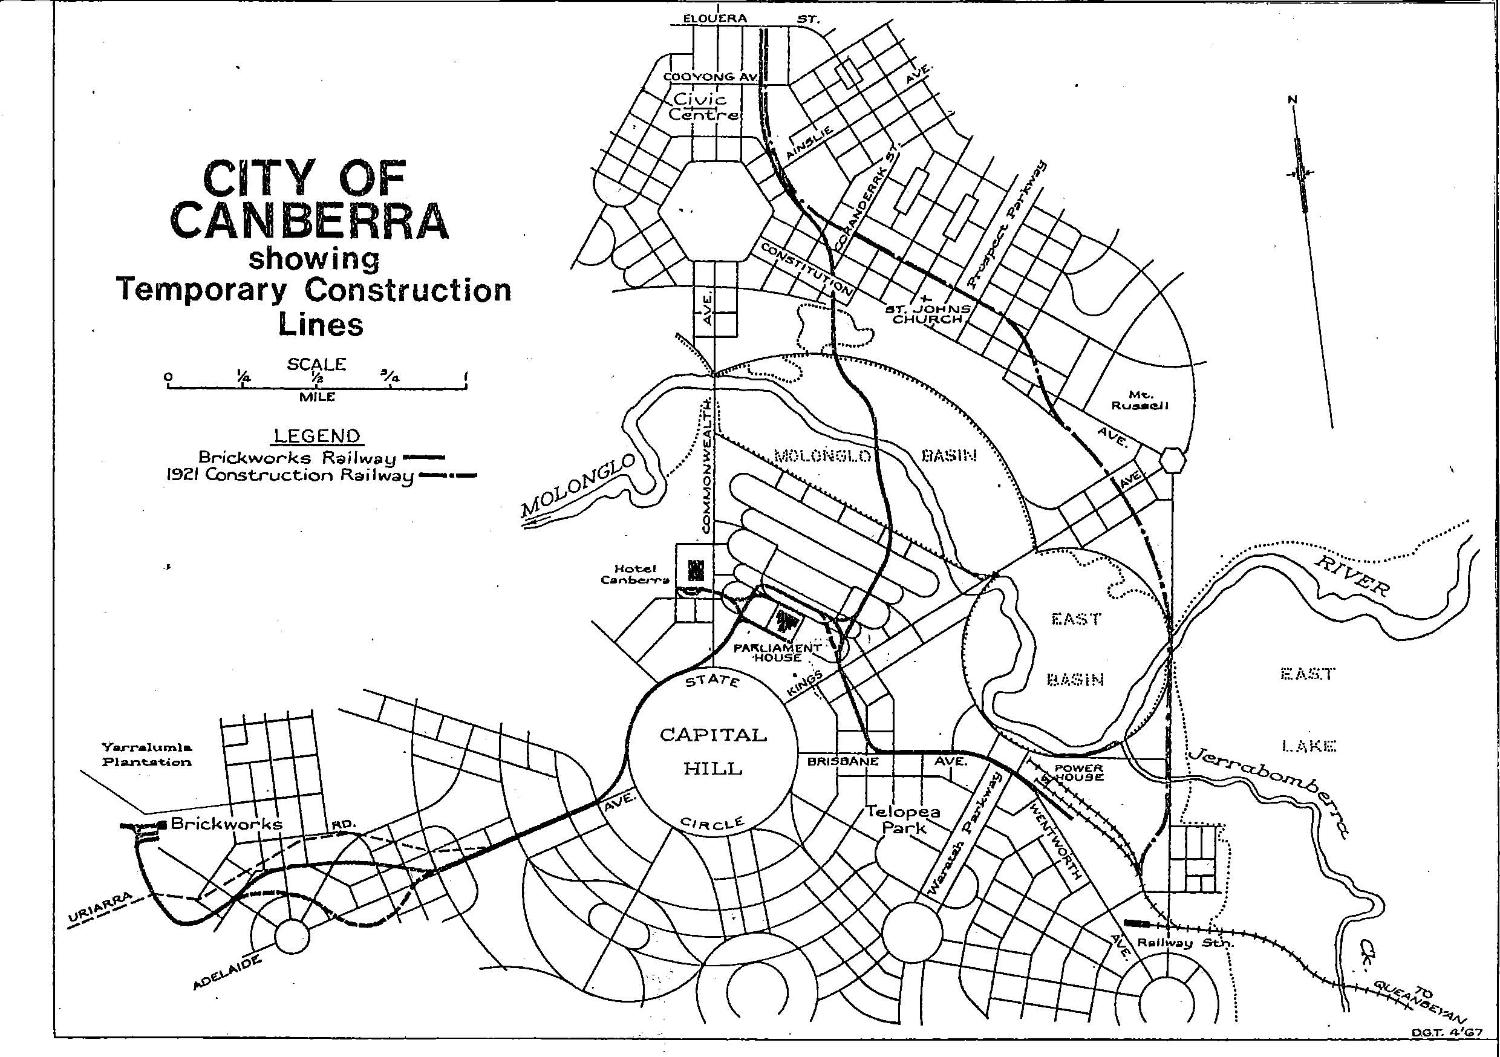

Source: the Australian Railway Historical Society Bulletin No 355- May, 1967

History

One of the most obvious prerequisites to the speedy establishment of Canberra, which was in an open, relatively uninhabited area, was an adequate supply of good bricks. No time was lost therefore in seeking out a local site for a brick-works, and satisfactory clays were found at Yarralumla or "Westridge" as Griffin had named it. There the Commonwealth Brickworks was established in 1913.

Bricks were required for construction at the Power House at Kingston (completed 1915), Parliament House(1927), Hotel Canberra (now the Hyatt, 1927) and other public buildings and offices including Telopea Park School (1923), East Block (1927), Albert Hall (1928) and Hotel Kurrajong (1926).

The bricks were moved by steam traction engines that hauled heavy iron-wheeled trailers on mostly unmade roads. This proved unsatisfactory and time consuming as the traction engines only achieved two round trips a day between the brick-works and the Parliament House. By the end of 1923, a 3 ft 6 inch (1067 mm) gauge steam-hauled railway was constructed to provide more effective transport. The southern terminus was at the Power House, where the line connected with a small engine shed.

After the failure of the standard gauge railway to Civic Centre, following collapse of the causeway bridge in the floods of 1922, the brickworks railway was extended to Civic, crossing the Molonglo River on a small timber bridge near the Scott's Crossing Road. It is understood that in the city area the abandoned standard gauge track was used by moving one rail a distance of 14.5 inches across on the existing sleepers to form the narrower gauge. It is believed the brickworks tramway terminated about 40 feet beyond the Civic Centre platform.

In the clean up and extensive landscaping works prior to the opening of Parliament House on 9 May 1927, and possibly also because it had by that stage become more economical to transport the bricks by motor lorry, the railway was removed. At the time of closure, the capacity of the brickworks was 6 million bricks per annum. The bricks produced at the Brickworks are often colloquially referred to as ‘Canberra Reds’.

References

Institution of Engineers, Engineering Heritage of the ACT, Chapter 2, The Canberra Branch

BT McDonald, The Australian Historical Railway Society, Vol. XVIII Bulletin No 355 May 1967, Railways in the Australian Capital Territory.

Draft Proposed Entry to an interim Heritage Places Register Yarralumla Brickworks Railway Remnants, National Trust of Australia c 2004

IMAGES

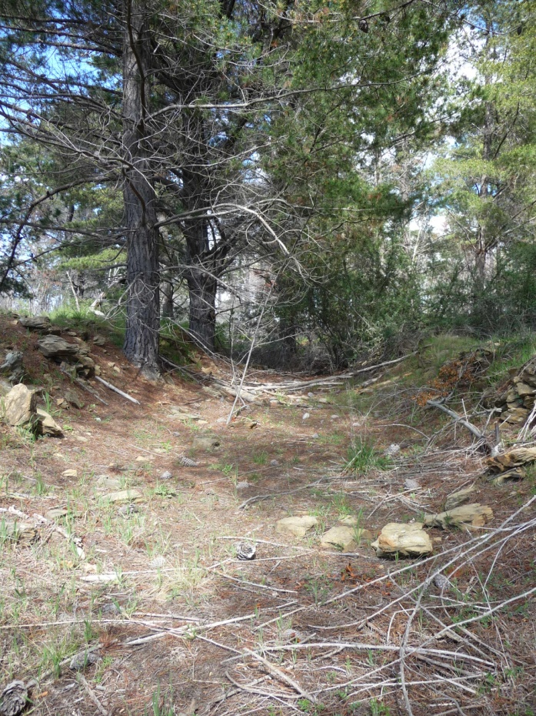

One of the three former lines where it goes through a short cutting

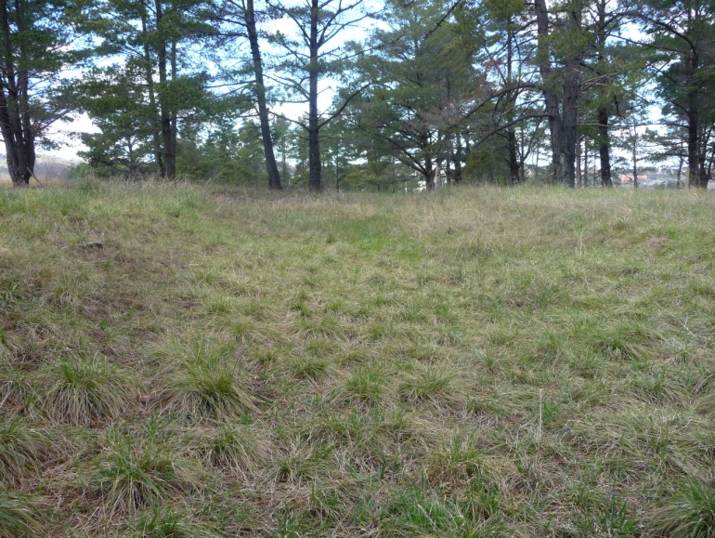

The embankment (marked by arrows) looking southeast towards Dudley Street, Yarralumla and the old Cotter Road
SITE PLAN

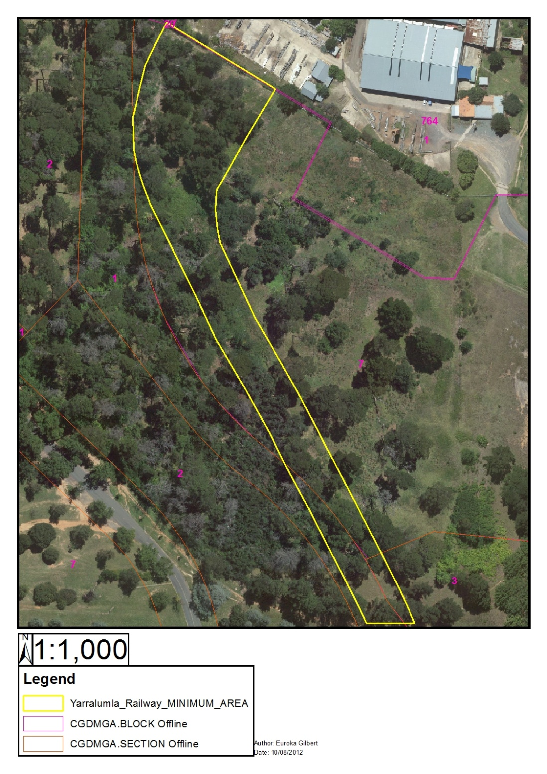

Figure 1. Yarralumla Brickworks Railway Remnants.

