Australian Capital Territory

Planning and Development (Technical Amendment—Kingston) Plan Variation 2013 (No 1)*

Notifiable Instrument NI2013—53
Technical Amendment No 2012—37
made under the
Planning and Development Act 2007, section 89 (Making technical amendments) s96 (land ceases to be in future urban area)

This plan variation commences on the day after it is notified.

Variation No 2012—37 to the Territory Plan has been approved by the Planning and Land Authority.

Variation to the Territory Plan
The Territory Plan map is varied as indicated in Annexure A to identify the zones that apply to the land ceasing to be in a future urban area.

Variation to the Precinct Code
Replace the Kingston Precinct Code at Annexure B to incorporate ongoing block specific provisions for the area.

Jim Corrigan
Delegate of ACT Planning and Land Authority
31 January 2013

THIS IS PAGE ONE OF ANNEXURE A
TO NOTIFIABLE INSTRUMENT NI2013 – 53

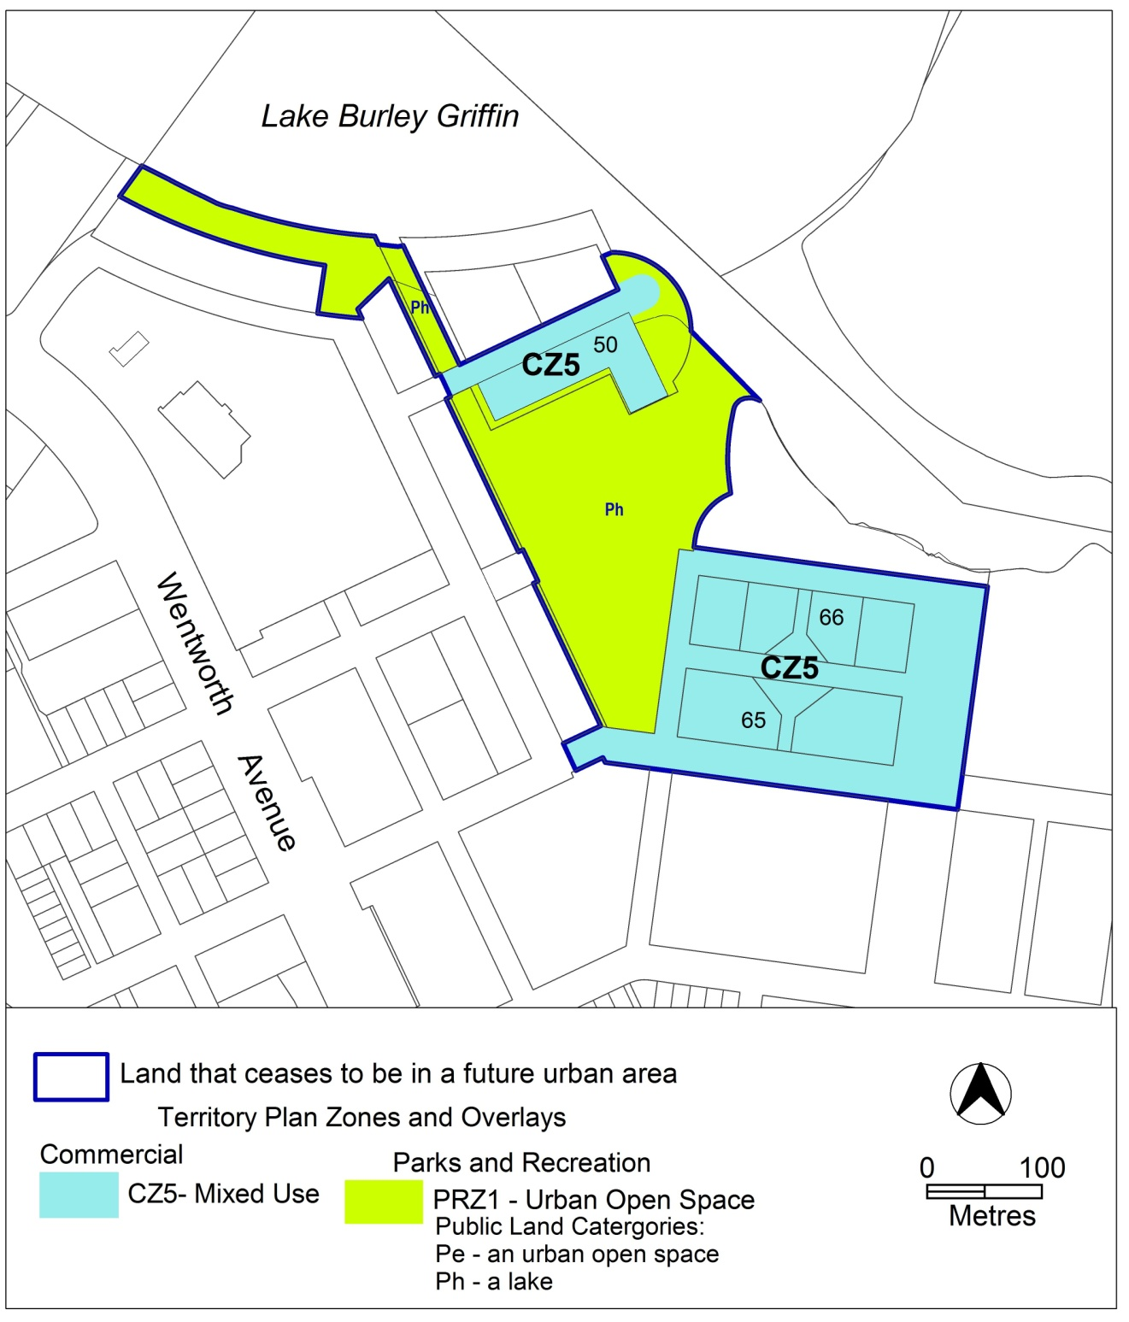

Jim Corrigan
Delegate of ACT Planning and Land Authority
31 January 2013

Annexure B

Kingston Precinct Map and Code

includes
Kingston Group Centre

This page is intentionally blank.

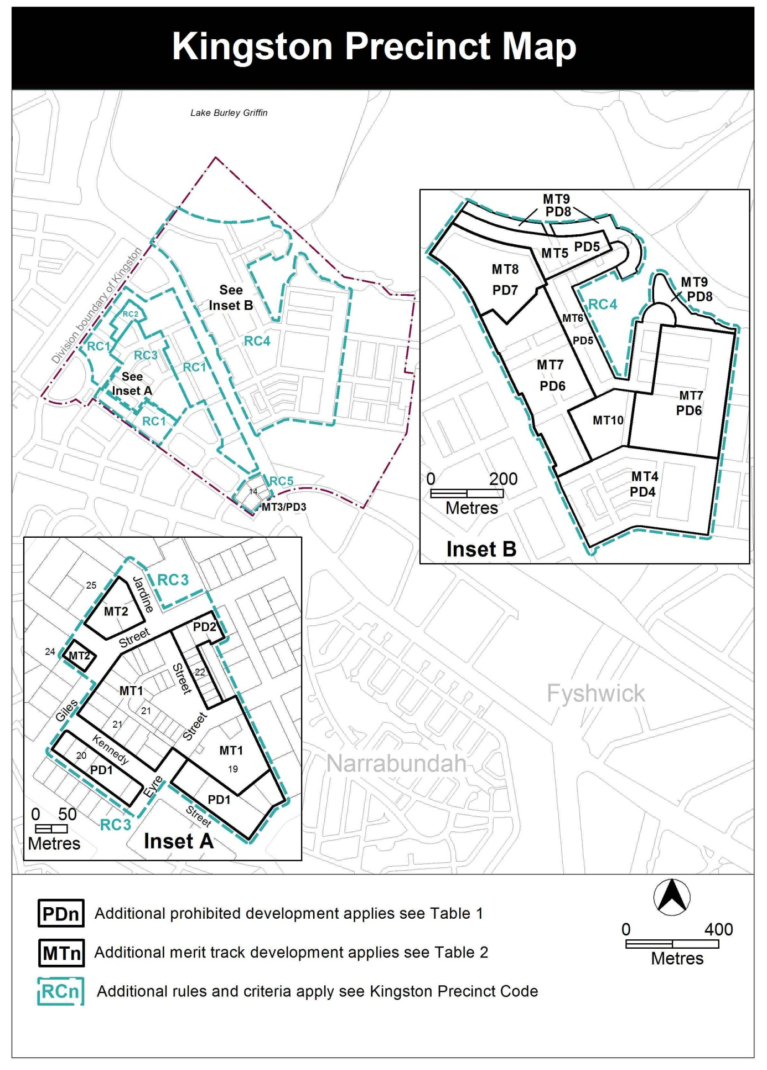
Assessment Tracks

The following tables identify the additional prohibited development and additional merit track development for blocks and parcels shown in the Kingston Precinct Map (identified as PDn or MTn). Development that is exempt from requiring development approval, other prohibited development and the minimum assessment track applicable to each development proposal is set out in the relevant zone development table.

The following tables constitute part of the relevant zone development table.
Table 1 – Additional prohibited development
Additional prohibited development
Suburb precinct map label | Zone | Development
PD1 | CZ2 | club  drink establishment  indoor entertainment facility  indoor recreation facility  restaurant  SHOP (except art, craft and sculpture dealer and personal services)  tourist facility  tourist resort
PD2 | CZ2 | club  drink establishment  indoor entertainment facility
PD3 | CZ2 | drink establishment  indoor entertainment facility  tourist facility  tourist resort
PD4 | CZ5 | hotel  place of worship  religious associated use
PD5 | CZ5 | place of worship  religious associated use
PD6 | CZ5 | hotel
PD7 | CZ5 | boarding house  child care centre  hotel  motel  place of worship  religious associated use
PD8 | PRZ1 | aquatic recreation facility(not permitted adjacent to Jerrabomberra Creek)

Table 2 – Additional merit track development
Additional merit track development that may be approved subject to assessment
Suburb precinct map label | Zone | Development
MT1 | CZ1 | industrial trades  municipal depot  store
MT2 | CZ2 | funeral parlour  light industry  service station  veterinary hospital
MT3 | CZ2 | service station
MT4 | CZ5 | craft workshop  light industry  major utility instillation  place of assembly  scientific research establishment  service station  tourist facility
MT5 | CZ5 | aquatic recreation facility (except on blocks adjacent to Jerrabomberra Creek)  club  craft workshop  drink establishment  indoor entertainment facility  light industry  MAJOR UTILITY INSTALLATION  place of assembly  scientific research establishment  tourist facility  tourist resort
MT6 | CZ5 | aquatic recreation facility (except on blocks adjacent to Jerrabomberra Creek)  club  craft workshop  drink establishment  indoor entertainment facility  light industry  MAJOR UTILITY INSTALLATION  municipal depot  place of assembly  scientific research establishment  tourist facility (excluding service station)  tourist resort
MT7 | CZ5 | craft workshop  MAJOR UTILITY INSTALLATION  place of assembly  scientific research establishment  service station  tourist facility (excluding service station)
MT8 | CZ5 | craft workshop  drink establishment  indoor entertainment facility  light industry  MAJOR UTILITY INSTALLATION  place of assembly  scientific research establishment  tourist facility excluding service station
MT9 | PRZ1 | car park  MAJOR UTILITY INSTALLATION (only permitted where required for the essential operation of the electricity supply network, the augmentation of the local water and sewerage system or the management of the stormwater system)  pedestrian plaza
MT10 | PRZ1 | car park  child care centre  Emergency services facility  Indoor recreation facility  MAJOR UTILITY INSTALLATION (only permitted where required for the essential operation of the electricity supply network, the augmentation of the local water and sewerage system or the management of the stormwater system)  pedestrian plaza  tourist facility excluding service station

Kingston Precinct Code

Contents
Introduction 3
Additional rules and criteria 5
RC1 – Residential redevelopment area 5
Element 1: Buildings 5
1.1 Number of storeys 5
RC2 – Jardine Street redevelopment area 5
Element 2: Buildings 5
2.1 Height of building 5
RC3 – Kingston Group Centre 6
Element 3: Use 6
3.1 Ground floor uses 6
3.2 Residential use on ground floor – sections 19 and 20 7
3.3 SHOP – floor area limit - section 22 7
3.4 Industrial trades, municipal depot, store 8
3.5 Development on nominated car parking areas 8
Element 4: Buildings 8
4.1 Active frontages 8
4.2 Plot ratio - sections 19 and 20 8
4.3 Noise management plan – section 22 9
RC4 – Kingston Foreshore 10
Element 5: Use 10
5.1 Shop 10
5.2 Major utility installation 10
5.3 Residential use and office 11
5.4 Office 11
Element 6: Buildings 12
6.1 Number of storeys 12
6.2 Roof forms, materials and finishes 13
6.3 Kerridge Street 16
6.4 Trevillian Quay 16
Element 7: Site 17
7.1 Outdoor lighting 17
7.2 Kerridge Street - deep soil landscape zones 17
7.3 Trevillian Quay - shared zone 17
7.4 Trevillian Quay - pedestrian areas 17
RC5 – Canberra Avenue Corridor Site 19
Element 8: Use 19
8.1 Restaurant and shop 19
Element 9: Buildings 19
9.1 Number of storeys 19
9.2 Materials and finishes 19

Figures
Figure 1 Kingston Group Centre 7
Figure 2 Kingston Foreshore 11
Figure 3 Kerridge Street 14
Figure 4 Trevillian Quay - South 15

Introduction
Name
The name of this code is Kingston Precinct Code.
Application
The code applies to the Division of Kingston.
Purpose
This code provides additional planning, design and environmental controls for specific areas or blocks and may also contain references to provisions in other codes.
In conjunction with other relevant codes it will be used by the Authority to assess development applications and offer guidance to intending applicants in designing development proposals and preparing development applications.
Structure
This code contains additional rules and/or criteria for particular blocks or parcels identified as areas RCn on the precinct map, to be read in conjunction with the relevant development code. It may also contain sub-parts.
Each element has one or more rules and, unless the respective rule is mandatory, each rule has an associated criterion. Rules provide quantitative, or definitive, controls. By contrast, criteria are chiefly qualitative in nature.
In some instances rules are mandatory. Such rules are accompanied by the words “This is a mandatory requirement. There is no applicable criterion.” Non-compliance with a mandatory rule will result in the refusal of the development application. Conversely, the words “There is no applicable rule” is found where a criterion only is applicable.
Code hierarchy
Under the Planning and Development Act 2007, where more than one type of code applies to a development, the order of precedence if there is inconsistency of provisions between codes is: precinct code, development code and general code.
If more than one precinct code applies to the site, the most recent precinct code takes precedence to the extent of any inconsistency.
Definitions
Defined terms, references to legislation and other documents are italicised.
Definitions of terms used in this code are listed in part 13 of the Territory Plan or, for terms applicable only to this code, associated with the respective rule.
Acronyms
ACTPLA Planning and Land Authority within the ACT Environment and Sustainable Development Directorate
EPA ACT Environment Protection Authority
ESA ACT Emergency Services Agency
ESDD ACT Environment and Sustainable Development Directorate
NCA National Capital Authority
P&D Act Planning and Development Act 2007
TAMS ACT Territory and Municipal Services Directorate

Additional rules and criteria
This part applies to blocks and parcels identified in the Kingston Precinct Map (RCn). It should be read in conjunction with the relevant zone development code and related codes.
RC1 – Residential redevelopment area
This part applies to the area RC1 as shown on the Kingston precinct map.
- Buildings
Rules | Criteria
  - Number of storeys
The maximum number of storeys is 3. | Buildings are predominantly 3 storeys, with a maximum height of 4 storeys only where it is not the dominant feature of a street frontage.

RC2 – Jardine Street redevelopment area
This part applies to the area RC2 as shown on the Kingston precinct map.
- Buildings
  - Height of building
No part of a building, including rooftop plant, is above RL 609.3 AHD. | This is a mandatory requirement. There is no applicable criterion.

RC3 – Kingston Group Centre
This part applies to the Kingston Group Centre shown as RC3 on the Kingston precinct map. RC3 includes the Kingston Group Centre.
- Use
Rules | Criteria
  - Ground floor uses
This rule applies to sites with frontage to main pedestrian areas and routes in CZ1.  Only the following uses are permitted at the ground floor level:  - business agency  - club  - community activity centre  - drink establishment  - financial establishment  - hotel  - indoor entertainment facility  - indoor recreation facility  - public agency  - restaurant  - SHOP. | Buildings fronting main pedestrian areas and routes incorporate uses on the ground floor that generate activity in the public space.
There is no applicable rule. | This criterion applies to sites with frontage to main pedestrian areas and routes in CZ2.  Buildings incorporate uses on the ground floor that generate activity in the public space.

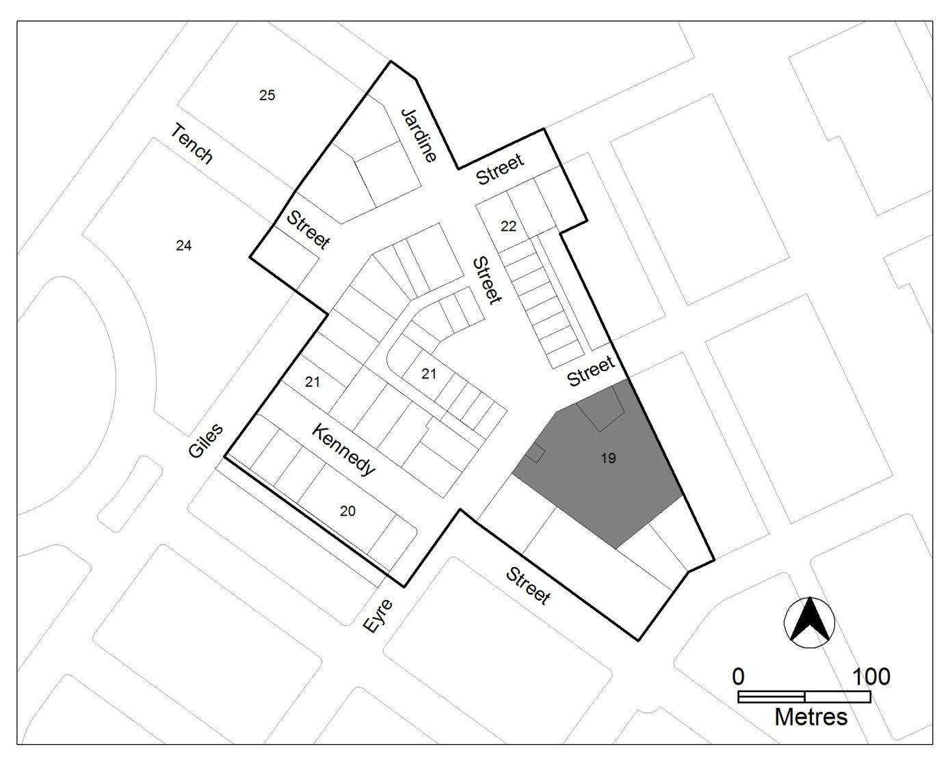
Figure 1 Kingston Group Centre

Rules | Criteria
  - Residential use on ground floor – sections 19 and 20
This rule applies to Kingston sections 19 and 20.  RESIDENTIAL USE is permitted on ground floor level is where development complies with Australian Standard AS4299 – Adaptable housing (class C) and the Access and Mobility General Code | This is a mandatory requirement. There is no applicable criterion.
  - SHOP – floor area limit - section 22
This rule applies to Kingston section 22.  The maximum gross floor area of SHOP is 300m². | This is a mandatory requirement. There is no applicable criterion.
  - Industrial trades, municipal depot, store
One or more of the following uses are permitted only in the shaded area shown in figure 1 and only in association with a structured car park:  - industrial trades  - municipal depot  - store. | This is a mandatory requirement. There is no applicable criterion.
  - Development on nominated car parking areas
This rule applies to the shaded area shown in figure 1.  Development complies with all of the following:  - the existing number of car parking spaces is retained on the site and made available for public use at all times  - provides car parking that is generated by the development on site in accordance with the Parking and Vehicular Access General Code in addition to the spaces required by item a) | Development meets all of the following:  - in accordance with the Parking and Vehicular Access General Code, there is enough car parking for the needs of the centre as a whole  - the development does not adversely affect the overall function of the centre in terms of economic, social, traffic and parking and urban design impacts.

- Buildings
Rules | Criteria
  - Active frontages
Buildings incorporate display windows and entrances with direct pedestrian access at ground floor level on frontages to main pedestrian areas and routes and public open spaces. | Buildings achieve all of the following:  - direct access from main pedestrian areas  - avoid extensive lengths of blank walls unrelieved by doors, display windows or the like
  - Plot ratio - sections 19 and 20
There is no applicable rule. | This criterion applies to Kingston sections 19 and 20.  The plot ratio complies with all of the following:  - compatibility with existing, or future desired character of, adjacent development  - appropriate to the scale and function of use  - minimise detrimental impacts, including overshadowing and excessive scale  The maximum plot ratio is 50%.
  - Noise management plan – section 22
This rule applies to section 22 blocks 21, 25-33.  Development involving one or more of the following uses is only permitted where a noise management plan has been prepared by a suitably qualified person and endorsed by the Environment Protection Authority (EPA):  - hotel  - motel  - restaurant  The noise management plan will detail the proposed design, siting and construction methods that will be used to ensure compliance with the Environment Protection Regulation 2005 and Noise Environment Protection Policy 2010. | This is a mandatory requirement. There is no applicable criterion.

RC4 – Kingston Foreshore
This part applies to the Kingston Foreshore shown as RC4 on the Kingston precinct map.
- Use
Rules | Criteria
  - Shop
There is no applicable rule. | SHOP development achieves one or more of the following:  - a convenience service limited to the local workforce and residents  - related to the sale of entertainment and leisure goods such as specialty items or arts, crafts and souvenirs
The maximum gross floor area of SHOP selling food is 250m². | This is a mandatory requirement. There is no applicable criterion.
  - Major utility installation
Only a MAJOR UTILITY INSTALLATION that is essential to the operation of the electricity supply network, the augmentation of the local water and sewerage system or the management of the stormwater system may be approved.  An application for a MAJOR UTILITY INSTALLATION is accompanied by written endorsement of a relevant service provider. | This is a mandatory requirement. There is no applicable criterion.

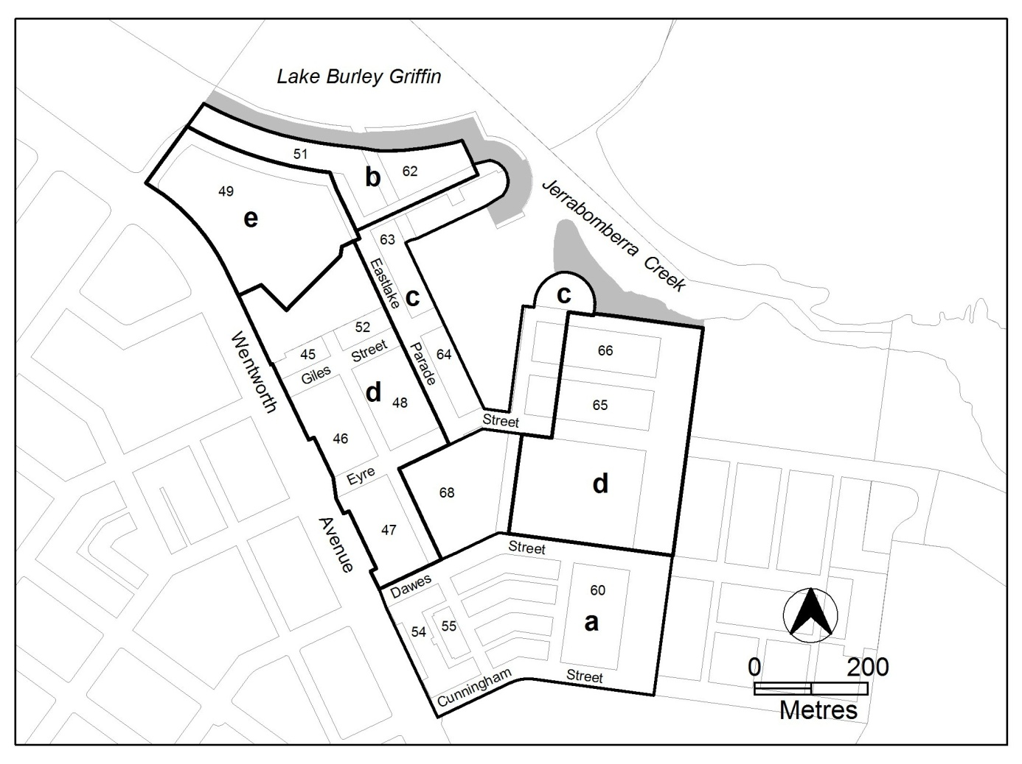
Figure 2 Kingston Foreshore

Rules | Criteria
  - Residential use and office
There is no applicable rule. | This rule applies to the area c shown in figure 2.  Buildings at the ground floor level achieve all of the following:  - avoid office and RESIDENTIAL USE in areas fronting main pedestrian areas and routes  - adaptable for commercial use
  - Office
This rule applies to the areas b, c and e shown in figure 2.  The maximum gross floor area of office complies with all of the following  - 500m² per tenancy  - 2000m² per lease | This is a mandatory requirement. There is no applicable criterion.
This rule applies to the area d shown in figure 2.  The maximum gross floor area of office per lease is 2000m². | This is a mandatory requirement. There is no applicable criterion.

- Buildings
Rules | Criteria
  - Number of storeys
The maximum number of storey is 4 with a parapet level at the third storey level. | The number of storeys achieve all of the following:  - a limited number of buildings may exceed 4 storeys provided they comply with all of the following:  - they achieve urban design objectives such as adding visual interest to the built form, appropriately framing major public spaces, marking important corners or transition points, or screening unsightly elements from the public domain  - they do not significantly impact on the landscape of the area  - their ground floor level is not greater than RL 560m  - they do not detract or compromise views and vistas to the Power House  - the footprint of the higher building elements is no greater than a 15m x 20m rectangle  - to retain significant visual links between the Power House building and East Basin, the roofline of development in area b is punctuated to frame and emphasise the views of the Power House building  - the overall maximum height of building does not exceed the lesser of RL578m or 20m
  - Roof forms, materials and finishes
There is no applicable rule. | Building roof forms, materials and finishes achieve all of the following  - colour scheme is light in tone although some highlighting with darker colours may be acceptable where these do not present the dominant colour scheme when viewed from or across Lake Burley Griffin  - high quality, durable and low maintenance materials are used on buildings and structures near the edge of Lake Burley Griffin  - avoid the use of highly reflective materials on buildings fronting the edge of Lake Burley Griffin

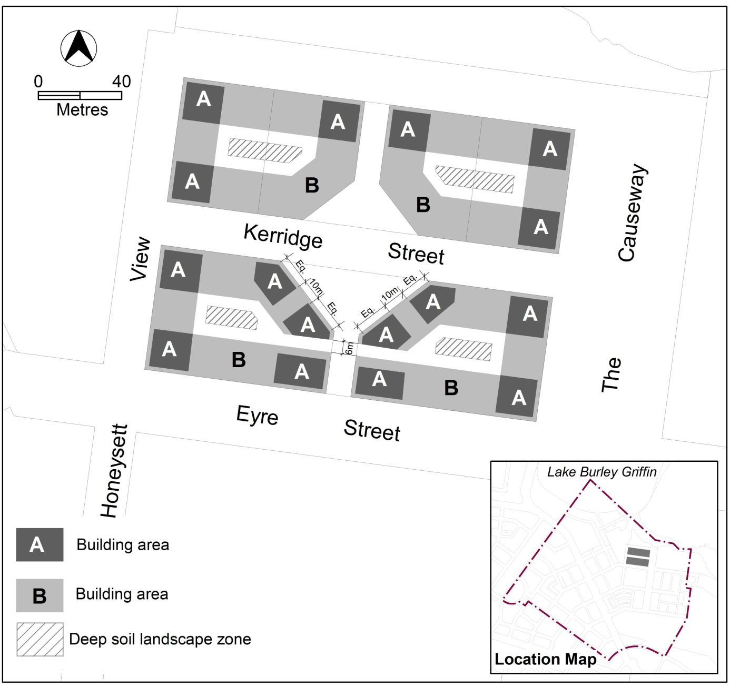

Figure 3 Kerridge Street
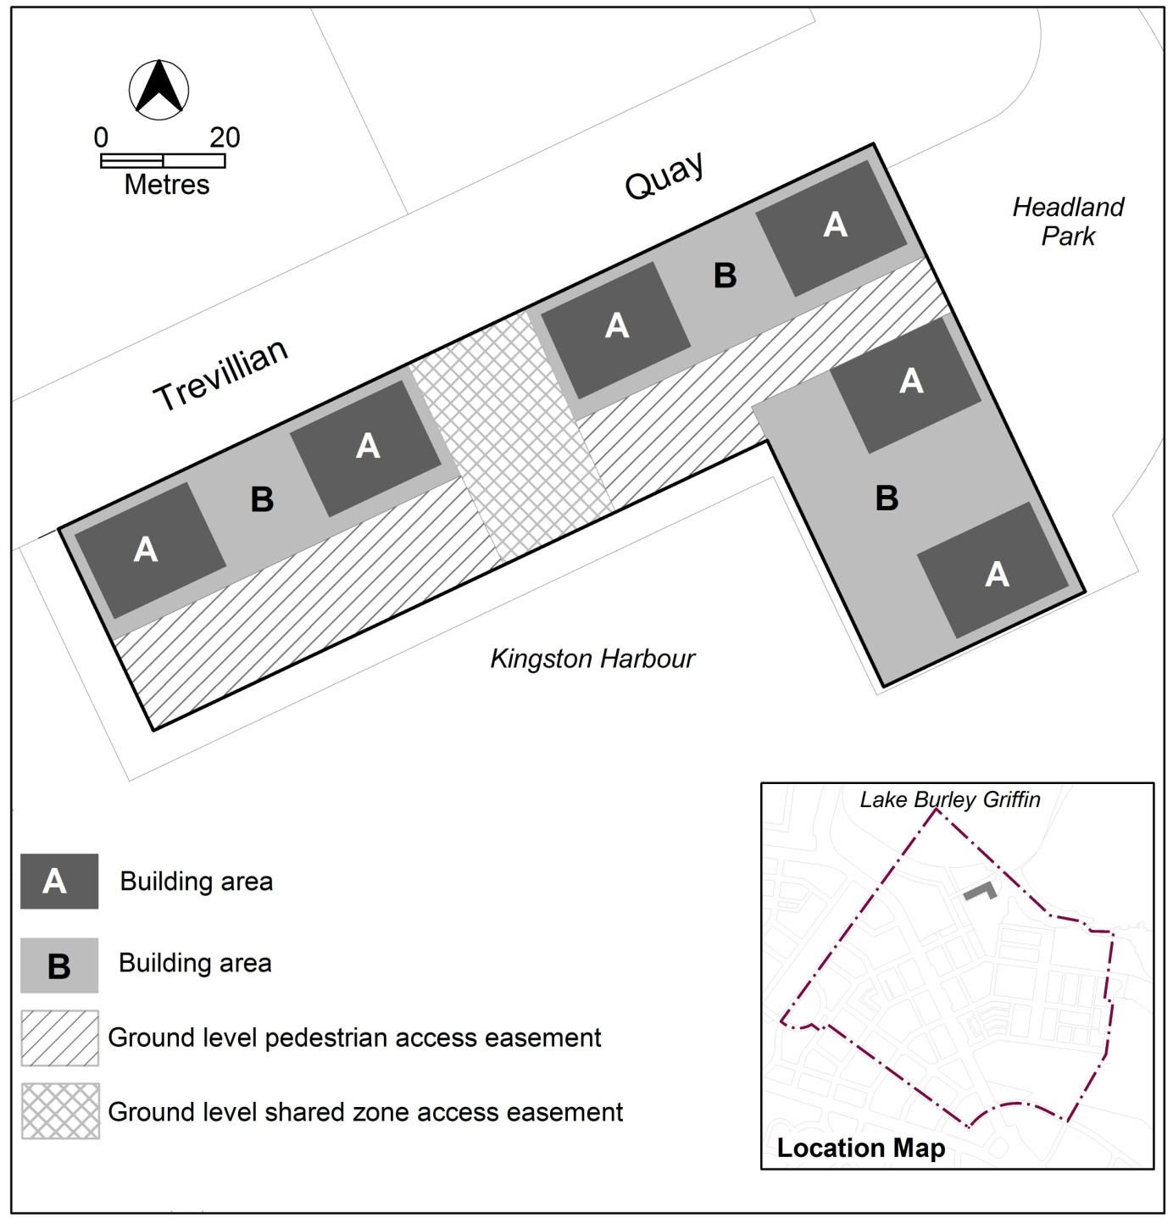
Figure 4 Trevillian Quay - South

Rules | Criteria
  - Kerridge Street
This rule applies to each area A shown in figure 3.  The maximum number of storeys is 6.  The maximum height of building is the lesser of RL578 and 20m.  The maximum floor area for storey 5 is 300m².  The maximum floor area for storey 6 is 300m².  The maximum external horizontal dimension for any part of the building over 4 storeys is 20m.  The minimum front boundary setback for that part of the building with more than 4 storeys is 2m.  Rule 18 does not apply. | This is a mandatory requirement. There is no criterion.
This rule applies to each area B shown in figure 3.  The maximum number of storeys is 4.  The maximum external horizontal depth is 18m (including enclosed building area and articulation elements but excluding awnings over footpaths and basements). | 4 storey building elements achieve all of the following:  - alignment to the block perimeter  - high levels of natural daylight, ventilation and solar access to dwellings  - central courtyards sized to meet the reasonable needs of residents.
  - Trevillian Quay
This rule applies to each area A shown in  figure 4.  The maximum dimensions for each area A are 20m x 15m.  The maximum number of storeys is 6.  The maximum height of building is the lesser of RL578 and 20m  The minimum setback from Trevillian Quay and Headland Park for that part of the building with more than 4 storeys is 2m.  Rule 18 does not apply. | This is a mandatory requirement. There is no criterion.
This rule applies to each area B shown in figure 4.  The maximum number of storeys is 4. | This is a mandatory requirement. There is no criterion.
- Site
Rules | Criteria
  - Outdoor lighting
There is no applicable rule. | Outdoor lighting in the area should generally use full-cut off light fittings and up-lighting of buildings and structures should be carefully designed to keep night time overspill lighting to a minimum.
There is no applicable rule. | The overall lighting impact should not compete in prominence with the lighting of the National Triangle. The area should be lit predominantly with high pressure sodium light sources for streets and mercury vapour for pedestrian routes. Lake frontages external lighting should use metal halide sources. There should be no flashing or laser beam lighting on or around buildings fronting Lake Burley Griffin.
  - Kerridge Street - deep soil landscape zones
This rule applies to the hatched areas identified as deep soil landscape zones in figure 3.  The location of deep soil landscape zones are indicatively shown in figure 3.  Deep soil landscape zones represent a minimum of 10% of the total site area. | Provision is made for sufficient soil to allow planting and growth of healthy canopy trees in the central courtyards.
  - Trevillian Quay - shared zone
Ground level shared zone access easements are provided in accordance with figure 4. | Shared zones achieve all of the following:  - safe and convenient public pedestrian access to buildings on the site and the foreshore  - reasonable vehicular access to the foreshore.
  - Trevillian Quay - pedestrian areas
Ground level pedestrian access easements are provided in accordance with figure 4. | Pedestrian access easements achieve all of the following:  - safe and convenient public pedestrian access to buildings on the site and the foreshore  - provision for small scale ancillary buildings and structures associated with harbor operations.
RC5 – Canberra Avenue Corridor Site
This part applies to blocks and parcels within area RC5 shown on the Kingston precinct map.
RC5 includes the Canberra Avenue corridor site.
- Use
Rules | Criteria
  - Restaurant and shop
One or more of the following uses are permitted where it is ancillary to other uses:  - restaurant  - SHOP | This is a mandatory requirement. There is no applicable criterion.

- Buildings
Rules | Criteria
  - Number of storeys
The maximum number of storey is 4. | The number of storeys comply with all of the following:  - are compatible with existing, or future desired character of, adjacent development  - are appropriate to the scale and function of the use  - minimise detrimental impacts, including overshadowing and excessive scale  - are no higher than the established tree canopy along main avenues with primarily landscaped frontage
  - Materials and finishes
Building colours are off-white to light buff/grey. | Building colours achieve all of the following:  - Relate to clearly defined elements of the building  - are predominantly earthy toned  - minor elements in the building facade may be accented  - subsidiary to the main off-white to light buff/grey materials

