Australian Capital Territory
Public Sector Management (ACT Public Service) Code of Conduct 2013
Notifiable instrument NI2103–588
made under the
Public Sector Management Standards 2006, s 6 (ACTPS Code of Conduct)

1 Name of instrument
This instrument is the Public Sector Management (ACT Pubic Service) Code of Conduct 2013.
2 Commencement
This instrument commences on the day after notification.
3 ACT Public Service Code of Conduct
I have developed the attached ACT Public Service Code of Conduct.

Andrew Kefford
Commissioner for Public Administration
18 December 2013

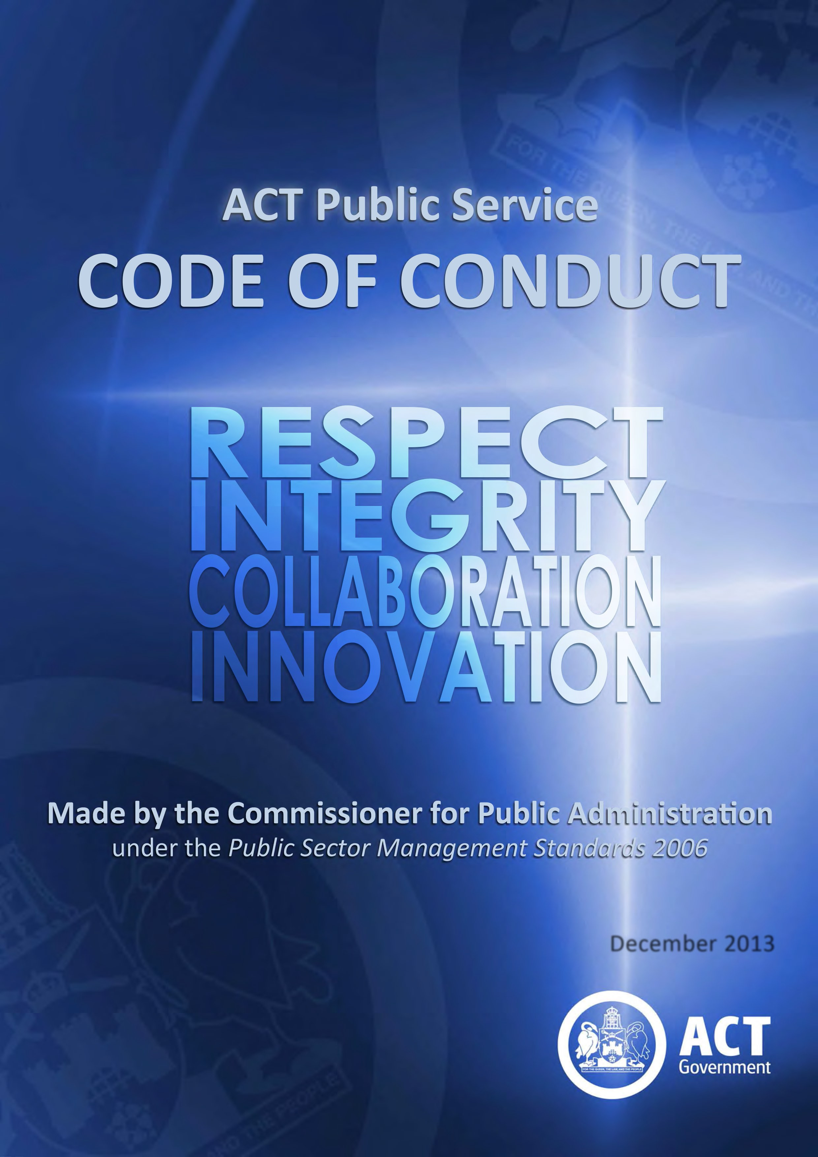

December 2013

ACT PUBLIC SERVICE CODE OF CONDUCT

Made by the Commissioner for Public Administration Under the Public Sector Management Standards 2006

Workforce Capability and Governance Division Phone number: +61 2 620 50358

Publication Date: October 2012 Updated: December 2013

CONTENTS
FOREWORD 1
THE EMPLOYEE VALUES 3
SIGNATURE BEHAVIOURS 4
THE ACTPS CODE OF CONDUCT 5
TAKE YOUR JOB SERIOUSLY 6
BE ACCOUNTABLE 6
BE PREPARED 7
COMMUNICATE EFFECTIVELY 7
GIVE AND RECEIVE INFORMATION AND ADVICE WITHOUT FEAR 8
SERVE THE GOVERNMENT OF THE DAY 8
BE CONSTRUCTIVE 9
MAKE SOUND DECISIONS 9
UNDERSTAND YOUR LEGAL OBLIGATIONS 10

FOREWORD
The ACT Public Service (ACTPS) serves a city-­‐state government and provides critical services and infrastructure to Canberra and the surrounding region. We are a diverse organisation of almost 20,000 people with responsibilities that range from Namadgi National Park to green-­‐ and brown-­‐field development fronts, from buses to fire engines, from municipal services to the health, education and justice systems, and from supporting the most vulnerable people in our community to fostering business development and innovation.
We are a service founded on the principles of impartial stewardship, responsiveness, accountability, fairness, equity, integrity, and efficiency outlined in sections 6, 7 and 8 of the Public Sector Management Act (1994) (the PSM Act).
The ACTPS offers an unrivalled range of career paths across numerous professional streams. We are fortunately placed to be a leader in innovation in public policy design and service delivery. The size of the ACTPS, the contained geographic scope of Canberra, and the collocation of leading academic institutions together create fertile ground for developing and demonstrating leading public service practice.
A key determinant of that performance is how we do our jobs, and how we behave towards each other and those we serve. The citizens of the ACT and governments of the day rightly have high expectations of us that not only will we do the right thing, but we will do it the right way.
In 2011 the ACTPS was reconstituted as a single enterprise led by the Head of Service. It was recognised at the time that the cultural and behavioural changes inherent in that structural change would take time and effort to develop and nurture. This Code has been developed through a process of consultation with staff and unions and provides a clear statement of how people employed under the PSM Act are expected to behave.
This Code is founded on the ACTPS values of Respect, Integrity, Collaboration and Innovation and ten signature behaviours that all people employed under the PSM Act are expected to demonstrate. The ACTPS signature behaviours embody the principles of decency, courtesy, professionalism and fairness and exemplify ways of working and the workplace culture that the ACTPS strives to nurture.
The Code was launched in October 2012, and is the first step in a comprehensive set of reforms to our service that will be founded on the ACTPS Values and Signature Behaviours.
One example of these reforms is the development and implementation of the ACT Public Service Performance Framework. The Framework was launched in July 2013 and explicitly lists behaviours and the way that we interact with others as an element of staff work performance. In this way, the Framework provides a means of setting expectations and providing feedback in relation to behaviour, and supports the Code by building the ACTPS Values and Signature Behaviours into the everyday work practices of all staff.
Of course, the way in which an individual demonstrates behaviours consistent with this Code will vary depending on the type of work they do. The Code is deliberately not prescriptive or compliance focussed for this reason: it provides guidance and examples rather than a checklist.

Section 9 of the PSM Act has been known colloquially for some time as the “Code of Conduct”. This Code and section 9 are in one sense, two sides of the same coin. Section 9 which sets out General Obligations of Public Employees will remain the formal test for alleged misconduct for now and this Code is not intended to replace existing disciplinary procedures set out in the PSM Act and relevant industrial agreements. Over time, however, and subject to proper consultation and required parliamentary processes, amendments are envisaged to the PSM Act that will further embed the ACTPS Values and Signature Behaviours. In the meantime, this Code provides guidance on the sorts of behaviours we should all expect of our colleagues, and in so doing, provides guidance on behaviours that are consistent with the requirements of section 9.
The Code does not presume we are all the same, but it does require us all to have a proper discussion in our teams about what the ACTPS Values and Signature Behaviours look like at our place. These conversations will need to be ongoing ones: new staff will take time to come up to speed, and the responsibility on all of us is to make this Code live and breathe. Crucially, this includes calling inappropriate behaviour when we see it.
It is my hope that the ACTPS Code of Conduct will become the centrepiece of an organisation where one service is a meaningful statement of who we are and how we do things around here.

Andrew Kefford
Commissioner for Public Administration December 2013

THE EMPLOYEE VALUES
The ACT Public Service (ACTPS) Employee Values and Signature Behaviours define who we are as an organisation. They are the touchstones by which we should measure our own – and others’ – behaviour. In a service as diverse as ours, how those values and behaviours are given life will look different depending on our particular professional and organisational context, but those unifying Values and Signature Behaviours will still be recognisable.

The ACTPS Employee Values of Respect, Integrity, Collaboration and Innovation are enshrined in the Public Sector Management Standards and carry the endorsement of the Head of Service and the Strategic Board.

Respect
Respect in the ACTPS means treating others with the sensitivity, courtesy and understanding we would wish for ourselves, and recognising that everyone has something to offer. It means thinking “would I be happy if this was happening to me” and rests on a foundation of fundamental decency in our dealings with colleagues and clients alike.

Integrity
Integrity in the ACTPS means being apolitical, honest, dependable, and accountable in our dealings with ministers, the Parliament, the public and each other. It means recognising achievement, not shirking uncomfortable conversations and implies a consistency in our dealings with others.

Collaboration
Collaboration in the ACTPS means actively sharing information and resources, working together towards shared goals and asking “who else do I need to talk to to get this right”. It means actively seeking opportunities for breaking down unhealthy silos and relies on genuine engagement with colleagues in the ACTPS and with the broader community.

Innovation
Innovation in the ACTPS means asking “but why”, actively seeking out new and better ways of doing what we do (as well as better things to do), and not settling for how it has always been. It means empowering colleagues at all levels to raise new ideas and necessitates sensible and thoughtful engagement with risk.

SIGNATURE BEHAVIOURS

In demonstrating Respect...
1. We take pride in our work
2. We value and acknowledge the contribution of other
3. We relate to colleagues and clients in a fair, decent, caring and professional manner
In demonstrating Integrity...
4. We do what we say we’ll do and respond appropriately, especially when the unexpected occurs
5. We take responsibility and are accountable for our decisions and actions
6. We engage genuinely with the community, and manage the resources entrusted to us honestly and responsibly
In demonstrating Collaboration...
7. We work openly and share appropriate information to reach shared goals
8. We actively seek out other views when solving problems and value and act on feedback on how we can do things better
In demonstrating Innovation...
9. We look for ways to continuously improve our services and skills
10. We are open to change and new ideas from all sources

While managers and senior staff have a heightened responsibility to model the values and signature behaviours, the obligation on all of us is to continually test our own behaviours against the descriptions set out in this Code. It gives both permission to raise concerns and a language in which to have a conversation about improving our workplaces. These should be ongoing conversations, as well as a focus of regular performance management and professional development discussions.

All the values and signature behaviours are equally important, but at times we may need to give one value more prominence than another. That said, we should try to avoid giving one value so much importance that we cannot observe the others.

THE ACTPS CODE OF CONDUCT
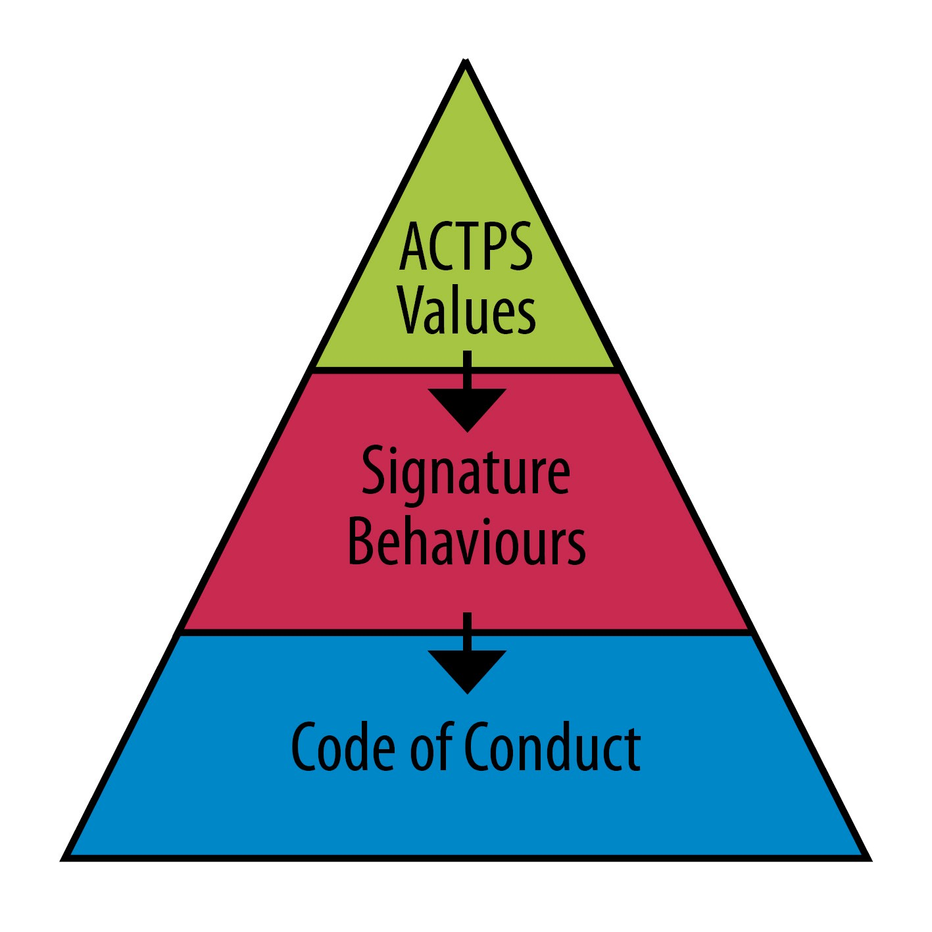
The ACTPS Code of Conduct expands and gives examples of the sorts of behaviours that give life to the ACTPS Values and signature behaviours.

The ACTPS Code of Conduct applies to our conduct in all circumstances including face to face interaction, engagement on social media, in published material, in written briefing materials and in meetings.

We are all responsible for considering whether we are applying the Code when we do our work, and thinking about how our behaviour could be improved.

The Code is broken into sections, and the values to which each section applies most are highlighted. In this way, the sections are also tied to the signature behaviours.

Each section has two parts: obligations we all have, and additional responsibilities for those of us responsible for managing staff.

TAKE YOUR JOB SERIOUSLY | Respect  Integrity  Collaboration  Innovation
We all should:
- act professionally and recognise the trust placed in us as public servants
- take responsibility to find out what we need to know to do our jobs
- do our jobs to the best of our ability
- think critically about improving how we do our jobs
- acknowledge mistakes openly and learn from them
- work safely and sustainably
If we manage people, we should also:
- be approachable and explain how our team’s work fits into the big picture
- explain duties and expectations clearly
- give constructive feedback to help build skills and confidence
- acknowledge success and achievements
- identify opportunities for and support professional development
- provide information or assistance
- share our skills, experience and expertise
- fairly manage workload across our team
- make work/life balance a priority

BE ACCOUNTABLE | Respect  Integrity  Collaboration  Innovation
We all should:
- know what is expected of us
- know our boundaries
- do what we say we’re going to do
- take responsibility for and consider the consequences of our decisions and actions
- be reliable and consistent in what we do and how we do it
- be aware of, and properly manage, potential conflicts of interest
- use information appropriately and respect the different capacities in which we deal with individuals

If we manage people, we should also:
- manage performance and underperformance fairly
- clearly explain what is expected of our staff
- lead by example
- discuss work priorities and fairly manage changing priorities

BE PREPARED | Respect  Integrity  Collaboration  Innovation
We all should:
- think about what is important for other people to know and act accordingly
- think about the consequences of what we are doing
- keep people informed about what we are doing
- know our limits and ask for help when we need it
- discuss openly what we can and can’t do
If we manage people, we should also:
- make sure we know who we need to keep informed
- foster a working environment where people feel confident to deliver bad news
- provide the information and resources our staff need
- offer help when our staff need it
- make sure we all understand what our responsibilities are
- ensure we all are sufficiently skilled or trained to do our jobs

COMMUNICATE EFFECTIVELY | Respect  Integrity  Collaboration  Innovation
We all should:
- be considerate and courteous in all our interactions
- treat colleagues and clients with decency and respect
- give each other a chance to explain our actions and thought processes
- be clear about what we can and can’t do
- provide proper reasons for our decisions
If we manage people, we should also:
- provide timely information

- provide genuine and constructive feedback on a regular basis
- explain how individuals fit into the big picture

GIVE AND RECEIVE INFORMATION AND ADVICE WITHOUT FEAR | Respect  Integrity  Collaboration  Innovation
We all should:
- share information appropriately
- provide impartial, comprehensive, and robust advice
- provide accurate information (and promptly correct errors if they are made)
- explain any doubts about the reliability of information
- speak up -­‐ doing nothing is not an option
If we manage people, we should also:
- be clear about what advice is being sought and why
- explain why a decision has been made
- build a working environment where advice and information provided by staff contributes to agreed goals

SERVE THE GOVERNMENT OF THE DAY | Respect  Integrity  Collaboration  Innovation
We all should:
- implement the policies of the government of the day and be responsive to its agenda
- consider our actions and how they might be perceived by the general public
- be aware of any perceived or real conflicts of interest (including in relation to party-­‐political activities)
- ensure we communicate with the Government through approved channels
- recognise we are the stewards and not owners of the shared assets of the people of the ACT and serve the community on behalf of the Government, not in our own right
If we manage people, we should also:
- promptly communicate any changes in policy or role
- assist in navigating ambiguity and changes in political direction
- provide clear direction and example in standards of proper conduct

BE CONSTRUCTIVE | Respect  Integrity  Collaboration  Innovation
We all should:
- ask why things are done the way they are
- be willing to help make changes and consider different options
- solve problems rather than complain about them
- use feedback and new ideas to improve service outcomes
- do things without requiring something in return
- acknowledge the achievements of others, and share responsibility and accolades
- seek success without compromising the success of others
If we manage people, we should also:
- encourage our staff to identify problems and suggest solutions to them
- respond quickly and helpfully when issues are identified
- encourage continuous improvement
- encourage sensible and thoughtful engagement with risk
- seek to understand and learn rather than blame when things go wrong

MAKE SOUND DECISIONS | Respect  Integrity  Collaboration  Innovation
We all should:
- know our obligations and powers under the relevant law or policy
- understand any procedures required by law for making the decision
- ensure the principles of natural justice are applied in our decision making
- not be biased or appear biased
- provide proper reasons for our decisions
If we manage people, we should also:
- ensure decision makers understand their boundaries, accountabilities, legislative context and obligations

UNDERSTAND YOUR LEGAL OBLIGATIONS | Respect  Integrity  Collaboration  Innovation
We all should:
- understand our obligations under section 9 of the Public Sector Management Act 1994 and relevant industrial agreements
- understand our obligations under laws that apply to all public employees including the:
  - Discrimination Act 1991
  - Financial Management Act 1996 o Freedom of Information Act 1989 o Human Rights Act 2004
  - Public Interest Disclosure Act 2012
  - Territory Records Act 2002
  - Work Health and Safety Act 2011
  - Privacy Act 1988 (Cwlth)
If we manage people, we should also:
- help our staff understand how to meet their legal obligations

