Australian Capital Territory

Planning and Development (Technical Amendment—Lawson) Plan Variation 2014 (No 1)*

Notifiable Instrument NI2014—11
Technical Amendment No 2013—20
made under the
Planning and Development Act 2007, section 89 (Making technical amendments) s96 (land ceases to be in future urban area)

This plan variation commences on the day after it is notified.

Variation No 2013—20 to the Territory Plan has been approved by the Planning and Land Authority.

Variation to the Territory Plan
The Territory Plan map is varied as indicated in Annexure A to identify the zones that apply to the land ceasing to be in a future urban area.

Introduction of the Precinct Map and Code
Annexure B proposes to introduce the Lawson Precinct Map and Code for ongoing block specific provisions for this area.

Ben Ponton
Delegate of the Planning and Land Authority
13 January 2014

THIS IS PAGE ONE OF ANNEXURE A
TO NOTIFIABLE INSTRUMENT NI2014–11

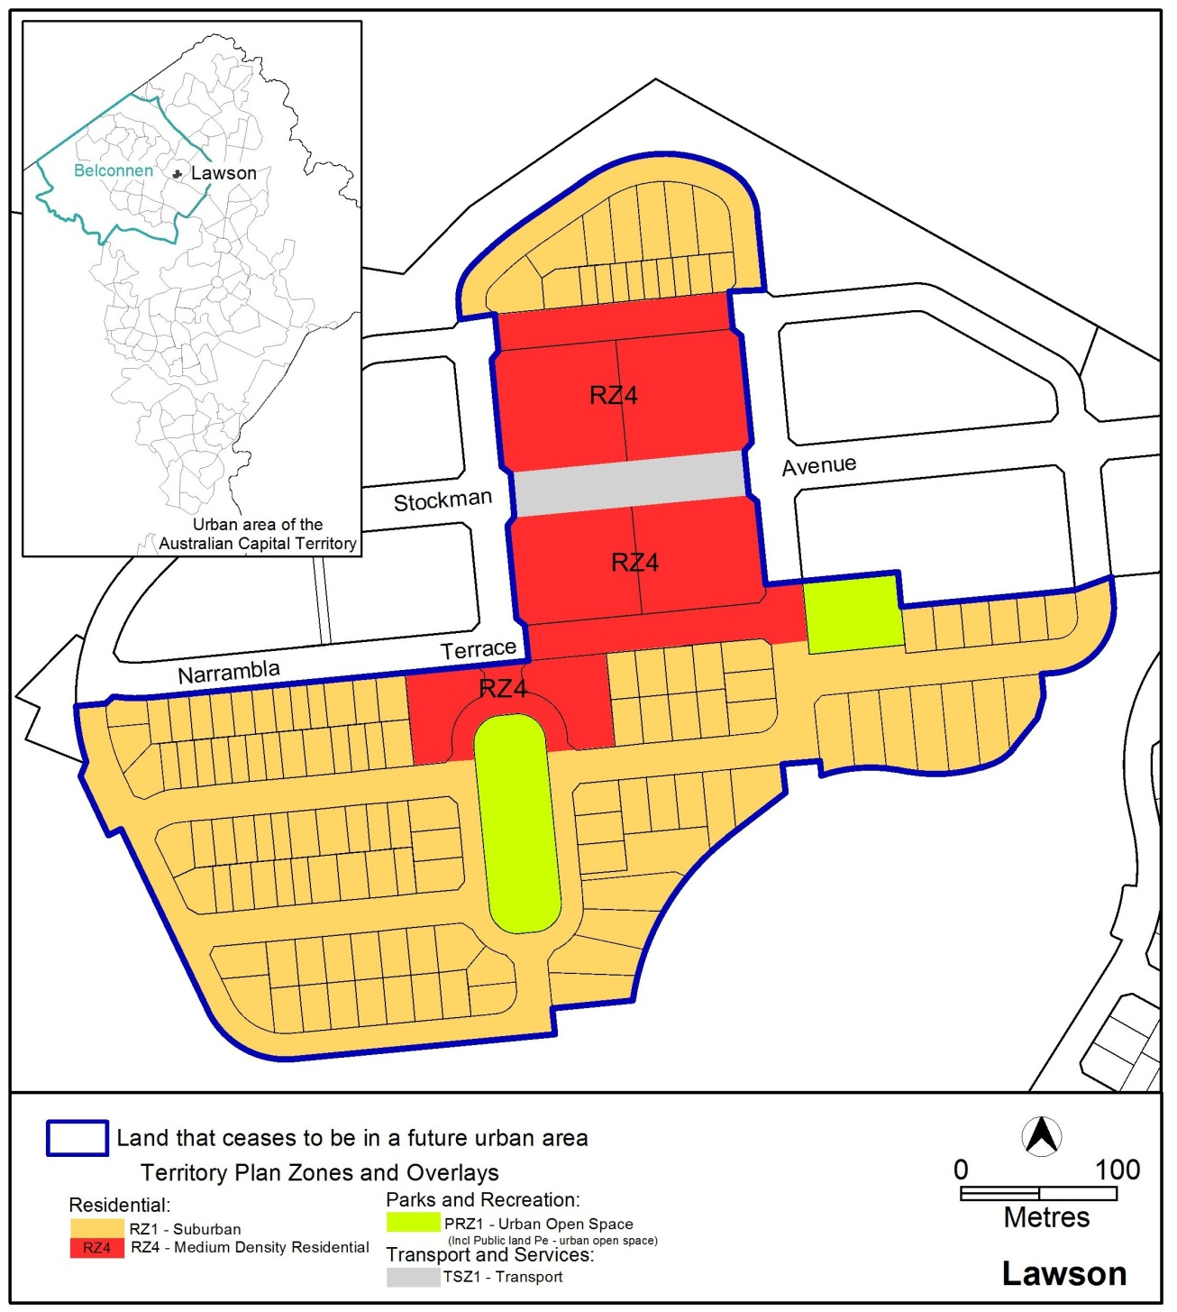

Ben Ponton
Delegate of the Planning and Land Authority
13 January 2014

THIS IS ANNEXURE B
TO NOTIFIABLE INSTRUMENT NI2014–11

Ben Ponton
Delegate of the Planning and Land Authority
13 January 2014

Lawson Precinct Map and Code

This page is intentionally blank.

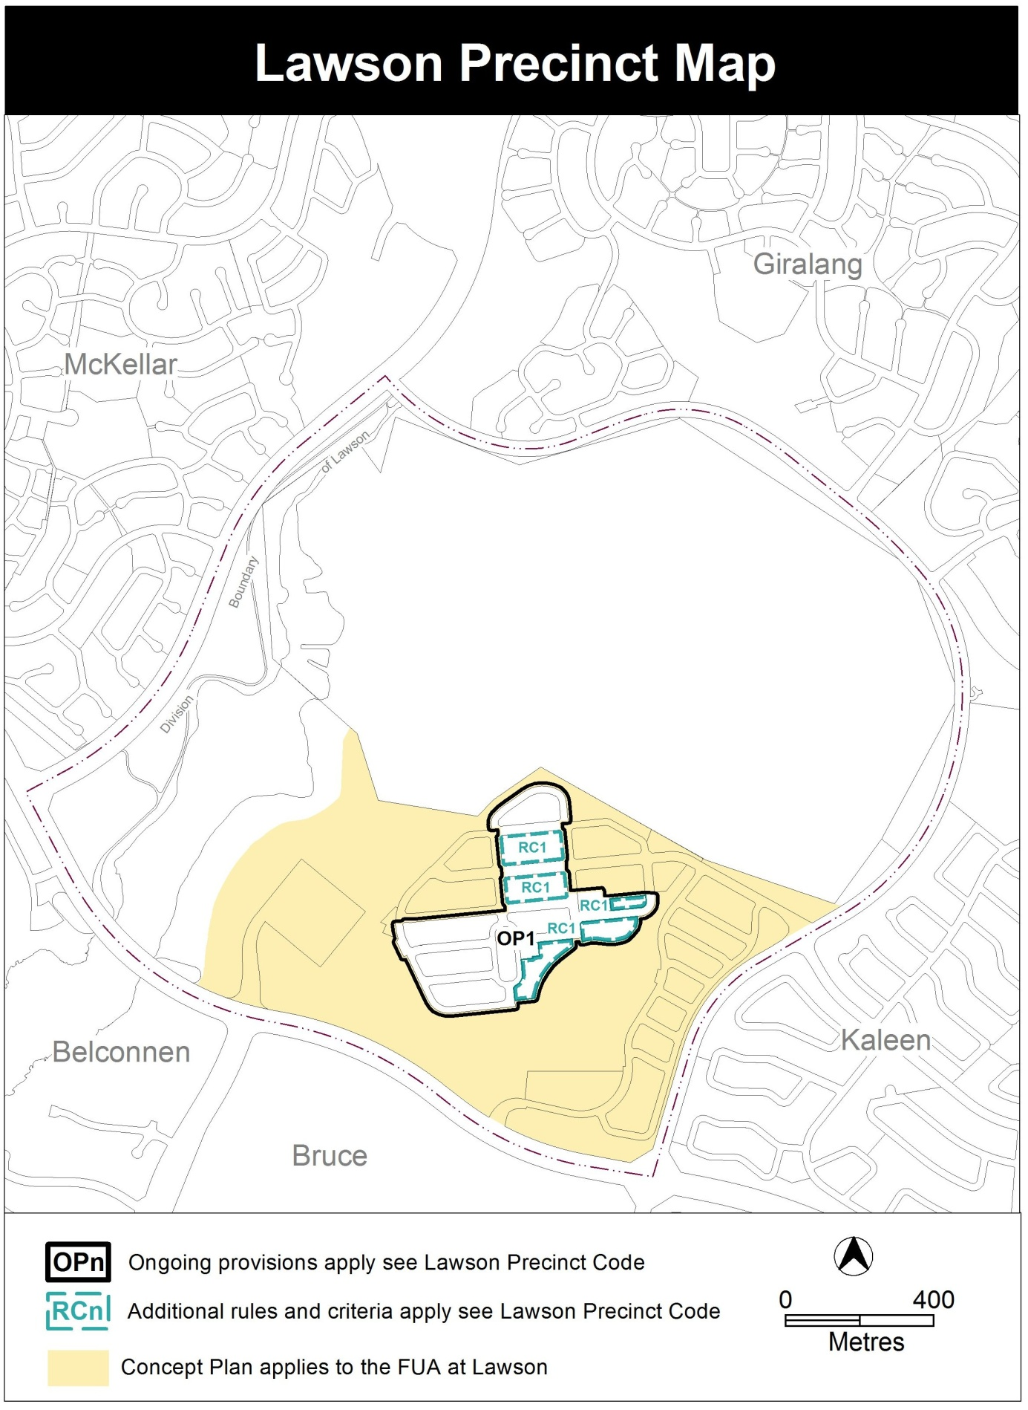

Lawson Precinct Code

Contents
Introduction 3
Additional rules and criteria 5
RC1 – Lawson residential estate 5
Element 1: Building heights 5
1.1 Number of storeys 5
1.2 Building heights 5
Element 2: Vehicular access 5
2.1 Vehicular access 5
Other ongoing provisions 7
OP1 – Lawson residential area 7

Figures
Figure 1 6
Figure 2 6
Figure 3 7

Introduction
Name
The name of this code is Lawson Precinct Code.
Application
The code applies to the Division of Lawson.
Purpose
This code provides additional planning, design and environmental controls for specific areas or blocks and may also contain references to provisions in other codes.
In conjunction with other relevant codes it will be used by the Authority to assess development applications and offer guidance to intending applicants in designing development proposals and preparing development applications.
Structure
This code contains additional rules and/or criteria for particular blocks or parcels identified as areas RCn on the precinct map, to be read in conjunction with the relevant development code. It may also contain sub-parts.
Each element has one or more rules and, unless the respective rule is mandatory, each rule has an associated criterion. Rules provide quantitative, or definitive, controls. By contrast, criteria are chiefly qualitative in nature.
In some instances rules are mandatory. Such rules are accompanied by the words “This is a mandatory requirement. There is no applicable criterion.” Non-compliance with a mandatory rule will result in the refusal of the development application. Conversely, the words “There is no applicable rule” is found where a criterion only is applicable.
Code hierarchy
Under the Planning and Development Act 2007, where more than one type of code applies to a development, the order of precedence if there is inconsistency of provisions between codes is: precinct code, development code and general code.
If more than one precinct code applies to the site, the most recent precinct code takes precedence to the extent of any inconsistency.
Definitions
Defined terms, references to legislation and other documents are italicised.
Definitions of terms used in this code are listed in part 13 of the Territory Plan or, for terms applicable only to this code, associated with the respective rule.
Acronyms
EPA ACT Environment Protection Authority
ESA ACT Emergency Services Agency
ESDD ACT Environment and Sustainable Development Directorate
NCA National Capital Authority
P&D Act Planning and Development Act 2007
TAMS ACT Territory and Municipal Services Directorate

Additional rules and criteria
This part applies to blocks and parcels identified in the Lawson Precinct Map (RCn). It should be read in conjunction with the relevant zone development code and related codes.
RC1 – Lawson residential estate
This part applies to blocks and parcels identified in area RC1 shown on the Lawson Precinct Map.
- Building heights
Rules | Criteria
  - Number of storeys
The following rule applies to area A in Figure 1:  The minimum number of storeys for dwellings in this location is 2. | This is a mandatory requirement. There is no applicable criterion.
  - Building heights
R2  The following rule applies to the hatched area as shown in Figure 2.  No part of any building is to extend above RL620. | This is a mandatory requirement. There is no applicable criterion.

Element 2: Vehicular access
Rules | Criteria
2.1 Vehicular access
R3  No vehicular access is permitted to buildings in places as indicated in Figure 1 | This is a mandatory requirement. There is no applicable criterion.

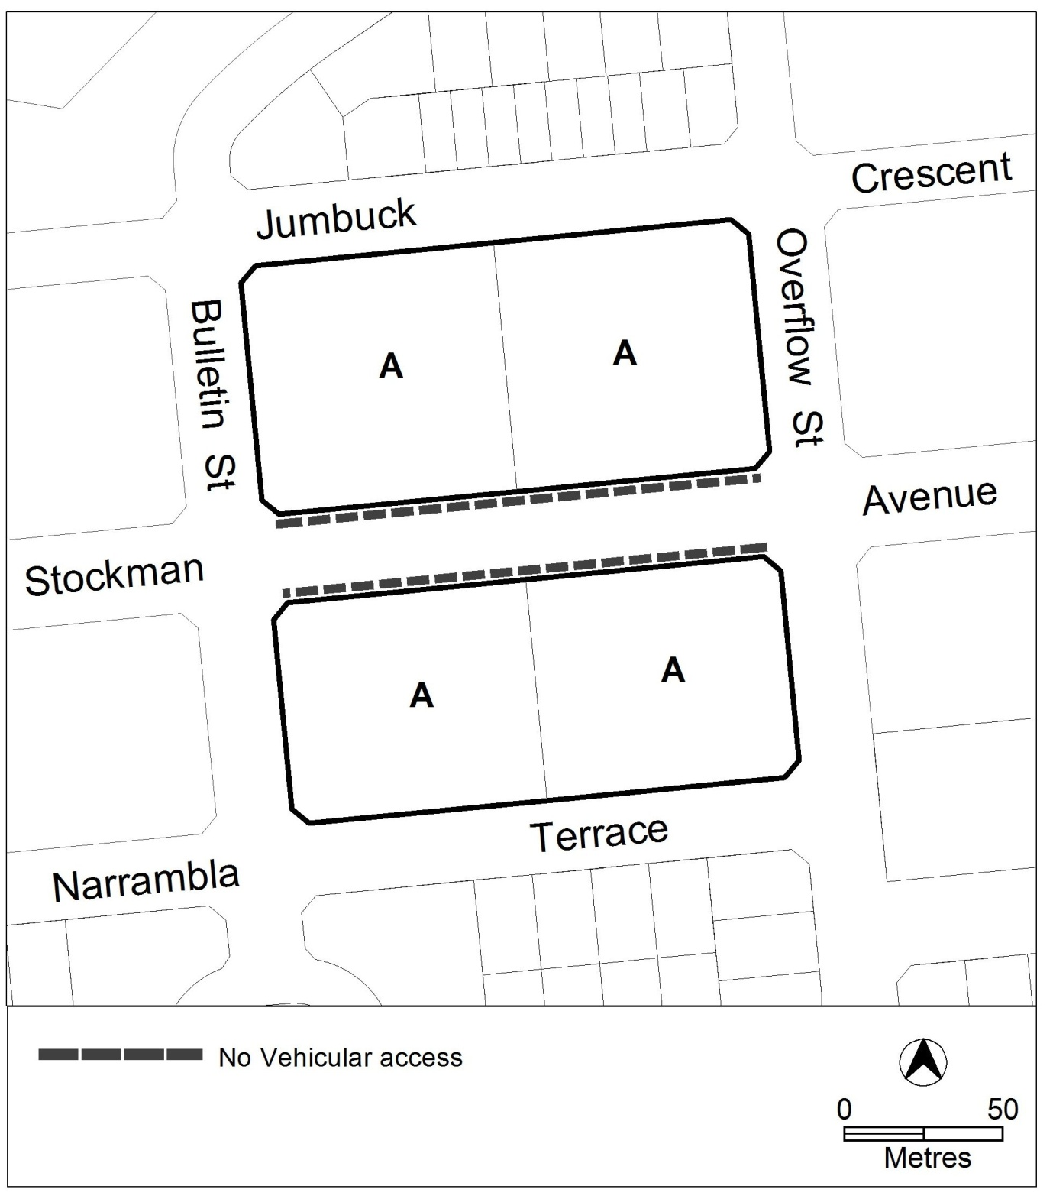
Figure 1

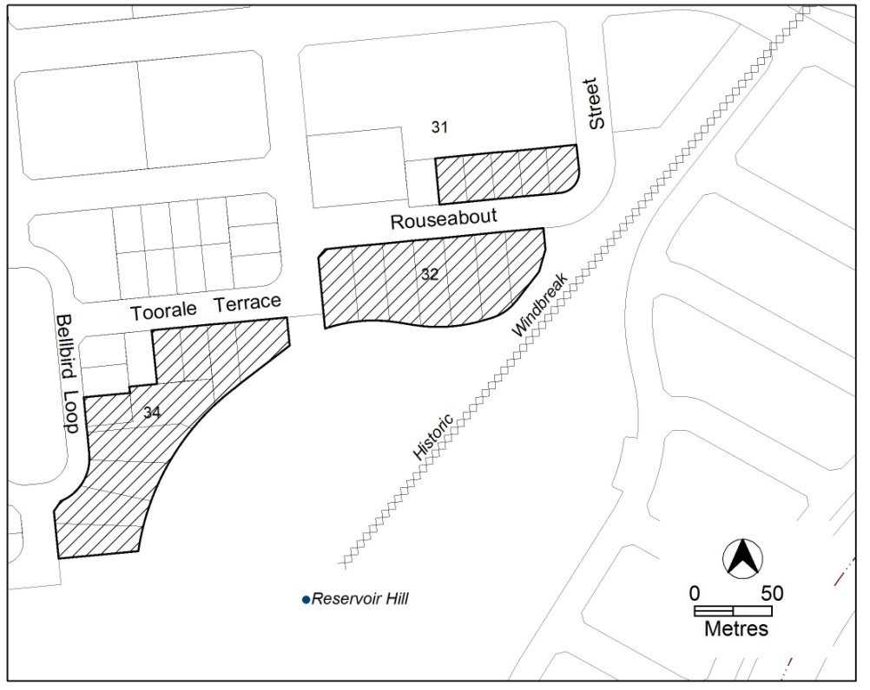
Figure 2
Other ongoing provisions
This part applies to blocks and parcels identified as ongoing provisions (OPn) in the Lawson Precinct Map. It should be read in conjunction with the relevant zone development code and related codes.
OP1 – Lawson residential area
This part applies to blocks and parcels identified in area OP1 shown on the Lawson Precinct Map.
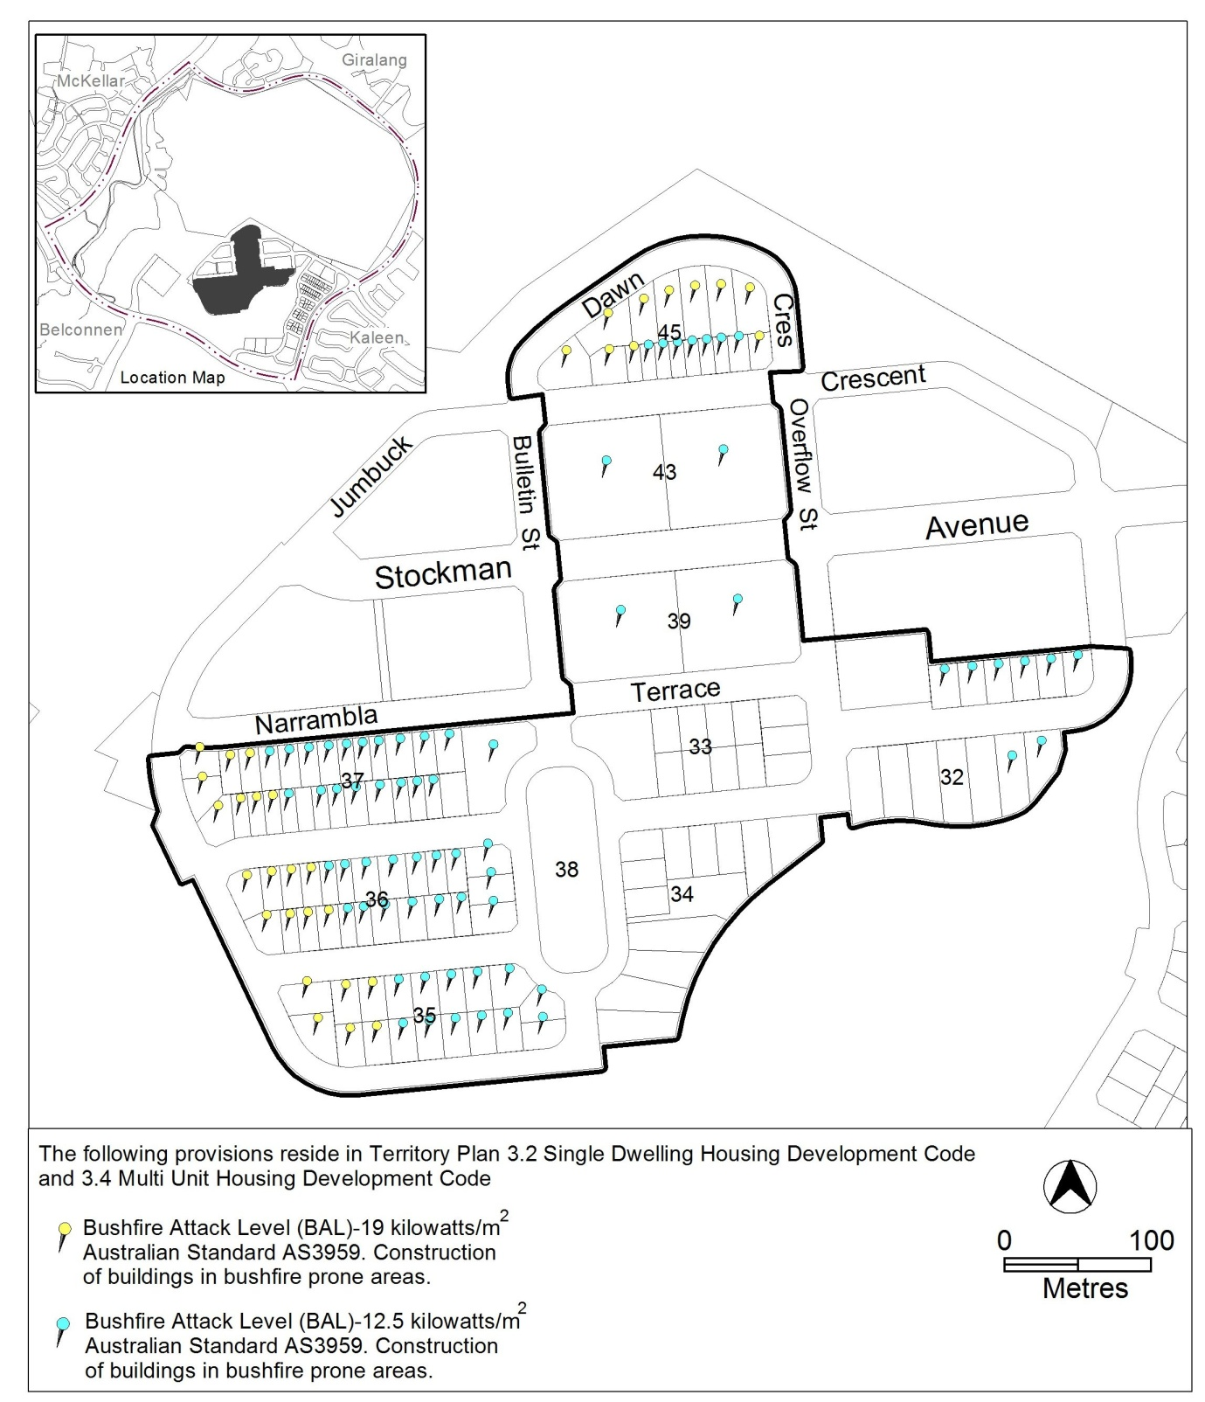
Figure 3

