Australian Capital Territory

Planning and Development (Technical Amendment—code, clarification and redundancy amendment) Plan Variation 2014 (No 1)*

Notifiable Instrument NI2014—13

Technical Amendment No 2013—12
made under the
Planning and Development Act 2007, section 89 (Making technical amendments)

This technical amendment commences on 17 January 2014.

Variation No 2013—12 to the Territory Plan has been approved by the Planning and Land Authority.

Dorte Ekelund
Planning and Land Authority
3 January 2014

Planning and Development Act 2007

Technical Amendment to the Territory Plan
Variation 2013 – 12

Changes to the residential zones development code, single dwelling housing development code and multi unit housing development code

January 2014

Commencement version

Contents
1. INTRODUCTION 3
1.1 Purpose 3
1.2 Public consultation 4
1.3 National Capital Authority 4
1.4 Process 4
2. EXPLANATION 5
2.1 Residential Zones Development Code 5
2.2 Single Dwelling Housing Development Code 11
2.3 Multi unit housing development code 31
3. TECHNICAL AMENDMENT 34
3.1 Residential Zones Development Code 34
3.2 Single dwelling housing development code 37
3.3 Multi unit housing development code 47

- INTRODUCTION
  - Purpose

This technical amendment makes the following changes to the Territory Plan.

Residential Zones Development Code
- Increase maximum size of secondary residence from 75m² to 90m²
- Retention of private open space requirements for an existing dwelling where a secondary residence is proposed
- Clarification of requirement for statement of endorsement for demolition
- Removal of rule R39 relating to subdivision under Unit Titles Act 2001
- Clarify that rule R57 water sensitive urban design requirements for multi unit residential development does not include secondary residences.

Single Dwelling Housing Development Code
- Remove references to Molonglo valley from building envelope provisions
- Amendments to solar envelope provisions to eliminate gaps in range of solar aspect angles
- Reintroduce description of articulation elements in Table 3C.
- Amendments to alternative side and rear setbacks for mid sized blocks
- Add a criterion for walls on or near side boundaries for mid sized blocks
- Amend criterion C41 regarding amenity for principal private open space to bring in line with other similar criteria, and add provision on access to sunlight for year round use
- Changes to R43 regarding water sensitive urban design, to include reference to secondary residences and extensions and renovations other than minor work.

Multi Unit Housing Development Code
- Clarification of dwelling replacement provision for single dwelling blocks
- Amendments to solar envelope provisions due to eliminate gaps in range of solar aspect angles

  - Public consultation
Under section 88 of the Planning and Development Act 2007 (the Act) this type of technical amendment is subject to limited public consultation. The public was notified through a newspaper notice. At the conclusion of the limited consultation period, any representations were considered by the planning and land authority (the Authority) within the Environment and Sustainable Development Directorate. The Authority then determines a day when the technical amendment is to commence by way of a commencement notice.

  - National Capital Authority
The National Capital Authority has been advised of this technical amendment.

  - Process
This technical amendment has been prepared in accordance with section 87 of the Planning and Development Act 2007 (the Act). Comments received from the public and the National Capital Authority were taken into account before the planning and land authority “made” the technical amendment under section 89 of the Act. The planning and land authority must now notify the public of its decision.
- EXPLANATION

  - Residential Zones Development Code

    - Increase maximum size of secondary residences
The intent of the secondary residence provisions is to enable a small dwelling on a block in addition to the main dwelling to provide an alternative housing choice. With the requirement to meet adaptability standards, it has been identified that the 75m² maximum size limit makes it difficult to achieve an appropriately proportioned dwelling. For this reason, the maximum size has been increased to 90m².

Existing provision

Rules | Criteria
4.1 Design and siting
R7  The maximum dwelling size* of a secondary residence is 75m².  *For the purpose of this rule, dwelling size is the floor area measured to the outside face of external walls (including internal walls between the living areas and garage) but excludes the garage. | This is a mandatory requirement. There is no applicable criterion.

Amended provision

Rules | Criteria
4.1 Design and siting
R7  The maximum dwelling size* of a secondary residence is 90m².  *For the purpose of this rule, dwelling size is the floor area measured to the outside face of external walls (including internal walls between the living areas and garage) but excludes the garage. | This is a mandatory requirement. There is no applicable criterion.

Compliance with the Planning and Development Act 2007
Section | Statement
s87(b) a variation (a code variation) that –  - would only change a code  - is consistent with the policy purpose and policy framework of the code; and  - is not an error variation. | Compliant. This amendment would ensure that an appropriately sized secondary residence can meet the required adaptability standards.
    - Retention of private open space provisions for existing dwelling when secondary residences are proposed
With the introduction of secondary residences, it was not intended that the compliance of the existing dwelling with the provisions of the Single Dwelling Housing Development Code (SDHDC) be compromised by the location of a secondary residence. This includes the impact on the principal private open space and solar access of the main dwelling. A provision has been added to the applicable residential codes to clarify that when a secondary residence is added to a block, the existing dwelling must remain compliant with the SDHDC. A requirement that a block containing both a single dwelling and a secondary residence must still comply with the POS requirements for the block overall has been included for clarification purposes.

Existing provisions

4.1 Design and siting
R11  Secondary residences comply with Element 1 of the Single Dwelling Housing Development Code. | This is a mandatory requirement, there is no applicable criterion.

New provisions (underlined)

4.1 Design and siting
R11  For blocks containing a secondary residence:  - Secondary residences comply with Element 1 and Element 6 of the Single Dwelling Housing Development Code  - The main residence continues to comply with the provisions of the Single Dwelling Housing Development Code. | This is a mandatory requirement, there is no applicable criterion.

4.1 Design and siting
R11A  The total private open space on the block complies with the private open space for single dwelling housing as prescribed in Element 5 of the Single Dwelling Housing Development Code | This is a mandatory requirement, there is no applicable criterion.

Compliance with the Planning and Development Act 2007
Section | Statement
s87(b) a variation (a code variation) that –  - would only change a code  - is consistent with the policy purpose and policy framework of the code; and  - is not an error variation. | Compliant. This amendment would clarify the intent to retain the principal POS provision of the existing dwelling on a residential block where a secondary residence is proposed.

    - Demolition – statement of endorsement requirement
Rule R33 implies that the statement of endorsement needs to be lodged with the initial development application (DA) for demolition rather than it being required before approval. The rule has been adjusted to clarify that the statement of endorsement needs to be provided prior to approval and not necessarily at the lodgement of the DA.

Existing provision

8.1 Statement of endorsement
R33  The development application for demolition is accompanied by a statement of endorsement for utilities (including water, sewerage, stormwater, electricity and gas) in accordance with section 148 of the Planning and Development Act 2007 confirming all of the following:  - all network infrastructure on or immediately adjacent the site has been identified on the plan  - all potentially hazardous substances and conditions (associated with or resulting from the demolition process) that may constitute a risk to utility services have been identified  - all required network disconnections have been identified and the disconnection works comply with utility requirements  - all works associated with the demolition comply with and are in accordance with utility asset access and protection requirements. | This is a mandatory requirement, there is no applicable criterion.

Amended provision (underlined)

8.1 Statement of endorsement
R33  A statement of endorsement for utilities (including water, sewerage, stormwater, electricity and gas) in accordance with section 148 of the Planning and Development Act 2007 is provided confirming all of the following:  - all network infrastructure on or immediately adjacent the site has been identified on the plan  - all potentially hazardous substances and conditions (associated with or resulting from the demolition process) that may constitute a risk to utility services have been identified  - all required network disconnections have been identified and the disconnection works comply with utility requirements  - all works associated with the demolition comply with and are in accordance with utility asset access and protection requirements. | This is a mandatory requirement, there is no applicable criterion.

Compliance with the Planning and Development Act 2007
Section | Statement
s87(b) a variation (a code variation) that –  - would only change a code  - is consistent with the policy purpose and policy framework of the code; and  - is not an error variation. | Compliant.

    - Subdivision under the Unit Titles Act 2001
The Unit Titles Act 2001 (the Act) was amended in 2011 to include the requirements referred to in Rule R39. As such, R39 is a duplication of the requirements in the Act, and it is therefore not necessary for it to be included in the Residential Zones Development Code.

Existing provision

9.5 Subdivision under the Unit Titles Act
R39  Subdivision under the Unit Titles Act 2001 is permitted only where the lease expressly provides for the number of units or dwellings provided for in the proposed subdivision.  Note: The Unit Titles Act 2001 contains provisions affecting the subdivision two dwellings. | This is a mandatory requirement. There is no applicable criterion.

Change to provision

Remove Item 9.5 and Rule R39 from the Residential Zones Development Code

Compliance with the Planning and Development Act 2007
Section | Statement
s87(g) a variation to omit something that is obsolete or redundant in the territory plan | Compliant. As the Unit Titles Act 2001 contains the same requirements, this rule is now redundant.

    - Water sensitive urban design
Rule R57 has been adjusted to clarify that water sensitive urban design requirements in the Residential Zones Development Code that apply to multi unit residences do not apply to secondary residences.

Existing provision

14.1 Water sensitive urban design
R57  This rule applies to all multi-unit residential development except for minor extensions.  The development achieves a minimum 40% reduction in mains water consumption compared to an equivalent development constructed in 2003, without any reliance on landscaping measures.  Compliance with this rule is demonstrated by a report by a suitably qualified person using the ACTPLA on-line assessment tool or another tool referred to in the Water Ways: Water Sensitive Urban Design General Code.  For this element:  minor extension means an extension where the increase in the combined roof plan area, driveway, car manoeuvring areas and car parking areas is less than 25% of the total of the areas of these components at the date of lodgement of the development application. | This is a mandatory requirement, there is no applicable criterion.

Amended provision (underlined)

14.1 Water sensitive urban design
R57  This rule applies to all multi-unit residential development except for minor extensions and secondary residences.  The development achieves a minimum 40% reduction in mains water consumption compared to an equivalent development constructed in 2003, without any reliance on landscaping measures.  Compliance with this rule is demonstrated by a report by a suitably qualified person using the ACTPLA on-line assessment tool or another tool referred to in the Water Ways: Water Sensitive Urban Design General Code.  For this element:  minor extension means an extension where the increase in the combined roof plan area, driveway, car manoeuvring areas and car parking areas is less than 25% of the total of the areas of these components at the date of lodgement of the development application. | This is a mandatory requirement, there is no applicable criterion.

Compliance with the Planning and Development Act 2007
Section | Statement
s87(h) a variation to clarify the language in the territory plan if it does not change the substance of the plan. | Compliant. This amendment clarifies the requirements of the provision, without changing the substance.

  - Single Dwelling Housing Development Code

    - Building envelopes in the Molonglo Valley
Items 1.5, 1.6 and 1.7 and Rules R6, R7, R8 and R9 refer to building envelope requirements in the Molonglo Valley. The specific reference to the Molonglo Valley in these items and rules has been removed as different provisions are located in the Coombs and Wright precinct codes for existing blocks. Furthermore, the rules will apply to all new blocks regardless of location.

Current provisions
1.5 Building envelope - all large blocks, mid sized blocks approved after 5 July 2013, all large and mid sized blocks in the Molonglo Valley and integrated housing development parcels
R6  This rule applies to all of the following:  - large blocks  - mid sized blocks approved under an estate development plan after 5 July 2013  - mid sized blocks in the district of Molonglo Valley  - integrated housing development parcels  but does not apply to that part of the building on a single dwelling block that is required to be built to a boundary of the block by a precinct code applying to an integrated housing development parcel of which the block is a part.  Buildings are sited wholly within the building envelope formed by projecting planes over the subject block comprising lines projected at 45º to the horizontal from an infinite number of points on a line of infinite length 3.5m above each side and rear boundary, except as required by the next rule  Refer to figure 1. | C6  Buildings achieve all of the following:  - consistency with the desired character  - reasonable levels of privacy for dwellings on adjoining residential blocks and their associated private open space.

1.6 Sun angle building envelope - all large blocks, mid sized blocks approved after 5 July 2013, compact blocks approved after 5 July 2013, all blocks in the Molonglo Valley and integrated housing development parcels
R7  This rule applies to all of the following:  - large blocks  - mid sized blocks approved under an estate development plan after 5 July 2013  - compact blocks approved under an estate development plan after 5 July 2013  - all blocks in the district of Molonglo Valley  - integrated housing development parcels  but does not apply to that part of the building on a single dwelling block that is required to be built to a boundary of the block by a precinct code applying to an integrated housing development parcel of which the block is a part.  Buildings are sited wholly within the building envelope formed by planes projected over the subject block at Xº to the horizontal from the height of the solar fence on any northern boundary of an adjoining residential block.  The height of the solar fence is:  - in the primary building zone – 2.4m  - all other parts of the boundary – 1.8m  This rule does not apply to any part of a northern boundary to an adjoining residential block that is used primarily to provide access to the main part of the residential block (ie a “battleaxe” handle). The previous rule applies to this boundary.  Xº is the apparent sun angle at noon on the winter solstice. For the purposes of this rule values for X are given in table 1.  Refer to figure 1. | C7  Buildings achieve all of the following:  - consistency with the desired character  - reasonable solar access to dwellings on adjoining residential blocks and their associated private open space  - do not shadow the windows of habitable rooms (other than bedrooms) of any approved and constructed dwelling on an adjoining residential block at noon on the winter solstice  - do not overshadow the principal private open space of any approved and constructed dwelling on an adjoining residential block to a greater extent than a 2.4m fence on the boundary at noon on the winter solstice.
1.7 Building envelope – mid sized blocks approved before 5 July 2013 except in Molonglo Valley
R8  This rule applies to mid sized blocks with one of the following characteristics:  - approved under an estate development plan before 5 July 2013  - for which a lease was granted before 5 July 2013  but does not apply to blocks located in the district of Molonglo Valley.  Buildings are sited wholly within the building envelope formed by projecting planes over the subject block comprising:  - within the primary building zone -  - lines projected at 45º to the horizontal from an infinite number of points on a line of infinite length 4.5m above each side boundary, except for northern boundaries of adjoining residential blocks  - from northern boundaries of adjoining residential blocks, lines projected at 45º to the horizontal from an infinite number of points on a line of infinite length 2m above these boundaries.  - despite item ii), where a wall is located on a northern boundary of an adjoining residential block, lines projected at 30º to the horizontal from an infinite number of points on a line of infinite length 3m above these boundaries.  - within the rear zone -  - lines projected at 30º to the horizontal from an infinite number of points on a line of infinite length 3.5m above each side and rear boundary, except for northern boundaries of adjoining residential blocks  - from northern boundaries of adjoining residential blocks, lines projected at 30º to the horizontal from an infinite number of points on a line of infinite length 2m above these boundaries.  Refer Figure 2. | C8  Buildings achieve all of the following:  - consistency with the desired character  - reasonable levels of privacy for dwellings and their associated private open space on adjoining residential blocks  reasonable solar access to dwellings and their associated private open space on adjoining residential blocks.
R9  This rule applies to mid-sized blocks and compact blocks with one of the following characteristics:  - approved under an estate development plan before (commencement date)  - for which a lease was granted before (commencement date)  but does not apply to blocks located in the district of Molonglo Valley.  Where a garage wall is located on, or setback from, the northern boundary of an adjoining residential block, a 1m encroachment of the wall is permitted vertically beyond the building envelope, provided the wall and roof element associated with the wall do not encroach beyond a plane comprising lines projected at 30º to the horizontal from an infinite number of points on a line of infinite length 3m above the respective boundary.  Refer Figure 2. | C9  Buildings achieve all of the following:  - consistency with the desired character  - reasonable levels of privacy for dwellings and their associated private open space on adjoining residential blocks  - reasonable solar access to dwellings and their associated private open space on adjoining residential blocks.

Amended provisions

1.5 Building envelope - all large blocks, mid sized blocks approved after 5 July 2013, all large and mid sized blocks in the Molonglo Valley and integrated housing development parcels
R6  This rule applies to all of the following:  - large blocks  - mid sized blocks approved under an estate development plan after 5 July 2013  - mid sized blocks in the district of Molonglo Valley  - integrated housing development parcels  but does not apply to that part of the building on a single dwelling block that is required to be built to a boundary of the block by a precinct code applying to an integrated housing development parcel of which the block is a part.  Buildings are sited wholly within the building envelope formed by projecting planes over the subject block comprising lines projected at 45º to the horizontal from an infinite number of points on a line of infinite length 3.5m above each side and rear boundary, except as required by the next rule.  Refer to figure 1. | C6  Buildings achieve all of the following:  - consistency with the desired character  - reasonable levels of privacy for dwellings on adjoining residential blocks and their associated private open space.

1.6 Sun angle building envelope - all large blocks, mid sized blocks approved after 5 July 2013, compact blocks approved after 5 July 2013, all blocks in the Molonglo Valley and integrated housing development parcels
R7  This rule applies to all of the following:  - large blocks  - mid sized blocks approved under an estate development plan after 5 July 2013  - compact blocks approved under an estate development plan after 5 July 2013  - all blocks in the district of Molonglo Valley  - integrated housing development parcels  but does not apply to that part of the building on a single dwelling block that is required to be built to a boundary of the block by a precinct code applying to an integrated housing development parcel of which the block is a part.  Buildings are sited wholly within the building envelope formed by planes projected over the subject block at Xº to the horizontal from the height of the solar fence on any north facing boundary of an adjoining residential block.  The height of the solar fence is:  - in the primary building zone – 2.4m  - all other parts of the boundary – 1.8m  This rule does not apply to any part of a north facing boundary to an adjoining residential block that is used primarily to provide access to the main part of the residential block (ie a “battleaxe” handle). The previous rule applies to this boundary.  Xº is the apparent sun angle at noon on the winter solstice. For the purposes of this rule values for X are given in table 1.  Refer to figure 1. | C7  Buildings achieve all of the following:  - consistency with the desired character  - reasonable solar access to dwellings on adjoining residential blocks and their associated private open space  - do not shadow the windows of habitable rooms (other than bedrooms) of any approved and constructed dwelling on an adjoining residential block at noon on the winter solstice  - do not overshadow the principal private open space of any approved and constructed dwelling on an adjoining residential block to a greater extent than a 2.4m fence on the boundary at noon on the winter solstice.
1.7 Building envelope – mid sized blocks approved before 5 July 2013 except in Molonglo Valley
R8  This rule applies to mid sized blocks with one of the following characteristics:  - approved under an estate development plan before 5 July 2013  - for which a lease was granted before 5 July 2013  but does not apply to blocks located in the district of Molonglo Valley.  Buildings are sited wholly within the building envelope formed by projecting planes over the subject block comprising:  - within the primary building zone -  - lines projected at 45º to the horizontal from an infinite number of points on a line of infinite length 4.5m above each side boundary, except for north facing boundaries of adjoining residential blocks  - from north facing boundaries of adjoining residential blocks, lines projected at 45º to the horizontal from an infinite number of points on a line of infinite length 2m above these boundaries.  - despite item ii), where a wall is located on a north facing boundary of an adjoining residential block, lines projected at 30º to the horizontal from an infinite number of points on a line of infinite length 3m above these boundaries.  - within the rear zone -  - lines projected at 30º to the horizontal from an infinite number of points on a line of infinite length 3.5m above each side and rear boundary, except for north facing boundaries of adjoining residential blocks  - from north facing boundaries of adjoining residential blocks, lines projected at 30º to the horizontal from an infinite number of points on a line of infinite length 2m above these boundaries.  Refer Figure 2. | C8  Buildings achieve all of the following:  - consistency with the desired character  - reasonable levels of privacy for dwellings and their associated private open space on adjoining residential blocks  reasonable solar access to dwellings and their associated private open space on adjoining residential blocks.
R9  This rule applies to mid-sized blocks and compact blocks with one of the following characteristics:  - approved under an estate development plan before 5 July 2013  - for which a lease was granted before 5 July 2013  but does not apply to blocks located in the district of Molonglo Valley.  Where a garage wall is located on, or setback from, the north facing boundary of an adjoining residential block, a 1m encroachment of the wall is permitted vertically beyond the building envelope, provided the wall and roof element associated with the wall do not encroach beyond a plane comprising lines projected at 30º to the horizontal from an infinite number of points on a line of infinite length 3m above the respective boundary.  Refer Figure 2. | C9  Buildings achieve all of the following:  - consistency with the desired character  - reasonable levels of privacy for dwellings and their associated private open space on adjoining residential blocks  - reasonable solar access to dwellings and their associated private open space on adjoining residential blocks.

Compliance with the Planning and Development Act 2007
Section | Statement
s87(b) a variation (a code variation) that –  - would only change a code  - is consistent with the policy purpose and policy framework of the code; and  - is not an error variation. | Compliant.

    - Solar envelope and apparent sun angles

The range of aspect angles in the apparent sun angle table contained gaps with no solar envelope to cover aspects of a block between 9-10º east and west of north, 19-20º east and west of north, and 29-30º east of north. To rectify this issue amendments to include all angles are shown in revised Table 1B below:

Existing provision

Table 1B – Apparent sun angle (X) at noon on the winter solstice (21 June)

Aspect of northern boundary  (bearing of line drawn perpendicular to the boundary) | Angle  (X)
North 0-9º East  North 0-9º West | 31º
North 10-19º East  North 10-19º West | 32º
North 20-29º East  North 20-29º West | 34º
North 30-39º East  North 30-39º West | 36º
North 40-45º East  North 40-45º West | 39º

Amended provision (See underlined and struck-through)

Table 1B – Apparent sun angle (X) at noon on the winter solstice (21 June)

Aspect of northern boundary  (bearing of line drawn perpendicular to the boundary) | Angle  (X)
North 0-9° to <10° East  North 0-9° to <10° West | 31°
North 10-19° to <20° East  North 10-19° to <20° West | 32°
North 20-29° to <30° East  North 20-29° to <30° West | 34°
North 30-39° to <40° East  North 30-39° to <40° West | 36°
North 40 to 45° East  North 40 to 45° West | 39°

Compliance with the Planning and Development Act 2007

Section | Statement
s87(b) a variation (a code variation) that –  - would only change a code  - is consistent with the policy purpose and policy framework of the code; and  - is not an error variation. | Compliant. The change to the definition and tables is consistent with the policy purpose of this provision.

    - Description of articulation elements
Under the previous Single Dwelling Housing Development Code the mid size block provisions included a definition of articulation elements. As these are referred to in the front setback provisions the definition has been re-inserted into the new single dwelling code

Existing provision

Table 3C: Front boundary setbacks – mid sized blocks in subdivisions approved on or after 31 March 2008 (refer appendix 1 diagrams 6, 7 and 8)
 | minimum setback to front boundary | Exceptions
 |  | minimum setback to secondary street frontage | minimum setback to open space or pedestrian paths wider than 6m | minimum setback to rear lane or pedestrian paths less than 6m wide
all floor levels | 4m | 3m | 3m | nil
articulation elements – all floor levels | 3m | not applicable | not applicable | not applicable
garage | 5.5m  Minimum of 1.5m behind the front building line except where there is a courtyard wall in the front zone |  | 3m | nil

New provision (underlined)

Table 3C: Front boundary setbacks – mid sized blocks in subdivisions approved on or after 31 March 2008 (refer appendix 1 diagrams 6, 7 and 8)
 | minimum setback to front boundary | exceptions
 |  | minimum setback to secondary street frontage | minimum setback to open space or pedestrian paths wider than 6m | minimum setback to rear lane or pedestrian paths less than 6m wide
all floor levels | 4m | 3m | 3m | nil
articulation elements* – all floor levels | 3m | not applicable | not applicable | not applicable
garage | 5.5m  Minimum of 1.5m behind the front building line except where there is a courtyard wall in the front zone |  | 3m | nil
*Articulation elements can include verandahs, porches, awnings, shade devices, pergolas and the like (a carport is not considered an articulation element)

Compliance with the Planning and Development Act 2007
Section | Statement
s87(b) a variation (a code variation) that –  - would only change a code  - is consistent with the policy purpose and policy framework of the code; and  - is not an error variation. | Compliant. The addition of this wording is consistent with the policy purpose of this provision.

    - Setbacks – mid size blocks
The current lower and upper floor side boundary setbacks for mid sized blocks nominated in a precinct code as an alternative side boundary setback block do not reflect the setbacks included in the previous version of the Single Dwelling Housing Development Code. As this was not a specific change proposed by Variation 306, the previous provisions have been reverted to prior to Variation 306 in order to avoid any further confusion.
The setback tables and diagrams have been amended accordingly. Diagram 8 in Appendix 1 has been replaced with two separate diagrams, Diagrams 8A and 8B.

Current provision
Table 6C: Alternative side and rear setbacks – mid sized blocks in subdivisions approved on or after 2 October 2009 – applicable only to blocks nominated in a precinct code as an alternative boundary setback block (refer appendix 1 diagram 8)
 | minimum side boundary setback  within the primary building zone |  | minimum side boundary setback  within the rear zone |  | minimum rear boundary setback
 | side boundary 1 | side boundary 2 | side boundary 1 | side boundary 2
lower floor level | 1.5m  4m^ | 1.5m  nil* ^^ | 1.5  4m^ | 1.5 | 3m  nil** ^^
upper floor level – external wall | 3m | 1.5m  nil* ^^ ** | not applicable
upper floor level – unscreened element | 6m | 6m

* see R15
** only where specifically permitted under a precinct code.
^ minimum setback applies to not less than 50% of the building length. That part of the building at this set back is not less than 4m rearwards of the front building line. The building length is measured 4m behind the front building line.
^^ does not apply to that part of a wall with a window of any sort

Diagram 8: Mid-sized blocks approved on or after 2 October 2009 – alternative side and rear setbacks applicable only to nominated blocks in a precinct code
(refer Tables 3C and 6C)

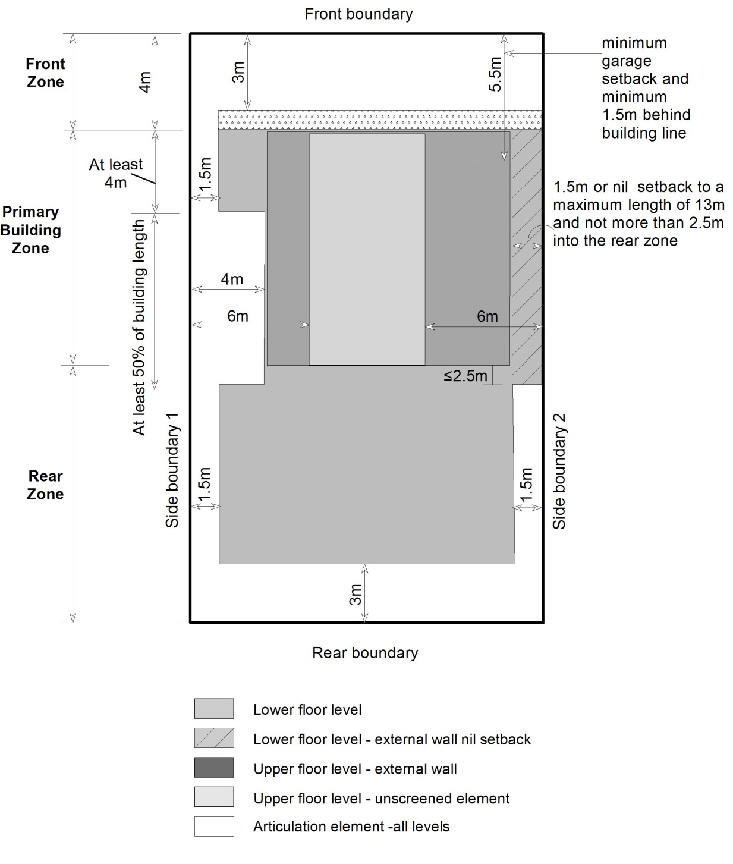

New provision

Replace Table 6C and Diagram 8 with:

Table 6C - Alternative Side Boundary Setbacks (blocks must be nominated in a precinct code) (Refer Figures )

 | South^ Facing Boundary | North^^ Facing Boundary | East/ West^^^ Facing Boundary 1 | East / West^^^ Facing Boundary 2*
Lower floor level in the PBZ | 1.5m  0m** | 1.5m  4.0m+ | 1.5m | 1.5m  0m**
Lower floor level in the RZ | 1.5m | 1.5m  4.0m+ | 1.5m | 1.5m
Upper floor level – external wall in PBZ | 1.5m | 1.5m  4.0m+ | 1.5m | 1.5m
Upper floor level – external wall in RZ | Not permitted | Not permitted | 3.0m | 3.0m
Upper floor level – unscreened element in the PBZ | 6.0m | 6.0m | 6.0m | 6.0m
Upper floor level – unscreened element in the RZ | Not permitted | Not permitted | 6.0m | 6.0m
^ South facing boundary means a boundary of a block where a line drawn perpendicular to the boundary outwards is orientated between south 30 degrees west and south 20 degrees east.
^^ North facing boundary means a boundary of a block where a line drawn perpendicular to the boundary outwards is orientated between north 20 degrees west and north 30 degrees east.
^^^ East/West boundary means a boundary of a block where a line drawn perpendicular to the boundary outwards is orientated either between east 20 degrees north and east 30 degrees south or between west 30 degrees north and west 20 degrees south.
* Boundary 2 may be stipulated in a precinct code.
** Provided the total length of the wall on the boundary does not exceed 13m (may extend up to 2.5m into the rear zone). Blank walls on boundaries may include walls to garages and non habitable rooms and cavity walls to habitable rooms.
+ The dwelling is required to be setback 4m from the north facing boundary for 50% or greater of the building length commencing from 4m or greater behind the front building line. The building length is measured 4m behind the front building line.

Diagram 8A: Mid-sized blocks approved on or after 2 October 2009 – alternate side and rear setbacks applicable only to nominated blocks in a precinct code (east and west facing side boundaries)

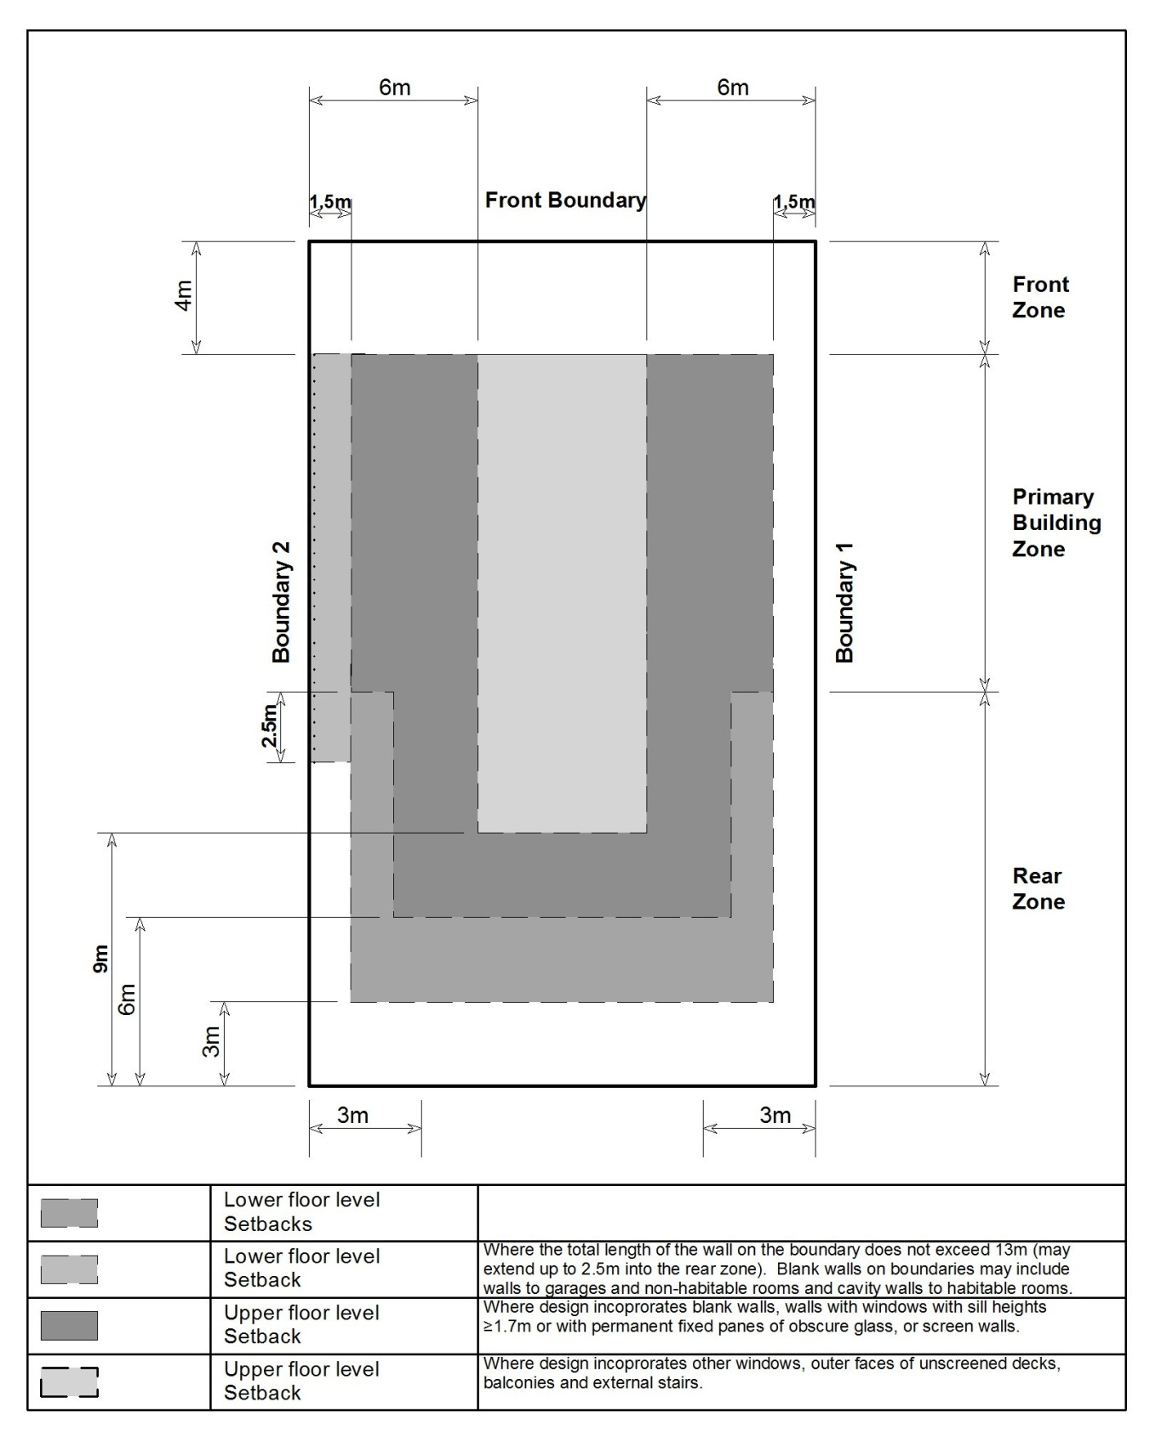

Diagram 8B: Mid-sized blocks approved on or after 2 October 2009 – alternate side and rear setbacks applicable only to nominated blocks in a precinct code (north facing and south facing side boundaries)

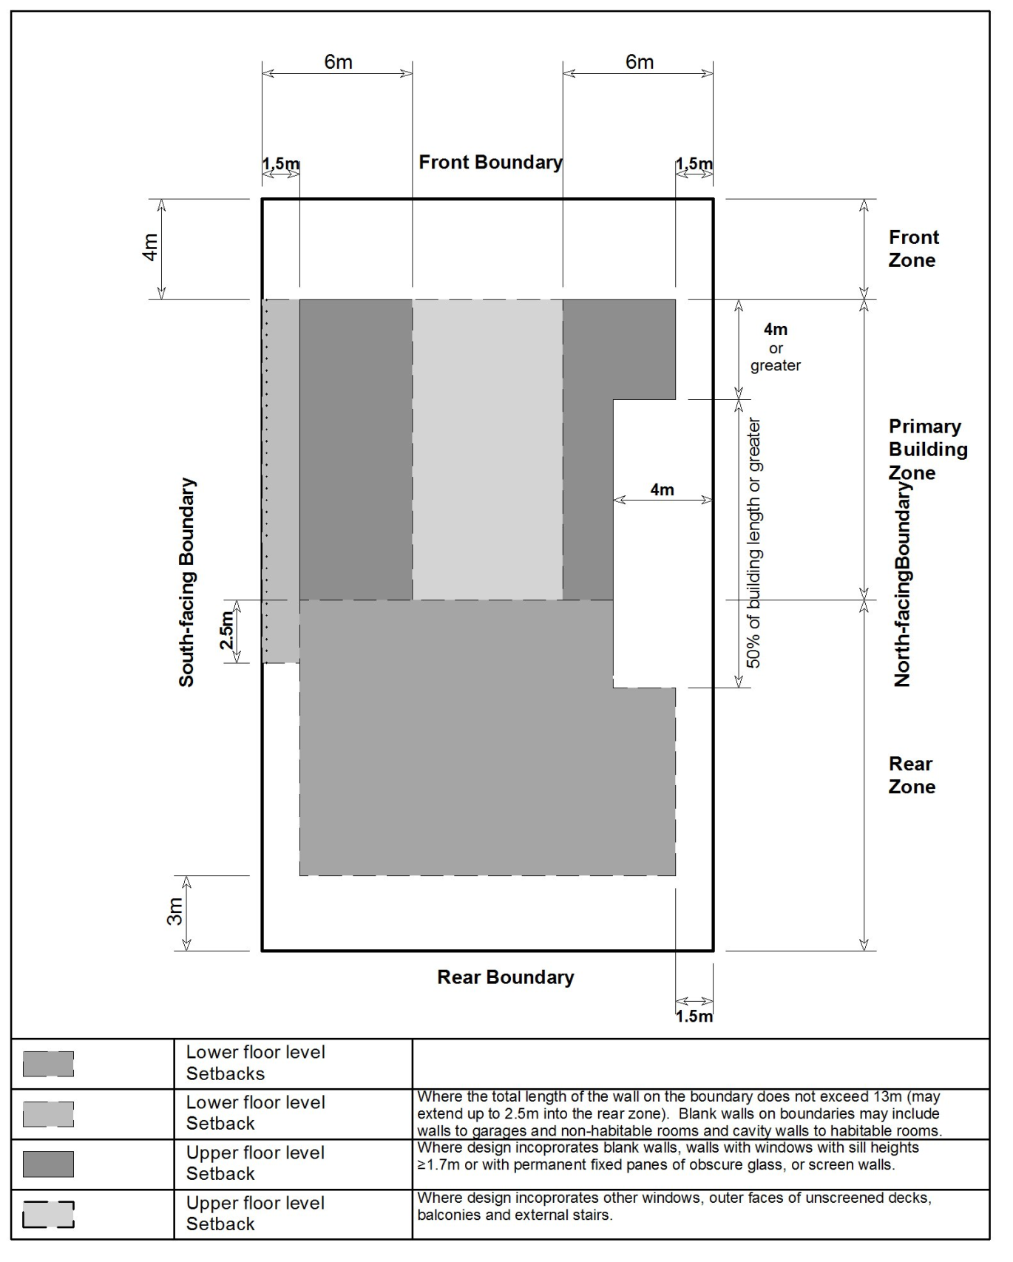

Compliance with the Planning and Development Act 2007
Section | Statement
s87(b) a variation (a code variation) that –  - would only change a code  - is consistent with the policy purpose and policy framework of the code; and  - is not an error variation. | Compliant. This proposed change will rectify an unintended change, without changing the substance of the code.

    - Walls on or near side and rear boundaries – mid sized blocks
Rule R15 does not allow any flexibility in situations such as angular encroachments or location of existing structures. Similar to R14 (pertaining to large blocks), a criterion has been added to the rule to allow walls between 180mm and 900mm from a boundary be considered if they allow adequate separation between dwellings and reasonable privacy for dwellings and principal private open space on adjoining residential blocks.

Current provision

1.13 Walls on or near side and rear boundaries – mid sized blocks
R15  This rule applies to mid sized blocks, but does not apply to that part of the building that is required to be built to a boundary of the block by a precinct code applying to an integrated housing development parcel of which the block is a part.  A wall with a setback of less than 900mm to a side or rear boundary complies with all of the following:  - not more than 13m in length  - extends no more than 2.5m into the rear zone | This is a mandatory requirement. There is no applicable criterion.

New provision (underlined)

1.13 Walls on or near side and rear boundaries – mid sized blocks
R15  This rule applies to mid sized blocks, but does not apply to that part of the building that is required to be built to a boundary of the block by a precinct code applying to an integrated housing development parcel of which the block is a part.  A wall with a setback of less than 900mm to a side or rear boundary complies with all of the following:  - not more than 13m in length  - extends no more than 2.5m into the rear zone | C15  Walls are sited to achieve all of the following:  - consistency with the desired character  - reasonable privacy for dwellings on adjoining residential blocks  - reasonable privacy for principal private open space on adjoining residential blocks.

Compliance with the Planning and Development Act 2007
Section | Statement
s87(b) a variation (a code variation) that –  - would only change a code  - is consistent with the policy purpose and policy framework of the code; and  - is not an error variation. | Compliant. Provides flexibility to an otherwise mandatory rule for similar instances as is the case on large blocks.

    - Principal private open space
Criterion C41 c) refers to service functions such as clothes drying and mechanical services. This has been replaced with ‘domestic storage’ in line with other similar criteria as ‘mechanical services’ is not considered to be a service function that would be accommodated within a principal private open space area for a single dwelling.
An additional paragraph e) has also been added to C41 to include reference to reasonable access to sunlight to enable year round use.

Existing provision
5.3 Principal private open space
R41  At least one area of principal private open space on the block complies with all of the following:  - minimum area and dimensions specified in table 8.  - at ground level  - directly accessible from, and adjacent to, a habitable room other than a bedroom  - screened from adjoining public streets and public open space  - located behind the building line, except where enclosed by a courtyard wall  - is not located to the south, south-east or south-west of the dwelling, unless it achieves not less than 3 hours of direct sunlight onto 50% of the minimum principal private open space area between the hours of 9am and 3pm on the winter solstice  (21 June). | C41  Principal private open space achieves all of the following:  - is proportionate to the size of the dwelling  - capable of enabling an extension of the function of the dwelling for relaxation, dining, entertainment, recreation, and it is directly accessible from the dwelling  - accommodates service functions such as clothes drying and mechanical services  - is screened from public streets and public open space with pedestrian or cycle paths

Amended provision (underlined)

5.3 Principal private open space
R41  At least one area of principal private open space on the block complies with all of the following:  - minimum area and dimensions specified in table 8.  - at ground level  - directly accessible from, and adjacent to, a habitable room other than a bedroom  - screened from adjoining public streets and public open space  - located behind the building line, except where enclosed by a courtyard wall  - is not located to the south, south-east or south-west of the dwelling, unless it achieves not less than 3 hours of direct sunlight onto 50% of the minimum principal private open space area between the hours of 9am and 3pm on the winter solstice  (21 June). | C41  Principal private open space achieves all of the following:  - is proportionate to the size of the dwelling  - capable of enabling an extension of the function of the dwelling for relaxation, dining, entertainment, recreation, and it is directly accessible from the dwelling  - accommodates service functions such as clothes drying and domestic storage  - is screened from public streets and public open space with pedestrian or cycle paths  - reasonable access to sunlight to enable year round use

Compliance with the Planning and Development Act 2007
Section | Statement
s87(b) a variation (a code variation) that –  - would only change a code  - is consistent with the policy purpose and policy framework of the code; and  - is not an error variation. | Compliant. The changes are consistent with the policy purpose of this provision for ensuring the amenity of the principal private open space of a single dwelling is retained

    - Water sensitive urban design
Rule R43 has been amended to reflect previous wording regarding extensions and redevelopment and that it applies to secondary residences.

Existing provision

6.1 Water sensitive urban design
R43  This rule applies to all new single dwellings, except minor extensions.  The development complies with one of the following:  - Option A  - Option B  For this rule  Option A is:  - on compact blocks -  - no minimum water storage requirement  - minimum WELS rated plumbing fixtures  - on mid-sized blocks -  - minimum on site water storage of water from roof harvesting is 2,000 litres  - 50% or 75m² of roof plan area, whichever is the lesser, is connected to the tank and the tank is connected to at least a toilet, laundry cold water and all external taps  - on large blocks up to 800m² -  - minimum on site water storage of water from roof harvesting is 4,000 litres  - 50% or 100m² of roof plan area, whichever is the lesser, is connected to the tank and the tank is connected to at least a toilet, laundry cold water and all external taps  - on large blocks 800m² or greater -  - minimum on site water storage of water from roof harvesting is 5,000 litres  - 50% or 125m² of roof plan area, whichever is the lesser, is connected to the tank and the tank is connected to at least a toilet, laundry cold water and all external taps.  Option B is:  A greywater system captures all bathroom and laundry greywater and treats it to Class A standard. The treated greywater is connected to all laundry cold water, toilet flushing and all external taps.  For this rule minor extension means an extension where the increase in the combined roof plan area, driveway, car manoeuvring areas and car parking areas is less than 25% of the total of the areas of these components at the date of lodgement of the development application or building application, whichever is earlier. | C43  Evidence is provided that the development achieves a minimum 40% reduction in mains water consumption compared to an equivalent development constructed in 2003, using the ACTPLA on-line assessment tool or another tool. The 40% target is met without any reliance on landscaping measures to reduce consumption.

Amended provision (underlined)

6.1 Water sensitive urban design
R43  This rule applies to:  - all new single dwellings,  - secondary residences, and  - extensions and alterations (but does not apply to minor extensions).  The development complies with one of the following:  - Option A  - Option B  For this rule  Option A is:  - on compact blocks -  - no minimum water storage requirement  - minimum WELS rated plumbing fixtures  - on mid-sized blocks -  - minimum on site water storage of water from roof harvesting is 2,000 litres  - 50% or 75m² of roof plan area, whichever is the lesser, is connected to the tank and the tank is connected to at least a toilet, laundry cold water and all external taps  - on large blocks up to 800m² -  - minimum on site water storage of water from roof harvesting is 4,000 litres  - 50% or 100m² of roof plan area, whichever is the lesser, is connected to the tank and the tank is connected to at least a toilet, laundry cold water and all external taps  - on large blocks 800m² or greater -  - minimum on site water storage of water from roof harvesting is 5,000 litres  - 50% or 125m² of roof plan area, whichever is the lesser, is connected to the tank and the tank is connected to at least a toilet, laundry cold water and all external taps.  Option B is:  A greywater system captures all bathroom and laundry greywater and treats it to Class A standard. The treated greywater is connected to all laundry cold water, toilet flushing and all external taps.  For this rule minor extension means an extension where the increase in the combined roof plan area, driveway, car manoeuvring areas and car parking areas is less than 25% of the total of the areas of these components at the date of lodgement of the development application or building application, whichever is earlier. | C43  Evidence is provided that the development achieves a minimum 40% reduction in mains water consumption compared to an equivalent development constructed in 2003, using the ACTPLA on-line assessment tool or another tool. The 40% target is met without any reliance on landscaping measures to reduce consumption.

Compliance with the Planning and Development Act 2007
Section | Statement
s87(b) a variation (a code variation) that –  - would only change a code  - is consistent with the policy purpose and policy framework of the code; and  - is not an error variation. | Compliant. The rule now includes reference to secondary dwellings that were introduced in Variation 306, and also includes extensions and renovations other than minor work.

  - Multi unit housing development code

    - Dwelling replacement – single dwelling blocks

Rule R5 was introduced in Variation 306 in response to concerns in the community regarding redevelopment areas that were losing dwellings that were suitable for larger households. For example, three bedroom single dwellings were being replaced with multi unit developments that only contained predominantly one bedroom units. However it has become evident that, especially in the older suburbs, there are a number of cases of existing two bedroom houses that are being removed as part of a multi unit redevelopment. It is reasonable in such cases that the redevelopment proposal is only required to provide ‘replacement’ dwellings of the same number of bedrooms as what the existing single dwelling contains, prior to redevelopment.

Existing provision

3.1 Dwelling replacement – single dwelling blocks
R5  This rule applies to single dwelling blocks in all residential zones that are proposed to be redeveloped for multi unit housing, but does not apply to supportive housing.  The number of dwellings with three or more bedrooms is not fewer than:  - where there has been no consolidation of blocks – 1  - in all other cases – a number equal to the total number of blocks originally leased or used for the purpose of single dwelling housing that have been consolidated or proposed to be consolidated. | This is a mandatory requirement. There is no applicable criterion.

Amended provision (underlined and struck through)

3.1 Dwelling replacement – single dwelling blocks
R5  This rule applies to single dwelling blocks in all residential zones that are proposed to be redeveloped for multi unit housing, but does not apply to supportive housing.  The number of dwellings with three or more bedrooms is not fewer than:  - where there has been no consolidation of blocks – 1 replacement dwelling  - in all other cases – a number equal to the total number of blocks originally leased or used for the purpose of single dwelling housing that have been consolidated or proposed to be consolidated.  For this rule the following number of bedrooms per replacement dwelling are provided:  - where the original dwelling is one or two bedrooms -2  - where the original dwelling is three or more bedrooms – 3 or more | This is a mandatory requirement. There is no applicable criterion.

Section | Statement
s87(b) a variation (a code variation) that –  - would only change a code  - is consistent with the policy purpose and policy framework of the code; and  - is not an error variation. | Compliant. The provision now provides more clarity in circumstances where the existing dwelling being replaced contains less than three bedrooms.

    - Solar envelope and apparent sun angles

The range of aspect angles in the apparent sun angle table contains gaps with no solar envelope to cover aspects of a block between 9-10º east and west of north, 19-20º east and west of north, and 29-30º east of north. To rectify this issue the table has been amended to include all angles as shown in amended Table A4B below:

As part of this technical amendment, Table A4B has also been renamed Table A4 due to Table A4A being removed as part of TA2013-10.

Existing provision

Table A4B – Apparent sun angle at noon on the winter solstice

Aspect of northern boundary  (bearing of line drawn perpendicular to the boundary) | Angle  (X)
North 0-9º East  North 0-9º West | 31 º
North 10-19º East  North 10-19º West | 32 º
North 20-29º East  North 20-29º West | 34 º
North 30-39º East  North 30-39º West | 36º
North 40-45º East  North 40-45º West | 39 º

Amended provision (underlined and struck-out)

Table A4B – Apparent sun angle at noon on the winter solstice

Aspect of northern boundary  (bearing of line drawn perpendicular to the boundary) | Angle  (X)
North 0-9° to <10° East  North 0-9° to <10° West | 31°
North 10-19° to <20° East  North 10-19° to <20° West | 32°
North 20-29° to <30° East  North 20-29° to <30° West | 34°
North 30-39° to <40° East  North 30-39° to <40° West | 36°
North 40 to 45° East  North 40 to 45° West | 39°

Section | Statement
s87(b) a variation (a code variation) that –  - would only change a code  - is consistent with the policy purpose and policy framework of the code; and  - is not an error variation. | Compliant. The table reflects the changes to revert back to the previous definition of north facing boundary.

- TECHNICAL AMENDMENT
  - Residential Zones Development Code

- Part B – Other forms of residential development, Element 4: Secondary residences; section 4.1 Design and siting

Substitute
Rules | Criteria
4.1 Design and siting
R7  The maximum dwelling size* of a secondary residence is 90m².  *For the purpose of this rule, dwelling size is the floor area measured to the outside face of external walls (including internal walls between the living areas and garage) but excludes the garage. | This is a mandatory requirement. There is no applicable criterion.

- Part B – Other forms of residential development, Element 4: Secondary residences; section 4.1 Design and siting

Substitute
4.1 Design and siting
R11  For blocks containing a secondary residence:  - Secondary residences comply with Element 1 and Element 6 of the Single Dwelling Housing Development Code  - The main residence continues to comply with the provisions of the Single Dwelling Housing Development Code. | This is a mandatory requirement, there is no applicable criterion.

- Part B – Other forms of residential development, Element 4: Secondary residences; section 4.1 Design and siting

Add
4.1 Design and siting
R11A  The total private open space on the block complies with the private open space for single dwelling housing as prescribed in Element 5 of the Single Dwelling Housing Development Code | This is a mandatory requirement, there is no applicable criterion.

- Part C – Demolition; Element 8: Demolition; section 8.1 Statement of Endorsement

Substitute
8.1 Statement of endorsement
R33  A statement of endorsement for utilities (including water, sewerage, stormwater, electricity and gas) in accordance with section 148 of the Planning and Development Act 2007 is provided confirming all of the following:  - all network infrastructure on or immediately adjacent the site has been identified on the plan  - all potentially hazardous substances and conditions (associated with or resulting from the demolition process) that may constitute a risk to utility services have been identified  - all required network disconnections have been identified and the disconnection works comply with utility requirements  - all works associated with the demolition comply with and are in accordance with utility asset access and protection requirements. | This is a mandatory requirement, there is no applicable criterion.

- Part D – Subdivision and consolidation; Element 9: Subdivision and consolidation; section 9.5 Subdivision under the Unit Titles Act; R39

Omit rule R39

- Part G – General Controls; Element 14: Environment; section 14.1 Water sensitive urban design

Substitute
14.1 Water sensitive urban design
R57  This rule applies to all multi-unit residential development except for minor extensions and secondary residences.  The development achieves a minimum 40% reduction in mains water consumption compared to an equivalent development constructed in 2003, without any reliance on landscaping measures.  Compliance with this rule is demonstrated by a report by a suitably qualified person using the ACTPLA on-line assessment tool or another tool referred to in the Water Ways: Water Sensitive Urban Design General Code.  For this element:  minor extension means an extension where the increase in the combined roof plan area, driveway, car manoeuvring areas and car parking areas is less than 25% of the total of the areas of these components at the date of lodgement of the development application. | This is a mandatory requirement, there is no applicable criterion.

  - Single dwelling housing development code

- Element 1: Building and site controls; sections 1.5 to 1.7; rules/criteria R6/C6 to R9/C9

Substitute

1.5 Building envelope - all large blocks, mid sized blocks approved after 5 July 2013 and integrated housing development parcels
R6  This rule applies to all of the following:  - large blocks  - mid sized blocks approved under an estate development plan after 5 July 2013  - integrated housing development parcels  but does not apply to that part of the building on a single dwelling block that is required to be built to a boundary of the block by a precinct code applying to an integrated housing development parcel of which the block is a part.  Buildings are sited wholly within the building envelope formed by projecting planes over the subject block comprising lines projected at 45º to the horizontal from an infinite number of points on a line of infinite length 3.5m above each side and rear boundary, except as required by the next rule.  Refer to figure 1. | C6  Buildings achieve all of the following:  - consistency with the desired character  - reasonable levels of privacy for dwellings on adjoining residential blocks and their associated private open space.

1.6 Sun angle building envelope - all large blocks, mid sized blocks approved after 5 July 2013, compact blocks approved after 5 July 2013 and integrated housing development parcels
R7  This rule applies to all of the following:  - large blocks  - mid sized blocks approved under an estate development plan after 5 July 2013  - compact blocks approved under an estate development plan after 5 July 2013  - integrated housing development parcels  but does not apply to that part of the building on a single dwelling block that is required to be built to a boundary of the block by a precinct code applying to an integrated housing development parcel of which the block is a part.  Buildings are sited wholly within the building envelope formed by planes projected over the subject block at Xº to the horizontal from the height of the solar fence on any north facing boundary of an adjoining residential block.  The height of the solar fence is:  - in the primary building zone – 2.4m  - all other parts of the boundary – 1.8m  This rule does not apply to any part of a north facing boundary to an adjoining residential block that is used primarily to provide access to the main part of the residential block (ie a “battleaxe” handle). The previous rule applies to this boundary.  Xº is the apparent sun angle at noon on the winter solstice. For the purposes of this rule values for X are given in table 1.  Refer to figure 1. | C7  Buildings achieve all of the following:  - consistency with the desired character  - reasonable solar access to dwellings on adjoining residential blocks and their associated private open space  - do not shadow the windows of habitable rooms (other than bedrooms) of any approved and constructed dwelling on an adjoining residential block at noon on the winter solstice  - do not overshadow the principal private open space of any approved and constructed dwelling on an adjoining residential block to a greater extent than a 2.4m fence on the boundary at noon on the winter solstice.
1.7 Building envelope – mid sized blocks approved before 5 July 2013
R8  This rule applies to mid sized blocks with one of the following characteristics:  - approved under an estate development plan before 5 July 2013  - for which a lease was granted before 5 July 2013  Buildings are sited wholly within the building envelope formed by projecting planes over the subject block comprising:  - within the primary building zone -  - lines projected at 45º to the horizontal from an infinite number of points on a line of infinite length 4.5m above each side boundary, except for north facing boundaries of adjoining residential blocks  - from north facing boundaries of adjoining residential blocks, lines projected at 45º to the horizontal from an infinite number of points on a line of infinite length 2m above these boundaries.  - despite item ii), where a wall is located on a north facing boundary of an adjoining residential block, lines projected at 30º to the horizontal from an infinite number of points on a line of infinite length 3m above these boundaries.  - within the rear zone -  - lines projected at 30º to the horizontal from an infinite number of points on a line of infinite length 3.5m above each side and rear boundary, except for north facing boundaries of adjoining residential blocks  - from north facing boundaries of adjoining residential blocks, lines projected at 30º to the horizontal from an infinite number of points on a line of infinite length 2m above these boundaries.  Refer Figure 2. | C8  Buildings achieve all of the following:  - consistency with the desired character  - reasonable levels of privacy for dwellings and their associated private open space on adjoining residential blocks  reasonable solar access to dwellings and their associated private open space on adjoining residential blocks.
R9  This rule applies to mid-sized blocks and compact blocks with one of the following characteristics:  - approved under an estate development plan before 5 July 2013  - for which a lease was granted before 5 July 2013  Where a garage wall is located on, or setback from, the northern boundary of an adjoining residential block, a 1m encroachment of the wall is permitted vertically beyond the building envelope, provided the wall and roof element associated with the wall do not encroach beyond a plane comprising lines projected at 30º to the horizontal from an infinite number of points on a line of infinite length 3m above the respective boundary.  Refer Figure 2. | C9  Buildings achieve all of the following:  - consistency with the desired character  - reasonable levels of privacy for dwellings and their associated private open space on adjoining residential blocks  - reasonable solar access to dwellings and their associated private open space on adjoining residential blocks.

- Element 1: Building and site controls, Table 1B

Substitute
Table 1B – Apparent sun angle (X) at noon on the winter solstice (21 June)

Aspect of northern boundary  (bearing of line drawn perpendicular to the boundary) | Angle  (X)
North 0° to <10° East  North 0° to <10° West | 31°
North 10° to <20° East  North 10° to <20° West | 32°
North 20° to <30° East  North 20° to <30° West | 34°
North 30° to <40° East  North 30° to <40° West | 36°
North 40 to 45° East  North 40 to 45° West | 39°

- Element 1: Building and site controls, Table 3C

Insert underlined text
Table 3C: Front boundary setbacks – mid sized blocks in subdivisions approved on or after 31 March 2008 (refer appendix 1 diagrams 6, 7 and 8)
 | minimum setback to front boundary | exceptions
 |  | minimum setback to secondary street frontage | minimum setback to open space or pedestrian paths wider than 6m | minimum setback to rear lane or pedestrian paths less than 6m wide
all floor levels | 4m | 3m | 3m | nil
articulation elements* – all floor levels | 3m | not applicable | not applicable | not applicable
garage | 5.5m  Minimum of 1.5m behind the front building line except where there is a courtyard wall in the front zone |  | 3m | nil
*Articulation elements can include verandahs, porches, awnings, shade devices, pergolas and the like (a carport is not considered an articulation element)

- Element 1: Building and site controls, Table 6C

Substitute
Table 6C - Alternative Side Boundary Setbacks (blocks must be nominated in a precinct code) (Refer appendix 1 diagrams 8A and 8B)

 | South^ Facing Boundary | North^^ Facing Boundary | East/ West^^^ Facing Boundary 1 | East / West^^^ Facing Boundary 2*
Lower floor level in the PBZ | 1.5m  0m** | 1.5m  4.0m+ | 1.5m | 1.5m  0m**
Lower floor level in the RZ | 1.5m | 1.5m  4.0m+ | 1.5m | 1.5m
Upper floor level – external wall in PBZ | 1.5m | 1.5m  4.0m+ | 1.5m | 1.5m
Upper floor level – external wall in RZ | Not permitted | Not permitted | 3.0m | 3.0m
Upper floor level – unscreened element in the PBZ | 6.0m | 6.0m | 6.0m | 6.0m
Upper floor level – unscreened element in the RZ | Not permitted | Not permitted | 6.0m | 6.0m
^ South facing boundary means a boundary of a block where a line drawn perpendicular to the boundary outwards is orientated between south 30 degrees west and south 20 degrees east.
^^ North facing boundary means a boundary of a block where a line drawn perpendicular to the boundary outwards is orientated between north 20 degrees west and north 30 degrees east.
^^^ East/West boundary means a boundary of a block where a line drawn perpendicular to the boundary outwards is orientated either between east 20 degrees north and east 30 degrees south or between west 30 degrees north and west 20 degrees south.
* Boundary 2 may be stipulated in a precinct code.
** Provided the total length of the wall on the boundary does not exceed 13m (may extend up to 2.5m into the rear zone). Blank walls on boundaries may include walls to garages and non habitable rooms and cavity walls to habitable rooms.
+ The dwelling is required to be setback 4m from the north facing boundary for 50% or greater of the building length commencing from 4m or greater behind the front building line. The building length is measured 4m behind the front building line.

- Element 1: Building and site controls

Substitute
1.13 Walls on or near side and rear boundaries – mid sized blocks
R15  This rule applies to mid sized blocks, but does not apply to that part of the building that is required to be built to a boundary of the block by a precinct code applying to an integrated housing development parcel of which the block is a part.  A wall with a setback of less than 900mm to a side or rear boundary complies with all of the following:  - not more than 13m in length  - extends no more than 2.5m into the rear zone | C15  Walls are sited to achieve all of the following:  - consistency with the desired character  - reasonable privacy for dwellings on adjoining residential blocks  - reasonable privacy for principal private open space on adjoining residential blocks.

- Element 5: Amenity; Section 5.3 Principal private open space

Substitute
5.3 Principal private open space
R41  At least one area of principal private open space on the block complies with all of the following:  - minimum area and dimensions specified in table 8.  - at ground level  - directly accessible from, and adjacent to, a habitable room other than a bedroom  - screened from adjoining public streets and public open space  - located behind the building line, except where enclosed by a courtyard wall  - is not located to the south, south-east or south-west of the dwelling, unless it achieves not less than 3 hours of direct sunlight onto 50% of the minimum principal private open space area between the hours of 9am and 3pm on the winter solstice  (21 June). | C41  Principal private open space achieves all of the following:  - is proportionate to the size of the dwelling  - capable of enabling an extension of the function of the dwelling for relaxation, dining, entertainment, recreation, and it is directly accessible from the dwelling  - accommodates service functions such as clothes drying and domestic storage  - is screened from public streets and public open space with pedestrian or cycle paths  - reasonable access to sunlight to enable year round use

- Element 6: Environment; Section 6.1 Water sensitive urban design

Substitute
6.1 Water sensitive urban design
R43  This rule applies to  - all new single dwellings,  - secondary residences, and  - extensions and alterations (but does not apply to minor extensions).  The development complies with one of the following:  - Option A  - Option B  For this rule  Option A is:  - on compact blocks -  - no minimum water storage requirement  - minimum WELS rated plumbing fixtures  - on mid-sized blocks -  - minimum on site water storage of water from roof harvesting is 2,000 litres  - 50% or 75m² of roof plan area, whichever is the lesser, is connected to the tank and the tank is connected to at least a toilet, laundry cold water and all external taps  - on large blocks up to 800m² -  - minimum on site water storage of water from roof harvesting is 4,000 litres  - 50% or 100m² of roof plan area, whichever is the lesser, is connected to the tank and the tank is connected to at least a toilet, laundry cold water and all external taps  - on large blocks 800m² or greater -  - minimum on site water storage of water from roof harvesting is 5,000 litres  - 50% or 125m² of roof plan area, whichever is the lesser, is connected to the tank and the tank is connected to at least a toilet, laundry cold water and all external taps.  Option B is:  A greywater system captures all bathroom and laundry greywater and treats it to Class A standard. The treated greywater is connected to all laundry cold water, toilet flushing and all external taps.  For this rule minor extension means an extension where the increase in the combined roof plan area, driveway, car manoeuvring areas and car parking areas is less than 25% of the total of the areas of these components at the date of lodgement of the development application or building application, whichever is earlier. | C43  Evidence is provided that the development achieves a minimum 40% reduction in mains water consumption compared to an equivalent development constructed in 2003, using the ACTPLA on-line assessment tool or another tool. The 40% target is met without any reliance on landscaping measures to reduce consumption.

- Appendix 1

Substitute

Diagram 8A: Mid-sized blocks approved on or after 2 October 2009 – alternate side and rear setbacks applicable only to nominated blocks in a precinct code (east and west facing side boundaries)

Diagram 8B: Mid-sized blocks approved on or after 2 October 2009 – alternate side and rear setbacks applicable only to nominated blocks in a precinct code (north facing and south facing side boundaries)

  - Multi unit housing development code

- Part A – General controls; Element 3: Building and site controls; section 3.1 Dwelling replacement – single dwelling blocks

Substitute
3.1 Dwelling replacement – single dwelling blocks
R5  This rule applies to single dwelling blocks in all residential zones that are proposed to be redeveloped for multi unit housing, but does not apply to supportive housing.  - where there has been no consolidation of blocks – 1 replacement dwelling  - in all other cases – a number equal to the total number of blocks originally leased or used for the purpose of single dwelling housing that have been consolidated or proposed to be consolidated.  For this rule the following number of bedrooms per replacement dwelling are provided:  - where the original dwelling is one or two bedrooms - 2  - where the original dwelling is three or more bedrooms – 3 or more | This is a mandatory requirement. There is no applicable criterion.

- Part A – General controls; Element 3: Building and site controls; Table A4B

Substitute
Table A4 – Apparent sun angle at noon on the winter solstice

Aspect of northern boundary  (bearing of line drawn perpendicular to the boundary) | Angle  (X)
North 0° to <10° East  North 0° to <10° West | 31°
North 10° to <20° East  North 10° to <20° West | 32°
North 20° to <30° East  North 20° to <30° West | 34°
North 30° to <40° East  North 30° to <40° West | 36°
North 40 to 45° East  North 40 to 45° West | 39°

Interpretation service
