Australian Capital Territory
Planning and Development (Draft Variation No 321) Consultation Notice 2014
Notifiable instrument NI2014—179
made under the
Planning and Development Act 2007, section 63 (Public consultation—notification) and section 64 (Public consultation—notice of interim effect etc)

Under the Planning and Development Act 2007 (the Act), section 63(1), the planning and land authority has prepared Draft Variation No 321 to the Territory Plan – Pialligo Agricultural Area (see Annexure A).
Draft Variation No 321 to the Territory Plan proposes to incorporate the recommendations of the Pialligo master plan to retain and protect the agricultural use of the land while encouraging low scale agricultural related or ancillary commercial uses along Beltana Road, and providing the opportunity for an emergency services facility to be located at the corner of Pialligo Avenue and Beltana Road.
The draft variation and background document, being the Pialligo master plan, are available online at www.act.gov.au/draftvariations until the closing date for written comments. Background documents are available at www.act.gov.au/pialligo.

Printed copies of the draft variation and background document are available for inspection and purchase at the Environment and Sustainable Development Customer Service Centre, 16 Challis Street, Dickson, Monday to Friday (except public holidays) between 8:30am and 4:30pm. Please call 6207 1923 to arrange a copy for purchase.

Written comments from the public are invited by 13 June 2014.

Comments should include reference to the draft variation, your name and contact details, and be addressed to the Territory Plan Unit.

Comments can be:
- emailed to dv.comments@act.gov.au
- mailed to Territory Plan Comments, GPO Box 158, Canberra, ACT 2601
- delivered to ESDD’s Customer Service Centre at 16 Challis Street, Dickson

Copies of written comments will be made publicly available 10 working days after the closing date for no less than 15 working days at ESDD’s Customer Service Centre in Dickson and may be published on ESDD’s website.

Please note that comments made available will include personal contact details unless excluded under section 411 or 412 of the Act. A request for exclusion under these sections must be in writing, clearly identifying what you are seeking to exclude and how the request satisfies the exclusion criteria.

Effect of the draft variation

Section 65 of the Act applies to the draft variation. This means that, in addition to the Territory Plan, the provisions of Draft Variation No 321 apply to development applications lodged on or after 2 May 2014. The draft variation is part of the Territory Plan for a period of up to one year unless the draft variation is commenced, is withdrawn or rejected by the Legislative Assembly. During this period, the ACT Government must not do or approve anything that would be inconsistent with the Territory Plan.

Jim Corrigan
Delegate of the ACT planning and land authority
23 April 2014

Planning and Development Act 2007

Draft
Variation to the
Territory Plan
No 321

Pialligo Agricultural Area –
Amendments to the
Pialligo precinct map and code

May 2014

Draft variation for public consultation prepared
under s60 of the Planning and Development Act 2007

This page is intentionally blank.

Contents
1. INTRODUCTION 1
1.1 Summary of the Proposal 1
1.2 Outline of the process 1
1.3 This document 2
1.4 Public Consultation 2
2. EXPLANATORY STATEMENT 3
2.1 Background 3
2.2 Site Description 3
2.3 Current Territory Plan Provisions 4
2.4 Proposed Changes 5
2.4.1 Proposed Changes to the Territory Plan Map 5
2.4.2 Proposed Changes to Territory Plan 6
2.5 Reasons for the Proposed Draft Variation 6
2.6 Planning Context 7
2.6.1 National Capital Plan 7
2.6.2 Territory Plan 7
2.7 Interim Effect 8
2.8 Consultation with Government Agencies 8
3. DRAFT VARIATION 13
3.1 Variation to the Territory Plan 13

This page is intentionally blank.

- INTRODUCTION
  - Summary of the Proposal
The draft variation proposes to amend the Pialligo precinct map and code to guide future development within the Pialligo agricultural area.
The amendments to the Pialligo precinct map and code, drawing on the recommendations of the Pialligo master plan released in November 2013, will provide clear direction on the future desired character of the area while protecting the semi-rural character of the area, and ensuring the potential for agricultural uses are retained.
  - Outline of the process
The Commonwealth’s Australian Capital Territory (Planning and Land Management) Act 1988 allows for the Legislative Assembly to make laws to establish a Territory Planning Authority and for that Authority to prepare and administer a Territory Plan. The Planning and Development Act 2007 (the Act) establishes the planning and land authority as the Authority which prepares and administers the Territory Plan, including continually reviewing and proposing amendments as necessary. The functions of the planning and land authority are administered by the Environment and Sustainable Development Directorate (ESDD).
The Territory Plan is comprised of a written statement and a map. The written statement contains a number of parts, namely governance; strategic directions; zones (including objectives and development tables and zone or centre development codes); precinct codes; general codes; overlays; definitions; structure plans, concept plans and development codes for future urban areas.
The Territory Plan Map graphically represents the applicable land use zones (under the categories of residential, commercial, industrial, community facility, urban parks and recreation, transport and services and non urban), precincts and overlays. The zone, precinct and overlay requirements are detailed in the volumes of the Territory Plan.
Draft variations to the Territory Plan are prepared in accordance with the Act. Following the release of the draft variation under section 63 of the Act, submissions from the public are invited. At the conclusion of the consultation period the ESDD submits a report on consultation and a recommended final variation to the Minister responsible for planning for approval. The Minister has the discretion to determine if referral to the Legislative Assembly standing committee responsible for planning is warranted prior to approval, depending on the nature and significance of the proposal. If the draft variation is referred to the committee by the Minister or otherwise, the Minister must consider the findings of the committee before deciding whether to approve the draft variation.
If the Minister approves the variation, the variation and associated documents will be tabled in the Legislative Assembly. Unless disallowed by the Legislative Assembly within five sitting days, the variation commences on a day nominated by the Minister.
  - This document
This document contains the background information in relation to the proposed variation. It comprises the following parts
Part 1 This Introduction
Part 2 An Explanatory Statement, which gives reasons for the proposed variation and describes its effect
Part 3 The Draft Variation, which details the precise changes to the Territory Plan that are proposed
  - Public Consultation
Written comments about the draft variation are invited from the public by 13 June 2014.
Comments should include reference to the draft variation, your name and contact details, and be addressed to the Territory Plan Unit.
Comments can be:
emailed to dv.comments@act.gov.au
mailed to Territory Plan Comments, GPO Box 158, Canberra, ACT 2601
delivered to ESDD’s Customer Service Centre at 16 Challis Street, Dickson
Copies of written comments will be made available (unless excluded) for public inspection for no less than 15 working days starting 10 working days after the closing date for comment. The comments will be available at ESDD’s customer service centre in Dickson and may be published on ESDD’s website.
Comments made available will include personal contact details unless excluded under section 411 or 412 of the Planning and Development Act 2007. A request for exclusion under these sections must be in writing, clearly identifying what you are seeking to exclude and how the request satisfies the exclusion criteria.
Further Information
The draft variation and background documents are available online at www.act.gov.au/draftvariations until the closing date for written comments.
Printed copies of the draft variation (this document) and background documents are available for inspection and purchase at the Environment and Sustainable Development Customer Service Centre, 16 Challis Street, Dickson, Monday to Friday (except public holidays) between 8:30am and 4:30pm. Please call 6207 1923 to arrange a copy for purchase.

- EXPLANATORY STATEMENT
  - Background
Pialligo has a long history of human use, with numerous archaeological artefacts recording use of the area by Aboriginal people. During the development of Canberra, the Pialligo area was used as a food production area for the town, though over time agricultural use has declined. The area still contains orchards as well as production nurseries, however these uses are slowly disappearing, with pressure for additional commercial and residential uses to be permitted to retain the viability of the land. The pressure to diversify the permissible uses of the land risks impacting on the existing agricultural uses. These pressures will need to be managed appropriately with controls in place to ensure existing agricultural uses, and the potential for future agricultural uses, are not overly constrained by new development within the suburb.
The Pialligo master plan was developed by ESDD to assess the character of the existing area, consider the opportunities and constraints and develop a vision and principles for the suburb. It also provides recommendations to manage future development and infrastructure to achieve the goals of the master plan. DV321 Pialligo amends the Pialligo precinct map and code to incorporate a number of the recommendations of the Pialligo master plan.
  - Site Description
The subject area is a portion of the suburb of Pialligo, south of Pialligo Avenue and covering blocks adjoining Beltana Road and Kallaroo Road, excluding the portion of the suburb south of the Canberra airport.
The land adjoins Molonglo River to the west and south, with the Canberra airport on designated land to the north and west.
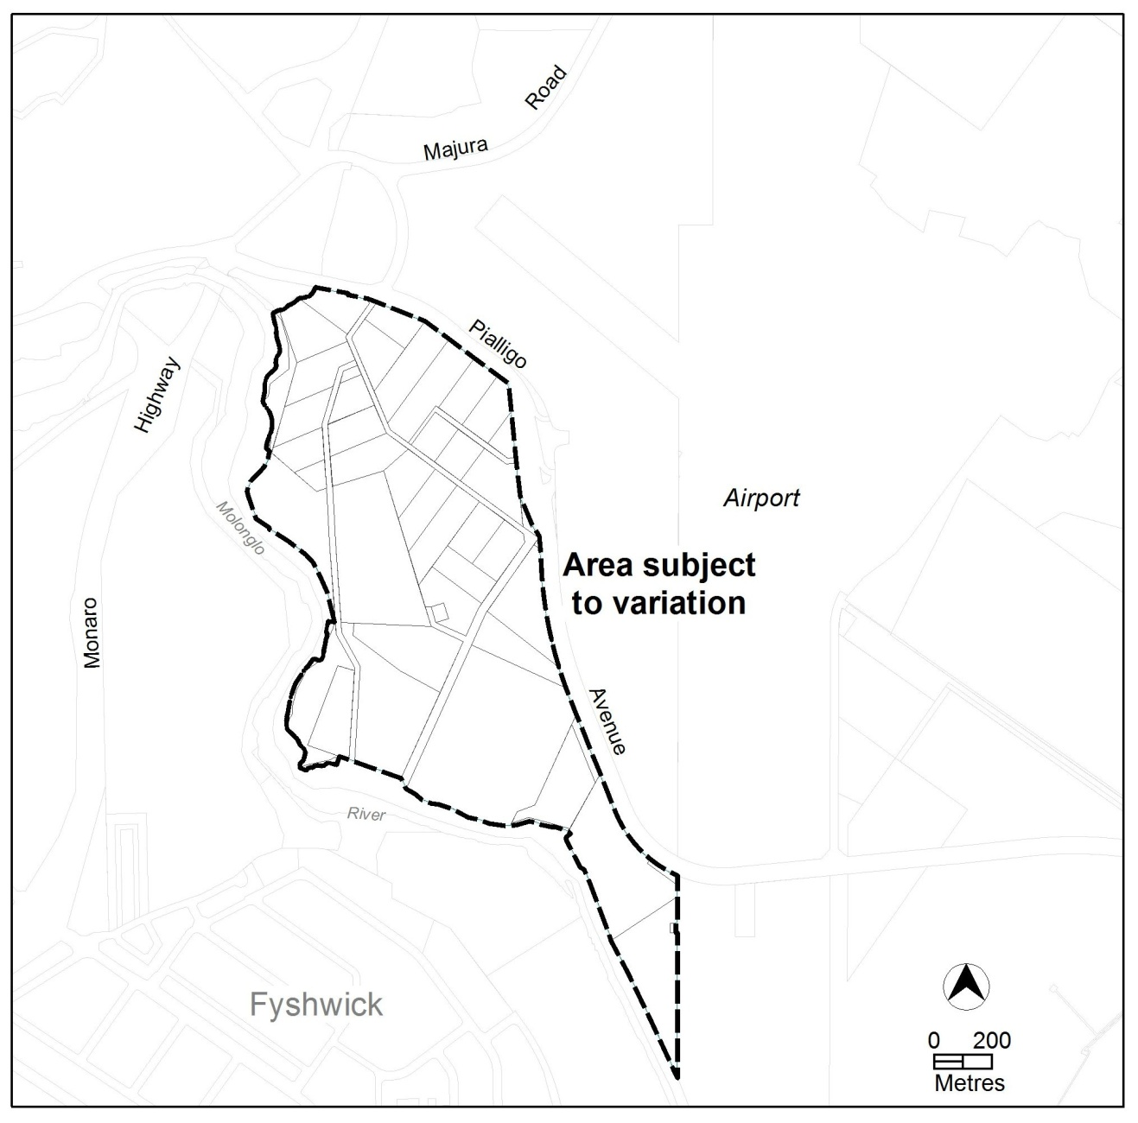
Figure 1 Area subject to variation
  - Current Territory Plan Provisions
The Territory Plan zones for the area subject to this variation are shown in Figure 2.
The area is predominately zoned NUZ1 – broadacre zone, with land adjacent to the Molonglo River zoned NUZ4 – river corridor. The Non-Urban Zones Development Code applies to development in both zones, with area specific provisions for each located in the Pialligo precinct map and code.

The NUZ1 zone is divided into Area A and Area B in the current Pialligo precinct map and code, with restrictions on uses in each.
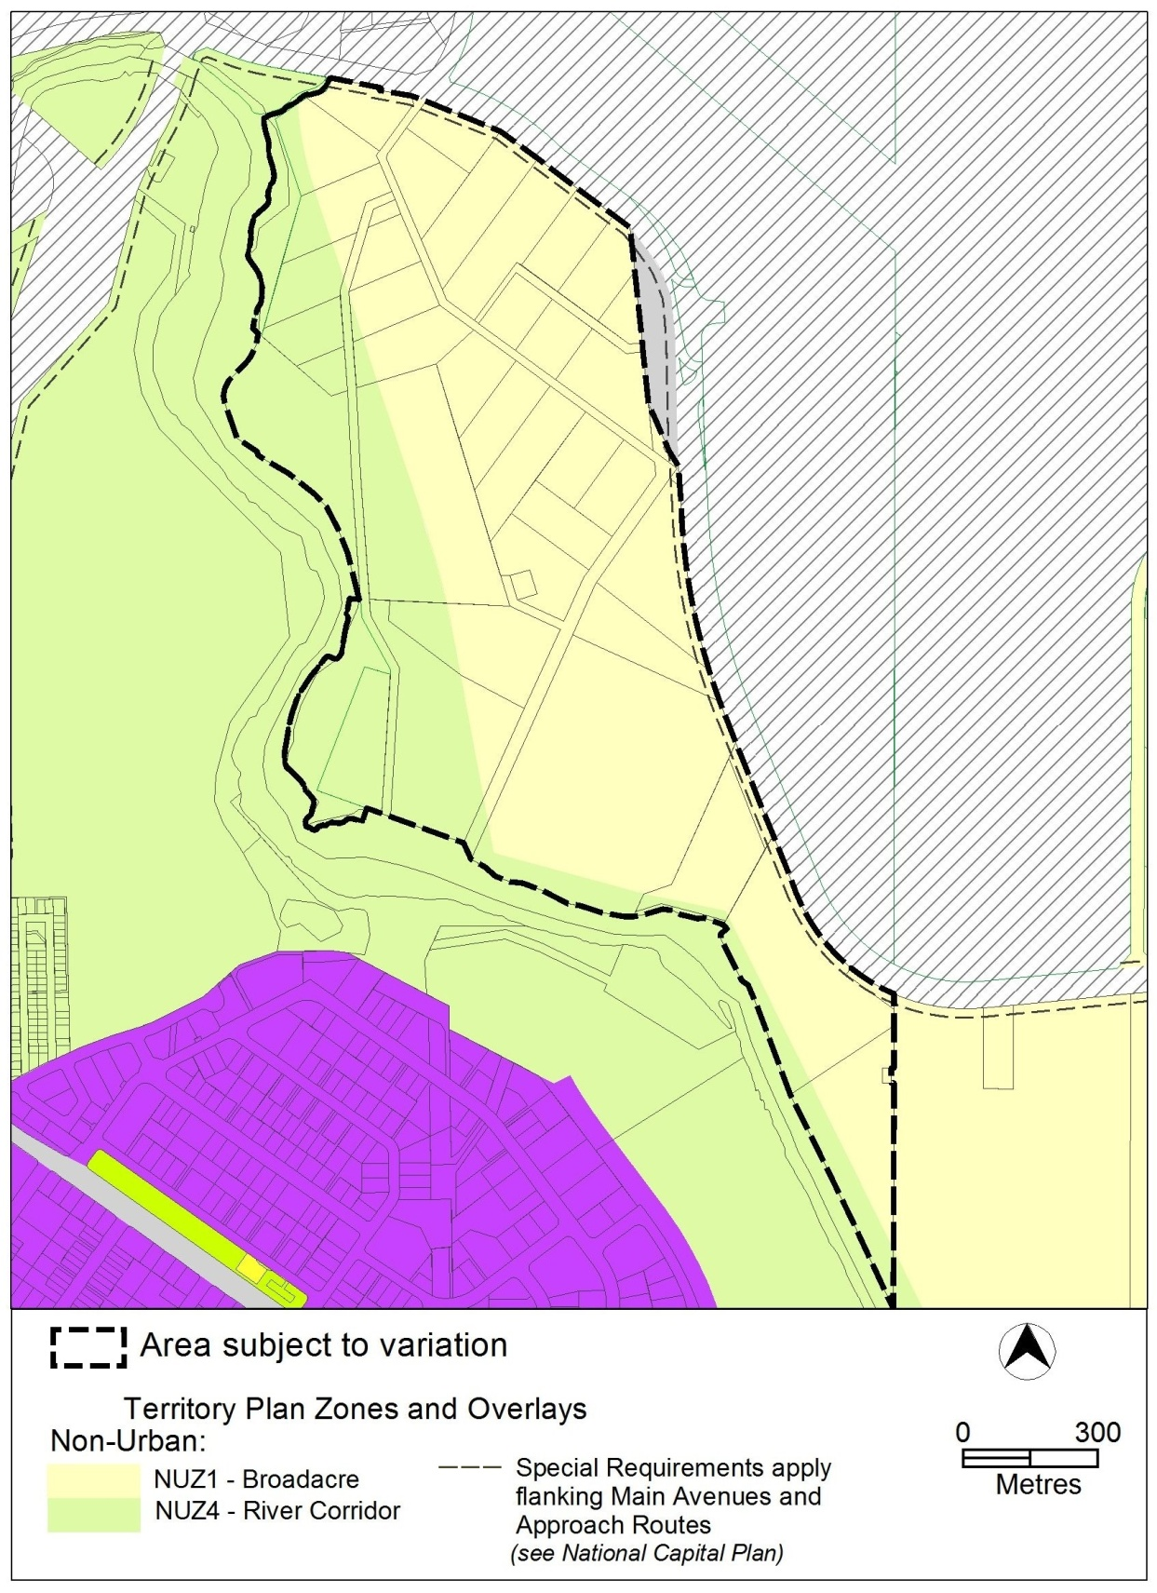
Figure 2 Territory Plan Zones Map
  - Proposed Changes
    - Proposed Changes to the Territory Plan Map
There are no changes proposed to the zones or zone boundaries as part of this variation.
    - Proposed Changes to Territory Plan
It is proposed to amend the Pialligo precinct map by:
- realigning the current areas ‘a’ and ‘b’, with the new area ‘A’ to be an area 60 metres on either side of Beltana Road, and area ‘B’ to be the remainder of the NUZ1 land outside of area ‘A’.
- extending the prohibited and permitted uses from the original area ‘A’ to apply to all of the NUZ1 land in the subject area.
It is proposed to amend the Pialligo precinct code to:
- nominate an area along Beltana Road providing additional flexibility in ancillary development
- introduce site coverage controls to provide a moderate level of development while protecting the agricultural nature of the area from overdevelopment
- permit emergency services facility on block 25 section 2 only, including setback controls and gross floor area restrictions
- control less compatible uses to ensure agricultural use remains the primary activity
- ensure existing agricultural uses are not overly constrained by new development on adjoining blocks
- include provisions to assist in the protection of unearthed archaeological artefacts if they are discovered in the course of undertaking an approved development
  - Reasons for the Proposed Draft Variation
The reasons for the proposed draft variation are as follows:
- to incorporate the requirements of the Pialligo master plan
- to focus development, particularly ancillary development along Beltana Road, while restricting ancillary development on land further away from public areas to retain and protect the agricultural potential of the land
- to protect the unique character, landscape and history of Pialligo
- to permit a moderately higher level of flexibility for lessees to develop their blocks to accommodate changing markets and community needs
- to permit the future development of an emergency services facility to service Pialligo and the surrounding area
- to limit uses not compatible with the existing or desired future character of the area, to sites where they are currently approved
  - Planning Context
    - National Capital Plan
The Australian Capital Territory (Planning and Land Management) Act 1988 established the National Capital Authority (NCA) with two of its functions being to prepare and administer a National Capital Plan (NCP) and to keep the NCP under constant review and to propose amendments to it when necessary.
The NCP, which was published in the Commonwealth Gazette on 21 January 1990 is required to ensure that Canberra and the Territory are planned and developed in accordance with their national significance. The Planning and Land Management Act 1988 also required that the Territory Plan is not inconsistent with the NCP.
    - Territory Plan
Statement of Strategic Directions
The proposal is consistent with the Territory Plan’s statement of strategic directions in terms of environmental, economic and social sustainability and spatial planning and urban design principles.
1.6 The pattern of development is to reflect land capability constraints resulting from topography, soils, geotechnical factors, drainage, natural hazards, micro-climate and the sensitivity of ecosystems. Particular attention will be given to the need to conserve soil, water and vegetation; maintain biological diversity; safeguard important ecosystems and ecological processes; and provide and protect wildlife corridors.
The draft variation is consistent with this requirement as it protects the valuable agricultural soils by constraining ancillary development, and encouraging buildings to be concentrated along the access road. This will reduce potential impacts to the agricultural land and the riparian corridor along Molonglo River.
1.9 Urban expansion will be contained in order to minimise impacts on valuable natural and rural areas
The proposal will manage development pressures on Pialligo by consolidating the majority of permissible development towards the already commercially focussed Beltana Road corridor, and restricting development further away, protecting the majority of the land from significant levels of development.
1.22 urban development will be planned in a manner that promotes community vitality and safety, applying principles of crime prevention through environmental design. Provision will also be made for emergency services infrastructure necessary to ensure a high standard of safety for residents and visitors.
The proposed precinct code proposes including emergency services facility as a permitted use in a specific location adjacent to a main arterial transport route. This will provide for the potential future location of such a facility within the Pialligo area that will service the greater area.
1.25 Heritage and cultural values will be safeguarded, including in particular those of the Territory’s Aboriginal peoples and those derived from both its rural history and urban development as the National Capital. The distinctive qualities of residential areas and other places, as well as elements of community heritage, will also be recognised and their conservation promoted.
This principle is met through the protection of the distinctive character of the land by constraining the level of development permitted, and encouraging development towards the access road while protecting the majority of the land. The heritage aspects of the area are protected through the operation of the Heritage Act.
2.16 Retention of Canberra’s unique landscape setting, including the integration of natural and cultural elements that create its ‘garden city’ and ‘bush capital’ qualities, will be accorded the highest priority. Special attention will be given to safeguarding visual amenity, protecting vegetation and other important features within the established urban landscape, and ensuring the high quality of environmental design in new developments or redevelopment.
DV321 complies with this principle through the protection of the natural features of the land and semi rural landscape character by introduction of new provisions into the precinct code to manage development, including building heights, to reduce potential impacts on the physical and visual character of the area.
  - Interim Effect
Section 65 of the Planning and Development Act 2007 applies to the draft variation. This means that, in addition to the Territory Plan, the provisions of Draft Variation No 321 apply to development applications lodged on or after 2 May 2014.
The effect of section 65 during the defined period means that the ACT Government must not do or approve anything that would be inconsistent with the Territory Plan. Put simply, the provisions of the draft variation are part of the Territory Plan for a period of up to one year from the date of this notice, unless the draft variation commences, is withdrawn or rejected by the ACT Legislative Assembly.
  - Consultation with Government Agencies
The ESDD is required to, in preparing a draft variation under section 61(b) consult with each of the following in relation to the proposed draft variation:
- the national capital authority
- the conservator of flora and fauna
- the environment protection authority
- the heritage council
- if the draft variation would, if made, be likely to affect unleased land or leased public land – each custodian for the land likely to be affected

National Capital Authority
The National Capital Authority provided the following comments on 12 December 2013:
“I advise that DV321 is not inconsistent with the National Capital Plan.”
Response
Noted.
Conservator of Flora and Fauna
The Conservator of Flora and Fauna made the following comments on
25 November 2013:
“I have reviewed the draft variation and the following comments are provided:
- C31 states that development applications are to be supported by Property Plans but it is unclear about the purpose of these plans, and how they differ from a Land Management Agreement, which is a statutory requirement under the Planning Act for any lease that contains a rural purpose. The requirement for the plans to identify how the high quality agricultural soils, vegetation and natural drainage areas and lines are to be managed and protected during construction will also confuse these plans with sediment and erosion control plans which are a statutory requirement under the Environment Protection Act 1997. If the purpose of the plans is to protect the high quality agricultural soils in the area for the long term, then the Criteria needs to be made a Rule, and needs to specify that a plan must be submitted identifying how the proposed development protects these values from the development.
- If it has been determined that Pialligo is to retain its rural character, then the Territory Plan needs to clearly articulate that the number of residences allowable on an individual block is necessary for the management of any of the allowable uses and that any additional development must be justified on management grounds e.g. for an intensive agricultural use, and that the size and design of any development (including residential) is in character of the area.”
Response
The property plan provision in the draft code has been amended to clarify the intended purpose of the plan and to assist in the assessment of development proposals against the requirement.
The provisions regulating the provision of residential development have also been amended to better reflect the intention that residential is only permitted where ancillary and designed to reflect this purpose.
Environment Protection Authority
The Environment Protection Authority provided the following comments on 18 December 2013:
“I have reviewed the document and do not support the variation is its current form. During work carried out for the development of the Master Plan, the issue of compatible land usage was discussed in relation to agricultural uses adjacent residential. Noise, odour and spray drift impacts have the potential to cause conflict between neighbouring properties where agricultural activities are undertaken in proximity to residential areas. The Pialligo Master Plan refers to this potential conflict including separation guidelines and vegetative buffers. This has not been reflected in the Precinct Code. The Precinct Code should be updated to include a specific reference to the EPA’s requirements relating to new dwellings and the requirement for assessment against potential impacts and compatibility concerns from neighbouring agricultural activities. Where vegetative buffers are required, updated Land Management Agreements must be provided indicating the type of vegetation to be incorporated, and the ongoing management required for the maintenance of the vegetation.
Furthermore, Noise Management Plan requirements listed under the Commercial Zones Development code will not apply to the Pialligo Precinct. Development Applications in Commercial Zones including noisy uses such as restaurants are required to include consideration for noise impacts by the inclusion of a Noise Management Plan. This is to ensure that noise impacts are considered at early planning stages. Element 6, Rule 6.1 of the Commercial Zones development code should be duplicated in the updated precinct code. This will ensure that Noise Management Plans are included as requirements for noisy uses, consistent with requirements in commercial zones.”
In response to amendments to DV321 incorporating the recommendations above, the EPA provided the following comments on 17 February 2014:
“Previous comments made by the EPA on the 18th of December 2013 requesting changes to the draft document have been satisfactorily addressed and as such the proposed variation is supported in its current form.”
Response
Noted.
Heritage Council
The Heritage Council provided the following comments on 6 December 2013:
“Development restriction measures in the proposed precinct code are sympathetic with the Aboriginal heritage values of Pialligo. However, as indicated in the Pialligo Master Plan (November 2013) an Anticipated and Unanticipated Discovery Protocol must be developed for inclusion into the final Precinct Code.”
Response
The draft precinct code has been amended to include maps identifying areas where development will require endorsement from the Heritage Council due to the likely presence of undiscovered archaeological artefacts.
Land Custodian – Territory and Municipal Services Directorate (TAMS)
The land custodian provided the following comments on 16 December 2013:
“TAMS supports the release of DV 321 for public consultation.

TAMS will appreciate the following comments being taken into consideration during the design phase.

Traffic conditions on Beltana road / Parking facility
The proposed new development should evaluate the traffic impact assessment and consider the current road configuration of the bend at the Western end of Beltana road. There should be a turn-around facility on the Beltana road which enables the vehicles to make a ‘U turn’ if required.

The week-day traffic exiting Beltana road from 8 am until 6 pm in November 2012 was 1176 vehicles, and on Saturday and Sunday during the same time period, 1702 and 1658 respectively. November 2013 traffic data for the week-day, Saturday and Sunday were 1193, 1532 and 1508, respectively. This indicates that there has been a marginal increase in traffic on weekdays during the course of 2013 due to the increase in commercial activities.

Pialligo Master Plan indicates that there is no line marking for the on-street parking on the Beltana road. Any new development would need to consider the impact on parking and provide required improvements.

Pedestrian / Cycling Access
Presently there is no cycling and walking access on the Beltana road. With the proposed new development access should be made available for pedestrian and cycling facilities which will connect Pialligo Avenue, Morshead Drive, and Monaro Highway.

Easement over Pialligo Brook / service infrastructure (pipes and cables) easement
The Pialligo Brook is characterised by many trees. The existing earthen channel requires continuous cleaning to avoid back water adjacent leases and the airport culverts. Lease holders should maintain the Pialligo brook to ensure that the brook is free flowing.

The design of service infrastructure (pipes and cables) easements should be in accordance with TAMS requirements and other service provider guidelines. These should be accessible for any reconstruction, operation and maintenance at any time.

Longitudinal drainage
On the Northern side of the Beltana Road, Pialligo Brook is characterised by a small earthen channel with relatively low flow capacity and any substantial storm causes flooding across the flood plain. The proposed new developments along the northern side of the Beltana road should be designed to ensure that they do not exacerbate the flooding currently experienced.

Cleaning and maintenance of the flow regime
There should be a continuous cleaning regime of the Pialligo Brook by lessees to ensure maintenance of the flow regime. This is very important to ensure minimal flooding of adjacent leases.

Action buses
Action school buses are presently running along Beltana road. The proposed new development should be trafficable for Action buses with a turnaround facility.
Kerb height should be a maximum 150mm on all corners on bus routes to allow for overhang of vehicle.“

Response
A number of the matters raised are ongoing maintenance or infrastructure issues that cannot be regulated by the provisions contained in DV321. The issues raised may be appropriate as conditions or advice on the approval of any future development application, or as future infrastructure works by the relevant agency.

- DRAFT VARIATION
  - Variation to the Territory Plan
The Territory Plan is varied as follows:
10. Precinct Maps and Codes, Pialligo Precinct Map and Code
Substitute all of the following with the nominated attachment
Pialligo Precinct Map and development tables – Attachment A
Pialligo Precinct Code, RC1 – Pialligo Agricultural Area – Attachment B
Renumber
RC2 – Pialligo Quarry to RC3 – Pialligo Quarry
insert
RC2 – NUZ4 River Corridor – Attachment C
Note: The precinct code’s contents page will require updating.

Interpretation service
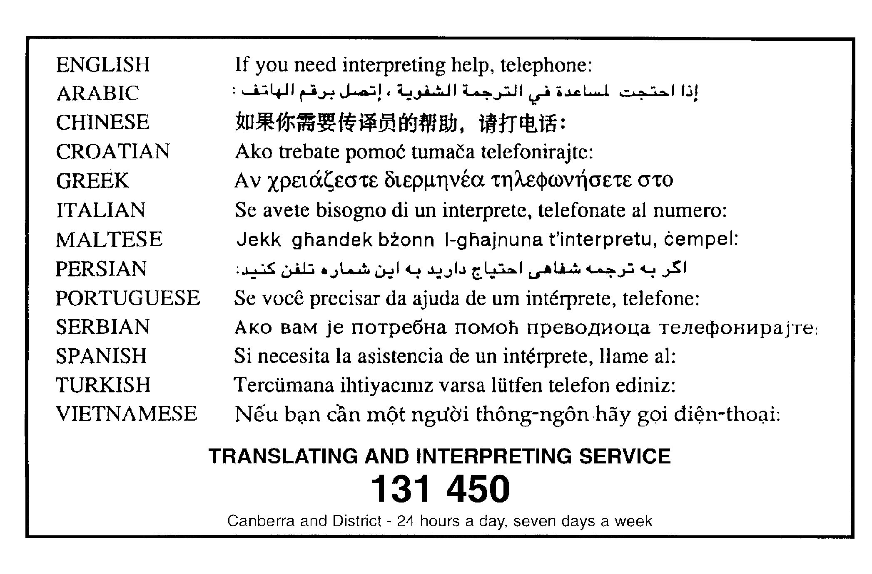

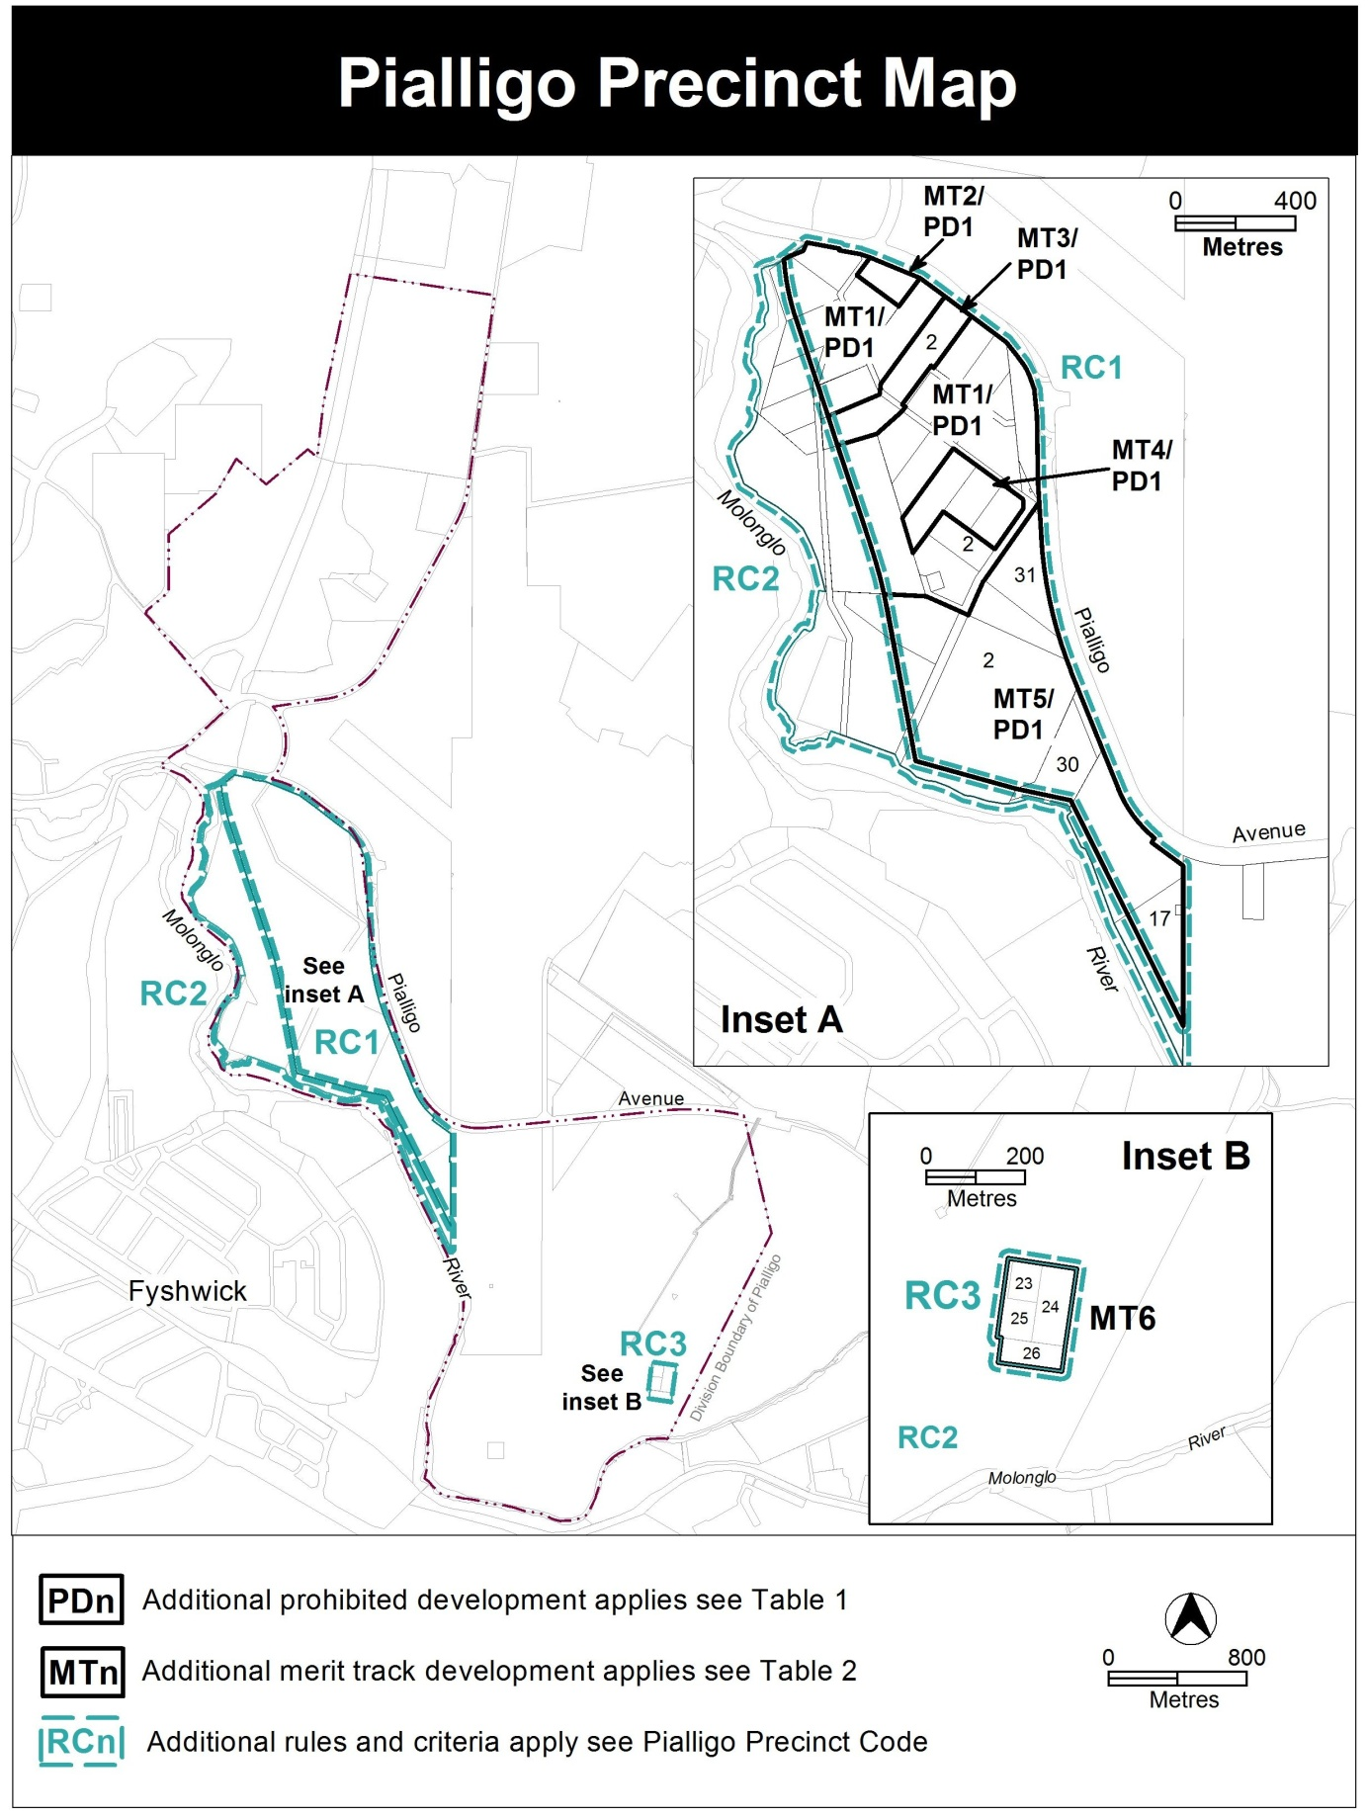

Assessment Tracks
The following tables identify the additional prohibited development and additional merit track development for blocks and parcels shown in the Pialligo Precinct Map (identified as PDn or MTn). Development that is exempt from requiring development approval, other prohibited development and the minimum assessment track applicable to each development proposal is set out in the relevant zone development table.

The following tables constitute part of the relevant zone development table.

Table 1 – Additional prohibited development
Additional prohibited development
Suburb precinct map label | Zone | Development
PD1 | NUZ1 | caravan park / camping ground  cemetery  communications facility  community activity centre  corrections facility  defence installation  educational establishment  health facility  land management facility  MAJOR UTILITY INSTALLATION  municipal depot  place of worship  residential care accommodation  scientific research establishment  service station  subdivision  supportive housing  tourist facility  transport depot  woodlot

Table 2 – Additional merit track development
Additional merit track development that may be approved subject to assessment
Suburb precinct map label | Zone | Development
MT1 | NUZ1 | retail plant nursery  produce market
MT2 | NUZ1 | emergency services facility
MT3 | NUZ1 | dog kennels  retail plant nursery  produce market
MT4 | NUZ1 | bulk landscape supplies  retail plant nursery  produce market
MT5 | NUZ1 | produce market
MT6 | NUZ1 | mining industry

RC1 – Pialligo Agricultural Area
This part applies to blocks and parcels identified in area RC1 shown on the Pialligo Precinct Map.
Desired character
The character of Pialligo consists of a rural landscape with nurseries and small scale shops, craft stores, restaurants and cafes sited close to Beltana Road. The majority of land in Pialligo away from Beltana Road will have a strong agricultural and landscape character with low scale built form sympathetic to the environment, visually and physically separated by distance and landscaping between buildings.

- Use
Rules | Criteria
  - Area A and B
Area ‘A’, shown in figure 1, is defined as leased land located within 60 metres of the Beltana Road reservation; except where the following applies:  - for block 15 section 2, area ‘A’ is not less than 60m and not more than 120m from Beltana Road  Area ‘B’, shown in figure 1, is identified as the remaining leased land excluding area ‘A’, and excluding the hatched area in figure 1. | This is a mandatory requirement. There is no applicable criterion.
  - Ancillary commercial uses – floor space limit
This rule applies to development located within area ‘A’ shown in figure 1.  The maximum gross floor area for each of the following ancillary uses is:  - craft workshop – maximum 200m² per lease with a maximum 150m² per craft workshop  - industrial trades restricted to workshops associated with rural activity – maximum 200m² per lease with a maximum 150m² per industrial trade workshop  - produce market – maximum 300m² per lease with a maximum 100m² per produce market  - restaurant – maximum 250m² per lease with a maximum 150m² per restaurant  - SHOP restricted to an art, craft or sculpture dealer – 100m² | This is a mandatory requirement. There is no applicable criterion.

Rules | Criteria
This rule applies to development:  - on blocks with a leased area of 100,000m² or less; and  - located within area ‘B’ shown in figure 1.  The maximum gross floor area for each of the following ancillary uses is:  - craft workshop – 100m²  - industrial trades restricted to workshops associated with rural activity – 100m²  - produce market – 150m²  - restaurant – 100m²  - SHOP restricted to an art, craft or sculpture dealer – 50m² | This is a mandatory requirement. There is no applicable criterion.
This rule applies to development:  - on blocks with a leased area of more than 100,000m²; and  - located within area ‘B’ shown in figure 1.  The maximum gross floor area for each of the following ancillary uses is:  - craft workshop – 150m²  - industrial trades restricted to workshops associated with rural activity – 150m²  - produce market – 200m²  - restaurant – 150m²  - SHOP restricted to an art, craft or sculpture dealer – 50m² | This is a mandatory requirement. There is no applicable criterion.
The total site coverage of all ancillary commercial development in area ‘B’ shown in figure 1 is limited to:  - 8% of the total block area for blocks less than 100,000m²,  - 6% of the total block area for blocks equal to or greater than 100,000m²  For the purposes of this rule, site coverage includes car parking areas. | This is a mandatory requirement. There is no applicable criterion.

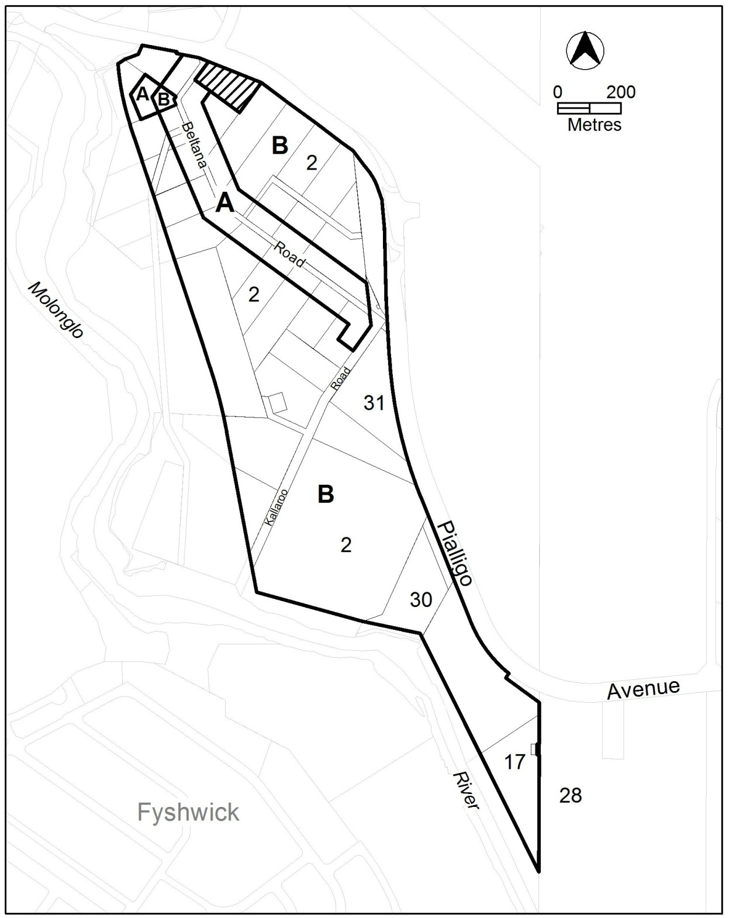

Figure 1 Pialligo agricultural area

Rules | Criteria
  - Residential use
This rule applies to blocks with a leased area of 100,000m² or less.  A maximum of two dwellings are permitted per block | This is a mandatory requirement. There is no applicable criterion.
This rule applies to blocks with a leased area of more than 100,000m².  A maximum of three dwellings are permitted per block. | This is a mandatory requirement. There is no applicable criterion.
Residential development is limited to 500m² gross floor area per block. | Residential development complies with all of the following:  - is consistent with the desired character  - protects environmental and heritage values of the area  - does not detrimentally impact on the operation of adjoining agricultural uses  - does not significantly impact on the agricultural potential of the block
  - Limits on permitted uses
Emergency services facility is limited to 1400m² gross floor area | This is a mandatory requirement. There is no applicable criterion.
This rule applies to all blocks in section 2, except for the hatched area shown in figure 1.  Subdivision of existing leases is not permitted. | This is a mandatory requirement. There is no applicable criterion.
There is no applicable rule. | This criterion applies to the hatched area in figure 1.  Subdivision is only permitted as part of a development providing publicly accessible open space.
  - Building location
All new buildings are located within 200m of the front block boundary addressing Beltana Road or Kallaroo Road. | Buildings may be located further than 200m from the front boundary where reasonable justification is provided that demonstrates the location of the building:  - is consistent with the desired character  - reflects the existing development pattern  - protects environmental values of the area  - protects heritage values of the area  - does not detrimentally impact on the operation of adjoining agricultural uses  - does not significantly impact on the agricultural potential of the block

- Site
Rules | Criteria
  - Built form
The maximum number of storeys is two. | This is a mandatory requirement. There is no applicable criterion.
There is no applicable rule. | This criterion applies to development in area ‘A’ shown in figure 1.  Building frontages facing Beltana Road achieve all of the following:  - provide opportunities for views into and out of the building  - are not dominated by extensive lengths of blank facades, substations or other service infrastructure  - provide articulated facades
This rule applies to buildings in the hatched area shown in figure 1.  The maximum height of building is 8.5m. | Building height is consistent with the desired character.
Roofs are of pitched construction. | Roofs are designed and constructed to be consistent with the desired character.
  - Site facilities
There is no applicable rule. | Car parking areas:  - are screened from the street; and  - do not significantly reduce the agricultural potential of blocks.
There is no applicable rule. | Waste collection areas, loading docks and service areas are screened from the street and adjoining public spaces.
There is no applicable rule. | A maximum of two verge crossovers are provided per block frontage.
  - Front setbacks to Beltana and Kallaroo Road
The minimum setback to each front boundary adjoining Beltana Road or Kallaroo Road is 6m. | Front setbacks:  - are consistent with the desired character  - reflect the existing development pattern  - are related to the height of the building to ensure pedestrian scale at street level  - provide reasonable space between the development and front boundary to permit deep root planting
This rule applies to buildings in the hatched area shown in figure 1.  The minimum setback to Beltana Road front boundary is 40m. | This is a mandatory requirement. There is no applicable criterion.
  - Side setbacks
This rule applies to area ‘A’ in figure 1.  The minimum setback to each side boundary is 8m. | Side setbacks:  - are consistent with the desired character  - reflect the existing development pattern  - provide sufficient separation to provide a landscape buffer between development and the adjoining boundary  - do not detrimentally impact on the operation of adjoining agricultural uses
This rule applies to buildings in the hatched area shown in figure 1.  The minimum setback to each side boundary is 25m. | This is a mandatory requirement. There is no applicable criterion.
  - Setbacks to Pialligo Avenue
This rule applies to development on blocks with a boundary adjoining Pialligo Avenue road reservation, except for blocks located at the intersection of Pialligo Avenue and Beltana Road.  The minimum setback of buildings and structures to boundaries adjoining Pialligo Avenue is 20m. | This is a mandatory rule. There is no applicable criterion.
This rule applies to development on blocks located at the intersection of Pialligo Avenue and Beltana Road:  The minimum setback of buildings and structures to Pialligo Avenue front boundary is 20m. | Setbacks to Pialligo Avenue may be reduced to 10m where development:  - is consistent with the existing or desired character and any applicable development control plan, and  - incorporates a landscaped area between the building line and the boundary suitable for deep root planting that screens development from Pialligo Avenue and contributes to defining the entrance to the suburb.
  - Active frontages
This rule applies to commercial development in area A shown in figure 1.  Street frontages and building design comply with all of the following:  - buildings incorporate clear display windows at the ground floor level  - buildings incorporate direct pedestrian access at grade with the verge level for access and egress for persons with disabilities | Development achieves all of the following:  - where building access is provided, direct pedestrian access  - provide opportunities for views into and out of the building
There is no applicable rule. | Extensive lengths of blank facades, loading docks, substations and other service infrastructure do not dominate the street frontage along Beltana Road.
  - Potentially noisy uses
This rule applies to any of the following:  - emergency services facility.  - outdoor recreation facility  - restaurant  Development complies with a noise management plan prepared by a suitable qualified person and endorsed by the Environment Protection Authority (EPA).  The noise management plan will detail the proposed design, siting and construction methods that will be employed to ensure compliance with the Noise Zone Standard as detailed in the Environment Protection Regulation 2005, based on the estimated noise levels when the facility is in use.  Note: A condition of development approval may be imposed to ensure compliance with the endorsed noise management plan. | This is a mandatory rule. There is no applicable criterion.
  - Property plans
Development applications are supported by property plans that:  - identify all of the following  - high quality agricultural soils  - vegetation  - natural drainage areas and lines  - describe how the items at point a) will be managed and protected both during construction, and in the ongoing use of the site.  Note:  This requirement is separate and in addition to any assessment of environmental effects and/or plans of management required. | This is a mandatory rule. There is no applicable criterion.
  - Heritage – potential archaeological artefacts
This rule applies to the shaded area in figure 2.  Applications for development are accompanied by written endorsement from the Heritage Council. | Development without written endorsement will be referred to the Heritage Council, and its advice considered before the determination of the application.
  - Environment Protection – landscape buffers to agricultural uses
Applications for new dwellings and or alterations to existing dwellings are accompanied by a report from a suitably qualified person, with written endorsement from Environment Protection Authority (EPA), advising whether a vegetative buffer is required to separate the residential development from adjoining agricultural uses.  Where vegetative buffers are required to separate residential development from agricultural uses, updated Land Management Agreements must be provided that:  - indicate the species and planting arrangement of vegetation to be incorporated; and  - detail the ongoing management required for the maintenance of the vegetation. | Reports without written endorsement will be referred to the EPA, and its advice considered before the determination of the application.

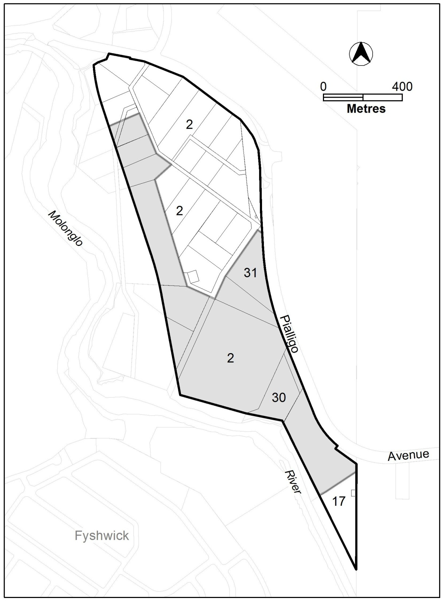
Figure 2 Areas with potential archaeological artefacts – NUZ1

RC2 – NUZ4 River corridor
This part applies to blocks and parcels identified in area RC2 shown on the Pialligo Precinct Map.

- Heritage
Rules | Criteria
  - Heritage – potential archaeological artefacts
This rule applies to the shaded area in figure 3.  Applications for development are accompanied by written endorsement from the Heritage Council. | Development without written endorsement will be referred to the Heritage Council, and its advice considered before the determination of the application.

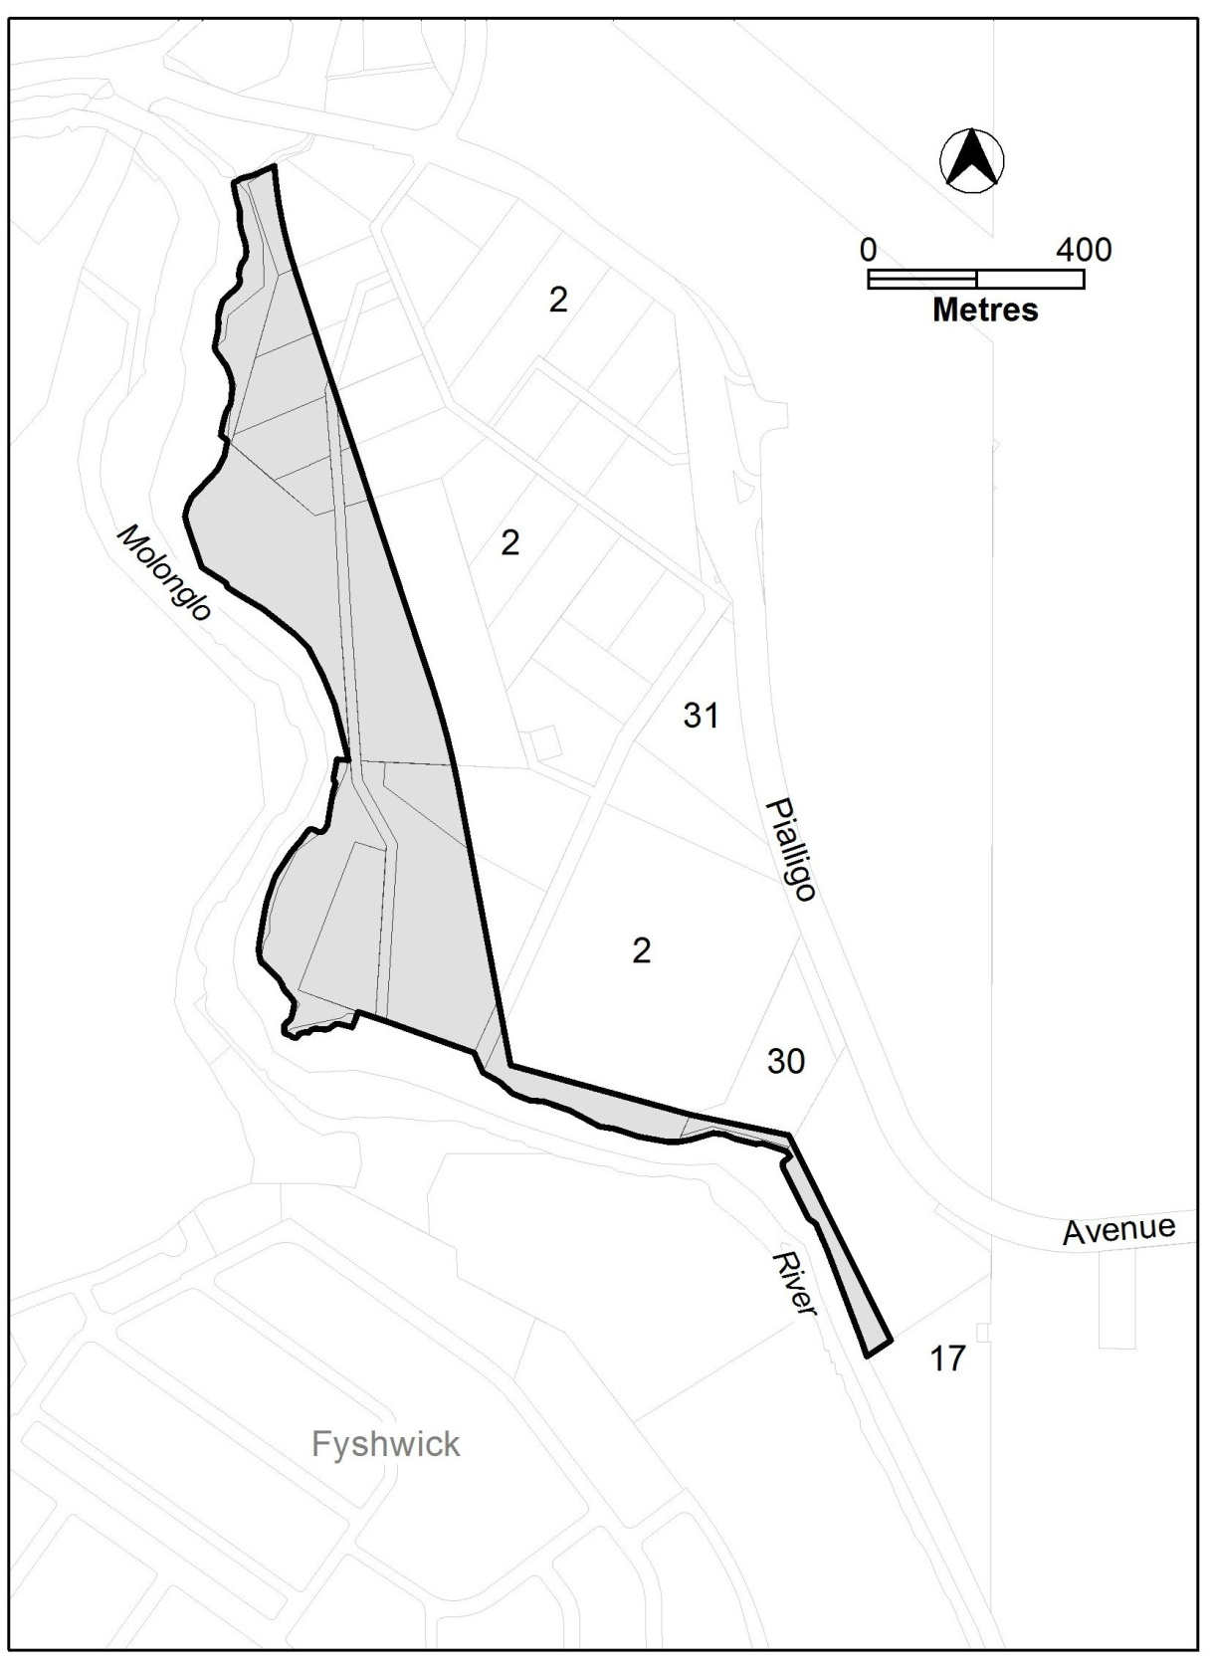
Figure 3 Areas with potential archaeological artefacts – NUZ4

