Australian Capital Territory

Planning and Development (Technical Amendment—Miscellaneous Amendment) Plan Variation 2014 (No 2)

Notifiable Instrument NI2014—180

Technical Amendment No 2014—07
made under the
Planning and Development Act 2007, section 89 (Making technical amendments)

This technical amendment commences on 2 May 2014.

Variation No 2014—07 to the Territory Plan has been approved by the planning and land authority.

Jim Corrigan
Delegate of the Planning and Land Authority
28 April 2014

Planning & Development Act 2007

Technical Amendment
to the Territory Plan
Variation 2014-07

Miscellaneous technical amendment – corrections to Casey precinct map and code

May 2014

This page is left intentionally blank
Table of Contents

1. INTRODUCTION 1
Purpose 1
Public consultation 1
Process 1
ACT Planning Strategy 1
Compliance with the Act 1
2. EXPLANATION 2
2.1 Casey precinct map and code 2
2.2 Casey Precinct map and code 5
3. TECHNICAL AMENDMENT 8
3.1 Casey precinct map and code 8

This page is left intentionally blank

- INTRODUCTION

Purpose
This technical amendment makes the following changes to the Territory Plan:

Casey precinct map and code
- Correction to Figure 5 Casey residential area 3

Public consultation
Under section 88 of the Planning and Development Act 2007 (the Act) this type of technical amendment is not subject to public consultation.

Process
This technical amendment has been prepared in accordance with section 87 of the Planning and Development Act 2007 (the Act). The planning and land authority must notify the public of the commencement of this technical amendment.

ACT Planning Strategy
This technical amendment is not inconsistent with the ACT Planning Strategy.

Compliance with the Act
This technical amendment is compliant with:
Section 87(a) of the Planning and Development Act 2007 in that:
i) would not adversely affect anyone’s rights if approved; and
ii) has as its only object the correction of a formal error in the plan.

Statement of compliance with Planning and Development Act 2007

Section | Statement
s87(a).  - would not adversely affect anyone’s rights if approved; and  - has as its only object the correction of a formal error in the plan | Compliant. This TA only corrects a formal error in the Casey precinct map and code relating to Figure 5.

- EXPLANATION
  - Casey precinct map and code – previous FUA uplift area omission
Figure 5 in the Casey precinct map and code was correct in the version of the precinct map and code published on 5 February 2014. However, when future urban area (FUA) uplift changes were made to Casey and the updated precinct map and code was published on 18 March 2014, the figure showing only the recently uplifted area was inadvertently added. Figure 5 has been corrected in this technical amendment to show the previously uplifted area and the most recently uplifted area combined in the same diagram.

Previous figure 5 (Effective 5 February 2014)
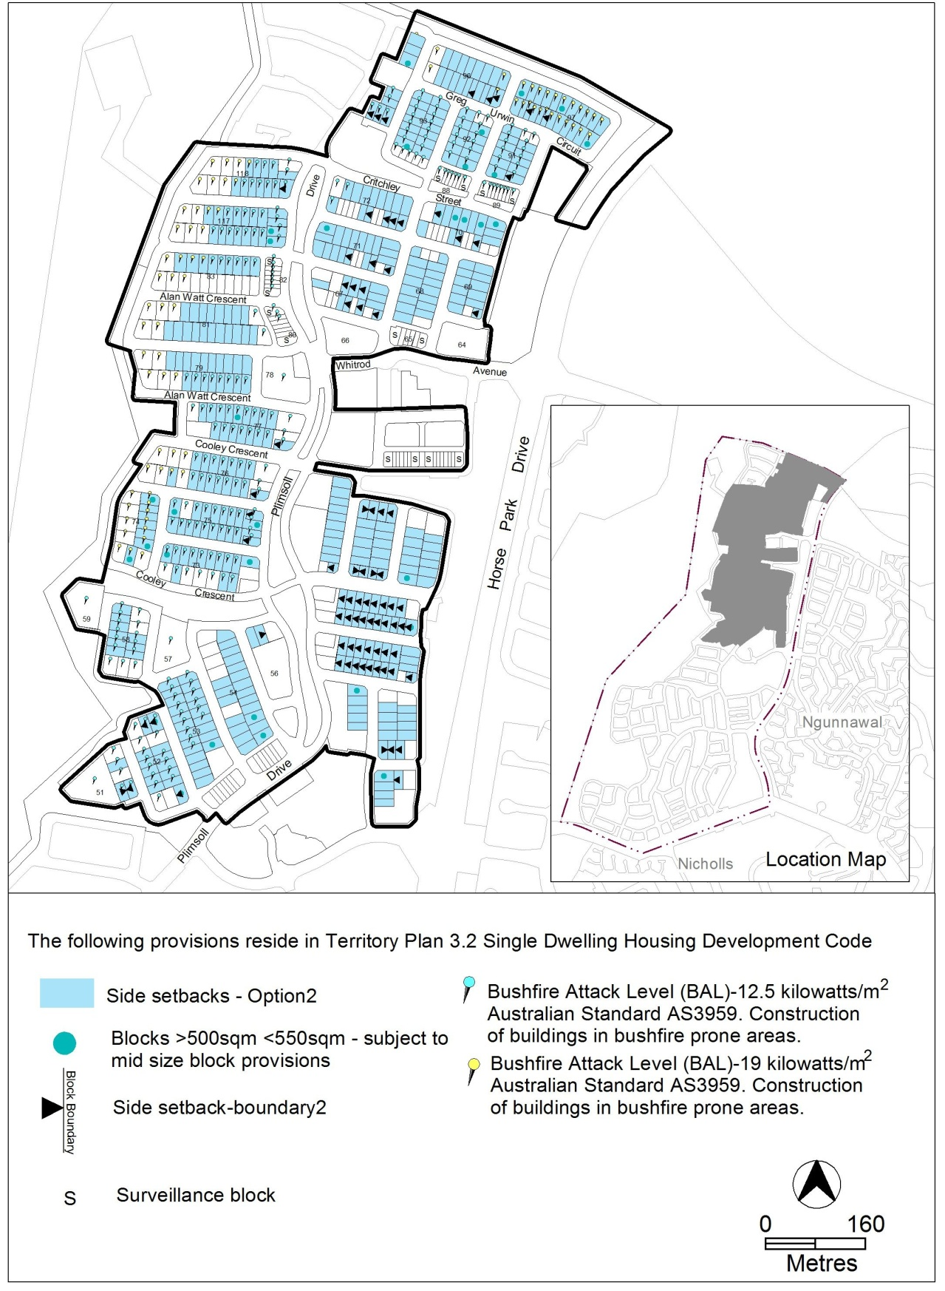
Existing figure 5 (Effective 18 March 2014)
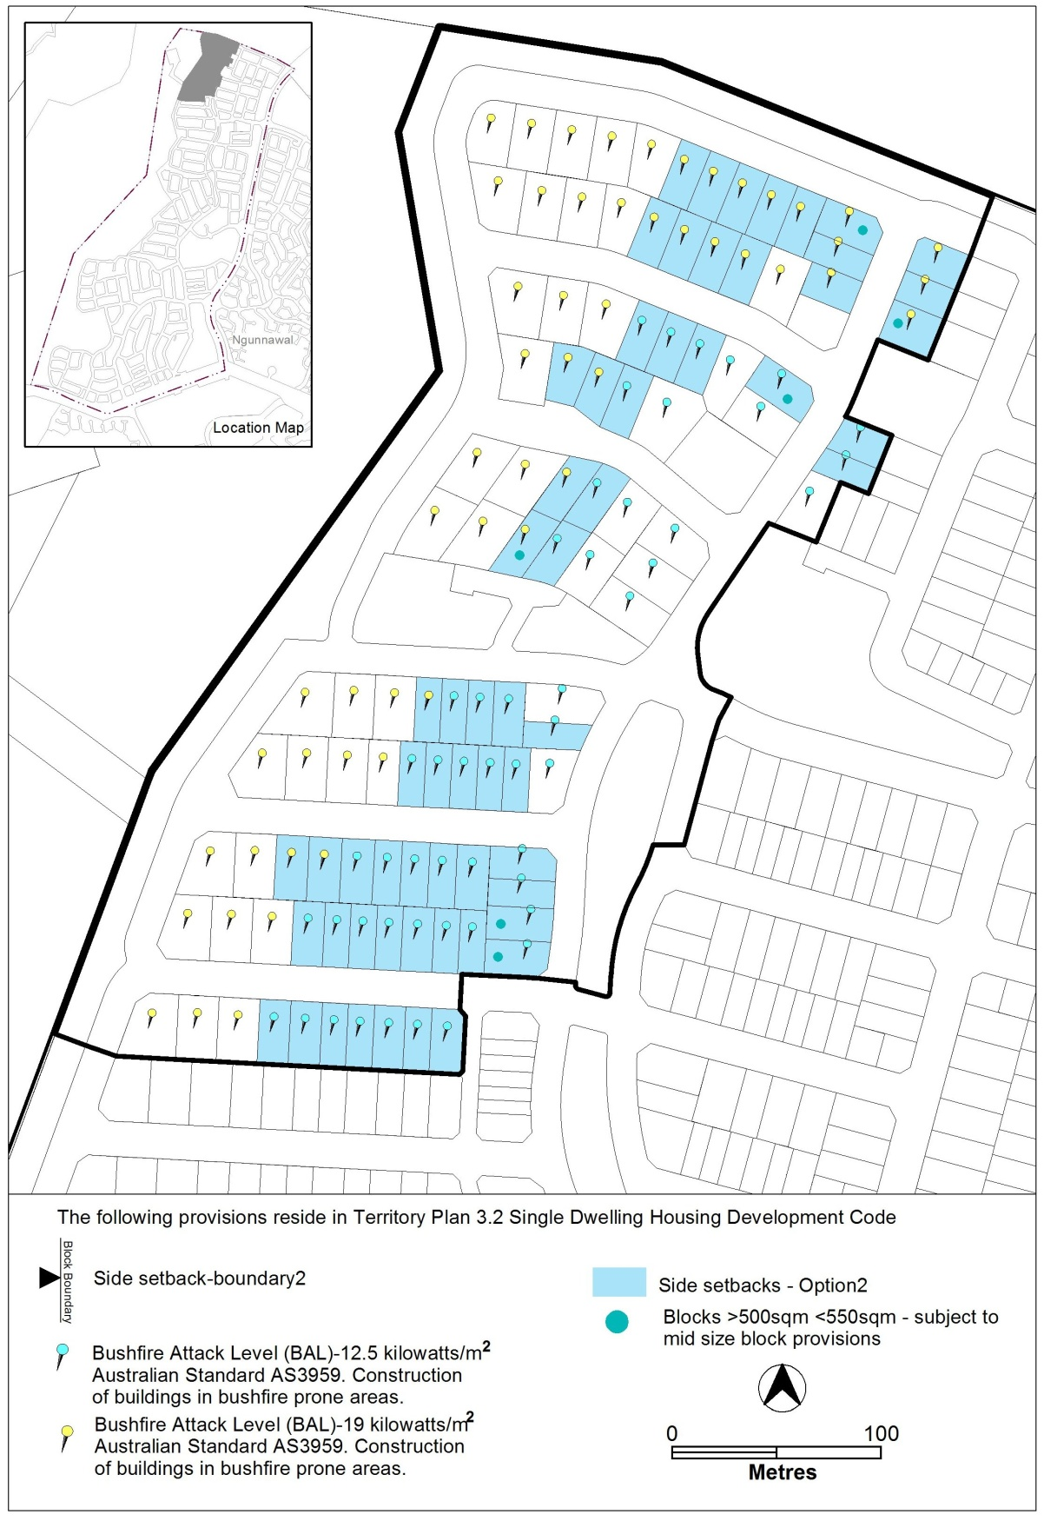

Proposed (corrected) figure 5

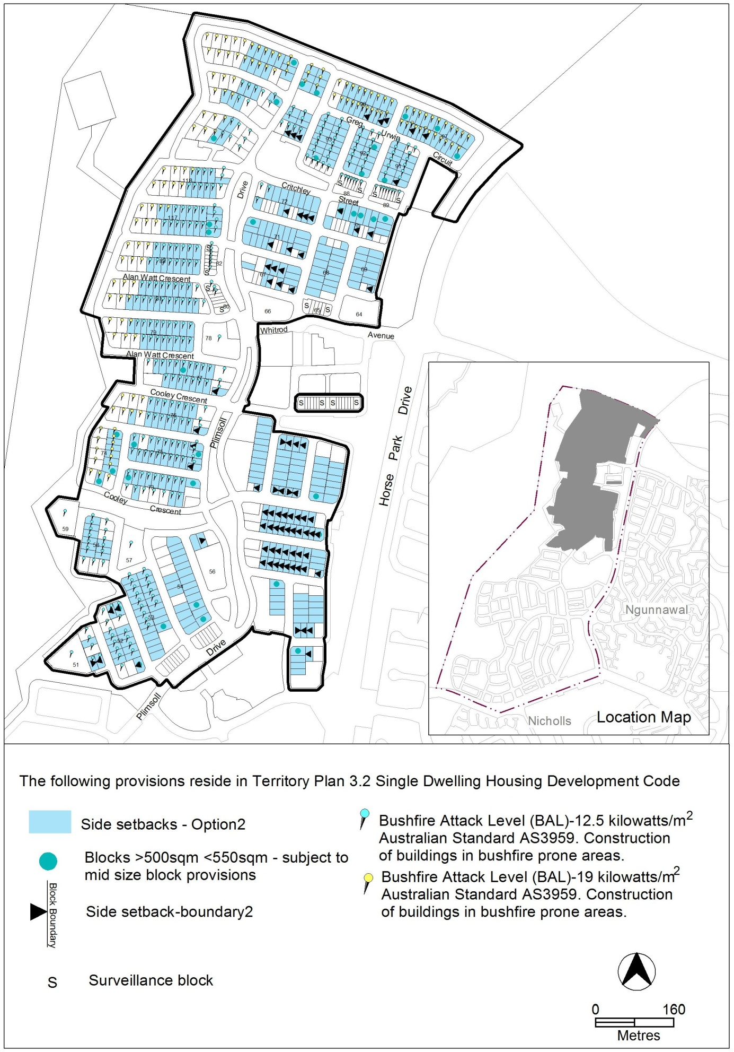
  - Casey Precinct map and code – omitted BALs and setbacks area
Figure 5 in the Casey precinct map and code was correct in the version of the precinct map and code published on 3 May 2013. However, when future urban area (FUA) uplift changes were made to Casey and the updated precinct map and code was published on 5 February 2014, part of the Bushfire Attack Levels (BAL) in sections 79, 81 and 83 had been inadvertently omitted. Also part of the Side Setbacks– Option 2 area had been inadvertently omitted from Section 83. Figure 5 has been corrected in this technical amendment to show the previously uplifted area and the most recently uplifted area combined in the same diagram.

Previous figure 5 (Effective 3 May 2013)
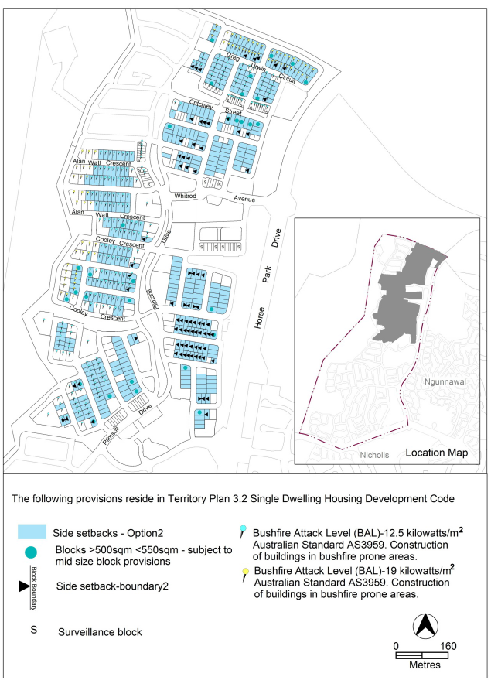
Previous figure 5 (Effective 5 February 2014)

Proposed (corrected) figure 5
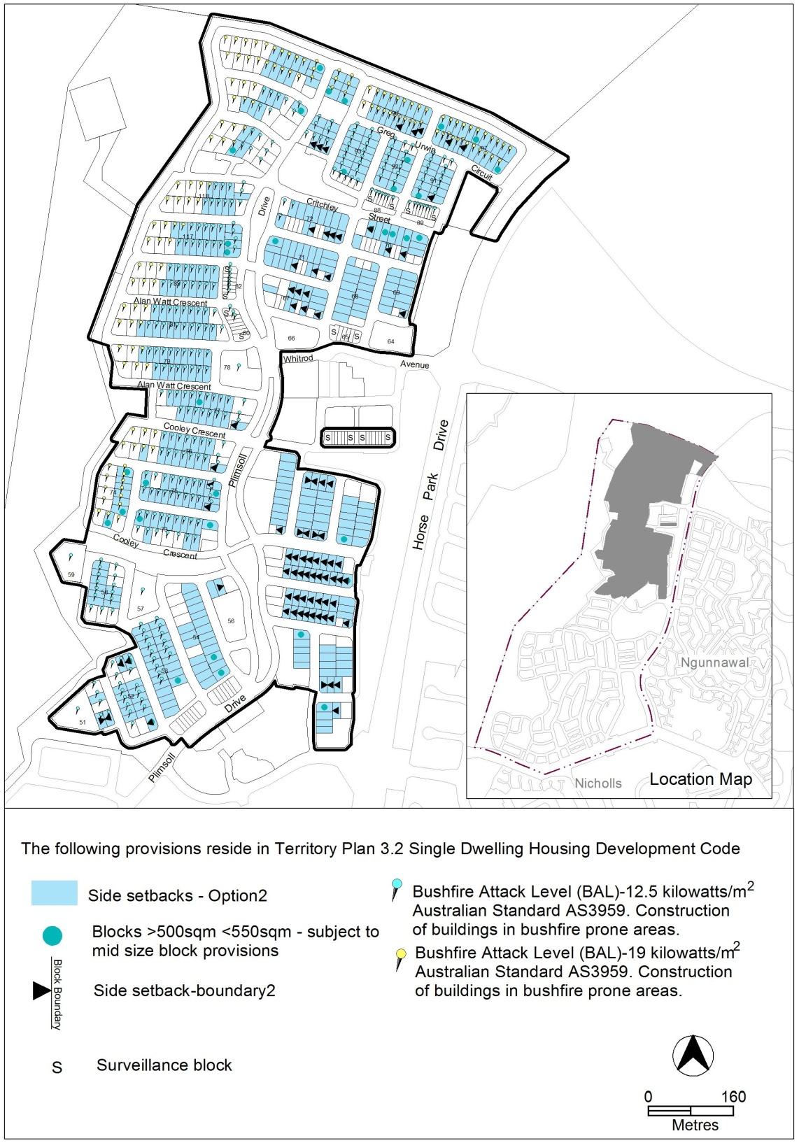

- TECHNICAL AMENDMENT
  - Casey precinct map and code
- OP3 – Casey residential area 3 – Figure 5 Casey residential area 3

Substitute
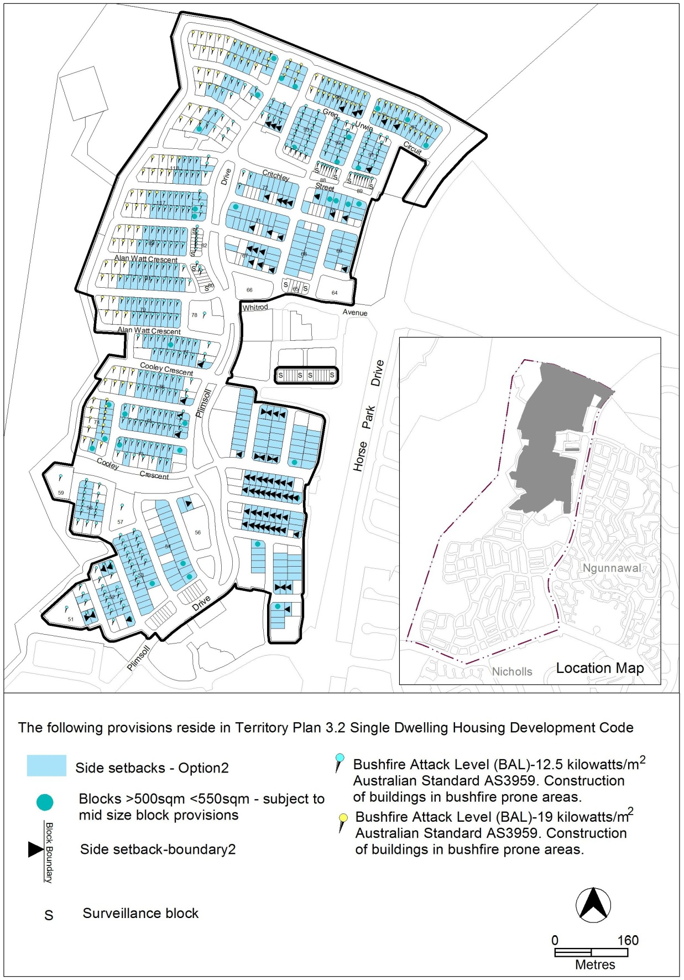

Interpretation service
