Australian Capital Territory
Planning and Development (Plan Variation No 326) Notice 2014
Notifiable Instrument NI2014-189
made under the
Planning and Development Act 2007, section 76(3)

- Name of instrument
This instrument is the Planning and Development (Plan Variation No 326) Notice 2014*.

- Plan Variation No 326
On 2 May 2014, the Minister for Planning approved a draft of the attached plan variation to the Territory Plan (Annexure A) under s76 (3).

Jim Corrigan
Delegate of the Planning and Land Authority
5 May 2014

Planning and Development Act 2007

Variation to the
Territory Plan
No 326

Chisholm Section 590
Caroline Chisholm Park

Final variation prepared under s76 of the
Planning and Development Act 2007

This page is intentionally blank.

Contents

1. EXPLANATORY STATEMENT 1
1.1 Background 1
1.2 Summary of the Proposal 1
1.3 The National Capital Plan 1
1.4 Site Description 2
1.5 Current Territory Plan Provisions 4
1.6 Changes to the Territory Plan 5
1.7 Consultation on the Draft Variation 5
1.8 Revisions to the Draft Variation Recommended to the Minister 5
2. VARIATION 6
2.1 Variation to the Territory Plan 6

This page is intentionally blank.

- EXPLANATORY STATEMENT
  - Background
Section 590 Chisholm is zoned CZ4 – local centre, however has never been leased or developed for commercial purposes. The land was released for sale in the mid 1990’s but was not sold as the surrounding catchment for the centre was considered to be too small to support a local commercial centre. Around that time a small public playground was established on the site. In 2010 the (then) ACTPLA received a request for a direct sale of the site to a major supermarket group. The request was not supported due to the size of the site seen to be limiting the potential for sufficient parking to be provided on site, and proximity of the site to existing commercial centres. In late-2011 the ACT Government proposed another auction of the site, for medium density residential. Following community consultation where a number of residents raised concerns with the loss of the land as a public space, the ACT Government announced in 2012 that the site would not be sold for development, but would instead be retained as a park for the local community. The Government also indicated that the park would be named after Caroline Chisholm. In order for the park to be formally named after Caroline Chisholm, the Public Place Names Act 1989 requires land to be zoned PRZ1 urban open space zone. Therefore, this variation is rezoning the land PRZ1.

  - Summary of the Proposal
Variation No 326 (V326) rezones Chisholm section 590 from CZ4 Local Centre zone to PRZ1 Urban Open Space zone. The site had been retained by the ACT Government for a future local commercial centre, though in response to community concerns to the proposed sale of the land in 2012, the ACT Government agreed to retain the site as a park for the local community. The Government also proposed to officially name the park after Caroline Chisholm. In order to protect the park and playground, and for the official naming to occur, the site is required to be rezoned to PRZ1 urban open space.

  - The National Capital Plan
The Australian Capital Territory (Planning and Land Management) Act 1988 established the National Capital Authority (NCA) with two of its functions being to prepare and administer a National Capital Plan (NCP) and to keep the NCP under constant review and to propose amendments to it when necessary.
The NCP, which was published in the Commonwealth Gazette on 21 January 1990 is required to ensure that Canberra and the Territory are planned and developed in accordance with their national significance. The Planning and Land Management Act 1988 also required that the Territory Plan is not inconsistent with the NCP.
In accordance with section 10 of the Australian Capital Territory (Planning and Land Management) Act 1988, the National Capital Plan defines the planning principles and policies for Canberra and the Territory, for giving effect to the object of the NCP and sets out the general policies to be implemented throughout the Territory, including the range and nature of permitted land uses.
It also sets out the detailed conditions of planning, design and development for areas that have special significance to the National Capital known as designated areas and identifies special requirements for the development of some other areas.

  - Site Description
Section 590 (consisting of blocks 6 and 7) Chisholm, in the Tuggeranong District is a vacant site located at the south west corner of Heagney Crescent and Deamer Crescent. The site is bounded by the following:
- Heagney Crescent to the north;
- Deamer Crescent to the east;
- Open space (block 21 , section 516 and block 10 section 518) and floodway reserve to the south;
- single dwelling residential development on blocks 1 and 8 section 517 to the west.
The site has an area of approximately 6272m². The site is currently used as informal open space with a centrally located public playground, installed and maintained by TAMSD.
Features on the site are limited to the playground structure, dryland grasses, remnant and newer trees, and stormwater easements through the site. Footpaths cross the site in a north-south direction, central to the site and east-west along the southern boundary. This network provides connectivity for pedestrians between the surrounding streets, the playground and open space to the south. The site slopes north to south, with substantial drainage swales extending across the site from road low points in Heagney Crescent and Deamer Crescent.

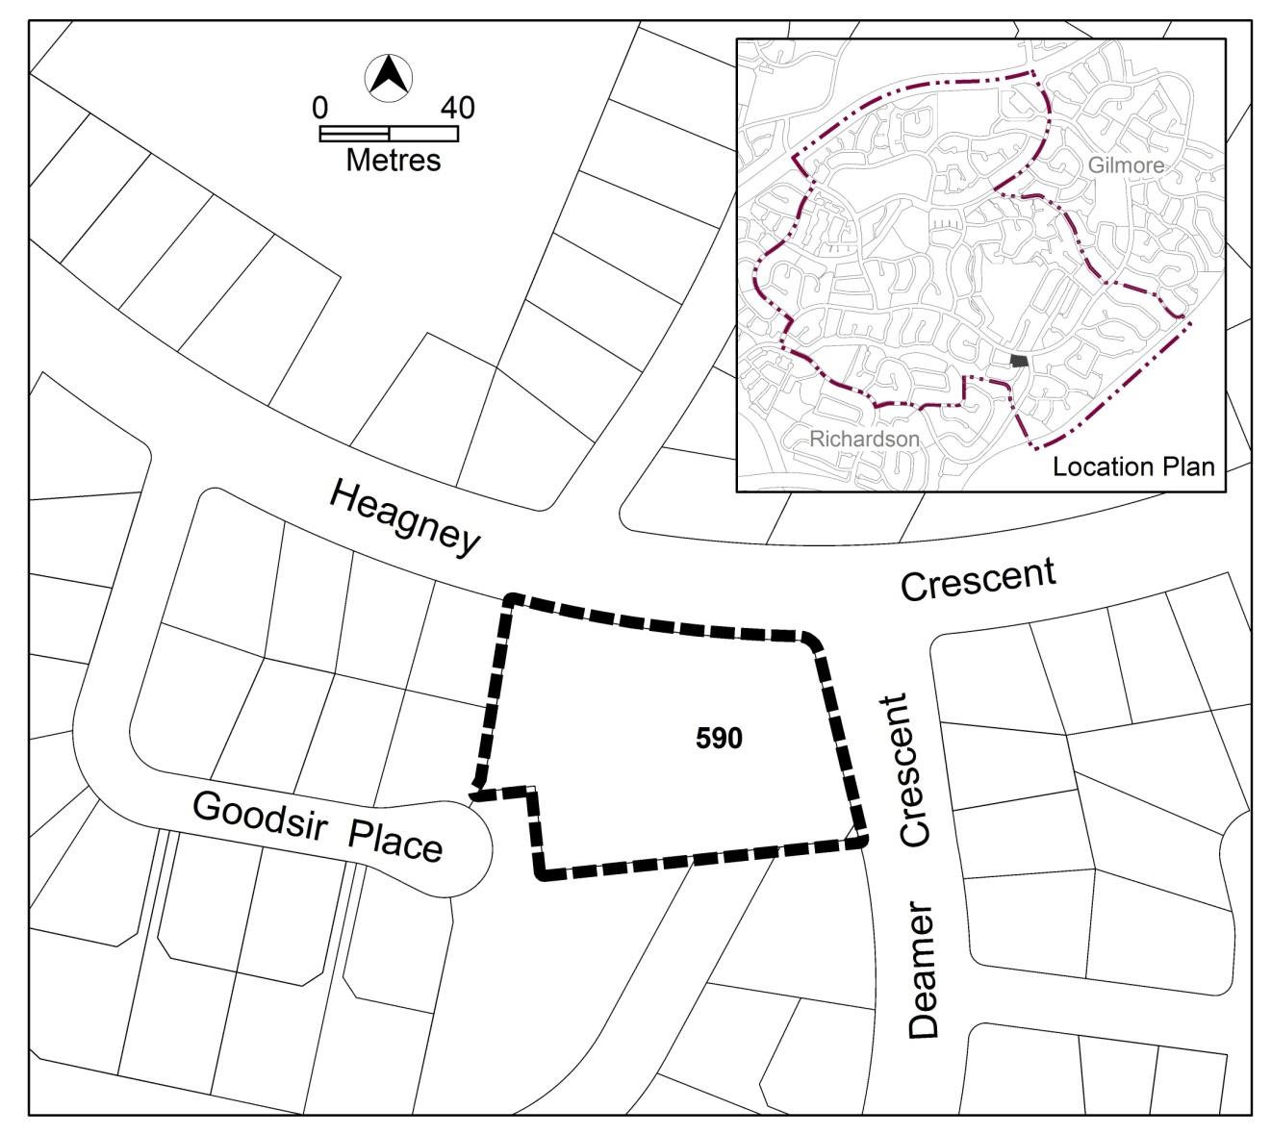
Figure 1 Site Plan

  - Current Territory Plan Provisions
The Territory Plan map for the area subject to this variation is shown in Figure 2.
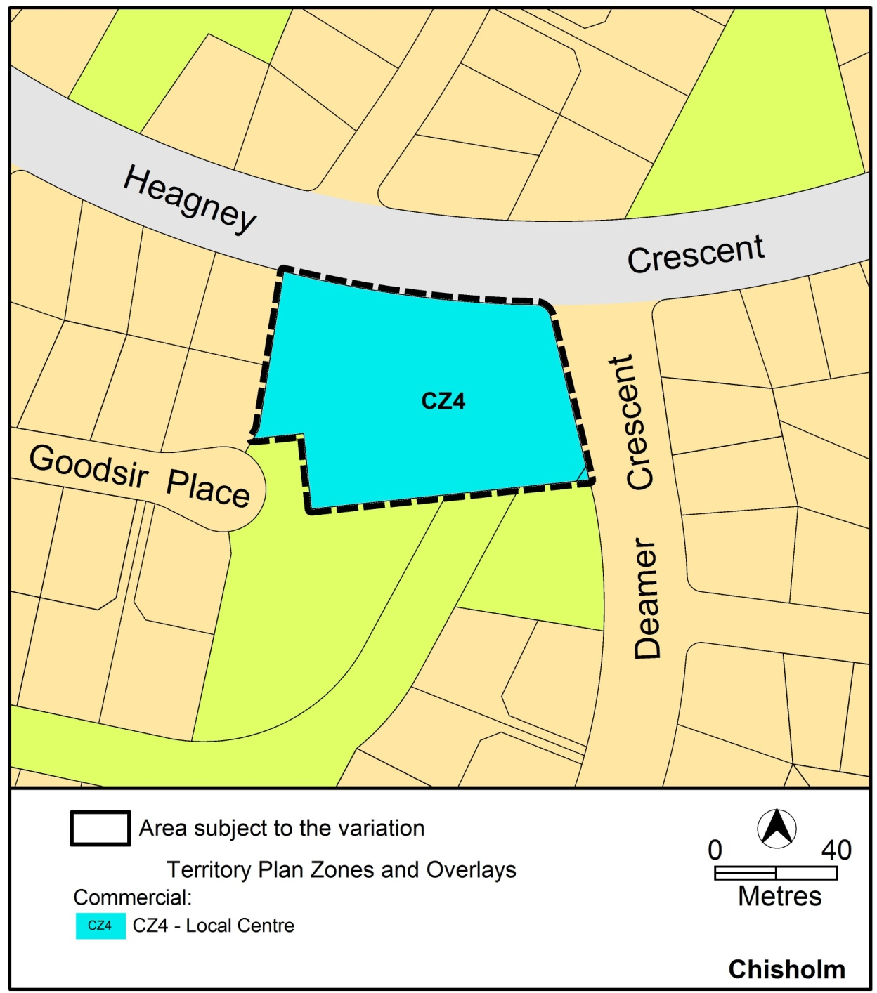
Figure 2 Territory Plan Zones Map

  - Changes to the Territory Plan
Detailed changes to the Territory Plan are noted in section 2 of this document.

  - Consultation on the Draft Variation
Draft Variation No 326 (DV326) was released for public comment between 14 December 2013 and 17 February 2014. A consultation notice under section 63 of the Planning and Development Act 2007 (P&D Act) was published on the ACT Legislation Register on 14 December 2013 and in The Canberra Times on 15 December 2014.
A total of five written submissions were received, which included submissions from the Chisholm Community Park Committee and the Tuggeranong Community Council. All submissions supported the proposed variation.

The above submissions were considered and are detailed in a report on consultation. No changes were made as a result of consultation. The outcomes of consultation were considered by the Minister responsible for planning prior to approval of this variation.

  - Revisions to the Draft Variation Recommended to the Minister
No changes were made to the draft variation recommended to the Minister.

- VARIATION
  - Variation to the Territory Plan
The Territory Plan map is varied as shown in Figure 3 for the area shown as subject to the variation.

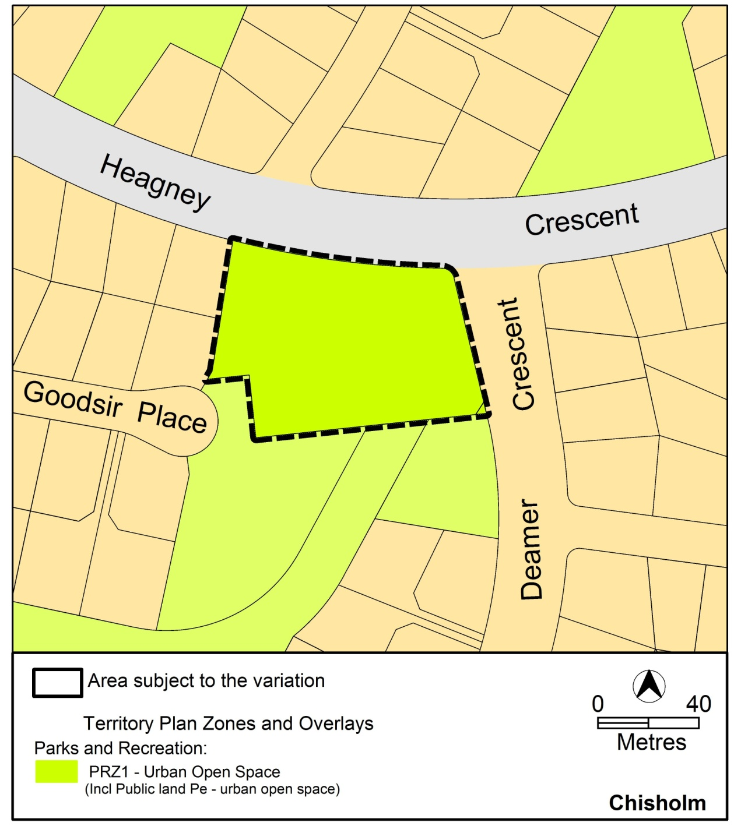
Figure 3 Proposed Territory Plan Provisions

Interpretation service
