Australian Capital Territory

Planning and Development (Technical Amendment—Lawson) Plan Variation 2014 (No 3)*

Notifiable Instrument NI2014—260
Technical Amendment No 2014—11
made under the
Planning and Development Act 2007, section 89 (Making technical amendments) s96 (land ceases to be in future urban area)

This plan variation commences on the day after it is notified.

Variation No 2014—11 to the Territory Plan has been approved by the Planning and Land Authority.

Variation to the Territory Plan
The Territory Plan map is varied as indicated in Annexure A to identify the zones that apply to the land ceasing to be in a future urban area.

Variation to the Precinct Map and Code
Substitute Lawson Precinct Map and replace page 5 and replace Figure 1, Figure 2 and Figure 3 of the Lawson Precinct Map and Code at Annexure B to incorporate ongoing block specific provisions for the area.

Jim Corrigan
Delegate of the Planning and Land Authority
4 June 2014

THIS IS PAGE ONE OF ANNEXURE A
TO NOTIFIABLE INSTRUMENT NI2014–260

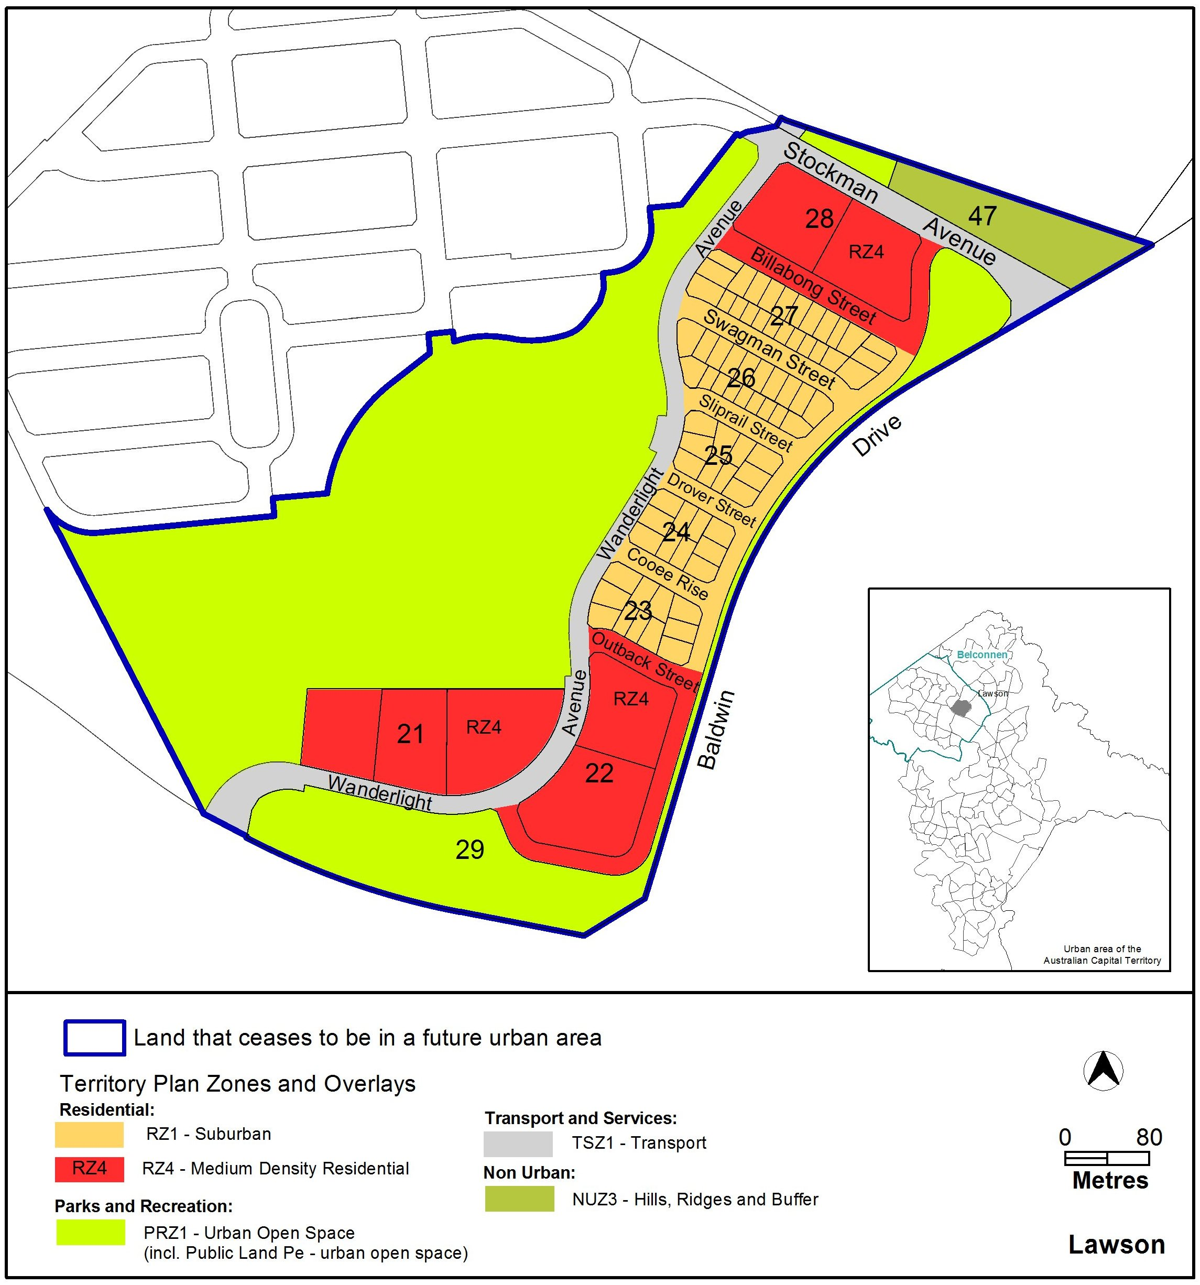

Jim Corrigan
Delegate of the Planning and Land Authority
4 June 2014
THIS IS PAGE ONE OF ANNEXURE B
TO NOTIFIABLE INSTRUMENT NI2014–260

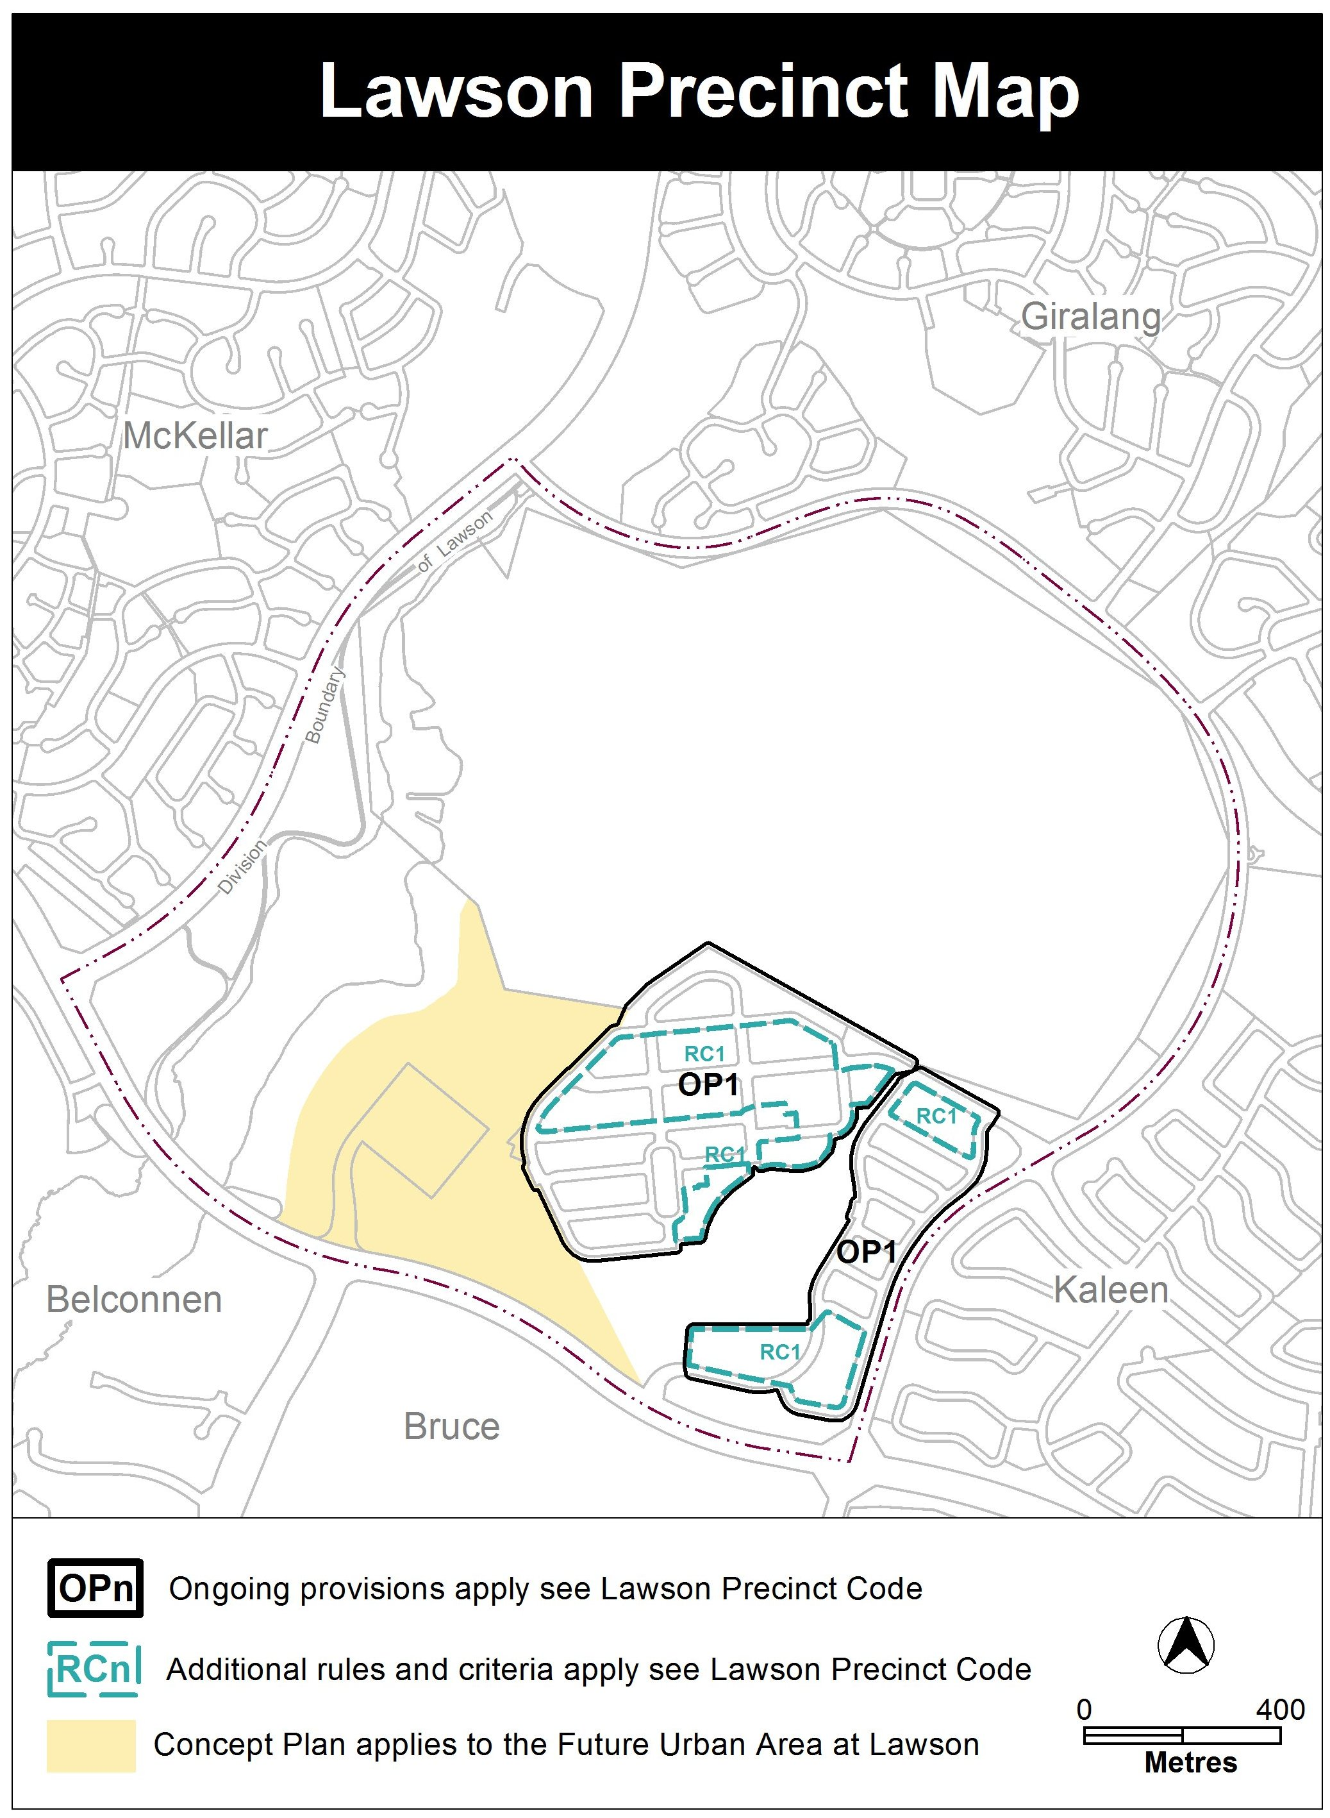

Jim Corrigan
Delegate of the Planning and Land Authority
Date
THIS IS PAGE TWO OF ANNEXURE B
TO NOTIFIABLE INSTRUMENT NI2014–260

Additional rules and criteria

This part applies to blocks and parcels identified in the Lawson Precinct Map (RCn). It should be read in conjunction with the relevant zone development code and related codes.

RC1 – Lawson residential estate
This part applies to blocks and parcels identified in area RC1 shown on the Lawson Precinct Map.

Element 1: Building heights
Rules | Criteria
1.1 Number of storeys
R1  The following rule applies to area A in Figure 1:  The minimum number of storeys for dwellings in this location is 2. | This is a mandatory requirement. There is no applicable criterion.
1.2 Building heights
R2  The following rule applies to the hatched area as shown in Figure 2.  No part of any building is to extend above RL620 except in the area between east of the historic windbreak and south east of Reservoir Hill where no part of the dwelling may extend beyond RL625. | This is a mandatory requirement. There is no applicable criterion.

Element 2: Vehicular access
Rules | Criteria
2.1 Vehicular access
R3  No vehicular access is permitted to buildings in places as indicated in Figure 1 | This is a mandatory requirement. There is no applicable criterion.

Jim Corrigan
Delegate of the Planning and Land Authority
4 June 2014

THIS IS PAGE THREE OF ANNEXURE B
TO NOTIFIABLE INSTRUMENT NI2014–260

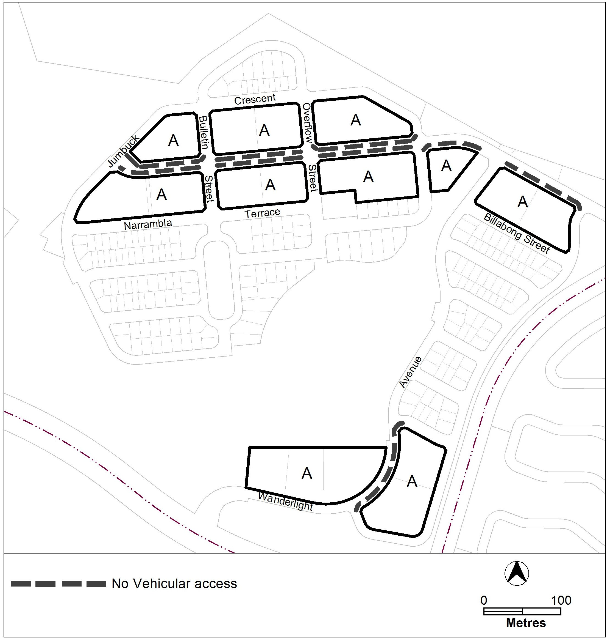

Jim Corrigan
Delegate of the Planning and Land Authority
4 June 2014

THIS IS PAGE FOUR OF ANNEXURE B
TO NOTIFIABLE INSTRUMENT NI2014–260

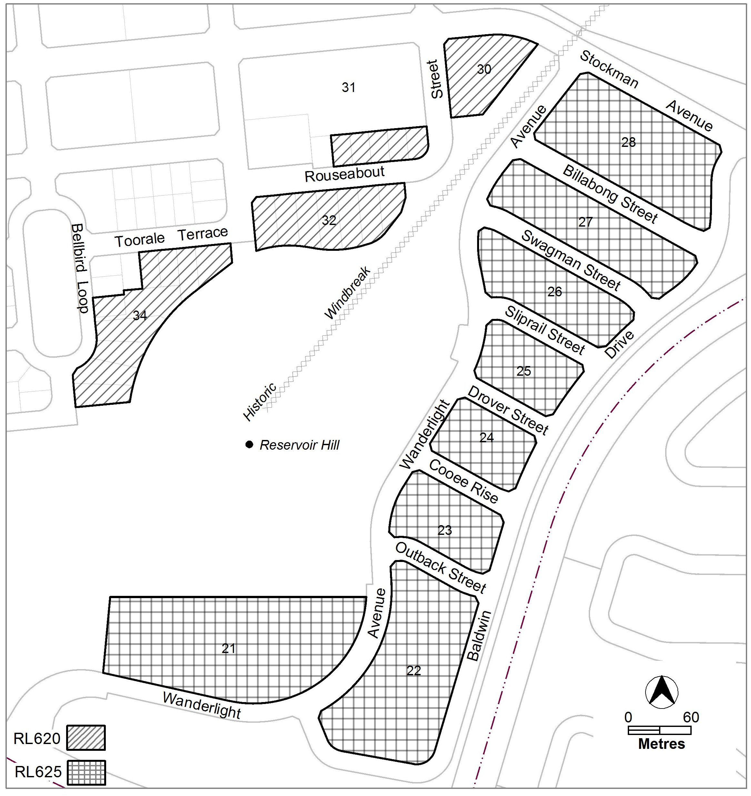

Jim Corrigan
Delegate of the Planning and Land Authority
4 June 2014

THIS IS PAGE FIVE OF ANNEXURE B
TO NOTIFIABLE INSTRUMENT NI2014–260

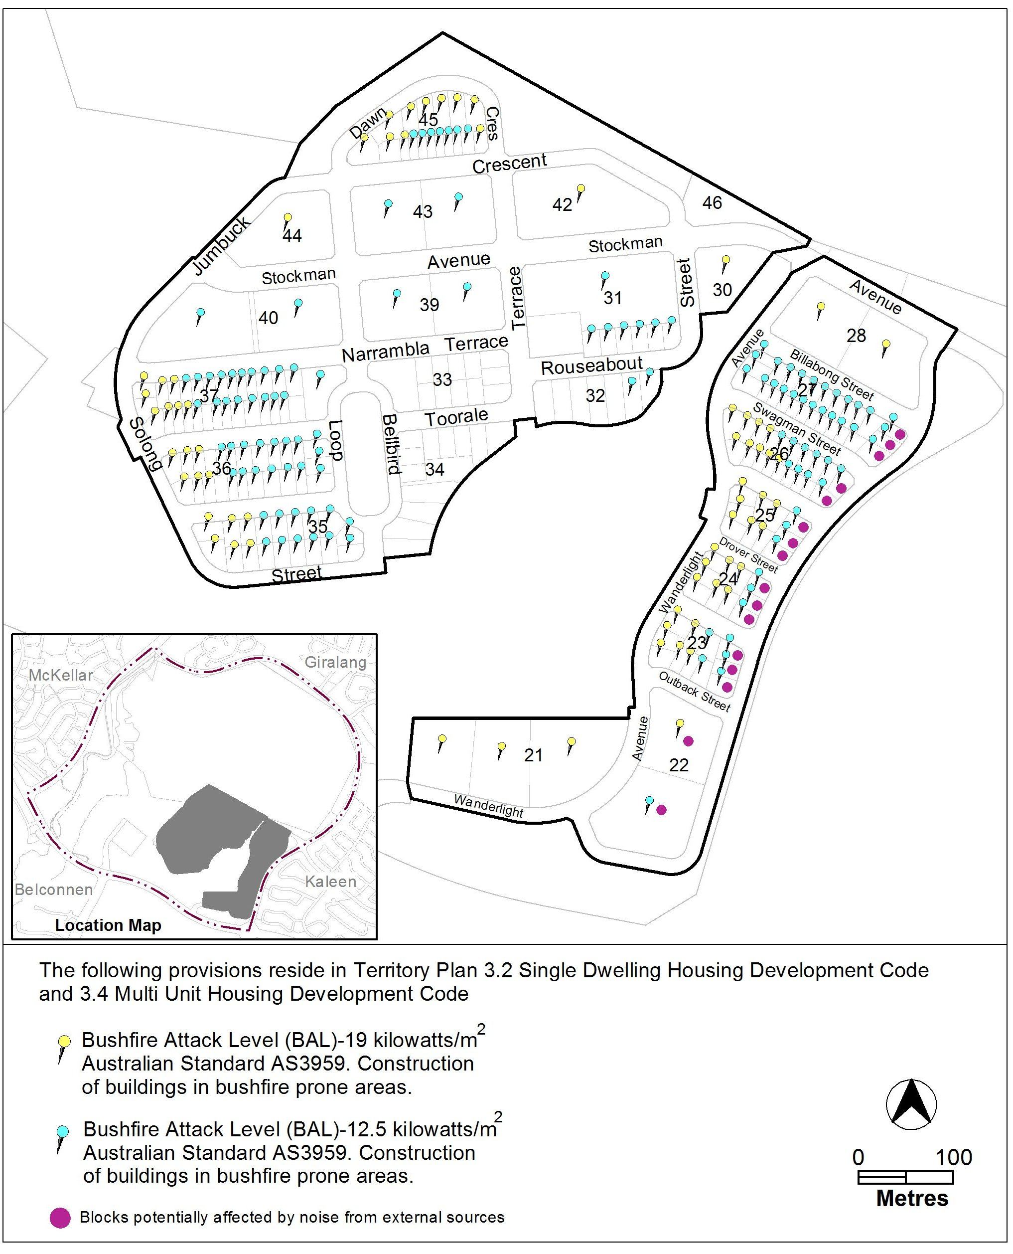

Jim Corrigan
Delegate of the Planning and Land Authority
4 June 2014

