Australian Capital Territory

Planning and Development (Technical Amendment—clarification amendment) Plan Variation 2014 (No 1)

Notifiable Instrument NI2014—274

Technical Amendment No 2014—04
made under the
Planning and Development Act 2007, section 89 (Making technical amendments)

This technical amendment commences on 20 June 2014.

Variation No 2014—04 to the Territory Plan has been approved by the planning and land authority.

Jim Corrigan
Delegate of the Planning and Land Authority
17 June 2014

Planning & Development Act 2007

Technical Amendment
to the Territory Plan
Variation 2014-04

Various clarification amendments including changes to Casey precinct code

June 2014

Commencement version

Table of Contents

1. INTRODUCTION 2
1.1 Purpose 2
1.2 Public consultation 2
1.3 National Capital Authority 2
1.4 Process 2
1.5 Types of technical amendments under the Act 3
2. EXPLANATION 4
2.1 Multi unit housing development code 4
2.2 Casey precinct map and code 5
2.3 Definitions 12
3. TECHNICAL AMENDMENT 13
3.1 Multi unit housing development code 13
3.2 Casey precinct map and code 13
3.3 Definitions 19

- INTRODUCTION
  - Purpose
This technical amendment makes the following clarification amendments to the Territory Plan.
Multi unit housing development code
- Clarification of rule R101 regarding requirements for statement of compliance from utility providers
Casey precinct map and code
- Clarification of dimensions for setbacks for buildings within the maximum building zone in the RC3 residential area of Casey
Definitions
- Add ‘men’s shed under the column “Some Common Terminology” for Community activity centre in Definitions – Part A Definitions of Development

  - Public consultation
Under section 88 of the Planning and Development Act 2007 (the Act) this type of technical amendment is subject to limited public consultation. The public was notified through a newspaper notice. At the conclusion of the limited consultation period, any representations were considered by the planning and land authority (the Authority) within the Environment and Sustainable Development Directorate. The Authority then determines a day when the technical amendment is to commence by way of a commencement notice.

  - National Capital Authority
The National Capital Authority has been advised of this technical amendment.

  - Process
This technical amendment has been prepared in accordance with section 87 of the Planning and Development Act 2007 (the Act). Comments received from the public and the National Capital Authority were taken into account before the planning and land authority “made” the technical amendment under section 89 of the Act. The planning and land authority must now notify the public of its decision.

  - Types of technical amendments under the Act
The following categories of technical amendments are provided under section 87 of the Act:
(a) a variation (an error variation) that –
- would not adversely affect anyone’s rights if approved; and
- has as its only object the correction of a formal error in the plan

(b) a variation (a code variation) that –
- would only change a code; and
- is consistent with the policy purpose and policy framework of the code; and
- is not an error variation
(c) a variation in relation to a future urban area under section 95 (Technical amendments – future urban areas);
(d) a variation in relation to an estate development plan under section 96 (Effect of approval of estate development plan);
(e) a variation to change the boundary of a zone or overlay under section 96A (Rezoning – boundary changes);
(f) a variation required to bring the territory plan into line with the national capital plan;
(g) a variation to omit something that is obsolete or redundant in the territory plan;
(h) a variation to clarify the language in the territory plan if it does not change the substance of the plan;
(i) a variation to relocate a provision within the territory plan if the substance of the provision is not changed.
Following each item in Part 2 Explanation of this technical amendment is a statement of compliance against the specific criteria for the relevant category of technical amendment.
TA2014-04 has been prepared in accordance with section 87(h) of the Act.

- EXPLANATION
This part of the technical amendment document explains the changes to be made to the Territory Plan, the reasons for the change, and a statement of compliance against the relevant section of the Act.

  - Multi unit housing development code
Rule R101 has been made clearer to ensure that the wording of the rule does not contradict Note 3 which is related to the rule. This allows the flexibility for an applicant to either lodge an application with or without the necessary statements of compliance, as these can be obtained by ESDD through the entity referral stage of the assessment of the application. It should be noted that an application cannot be decided without this statement of compliance.

Existing provision

Rules | Criteria
13.1 Utilities
R101  A statement of compliance from each relevant utility provider (for water, sewerage, electricity, stormwater and gas) is provided, which confirms that the location and nature of earthworks, utility connections, proposed buildings, pavements and landscape features comply with utility standards, access provisions and asset clearance zones.  Note 1: If there is no stormwater easement or Territory owned stormwater pipes located within the property boundary, a “Statement of Compliance” for stormwater from TAMS (Asset Acceptance) is not required to be obtained  Note 2:Where there is conflict between planning and utility requirements, the utility requirements take precedence over other codified or merit provisions  Note 3: If a statement of compliance is not provided the application will be referred to the relevant agency in accordance with the requirements of the Planning and Development Act 2007. | This is a mandatory requirement. There is no applicable criterion.

Proposed provision (underlined wording above removed)

Rules | Criteria
13.1 Utilities
R101  A statement of compliance from each relevant utility provider (for water, sewerage, electricity, stormwater and gas) confirms that the location and nature of earthworks, utility connections, proposed buildings, pavements and landscape features comply with utility standards, access provisions and asset clearance zones.  Note 1: If there is no stormwater easement or Territory owned stormwater pipes located within the property boundary, a “Statement of Compliance” for stormwater from TAMS (Asset Acceptance) is not required to be obtained  Note 2:Where there is conflict between planning and utility requirements, the utility requirements take precedence over other codified or merit provisions  Note 3: If a statement of compliance is not provided the application will be referred to the relevant agency in accordance with the requirements of the Planning and Development Act 2007. | This is a mandatory requirement. There is no applicable criterion.

Statement of compliance with the Planning and Development Act 2007

Section | Statement
s87(h) a variation to clarify the language in the territory plan if it does not change the substance of the plan. | Compliant. This amendment would ensure that the wording in the rule is consistent with Note 3.

  - Casey precinct map and code
The current diagram - Figure 2 Maximum Building Zone for the RC3 – Residential area in Casey does not show the specific numerical setbacks for the blocks, which is causing confusion as designers and builders are having to estimate the setbacks from the shading on the diagram. The dimensions for setbacks for buildings within the maximum building zone has been clarified by providing the specific dimensions for the blocks as shown in Figures 2a- 2d. Formatting issues have been rectified.

Existing provision

RC3 – Residential
This part applies to blocks and parcels identified in area RC3 shown on the Casey Precinct Map.
Element 3: Maximum Building Zone
Rules | Criteria
3.1 Integrated Dwelling Design
R12  Dwellings are designed and sited within the maximum building zone as shown in Figure 2 and any specified height limits as shown in Figure 1.  Note: All dwellings are to be designed and sited in accordance with all relevant requirements of the Single Dwelling Housing Development Code. | C12  Dwellings are designed and sited in an integrated manner to achieve passive solar efficiency and direct solar access to principal private open space of the subject and adjoining blocks.

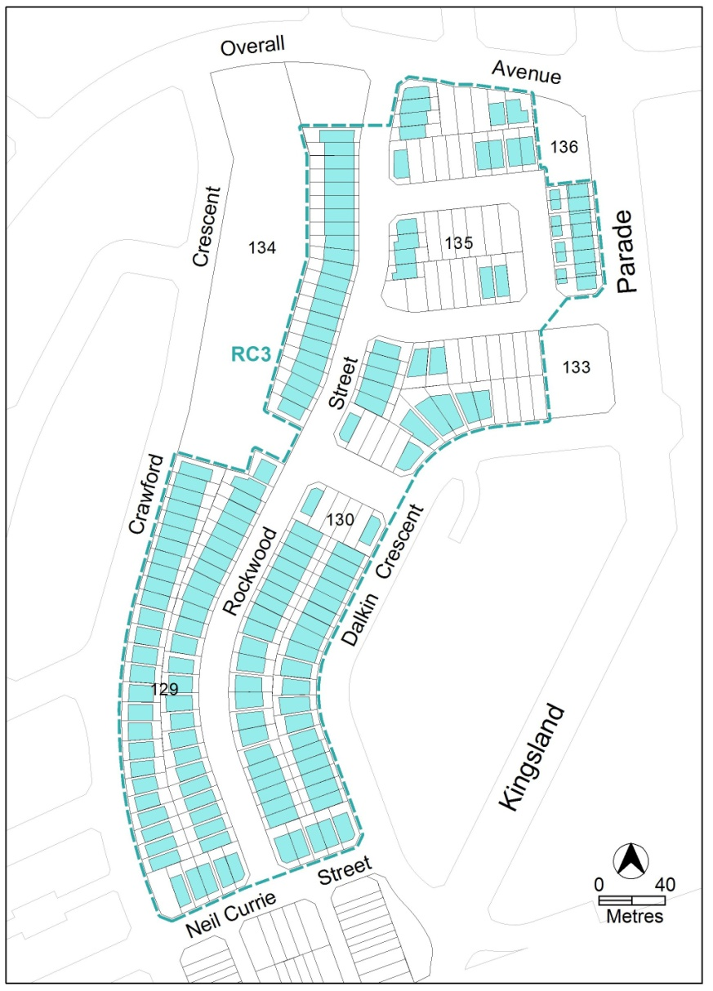

Figure 2 Maximum Building Zone

Proposed provision

RC3 – Residential
This part applies to blocks and parcels identified in area RC3 shown on the Casey Precinct Map.
Element 1: Maximum Building Zone
Rules | Criteria
1.1 Integrated Dwelling Design
R12  Dwellings are designed and sited within the maximum building zone as shown in Figure 2.  Note: the maximum building zone only relates to lower floor levels. Upper floor level to be designed in accordance with the requirements of the Single Dwelling Housing Development Code. | C12  Dwellings are designed and sited in an integrated manner to achieve passive solar efficiency and direct solar access to principal private open space of the subject and adjoining blocks.
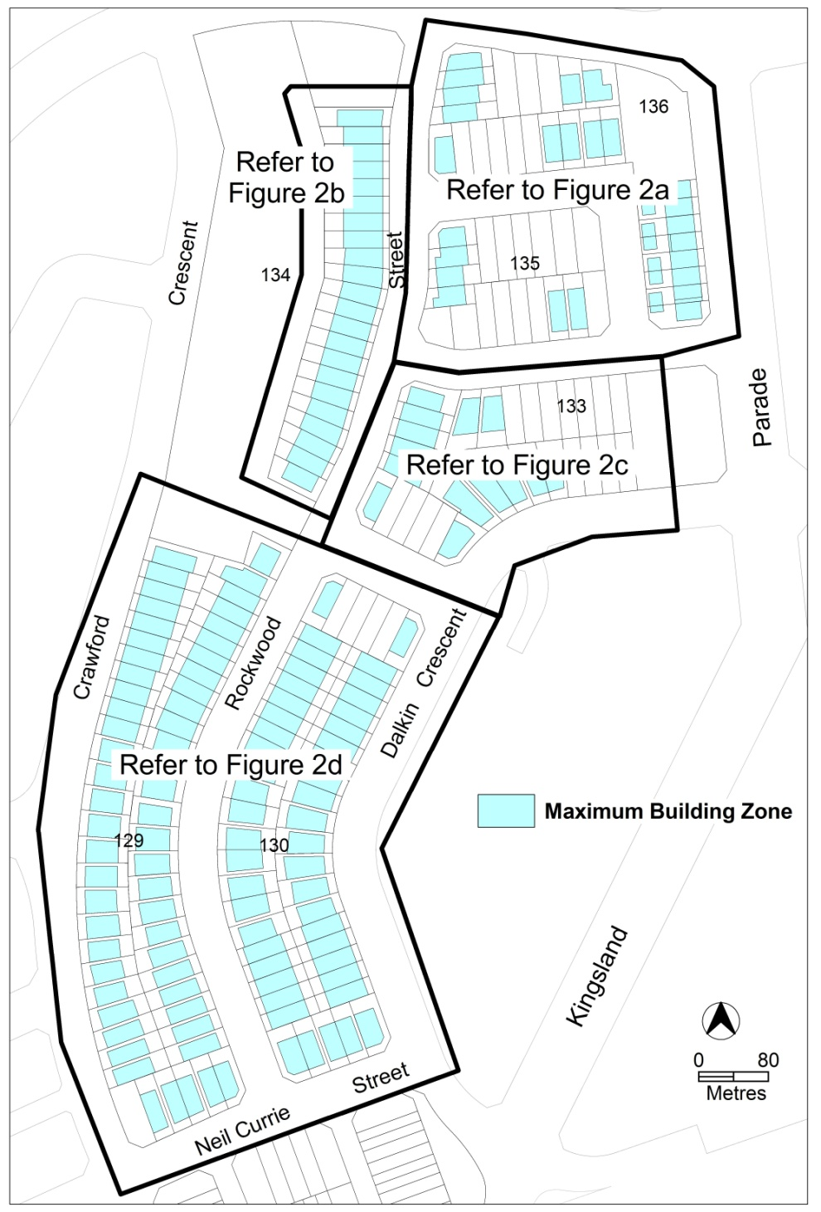

Figure 2 Maximum Building Zone

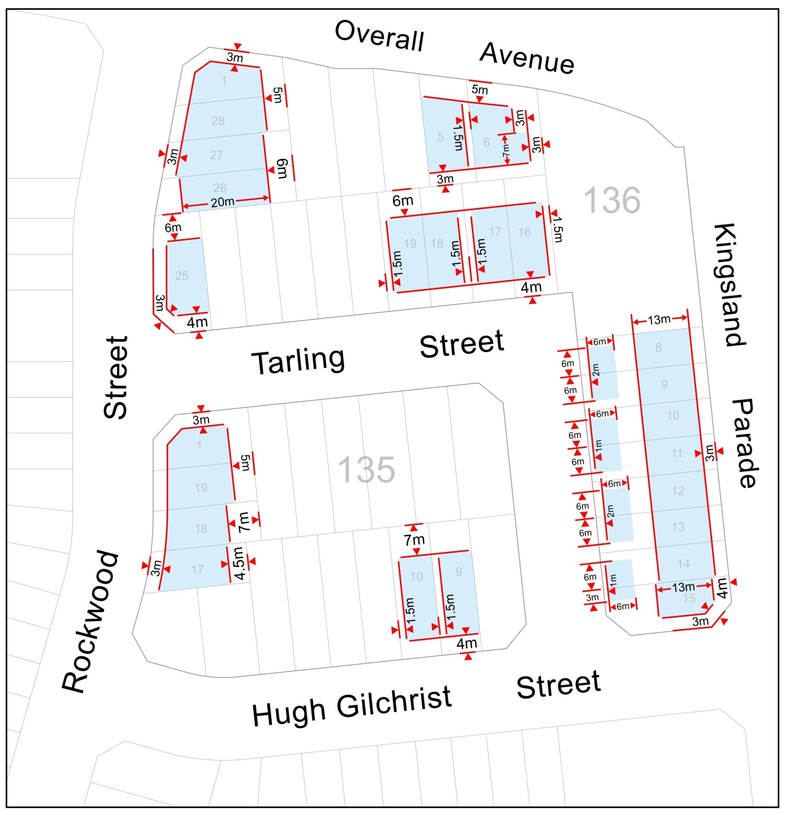

Figure 2a Detail of Maximum Building Zone - sections 135 and 136

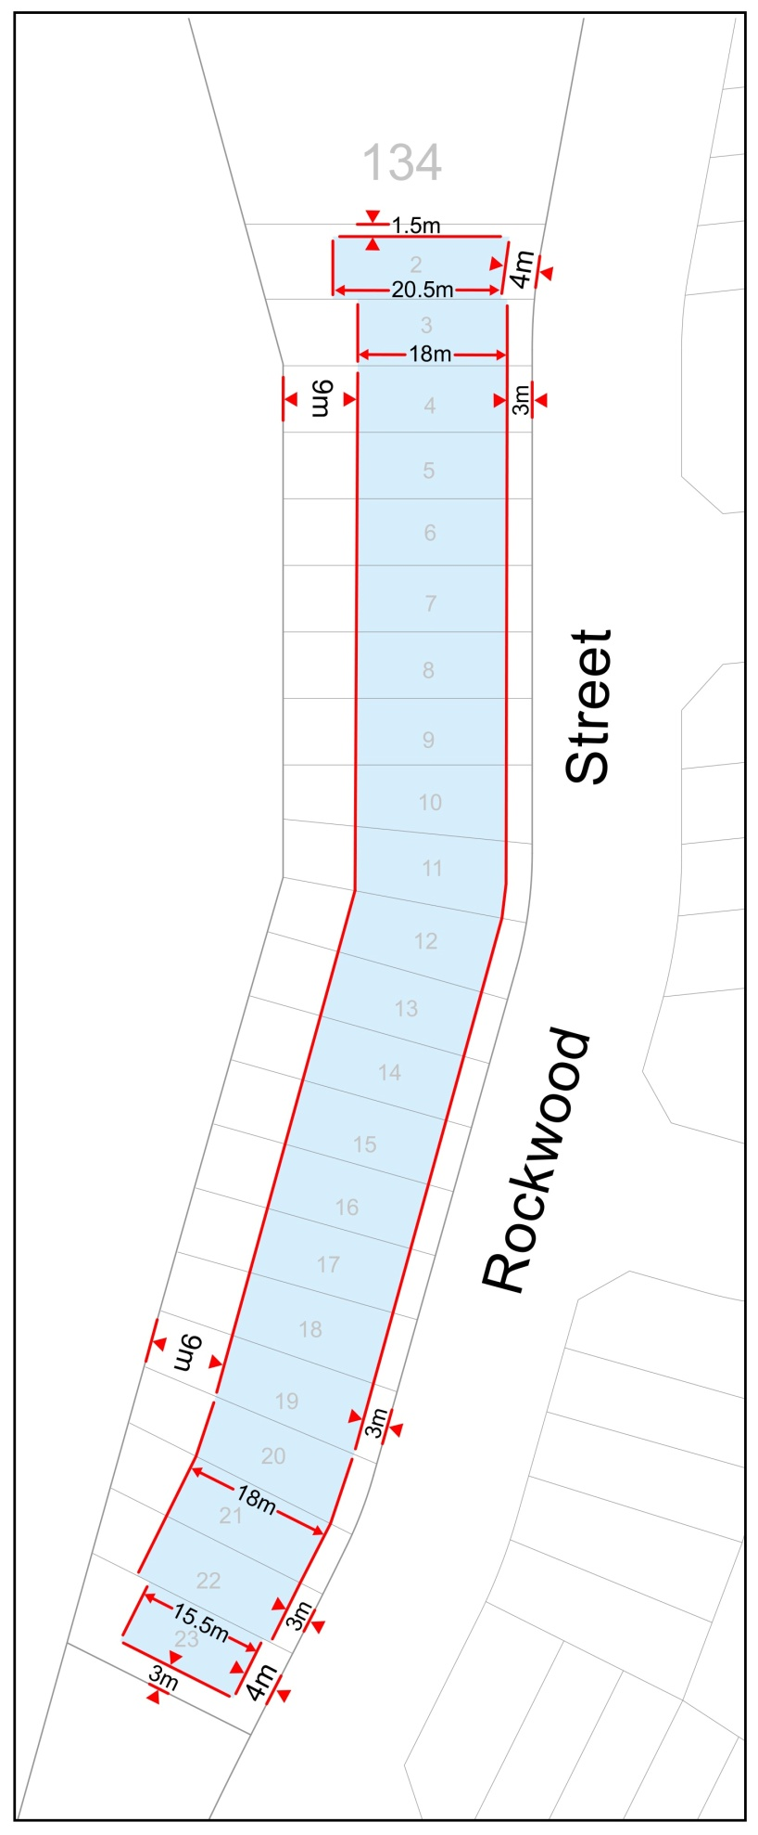
Figure 2b Detail of Maximum Building Zone - section 134
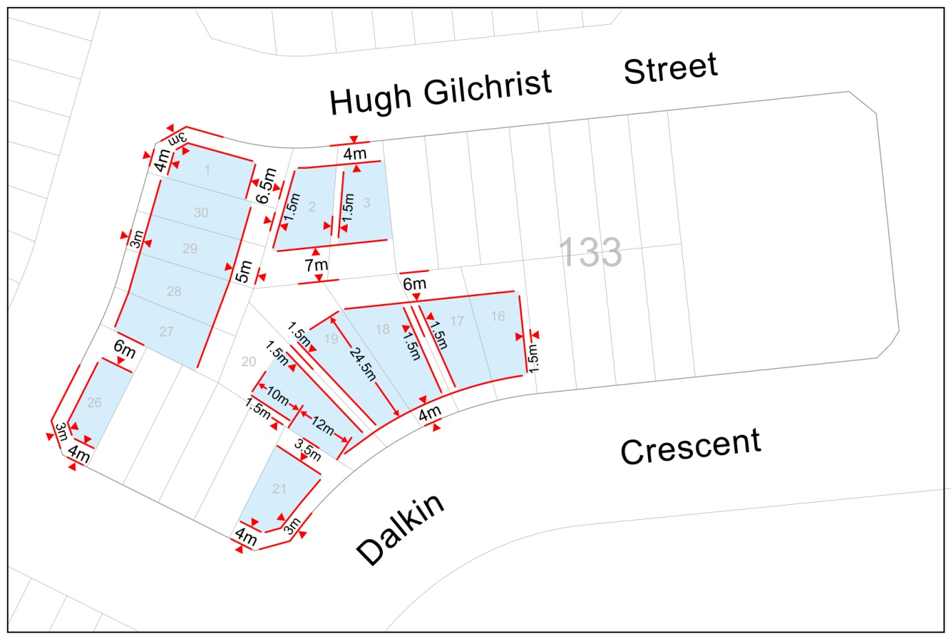
Figure 2c Detail of Maximum Building Zone - section 133

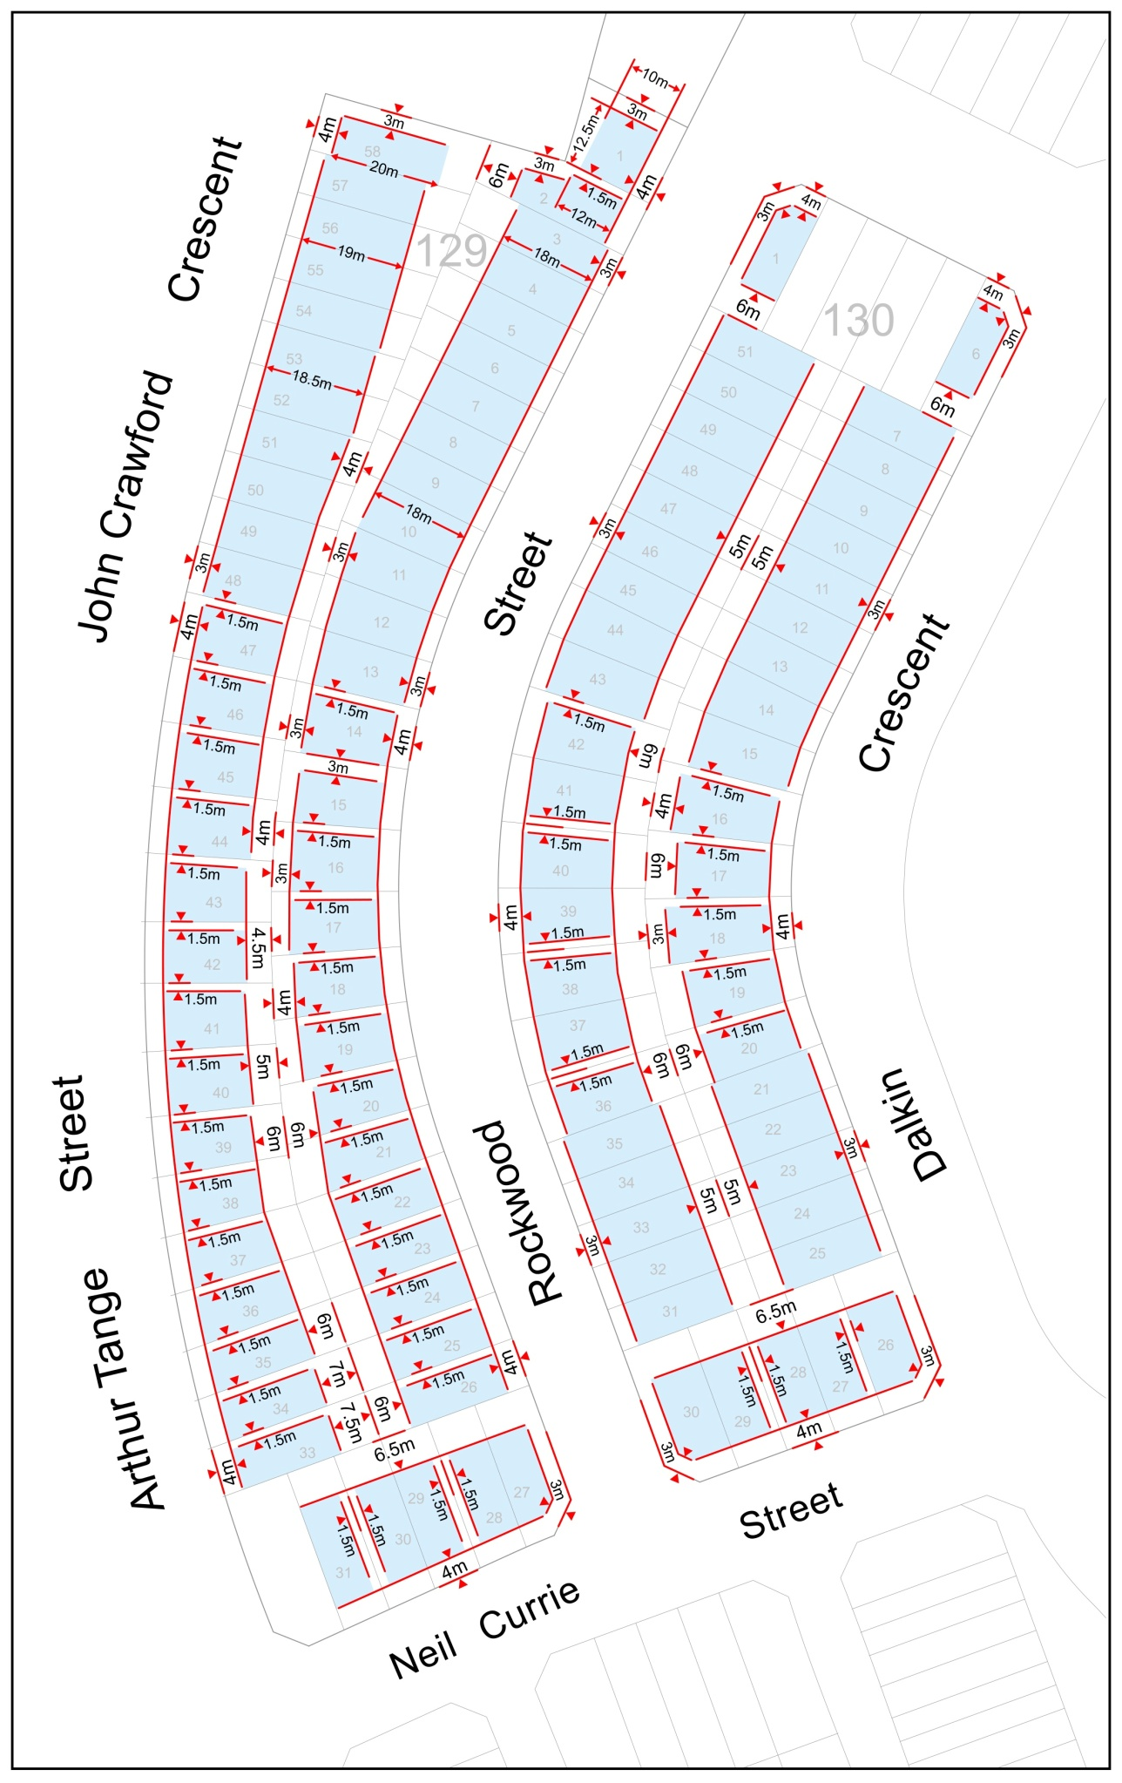
Figure 2d Detail of Maximum Building Zone - sections 129 and 130
Statement of compliance with the Planning and Development Act 2007

Section | Statement
s87(h) a variation to clarify the language in the territory plan if it does not change the substance of the plan. | Compliant. This amendment would provide greater certainty by clarifying the specific dimensions for the maximum building zones for blocks in the RC3 Residential area of Casey.

  - Definitions
The term “men’s shed” has been added to Some Common Terminology for a Community activity centre so as to clarify that this activity is a legitimate community use included under the definition of Community activity centre.

Compliance with the Planning and Development Act 2007
Section | Statement
s87(h) a variation to clarify the language in the territory plan if it does not change the substance of the plan. | Compliant. This amendment adds ‘men’s shed’ to Some Common Terminology to clarify what can be covered by the definition of community activity centre without changing the substance of the plan.

- TECHNICAL AMENDMENT
This section of the technical amendment document provides the actual instructions for implementing the changes to the Territory Plan.

  - Multi unit housing development code

- Part D – Endorsement by government agencies (entities); Element 13: Utilities; item 13.1 Utilities; Rule R101

Substitute

Rules | Criteria
13.1 Utilities
R101  A statement of compliance from each relevant utility provider (for water, sewerage, electricity, stormwater and gas) confirms that the location and nature of earthworks, utility connections, proposed buildings, pavements and landscape features comply with utility standards, access provisions and asset clearance zones.  Note 1: If there is no stormwater easement or Territory owned stormwater pipes located within the property boundary, a “Statement of Compliance” for stormwater from TAMS (Asset Acceptance) is not required to be obtained  Note 2:Where there is conflict between planning and utility requirements, the utility requirements take precedence over other codified or merit provisions  Note 3: If a statement of compliance is not provided the application will be referred to the relevant agency in accordance with the requirements of the Planning and Development Act 2007. | This is a mandatory requirement. There is no applicable criterion.

  - Casey precinct map and code

- RC3 – Residential

Substitute with:

Element 1: Maximum Building Zone
Rules | Criteria
1.1 Integrated Dwelling Design
R12  Dwellings are designed and sited within the maximum building zone as shown in Figure 2. Note: the maximum building zone only relates to lower floor levels. Upper floor level to be designed in accordance with the requirements of the Single Dwelling Housing Development Code. | C12  Dwellings are designed and sited in an integrated manner to achieve passive solar efficiency and direct solar access to principal private open space of the subject and adjoining blocks.

Figure 2 Maximum Building Zone

Figure 2a Detail of Maximum Building Zone - sections 135 and 136

Figure 2b Detail of Maximum Building Zone - section 134
Figure 2c Detail of Maximum Building Zone - section 133

Figure 2d Detail of Maximum Building Zone - sections 129 and 130
  - Definitions
- Part A – Definitions of Development: Community activity centre

Add under the column: Some Common Terminology:

Men’s shed

Interpretation service
