Australian Capital Territory
Planning and Development (Draft Special Variation No S323 Symonston Mental Health Facility) Consultation Notice 2014
Notifiable instrument NI2014–279
made under the
Planning and Development Act 2007, section 85D (Public consultation—notification)

1 Name of instrument
This instrument is the Planning and Development (Draft Special Variation No S323 Symonston Mental Health Facility) Consultation Notice 2014.
2 Commencement
This instrument commences on 20 June 2014.
3 Public consultation–notification
Copies of the draft special variation are available online at www.act.gov.au/draftvariations for public inspection during the consultation period.
Printed copies of the draft special variation are available for inspection and purchase at the Environment and Sustainable Development Directorate (ESDD) Customer Service Centre, 16 Challis Street, Dickson, Monday to Friday (except public holidays) between 8:30am and 4:30pm. Please call 6207 1923 to arrange a copy for purchase.
Written comments about the draft special variation to the Environment and Sustainable Development Customer Service Centre are invited by Friday 11 July 2014.
Comments should include reference to the draft special variation, your name and contact details, and be addressed to the Territory Plan Variation Unit.
Consultation comments can be:
- emailed to Terrplan@act.gov.au
- mailed to Territory Plan Comments, GPO Box 158, CANBERRA, ACT 2601
- delivered to ESDD’s Customer Service Centre at 16 Challis Street, Dickson

Copies of consultation comments will be made available for public inspection for a period of at least 15 working days, starting 10 working days after the day the consultation period ends. The comments will be available at ESDD’s Customer Service Centre in Dickson and may be published on ESDD’s website.
Comments made available will include personal contact details unless excluded under section 411 or 412 of the Act. A request for exclusion under these sections must be in writing, clearly identifying what you are seeking to exclude and how the request satisfies the exclusion criteria.

Jim Corrigan
Delegate of the ACT Planning and Land Authority
18 June 2014

Planning and Development Act 2007

Draft Special
Variation to the
Territory Plan
No S323

Mental Health Facility
Symonston section 49
part blocks 11 and 14

June 2014

Draft special variation for public consultation prepared
under s85B of the Planning and Development Act 2007

This page is intentionally blank.

Contents

1. INTRODUCTION 1
1.1 Summary of the proposal 1
1.2 Draft special variation 1
1.3 Outline of the process 2
1.4 This document 3
1.5 Public consultation 3
2. EXPLANATORY STATEMENT 5
2.1 Background 5
2.2 Site Description 6
2.3 Current Territory Plan Provisions 7
2.4 Proposed Changes 8
2.4.1 Proposed Definition 8
2.4.2 Proposed Changes to the Symonston Precinct Map 8
2.4.3 Proposed Changes to Symonston Precinct Table 2 8
2.5 Reasons for the Proposed Draft Special Variation 9
2.5.1 Preparation of the Draft Special Variation 9
2.5.2 Statement Against Section 85I Criteria 9
2.6 Planning Context 11
2.6.1 National Capital Plan 11
3. VARIATIONS TO THE TERRITORY PLAN 12
3.1 Special variation to the Territory Plan 12

This page is intentionally blank.

- INTRODUCTION
  - Summary of the proposal
The need for a secure mental health facility in the ACT has been identified for people who require short-to medium term treatment and placement in a secure mental health facility. The development of the facility is an ACT Government priority and is part of stage one of the ACT Government’s Health Infrastructure Program. Information about this program is available via the ACT Health Directorate website:
http://health.act.gov.au/consumers/health-infrastructure-program/
The Planning and Development 2007 (the Act) has been amended to introduce a new type of variation to the Territory Plan, being a special variation, specifically for the proposed mental health facility at Symonston. This new process, which will result in reduced timeframes for the required variation to the Territory Plan, represents a fast-tracking of the Symonston mental health facility through the planning system, while still allowing important community consultation processes to take place.

  - Draft special variation
This draft special variation number S323 (DSV323) has been prepared by the planning and land authority within the Environment and Sustainable Development Directorate (ESDD) in accordance with section 85B (1) of the Planning and Development Act 2007 (the Act) as follows:
The planning and land authority must prepare an instrument to make a draft variation of the territory plan in relation to the Symonston mental health facility (the draft special variation).
The draft special variation seeks to amend the Symonston precinct map and tables to allow the development of the site for a mental health facility in the area stipulated in schedule 6 of the Act, being part of blocks 11 and 14, section 49 Symonston, to be assessed under the merit development track of the Territory Plan.

  - Outline of the process
The Commonwealth’s Australian Capital Territory (Planning and Land Management) Act 1988 allows for the Legislative Assembly to make laws to establish a Territory Planning Authority and for that Authority to prepare and administer a Territory Plan. The Planning and Development Act 2007 (the Act) establishes the planning and land authority as the Authority which prepares and administers the Territory Plan, including continually reviewing and proposing amendments as necessary. The functions of the planning and land authority are administered by the Environment and Sustainable Development Directorate (ESDD).
The Territory Plan is comprised of a written statement and a map. The written statement contains a number of parts, namely governance; strategic directions; zones (including objectives and development tables and zone or centre development codes); precinct maps; precinct codes; general codes; overlays; definitions; structure plans, concept plans and development codes for future urban areas.
The Territory Plan Map graphically represents the applicable land use zones (under the categories of residential, commercial, industrial, community facility, urban parks and recreation, transport and services and non urban), precincts and overlays. The zone, precinct and overlay requirements are detailed in the Territory Plan.
Draft variations, including draft special variations, to the Territory Plan are prepared in accordance with the Act. Section 85B of the Act requires the planning and land authority to prepare a draft variation of the Territory Plan in relation to the Symonston mental health facility (the draft special variation). The draft special variation must identify the Symonston site and include any Territory Plan variations that are required to implement the special variation. The draft special variation must also state how the special variation would meet the criteria in section 85I, which sets out when the Executive may make a special variation.
Section 85C of the Act requires the planning and land authority to give written notice to the National Capital Authority inviting comment on the draft special variation.
Section 85D of the Act requires the planning and land authority to prepare a consultation notice stating that copies of the draft special variation are available for public inspection and purchase during the consultation period, and inviting people to give written comments about the draft special variation to the planning and land authority.

At the conclusion of the consultation period the planning and land authority must give the draft special variation to the Executive together with a report on consultation, which details any issues raised in accordance with section 85G of the Act.
The Executive may make the special variation for the Symonston mental health facility by a notifiable instrument that is published on the legislation register. The consultation report on the draft special variation must be included in the notifiable instrument.
The usual development application processes apply to the mental health facility.

  - This document
This document contains the background information in relation to the proposed special variation. It comprises the following parts
Part 1 This Introduction
Part 2 An Explanatory Statement, which gives reasons for the proposed special variation and describes its effect
Part 3 The changes to the Territory Plan that are required to implement the proposed special variation
  - Public consultation
Written comments about the draft special variation are invited from the public for 15 business days until the date stated in the consultation notice. The consultation notice is a notifiable instrument available on the ACT Legislation Register at www.legislation.act.gov.au. The consultation notice may also be accessed at the Environment and Sustainable Development Directorate (ESDD) website at www.act.gov.au/draftvariations.
Comments should include reference to the draft variation, your name and contact details, and be addressed to the Territory Plan Section.
Comments can be:
- emailed to terrplan@act.gov.au
- mailed to Territory Plan Comments, GPO Box 158, Canberra, ACT 2601
- delivered to ESDD’s Customer Service Centre at 16 Challis Street, Dickson
Copies of written comments will be made available (unless excluded) for public inspection for no less than 15 working days starting 10 working days after the closing date for comment. The comments will be available at ESDD’s customer service centre in Dickson and may be published on ESDD’s website.
Comments made available will include personal contact details unless excluded under section 411 or 412 of the Planning and Development Act 2007. A request for exclusion under these sections must be in writing, clearly identifying what you are seeking to exclude and how the request satisfies the exclusion criteria.
Further Information
The draft variation is available online at www.act.gov.au/draftvariations until the closing date for written comments.
Printed copies of the draft variation (this document) are available for inspection and purchase at the Environment and Sustainable Development Customer Service Centre, 16 Challis Street, Dickson, Monday to Friday (except public holidays) between 8:30am and 4:30pm. Please call 6207 1923 to arrange a copy for purchase.

- EXPLANATORY STATEMENT
  - Background
The need for a secure mental health facility in the ACT has been identified for people who require short-to medium term treatment and placement in a secure mental health facility. The development of the facility is an ACT Government priority and is part of stage one of the ACT Government’s Health Infrastructure Program.
The Planning and Development Act 2007 has been amended to facilitate the development of the mental health facility at Symonston consistent with the ACT Government’s commitment to the project.
In order to facilitate the development of a secure mental health facility at Symonston it is necessary to make changes to the Territory Plan. These changes involve inserting a new definition for a ‘mental health facility’ for the Symonston site into the definitions. A ‘mental health facility’ is added as an additional merit assessable use into the Symonston precinct code. No zoning changes are proposed.

  - Site Description
The subject site (refer to Figure 1 below) is located in the district of Symonston, south of Hindmarsh Drive, with access onto Mugga Lane. It is the site of the former Quamby youth detention centre, which operated between 1962 and 2008. The site is within the non urban area NUZ1 broadacre zone and adjoins a designated area, as defined in the National Capital Plan.

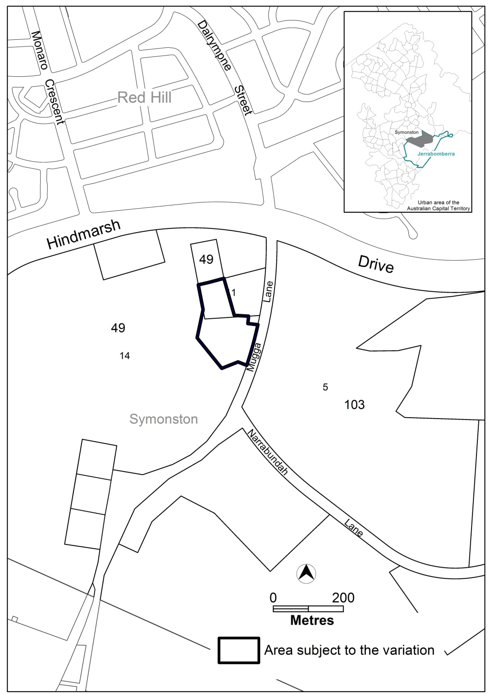
Figure 1 Site Plan

  - Current Territory Plan Provisions
The Symonston precinct map, currently applying to the area subject to this variation is shown in Figure 2.
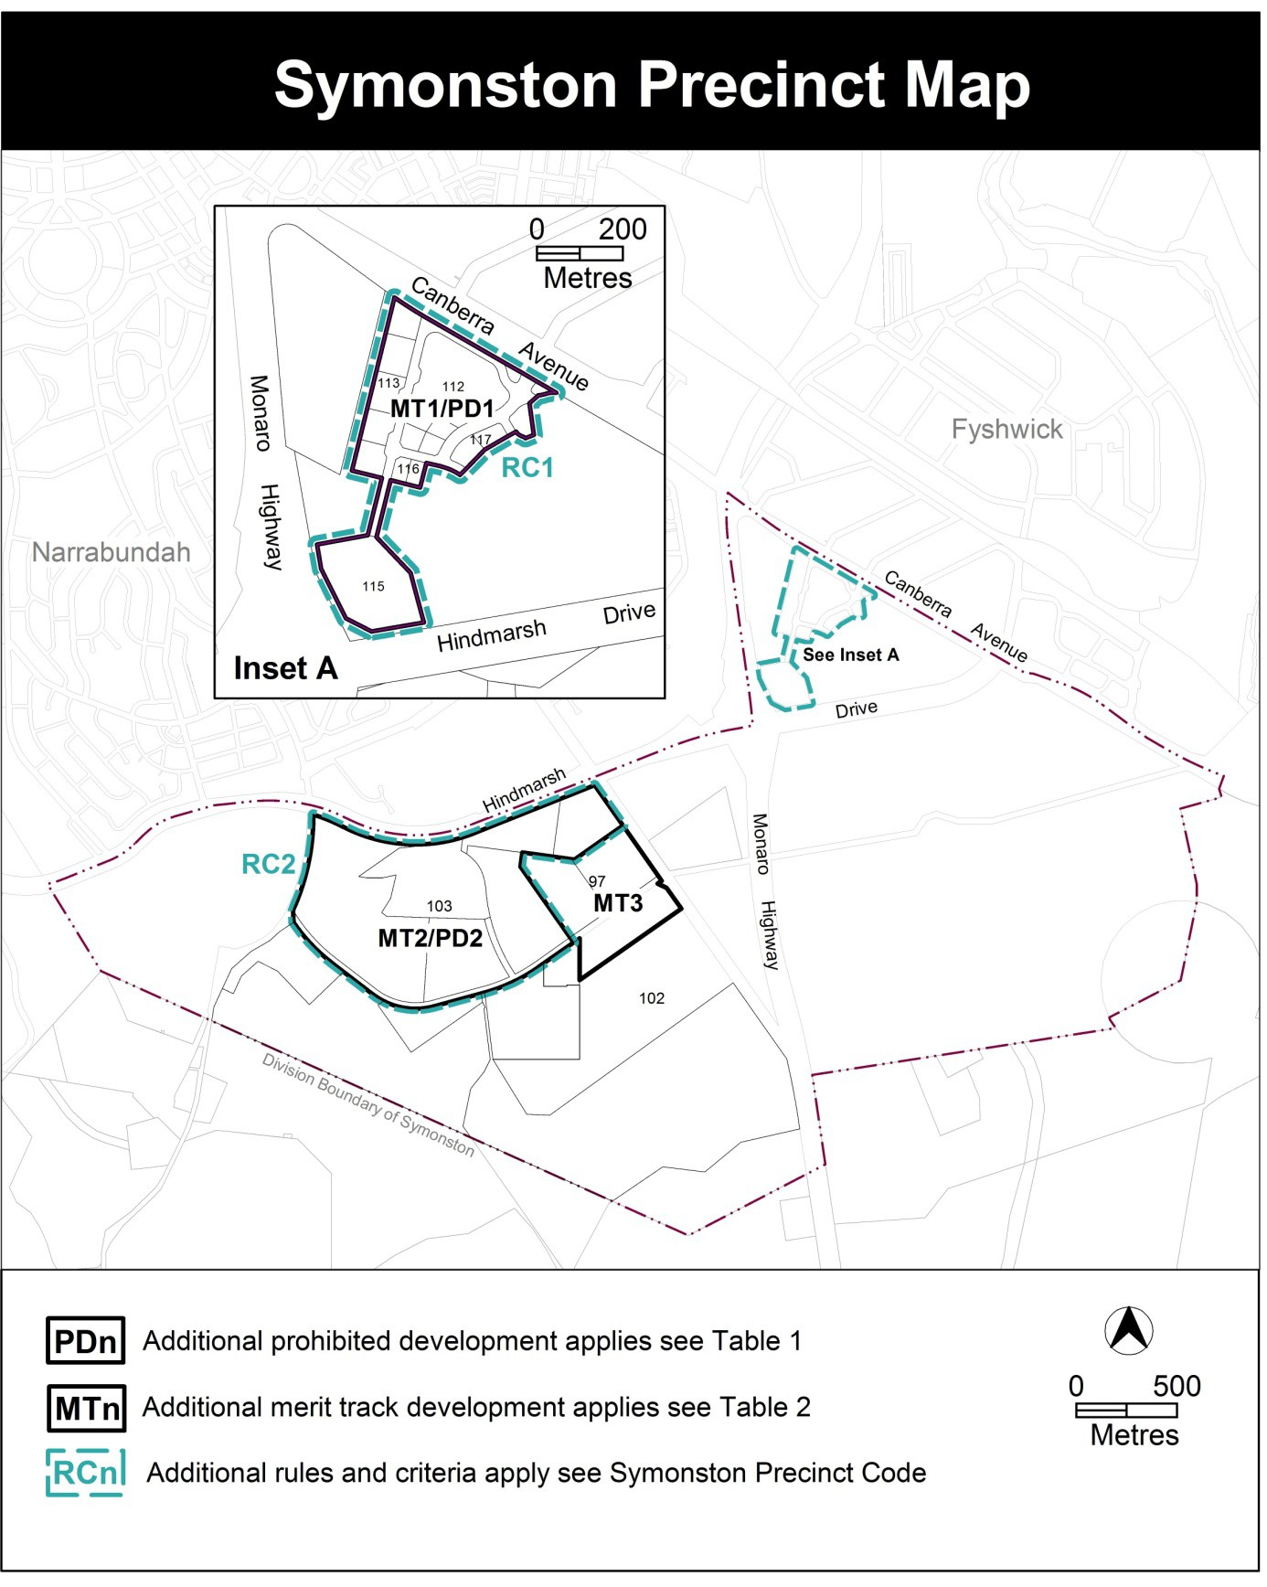Figure 2 Symonston Precinct Map

  - Proposed Changes
    - Proposed Definition
A definition for a mental health facility that will only apply to the Symonston site is proposed to be inserted into the Territory Plan. The definition confirms the intended use of the Symonston site for a mental health facility, as required by the Planning and Development Act, 2007. In doing so it differentiates the use of the Symonston site from other forms of health facilities.
The definition has the same meaning as under the Mental Health (Treatment and Care) Act, 1994. To assist understanding of the definition some common terms are proposed.
The following definition and some common terminology are proposed as follows:

Development | Some Common Terminology
Mental health facility has the same meaning as in the Mental Health (Treatment and Care) Act 1994 and this definition is only to be used for the Symonston site as defined in MT4 of the Symonston Precinct Map. | Secure mental health facility  Secure mental health unit

    - Proposed Changes to the Symonston Precinct Map
The proposed changes to the Symonston precinct map are indicated in Part 3 of this document and are intended to identify the site in Symonston where a mental health facility will be merit assessable development as follows:
- The Symonston precinct map is amended to include a new MT4 area – being the area of the proposed mental health facility.

    - Proposed Changes to Symonston Precinct Table 2
The proposed changes to the Symonston precinct table 2 are indicated at part 3 of this document and are intended to ensure that a mental health facility will be merit assessable development at the site identified in the Symonston precinct map as follows:
- Insert a new MT4 overlay for mental health facility as additional merit track development.

  - Reasons for the Proposed Draft Special Variation
    - Preparation of the Draft Special Variation
This draft special variation is prepared in accordance with section 85B of the Planning and Development Act 2007 (the Act).

Section 85B (c) of the Act states that the draft variation must state how the special variation would meet the criteria in section 85I.

    - Statement Against Section 85I Criteria
The Executive may only make the special variation under section 85I if—

(a) the planning and land authority has consulted the national capital authority and the public about the draft special variation in accordance with the requirements in section 85C; and

Response

This document (draft special variation) has been prepared for the comment of the National Capital Authority and the public.

(b) the Executive has considered the planning and land authority’s consultation report provided to the Executive by the authority under section 85G; and

Response

Any comments from the National Capital Authority or the public will be detailed in a report on consultation for consideration by the Executive.

(c) the Executive considers—
(i) the special variation will facilitate the Symonston mental health facility at the Symonston site; and

Response

The special variation will facilitate the Symonston mental health facility at the Symonston site by:
- Creating a new Territory Plan definition of ‘mental health facility’ for the Symonston site by referring to the dictionary definition in the Mental Health (Treatment and Care) Act 1994
and
- Amending the Symonston precinct map and assessment tracks (table 2) of the Territory Plan such that a mental health facility will be ‘merit assessable’ development on the subject land

(ii) there is no substantive public policy reason for the development of the Symonston mental health facility not to proceed. However, the Executive may make the special variation in a revised form to the draft special variation if, having regard to the report of the planning and land authority under section 85G, the Executive considers it appropriate to do so.

Response

The Symonston mental health facility is consistent with relevant public policy considerations including:
- It is considered that the proposal in not inconsistent with the National Capital Plan. The planning and land authority has invited comment from the National Capital Authority on this draft special variation.
- The proposal is consistent with the ACT Planning Strategy and the Statement of Strategic Directions of the Territory Plan by accommodating the development of a facility which:
  - responds to an identified need for a mental health facility to provide specialist health services for vulnerable members of the Canberra community with complex mental health needs
  - is located on a site that is:
    - currently surplus to ACT Government requirements and available for redevelopment
    - well located between the Alexander Maconochie Centre and the Canberra Hospital
    - separated from the surrounding built up residential areas
    - of a suitable size for the facility to be designed and sited to create a high quality bush setting offering a pleasant therapeutic environment.

  - Planning Context
    - National Capital Plan
The Australian Capital Territory (Planning and Land Management) Act 1988 established the National Capital Authority (NCA) with two of its functions being to prepare and administer a National Capital Plan (NCP) and to keep the NCP under constant review and to propose amendments to it when necessary.
The NCP, which was published in the Commonwealth Gazette on 21 January 1990, is required to ensure that Canberra and the Territory are planned and developed in accordance with their national significance. The Planning and Land Management Act 1988 also required that the Territory Plan is not inconsistent with the NCP.

- VARIATIONS TO THE TERRITORY PLAN
  - Special variation to the Territory Plan
The following variations to the Territory Plan are required to implement the special variation:

Variation to the Symonston precinct map
- Precinct Maps and Codes; Symonston Precinct Map and Code; Symonston Precinct Map

Substitute
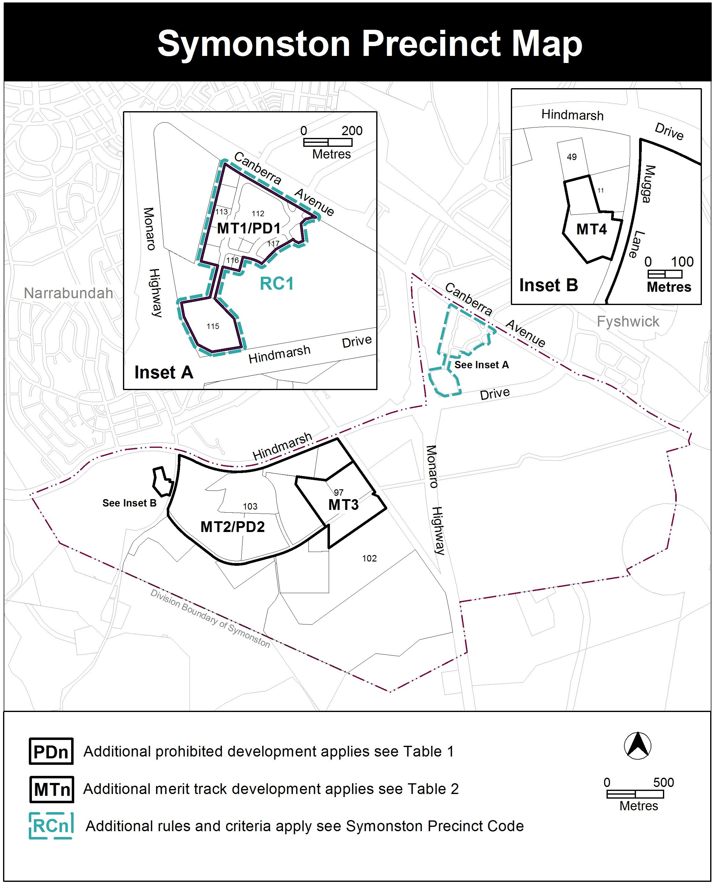
- Precinct Maps and Codes; Symonston Precinct Map and Code; Assessment Tracks; Table 2 – Additional merit track development

Substitute

Additional merit track development that may be approved subject to assessment
Suburb precinct map label | Zone | Development
MT1 | IZ1 | SHOP (excluding bulky goods  retailing)
MT2 | NUZ1 | cultural facility
MT3 | NUZ1 | mobile home park
MT4 | NUZ1 | Mental health facility

- Definitions; Part A – Definitions of Development

Insert
Umbrella Term | Development | Sub-categories | Some Common Terminology
 | Mental health facility has the same meaning as in the Mental Health (Treatment and Care) Act 1994 and this definition is only to be used for the Symonston site as defined in MT4 of the Symonston Precinct Map. |  | Secure mental health facility  Secure mental health unit

Interpretation service
