Australian Capital Territory

Pest Plants and Animals (Fireweed) Management Plan 2014 (No 1)

Notifiable Instrument NI2014—333

made under the

Pest Plants and Animals Act 2005, section 8 (Pest plant management plan)

1 Name of instrument
This instrument is the Pest Plants and Animals (Fireweed) Management Plan 2014 (No 1).

2 Commencement
This instrument commences on the day after notification.

3 Pest plant management plan – Fireweed
The document at schedule 1 is the pest plant management plan for the management of Fireweed (Senecio madagascariensis).

Shane Rattenbury
Minister for Territory and Municipal Services

15 July 2014

Australian Capital Territory

Pest Plant Management Plan - Fireweed
(Senecio madagascariensis)

made under the Pest Plants and Animals Act 2005, Part 2, Section 8 (1)
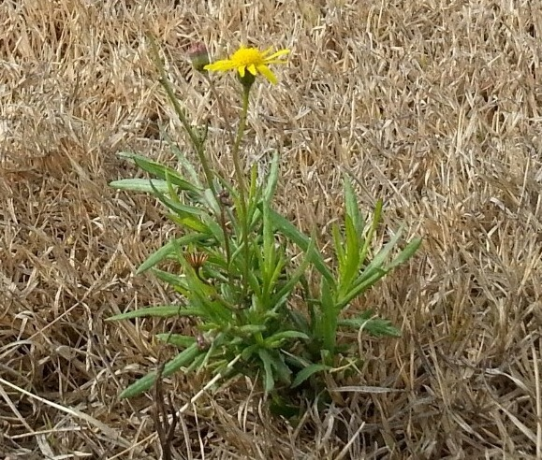
Fireweed in dormant Couch Turf. Photo by J.Conolly.

July 2014

Introduction

Fireweed (Senecio madagascariensis) was first recorded in the Hunter Valley in New South Wales around 1918. It may have been brought in as a garden plant or through shipped products. In the last 30 years it has rapidly increased its range, most likely through long distance transportation of agricultural and horticultural produce.

Fireweed is a declared pest plant in the ACT and is prohibited, notifiable and must be suppressed. Whist it is relatively common in many areas of NSW it is only occasionally found in the ACT, often in contaminated landscape materials.

This Pest Plant Management Plan (PPMP) provides a background to the species and its legal status, current locations in the ACT and region, the means of spread, threats posed by the species, control methods and the offences applicable under the ACT Pest Plants and Animals Act 2005.

Fireweed is recognised as a Weed of National Significance (WoNS) and a serious threat to biodiversity and agricultural production in the ACT.

This Plan is prepared in accordance with the Pest Plants and Animals Act 2005 and requires that any occurrence of Fireweed must be destroyed and its presence notified to the Director General of Territory and Municipal Services within 2 working days of becoming aware of its presence.

The following activities are an offence under the Pest Plants and Animals Act 2005:
- Any propagation or cultivation of the plant in the ACT; and
- The importation of Fireweed plants, seeds or materials contaminated with plants or seeds into the ACT.

Scope

This Pest Plant Management Plan applies to all urban and rural land in the ACT.

Legal status of Fireweed (S. madagascariensis)

Fireweed is declared under legislation in the following states and territories:

Federal Government
Fireweed was added as a Weed of National Significance (WoNS) in 2012.

New South Wales
Fireweed is a Class 4 noxious weed in 18 local government areas of NSW under the NSW Noxious Weeds Act 1993. This means the growth and spread of this species must be controlled according to the measures specified in a management plan published by the local control authority and the plant may not be sold, propagated or knowingly distributed (in a minority of local authority areas).

Queensland
Fireweed is a Class 2 weed, i.e. one that has already spread widely, but its impact is so serious that it needs to be controlled to avoid further spread onto properties that are still free of the pest. Landowners must take all reasonable steps to keep land free of this species (throughout the entire state). It is also illegal to sell a declared plant or its seed.

Western Australia
Fireweed is on the prohibited species list and not permitted entry into the state.

Victoria
Fireweed is an alert species in this state as it is considered to be a high-risk species due to its invasive potential and ability to adapt to climatic extremes. It has been recorded in East Gippsland.

South Australia
Fireweed is not yet present in SA, but has been declared a Class 2 weed to prevent its establishment as a naturalised species and to contain and destroy infestations if they occur.

ACT
Fireweed is a notifiable pest plant (i.e. a pest plant whose presence must be notified), and a prohibited pest plant (i.e. a pest plant whose propagation and supply is prohibited).

Identification

Fireweed is a daisy-like plant that grows from 10 to 60 cm high. It has a variable growth habit and leaf structure, but the most common form of fireweed is a low, heavily branched, annual or shortlived perennial plant.

Leaves
Generally bright green in colour, fleshy and narrow, leaves are 2–7 cm long, alternately arranged on the stem, and have serrated, entire or lobed margins. Broader leaves usually clasp around the stem.

Flowers
Small, yellow and daisy-like, flowers are 1–2 cm in diameter and arranged in clusters at the end of each branch. They can number from 0 to 200 per plant, and each flower will commonly have 13 petals and 21 bracts forming the ‘cup’ under the flower.

Seeds
Seeds are small (1–3 mm long), light and slender. They are cylindrical in shape and have a downy surface. They are attached to a pappus, consisting of fine, silky, white feathery hairs that aid in dispersal by wind.

Roots
Fireweed has a shallow, branched taproot with numerous fibrous roots growing from 10 to 20 cm deep.

Current & Potential Distribution in Australia

Fireweed is largely restricted to the south-eastern coast of Australia and has established along the entire NSW coast. First recorded in the Hunter Valley in 1918, it has spread south into Victoria and occurs as far north as central Queensland. It also occurs on the northern and southern tablelands of NSW and as isolated infestations in parts of inland NSW.

Recently new populations have been located in central and northern Queensland (Atherton Tableland and Roma).

In Victoria S. madagascariensis has been recorded in east Gippsland.

Fireweed is primarily a weed of beef and dairy pasture east of the Great Dividing Range and has the potential to infest extensive areas of valuable pasture over a wide area of the eastern seaboard, tablelands and rangeland locations.

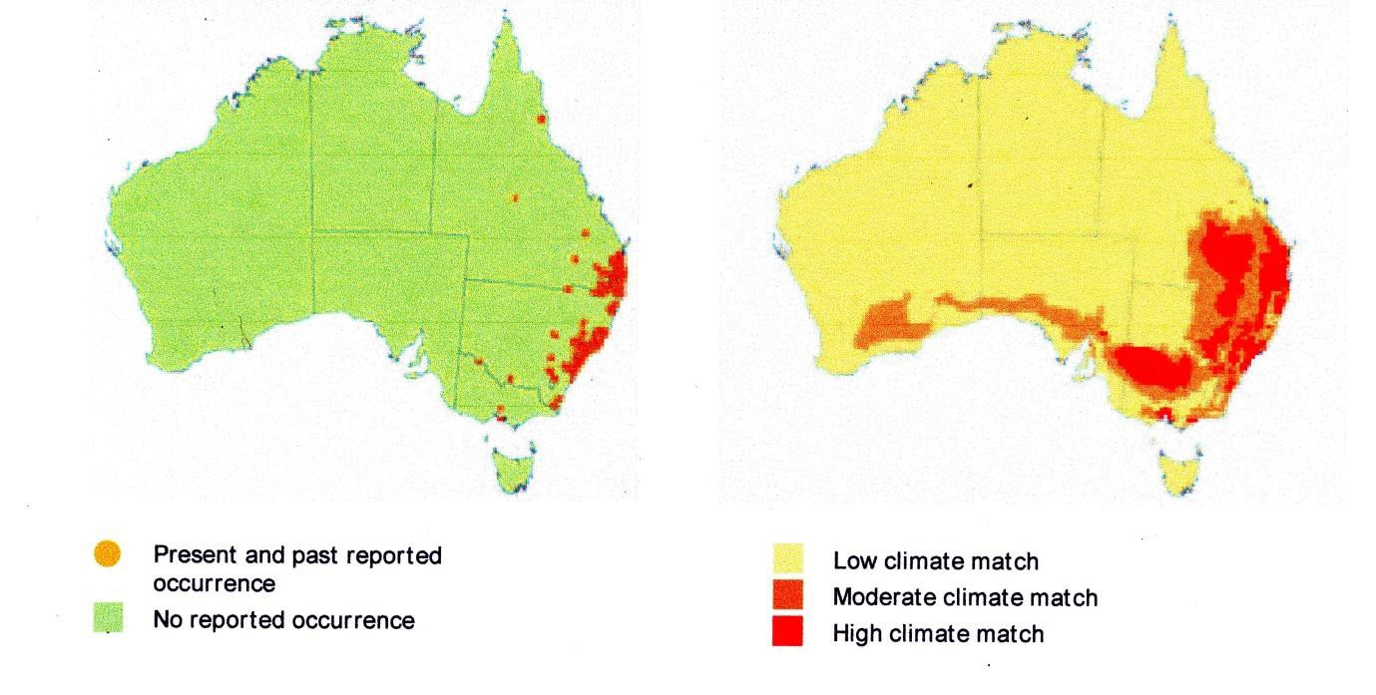Maps from Weed Management Guide – Fireweed. Licensed from the Commonwealth of Australia under a Creative Commons Attribution
3.0 Australia Licence.

The above maps indicate the current occurrence of S madagascariensis and the potential areas of a suitable and moderate climate match in Australia. S. madagascariensis has not yet reached its potential distribution, but the potentially suitable climatic areas match well all areas where the species currently occurs.

Current & potential distribution in the region & ACT
In our region Fireweed was first located along the verges of Mac’s Reef Road (Palerang Shire) abt. 2007. This road is a heavily used road for the transport of fodder from the south coast (Bega area) to rural residential zones and the ACT.

The species has recently arrived in the Australian Capital Territory. There are large patchy and scattered infestations (10% - 50% cover) on nature strips in the new suburbs of Crace, Franklin and Forde. These infestations are of considerable concern as they are located close to Mulligans Flat Nature Reserve, Mulangarri Grassland Reserve, Gungahlin Hill Nature Reserve and the Mitchell grasslands.

There are two other isolated infestations in suburban ACT, one site at Commonwealth Park and one plant confirmed in Mt Mugga –Mugga Nature Reserve.

Isolated infestations have also been located on the Federal Highway (in line with the route of outbreaks on Mac’s Reef Road in Palerang Shire) and the Monaro Highway, another route for fodder from the NSW south coast. New incursions in the ACT have also been associated with couch turf imported from suppliers in the Sydney region.

The six maps on the following pages indicate the known locations of Fireweed in the ACT.

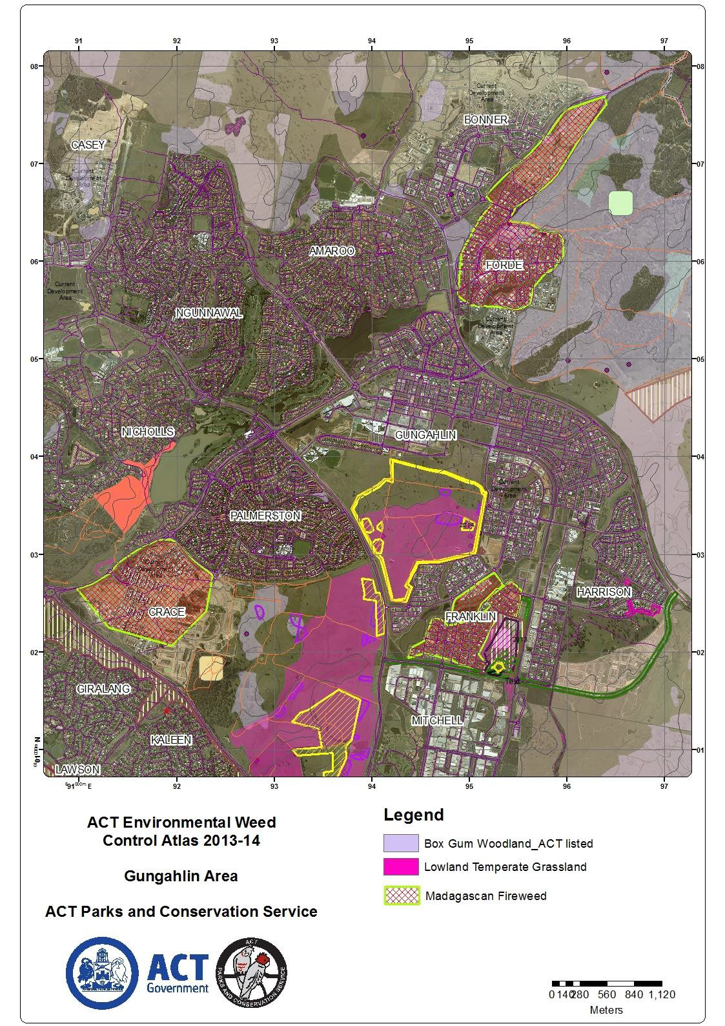

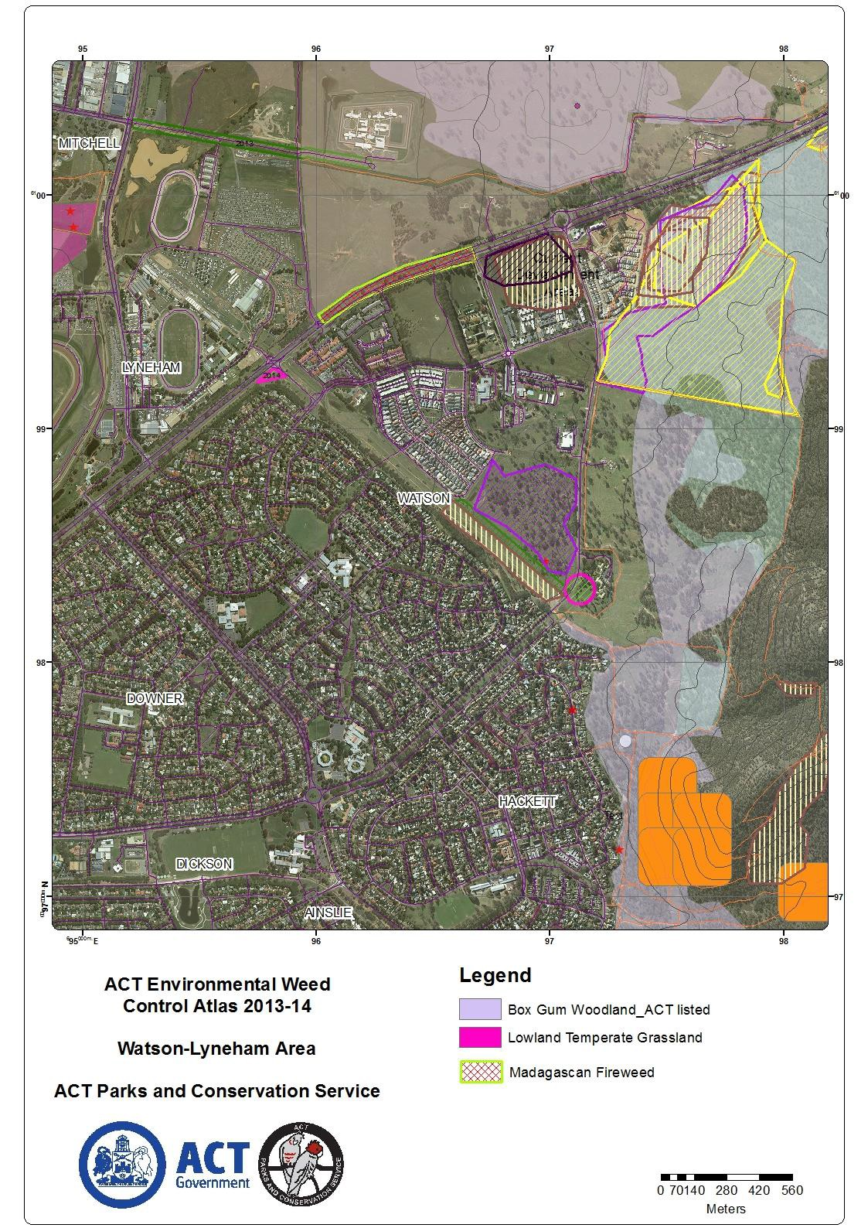

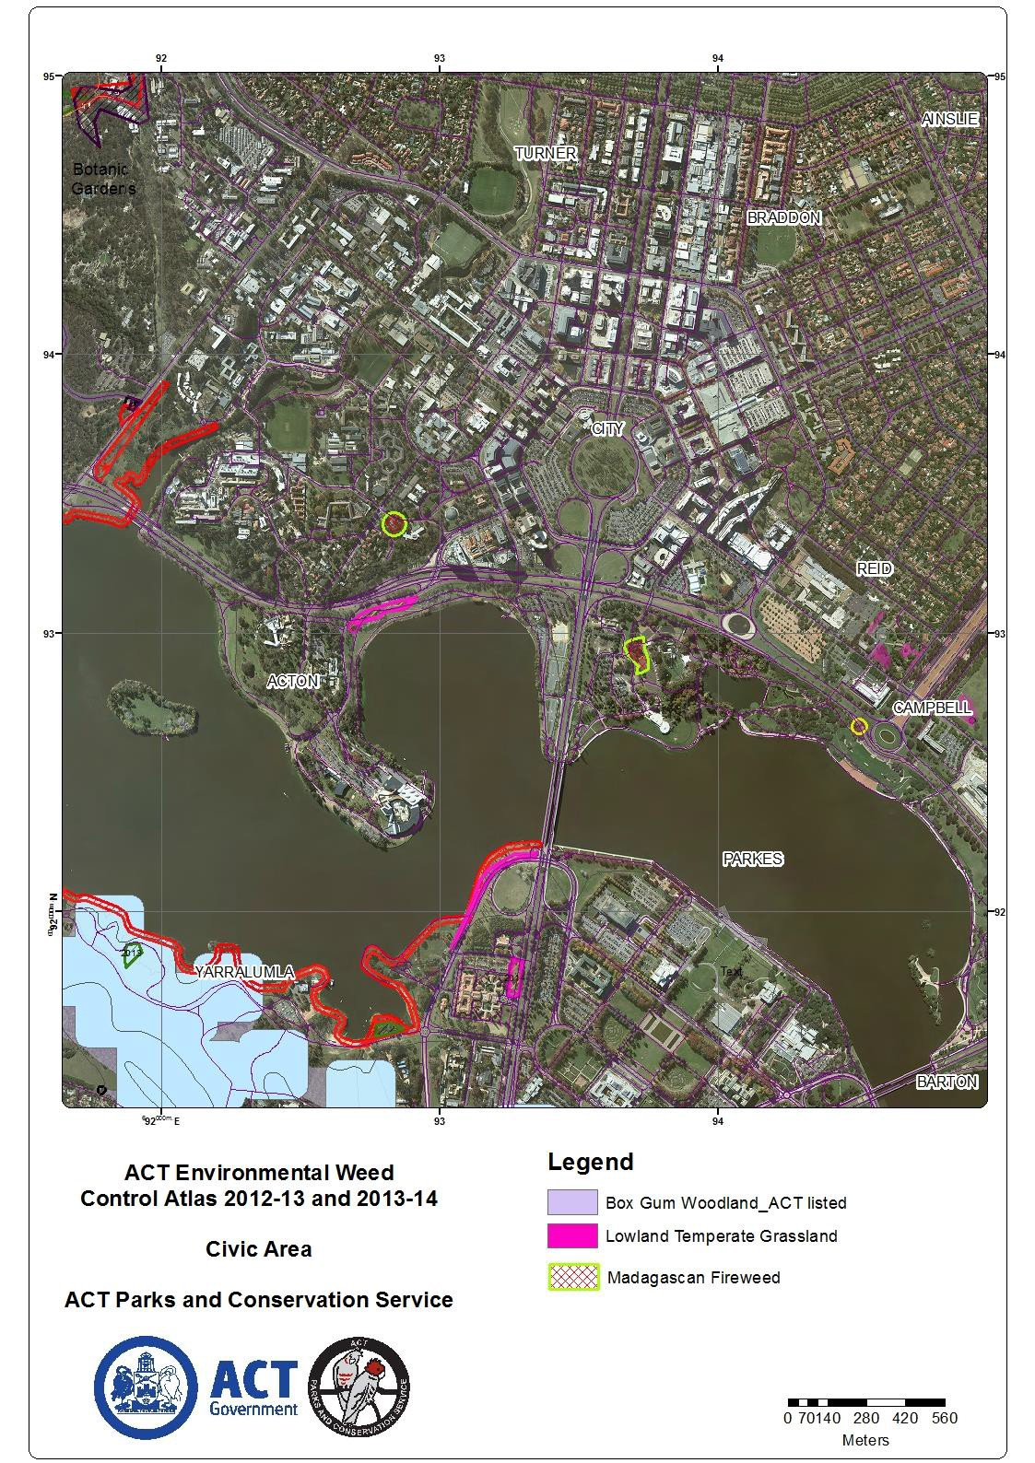

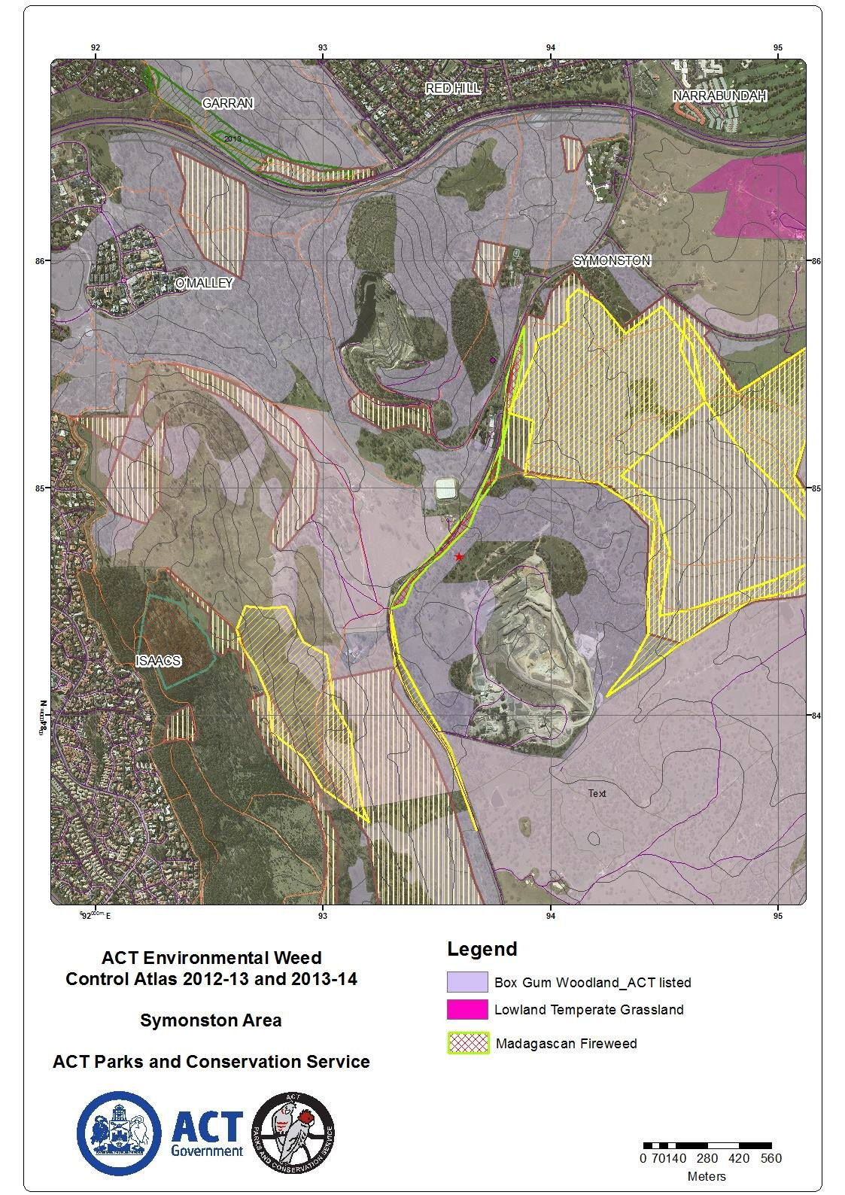

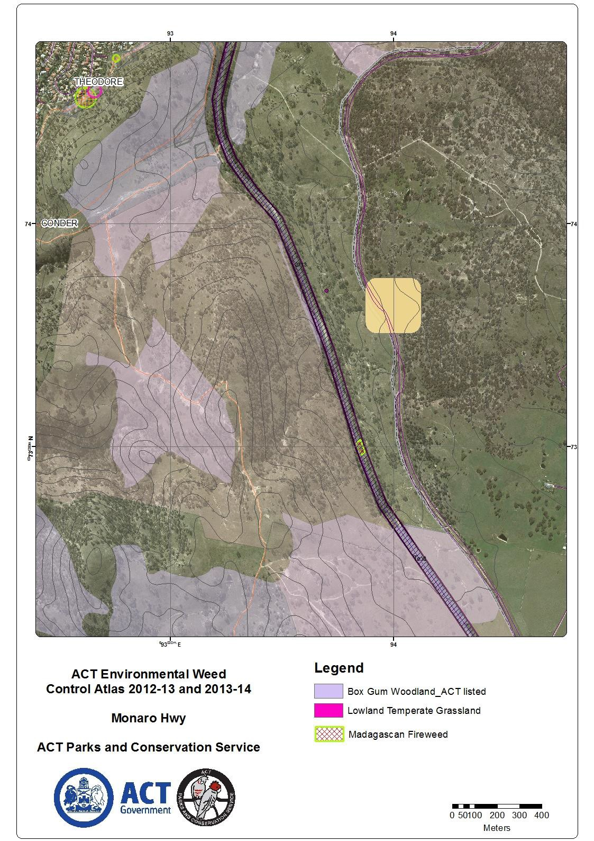

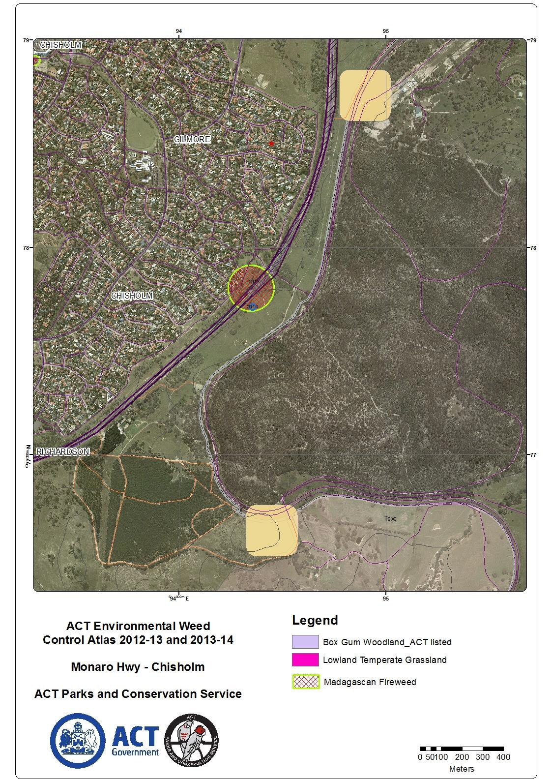

Main Means of Spread
S. madagascariensis reproduces primarily from seeds but can also occasionally form roots from stems that are in contact with earth or compost (mulch) as is common in many species of soft-wooded Asteraceae genera.

The seed is mainly dispersed by wind (usually within 5-10m of parent plant unless in windy conditions where the distance travelled could be substantially greater), but seeds may also be spread by animals (domestic, feral and natural wildlife), soil movement, vehicles and agricultural machinery, people (clothing) and contaminated hay, silage, grain and horticultural products. The latter materials (agricultural and horticultural produce) are transported considerable distances, and therefore are highly probably the main means of long distance dispersal. This is certainly the case for the outbreak of infestations in the ACT, where contaminated turf and fodder have been the causes of spread.

Flushes of flowering occur in spring and autumn, though some plants can be found flowering at most times of the year, making it difficult to stop fresh seed from entering the soil if plants are only controlled irregularly. Seed germination occurs in moist soils in Autumn and late Winter/Spring in temperatures between 15°C and 27°C. Individual plants produce between 25,000 and 30,000 seeds per annum. It has been recorded that an average of 42% of seedlings survived to maturity, and that 50% of plants flowered before they were 3 months old. About 80% of seeds have no dormancy period (or a low level of dormancy) and will germinate readily under suitable conditions of moisture and light. Seeds can remain viable for up to 10 years so Fireweed can produce a substantial soil seed-bank capable of rapid germination when conditions are favourable.

S. madagascariensis and the indigenous S. pinnatifolius share the two most abundant pollinators, honeybees and hoverflies, so S. madagascariensis is unlikely to be constrained by a lack of pollinators. S. madagascariensis is also grazed less than S. pinnatifolius, making it more likely to survive in new areas of infestation.

Preferred Habitats
The preferred habitats are disturbed sites including roadsides, railway easements and “waste” areas, but also grazed pasturelands. It has also been recorded in open woodlands, native grasslands, suburban bushland and parks. It appears to be reluctant to establish in undisturbed bushland, as Fireweed does not thrive in shady conditions.

- madagascariensis prefers subtropical to warm temperate areas where annual precipitation is at least 800mm. It germinates and survives well in drier areas such as the ACT.

It grows on a wide range of soil types, from high fertility, self-mulching clay soils to low fertility, and acid, sandy soils. It is most prolific in well-drained, lighter-textured, acid soils of low to medium fertility. It will not survive in poorly drained or waterlogged situations.

Some research has been done on the frost sensitivity of S. madagascariensis in a controlled environment which concluded that young seedlings were more sensitive to frost than older plants. Frost also made plants more prone to disease, so that even when regeneration of shoots occurred, plants often died. These results suggested that frost is an important factor in limiting the distribution of S. madagascariensis in Australia. Yet other research investigating the effect of frost suggested that Fireweed can become cold-acclimatised and that frost may not be an important factor in limiting the spread of Fireweed. Climate warming may also be a factor in the increased spread of Fireweed.

Variable Groundsel (Senecio pinnatifolius) is a native plant sometimes confused with Fireweed. It is widely distributed throughout alpine, arid and coastal environments which occurs in a range of climatic and geographical regions throughout Australia. Senecio pinnatifolius is found in locations where Fireweed is unlikely to grow, such as woodlands, bushland and undisturbed sites.

The Threat to Industry and the Environment

Fireweed is a Weed of National Significance (WoNS). It is regarded as a very serious weed because of its invasiveness, potential for spread, and economic and environmental impacts.

Impact on agriculture
S madagascariensis is a serious pasture weed in arable country and rangelands. It is able to grow on most soil types and aspects.

Infestations of this species may:
- reduce total grazing capacity through a decrease in pasture production as it competes strongly with pasture species. It forms a persistent seedbank if not controlled before it flowers and can rapidly dominate heavily grazed or neglected pasture, disturbed areas and drought affected land;
- decrease livestock growth rates as it is toxic and can cause slow growth rates, poor condition and illness of livestock with high consumption rates resulting in death (liver damage). Contaminated hay or silage should be suspect as green or dry foliage retains its toxicity. Poisoning can occur when plants are in dense infestation and selective feeding is difficult, or during drought when stock is less selective. Some stock (sheep and goats) are less susceptible, but goat milk has been noted as being tainted when grazed on Fireweed, and;
- incur high management/control costs.

Impact on native ecosystems
While the preferred habitats of Fireweed are disturbed sites (roadsides, railway easements and “waste” areas, grazed pasturelands), it has also been recorded in open woodlands, native grasslands, suburban bushland and parks.

Given that many of the ACT nature reserves located close to the current outbreak of Fireweed infestations are endangered grassland to open woodland reserves where light factors, suitable soils, adequate levels of precipitation and other climatic factors and open or “inter-tussock” spaces are common, there is a high probability that these important reserves will be conducive to Fireweed establishment. Management of this species in these locations will be just that – eradication will be impossible if it establishes in these areas. It appears to be less likely to establish in undisturbed bushland (especially forest, closed woodland), as Fireweed does not thrive in shady conditions.

There is also a high probability if it extends its range in the region Fireweed may interbreed with the closely related native species, S. pinnatifolius.

Impact in urban areas
The impact within the urban areas of Canberra may be of another nuisance weed, but the urban areas will be a significant source of infestations spreading into reserves and other natural areas in our region.

Control Methods

There is no single means of controlling Fireweed. A combination of physical, chemical and cultural controls is required to reduce infestations in large areas such as pastures and physical and chemical control in “natural” areas.
- in grazing areas management will include using grazing strategies, appropriate and timely fertiliser applications, maintaining pastures with high levels (75% - 80% ground cover) and strategic herbicide applications;
- in areas reserved for environmental uses and functions, hand-pulling individual plants and using focussed spot spraying of herbicide may be more acceptable.

Regardless of the landuse, to ensure that the best control of Fireweed is achieved, a thorough and systematic management program needs to be in place. Once Fireweed is established, it is extremely difficult to eradicate, and follow-up treatment is essential.

Cultural/Mechanical
Removing individual plants by hand is effective when infestations are very small or isolated, and can be a useful form of control in all situations, but especially urban and environmental areas. Once removed from the soil, and especially if flowering, viable seed can still be produced. The plants also maintain their toxicity once removed. All parts of the plant, especially the flowers, should be bagged and destroyed appropriately.

In arable areas, cultivation in March and April can stimulate a large proportion of the seedbank to germinate. These seedlings can then be controlled with a knockdown herbicide or further cultivation before sowing the forage crop.

Slashing is a common means of preventing flowering in areas where it can be undertaken (e.g. grazing paddocks). Slashing removes the flowers, but at best it delays flowering and seeding and at worst damages the pasture, making conditions more favourable for Fireweed. Fireweed also remains toxic after being cut and retains the potential as a source of stock poisoning.

Chemical
Herbicides are a safe and effective method of control as part of an integrated Fireweed management plan in urban, grazing and environmental areas. Herbicides are most effective if sprayed before plants reach maturity. Fireweed control is often not undertaken until the flowers appear. This is too late for effective control unless higher recommended rates of herbicide are applied. Herbicides are best applied in autumn soon after the peak germination period for Fireweed has passed. A well-timed herbicide application can be very effective in reducing the density of Fireweed infestation for more than a year. In agricultural areas, a competitive pasture should still be maintained.

There are a range of herbicides registered for fireweed control. In agricultural applications Bromoxynil herbicides cause less damage to pasture legumes but are only effective against fireweed seedlings and immature plants. These should only be applied in Autumn when the daily maximum air temperature falls to below 20°C, and damage to legumes is less likely to occur. Herbicides that cause more damage to pasture legumes have a longer application window and can be applied in spring if necessary. These herbicides include Grazon® Extra and metsulfuron-methyl. Stock withholding periods must be observed with herbicide use.

Table 1. Suggested herbicide management strategies for areas south of Sydney.
Explanation |  | Most plants are established by end of May.  Herbicides effective up to the end of July rapidly decline in effectiveness up to the end of August |  |  |  |  |  |  |  | Generally too late for herbicides |  | On farm planning for next autumn.
Plant  Growth  Stages | Dead | Increasing germination events and seedling establishment |  |  |  |  | Seedlings established growth (slow growth in July) towards flowering. |  |  | Flowering and sense-cence, |  | Dead
 |  | Jan | Feb | Mar | Apr | May | Jun | Jul | Aug | Sep | Oct | Nov | Dec
Best herbicide option |  | Avoid Herbicide use |  | Bromoxynil and Jaguar® most useful in pastures with legumes. Metsulfuron0methyl suitable for pastures without legumes. |  |  | Bromoxynil effective on rosettes, won’t damage pasture legumes. Metsulfuron-methyl suitable for pastures without legumes. |  |  | Herbicide use not ideal, earlier kill preferred, however Grazon® Extra, metsulfuron-methyl and Hotshot® (spot spray only) can be used to target flowering plants. Success and evaluation period; plan implementation strategies for next year.
Above table extracted from Fireweed – Weed of National Significance factsheet, Primary Industries & Agriculture, NSW Government.

In the ACT the newly established infestations are being treated by hand removal or spot spraying with Grazon® Extra.

Biological
Preliminary investigations with two Madagascan moths (Phycitodes and Lobesia sp) concluded that their plant host ranges were too wide and that they were found to feed on native Senecio species which may sustain damage if such insects were introduced. No releases were made and all these insects were destroyed. The blue stem borer moth (Patagoniodes farinari) is also common, but the larvae usually develop too slowly to have an impact.

An orange rust fungus (Puccinia lagenophorae) commonly affects Fireweed, particularly in lower country in wet weather. An outbreak of this rust fungus at the Australian National Botanic Gardens precluded the successful establishment of S. pinnatifolius in the early 1980’s. However, the extent to which this pathogen constrains Fireweed in Australia is largely unknown.

Other potential biological control agents have been identified, but rigorous testing is needed to ensure that they do not feed on closely related Australian native plants. No new biological agents are expected to be released in the near future.

Basic principles to control
The guiding principles of pasture management for Fireweed control are to:
- maintain a vigorous perennial pasture, using fertiliser applications on existing improved or native pastures and matching grazing pressure to pasture growth to maintain a dense pasture. These measures, and allowing a moderate body of pasture litter, particularly in late summer and autumn, will reduce fireweed seed germination and suppress seedling growth and development. If fireweed is a problem in native and unimproved pastures, it is important to ensure the pasture has at least 90% groundcover;

- allow perennial species to recover between grazing periods (pasture spelling). If density, quality and vigour of pastures have declined then pasture improvement by sowing suitable competitive pasture species may be an option. Without competition, fireweed will be able to quickly germinate following rain in autumn and spring and will grow more rapidly than the remaining pasture species. Use rotational or strip grazing. Set stocking should be avoided as it encourages selective grazing and will reduce pasture quality over time and reduce pasture density during low rainfall seasons. Completely locking up pastures is generally not recommended but may encourage recovery of perennial pasture species in overgrazed paddocks;
- In the face of severe ongoing drought, consider reducing overall stocking rates before pastures are overgrazed and the ground laid bare;
- maintain a balance between fireweed and other pasture species so that animals are not forced onto fireweed or other injurious species because there is nothing else to eat.

In environmental areas the basic principles are to keep on with physical and chemical control.

Pest Plant Management Requirements in the ACT

Under the Pest Plant and Animals Act 2005 (PPAA) Fireweed is a declared pest plant species in the ACT and is Notifiable and Prohibited. Its growth and spread must be controlled according to the measures specified in this pest management plan. The responsibility for the control of fire weed on private land rests with the land owner or occupier of the land.

Prevention Suppression and Destruction
As Fireweed is a new incursion in the early stage of invasion, only small isolated infestations exist. Emphasis must be given to the eradication of these infestations and any subsequent occurrences in the ACT.

The following activities are prohibited:
- Any propagation or cultivation of the plant in the ACT; and
- The importation of Fireweed plants, seeds or materials contaminated with plants or seeds into the ACT.
- The import of turf from turf farms in areas of NSW where Fireweed is known to occur.

Weed Hygiene
As Fireweed is spread by contaminated feed and horticultural produce, vehicles and machinery, good hygiene practices are very important to reduce the spread of seed, including:
- Turf imported into the ACT must be certified by the exporter as having been grown on a turf farm surrounded by a 2km Fireweed free zone.
- any other agricultural or horticultural produce imported into the ACT from areas where there are known Fireweed infestations must be checked by the exporter/importer before sale/purchase.
- any plant material removed as part of management programs should be bagged for disposal in approved landfill sites.

Legislation and Offences

The following activities are an offence under the Pest Plants and Animals Act 2005:
- Any propagation or cultivation of Fireweed in the ACT; and
- The importation of Fireweed plants, seeds or materials contaminated with plants or seeds into the ACT

The Pest Plant & Animals Act 2005 describes what an offence is and what is reckless in the case of Notifiable and Prohibited pest plant species:

Importation of Fireweed
- an offence is committed if a person imports a prohibited pest plant or a thing contaminated by a prohibited pest plant or whether the thing imported is likely to result in a spread of a prohibited pest plant (Section 10A, Clause 1 b, c and d).

Reckless supply of prohibited pest plant
- an offence is committed if a person supplies a thing contaminated by a prohibited pest plant (Clause 12 b ii).
- an offence is committed if a person is reckless about whether the thing supplied is contaminated by a prohibited pest plant (Clause 12 c ii).
- an offence is committed if a person is reckless about whether the supply results or is likely to result in the spread of prohibited pest plants of that kind (Clause 12 d).

Reckless use of vehicle or machinery
- an offence is committed a person uses a vehicle on which is a thing contaminated by a prohibited pest plant (Clause 13 b).
- an offence is committed is a person is reckless by using a vehicle on which is a thing that is contaminated by a prohibited pest plant (Clause 13 c).
- an offence is committed if a person is reckless about whether the use of the vehicle would result or would be likely to result in the spread of a prohibited pest plants of that kind (Clause 13 d).

References

- Qld Govt. Department of Agriculture, Forests & Fisheries website April 2014. Weed Risk Assessment - Fireweed (Senecio madagascariensis). http://oleolegoal.com/doc/pdf/download/www__daff__qld__gov__au--__data--assets--pdf_file--0008--49949--IPA-Fireweed-Risk-Assessment.pdf

- Sindal, Brian et. al. CRC for Weed Management website April 2014. The Spread and Distribution of Fireweed (Senecio madagascariensis) in Australia. http://fireweed.org.au/uploads/media/Brian_Sindel.pdf

- Primary Industry & Agriculture, NSW Government website April 2014. Fireweed – Weed of National Significance.
http://www.dpi.nsw.gov.au/agriculture/pests-weeds/weeds/profiles/fireweed

- Biosecurity Queensland website April 2014 - Factsheet on S madagascariensis. http://keyserver.lucidcentral.org/weeds/data/03030800-0b07-490a-8d04- 0605030c0f01/media/Html/Senecio_madagascariensis.htm

- Commonwealth Government. Weeds in Australia website April 2014. Factsheet on Senecio madagascariensis
http://www.environment.gov.au/cgi-bin/biodiversity/invasive/weeds/weeddetails.pl?taxon_id=2624

- Govt. of South Australia Declared Plant Policy April 2014 - Senecio madagascariensis. https://www.google.com.au/search?q=senecio+madagascariensis+in+Soiuth+Ausralia&ie=ut f-8&oe=utf-8&aq=t&rls=org.mozilla:en-US:official&client=firefox- a&channel=fflb&gfe_rd=cr&ei=eQ8-U6OSC6uN8QeSkYG4Cw

All maps indicating the locations of Fireweed in the ACT were supplied by the ACT Government.

