Australian Capital Territory

Planning and Development (Technical Amendment—Ngunnawal) Plan Variation 2014 (No 1)

Notifiable Instrument NI2014—570
Technical Amendment No 2014-21
made under the
Planning and Development Act 2007, section 89 (Making technical amendments) s96 (land ceases to be in future urban area)

This plan variation commences on the day after it is notified.

Variation No 2014—21 to the Territory Plan has been approved by the Planning and Land Authority.

Variation to the Territory Plan
The Territory Plan map is varied as indicated in Annexure A to identify the zones that apply to the land ceasing to be in a future urban area.

Variation to the Precinct Map and Code
Pages one to three of Annexure B indicate the changes to the Ngunnawal Precinct Map and Code incorporating the ongoing block specific provisions for the area:
- Substitute Ngunnawal Precinct Map
- Insert new RC1 – Residential and new Figure 1 and 2 after Page 5 of the Ngunnawal Precinct Map and Code.
- Replace existing Figure 1 and rename it Figure 3 in OP1 ongoing provisions of the Ngunnawal Precinct Map and Code

Jim Corrigan
Delegate of the Planning and Land Authority
30 October 2014

THIS IS PAGE ONE OF ANNEXURE A
TO NOTIFIABLE INSTRUMENT NI2014 –570

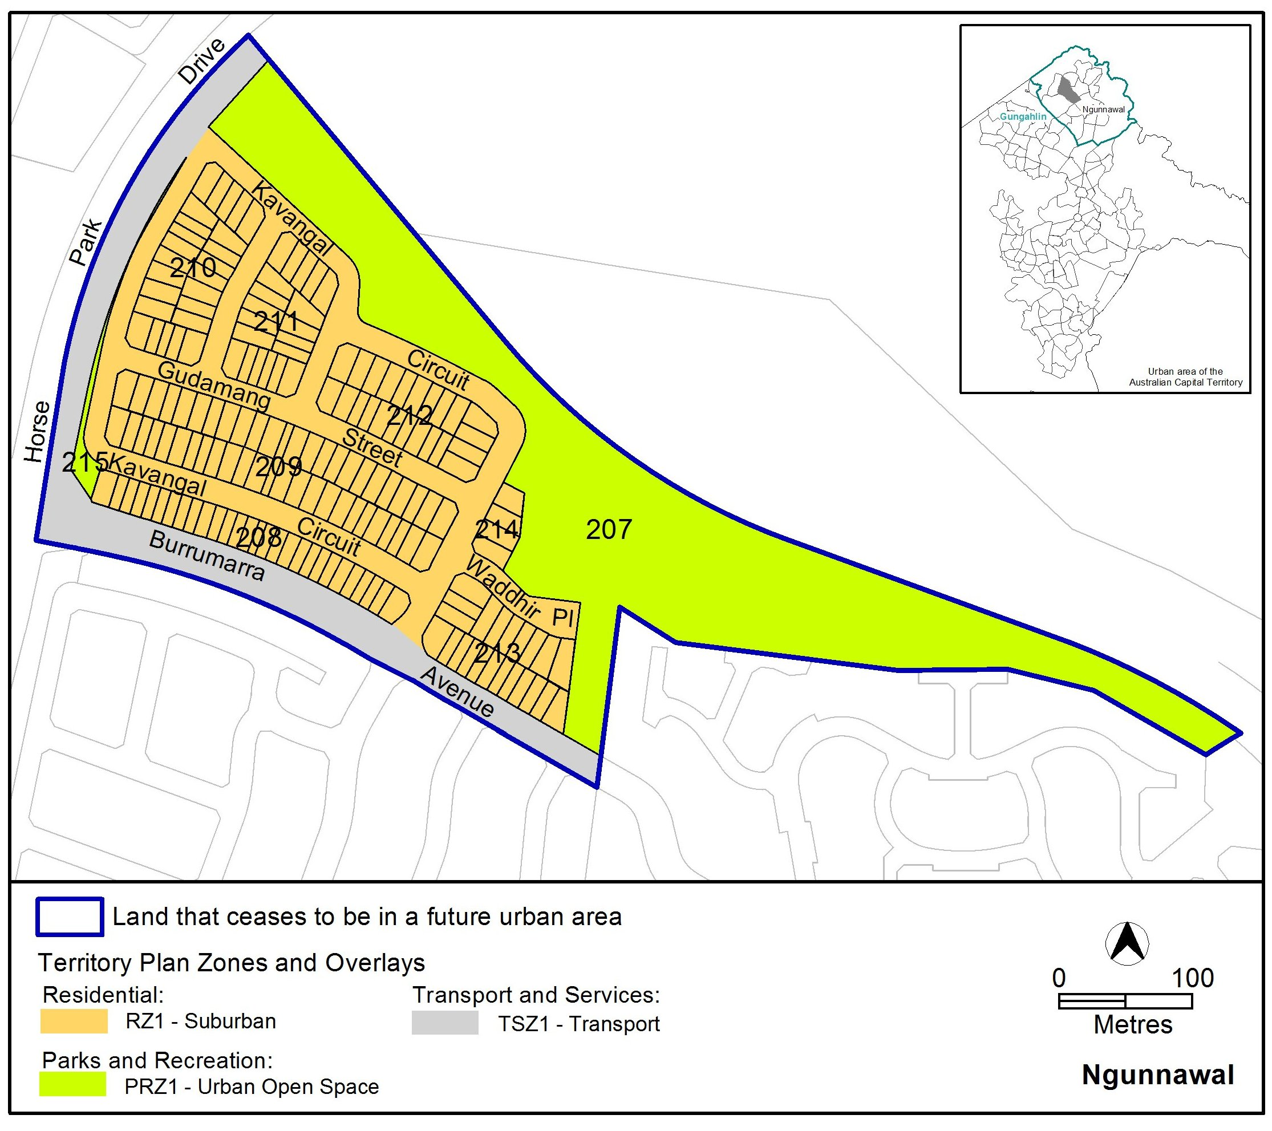

Jim Corrigan
Delegate of the Planning and Land Authority
30 October 2014
THIS IS PAGE ONE OF ANNEXURE B
TO NOTIFIABLE INSTRUMENT NI2014 –570

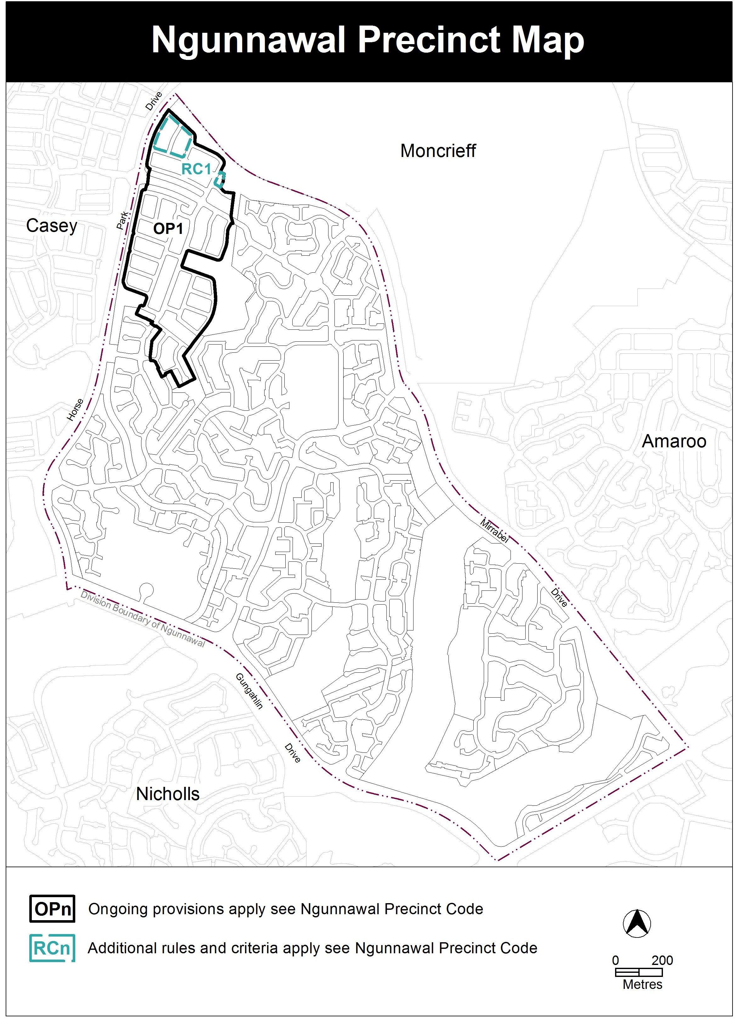

Jim Corrigan
Delegate of the Planning and Land Authority
30 October 2014
THIS IS PAGE TWO OF ANNEXURE B
TO NOTIFIABLE INSTRUMENT NI2014 –570

RC1 – Residential.................................................................

This part applies to blocks and parcels identified in area RC2 shown on the Ngunnawal Precinct Map.
Element 1: Building and site controls

Rules | Criteria
1.1 Number of storeys
R1  Minimum side boundary setback is 1.5m as indicated in Figure 1 and Figure 2. | This is a mandatory requirement. There is no applicable criterion.
R2  Maximum length of party wall is 13.5m as indicated in Figure 2. | This is a mandatory requirement. There is no applicable criterion.
R3  Maximum length of all walls facing the boundary within 900mm of a side boundary is as specified in Figure 2. | This is a mandatory requirement. There is no applicable criterion.

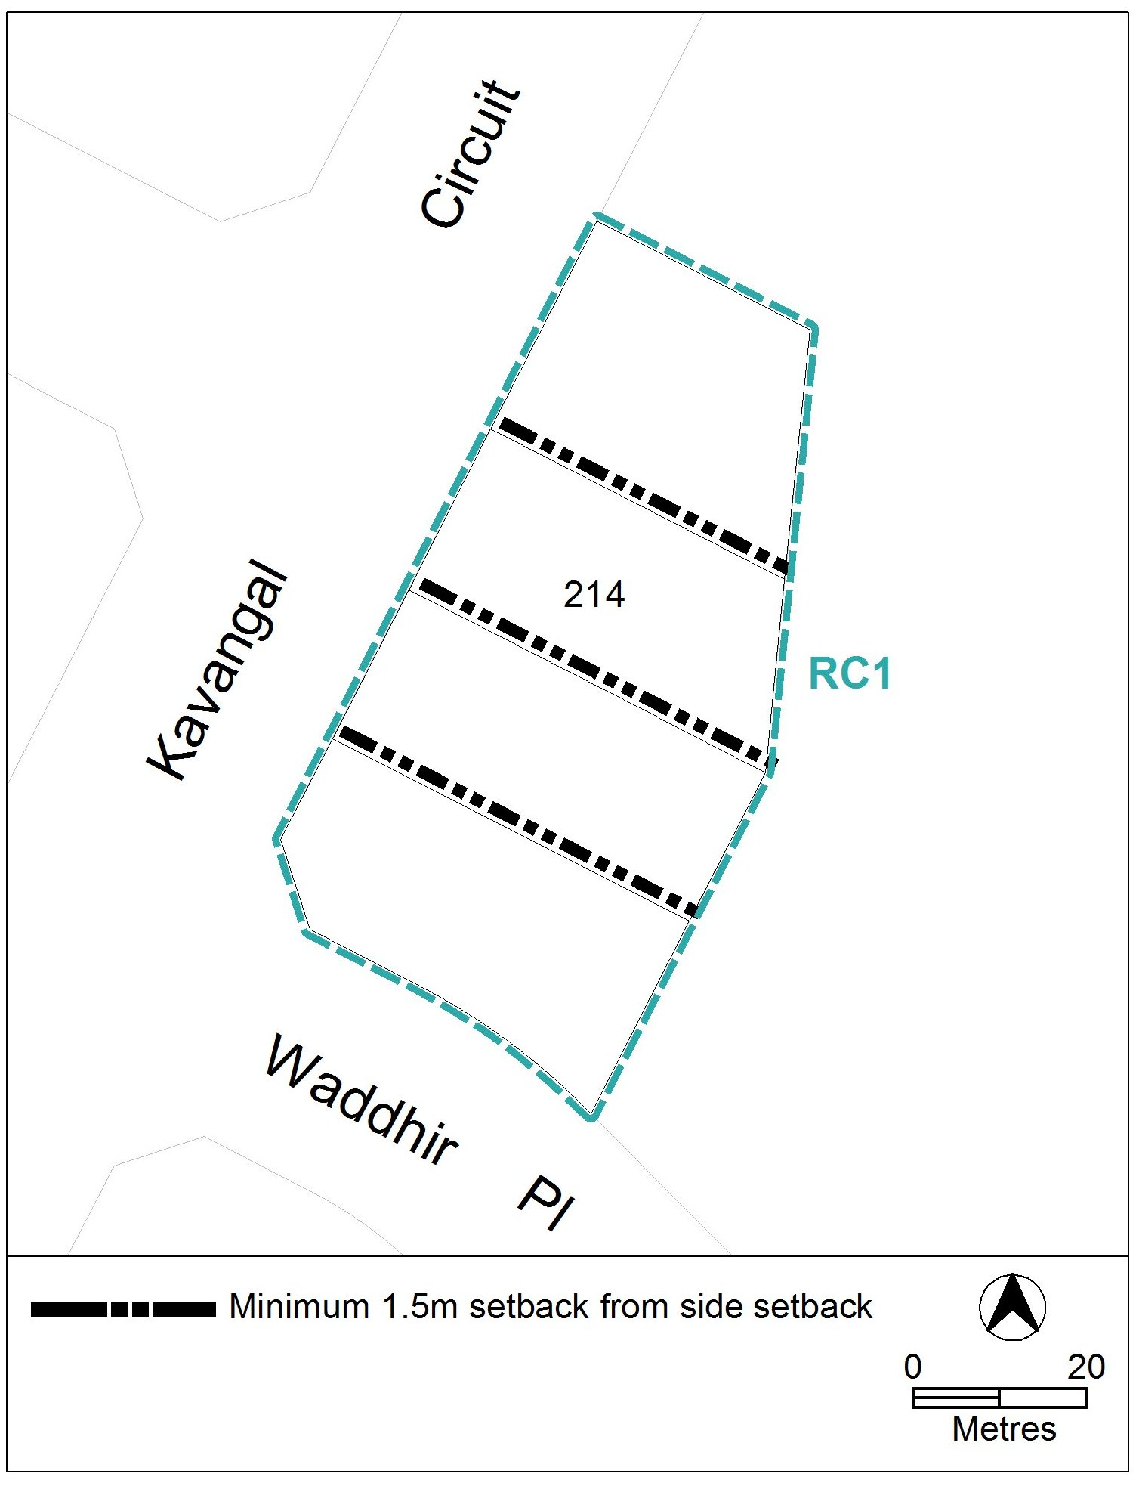
Figure 1 Setbacks

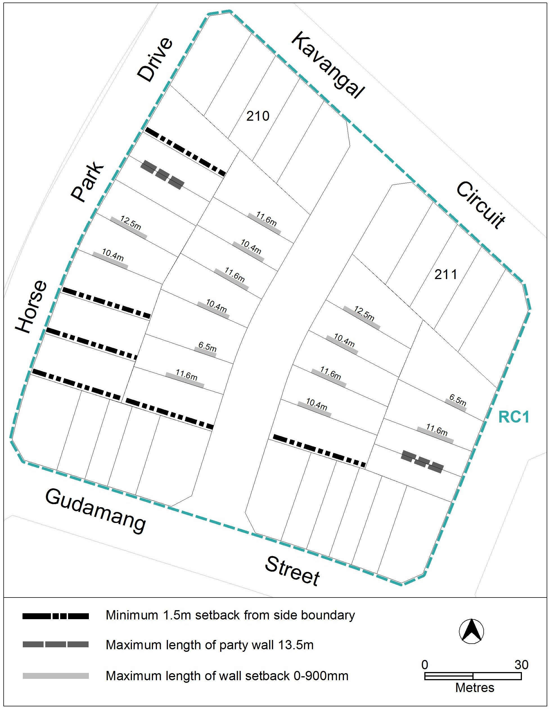
Figure 2 Setbacks

Jim Corrigan
Delegate of the Planning and Land Authority
30 October 2014
THIS IS PAGE THREE OF ANNEXURE B
TO NOTIFIABLE INSTRUMENT NI2014 –570

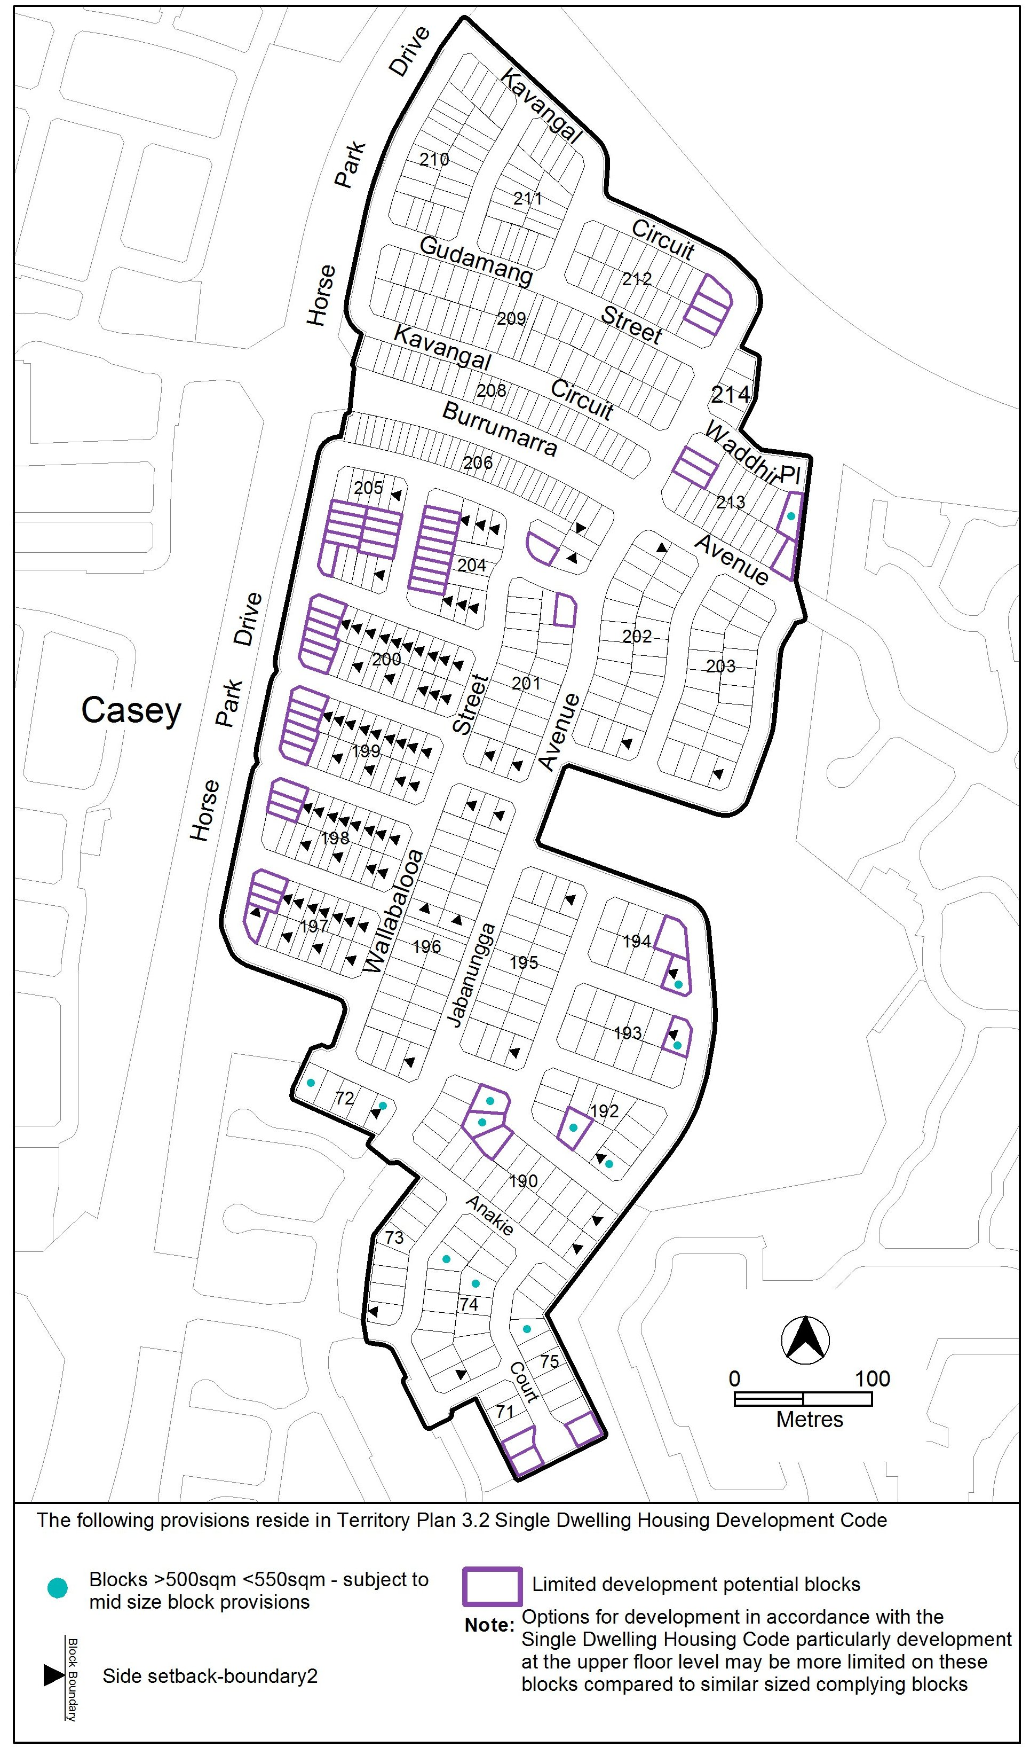
Figure 3 Ngunnawal residential area 1

Jim Corrigan
Delegate of the Planning and Land Authority
30 October 2014

