Australian Capital Territory
Planning and Development (Plan Variation No 308) Notice 2014
Notifiable Instrument NI2014-60
made under the
Planning and Development Act 2007, section 76(3)

- Name of instrument
This instrument is the Planning and Development (Plan Variation No 308) Notice 2014*.

- Plan Variation No 308
On 10 February 2014, the Minister for responsible for planning approved a draft of the attached plan variation to the Territory Plan (Annexure A) under s76 (3).

Jim Corrigan
Delegate of the Planning and Land Authority
13 February 2014

Planning and Development Act 2007

Variation to the
Territory Plan
No 308

Cooyong Street Urban Renewal Area
Braddon sections 53 and 57 and Reid section 7 – zoning changes and changes to the Braddon and Reid precinct maps and code

Final variation prepared under s76 of the
Planning and Development Act 2007

This page is intentionally blank.

Contents

1. EXPLANATORY STATEMENT 1
1.1 Background 1
1.2 Summary of the Proposal 1
1.3 The National Capital Plan 1
1.4 Site Description 2
1.5 Current Territory Plan Provisions 3
1.6 Changes to the Territory Plan 4
1.7 Consultation on the Draft Variation 4
1.8 Revisions to the Draft Variation recommended to the Minister 5
2. VARIATION 6
2.1 Variation to the Territory Plan map 6
2.2 Variation to the Territory Plan 7

This page is intentionally blank.

- EXPLANATORY STATEMENT
  - Background
The purpose of Territory Plan variation number 308 – Cooyong Street Urban Renewal Area (V308) is to facilitate the redevelopment of land in Braddon and Reid which is currently used for public housing accommodation at Allawah, Bega and Currong Flats and various church uses. The variation allows high density residential development and mixed-use development with some convenience retailing and office accommodation on part of the site. An area of urban open space is provided to protect a registered tree and to improve amenity.
  - Summary of the Proposal
The Braddon and Reid precinct maps and codes of the Territory Plan are amended as a result of V308 in order to guide redevelopment of the Cooyong Street urban renewal area and to ensure key planning outcomes are achieved. This includes: the subdivision pattern; the provision of minimum floor space areas for community facilities; the location of on-street car parking; the maximum height of buildings and plot ratios across the site.
V308 is consistent with the statement of strategic directions in the Territory Plan. It represents an opportunity for residential redevelopment and intensification in a strategic location with proximity to the city and transport options. V308 is also consistent with the ACT Planning Strategy 2012 and the liveable cities project ‘Realising the Capital in the City’ which amongst other things promotes the redevelopment of public housing immediately to the east and north of the city.
  - The National Capital Plan
The Australian Capital Territory (Planning and Land Management) Act 1988 established the National Capital Authority (NCA) with two of its functions being to prepare and administer a National Capital Plan (NCP) and to keep the NCP under constant review and to propose amendments to it when necessary.
The NCP, which was published in the Commonwealth Gazette on 21 January 1990 is required to ensure that Canberra and the Territory are planned and developed in accordance with their national significance. The Planning and Land Management Act 1988 also required that the Territory Plan is not inconsistent with the NCP.
In accordance with section 10 of the Australian Capital Territory (Planning and Land Management) Act 1988, the National Capital Plan defines the planning principles and policies for Canberra and the Territory, for giving effect to the object of the NCP and sets out the general policies to be implemented throughout the Territory, including the range and nature of permitted land uses.
It also sets out the detailed conditions of planning, design and development for areas that have special significance to the National Capital known as designated areas and identifies special requirements for the development of some other areas.
  - Site Description
The site is located in the area bounded by Cooyong Street, Kogarah Lane, Currong Street Donaldson Street and Cooyong Street as shown on Figure 1 site plan.
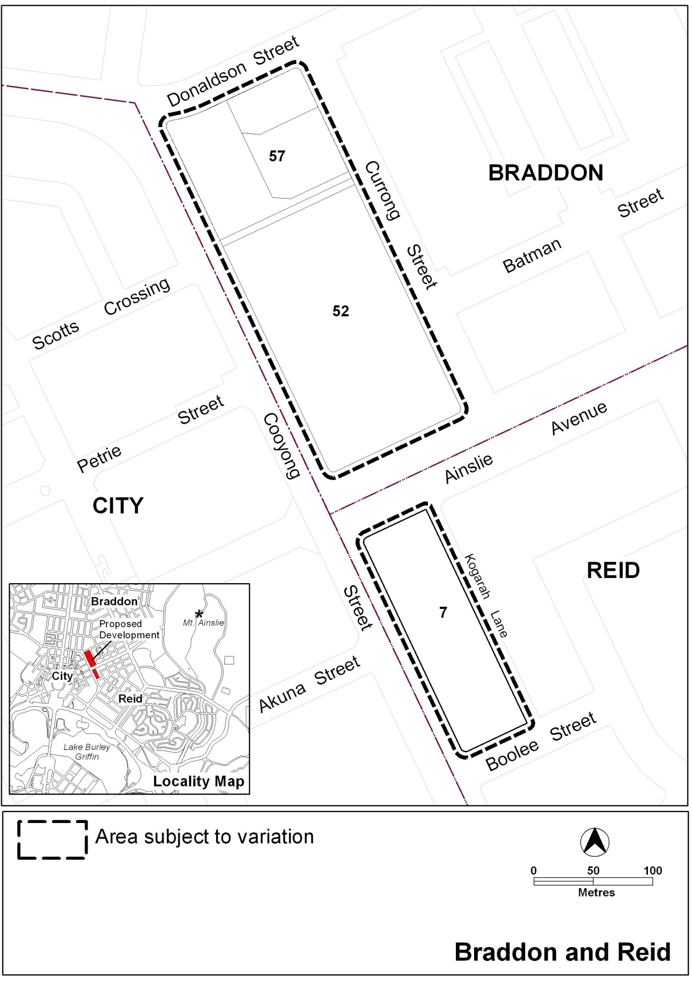

Figure 1 Site Plan
  - Current Territory Plan Provisions
The Territory Plan map zones for the area that are subject to this variation are shown in Figure 2.

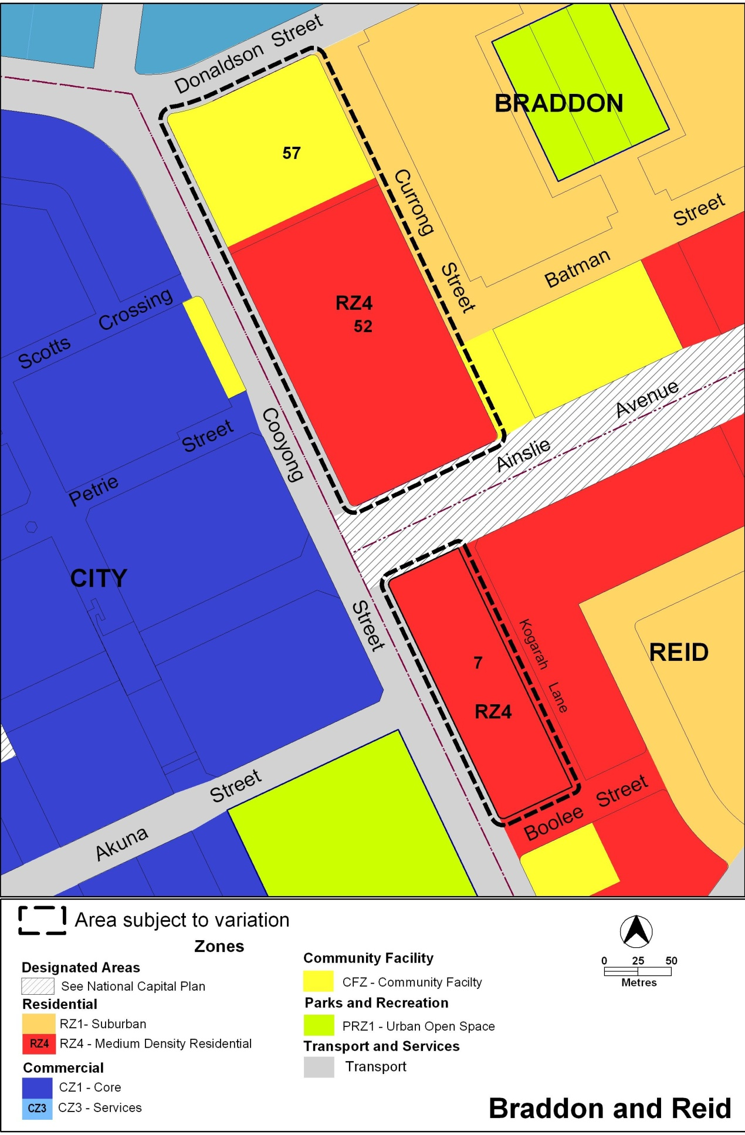
Figure 2 Territory Plan Zones Map
  - Changes to the Territory Plan
Detailed changes to the Territory Plan are noted in section 2 of this document.
  - Consultation on the Draft Variation
Draft variation 308 was released for public comment between 28 November 2011 and 20 February 2012. A consultation notice under section 63 of the Planning and Development Act 2007 was placed on the ACT Legislation Register on 6 December 2011. A consultation notice was also published in the Canberra Times on 30 November 2011 and in the Chronicle on 6 December 2011.
A total of 137 written submissions were received from the public as a result of the consultation process. The majority of submissions were from individual members of the public. However, the North Canberra Community Council, Burley Griffin Society, National Trust of Australia, Reid Residents Association and the ACT Greens also made submissions.
The main issues raised by submitters related to:
- Height and scale of the proposed buildings and associated impacts such as overshadowing and overlooking.
- Population density and the potential for future social impacts.
- Traffic and parking.
- Residential amenity and character including garden city values.
- Heritage issues particularly in relation to St Patrick’s Church and the heritage precincts of surrounding Braddon and Reid.
- City edge encroaching into the residential area.
The above issues were considered and are detailed in a report on consultation. Changes to the draft variation were informed by the issues raised and were documented in the recommended draft variation. Changes included:
- Inclusion of a statement of desired character
- Increase in the required amount of on-street parking
- Introduction of plot ratios
- Creation of a landscape corridor on Section 7 Reid
- Changes to building heights
- Introduction of building setbacks fronting Kogarah Lane
  - Revisions to the Draft Variation recommended to the Minister
The two tallest building elements on the corners of Ainslie Avenue and Cooyong Street have been reduced from a maximum of 15 storeys to 12 storeys after consideration of dissenting comments in the Special Report 3 - October 2013 of the Standing Committee and Planning, Environment and Territory and Municipal Services. The relevant plot ratio provision was also amended to reflect this reduction in building height. Other minor editorials have been made to ensure workability and clarity of the code provisions. However, these minor changes have not altered the policy of V308.

- VARIATION
  - Variation to the Territory Plan map
- Territory Plan map

The Territory Plan map is varied as indicated in Figure 3 Proposed Territory Plan map.
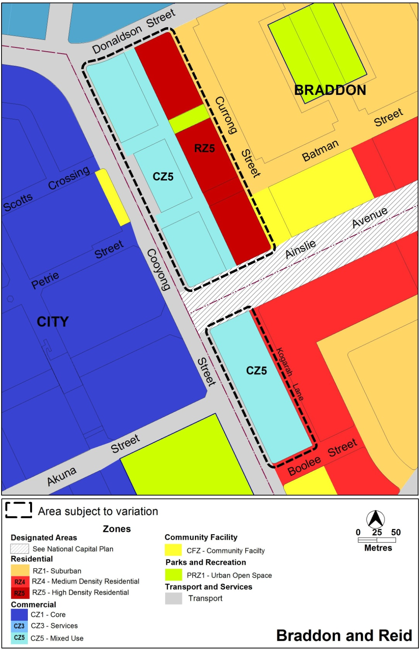
Figure 3 Proposed Territory Plan Map

  - Variation to the Territory Plan

Variation to the Braddon Precinct Map and Code
- Braddon Precinct Map

Substitute Braddon Precinct Map with the Braddon Precinct Map at Appendix 1

- RC2 - Cooyong Street urban renewal area

Insert RC2 – Cooyong Street urban renewal area at Appendix 2 after RC1- City Centre

Variation to the Reid Precinct Map and Code
- Reid Precinct Map

Substitute Reid Precinct Map with the Reid Precinct Map at Appendix 3

- RC2 - Cooyong Street urban renewal area

Insert RC2 – Cooyong Street urban renewal area at Appendix 4 after RC1 – Reid Preschool

Interpretation service
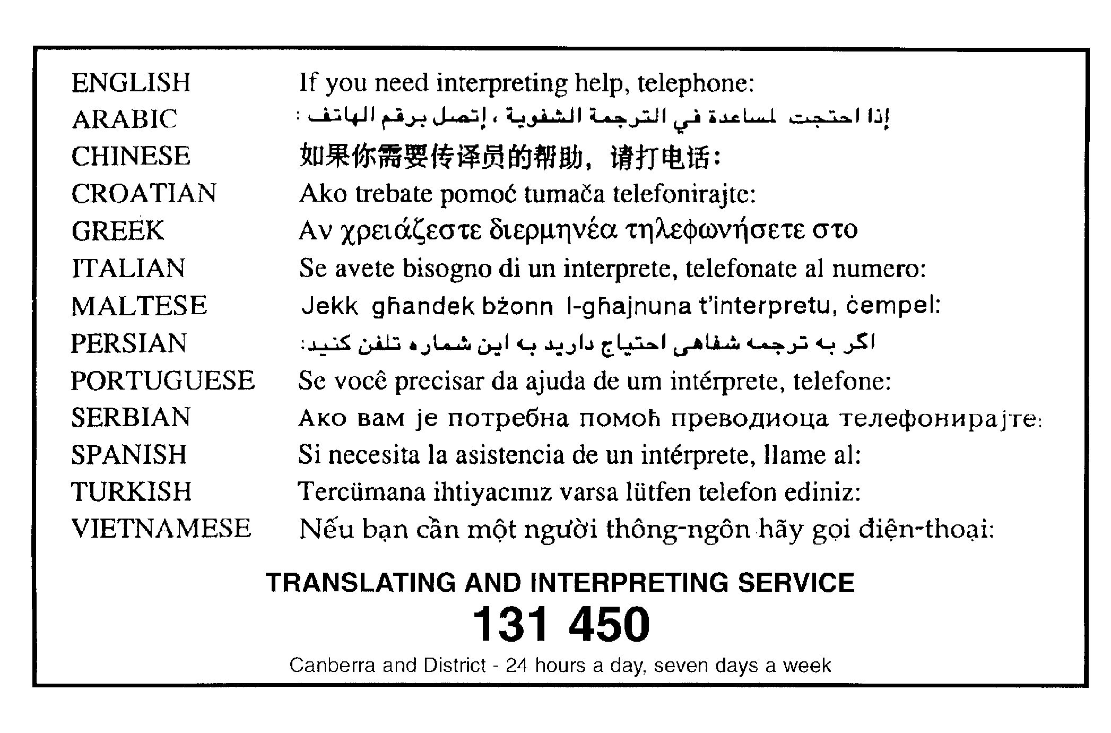

Appendix 1

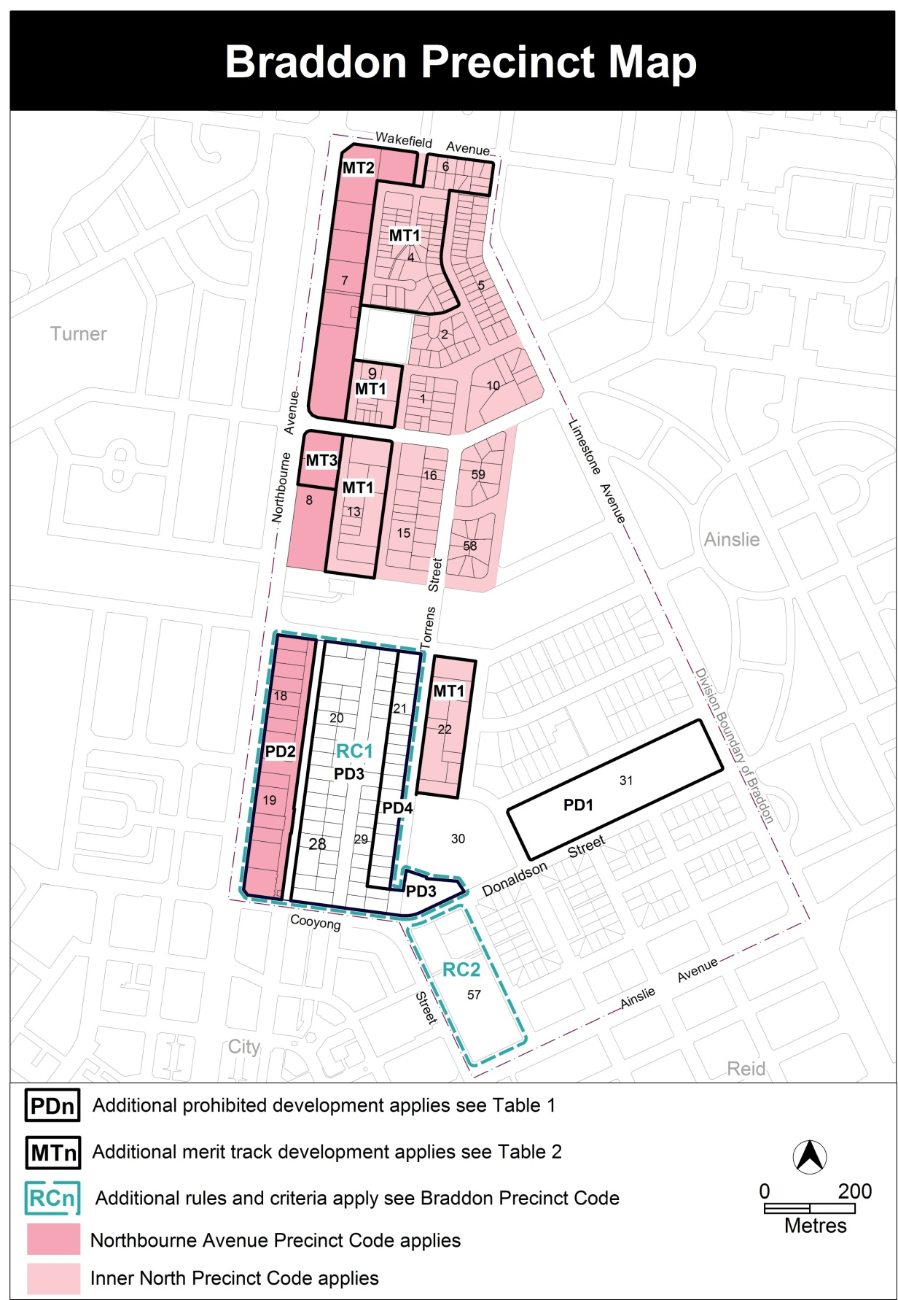

Appendix 2
RC2 – Cooyong Street urban renewal area

This part applies to blocks and parcels identified in area RC2 shown on the Braddon Precinct Map. RC2 is part of the Cooyong Street urban renewal area. For the other part, see the Reid Precinct Code.
Desired Character
The site has a strong urban edge to and active frontages along Cooyong Street.
A substantial component of the site is given over to higher rise buildings, with a focus on Cooyong Street and landmark taller buildings on the corners of Cooyong Street and Ainslie Avenue. There is a stepping down of building heights towards Currong Street. There is a modulation in building heights within each of the six (6) precincts including along Cooyong Street.
Buildings have variety in form and facade articulation. The location, scale and form of buildings promote solar access, privacy, cross ventilation and shielding from wind, noise and light to other buildings on the site and at the interface with the existing residential areas.
The configuration of buildings and modulation of building heights, scale and form promote ease of access for vehicles, cycles and pedestrians. There is a clear hierarchy of public and private zones through the site with safe and attractive pedestrian areas. The landscape and spaces between the buildings are of a high quality and fit for purpose with a clearly articulated public domain.

- Site
Rules | Criteria
  - Subdivision
There is no applicable rule. | Subdivision of the site is consistent with the pattern of proposed roads in Figure 8.
The design of each street complies with the road reserves shown in Figure 8. | Road reserves achieve all of the following:  - reasonable functionality  - reasonable safety  - provision for pedestrians and landscaping  - provision of adequate on street parking  - consistency with the desired character.
The following off-site works are provided:  - on-street car parking for a minimum of 222 car parking spaces across the Cooyong Street urban renewal area of both the Braddon and Reid precinct codes  - cycle paths  - pedestrian connections  - footpaths  - signalised intersections  - in Braddon sections 52 and 57, a service lane and car parking adjacent to convenience retailing area which is on block Ab in Figure 8 and Cooyong Street.  The locations of these off-site works are shown in Figure 8.  Note:  A condition of approval may be imposed to ensure compliance with this rule. | Off-site works provided by the applicant achieve all of the following:  - adequate on-street car parking  - provision for cyclists, pedestrians and motor vehicles with connections to the surrounding networks  - reasonable footpath widths  - provision for a service lane  - intersections endorsed by TAMS.

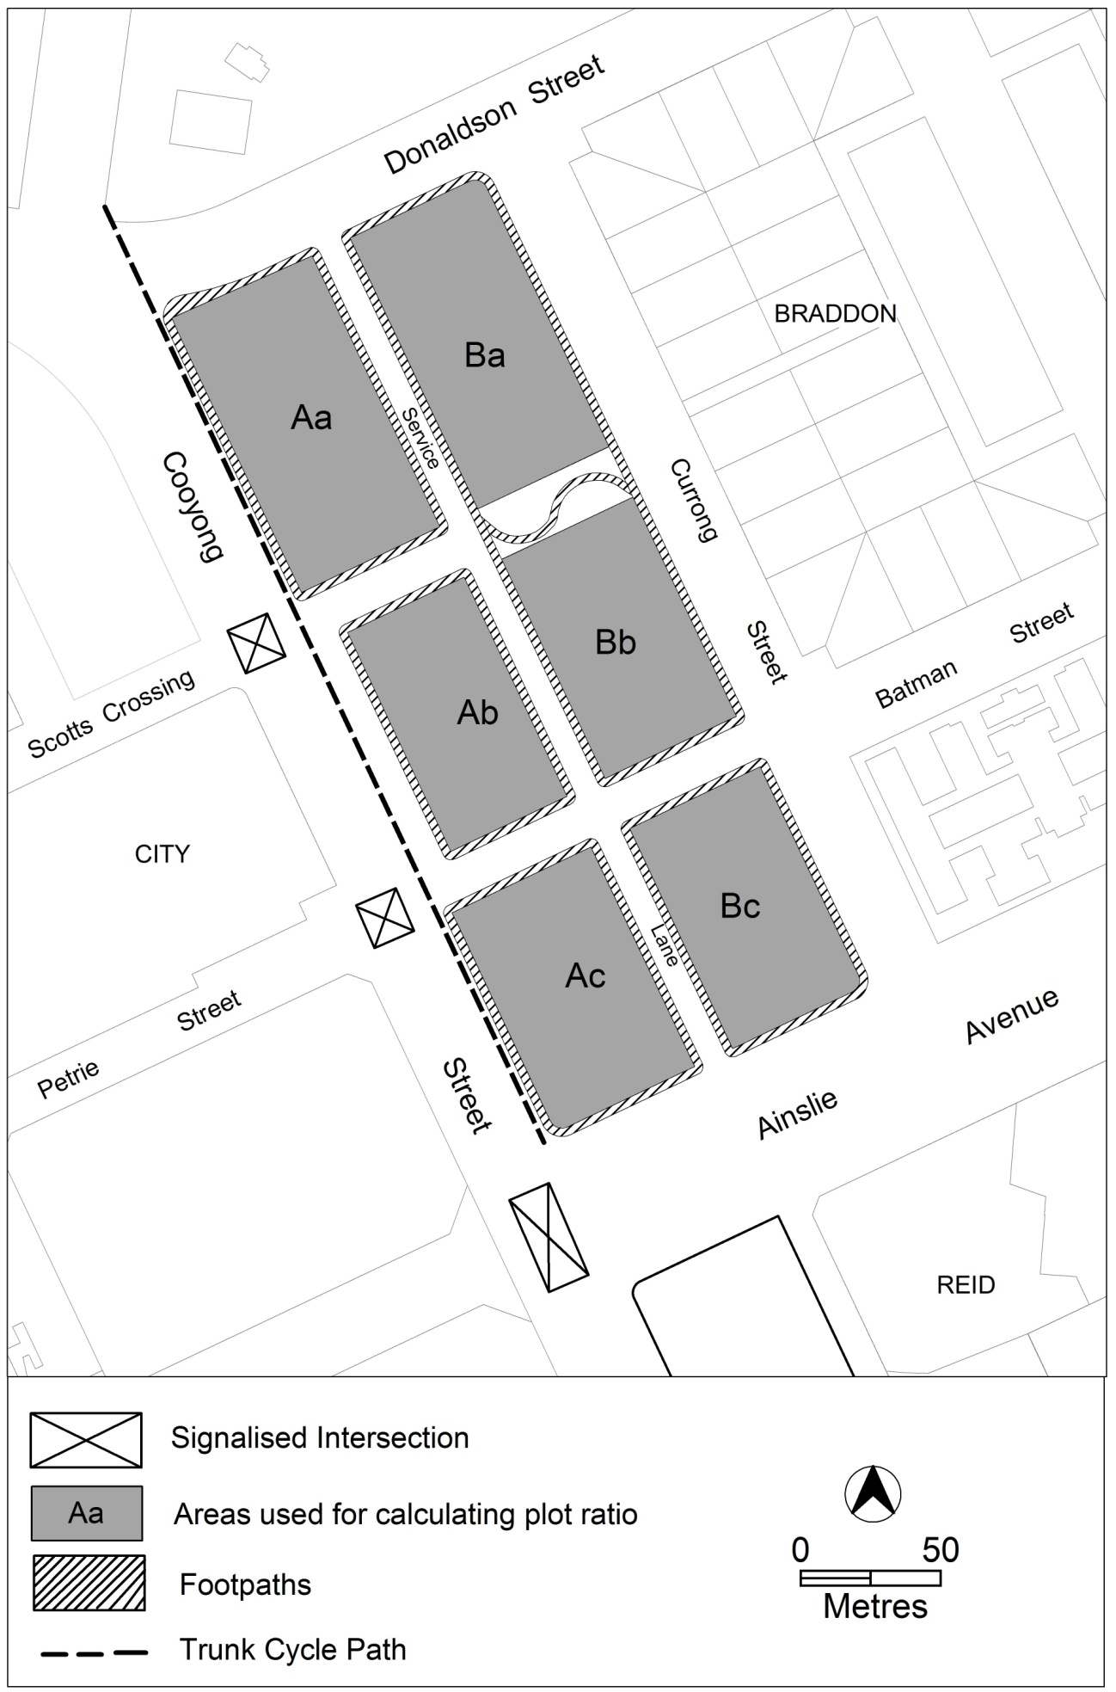

Figure 8 Subdivision and off-site works

Rules | Criteria
  - Car parking and site access
There is no applicable rule. | Public car parking achieves all of the following:  - adequate on-street parking  - accessibility to the existing road, cycling and pedestrian networks  - adequate spaces dedicated for moped / motor bike and small vehicles.
Access to on–site car parking and utility services of buildings in Braddon is from the nominated service lane shown in Figure 8. | This is a mandatory requirement. There is no applicable criterion.
Driveway access or egress to buildings from Ainslie Avenue, Cooyong Street and Donaldson Street is not permitted. | This is a mandatory requirement. There is no applicable criterion.
  - Public realm development
Landscaping and facilities in public areas are to be provided by the applicant in accordance with a public areas development plan prepared by a suitably qualified person. This plan is consistent with Figure 9 and shows, as a minimum, all of the following:  - an area of urban open space  - trees (including registered trees)  - street trees, both new and retained trees  - front setback area at ground level and above.  Note:  TAMS will endorse the landscaping plan if it complies with the relevant TAMS standards.  TAMS may endorse departures.  A condition of approval may be imposed to ensure compliance with this rule. | Landscaping achieves all of the following:  - quality space for recreation and relaxation of residents  - provision for on-site infiltration of stormwater run-off  - quality landscaping adjacent to Cooyong Street and Ainslie Avenue
Note: Neither rule R30 nor criterion C30 changes any requirement in the Territory Plan for the preparation of a tree management plan approved under the Tree Protection Act 2005.

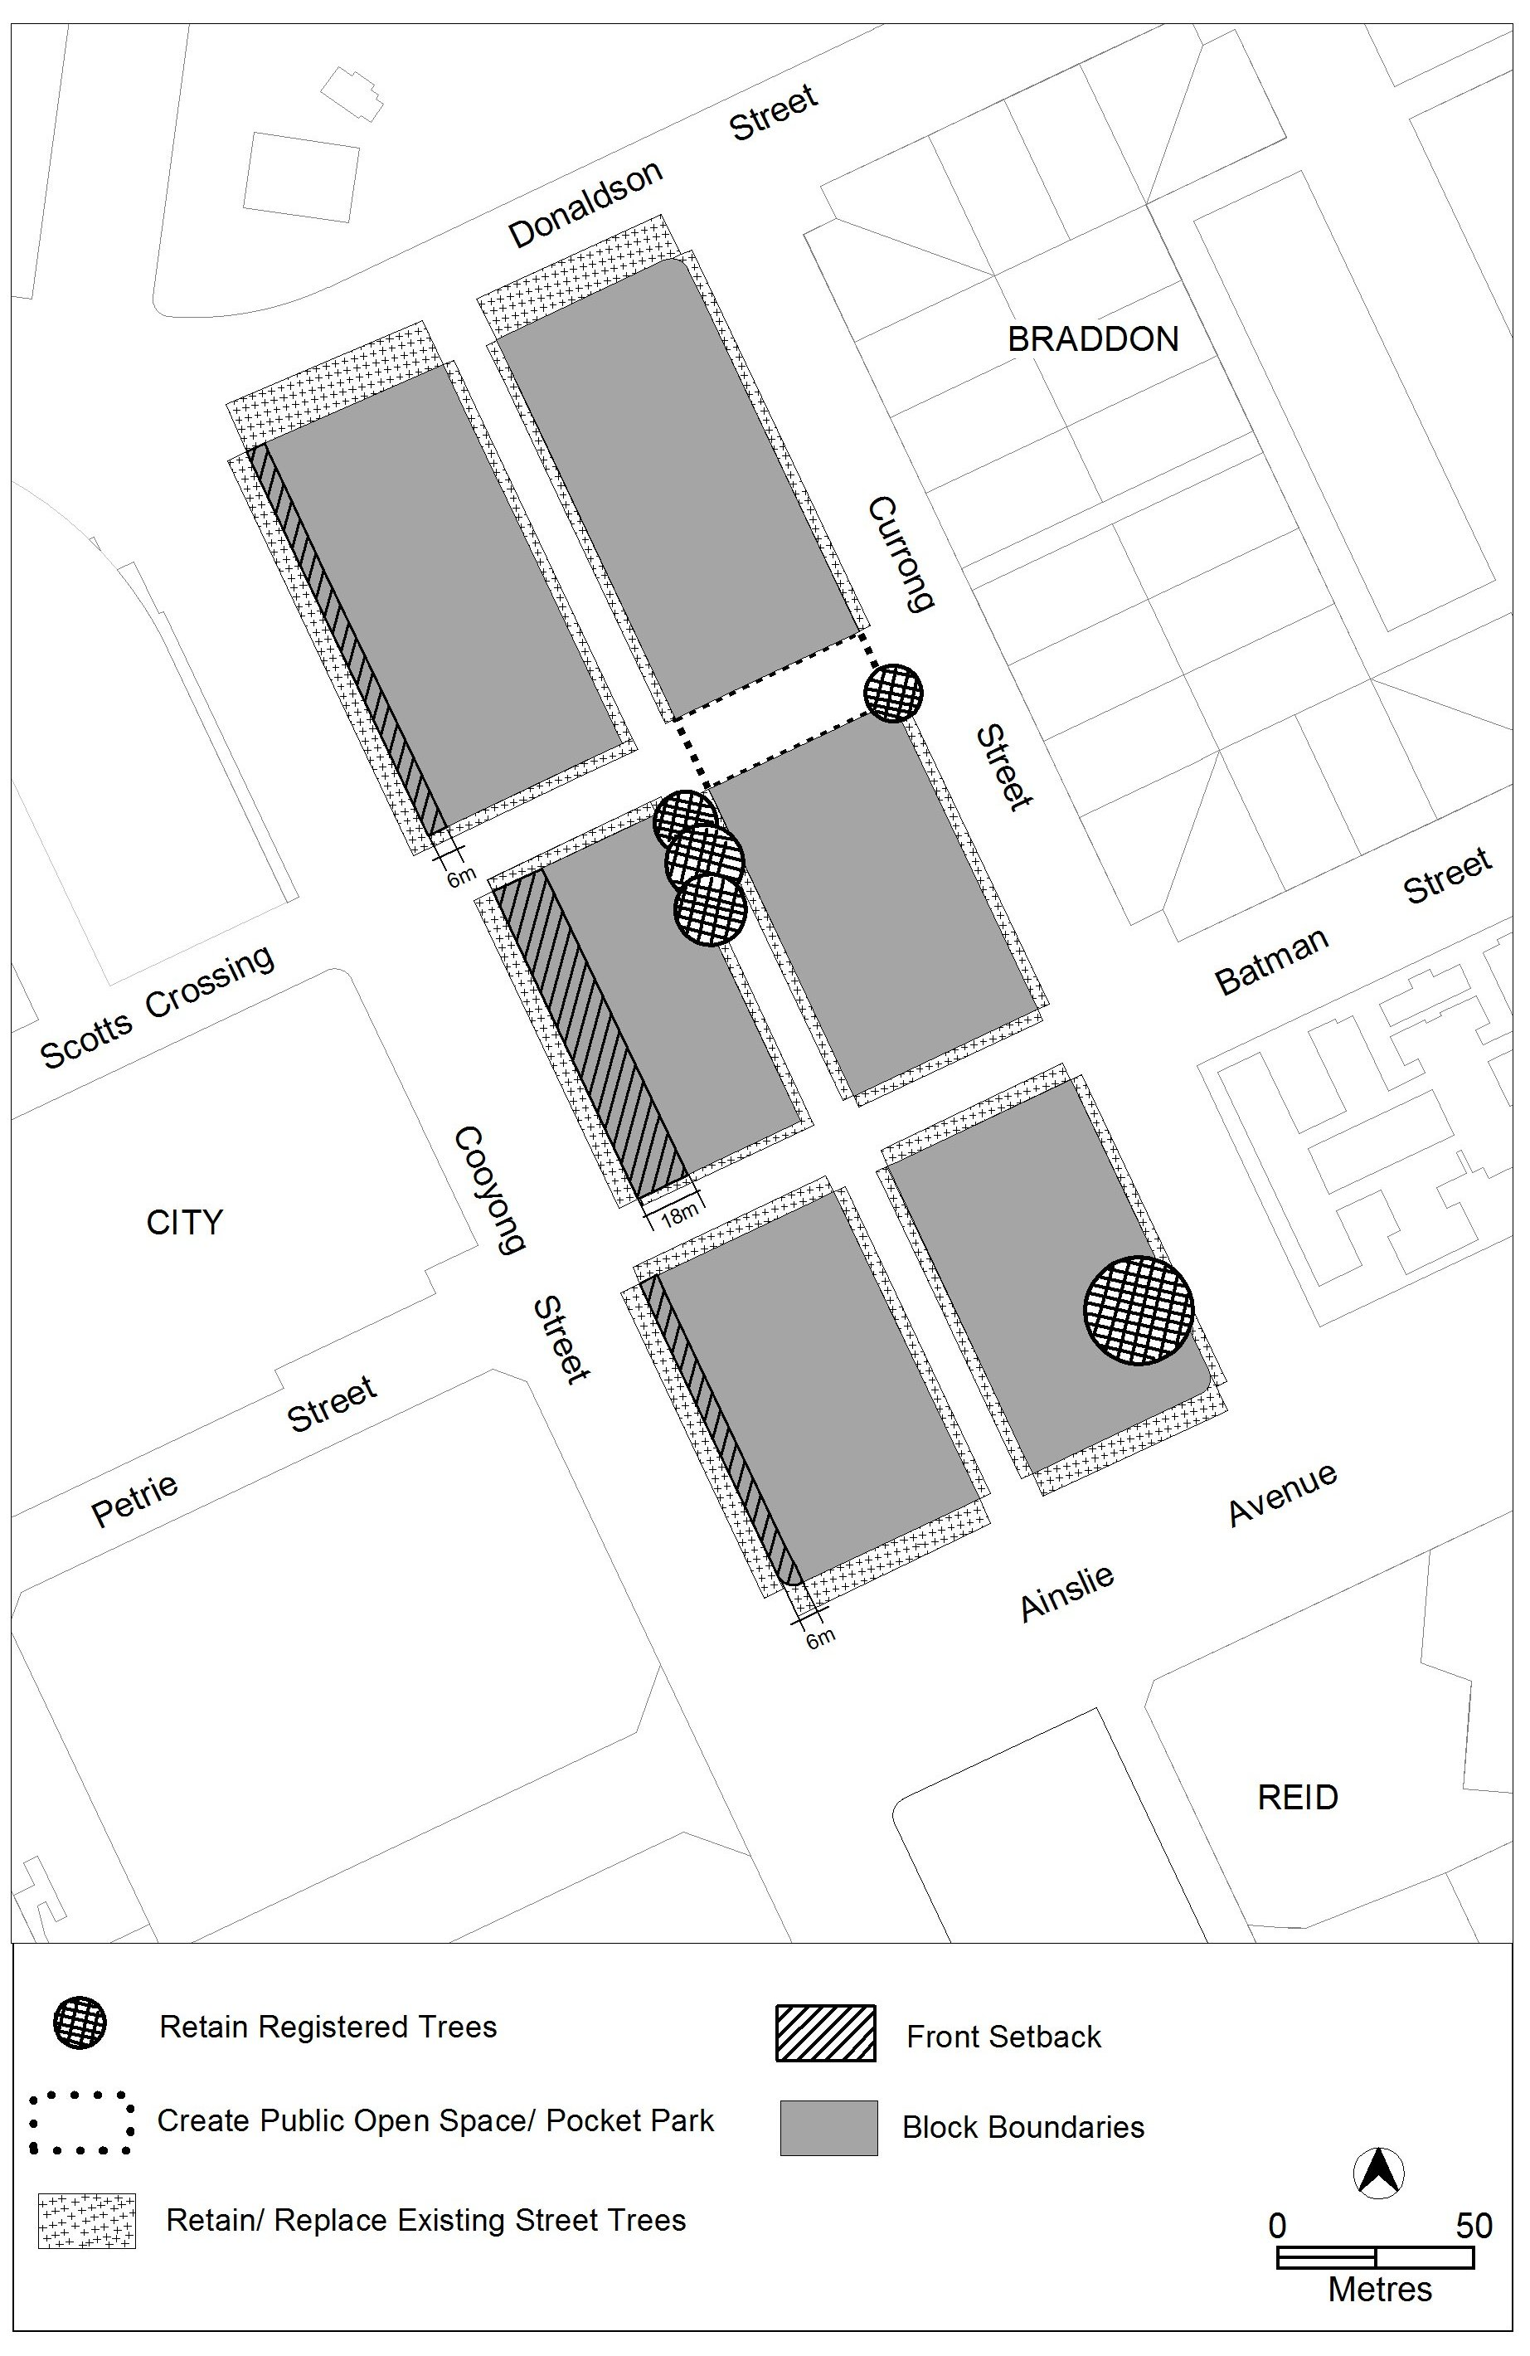
Figure 9 Landscaping
- Use
Rules | Criteria
  - General
This rule applies to buildings fronting Cooyong Street.  The following uses are not permitted above the ground floor:  - restaurant  - SHOP | This is a mandatory requirement. There is no applicable criterion.
This rule applies to buildings fronting Cooyong Street.  The following uses are not permitted above the first floor:  - COMMUNITY USE  - indoor recreation facility  - NON RETAIL COMMERCIAL USE | This is a mandatory requirement. There is no applicable criterion.
This rule applies to CZ5, but does not apply to parcel Ab shown in Figure 8.  The following gross floor area (GFA) restrictions apply:  - NON RETAIL COMMERCIAL USE: maximum GFA of 100m² per tenancy  - COMMUNITY USE and indoor recreation facility (where it is operated or subleased by a community organisation):  minimum GFA of 5 800 m² in total across the Cooyong Street urban renewal area of both the Braddon and Reid precinct codes.  - SHOP: maximum GFA of 200m² per tenancy  - Restaurant: maximum GFA of 200m² per tenancy. | This is a mandatory requirement. There is no applicable criterion.
  - Convenience retailing area (block Ab on Figure 8)
This rule applies to the convenience retailing area in parcel Ab shown in Figure 8.  RESIDENTIAL USE is not permitted at the ground floor level. | This is a mandatory requirement. There is no applicable criterion.

Rules | Criteria
This rule applies to the convenience retailing area in parcel Ab shown in Figure 8.  The maximum gross floor area (GFA) per tenancy or premises is:  - SHOP: maximum GFA of 800m²  - NON RETAIL COMMERCIAL USE: maximum GFA of 200m². | This is a mandatory requirement. There is no applicable criterion.

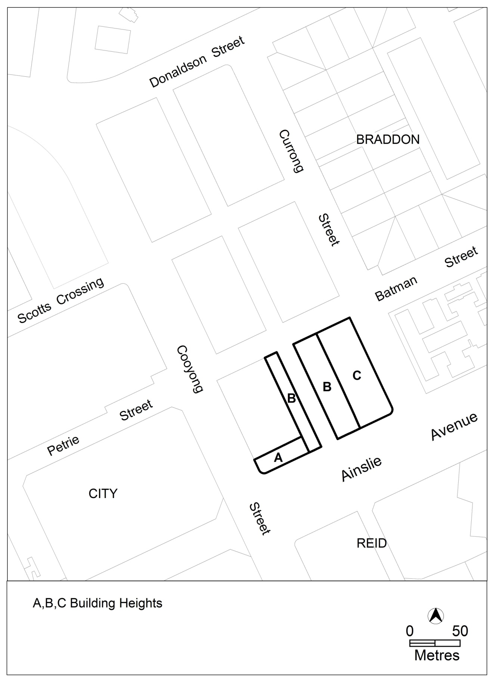
Figure 10 Building elements

- Buildings
Rules | Criteria
  - Height of buildings
This rule applies to CZ5 and building heights comply with one or more of the following:  - Buildings are contained within an envelope which rises 25 metres above datum ground level at the building line then returns at 45 degrees to a maximum of 28 metres (excluding rooftop plant and equipment) except as described below and as shown in Figure 10.  - Elements at location A in Figure 10 are no higher than 40 metres above datum ground level and a maximum of 12 storeys (excluding rooftop plant and equipment) and a maximum of 20 metres in length fronting Cooyong Street and 38 metres in length along the other frontage.  - Elements at location B in Figure 10 are no higher than 22 metres (excluding rooftop plant and equipment) above datum ground level. | This is a mandatory requirement. There is no applicable criterion.
This rule applies to RZ5 and building heights comply with one or more of the following:  - Elements at location B in Figure 10 are no higher than 22 metres (excluding rooftop plant and equipment) above datum ground level.  - Elements at location C in Figure 10 within 30 metres of Currong Street are no higher than 16 metres (excluding rooftop plant and equipment) above datum ground level.  Note 1:  Except where stated, building heights in RZ5 are regulated by the Multi Unit Housing Development Code. | This is a mandatory requirement. There is no applicable criterion.
Minimum number of storeys is 3. | This is a mandatory requirement. There is no applicable criterion.

  - Plot ratio
This rule applies to blocks and sections identified in Figure 8  The maximum plot ratio is:  - 360% for block Aa  - 490% for block Ab  - 390% for block Ac  - 170% for block Ba  - 160% for block Bb  - 330% for block Bc  Note: plot ratio is subject to the requirements of the Heritage Register. | Plot ratios are consistent with the desired character of the Cooyong Street urban renewal area.
  - Setback to Cooyong Street
This rule applies to parcels fronting Cooyong Street, except parcel Ab identified on Figure 8.  At the locations shown in Figure 9 the minimum setback is 6m. | Buildings and other structures achieve all of the following:  - presents a hard edge to the street  - provision of a landscaped area fronting Cooyong Street that satisfies criterion 30  - reasonable solar access to the public realm on Cooyong Street.
Note: Neither the previous rule nor criterion applies to underground car parking fronting Cooyong Street. The transfer of land above underground car parking to the Territory is not prevented by this provision.
This rule applies to the convenience retailing area parcel Ab shown in Figure 8.  Development in the convenience retailing area shown in Figure 8 complies with all of the following:  - the minimum setback to Cooyong Street is 18 metres  - display windows and shop fronts at ground floor level  - buildings include at-grade direct pedestrian access with verge level access and egress. | This is a mandatory requirement. There is no applicable criterion.
This rule applies to buildings fronting one or more of the following:  - Cooyong Street  - Ainslie Avenue  - public open space.  Display windows and pedestrian access are provided at the ground floor level. | Development can be adapted to incorporate active frontage with direct pedestrian access at ground floor of buildings fronting one or more of the following:  - Cooyong Street  - Ainslie Avenue  - Public open space
There is no applicable rule. | Floor to ceiling heights at the ground level of buildings fronting Cooyong Street and Ainslie Avenue can accommodate commercial use.
This rule applies to the frontage of blocks to Cooyong Street or Ainslie Avenue in CZ5.  The maximum percent of ground floor façade that is blank is 20%. | Ground floor facades of buildings fronting Cooyong Street and Ainslie Avenue present a varied and interesting design.
  - Building design
There is no applicable rule. | Development complies with all of the following:  - corner buildings contain focal points providing architectural interest and variety to the building design  - there is modulation in building heights across the site and along Cooyong Street  - entrances to common areas for residential use provide strong visual connection to the street and ensure a high level of surveillance  - driveways and pedestrian entrances to the site are visible from the boundary  - west-facing facades incorporate sun shading into building designs  - desired planning outcomes of:  - contributing to a high quality, environmentally sustainable residential development near Canberra’s main commercial centre  - balancing and protecting the high quality residential amenity while providing for community facilities and limited commercial use  - encouraging innovation in high quality design of the built form and open space  - minimising adverse impacts on environmental and heritage qualities within the precinct and adjacent sites  - supporting a street network that is designed for low vehicle speed and easy pedestrian access.
  - Rooftop gardens
There is no applicable rule. | Common open spaces in the form of rooftop gardens are provided and achieve all of the following:  - adequate access for residents, particularly on the higher floors  - sufficient space for recreation of residents  - reasonable solar access for gardening activities.

- Entity (Government agency) endorsement
Rules | Criteria
The following off-site works are to be endorsed by TAMS.  - on-street car parking  - other public car parking  - cycle paths  - pedestrian connections  - footpaths  - signalised intersections  - in Braddon sections 52 and 57, a service lane and car parking adjacent to convenience retailing area and Cooyong Street.  Note:  TAMS will endorse the plan if it complies with the relevant TAMS standards.  TAMS may endorse departures. | This is a mandatory requirement. There is no applicable criterion.
Road designs within the road reservations shown in Figure 8 are to be endorsed by TAMS.  Note:  TAMS will endorse the plan if it complies with the relevant TAMS standards.  TAMS may endorse departures. | This is a mandatory requirement. There is no applicable criterion.
Off-site works are provided in accordance with a public realm plan endorsed by TAMS.  Such a plan is consistent with Figures 8 and 9 and shows, as a minimum, all of the following:  - urban open space  - trees (including registered trees)  - street trees, both new and retained  - the treatment of front setback areas.  Note:  TAMS will endorse the public realm plan if it complies with Figure 9 and the relevant TAMS standards, which include Standard Specification 4 Urban Infrastructure Work Section 9, Design Specifications DS-4, DS-22 and DS-23.  TAMS may endorse departures. | This is a mandatory requirement. There is no applicable criterion.

Appendix 3

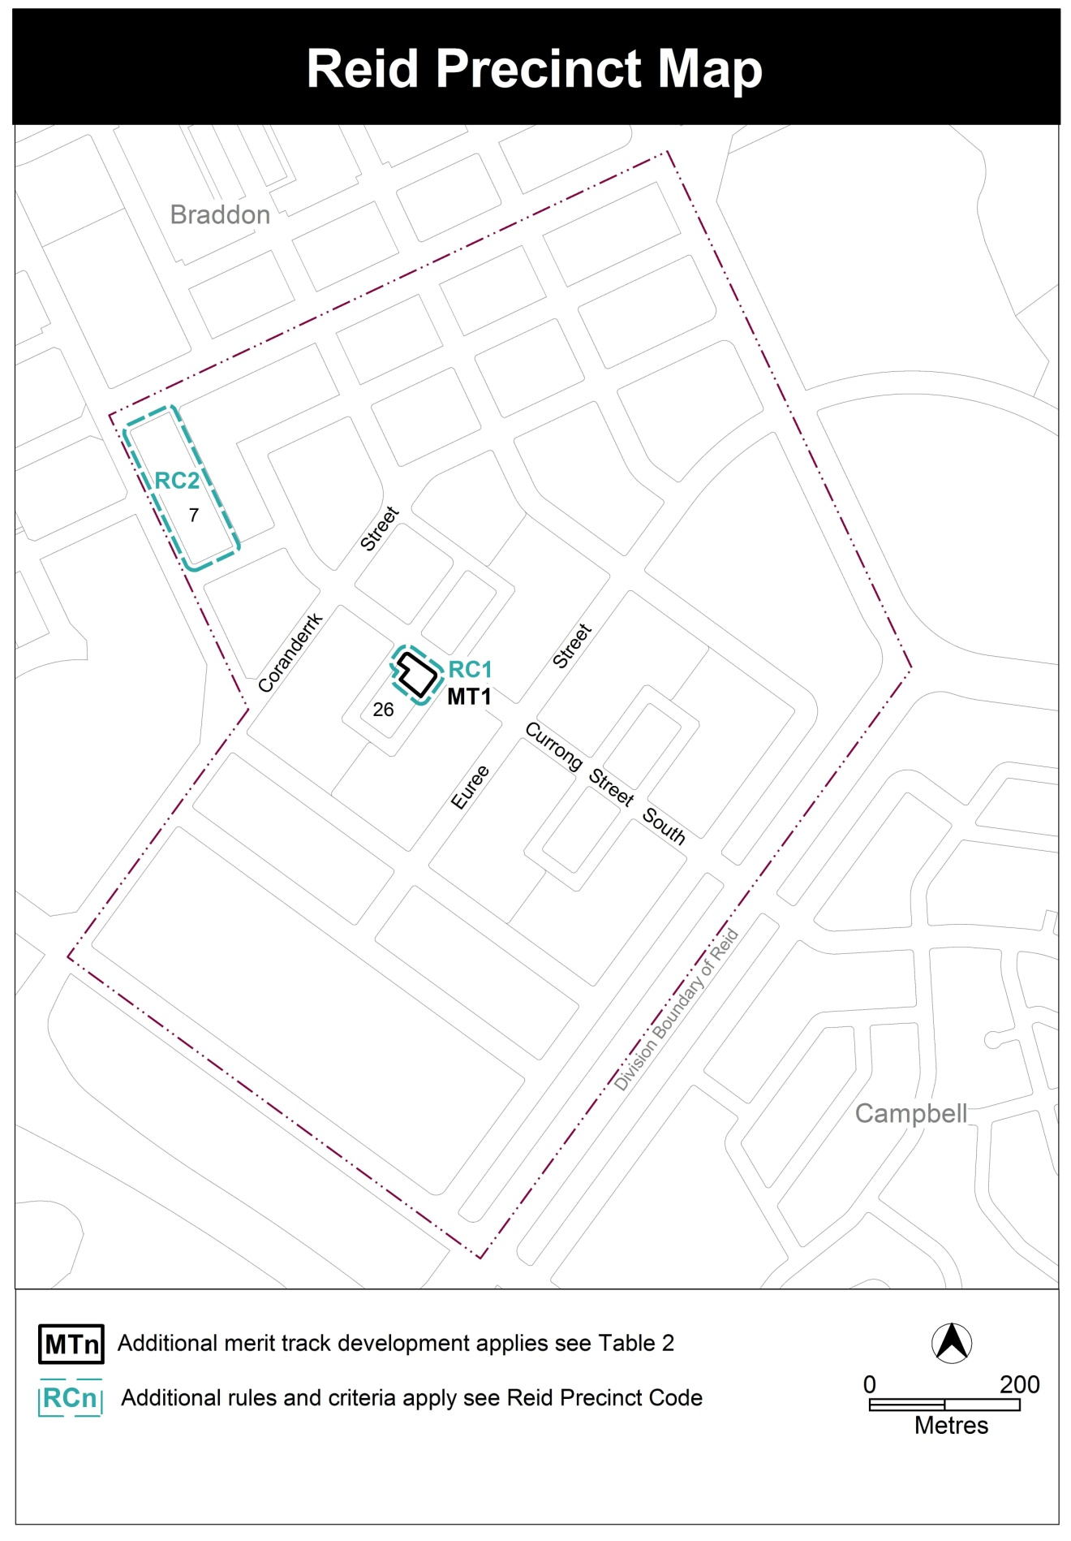

Appendix 4

RC2 - Cooyong Street urban renewal area

This part applies to block and parcels identified in area RC2 shown on the Reid Precinct Map. RC2 is part of the Cooyong Street urban renewal area. For the other part, see the Braddon Precinct Code.
Desired Character
The site has a strong urban edge to and active frontages along Cooyong Street.
A substantial component of the site is given over to higher rise buildings, with a focus on Cooyong Street and landmark taller buildings on the corners of Cooyong Street and Ainslie Avenue. There is a stepping down of building heights towards Kogarah Lane. There is a modulation in building heights within the two (2) precincts including along Cooyong Street.
Buildings have variety in form and facade articulation. The location, scale and form of buildings promote solar access, privacy, cross ventilation and shielding from wind, noise and light to other buildings on the site and at the interface with the existing residential areas of Reid.
The configuration of buildings and modulation of building heights, scale and form promote ease of access for vehicles, cycles and pedestrians. There is a clear hierarchy of public and private zones through the site with safe and attractive pedestrian areas. The landscape and spaces between the buildings are of a high quality and fit for purpose with a clearly articulated public domain.
- Site
Rules | Criteria
  - subdivision
There is no applicable rule. | Subdivision of the site is consistent with the pattern of proposed roads in Figure 1.  Note:  This includes provision of a stub road at the Akuna Street intersection to allow driveway access off the stub road to Reid section 7.
The design of each street complies with the road reserves shown in Figure 1. | Road reserves achieve all of the following:  - reasonable functionality  - reasonable safety  - provision for pedestrians and landscaping  - provision of adequate on street parking  - consistency with the desired character.
The following off-site works are provided:  - on-street car parking for a minimum of 222 car parking spaces across the Cooyong Street urban renewal area of both the Braddon and Reid precinct codes  - cycle paths  - pedestrian connections  - footpaths  - signalised intersections.  The locations of these offsite works are shown in Figure 1.  Note:  A condition of approval may be imposed to ensure compliance with this rule. | Off-site works provided by the applicant achieve all of the following:  - adequate on-street car parking  - provision for cyclists, pedestrians and motor vehicles with connections to the surrounding networks  - reasonable footpath widths  - provision for an access way in Reid  - intersections endorsed by TAMS.

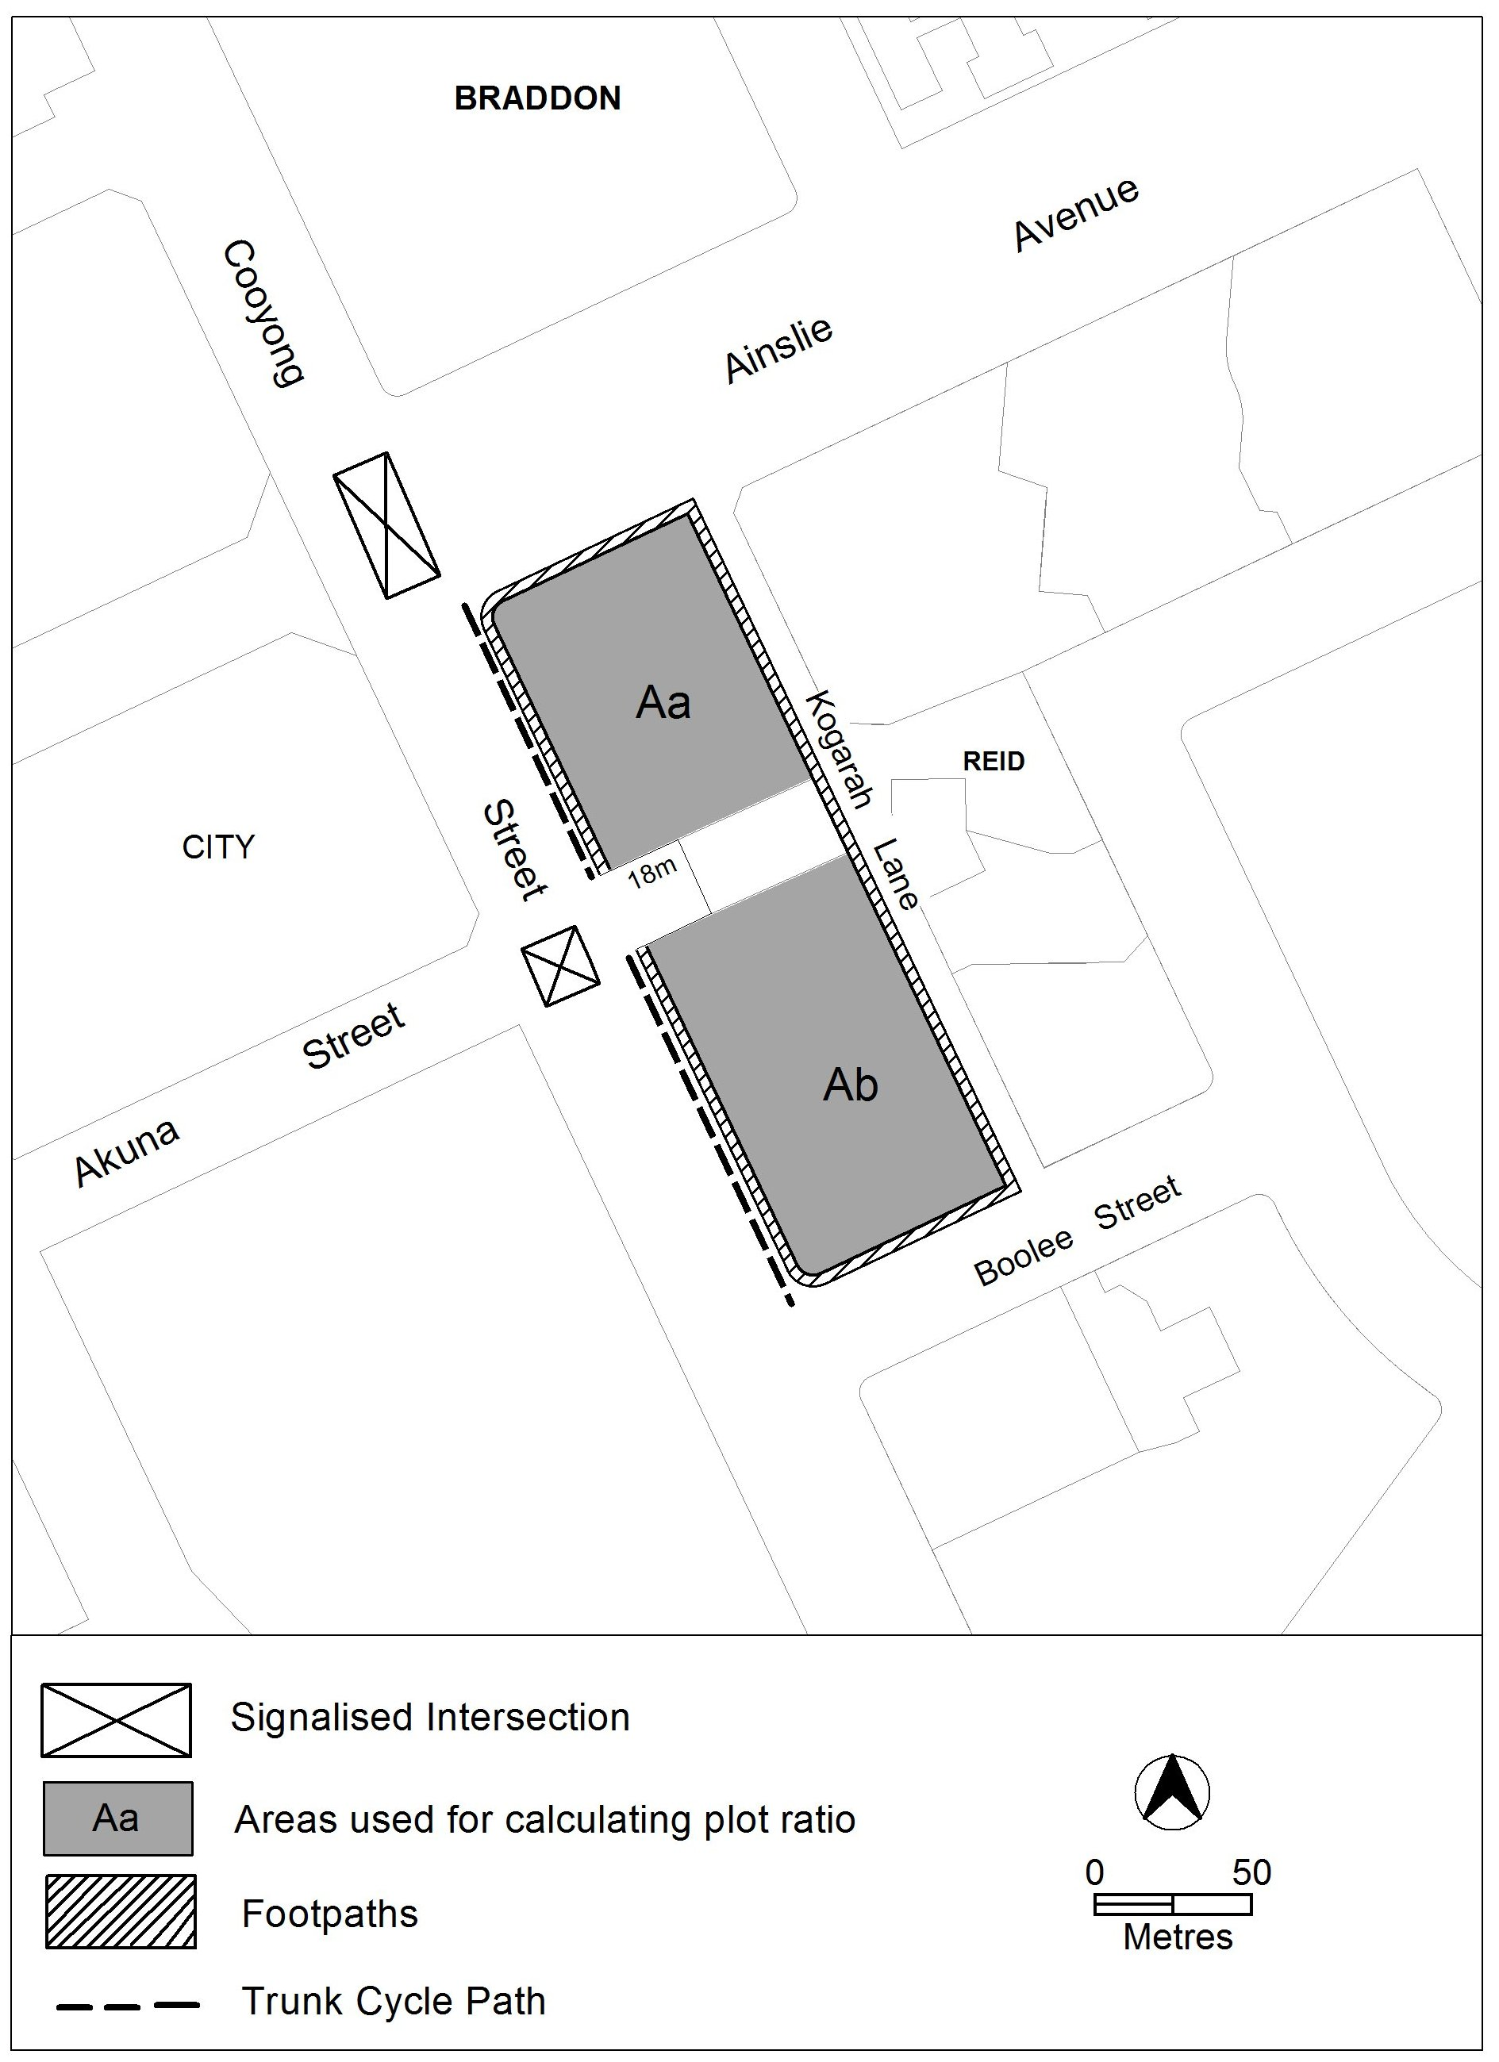

- Subdivision and off-site works

Rules | Criteria
  - Car parking and site access
There is no applicable rule. | Public car parking achieves all of the following:  - adequate on-street parking  - accessibility to the existing road, cycling and pedestrian networks  - adequate spaces dedicated for moped / motor bike and small vehicles.
Driveway access or egress to buildings from Ainslie Avenue and Cooyong Street is not permitted. | This is a mandatory requirement. There is no applicable criterion.
  - Public realm development
Landscaping and facilities in public areas are to be provided by the applicant in accordance with a public areas development plan prepared by a suitably qualified person. This plan is consistent with Figure 2 and shows, as a minimum, all of the following:  - trees (including registered trees)  - street trees, both new and retained trees  - front setback area at ground level and above.  Note:  TAMS will endorse the landscaping plan if it complies with the relevant TAMS standards.  TAMS may endorse departures.  A condition of approval may be imposed to ensure compliance with this rule. | Landscaping achieves all of the following:  - quality space for recreation and relaxation of residents  - provision for on-site infiltration of stormwater run-off  - quality landscaping adjacent to Cooyong Street and Ainslie Avenue
Note: Neither rule R7 nor criterion C7 changes any requirement in the Territory Plan for the preparation of a tree management plan approved under the Tree Protection Act 2005.

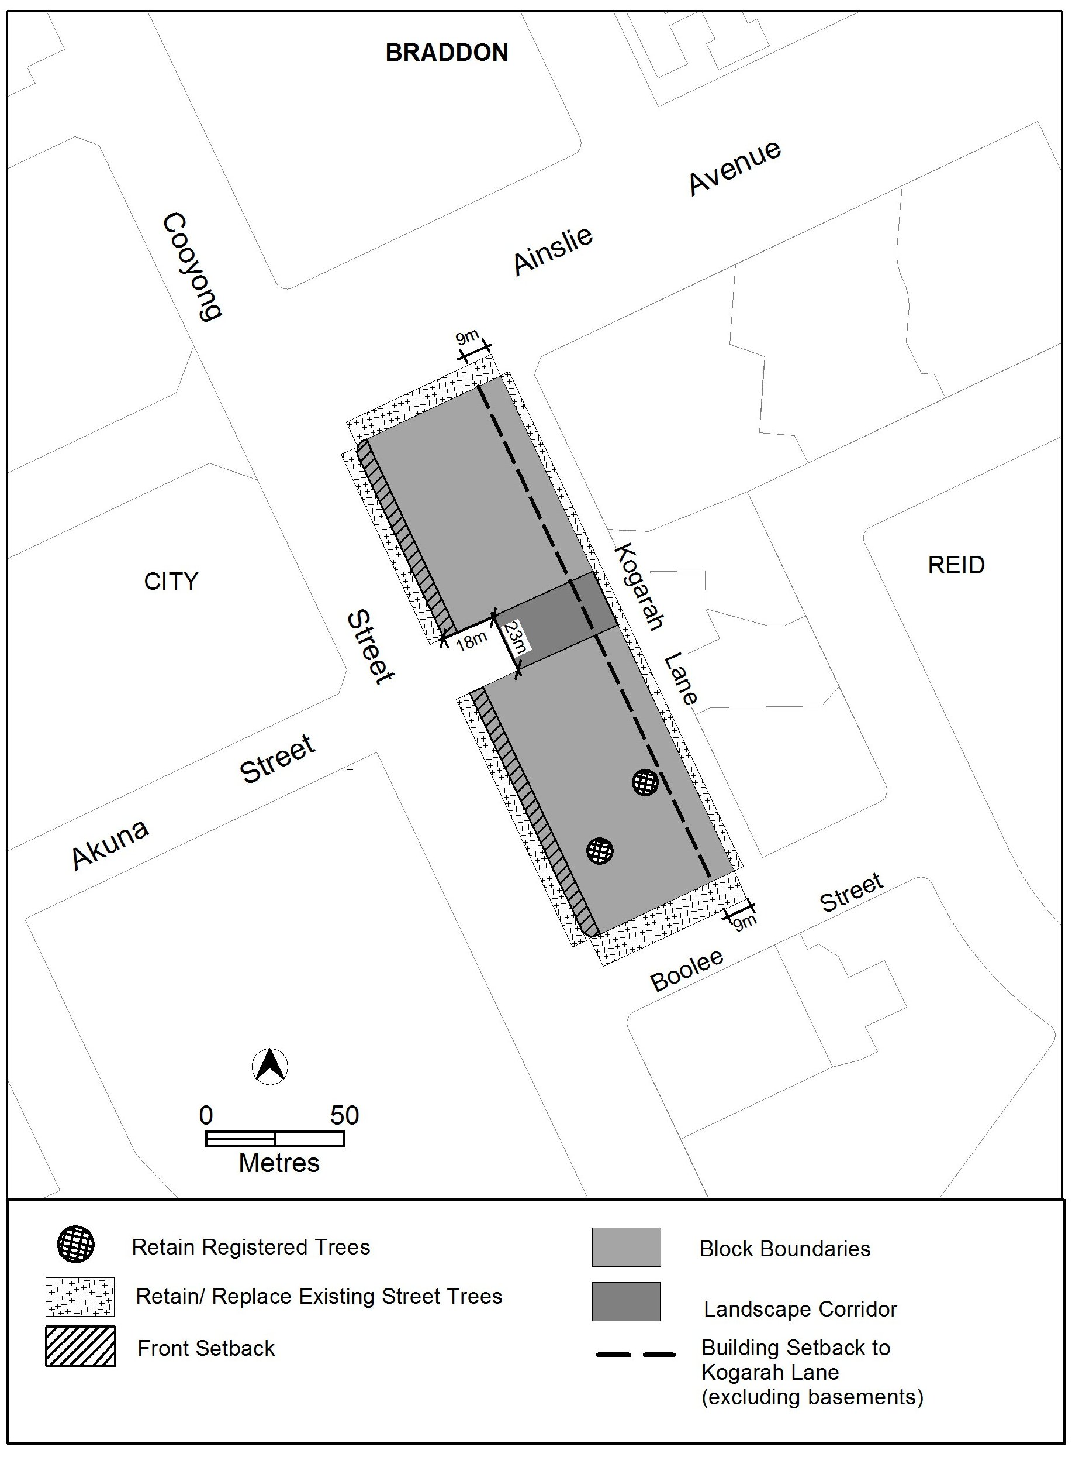
- Landscaping

- Use
Rules | Criteria
  - General
This rule applies to building fronting Cooyong Street.  The following uses are not permitted above the ground floor:  - restaurant  - SHOP | This is a mandatory requirement. There is no applicable criterion.
This rule applies to building fronting Cooyong Street.  The following uses are not permitted above the first floor:  - COMMUNITY USE  - indoor recreation facility  - NON RETAIL COMMERCIAL USE | This is a mandatory requirement. There is no applicable criterion.
This rule applies to CZ5.  The following gross floor area (GFA) restrictions apply:  - NON RETAIL COMMERCIAL USE: maximum GFA of 100m² per tenancy  - COMMUNITY USE and indoor recreation facility (where it is operated or subleased by a community organisation):  minimum GFA of 5 800 m² in total across the Cooyong Street urban renewal area of both the Braddon and Reid precinct codes  - SHOP: maximum GFA of 200m² per tenancy  - Restaurant: maximum GFA of 200m² per tenancy. | This is a mandatory requirement. There is no applicable criterion.

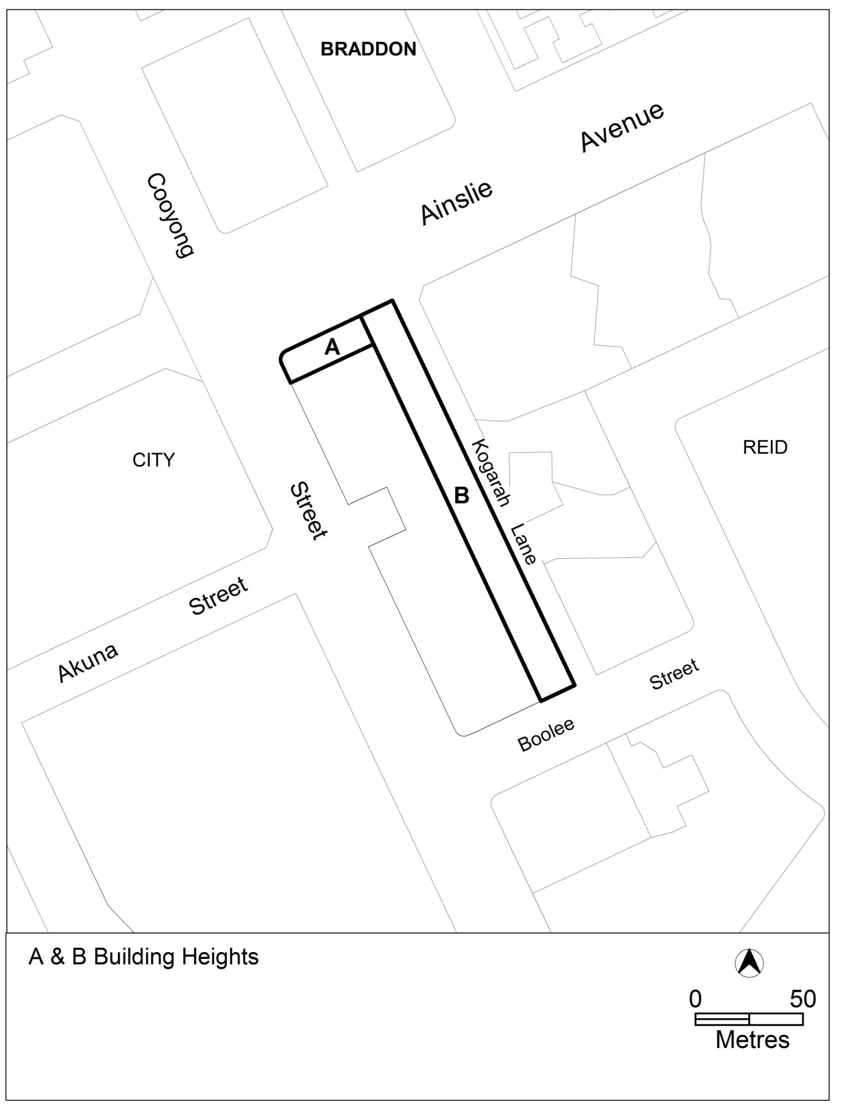
- Building elements
- Buildings
Rules | Criteria
  - Height of buildings
Building heights comply with one or more of the following:  - Buildings are contained within an envelope which rises 25 metres above datum ground level at the building line then returns at 45 degrees to a maximum of 28 metres (excluding rooftop plant and equipment) except as described below and as shown in Figure 3.  - Elements at location A in Figure 3 are no higher than 40 metres above datum ground level and a maximum of 12 storeys (excluding rooftop plant and equipment) and a maximum of 20 metres in length fronting Cooyong Street and 38 metres in length along the other frontage.  - Elements at location B in Figure 3 within 20 metres of Kogarah Lane are no higher than 16 metres (excluding rooftop plant and equipment) above datum ground level and a maximum of 20 metres in length fronting Kogarah Lane. | This is a mandatory requirement. There is no applicable criterion.
Minimum number of storeys is three 3. | This is a mandatory requirement. There is no applicable criterion.
  - Plot ratio
This rule applies to blocks and sections identified in Figure 1.  The maximum plot ratio is:  - 370% for block Aa  - 390% for block Ab | Plot ratios are consistent with the desired character of the Cooyong Street urban renewal area.
  - Setback to Cooyong Street
At the locations shown in Figure 2 fronting Cooyong Street the minimum setback is 6 metres. | Buildings and other structures achieve all of the following:  - presents a hard edge to the street  - provision of a landscaped area fronting Cooyong Street that satisfies criterion C7  - reasonable solar access to the public realm on Cooyong Street.
Note: Neither the previous rule nor criterion applies to underground car parking fronting Cooyong Street. The transfer of land above underground car parking to the Territory is not prevented by this provision.
This rule applies to buildings fronting one or more of the following:  - Cooyong Street  - Ainslie Avenue  - public open space.  Display windows and pedestrian access are provided at the ground floor level. | Development can be adapted to incorporate active frontage with direct pedestrian access at ground floor of buildings fronting one or more of the following:  - Cooyong Street  - Ainslie Avenue  - Public open space.
There is no applicable rule. | Floor to ceiling heights at the ground level of buildings fronting Cooyong Street and Ainslie Avenue can accommodate commercial use.
This rule applies to the frontage of blocks to Cooyong Styreet or Ainslie Avenue in CZ5.  The maximum percent of ground floor façade that is blank is 20%. | Ground floor facades of buildings fronting Cooyong Street and Ainslie Avenue present a varied and interesting design.
  - Setback to Kogarah Lane
At the location shown in Figure 2 fronting Kogarah Lane the minimum setback of buildings is 9 metres and the minimum setback of basements is 6 metres. | There is continuity of building lines fronting Kogarah Lane and the proposed service lane identified in the Braddon precinct code.  Deep root planting and other landscaping is provided in the area identified in Figure 2, between the building frontage and Kogarah Lane.
  - Landscape corridor
No buildings or structures are located within a 23 metre wide landscape corridor from the stub road off the Akuna Street Intersection through to Kogarah Lane as identified Figure 2. | Views, landscaping and pedestrian access are created through a link between Akuna Street in the City through to Kogarah Lane in Reid.
  - Building design
There is no applicable rule. | Development complies with all of the following:  - corner buildings contain focal points providing architectural interest and variety to the building design  - there is modulation in building heights across the site and along Cooyong Street  - entrances to common areas for residential use provide strong visual connection to the street and ensure a high level of surveillance  - driveways and pedestrian entrances to the site are visible from the boundary  - west-facing facades incorporate sun shading into building designs  - desired planning outcomes of:  - contributing to a high quality, environmentally sustainable residential development near Canberra’s main commercial centre  - balancing and protecting the high quality residential amenity while providing for community facilities and limited commercial use  - encouraging innovation in high quality design of the built form and open space  - minimising adverse impacts on environmental and heritage qualities within the precinct and adjacent sites  - supporting a street network that is designed for low vehicle speed and easy pedestrian access.
  - Rooftop gardens
There is no applicable rule. | Common open spaces in the form of rooftop gardens are provided and achieve all of the following:  - adequate access for residents, particularly on the higher floors  - sufficient space for recreation of residents  - reasonable solar access for gardening activities.

- Entity (Government agency) endorsement
Rules | Criteria
The following off-site works are to be endorsed by TAMS.  - on-street car parking for a minimum of 222 car parking spaces across the Cooyong Street urban renewal area of both the Braddon and Reid precinct codes  - other public car parking  - cycle paths  - pedestrian connections  - footpaths  - signalised intersections  Note:  TAMS will endorse the plan if it complies with the relevant TAMS standards.  TAMS may endorse departures. | This is a mandatory requirement. There is no applicable criterion.
Road designs within the road reservations shown in Figure 1 are to be endorsed by TAMS.  Note:  TAMS will endorse the plan if it complies with the relevant TAMS standards.  TAMS may endorse departures. | This is a mandatory requirement. There is no applicable criterion.
Off-site works are provided in accordance with a public realm plan endorsed by TAMS.  Such a plan is consistent with Figures 1 and 2 and shows, as a minimum, all of the following:  - urban open space  - trees (including registered trees)  - street trees, both new and retained  - the treatment of front setback areas.  Note:  TAMS will endorse the public realm plan if it complies with the relevant TAMS standards, which include Standard Specification 4 Urban Infrastructure Work Section 9, Design Specifications DS-4, DS-22 and DS-23.  TAMS may endorse departures. | This is a mandatory requirement. There is no applicable criterion.

