Australian Capital Territory
Planning and Development (Plan Variation No 338) Notice 2015
Notifiable Instrument NI2015-101
made under the
Planning and Development Act 2007, section 76(3)

- Name of instrument
This instrument is the Planning and Development (Plan Variation No 338) Notice 2015*.

- Plan Variation No 338
On Monday 2 March 2015, the Minister for Planning approved a draft of the attached plan variation to the Territory Plan (Annexure A) under s76 (3).

Jim Corrigan
Delegate of the Planning and Land Authority
10 March 2015

Planning and Development Act 2007

Variation to the
Territory Plan
No 338

ACT Government Land Release Program
Mitchell section 54 block 3
Amendment to the Territory Plan definitions and changes to the Mitchell precinct map and code

Final variation prepared under s76 of the
Planning and Development Act 2007

This page is intentionally blank.

Contents

1. EXPLANATORY STATEMENT 1
1.1 Background 1
1.2 Summary of the Proposal 3
1.3 The National Capital Plan 3
1.4 Site Description 3
1.5 Current Territory Plan provisions 5
1.6 Changes to the Territory Plan 7
1.7 Consultation on the draft variation 7
1.8 Revisions to the draft variation recommended to the Minister 7
2. VARIATION 8
2.1 Variation to the Territory Plan 8

This page is intentionally blank.

- EXPLANATORY STATEMENT
  - Background
    - Land Release Program 2014-15 to 2017-18
The supply and release of land is a central part of the Government’s economic and social strategy and supports the needs of a growing population, changing households and an expanding economy. In particular, land supply has an important role in providing a range of affordable housing choices, and in meeting the needs of the commercial and industrial sectors, factors that are crucial in attracting and retaining a skilled workforce.
The leasehold system in the ACT makes it unique as it provides the Government with the ability to influence when, where and how development occurs. Land sales also provide a significant source of funding.
Each year the ACT Government prepares four year indicative land release programs which sets out the Government’s intended program of residential, commercial, industrial, community and non-urban land releases.
The four year indicative land release programs are intended to provide guidance on the Government’s land release intentions and seek to balance economic, social, financial and environmental objectives to:
- promote the economic and social development and population growth of the Territory;
- meet the demand for land in the Territory;
- allow flexibility to respond to fluctuations in the market;
- establish an appropriate inventory of serviced land;
- provide an appropriate choice of land and housing options and facilitating the provision of affordable housing; and
- achieve satisfactory returns from the sale of unleased Territory land.
The identification of blocks for release is based on an assessment of overall demand drivers. Within the individual sectors land is made available in response to factors such as:
- population growth rates including net overseas migration;
- demographic changes eg changes to living arrangements, ageing population;
- existing supply by the private sector and demand from the market eg vacancy rates and rent levels;
- ACT Government objectives eg diversifying the economic and employment base of the Territory;
- Market confidence and the availability of finance;
- Employment rates;
- Responding to private sector initiatives, such as the development and growth of the Canberra Airport;
- Local factors which can affect the demand for particular types of land; and
- National trends eg growth of innovative, emerging and creative industries eg environmental technologies, medical and bio-technologies and information technology.
The Land Development Agency (LDA) is responsible for the delivery of the land release programs. Some of the objectives of the LDA in delivering the land release programs include:
- Pursuing initiatives to deliver affordable housing consistent with the Affordable Housing Action Plan;
- Developing urban renewal and development strategies for the city centre, town centres, major transport corridors and group centres;
- Establishing an inventory of environmentally cleared, planned, release ready and serviced land that will provide flexibility and alternative release options to cover any unanticipated delays on sites otherwise identified for release in the relevant period;
- Encouraging viable and liveable communities by providing a variety of block and dwelling types and public spaces to suit the needs of residents and surrounding communities; and
- Contributing to the redevelopment of the transit corridor between Gungahlin, Civic and Lake Burley Griffin through the Capital Metro and City to the Lake projects.
More information can be found at:
http://www.economicdevelopment.act.gov.au/land and http://www.lda.act.gov.au

    - Background to the Mitchell site
The objective of this variation is to make land available for larger scale civic administration uses. The Mitchell site offers a well located larger site of land within the NUZ1 zone suitable for civic administration uses. This is consistent with the National Capital Plan which allows ‘administrative uses’ in the broadacre areas.
  - Summary of the Proposal
The purpose of this variation is to allow civic administration uses on block 3 section 54 Mitchell, consistent with the National Capital Plan and to meet demand for such uses outside the urban area. The National Capital Plan currently allows ‘administrative uses’ within broadacre areas. In this way, the National Capital Plan accommodates administrative uses that require larger sites outside the urban area. However, the Territory Plan does not. This variation proposes to allow civic administration uses on the subject site to meet the demand for such uses consistent with the National Capital Plan.
  - The National Capital Plan
The Australian Capital Territory (Planning and Land Management) Act 1988 established the National Capital Authority (NCA) with two of its functions being to prepare and administer a National Capital Plan (NCP) and to keep the NCP under constant review and to propose amendments to it when necessary.
The NCP, which was published in the Commonwealth Gazette on 21 January 1990 is required to ensure that Canberra and the Territory are planned and developed in accordance with their national significance. The Planning and Land Management Act 1988 also required that the Territory Plan is not inconsistent with the NCP.
In accordance with section 10 of the Australian Capital Territory (Planning and Land Management) Act 1988, the National Capital Plan defines the planning principles and policies for Canberra and the Territory, for giving effect to the object of the NCP and sets out the general policies to be implemented throughout the Territory, including the range and nature of permitted land uses.
It also sets out the detailed conditions of planning, design and development for areas that have special significance to the National Capital known as designated areas and identifies special requirements for the development of some other areas.

  - Site Description
The subject site is Mitchell section 54, block 3 as shown in Figure 1. It has an area of approximately 4.25 hectares fronting Sandford Street, Hoskins Street and Nirta Place. The site adjoins NUZ1 broadacre zoned land on which the crematorium is located. The cemetery across the road is also included in the NUZ1 broadacre zone.
The site is about 4.5 kilometres from the Gungahlin Town Centre, 5.3 kilometres from Dickson and 8.3 kilometres from Civic. Mitchell is located close to the Federal Highway and Barton Highway. The proposed light rail corridor will be located in Flemington Road which forms the eastern boundary of Mitchell.
The subject site is unleased and undeveloped. It is managed by the Territory and Municipal Services Directorate.
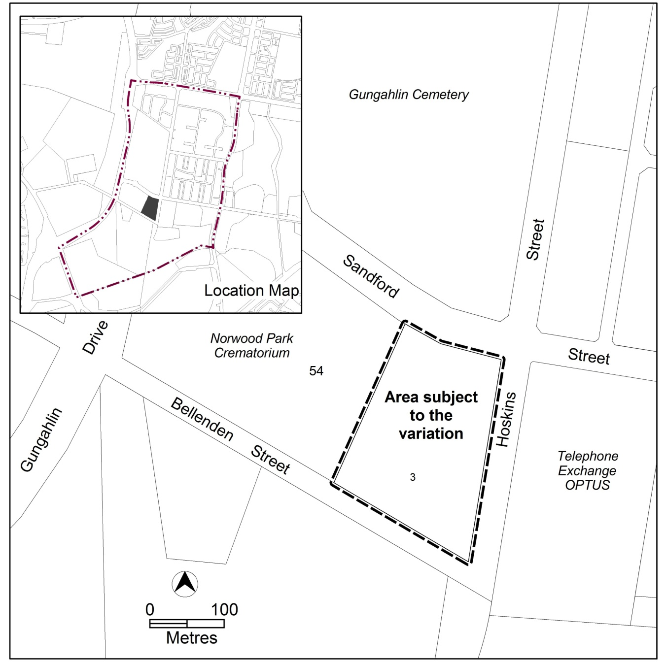
Figure 1 Site Plan

  - Current Territory Plan provisions
The current Territory Plan map zone for the area subject to this variation is shown in Figure 2. The current Mitchell precinct map is shown in Figure 3.

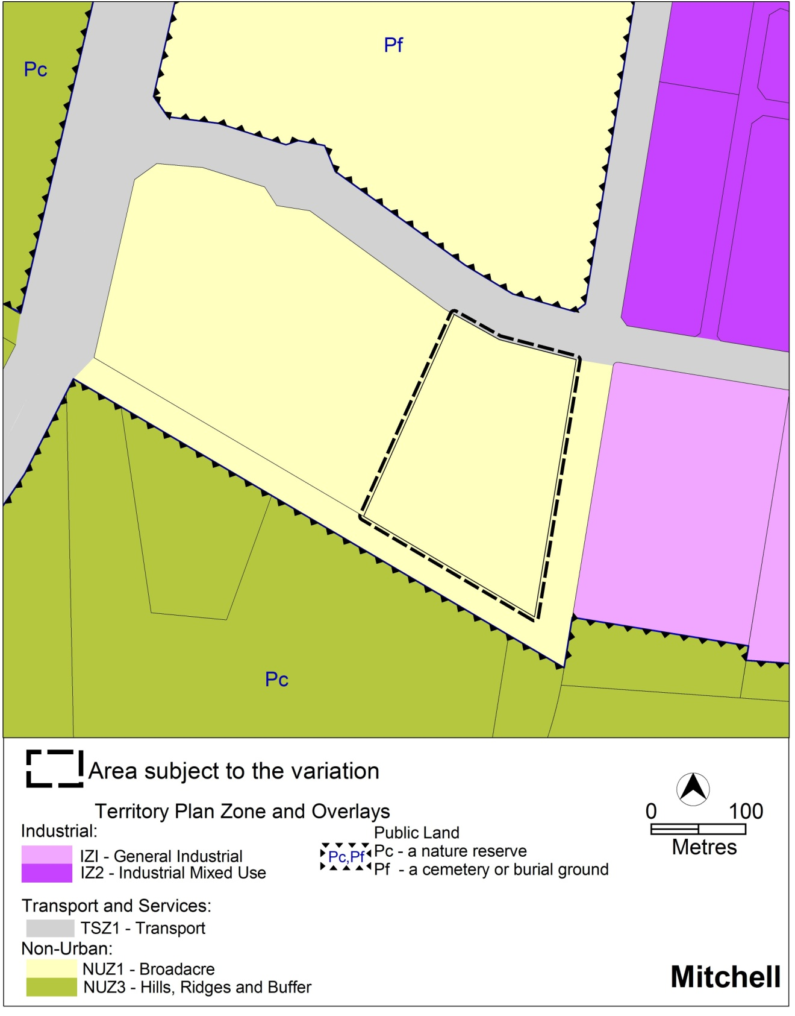
Figure 2 Territory Plan Zones Map

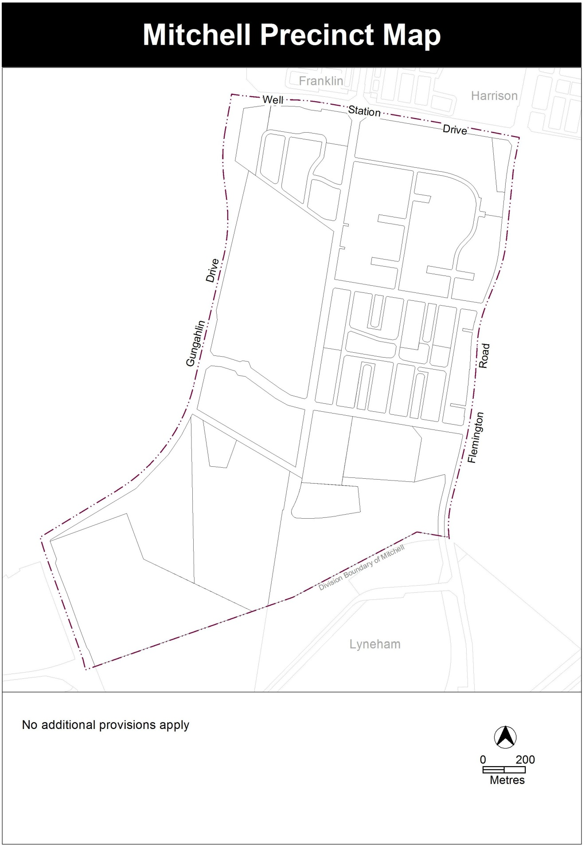
Figure 3 – Current Mitchell precinct map

  - Changes to the Territory Plan
    - Changes to the Territory Plan definitions
The changes to the Territory plan definitions are indicated at Part 2 of this document and involve adding the term ‘archive’ to the common terminology of the definition of ‘civic administration’.
    - Changes to the Mitchell precinct map and code
The changes to the Mitchell precinct map and code are indicated at Part 2 of this document and involve amending the Mitchell precinct map to allow civic administration on the site.
  - Consultation on the draft variation
Draft variation No 338 (DV338) was released for public comment between 7 November 2014 and 19 December 2014. A consultation notice under section 63 of the Planning and Development Act 2007 (the Act) was published on the ACT Legislation Register on 7 November 2014 and in the Canberra Times on 8 November 2014.
One (1) submission was lodged during the consultation period. This submission raised concerns about stormwater quantity and quality as a result of the future development of the site.
These issues were considered and are detailed in a report on consultation.

  - Revisions to the draft variation recommended to the Minister
No revisions were made to the draft variation that was placed on public consultation.

- VARIATION
  - Variation to the Territory Plan

Variation to the Definitions
- Definition of civic administration – common terminology

Insert
Archive

Variation to the Mitchell precinct map and code
- Mitchell Precinct Map

Substitute

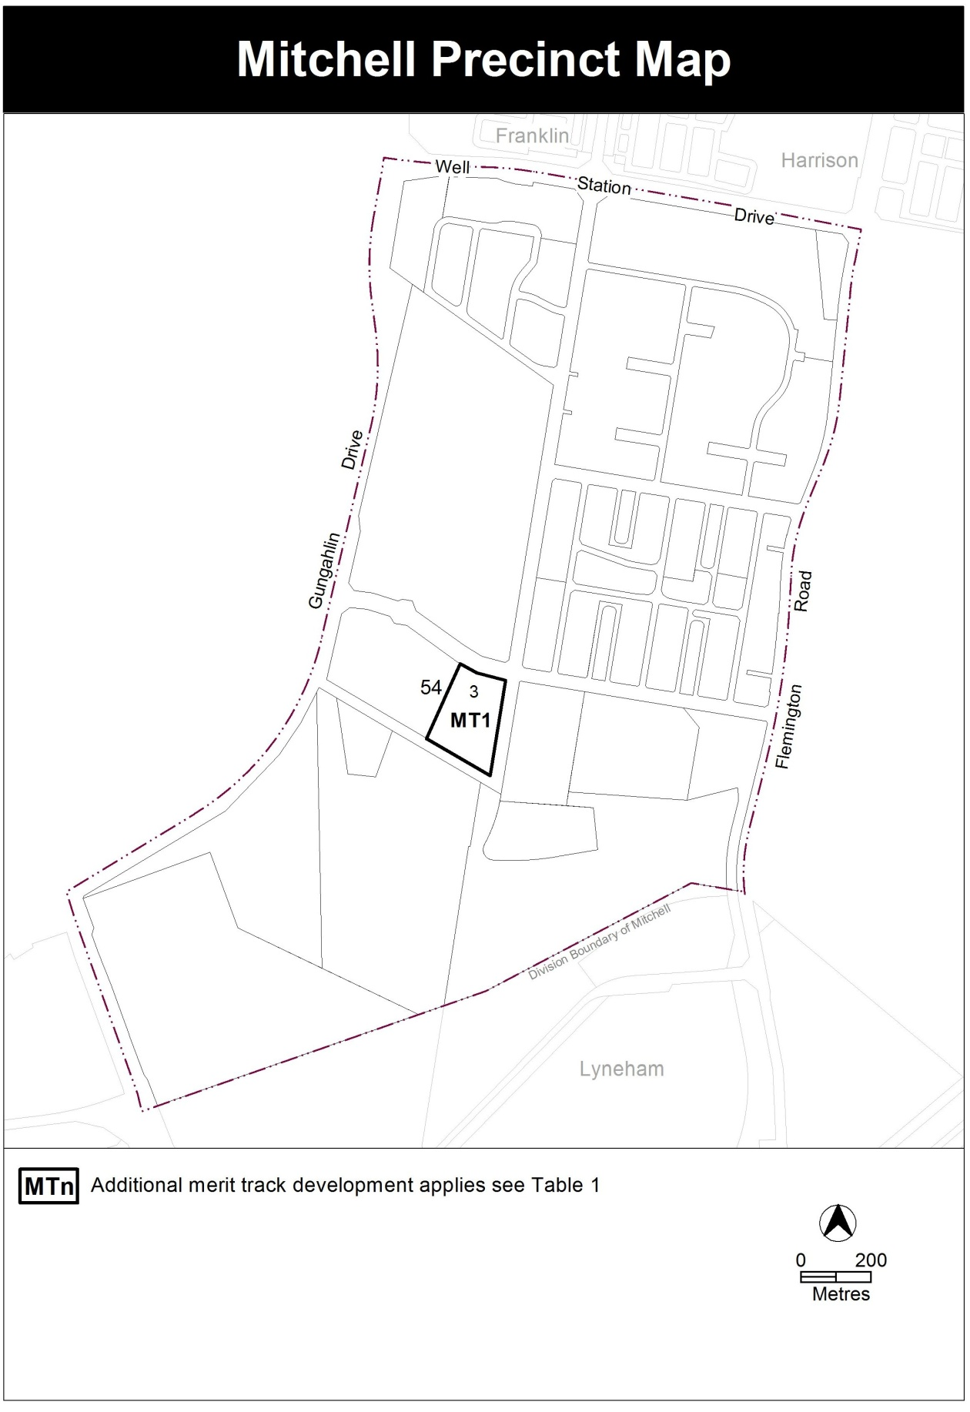

- Mitchell Precinct Map – Table 1

Insert
Table 1 – Additional merit track development
Additional merit track development that may be approved subject to assessment
Suburb precinct map label | Zone | Development
MT1 | NUZ1 | Civic administration

Interpretation service
