Australian Capital Territory
Planning and Development (Plan Variation No 322) Notice 2015
Notifiable Instrument NI2015-185
made under the
Planning and Development Act 2007, section 76(3)

- Name of instrument
This instrument is the Planning and Development (Plan Variation No 322) Notice 2015*.

- Plan Variation No 322
On Wednesday 29 April 2015, the Minister for Planning approved a draft of the attached plan variation to the Territory Plan (Annexure A) under s76 (3).

Jim Corrigan
Delegate of the Planning and Land Authority
1 May 2015

Planning and Development Act 2007

Variation to the
Territory Plan
No 322

ACT Government Land Release Program
Downer Urban Renewal Area
Downer section 61, block 17 and block 16
Zoning changes and changes to the
Downer precinct map and code

Final variation prepared under s76 of the
Planning and Development Act 2007

This page is intentionally blank.

Contents

1. EXPLANATORY STATEMENT 1
1.1 Background 1
1.1.1 Land Release Program 2014-15 to 2017-18 1
1.1.2 Background to the Downer site 3
1.2 Summary of the proposal 3
1.3 The National Capital Plan 4
1.4 Site Description 5
1.5 Current Territory Plan provisions 6
1.6 Changes to the Territory Plan 7
1.7 Consultation on the draft variation 7
2. VARIATION 8
2.1 Variation to the Territory Plan map 8
2.2 Variation to the Territory Plan 9

This page is intentionally blank.

- EXPLANATORY STATEMENT
  - Background
    - Land Release Program 2014-15 to 2017-18
The supply and release of land is a central part of the Government’s economic and social strategy and supports the needs of a growing population, changing households and an expanding economy. In particular, land supply has an important role in providing a range of affordable housing choices, and in meeting the needs of the commercial and industrial sectors, factors that are crucial in attracting and retaining a skilled workforce.
The leasehold system in the ACT makes it unique as it provides the Government with the ability to influence when, where and how development occurs. Land sales also provide a significant source of funding.
Each year the ACT Government prepares four year indicative land release programs which sets out the Government’s intended program of residential, commercial, industrial, community and non-urban land releases.
The four year Indicative land release programs are intended to provide guidance on the Government’s land release intentions and seek to balance economic, social, financial and environmental objectives to:
- promote the economic and social development and population growth of the Territory;
- meet the demand for land in the Territory;
- allow flexibility to respond to fluctuations in the market;
- establish an appropriate inventory of serviced land;
- provide an appropriate choice of land and housing options and facilitating the provision of affordable housing; and
- achieve satisfactory returns from the sale of unleased Territory land.

The identification of blocks for release is based on an assessment of overall demand drivers. Within the individual sectors land is made available in response to factors such as:
- population growth rates including net overseas migration;
- demographic changes eg changes to living arrangements, ageing population;
- existing supply by the private sector and demand from the market eg vacancy rates and rent levels;
- ACT Government objectives eg diversifying the economic and employment base of the Territory;
- Market confidence and the availability of finance;
- Employment rates;
- Responding to private sector initiatives, such as the development and growth of the Canberra Airport;
- Local factors which can affect the demand for particular types of land; and
- National trends eg growth of innovative, emerging and creative industries eg environmental technologies, medical and bio-technologies and information technology.
The Land Development Agency (LDA) is responsible for the delivery of the land release programs. Some of the objectives of the LDA in delivering the land release programs include:
- Pursuing initiatives to deliver affordable housing consistent with the Affordable Housing Action Plan;
- Developing urban renewal and development strategies for the city centre, town centres, major transport corridors and group centres;
- Establishing an inventory of environmentally cleared, planned, release ready and serviced land that will provide flexibility and alternative release options to cover any unanticipated delays on sites otherwise identified for release in the relevant period;
- Encouraging viable and liveable communities by providing a variety of block and dwelling types and public spaces to suit the needs of residents and surrounding communities; and
- Contributing to the redevelopment of the transit corridor between Gungahlin, Civic and Lake Burley Griffin through the Capital Metro and City to the Lake projects.
More information can be found at:
http://www.economicdevelopment.act.gov.au/land and http://www.lda.act.gov.au

    - Background to the Downer site
The purpose of this variation is to facilitate the redevelopment of land in Downer which is occupied by the former Downer primary school. The Economic Development Directorate (EDD) has prepared a proposal for high density residential development consistent with the ACT Affordable Housing Strategy.
The proposal also makes provision for a limited area for non-retail commercial uses, shops-limited to personal services only and community uses (including a child care centre, a health facility). The variation also recognises and protects the existing community uses of Downer, section 61, block 16.
The subject land adjoins the Downer local centre and is within 800metres from the Dickson group centre. The land comprises two separate blocks – Downer section 61, block 17 and block 16. The site is situated approximately 4km from Civic.
The Environment and Planning Directorate (EPD), in consultation with the relevant ACT Government agencies, evaluated the planning report in support of the proposal and has agreed to proceed with the preparation of this variation to the Territory Plan DV322.
DV322 has been prepared with the Downer local centre in mind. It is intended to compliment the reintroduction of commercial activity at the centre. The presence of high density residential development adjacent to the centre will assist to activate it. In return, the centre will meet the non commercial retail and personal services needs of the residents of the site as well as for Downer residents generally.
The variation has also taken into account the heritage values of the site and surrounds. The heritage values of the trees on and surrounding the site have been protected. Traffic, parking and residential amenity have been addressed through a design which focuses on improved access to the Downer local centre whilst also providing for access to the site.

  - Summary of the proposal
The objective of this variation is to facilitate the redevelopment of land in Downer which was formerly occupied by the Downer Primary School. The school closed in 1988 and the site has since been used as office accommodation for a range of organisations.
It is proposed to rezone block 17 to allow a mix of high density residential development consistent with the ACT Affordable Housing Strategy. It is also proposed to allow community use and a limited area for non retail commercial development and shops (limited to personal services only) on the site.
The rezoning of block 16 is to protect the existing use of the site for community uses by including the land in the CFZ community facility zone. It is currently included in the commercial CZ4 local centre zone.
A number of site specific provisions will be introduced into the Downer suburb precinct code to guide the re-development of the site. These provisions include details of additional prohibited development, additional merit track development, and building heights.
The site is included on the ACT Heritage register which prevails over any of the provisions in the Territory Plan.

  - The National Capital Plan
The Australian Capital Territory (Planning and Land Management) Act 1988 established the National Capital Authority (NCA) with two of its functions being to prepare and administer a National Capital Plan (NCP) and to keep the NCP under constant review and to propose amendments to it when necessary.
The NCP, which was published in the Commonwealth Gazette on 21 January 1990 is required to ensure that Canberra and the Territory are planned and developed in accordance with their national significance. The Planning and Land Management Act 1988 also required that the Territory Plan is not inconsistent with the NCP.
In accordance with section 10 of the Australian Capital Territory (Planning and Land Management) Act 1988, the National Capital Plan defines the planning principles and policies for Canberra and the Territory, for giving effect to the object of the NCP and sets out the general policies to be implemented throughout the Territory, including the range and nature of permitted land uses.
It also sets out the detailed conditions of planning, design and development for areas that have special significance to the National Capital known as designated areas and identifies special requirements for the development of some other areas.

  - Site Description
The subject land is identified in Figure 1. Block 17 section 61 Downer has an area of approximately 32,000m2. It is rectangular in shape with a frontage of approximately 250m to Bradfield Street and 120m to Melba Street and Frencham Street, with a slight (1%) fall from east to west.
Block 16 section 61 Downer has an area of 874m2. It is rectangular in shape and has dual frontage to both ends of Frencham Place. The site is currently occupied by a single storey building, which is occupied for community uses.

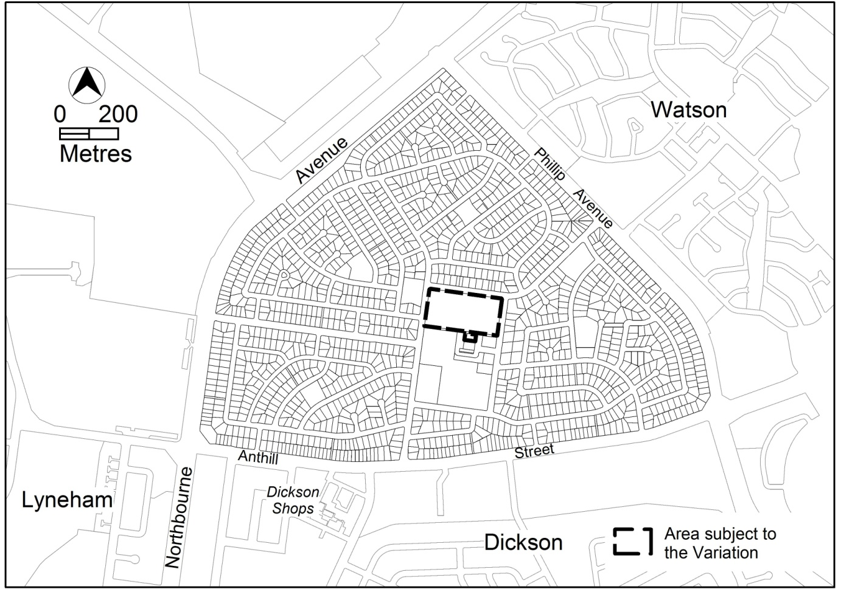
Figure 1 Location of the area to be rezoned

  - Current Territory Plan provisions
The Territory Plan map zone for the area subject to this variation is shown in Figure 2.
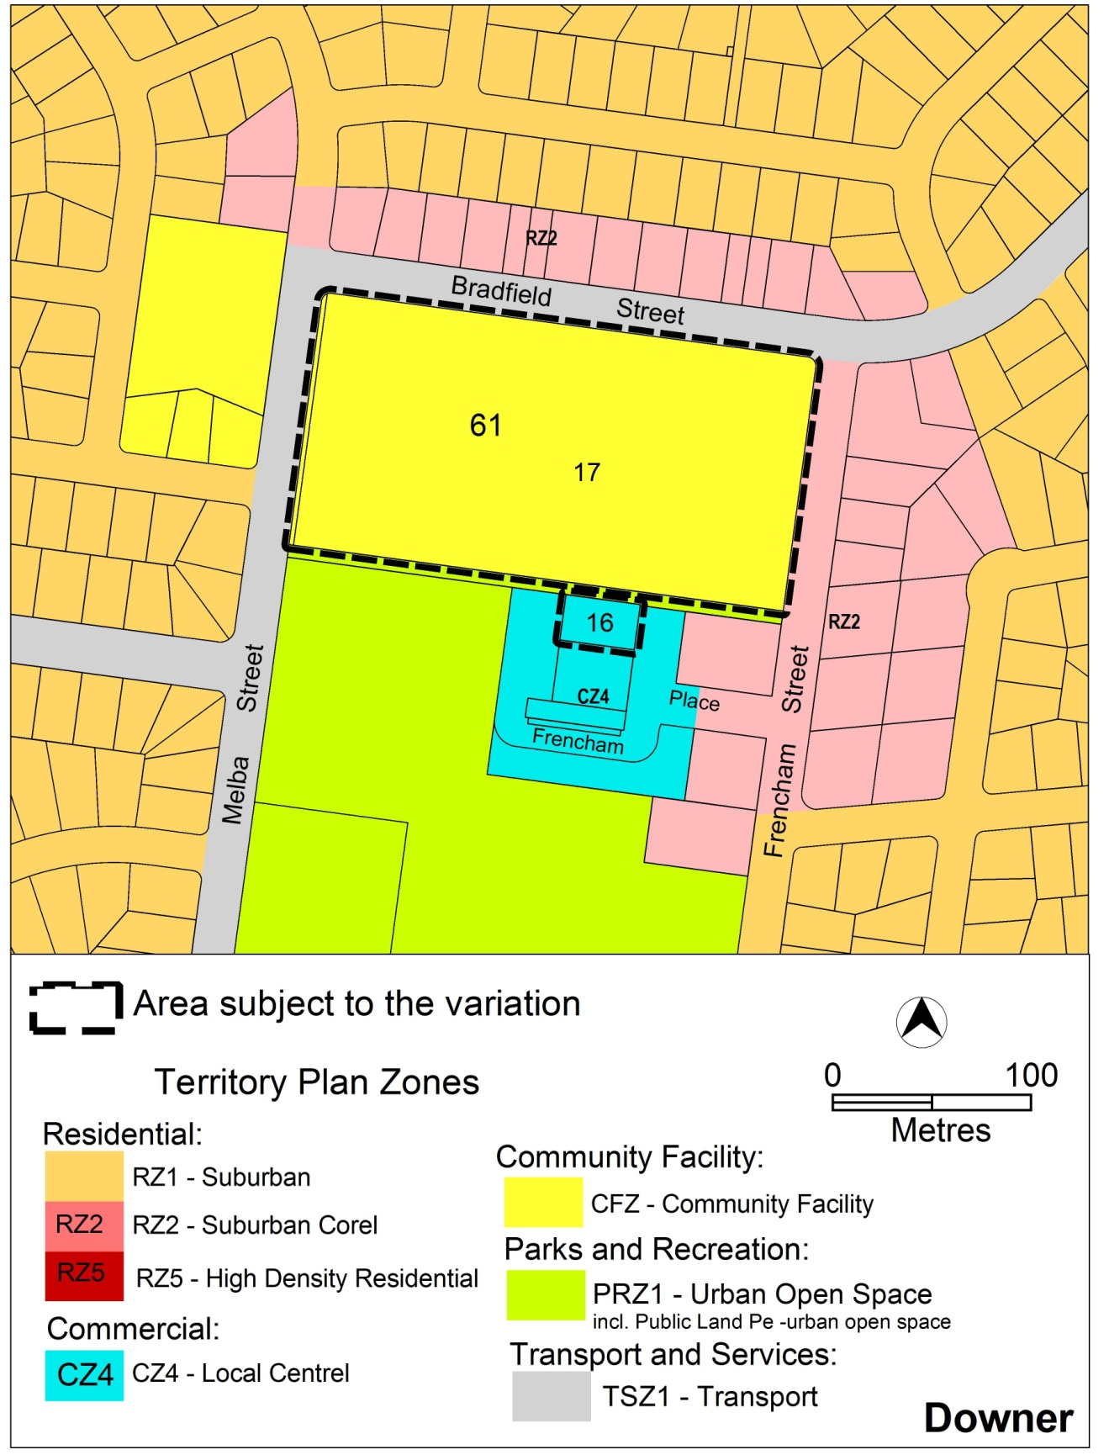
Figure 2 Territory Plan Zones Map

  - Changes to the Territory Plan
Detailed changes to the Territory Plan are noted in section 2 of this document.

  - Consultation on the draft variation
Draft Variation No 322 (DV322) was released for public comment between Friday 7 November 2014 and Friday 19 December 2014. A consultation notice under section 63 of the Planning and Development Act 2007 (P&D Act) was published on the ACT Legislation Register on 7 November 2014 and in The Canberra Times on Saturday 8 November 2014.
A total of 21written submissions were received. The main issues raised by submitters included:
- Community consultation processes
- The proposed RZ5 high density residential zone and consideration of alternatives
- Population density and dwelling limits
- Building heights, overlooking and overshadowing
- Building types and design
- Public realm and communal open space
- Traffic, access and parking
- Public transport
- Trees
- Community uses and facilities
- Public housing
- Property values

The above issues were considered and are detailed in a report on consultation. Changes to the draft variation were informed by the issues raised. The outcomes of consultation were considered by the Minister responsible for planning prior to approval of this variation.

- VARIATION
  - Variation to the Territory Plan map
Vv The Territory Plan map is varied as indicated in Figure 3 – Proposed Territory Plan Map

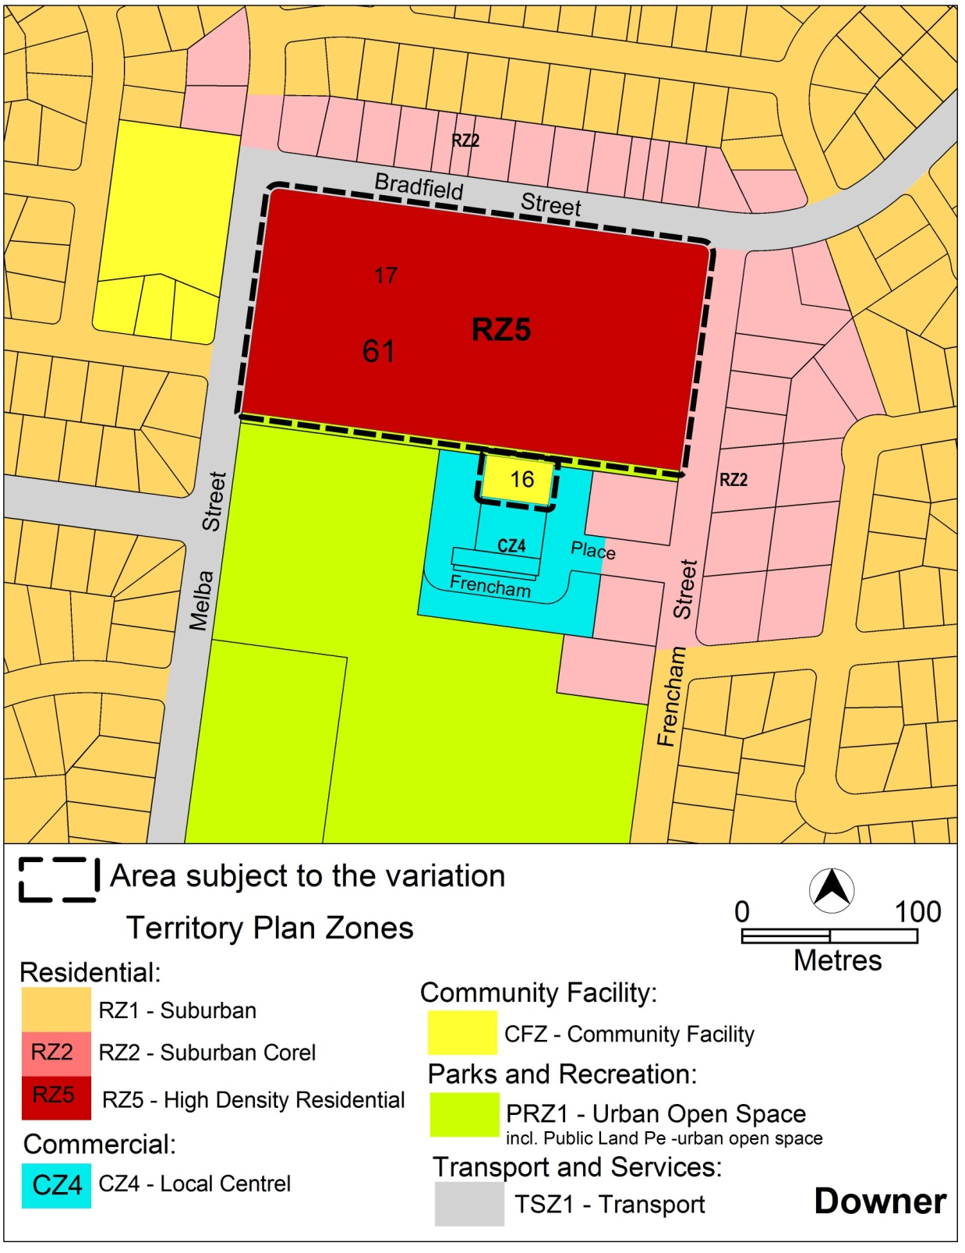
Figure 3 – Proposed Territory Plan map

  - Variation to the Territory Plan
The Territory Plan is varied as follows.
- Downer precinct map and code

Substitute Downer precinct map with the Downer precinct map and code at Appendix 1.

Interpretation service
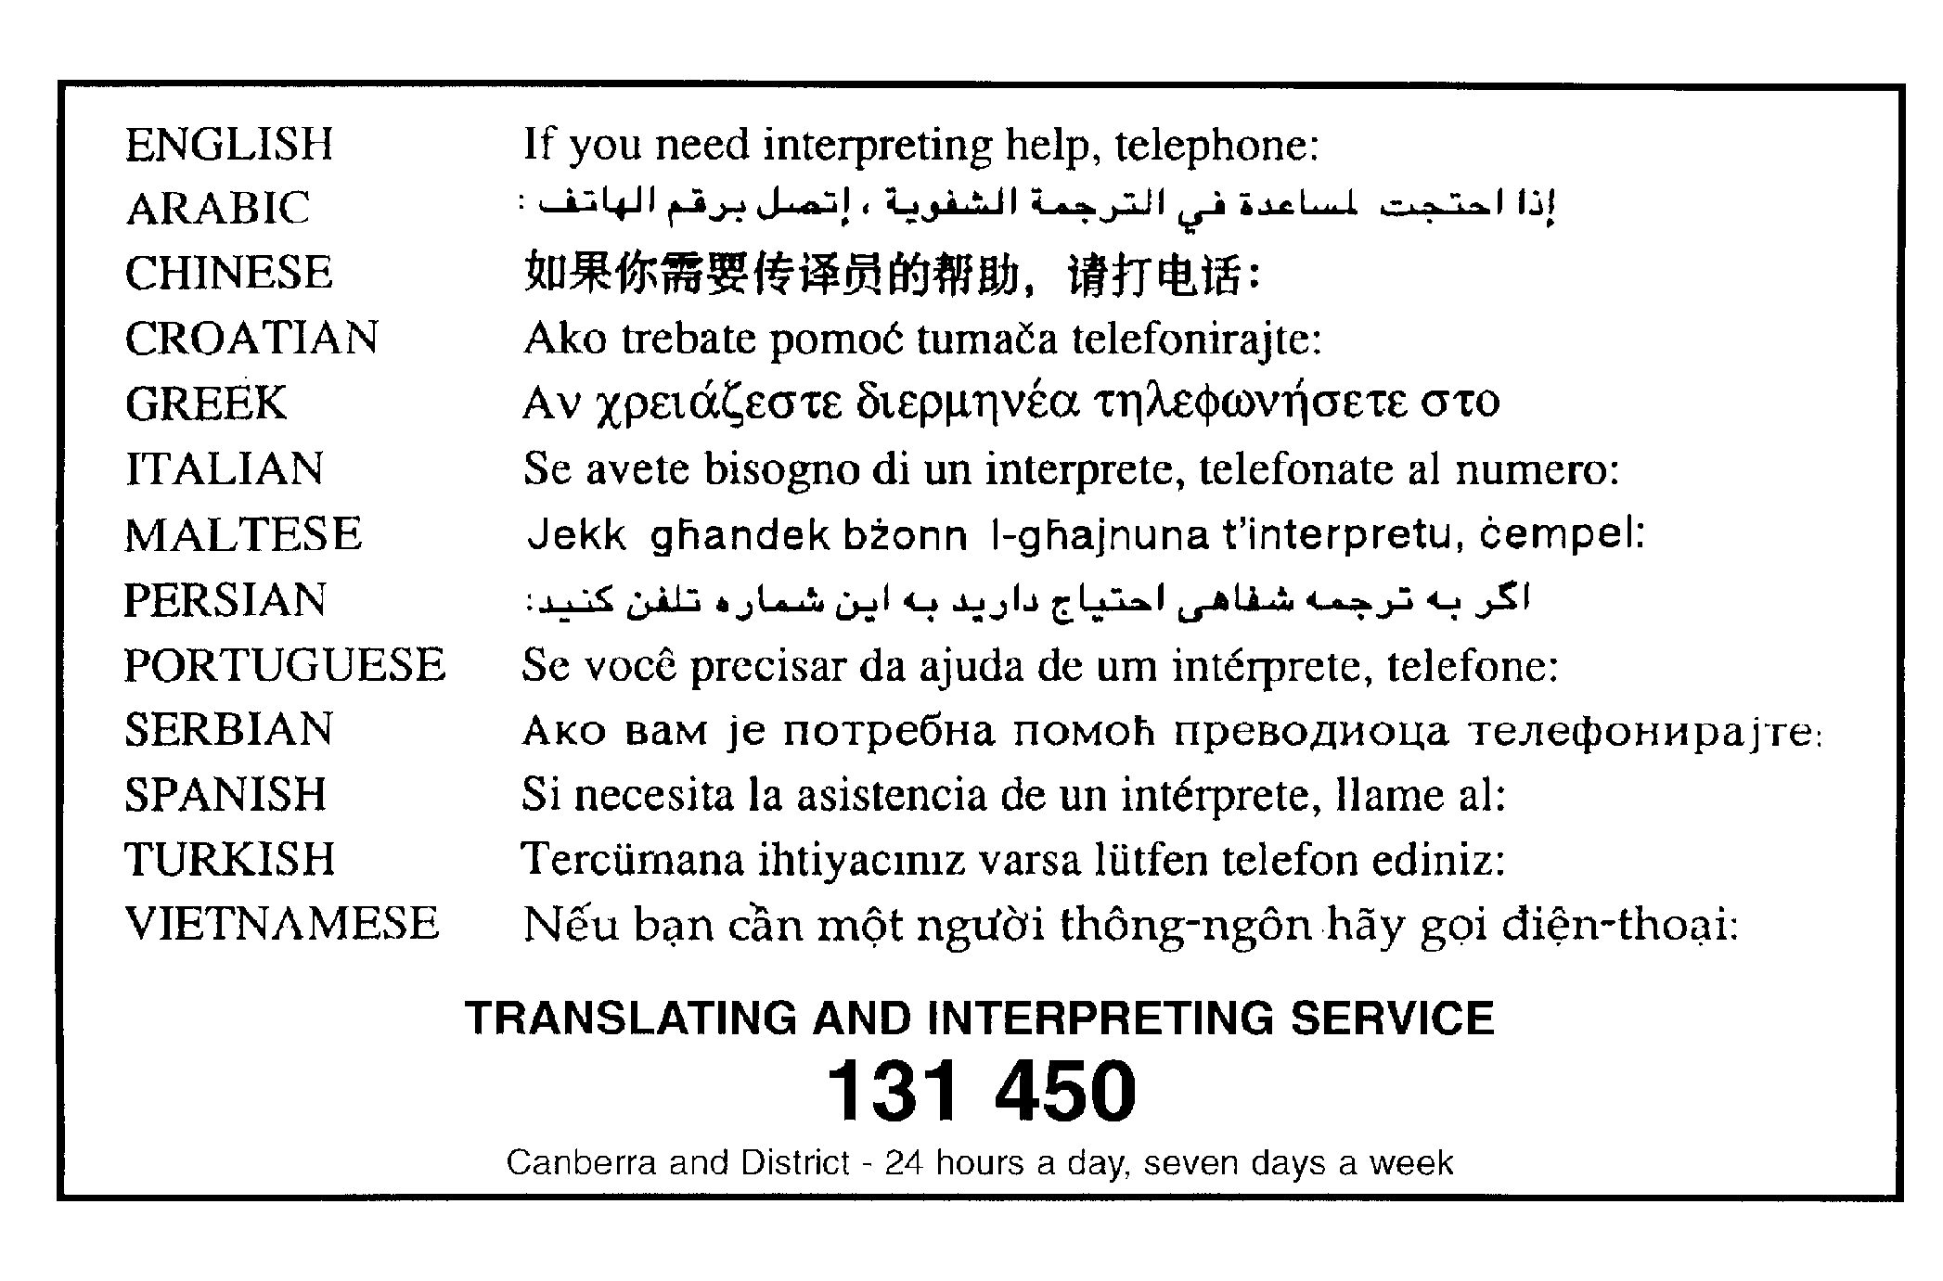

Appendix 1

Downer Precinct Map and Code

This page is intentionally blank.

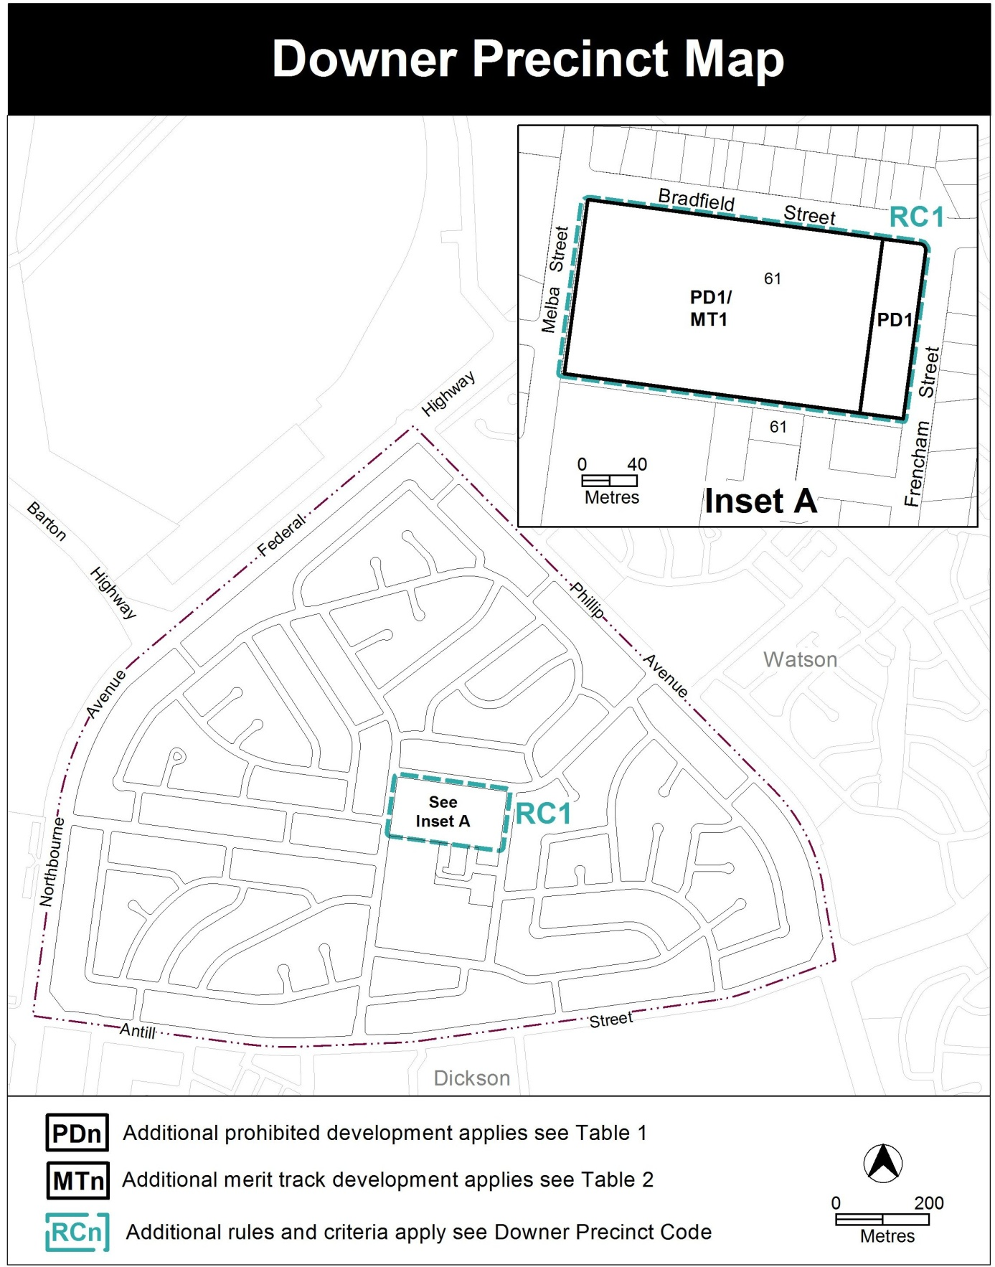

Assessment Tracks
The following tables identify the additional prohibited development and additional merit track development for blocks and parcels shown in the Downer precinct map (identified as PDn or MTn). Development that is exempt from requiring development approval, other prohibited development and the minimum assessment track applicable to each development proposal is set out in the relevant zone development table.
The following tables constitute part of the relevant zone development table.
Table 1 – Additional prohibited development
Additional prohibited development
Suburb precinct map label | Zone | Development
PD1 | RZ5 | boarding house  guest house  special dwelling

Table 2 – Additional merit track development
Additional merit track development that may be approved subject to assessment
Suburb precinct map label | Zone | Development
MT1 | RZ5 | Child care centre  Community activity centre  Health facility  Non retail commercial use  Personal service

Downer Precinct Code

Contents
Introduction 2
Additional rules and criteria 4
RC1 – Downer Urban Renewal Area 4
Element 1: Use 5
1.1 General (replaces Rule R47 and Criterion C47 of the residential zones development code) 5
1.2 Non residential uses 5
1.3 Number of dwellings 5
Element 2: Building and site controls 6
2.1 Site access 6
2.2 Desired character 6
2.3 Height of buildings 6
2.4 Setbacks 6
2.5 Communal open space 7
Element 3: Entity (Government agency) endorsement 7
3.1 Off-site works 7

Figures
Figure 1 Development provisions – Downer section 61 block 17 6

Introduction
Name
The name of this code is Downer Precinct Code.
Application
The code applies to the Division of Downer.
Purpose
This code provides additional planning, design and environmental controls for specific areas or blocks and may also contain references to provisions in other codes.
In conjunction with other relevant codes it will be used by the Authority to assess development applications and offer guidance to intending applicants in designing development proposals and preparing development applications.
Structure
This code contains additional rules and/or criteria for particular blocks or parcels identified as areas RCn on the precinct map, to be read in conjunction with the relevant development code. It may also contain sub-parts.
Each element has one or more rules and, unless the respective rule is mandatory, each rule has an associated criterion. Rules provide quantitative, or definitive, controls. By contrast, criteria are chiefly qualitative in nature.
In some instances rules are mandatory. Such rules are accompanied by the words “This is a mandatory requirement. There is no applicable criterion.” Non-compliance with a mandatory rule will result in the refusal of the development application. Conversely, the words “There is no applicable rule” is found where a criterion only is applicable.
Code hierarchy
Under the Planning and Development Act 2007, where more than one type of code applies to a development, the order of precedence if there is inconsistency of provisions between codes is: precinct code, development code and general code.
Definitions
Defined terms, references to legislation and other documents are italicised.
Definitions of terms used in this code are listed in part 13 of the Territory Plan or, for terms applicable only to this code, associated with the respective rule.

Acronyms
ACTPLA Planning and Land Authority within the ACT Environment and Planning Directorate
EPA ACT Environment Protection Authority
ESA ACT Emergency Services Agency
EPD ACT Environment and Planning Directorate
NCA National Capital Authority
P&D Act Planning and Development Act 2007
TAMS ACT Territory and Municipal Services Directorate

Additional rules and criteria
This part applies to blocks and parcels identified in the Downer Precinct Map (RCn). It should be read in conjunction with the relevant zone development code and related codes.
RC1 – Downer Urban Renewal Area
This part applies to blocks and parcels identified in area RC1 shown on the Downer precinct map.
Desired Character
The desired character for the Downer urban renewal area includes:
- Appropriate arrangement of buildings and spaces which enhances solar access to active public spaces on the site and surrounding the site and to private open space and landscaped areas on the site
- Open pedestrian access and permeability through the site, especially from Bradfield Street through to the Downer Local Centre
- High quality finishes with interesting building facades, detailing and articulation that provide visual interest and differentiation
- The townhouse elements up to a maximum of 2 storeys are located to the east of the site, along Frencham Street. Taller building elements up to a maximum of 4 storeys are located on the remainder of the site, providing a range and diversity of housing choices
- Landscaped spaces between the buildings are of a high quality that link the overall development together and contribute to the amenity of the area
- The built form and landscaping to maintain and enhance the visual relationship with the Downer Local Centre, Downer Oval and Mount Ainslie
- Development and active uses at the ground floor level promoting community and outdoor activity as well as crime prevention through active surveillance
- Provision of Childcare Centre to meet demand and retain an educational component to the site
- A high-level of sustainability, with a large percentage of the units facing north, and construction to achieve high-energy performance ratings
- Maintaining and enhancing the heritage listed trees and other mature trees on the site, and maintaining public access to the heritage listed stand of pine trees along Bradfield and Melba Streets.

- Use
Rules |  | Criteria
  - General (replaces Rule R47 and Criterion C47 of the residential zones development code)
Within area A, identified in Figure 1 the following uses are only permitted at ground floor level.  - Non retail commercial  - Personal service  - Child care centre,  - Community activity centre  - Health facility  Note: this does not exclude other uses from the ground floor level. | This is a mandatory requirement. There is no applicable criterion.
  - Non residential uses
Within area A, identified in Figure 1, the total maximum gross floor area of the following uses are:  - Non retail commercial uses - 250m²  - Personal service - 250m²  Note: this does not apply to child care centre, community activity centre or health facility | This is a mandatory requirement. There is no applicable criterion.
  - Number of dwellings
The maximum number of dwellings on the site is 300. |  | This is a mandatory requirement. There is no applicable criterion.

- Building and site controls
Rules | Criteria
  - Site access
Site access is provided by development of roads from Bradfield Street and from Melba Street which will be accessible by the public. | This is a mandatory requirement. There is no applicable criterion.
  - Desired character
There is no applicable rule. | Development of the Downer urban renewal area is in accordance with the desired character.
  - Height of buildings
This rule applies to the areas identified as A and B shown on figure 1.  The maximum height of building for the areas shown in figure 1 is:  - for area ‘A’, 4 storeys  - for area ‘B’, 2 storeys – area ‘B’ is measured as a minimum of 32 metres wide from the frontage of Frencham Street.  For this rule the building height excludes all of the following:  - roof top plant  - lift overruns  - antennas  - photovoltaic panels  - air conditioning units  - chimneys, flues and vents  Excluded items are setback from the building facade of the floor immediately below a minimum distance of 3m. | This is a mandatory requirement. There is no applicable criterion.
  - Setbacks
This rule applies to buildings fronting Bradfield Street or Melba Street.  Buildings are setback a minimum of 30 metres from the boundary. | The heritage listed trees on the boundaries fronting Bradfield and Melba Streets are not adversely impacted by development.
Note: setbacks to Melba, Bradfield and Frencham Streets are also subject to ACT Heritage Registration in relation to the heritage registered trees around the perimeter of the site.
  - Communal open space
There is no applicable rule | Communal open space is to achieve all of the following:  - Elements of the communal open space is provided in the form of central courtyards  - The courtyard communal open space is located on both sides of the public roads  - The courtyard communal open space is of a sufficient size to allow deep root planting for trees  - Wherever possible communal open space incorporates existing mature trees, including any heritage listed trees and elements of the old school courtyard.  Note: this criterion does not override the requirements for communal open space contained in the multi unit housing development code.

- Entity (Government agency) endorsement
Rules |  | Criteria
  - Off-site works
The following off-site works are to be endorsed by TAMS.  - on-street car parking  - other public car parking  - cycle paths  - pedestrian connections  - footpaths  - signalised intersections  Note:  TAMS will endorse the plan if it complies with the relevant TAMS standards.  TAMS may endorse departures. | This is a mandatory requirement. There is no applicable criterion.

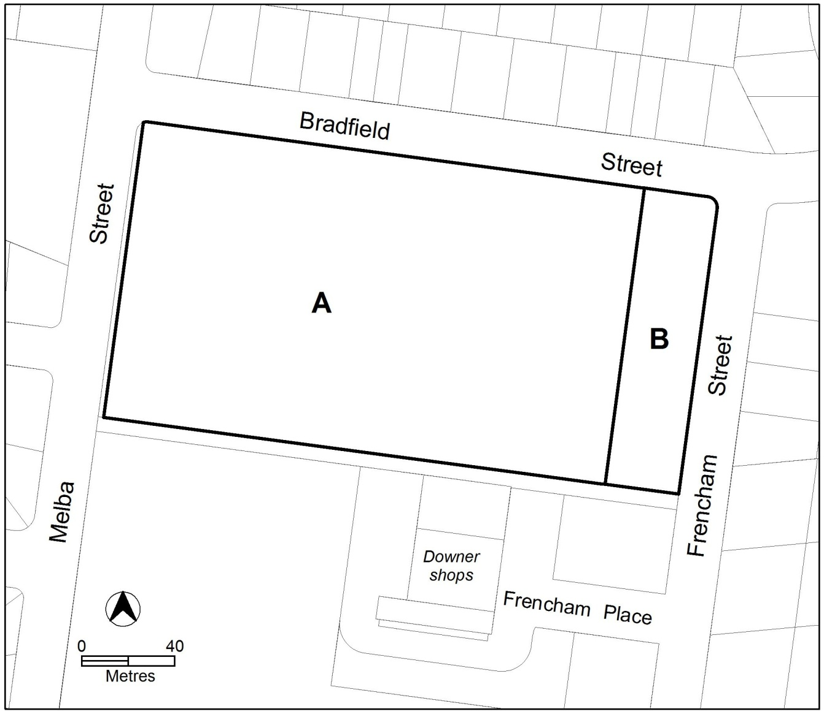
Figure 1 Development provisions – Downer section 61 block 17

