Australian Capital Territory

# Nature Conservation (Namadgi National Park) Activities Declaration 2015 (No 1)

## Notifiable instrument NI2015–411

made under the

Nature Conservation Act 2014, s256 (Conservator may make activities declarations)

### 1 Name of instrument

This instrument is the *Nature Conservation (Namadgi National Park) Activities Declaration 2015 (No1)*.

### 2 Commencement

This instrument commences on the day after notification.

### 3 Application

This instrument applies to the following areas:

1. The area outlined in bold on the map in schedule 1 that is shown as Zone 1B within the Namadgi National Park (Namadgi Zone 1B );
2. The area outlined in bold on the map in schedule 1 that is shown as Zone 3 within the Namadgi National Park (Namadgi Zone 3);
3. The area outlined in bold on the map in schedule 2 that is shown as Zone 2A of Namadgi National Park (Namadgi Zone 2A);
4. The area outlined in bold on the map in schedule 2 that is shown as Zone 2B of Namadgi National Park (Namadgi Zone 2B);
5. The area outlined in bold on the map in schedule 2 that is shown as Zone 3 of Namadgi National Park (Namadgi Zone 3).

### 4 Declaration

I declare that:

1. in Namadgi Zone 1B:
   1. the activities listed in Column 1 of schedule 3 are prohibited activities; and
   2. the activities listed in Column 2 of schedule 3 are restricted activities and may only be carried out if the requirements identified in Column 2 of schedule 3 for the relevant activity are complied with.
2. in Namadgi Zone 2A:
   1. the activities listed in Column 1 of schedule 4 are prohibited activities; and
   2. the activities listed in Column 2 of schedule 4 are restricted activities and may only be carried out if the requirements identified in Column 2 of schedule 4 for the relevant activity are complied with.
3. in Namadgi Zone 2B:
   1. the activities listed in Column 1 of schedule 5 are prohibited activities; and
   2. the activities listed in Column 2 of schedule 5 are restricted activities and may only be carried out if the requirements identified in Column 2 of schedule 5 for the relevant activity are complied with.
4. in Namadgi Zone 3 as identified on the map in Schedule 1:
   1. the activities listed in Column 1 of schedule 6 are prohibited activities; and
   2. the activities listed in Column 2 of schedule 6 are restricted activities and may only be carried out if the requirements identified in Column 2 of schedule 6 for the relevant activity are complied with.
5. in Namadgi Zone 3 as identified on the map in Schedule 2:
   1. the activities listed in Column 1 of schedule 6 are prohibited activities; and
   2. the activities listed in Column 2 of schedule 6 are restricted activities and may only be carried out if the requirements identified in Column 2 of schedule 4 for the relevant activity are complied with.

**Example - prohibited activity**

The activity of “camping” is a prohibited activity in Namadgi Zone 1B as this activity is listed in column 1 of schedule 3. This means that camping cannot be carried out in Namadgi Zone 1B under any circumstances.

**Example – restricted activity**

The activity of “camping” is a restricted activity in Namadgi Zone 2A as this activity is listed in column 2 of schedule 3. This means that the activity of camping cannot be carried out in Namadgi Zone 2A unless it is done in a way that meets the required condition. In this case, the required condition is that the form of camping be pack camping. Pack camping” means camping where the camper carries all of their camping gear to a site in a back pack

*Note 1*: Under section 256 of the *Nature Conservation Act 2014* (the Act) the Conservator of Flora and Fauna (Conservator) may declare activities in a reserve to be a restricted or prohibited activity if the Conservator reasonably believes that a certain activity, if carried out in a reserve, may have a negative impact on the reserve.

*Note 2*:Under section 169(1)(b) of the Act, Namadgi zones 1B, 2A, 2B and 3are “reserves” for the purposes of the Act because these areas include:

1. public land reserved in the Territory Plan as a Nature Reserve under section 315(b) of the Planning and Development Act 2007; and
2. public land reserved in the Territory Plan as a Special Purpose Reserve under section 315(d) of the *Planning and Development Act 2007*; and
   1. prescribed by section 5 of the *Nature Conservation Regulation 2015* as a reserve.

Dr Annie Lane  
Conservator of Flora and Fauna

10 July 2015

**Schedule 1**

**Namadgi National Park (North)**

**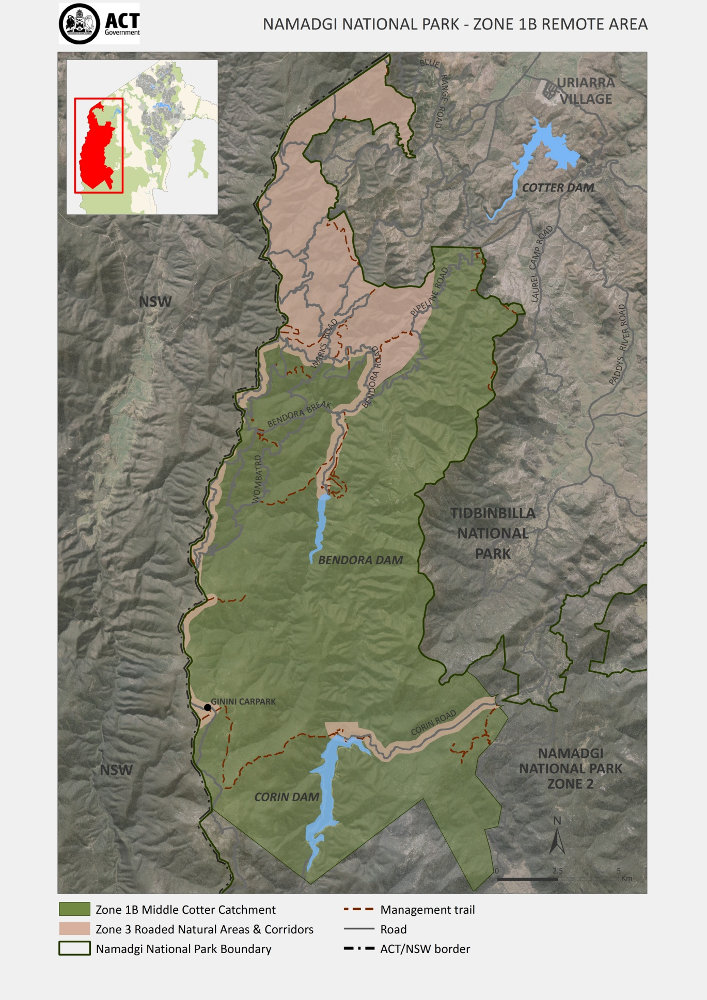**

NAMADGI NATIONAL PARK – NORTHERN SECTION

**Schedule 2**

**Namadgi National Park (South)**

**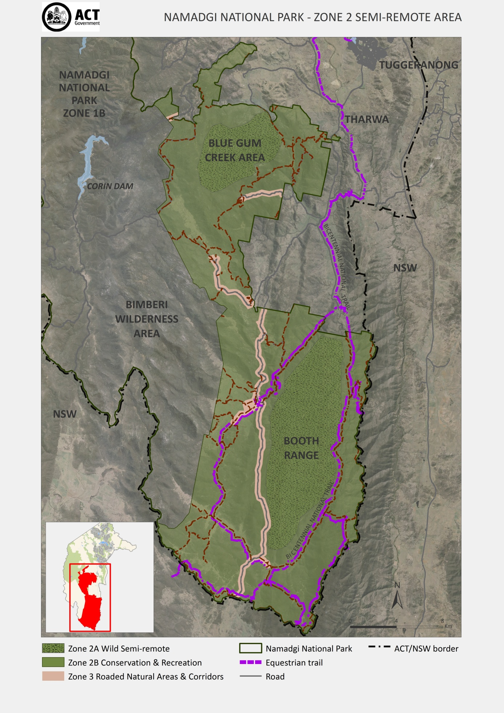**

NAMADGI NATIONAL PARK – SOUTHERN SECTION

**Schedule 3**

**Prohibited and Restricted Activities in   
Zone 1B** **marked on the map at Schedule 1**

**Namadgi National Park**

|  |  |  |  |  |
| --- | --- | --- | --- | --- |
| **Column 1** | |  | **Column 2** | |
| **PROHIBITED ACTIVITIES** | |  | **RESTRICTED ACTIVITIES** | |
| **NO DOGS** | **NODOGS)2.jpg** |  | **MOUNTAIN BIKE RIDING/CYCLING**  On sealed roads and formed trails north of Ginini Car Park (see Namadgi National Park (North) map in Schedule 1) | **mountainbike_riding (2).tif** |
| **NO EQUESTRIAN ACTIVITIES** | **NO HORSES.eps** |  | **ENVIRONMENT VOLUNTEER ACTIVITIES**  May be conducted only in accordance with approved volunteer works programs | **PCS SpotNOTEXT** |
| **NO CAMPING** | **NO_Camping** |  |  |  |
| **NO FIRES** |  |  |  |  |
| **NO FIREWOOD COLLECTION** | **No firewood collecting.eps** |  |  |  |
| **NO MOTORISED VEHICLES** | **NO VEHICLES.eps** |  |  |  |
| **NO WATERCRAFT** | **No watercraft.jpg** |  |  |  |

***Volunteer works programs*** means work programs that are (a) developed by volunteer groups under the *Parks, Conservation and Lands Volunteer Policy of September 2009 determined by Territory and Municipal Services (TAMS)* and (b) approved by the Parks and Conservation Service in TAMS, see <http://www.tams.act.gov.au>.

**Schedule 4**

**Prohibited and Restricted Activities in   
Zone 2A marked on the map at Schedule 2**

**Namadgi National Park**

|  |  |  |  |  |
| --- | --- | --- | --- | --- |
| **Column 1** | |  | **Column 2** | |
| **PROHIBITED ACTIVITIES** | |  | **RESTRICTED ACTIVITIES** | |
| **NO DOGS** | **NODOGS)2.jpg** |  | **CAMPING**  Pack camping only |  |
| **NO FIRES** |  |  | **EQUESTRIAN ACTIVITIES**  Allowed on marked equestrian trails only (see map at Schedule 2) |  |
| **NO FIREWOOD COLLECTION** | **No firewood collecting.eps** |  | **MOUNTAIN BIKE RIDING/CYCLING**  On sealed roads and formed trails | **cycling_large** |
| **NO MOTORISED VEHICLES** | **NO VEHICLES.eps** |  | **ENVIRONMENT VOLUNTEER ACTIVITIES**  May be conducted only in accordance with approved volunteer works programs | **PCS SpotNOTEXT** |

***Pack camping*** means camping where the camper carries all of their camping gear to a site in a back pack

***Volunteer works programs*** means work programs that are (a) developed by volunteer groups under the *Parks, Conservation and Lands Volunteer Policy of September 2009 determined by Territory and Municipal Services (TAMS)* and (b) approved by the Parks and Conservation Service in TAMS, see <http://www.tams.act.gov.au>.

**Schedule 5**

**Prohibited and Restricted Activities in   
Zone 2 B marked on the map at Schedule 2**

**Namadgi National Park**

|  |  |  |  |  |
| --- | --- | --- | --- | --- |
| **Column 1** | |  | **Column 2** | |
| **PROHIBITED ACTIVITIES** | |  | **RESTRICTED ACTIVITIES** | |
| **NO DOGS** | **NODOGS)2.jpg** |  | **CAMPING**  In designated campgrounds | **camping** |
| **NO FIREWOOD COLLECTION** | **No firewood collecting.eps** |  | **FIRES**  Are allowed in designated fire places at campgrounds | **woodbbq.tif** |
|  |  |  | **EQUESTRIAN ACTIVITIES**  Allowed on marked equestrian trails only (see map) |  |
|  |  |  | **MOUNTAIN BIKE RIDING/CYCLING**  On formed roads and equestrian trails unless signposted otherwise | **cycling_large** |
|  |  |  | **MOTORISED VEHICES**  On formed roads unless signposted otherwise | **VEHICLES.jpg** |
|  |  |  | **ENVIRONMENT VOLUNTEER ACTIVITIES**  May be conducted only in accordance with approved volunteer works programs | **PCS SpotNOTEXT** |

***Volunteer works programs*** means work programs that are (a) developed by volunteer groups under the *Parks, Conservation and Lands Volunteer Policy of September 2009 determined by Territory and Municipal Services (TAMS)* and (b) approved by the Parks and Conservation Service in TAMS, see <http://www.tams.act.gov.au>.

**Schedule 6**

**Prohibited and restricted activities in   
Zone 3 as marked on the maps at schedule 1 and schedule 2**

**Namadgi National Park**

|  |  |  |  |  |
| --- | --- | --- | --- | --- |
| **Column 1** | |  | **Column 2** | |
| **PROHIBITED ACTIVITIES** | |  | **RESTRICTED ACTIVITIES** | |
| **NO DOGS** | **NODOGS)2.jpg** |  | **CAMPING**  Pack camping only | **camping** |
| **NO EQUESTRIAN ACTIVITIES** | **NO HORSES.eps** |  | **ENVIRONMENT VOLUNTEER ACTIVITIES**  May be conducted only in accordance with approved volunteer works programs | **PCS SpotNOTEXT** |
| **NO FIRES** |  |  |  |  |
| **NO FIREWOOD COLLECTION** | **No firewood collecting.eps** |  |  |  |
| **NO MOTORISED VEHICLES** | **NO VEHICLES.eps** |  |  |  |
| **NO MOUNTAIN BIKE RIDING / CYCLING** | **No Cycling** |  |  |  |

***Pack camping*** means camping where the camper carries all of their camping gear to a site in a back pack

***Volunteer works programs*** means work programs that are (a) developed by volunteer groups under the *Parks, Conservation and Lands Volunteer Policy of September 2009 determined by Territory and Municipal Services (TAMS)* and (b) approved by the Parks and Conservation Service in TAMS, see <http://www.tams.act.gov.au>.