Australian Capital Territory
Planning and Development (Plan Variation No 331) Notice 2015
Notifiable Instrument NI2015-448
made under the
Planning and Development Act 2007, section 76(3)

- Name of instrument
This instrument is the Planning and Development (Plan Variation No 331) Notice 2015*

- Plan Variation No 331
On 28 July 2015, the Minister for Planning approved a draft of the attached plan variation to the Territory Plan (Annexure A) under s76 (3).

Jim Corrigan
Delegate of the Planning and Land Authority
29 July 2015

Planning and Development Act 2007

Variation to the
Territory Plan
No 331

ACT Public Housing Redevelopments
Lyons section 53 blocks 1, 4, 5 and 8 – (Strathgordon Court)
Zone changes and
Lyons precinct map and code amendments

Final variation prepared under s76 of the
Planning and Development Act 2007

This page is intentionally blank.

Contents

1. EXPLANATORY STATEMENT 1
1.1 Background 1
1.1.1 Public Housing Renewal Program 1
1.1.2 Background to the Lyons site 2
1.2 Summary of the Proposal 3
1.3 The National Capital Plan 4
1.4 Site Description 4
1.5 Current Territory Plan Provisions 6
1.6 Changes to the Territory Plan 8
1.7 Consultation on the Draft Variation 8
1.8 Revisions to the Draft Variation Recommended to the Minister 8
2. VARIATION 9
2.1 Variation to the Territory Plan 9
2.2 Variation to the Territory Plan written statements 10

This page is intentionally blank.

- EXPLANATORY STATEMENT
  - Background
    - Public Housing Renewal Program
Housing is critically important for the ACT community’s overall economic and social well-being. Public housing assists Canberrans on low incomes to reach their potential, to make a contribution and to share the benefits of our community.
The role of ACT public housing has changed over time through increased targeting to those most in need.
As at September 2014 there were 2,255 clients on the public housing waiting list with a further 962 public housing tenants on the transfer waiting list. Between 1 April 2014 and 30 September 2014 there have been 662 new applications received for public housing. Presently, the waiting time on the priority housing waiting list is 107 days. The demand for public housing is expected to grow.
As at September 2014 there were 11,826 public housing properties. Much of the public housing stock was constructed prior to Self-Government in 1988. The average of the ACT’s public housing stock is 29 years old. This is the oldest public housing portfolio in Australia, with consequent impacts on repairs and maintenance requirements.
The dwellings have been constructed in response to the requirements of the time, which can be for different purposes for which the stock is used now. The type of housing needed for public housing tenants has different requirements now. This means that it is necessary to renew the public housing stock so that it is better able to meet the needs of public housing tenants.
The Public Housing and Asset Management Strategy 2012 – 2017 provides a response to the challenges facing the public housing portfolio at a number of levels.
The utilisation of undeveloped land and improving the development opportunities of existing public housing properties has proved to be an effective strategy for the renewal of the public housing stock. The success of the Economic Stimulus Package can be in part attributed to the utilisation of community facility sites and the ability to utilise the growth capacity within the public housing portfolio. This process allowed tenants that were occupying larger properties to relocate to dwellings that better met their needs and are more affordable to manage and run. The use of land in Lyons provides the opportunity to deliver for public housing within established areas.
The Public Housing Asset Management Strategy also proposed a rolling program of disposal of poorly performing Multi Unit Properties with the aim of:
- Reducing concentrations of disadvantage;
- Aligning the public housing portfolio with tenant needs;
- Optimising the value of the asset;
- Providing better housing for existing and future tenants; and
- Improving the ‘look’ and ‘feel’ of the metropolitan area.
A review into the redevelopment opportunities of Gowrie Court, Strathgordon Court, Stuart Flats and Red Hill Flats is underway which may result in proposals to vary the Territory Plan.
Delivering more cost effective and sustainable living options in each district focuses on creating a greater diversity of housing options, with improved environmental outcomes being achieved through more energy efficient buildings using high energy efficient appliances. Creating a greater choice of housing in the community makes it easier for people to ‘age in the community’.
The Public Housing Asset Management Strategy 2012 – 2017 can be obtained at:
http://www.communityservices.act.gov.au/hcs/public_housing_asset_management_strategy

    - Background to the Lyons site
The variation changes the zoning for blocks 1, 4 and 8, section 53 Lyons from the residential RZ4 medium density zone, and block 5, section 53 Lyons from the PRZ1 urban open space zone to the residential RZ5 high density zone.
Block 1 is occupied by Strathgordon Court, a multi-unit housing complex that was purchased in 1975 and consists of 83 units, the majority of which have 2 bedrooms. Block 5 is an open space area which sits between Strathgordon Court and the intersection of Melrose Drive and Hindmarsh Drive. While block 5 is not formally included in Strathgordon Court it presents as part of the multi-unit complex, with the boundary not formally marked.
Blocks 4 and 8, section 53 are narrow blocks of unleased land fronting Melrose and Hindmarsh Drives.
The Community Services Directorate has consulted with the community to best determine how to develop Strathgordon Court (block 1) and block 5. It was made clear through the consultation with the community that block 5 was also part of the area for rezoning and redevelopment.
Block 5 is an isolated patch of public open space. It is not currently developed for or readily utilised as open space. In this regard, the redevelopment of the site includes provision for a landscaped area of communal open space fronting Swann Place in Lyons. This will assist in separating and screening the redevelopment site from the existing low density area of Lyons and to maximise development on the Melrose, Hindmarsh Drive corners.
The Territory Plan variation will facilitate the construction of a residential development with a maximum development of 10 storeys. The building heights along Hindmarsh Drive will be a mix of 8 and 10 storeys, similar to building heights along Melrose Drive. The maximum heights of buildings opposite block 2 (Woden Gardens) is 4 storeys. This is in response to feedback from Woden Gardens residents who requested an increase in height along Hindmarsh drive and a decrease in the height of buildings adjoining Woden Gardens.
Under the multi unit housing development code the existing RZ5 high density zone maximum building height is 21.5metres (approximately 6 storeys). In this regard, the variation identifies those areas where building heights in excess of 6 storeys are proposed. It also identifies the areas where four storey building heights are stipulated.
The provision for the buildings to step down towards the suburb of Lyons is intended to retain an appropriate streetscape and respond to the adjoining residential areas whilst maximising its location and proximity to the Woden town centre.

  - Summary of the Proposal
This variation changes blocks 1, 4 and 8 Section 53 Lyons from the residential RZ4 medium density zone to the residential RZ5 high density zone. It is changing block 5, section 53 Lyons from the PRZ1 urban open space zone to residential RZ5 high density zone.
The site, located on the corner of Melrose Drive and Hindmarsh Drive, consists of Strathgordon Court, a multi unit public housing complex and an isolated patch of public open space. The site is directly across the road from the Woden town centre and Woden bus interchange and is very well serviced in terms of public transport, employment and services.
The redevelopment of the site will allow the Community Services Directorate (CSD) to update ageing housing stock which is no longer fit for purpose, and also provide opportunities for a diversity of housing types and densities adjacent to the Woden town centre and major transport routes. It will also encourage urban intensification of development around the town centre whilst maintaining the residential amenity of surrounding low density residential areas of Lyons in accordance with the strategic directions of the Territory Plan.

  - The National Capital Plan
The Australian Capital Territory (Planning and Land Management) Act 1988 established the National Capital Authority (NCA) with two of its functions being to prepare and administer a National Capital Plan (NCP) and to keep the NCP under constant review and to propose amendments to it when necessary.
The NCP, which was published in the Commonwealth Gazette on 21 January 1990 is required to ensure that Canberra and the Territory are planned and developed in accordance with their national significance. The Planning and Land Management Act 1988 also required that the Territory Plan is not inconsistent with the NCP.
In accordance with section 10 of the Australian Capital Territory (Planning and Land Management) Act 1988, the National Capital Plan defines the planning principles and policies for Canberra and the Territory, for giving effect to the object of the NCP and sets out the general policies to be implemented throughout the Territory, including the range and nature of permitted land uses.
It also sets out the detailed conditions of planning, design and development for areas that have special significance to the National Capital known as designated areas and identifies special requirements for the development of some other areas.

  - Site Description
The subject site incorporating blocks 1, 4, 5 and 8, section 53 Lyons is directly adjacent to the Woden town centre which is to the east of the subject site, separated by Melrose Drive, a major arterial road that links Woden to Civic via Yarra Glen/Adelaide Avenue.
The site is accessible to the Woden town centre via signalised crossings at the intersections of Melrose Drive and Hindmarsh Drive as well as Melrose Drive and Brewer Street. There is also a pedestrian underpass south of the intersection of Corinna Street and Melrose Drive.
To the west of the site, separated from the existing low density area of Lyons by a band of PRZ1 Urban Open Space zoned land, are residential dwellings which are generally single storey in height and included within the RZ2 suburban core zone. To the north of block 1 is Woden Gardens, a residential development of 3 storeys in height. To the south is Hindmarsh Drive and the suburb of Chifley. Residential developments in that part of Chifley are within the RZ2 suburban core zone and are principally single storey.
The Lyons suburb contains a number of facilities such as a local shopping centre, primary school, child care centre and playing fields.
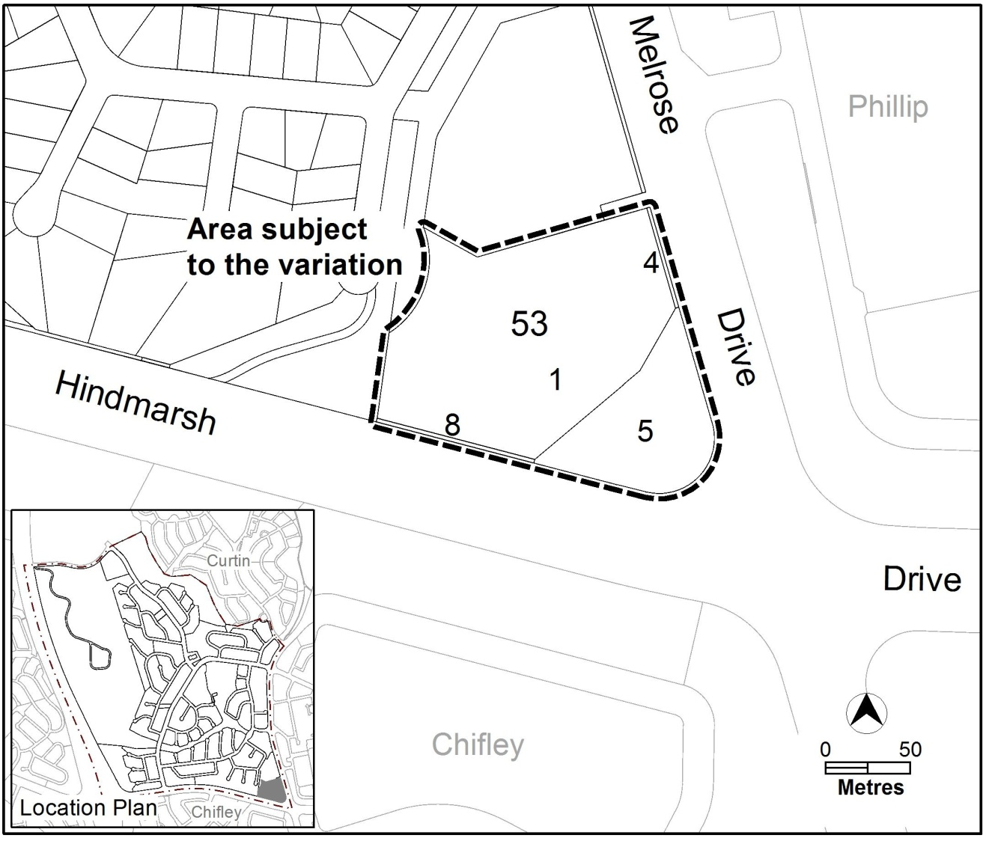
Figure 1 Site Plan

  - Current Territory Plan Provisions
The Territory Plan map for the area subject to this variation is shown in Figure 2. The Lyons precinct map is shown in Figure 3.
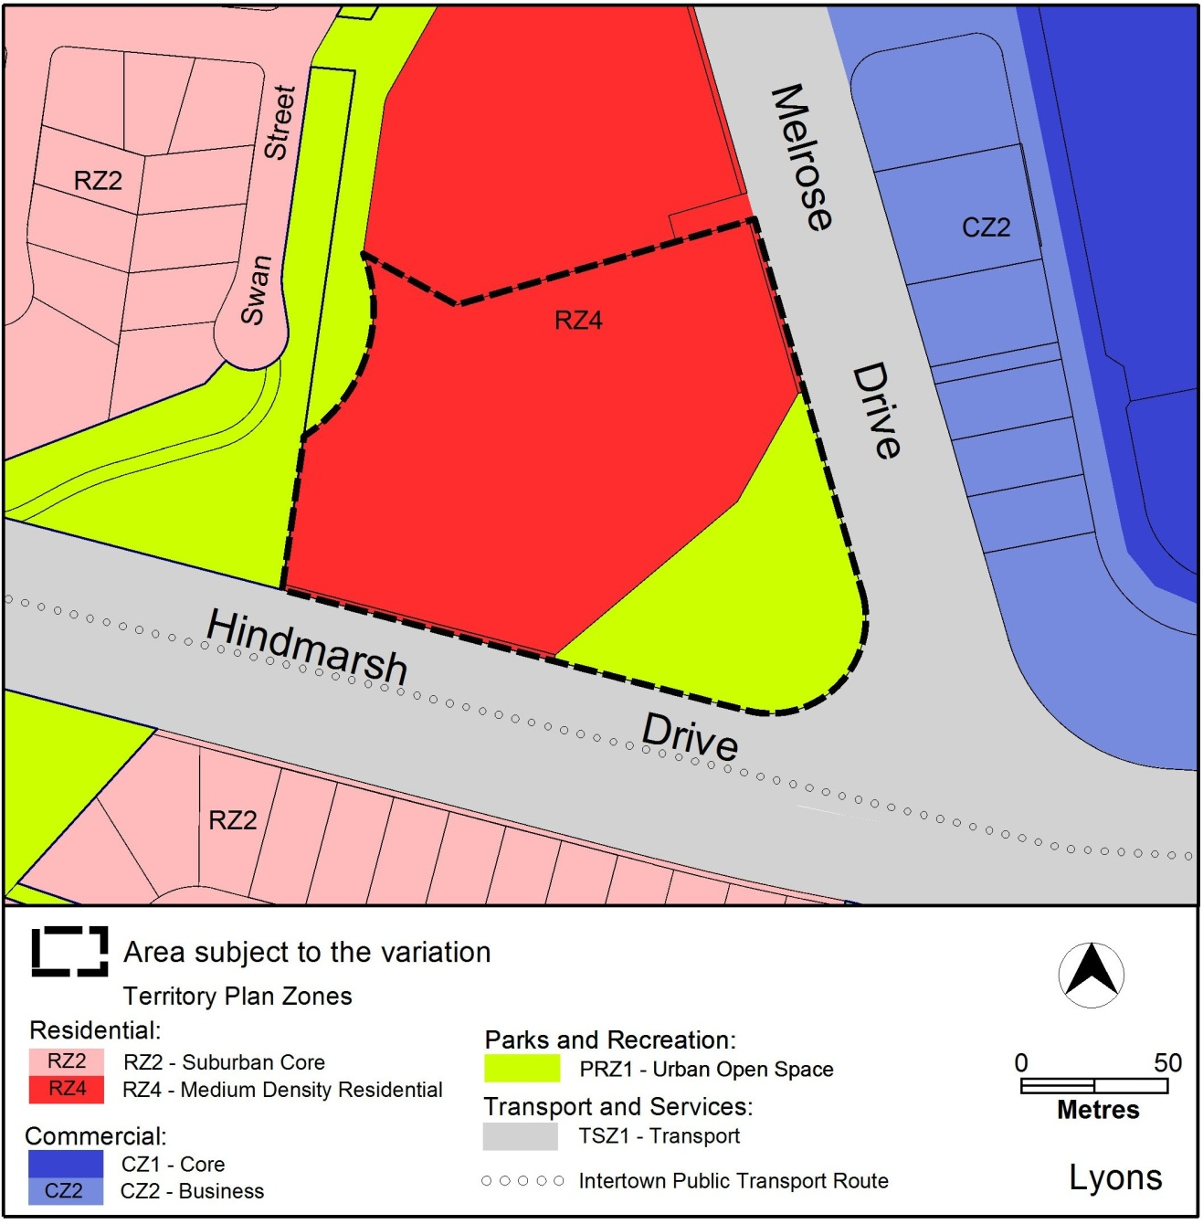

Figure 2 Territory Plan Zones Map

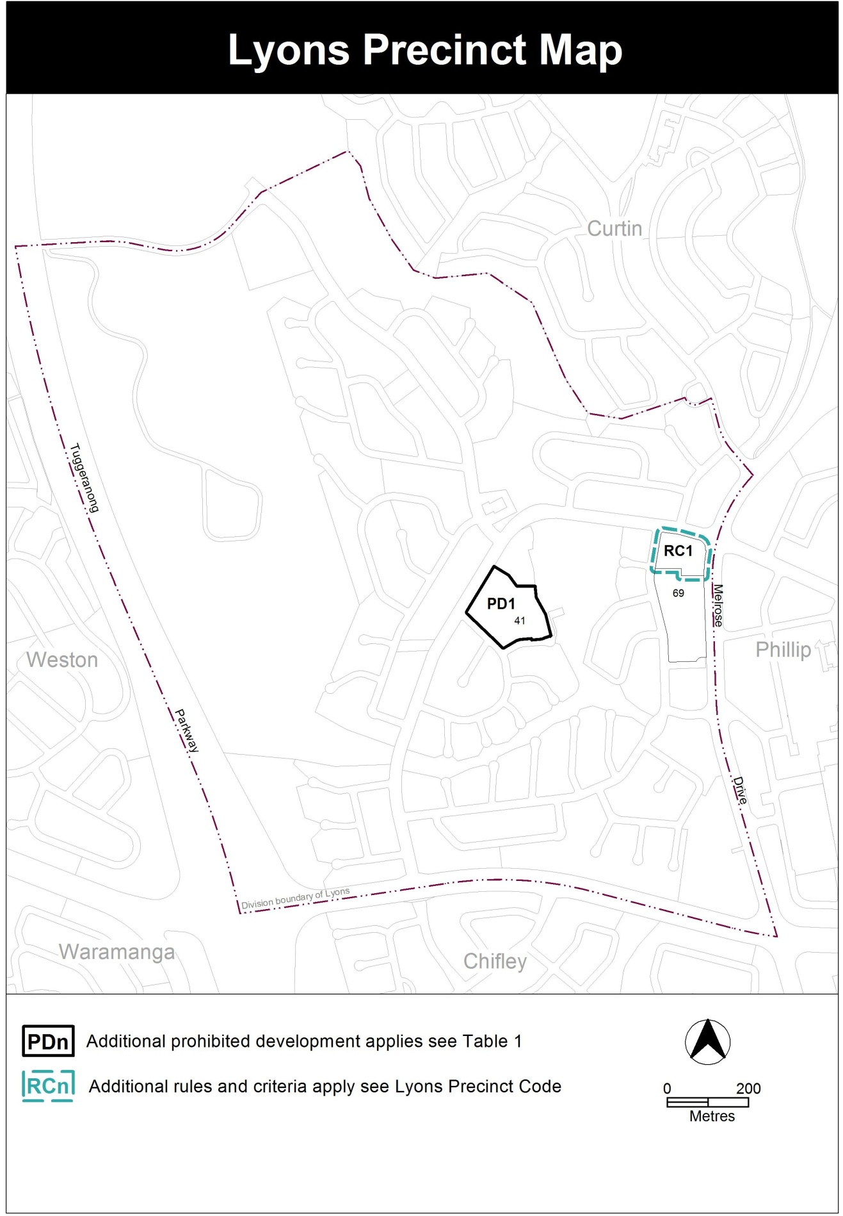Figure 3: current Lyons precinct map

  - Changes to the Territory Plan
Detailed changes to the Territory Plan are noted in section 2 of this document.

  - Consultation on the Draft Variation
Draft Variation No 331 (DV331) was released for public comment between Friday 7 November 2014 and Friday 19 December 2014. A consultation notice under section 63 of the Planning and Development Act 2007 (P&D Act) was published on the ACT Legislation Register on Friday 7 November 2014 and in The Canberra Times on Saturday 8 November 2014.
One written submission was received from the Woden Valley Community Council Inc (WVCC). Main issues raised included:

- density of development
- building heights
- Connectivity with the open space area
- Public transport
- Social housing distribution
- Environmental sustainability
The above issues were considered and are detailed in a report on consultation. No changes were made as a result of consultation. The outcomes of consultation were considered by the Minister responsible for planning prior to approval of this variation.

  - Revisions to the Draft Variation Recommended to the Minister
No changes were made to the draft variation recommended to the Minister.
- VARIATION
  - Variation to the Territory Plan
The Territory Plan map is varied as indicated in Figure 4 – proposed Territory Plan Map
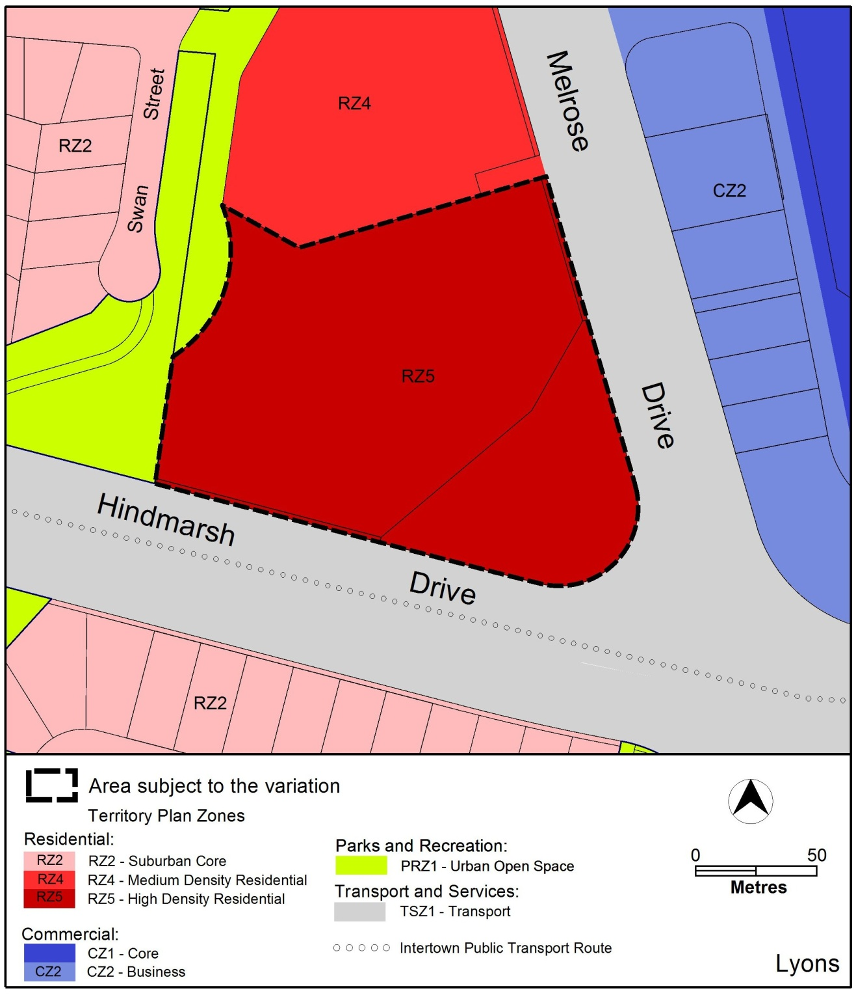
Figure 4: Variation to the Territory Plan Map

  - Variation to the Territory Plan written statements

Variation to the Lyons Precinct Map and Code
10. Precinct Map and Codes: Lyons Precinct Map and Code

Substitute
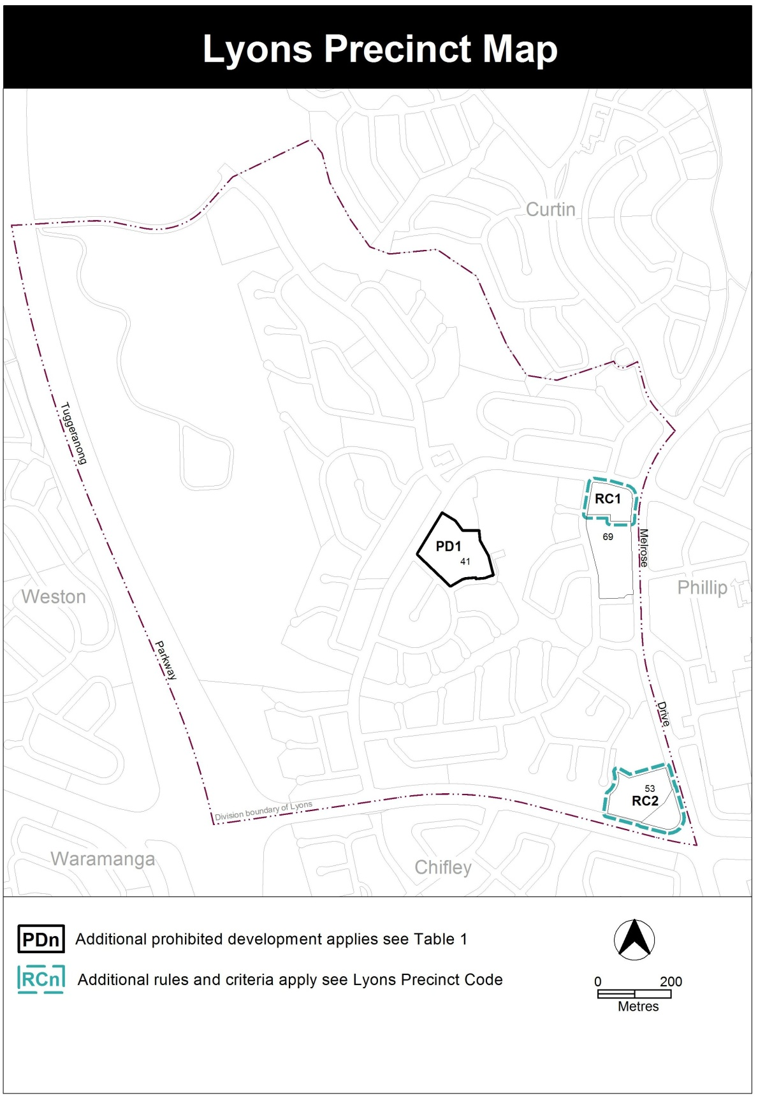

insert
RC2 – RZ5 zone additional provisions
This part applies to blocks and parcels identified in area RC2 shown on the Lyons precinct map.
Desired character
Increased building height to a maximum of 10 storeys with smaller separate buildings at 8 storeys along Hindmarsh Drive and Melrose Drive, separated by open space areas to maximise opportunities for landscaped communal and recreational spaces and provision for deep root planting areas. Higher built elements should be located adjacent to Melrose Drive and Hindmarsh Drive, with variation in the height of the buildings. Lower building elements should be located adjacent to block 2 – Woden Gardens. A variety of building typologies and materials should be used to create interest in the built form.
- Buildings
Rules | Criteria
  - Building height
This rule applies to the areas identified in Figure 1.  The maximum number of storeys in the areas shown on figure 1 are as follows:  - in area ‘a’– 10 storeys. Area ‘a’ is measured as :  - A maximum length of 85 metres along the Melrose Drive frontage from the midpoint at the intersection with Hindmarsh Drive  - A maximum length of 30 metres along the Hindmarsh Drive frontage from the midpoint at the intersection with Melrose Drive  - In area ‘b’ – 10 storeys. Area ‘b’ is measured as:  - A maximum length of 44 metres from the side boundary along the Hindmarsh Drive frontage  - A maximum depth of 67metres.  - In area ‘c’ – 8 storeys.  - In area ‘d’ – 8 storeys. Area ‘d’ is measured as:  - A maximum length of 47 metres along the Melrose Drive frontage adjacent to area ‘a’ above  - A maximum depth of 41metres.  - In area ‘e’ – 4 storeys.  Roof top plant that is set back and screened from the street is not included in the number of storeys. | This is a mandatory requirement. There is no applicable criterion.
  - Separation between buildings
Rules | Criteria
Development complies with all of the following:  - Development adjoining Hindmarsh Drive or Melrose Drive within the areas identified in Figure 1 complies with all of the following:  - Buildings are entirely contained within areas a, b, c and d and are not joined at the interface of these areas  - In area c there is a minimum of two buildings  - The minimum separation between buildings is 20m  Note this rule does not apply to buildings at the interface with area ‘e’. | Development along Hindmarsh Drive presents as distinct buildings separated by landscaped open space consistent with the desired character.
  - Setbacks
Rules | Criteria
Buildings are setback a minimum of 6metres from the Melrose Drive and Hindmarsh Drive frontages and intersection. | There are landscape buffers along the Melrose Drive and Hindmarsh Drive frontages and intersection.

- Environment
Rules | Criteria
  - Landscape area
Development incorporates a central landscape area with a minimum area of 3,000m² adjoining the northern side block boundary with provision of deep root planting areas.  Development in this area does not compromise deep root planting areas and is limited to:  - landscaping and landscape structures  - shade structures and the like | Development includes a reasonable area of open space that is consistent with the desired character.
  - Public realm
There is no applicable rule. | The tree canopy of the Melrose Drive and Hindmarsh Drive street verges are maintained and enhanced to restore a high quality public realm.

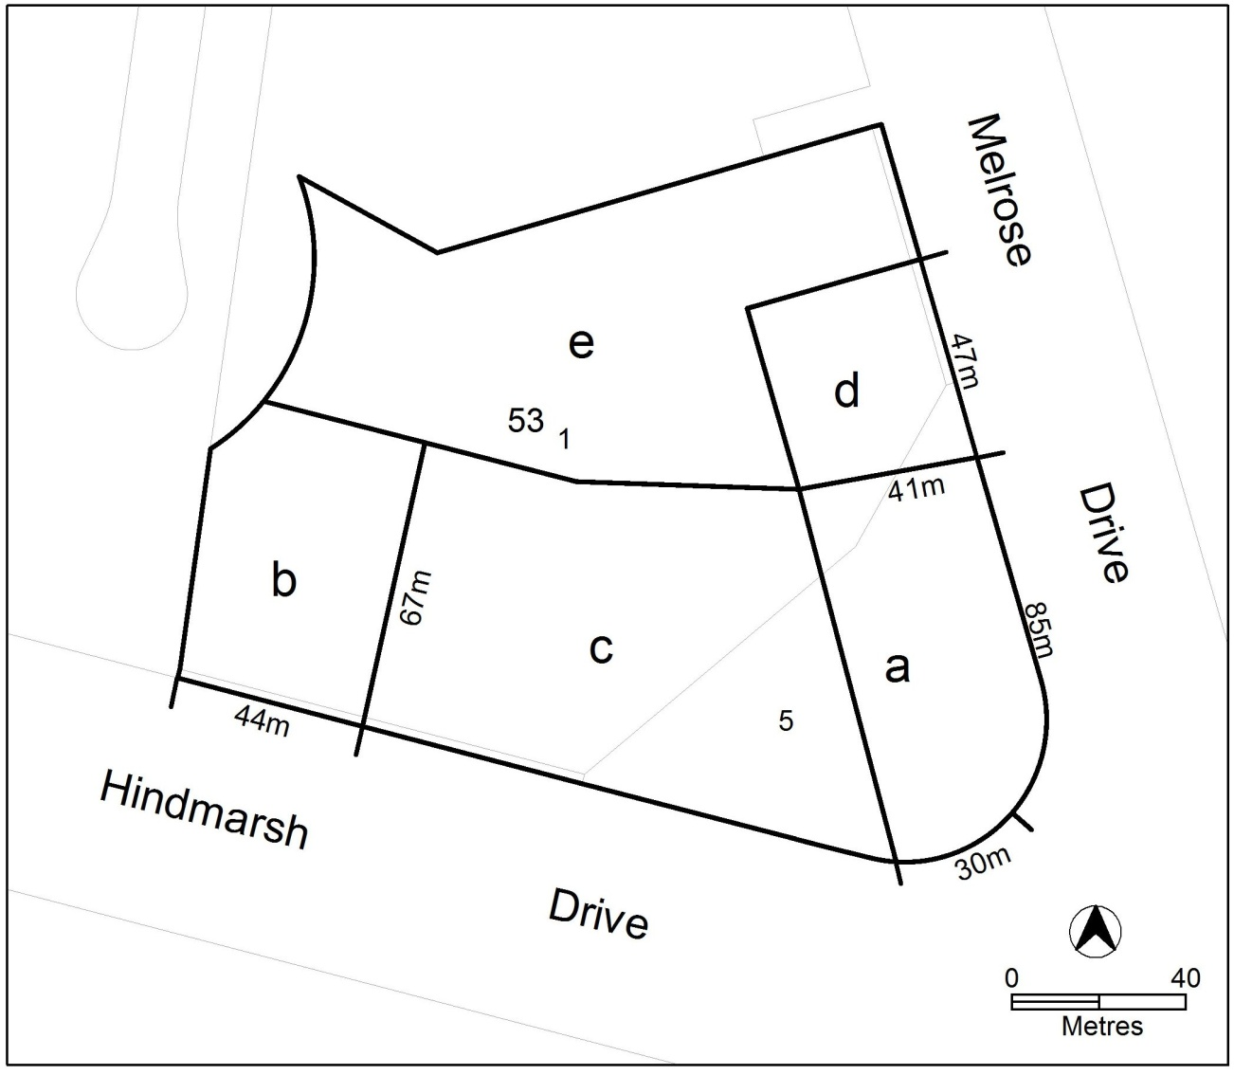
Figure 1 Building heights

Interpretation service

