Australian Capital Territory
Planning and Development (Plan Variation No 320) Notice 2015
Notifiable Instrument NI2015-540
made under the
Planning and Development Act 2007, section 76(3)

- Name of instrument
This instrument is the Planning and Development (Plan Variation No 320) Notice 2015*.

- Plan Variation No 320
On 16 September 2015, the Minister for Planning approved the attached plan variation to the Territory Plan (Annexure A) under s76 (3).

Christopher Collier
Delegate of the Planning and Land Authority
17 September 2015

Planning and Development Act 2007

Variation to the
Territory Plan
No 320

Erindale group centre and
surrounding community and recreation lands
Zone changes and amendments to the Wanniassa precinct map and code.

Final variation prepared under s76 of the
Planning and Development Act 2007

This page is intentionally blank.

Contents

1. EXPLANATORY STATEMENT 1
1.1 Background 1
1.2 Summary of the Proposal 2
1.3 The National Capital Plan 2
1.4 Site Description 3
1.5 Current Territory Plan Provisions 5
1.6 Changes to the Territory Plan 7
1.7 Consultation on the Draft Variation 7
1.8 Revisions to the Draft Variation Recommended to the Minister 7
2. VARIATION 8
2.1 Variation to the Territory Plan Map 8
2.2 Variation to the Territory Plan written statement 9

This page is intentionally blank.

- EXPLANATORY STATEMENT
  - Background
Variation to the Territory Plan No 320 (DV320) Erindale Group Centre draws on the recommendations of the Erindale group centre master plan, which is available at www.act.gov.au/erindale. The master plan was prepared by the planning and land authority, within the Environment and Planning Directorate (EPD), and included a number of community consultation periods from November 2010 through to February 2012. The master plan was endorsed by the ACT Government in September 2012.
A significant issue in the development of the master plan was the constraints imposed by the layout of the centre, including the road and pedestrian connections. The master plan addressed these issues by nominating new and amended road connections through the centre and identifying main pedestrian areas and links. A number of these have been incorporated into V320 to ensure that development of new sites, and redevelopment of existing blocks accommodates future connections identified in the master plan.
Another issue raised during community consultation of the Erindale master plan was the parking difficulties faced by users of the centre. The master plan identified a number of measures to address the parking issues within the centre, and while a number of these rely on future infrastructure works not associated with the variation, V320 ensures that the existing parking areas will be required to replace existing parking spaces if and when they are developed in the future.
The master plan contains restrictions on the location of future residential development in response to concerns raised during consultation, with a subsequent emphasis on the development of community facilities and commercial services within and around the centre. This has been followed through in the development of V320, with the potential for future residential development generally restricted to the south eastern corner of the subject area.
The Erindale Group Centre master plan considered development potential over the next 30 years, and while V320 has incorporated aspects of the longer term recommendations, it is anticipated that the provisions will be reviewed in five to ten years to ensure the centre is developing in accordance with the desired outcomes of the master plan.

  - Summary of the Proposal
Variation No 320 (V320) Erindale Group Centre and surrounding community and recreation lands amends the requirements for development in the Erindale Group Centre, and parts of the surrounding community facility and recreation lands, in the Wanniassa precinct map and code. The changes are drawn from the recommendations of the Erindale Group Centre master plan and will guide future development through rezoning of a number of areas within the centre, increasing maximum permitted building heights on selected sites, and amending road layouts and pedestrian routes. The changes are intended to promote Erindale centre as a thriving business and community hub, with employment opportunities, facilities and services for the surrounding population catchment while improving vehicle and pedestrian access through the centre.

  - The National Capital Plan
The Australian Capital Territory (Planning and Land Management) Act 1988 established the National Capital Authority (NCA) with two of its functions being to prepare and administer a National Capital Plan (NCP) and to keep the NCP under constant review and to propose amendments to it when necessary.
The NCP, which was published in the Commonwealth Gazette on 21 January 1990 is required to ensure that Canberra and the Territory are planned and developed in accordance with their national significance. The Planning and Land Management Act 1988 also required that the Territory Plan is not inconsistent with the NCP.
In accordance with section 10 of the Australian Capital Territory (Planning and Land Management) Act 1988, the National Capital Plan defines the planning principles and policies for Canberra and the Territory, for giving effect to the object of the NCP and sets out the general policies to be implemented throughout the Territory, including the range and nature of permitted land uses.
It also sets out the detailed conditions of planning, design and development for areas that have special significance to the National Capital known as designated areas and identifies special requirements for the development of some other areas.

  - Site Description
Erindale Group Centre is centrally located within the Tuggeranong district, and surrounded largely by community facility land, urban open space and suburban residential development. Erindale centre provides a wide range of services, including three schools, medical centres, a sports club, gymnastics centre, a number of restaurants and other food services as well as two service stations and a wide range of community facilities. Due to the high level of services available, Erindale centre is one of the busiest group centres in Canberra, with resultant pressures on the road network and parking facilities.
Erindale centre is fragmented into a number of disparate areas by busy roads running through the centre. McBryde Crescent runs east to west, separating the core retail area and community facilities area in the north from the commercial services area containing sporting facilities, restaurants and personal service businesses in the south. The centre is generally bounded by Ashley Drive to the east, Erindale Drive to the south, Sternberg Crescent to the north, and playing fields to the west.

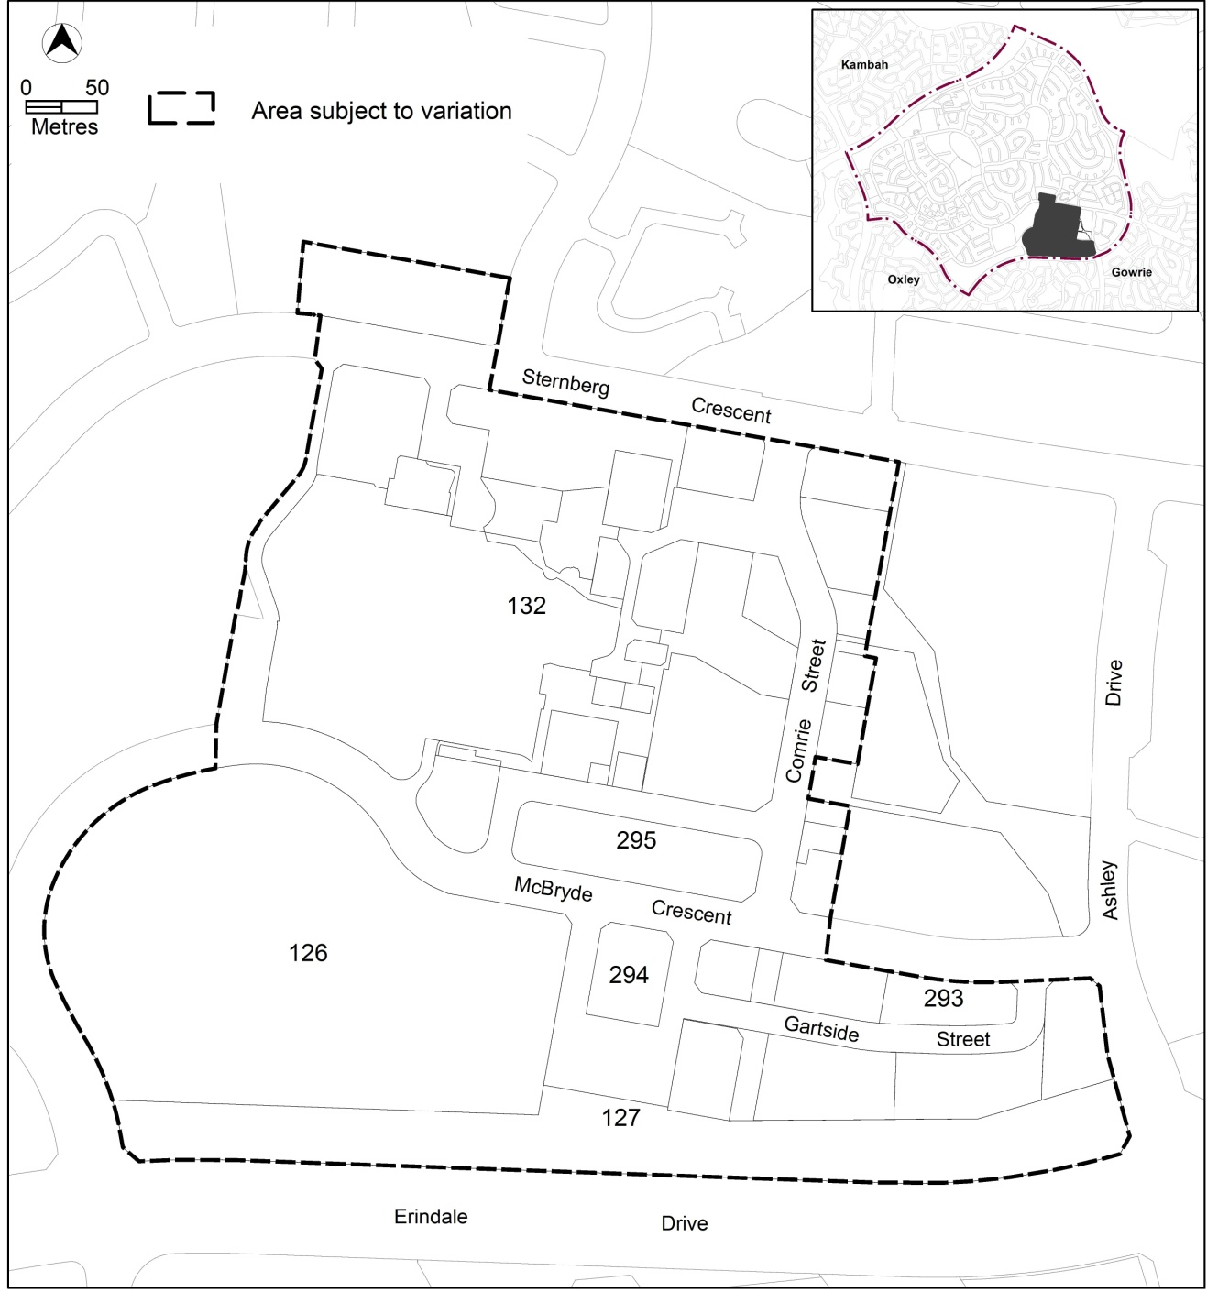
Figure 1: Erindale group centre and surrounding community and recreation lands

  - Current Territory Plan Provisions
The Territory Plan map for the area subject to this variation is shown in Figure 2.
The core commercial area (CZ1) is located at the corner of Comrie Street and McBryde Crescent, with relatively small areas of commercial business zone (CZ2) located to the north and east of the core area. To the west lies a large area of community facility zone (CFZ) containing a number of community facilities including Erindale College. A commercial services zone (CZ3) is located to the south east between McBryde Crescent and Erindale Drive. The Vikings club is located on entertainment, accommodation and leisure (CZ6) and restricted access recreation (PRZ2) zoned land to the south west.
The commercial zones are subject to the Commercial Zones Development Code, while the residential zones are subject to the Residential Zones Development Code and Multi Unit Housing Development Code. The Community Facility Development Code covers development in the community facility zones, and the Parks and Recreation Zone Development Code applies to development in the PRZ2 zone. Development in the TSZ1 zone is assessed against the Transport and Services Development Code. The general codes may also apply.
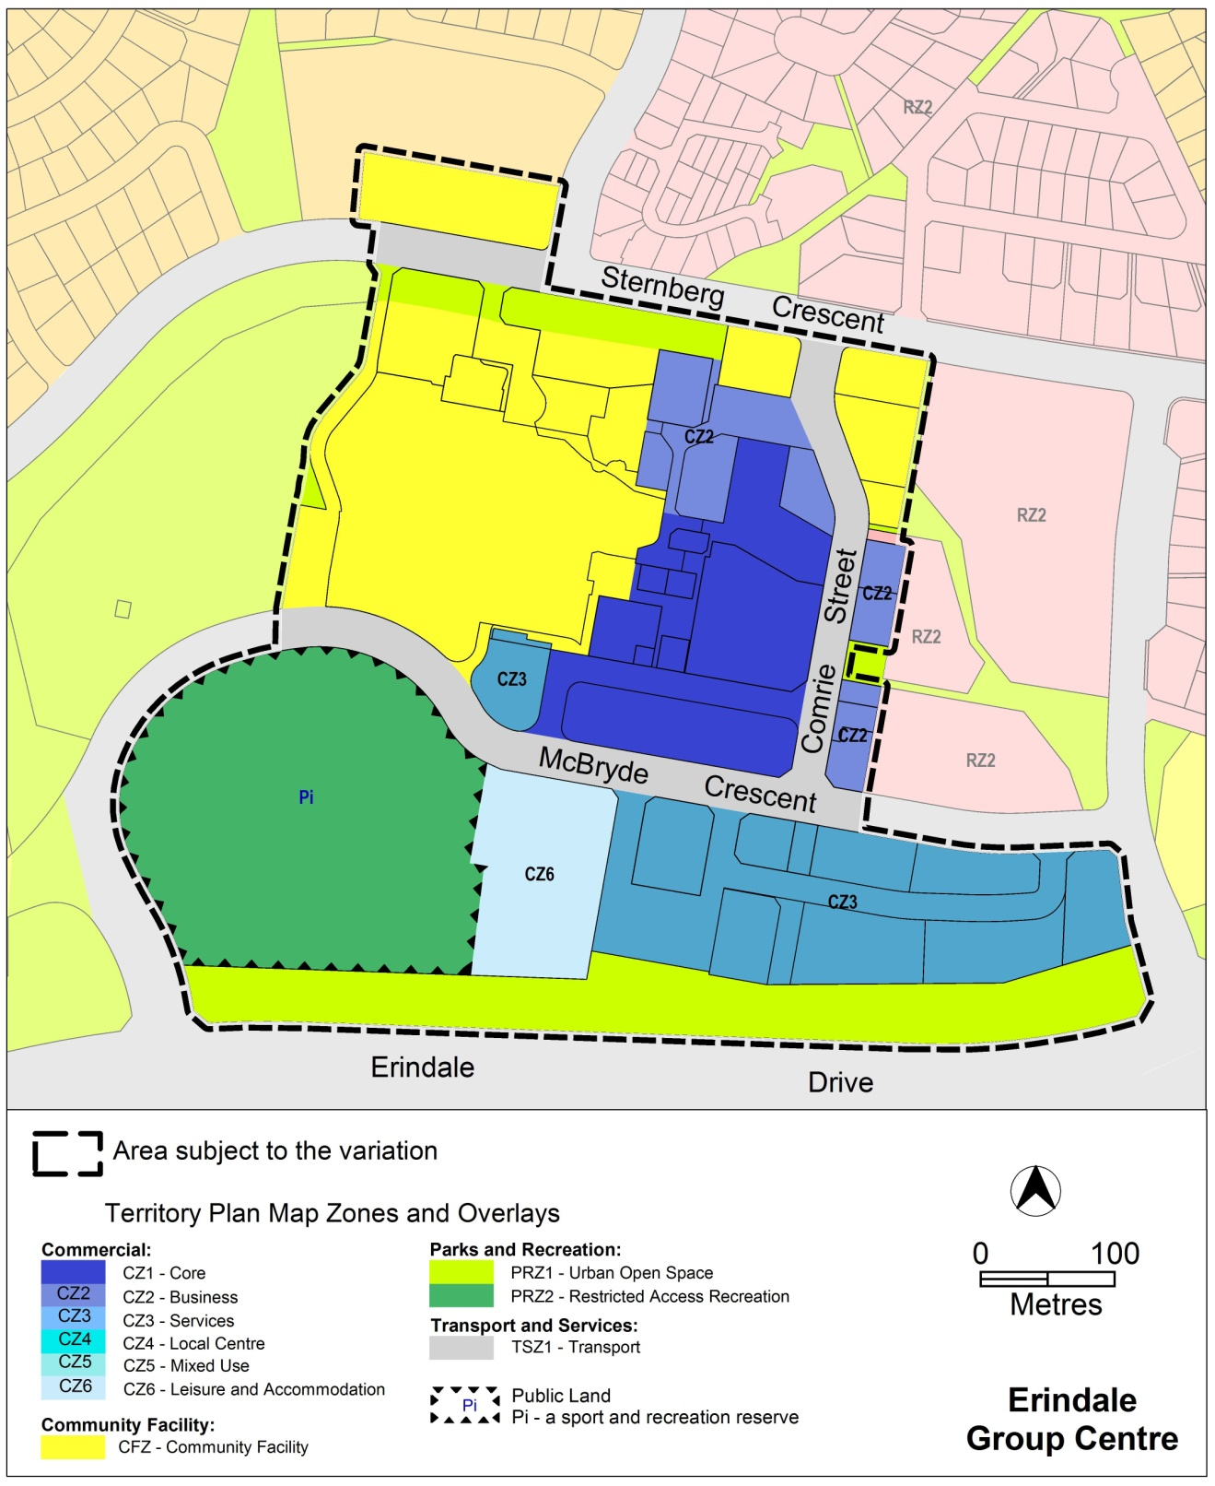
Figure 2: Territory Plan Zones Map

  - Changes to the Territory Plan
Detailed changes to the Territory Plan are noted in section 2 of this document.

  - Consultation on the Draft Variation
Draft Variation No 320 (DV320) was released for public comment between 2 May 2014 and 13 June 2014. A consultation notice under section 63 of the Planning and Development Act 2007 (P&D Act) was published on the ACT Legislation Register on 2 May 2014 and in The Canberra Times on 3 May 2014.
A total of 12 written submissions were received, which included nine submissions from local residents, and three by or on behalf of businesses and organisations operating in the centre.
Main issues raised by submitters included:
- concerns with existing traffic and parking and potential impact of development on existing parking levels
- impact of increased building heights on residential areas through overlooking and overshadowing
- concerns with rezoning of selected areas, and proposed uses being consistent with the master plan recommendations
- impact of the future intersection linking Ricardo Street to Erindale Drive on nearby residential areas
The above issues were considered and are detailed in a report on consultation. Changes were informed by the issues raised. The outcomes of consultation were considered by the Minister responsible for planning prior to approval of this variation.

  - Revisions to the Draft Variation Recommended to the Minister
The following changes were made:
- The variation written instructions at part 2.2 were amended to clarify the changes to the existing Wanniassa precinct code to incorporate V320.

- VARIATION
  - Variation to the Territory Plan Map
The Territory Plan map is varied as indicated in figure 3.

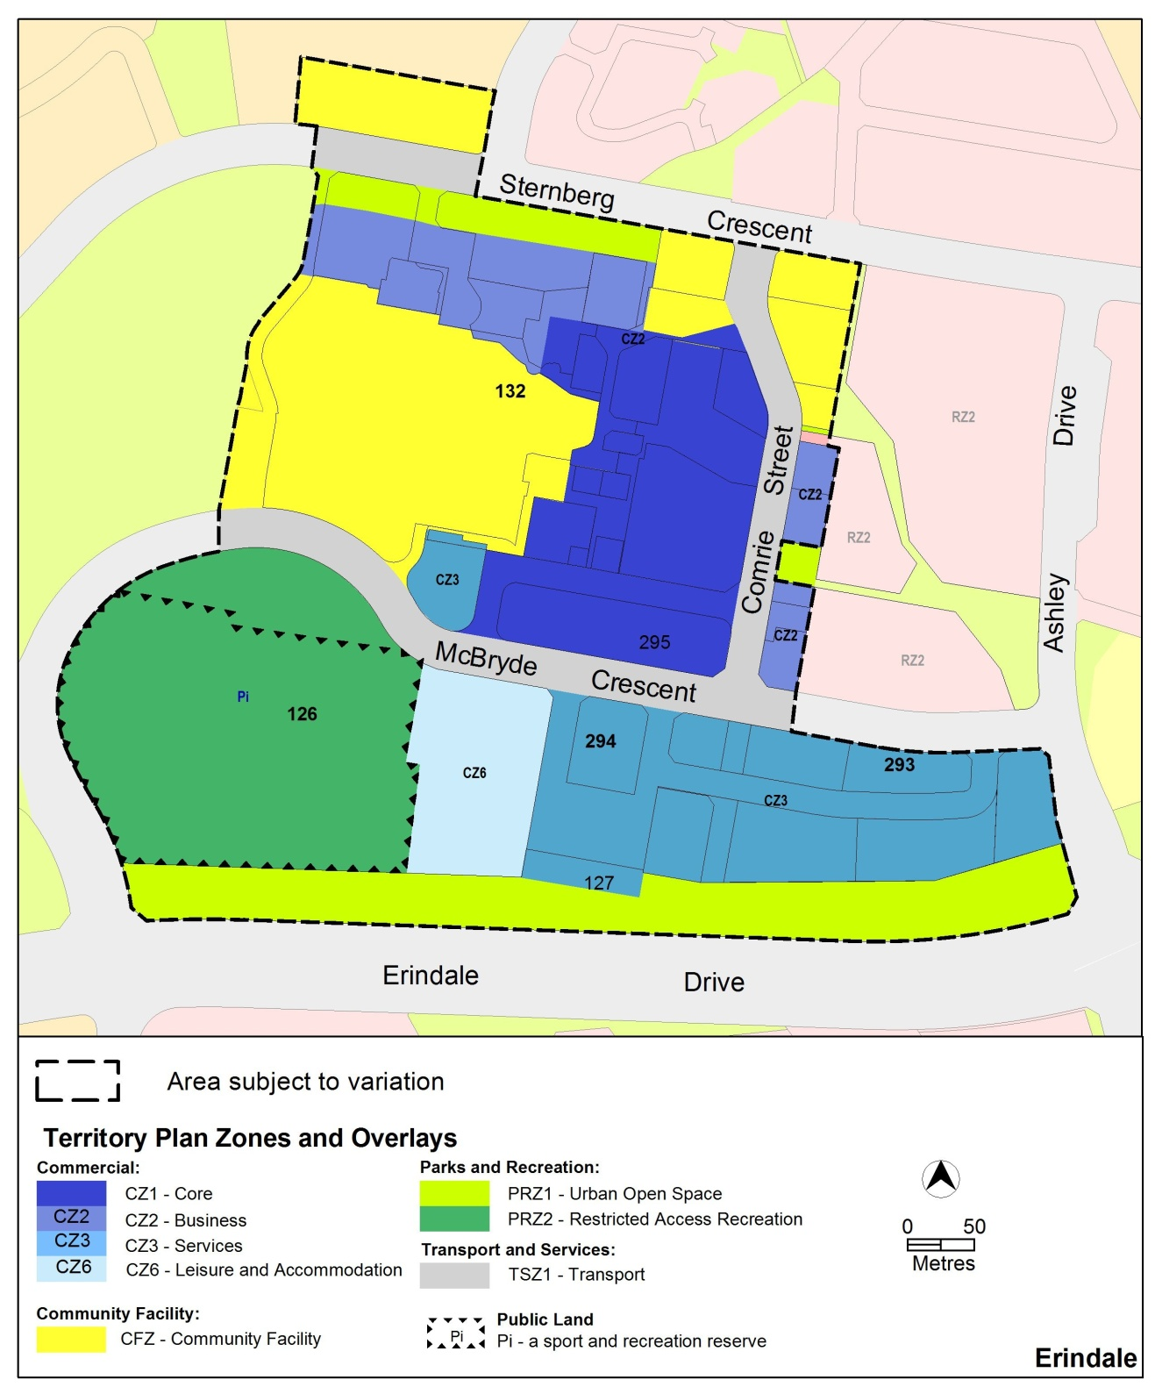
Figure 3

  - Variation to the Territory Plan written statement
The Territory Plan written statement is varied as follows:

Variation to the Wanniassa precinct map and code
10. Precinct maps and codes, Wanniassa precinct map and code
Substitute the following with the nominated attachment.
Wanniassa Precinct Map and Assessment Tracks tables at Attachment A
Wanniassa Precinct Code, RC1 – Erindale Group Centre at Attachment B
Insert
new RC2 – Erindale Community and Recreation Facilities at Attachment C after the substituted RC1
Renumber
current RC2 – Wanniassa Group Centre to RC3 – Wanniassa Group Centre
Under new heading RC3 – Wanniassa Group Centre, replace
This part applies to blocks and parcels identified in area RC2 shown on the Wanniassa Precinct Map
with
This part applies to blocks and parcels identified in area RC3 shown on the Wanniassa Precinct Map
Under new heading RC3 – Wanniassa Group Centre, renumber
Elements, sub-element headings, rules and criteria to follow on from new RC2 – Erindale Community and Recreation Facilities at Attachment C
Interpretation service
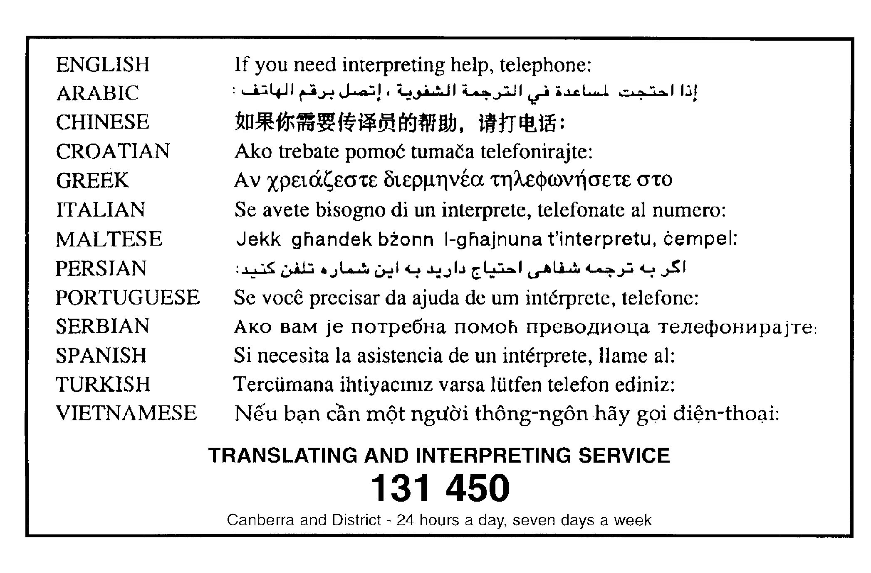

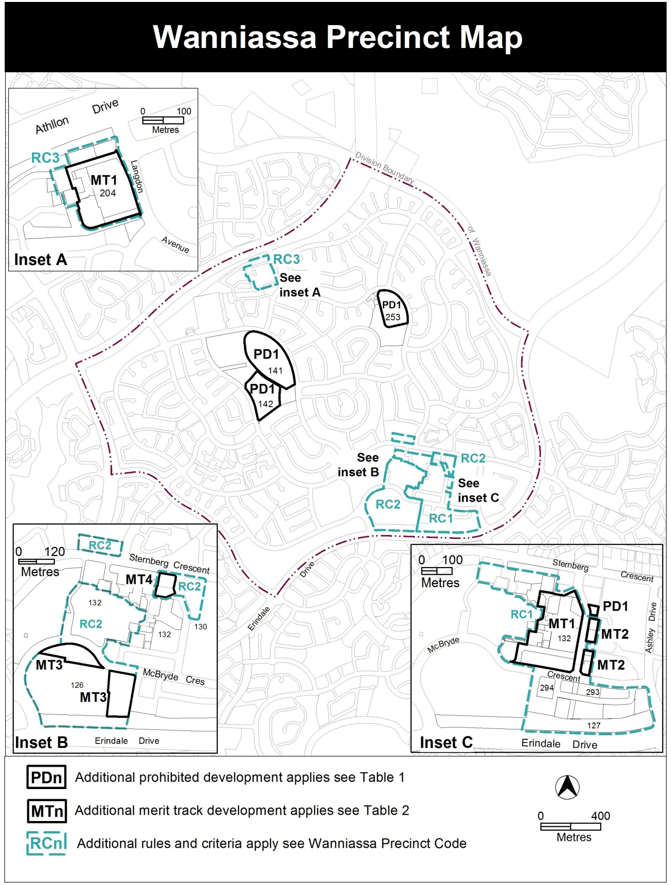

Assessment Tracks
The following tables identify the additional prohibited development and additional merit track development for blocks and parcels shown in the Wanniassa Precinct Map (identified as PDn or MTn). Development that is exempt from requiring development approval, other prohibited development and the minimum assessment track applicable to each development proposal is set out in the relevant zone development table.

The following tables constitute part of the relevant zone development table.

Table 1 – Additional prohibited development
Additional prohibited development
Suburb precinct map label | Zone | Development
PD1 | CFZ | retirement village  supportive housing

Table 2 – Additional merit track development
Additional merit track development that may be approved subject to assessment
Suburb precinct map label | Zone | Development
MT1 | CZ1 | industrial trades  municipal depot  store
MT2 | CZ2 | funeral parlour  light industry  service station  veterinary hospital
MT3 | PRZ2, CZ6 | NON RETAIL COMMERCIAL
MT4 | CFZ | business agency  office  public agency

RC1 – Erindale Group Centre
This part applies to blocks and parcels identified in area RC1 shown on the Wanniassa Precinct Map. RC1 includes the Erindale Group Centre.
Desired character
- A high quality landscaped pedestrian spine linking Erindale Drive to Sternberg Crescent, flanked by active building frontage
- development providing a convenient mix of community facilities, services, commercial, recreational facilities and transport opportunities
- a vibrant group centre with high quality open spaces designed with a focus on visibility, safety and accessibility
- a retail core with a central public open space area integrated with public transport and connecting the northern and southern areas
- Development provides interest and activity to the public realm through articulated facades to public spaces, avoiding solid, featureless walls of development

- Use
Rules | Criteria
  - Ground floor use
This rule applies to sites with primary active frontages shown in figure 1.  Only the following uses are permitted at the ground floor level:  - business agency  - club  - community activity centre  - drink establishment  - financial establishment  - hotel  - indoor entertainment facility  - indoor recreation facility  - public agency  - restaurant  - SHOP | This is a mandatory requirement. There is no applicable criterion.
There is no applicable rule. | This criterion applies to sites with secondary active frontages shown in figure 1.  Buildings incorporate uses on the ground floor that generate activity in the public space.

Rules | Criteria
  - Residential use
This rule applies in CZ1, CZ2 and CZ3.  RESIDENTIAL USE is only permitted at area ‘A’ in figure 1 | This is a mandatory requirement. There is no applicable criterion.

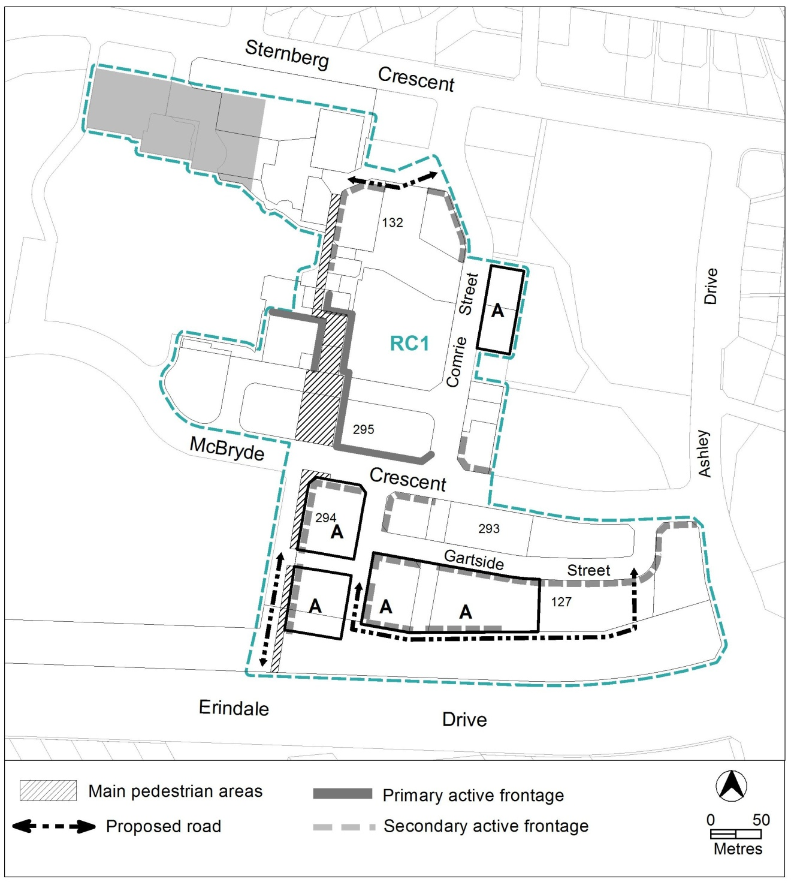
Figure 1: Erindale Group Centre

Rules | Criteria
  - Community uses
This rule applies to the areas shaded grey, shown in figure 1.  Development provides a minimum of 1,400m² gross floor area for community use. | Development application is supported by a report prepared by a suitably qualified person demonstrating that:  - suitable replacement community use facility has been provided or is too be provided elsewhere within the centre, and/or  - the land is no longer required for community use.
  - Industrial trades, municipal depot and store
This rule applies to the areas shaded grey, shown in figure 2.  One or more of the following uses are permitted only in the shaded area and only in association with a structured car park:  - industrial trades  - municipal depot  - store | This is a mandatory requirement. There is no applicable criterion.
  - Development on nominated car parking areas
This rule applies to the areas shaded grey, shown in figure 2.  Development complies with all of the following:  - the existing number of car parking spaces is retained on the site and made available for public use at all times  - provides car parking that is generated by the development on site in accordance with the Parking and Vehicular Access General Code in addition to the spaces required by item a) | Development achieves all of the following:  - any additional parking provision requirements (under the Parking and Vehicular Access General Code) for the development  - makes a substantial contribution to the long term publicly accessible parking supply for the group centre

- Buildings
Rules | Criteria
  - Building heights
This rule applies in CZ1, CZ2 and CZ3.  The maximum height of building is 10m, except for the following areas described in figure 2:  - area ‘a’ is the lesser of 12m or 3 storeys  - area ‘b’ is the lesser of 16m or 4 storeys  - area ‘c’ is the lesser of 20m or 5 storeys  Building height measurement excludes all of the following:  - roof top plant  - lift overruns  - antennas  - photovoltaic panels  - air conditioning units  - chimneys, flues and vents  The minimum setback of these excluded items from the building facade of the floor immediately below is 3m. | This is a mandatory requirement. There is no applicable criterion.
  - Building design
This rule applies in CZ1, CZ2 and CZ3.  The minimum floor to ceiling height at ground floor level is 3.6m. | The ground floor level of buildings is adaptable for commercial uses.
There is no applicable rule. | Building design achieves all of the following:  - corner buildings at the intersection of two roads contain focal points providing architectural interest and variety to the building design  - entrances to common areas for residential use provide strong visual connection to the street and ensure a high level of surveillance  - driveways and pedestrian entrances to the site are visible from the block boundary  - west-facing facades incorporate sun shading into building designs  - consistency with the desired character

Rules | Criteria
Development of 2 storeys or more complies with nominated building setbacks as follows:  - development adjoining:  - McBryde Crescent  - extension to Ricardo Street West  - Gartside Street  is built to the boundary adjoining the existing or proposed road reserve  - development adjoining the proposed road between Gartside Street and Erindale Drive is setback a minimum of 2 metres from the boundary adjoining the proposed road reserve | Minor departures from the indicated setbacks in building alignment may be permitted to provide small spaces for active uses along main pedestrian areas and routes, or where alternate setbacks are established by existing adjacent development, in which case setbacks are consistent with the desired character.
  - Plot ratio
There is no applicable rule. | Plot ratio achieves consistency with the desired character.
  - Main pedestrian areas and routes
This rule applies to main pedestrian areas shown in figure 1.  Development ensures pedestrian areas remain unenclosed and publicly accessible at all times  Note: A condition of approval may be imposed regarding the tenure of pedestrian routes. | This is a mandatory requirement. There is no applicable criterion.
  - Proposed roads
There is no applicable rule. | Subdivision of the blocks is generally consistent with the pattern of proposed roads shown in figure 1.
Development in the area shaded grey in figure 1 provides a vehicular access road connecting Wynne Street to the intersection of Sternberg Crescent and Langdon Avenue. | Development in the area shaded grey in figure 1 does not preclude the future provision of an access road connecting Wynne Street to the intersection of Sternberg Crescent and Langdon Avenue.

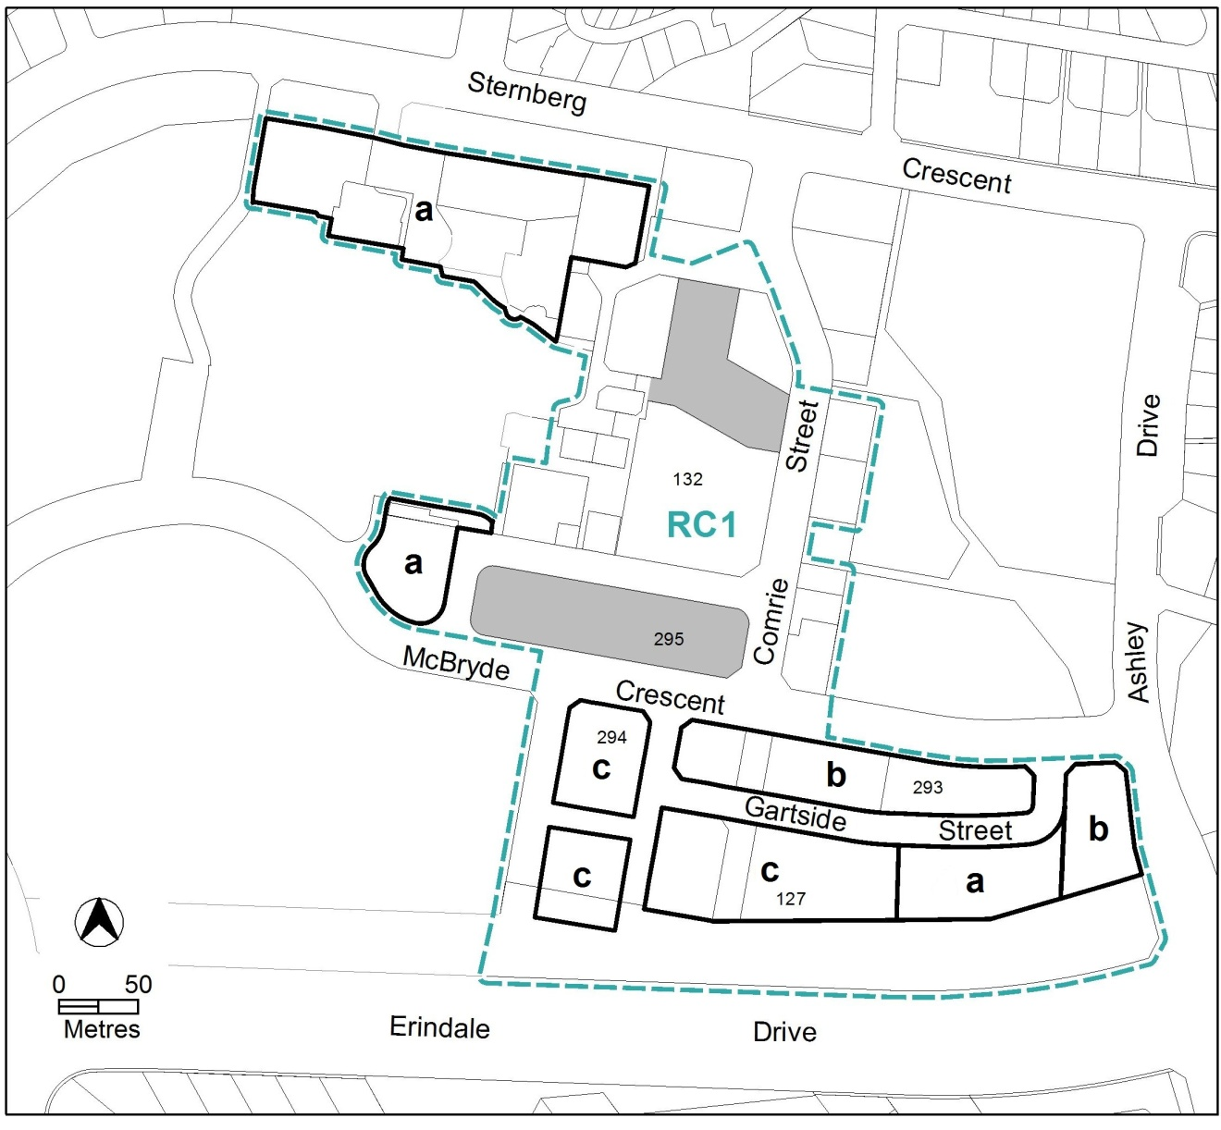
Figure 2: Building heights and nominated parking areas
Rules | Criteria
  - Active frontages
For buildings located along primary active frontage areas shown in figure 1, frontages and building design comply with all of the following:  - buildings incorporate clear display windows and/or shop fronts at the ground floor level  - buildings incorporate direct pedestrian access at grade with the verge level for access and egress for persons with disabilities  - tenancies at ground floor level that occupy more than a total of 20m of the street frontage present as more than one tenancy  - any areas of walls without windows contain displays, showcases and/or public art, with a maximum of 30% blank frontage per tenancy. | This is a mandatory requirement. There is no applicable criterion.
For buildings located along secondary active frontage areas shown in figure 1, frontages and building design comply with all of the following:  - buildings incorporate clear display windows and shopfronts at the ground floor level  - buildings incorporate direct pedestrian access at grade with the verge level for access and egress for persons with disabilities | Development at ground floor level achieves all of the following:  - is adaptable for shops  - direct pedestrian access at street level  - provide opportunities for views into and out of the building
Blank facades, open structured car parks, loading docks, substations and other service infrastructure are not located along primary active frontages shown in figure 1. | This is a mandatory requirement. There is no applicable criterion.
There is no applicable rule. | Extensive lengths of blank facades, open structured car parks, loading docks, substations and other service infrastructure do not dominate secondary active frontage areas shown in figure 1.

RC2 – Erindale Community and Recreation Facilities
This part applies to blocks and parcels identified in area RC2 shown on the Wanniassa Precinct Map.
- Use
Rules | Criteria
  - Business agency, office, public agency
This rule applies to any of the following located in area ‘A’ shown in figure 3:  The maximum gross floor area of all of the following uses does not exceed 2000m² per block:  - public agency  - office  - business agency | This is a mandatory requirement. There is no applicable criterion.
  - NON RETAIL COMMERCIAL
This rule applies to area ‘B’ and area ‘C’ shown in figure 3.  A maximum of 2,000m² gross floor area for NON RETAIL COMMERICAL is permitted within each area. | This is a mandatory requirement. There is no applicable criterion.
There is no applicable rule. | Development for non retail commercial uses is assessed against the requirements of Part A of the Commercial Zones Development Code.
  - SHOP – CZ6
There is no applicable rule. | Shops are appropriate to the primary function of the zone for tourist, recreation and leisure purposes.
  - Development fronting playing fields
There is no applicable rule. | This criterion applies to area ‘B’ shown in figure 3.  Development on the ground floor fronting the playing fields is compatible with the primary function of the outdoor recreation facility.

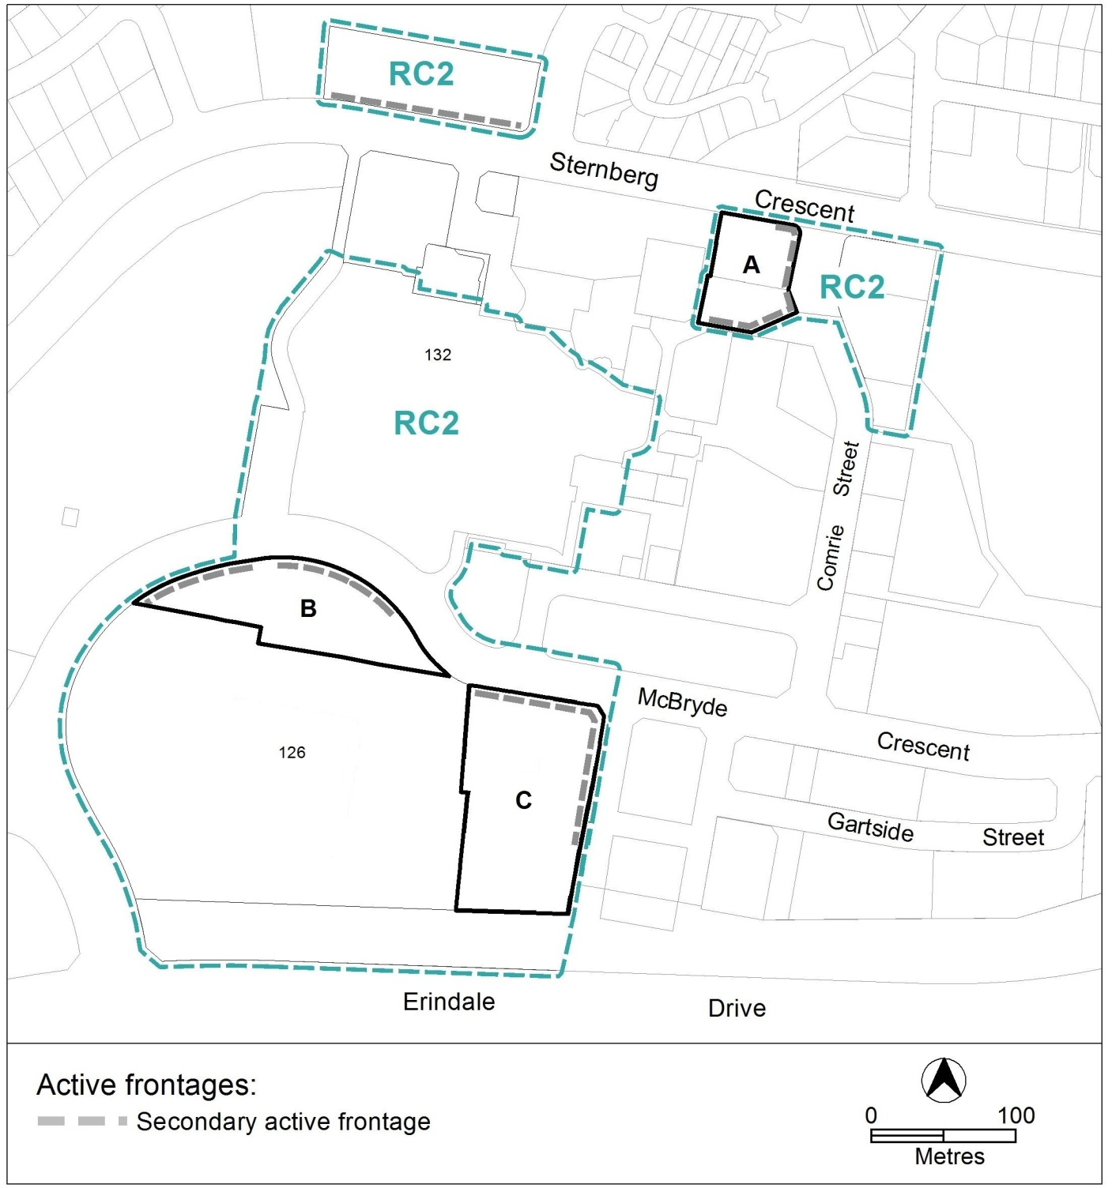
Figure 3: Additional uses and active frontages

- Building
Rules | Criteria
  - Active frontages
There is no applicable rule. | For buildings located along secondary active frontages shown in figure 3, development at ground floor level achieves all of the following:  - direct pedestrian access at street level  - views into and out of the building  - minimise the extent of blank facades
  - Building heights
The maximum height of building for the following areas shown in figure 4:  - area ‘a’ is the lesser of 12m or 3 storeys  - area ‘b’ is the lesser of 16m or 4 storeys  - area ‘c’ is the lesser of 20m or 5 storeys  Building height measurement excludes all of the following:  - roof top plant  - lift overruns  - antennas  - photovoltaic panels  - air conditioning units  - chimneys, flues and vents  The minimum setback of these excluded items from the building facade of the floor immediately below is 3m. | This is a mandatory requirement. There is no applicable criterion.

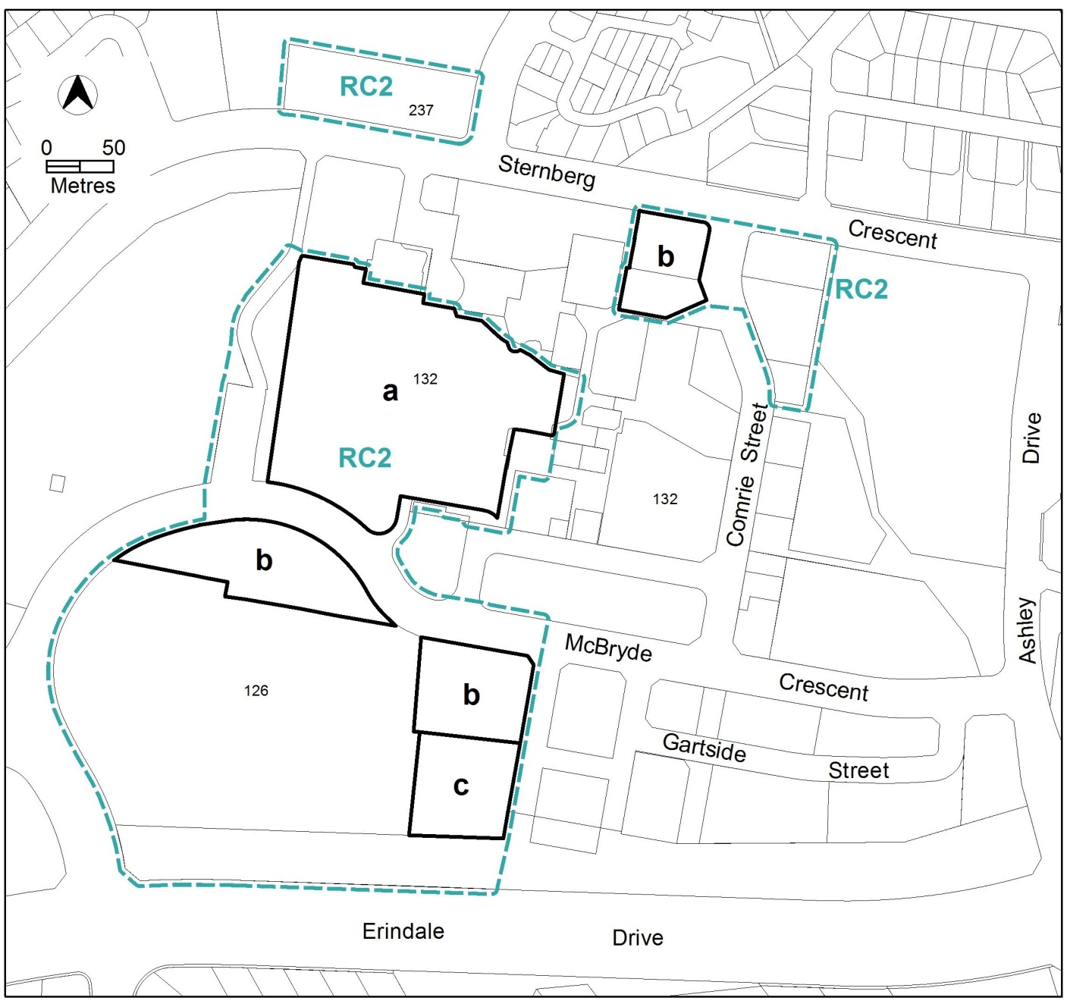
Figure 4: Community and recreation area building heights

