Australian Capital Territory

Heritage (Decision about Registration of Robertsons’ House, Oaks Estate) Notice 2015

**Notifiable Instrument NI2015—72**

made under the

Heritage Act 2004, s42 Notice of decision about registration

**1 Revocation**

This instrument replaces NI2014—459.

**2 Name of instrument**

This instrument is the *Heritage (Decision about Registration of Robertsons’ House,   
Oaks Estate) Notice 2015*.

**3 Registration details of the place**

Registration details of the place are at Attachment A: Register entry for   
Robertsons’ House, Oaks Estate.

**4 Reason for decision**

The ACT Heritage Council has decided that Robertsons’ House, Oaks Estate meets one or more of the heritage significance criteria at s 10 of the *Heritage Act 2004*. The register entry is at Attachment A.

**5 Date of registration**

12 February 2015

Anna Gurnhill  
A/g Secretary (as delegate for)  
ACT Heritage Council

12 February 2015



**AUSTRALIAN CAPITAL TERRITORY**

**HERITAGE REGISTER**

**(Registration)**

For the purposes of s. 40 of the *Heritage Act 2004*, an entry to the heritage register has been prepared by the   
ACT Heritage Council for the following place:

**Robertsons’ House**

Blocks 11-12 Section 7, Oaks Estate

**DATE OF REGISTRATION**

12 February 2015 Notifiable Instrument: 2015–72

Copies of the Register Entry are available for inspection at ACT Heritage. For further information please contact:

The Secretary

ACT Heritage Council

GPO Box 158, Canberra, ACT 2601

Telephone: 13 22 81

IDENTIFICATION OF THE PLACE

Robertsons’ House, 9 Hazel Street. Blocks 11-12 Section 7, Oaks Estate

This statement refers to the Heritage Significance of the place as required in s12(d) of the *Heritage Act 2004*.

STATEMENT OF HERITAGE SIGNIFICANCE

Robertsons’ House is a notable example of early 20th Century vernacular building that was constructed by its owner from locally found and recycled materials. Its construction was free from government control and building regulations, and has developed gradually over many decades in an organic fashion, depending on the needs of the occupants and what materials were available. [Criteria (f)]

It is constructed from various locally sourced materials that shed light on products and raw materials available at the time, such as flattened kerosene tins, bush poles, handmade concrete bricks and offcuts from building sites in the city. The materials and construction methods employed in the house and landscaping demonstrate a lifestyle that is very different to today and shows how builders overcame housing and materials shortages during the early construction phase of the ACT. [Criteria (c), (g) and (j)]

**FEATURES INTRINSIC TO THE HERITAGE SIGNIFICANCE OF THE PLACE**

The attributes listed below are assessed as features intrinsic to the heritage significance of the place and warrant conservation:

* Robertsons’ House including:
  + The final configuration of three bedrooms, the bathroom, the verandah, the kitchen divided in to two sections and the short hallway;
  + The remaining original material, consisting of bush poles, recycled weatherboards, handmade concrete bricks, the corrugated iron roofing, fixtures, internal doors, and in particular the flattened kerosene tins; and
  + The brick chimney with the original fireplace and the late-1950s Warmray No. 2 wood-fired heater.
* The outbuildings, including:
  + The northeast shed and attached toilet block, including the original material consisting of flattened tar drums, brick offcuts and seconds, internal shelving and work areas;
  + The western laundry and workshop, including the original materials consisting of flattened kerosene tins, handmade concrete bricks, bush poles, and sheets of metal, as well as the workbench and the early-1960s Simpson 2-Speed Wringer-Washer; and
  + The fowl shed, including the rendered concrete block walls and tiled roof.
* The original block layout of Block 7 Section G, today Blocks 11 and 12 Section 7, including
  + the siting of buildings within the blocks;
  + the landscaping of the mature pine trees (*Prinus radiata*) along the boundaries, other established trees including peppercorn trees (*Schinu*s), and the reclaimed brick paving; and
  + the fence posts of the paling fence along the north, east and west property line.

**CONSERVATION OBJECTIVE**

The guiding conservation objective is that Robertsons’ House shall be conserved and appropriately managed in a manner respecting its heritage significance and the features intrinsic to that heritage significance.

The ACT Heritage Council may adopt heritage guidelines applicable to the place under s25 of the *Heritage Act 2004*. For further information on guidelines applicable to the place, or for advice on proposed works or development, please contact ACT Heritage on 13 22 81.

**REASON FOR REGISTRATION**

Robertsons’ House, Oaks Estate, has been assessed against the heritage significance criteria and been found to have heritage significance when assessed against four criteria [(c), (f), (g) and (j)] under the *Heritage Act 2004*.

**ASSESSMENT AGAINST THE HERITAGE SIGNIFICANCE CRITERIA**

Pursuant to s.10 of the *Heritage Act 2004,*a place or object has heritage significance if it satisfies one or more of the following criteria. Significance has been determined by research as accessed in the references below. Future research may alter the findings of this assessment.

1. it demonstrates a high degree of technical or creative achievement (or both), by showing qualities of innovation, discovery, invention or an exceptionally fine level of application of existing techniques or approaches;

Robertsons’ House does not meet this criterion.

Robertsons’ House shows a degree of ingenuity in building with found materials, however, it was a common way of building at the time and there is no evidence that this building demonstrates a high degree of technical or creative achievement for the period in which it was created.

1. **it exhibits outstanding design or aesthetic qualities valued by the community or a cultural group;**

Robertsons’ House does not meet this criterion.

Robertsons’ House has been visited by numerous people through cultural tours conducted in Oaks Estate and has been highlighted by local residents as a place that adds to the character of Oaks Estate. However, there is no evidence that it exhibits outstanding design or aesthetic qualities that are valued by a cultural group or the broader ACT community.

1. **it is important as evidence of a distinctive way of life, taste, tradition, religion, land use, custom, process, design or function that is no longer practised, is in danger of being lost or is of exceptional interest;**

Robertsons’ House meets this criterion.

Robertsons’ House is important as evidence of the self-sufficient and resourceful builders of early Canberra, a distinctive way of life that is of exceptional interest, and their ability to create lasting homes from found materials, a building design that is no longer practised and is of exceptional interest.

Robertsons’ House is an excellent demonstration of the skill and resourcefulness of the early builders who lived in the ACT. As a skilled builder and ‘Jack of all trades’, Dick Robertson built his family home and extended it as needs and means required over a number of years. He used many varied building materials including bush poles, flattened kerosene tins (the kerosene would have been used as fuel for heating and lighting as the area did not have electricity at the time, but it was also marketed as a household cleaner), handmade concrete blocks, and various off cuts from construction jobs he had in the city (including material left over from the construction of the Provisional Parliament House). These materials were common at the time as was the practise of making one’s own building materials, but are now quite a rare occurrence due to modern manufacturing and availability of materials.

There were no drawn plans for the place or the extensions as it was built using Dick Robertson’s skill and experience as a builder and dependant on what materials he had available at the time. The place also includes a fowl shed, outdoor toilet and workshop created using the same vernacular construction techniques. The landscape of the rest of the blocks, including the mature trees, helps to illustrate a way of life no longer practised in the ACT of backyard industry (construction of water tanks and possibly mining of materials for making bricks) and self-sufficiency (keeping animals and large gardens for food).

1. **it is highly valued by the community or a cultural group for reasons of strong or special religious, spiritual, cultural, educational or social associations;**

Robertsons’ House does not meet this criterion.

Whilst Robertsons’ House is associated with an individual family and the local history of Oaks Estate, its heritage values are not associated with reasons of religion, spirituality, culture, educational evidence or societal valuing.

1. **it is significant to the ACT because of its importance as part of local Aboriginal tradition**

This criterion does not apply to Robertsons’ House.

1. **it is a rare or unique example of its kind, or is rare or unique in its comparative intactness**

Robertsons’ House meets this criterion.

Robertsons’ House is unique amongst vernacular buildings in the ACT as it retains the clearest evidence of its vernacular construction and materials as well as utilising a wide variety of recycled, repurposed and handmade materials. The materials used in construction reflect the lifestyle of the people at the time and the conditions. Flattened kerosene tins are used extensively as the fuel was an excellent and affordable heating and lighting source and the brands evident on the tins correspond to availability, such as the Vacuum Oil Company which had a depot down the road from Robertsons’ House. Other materials include wood from packing crates, recycled weatherboards from dismantled houses, old newspapers used in wall lining, local handmade concrete bricks, Canberra red brick seconds and offcuts, and several others.

1. **it is a notable example of a kind of place or object and demonstrates the main characteristics of that kind**

Robertsons’ House meets this criterion.

Robertsons’ House is a notable example of 20th Century vernacular building and demonstrates how builders overcame the housing shortages during the initial construction of the Federal Capital using their ingenuity and skill using found materials. Robertsons’ House retains the clearest evidence of its vernacular construction and materials as well as utilising a wide variety of recycled, repurposed and handmade materials. There are few comparable examples of 20th Century vernacular buildings because of the continual improvements that are the basis of such buildings continuing to replace and obscure the earlier evidence of this style of building. For example, the earlier house belonging to the Dick Robertson’s brother named Weowna on River Street of Oaks Estate has been continuously occupied for well over a century and some of the more recent renovations have included solar panels and air conditioning, and replacement of much of the original materials that have removed or obscured evidence of the early construction. This is one aspect of vernacular architecture that make it difficult to assess as they are usually continually worked on and those that are of a high enough quality to last will be difficult to distinguish from more conventional buildings.

1. **it has strong or special associations with a person, group, event, development or cultural phase in local or national history**

Robertsons’ House does not meet this criterion.

Whilst Dick Robertson, and the Robertson family in general, have a longstanding history with Oaks Estate and through his work has contributed to the building of the early ACT, there is no evidence that demonstrates that this contribution, while notable, is strong or special to the history of the broader ACT.

1. **it is significant for understanding the evolution of natural landscapes, including significant geological features, landforms, biota or natural processes**

This criterion does not apply to Robertsons’ House.

1. **it has provided, or is likely to provide, information that will contribute significantly to a wider understanding of the natural or cultural history of the ACT because of its use or potential use as a research site or object, teaching site or object, type locality or benchmark site**

Robertsons’ House meets this criterion.

The variety of materials used in the construction of Robertsons’ House has the ability to demonstrate what products were available locally and how people were able to modify and repurpose them.

The flattened kerosene tins used as cladding throughout the house and outbuildings can be dated and likely local origins determined based on designs and brand names and can then be used as a guide to construction phases. This methodology can be extended and applied to many other materials used in the house.

1. **for a place—it exhibits unusual richness, diversity or significant transitions of flora, fauna or natural landscapes and their elements**

This criterion does not apply to Robertsons’ House.

1. **for a place—it is a significant ecological community, habitat or locality for any of the following:**

(i) the life cycle of native species;

(ii) rare, threatened or uncommon species;

(iii) species at the limits of their natural range;

(iv) distinct occurrences of species.

This criterion does not apply to Robertsons’ House.

**SUMMARY OF THE PLACE**

**HISTORY AND PHYSICAL DESCRIPTION**

**HISTORY**

**Oaks Estate**

Robertsons’ House is an important component in the history of what is now the suburb of Oaks Estate.

The earliest known date for Aboriginal people in the region comes from Birrigai Rock Shelter which contains evidence from over twenty thousand years ago. The archaeology and ethnohistory of the area suggest that it was part of a wide range of landscapes utilised by past Aboriginal peoples based on seasonal use and pathways across the landscape. One of the main pathways in the region was based on the path of the Molonglo River and included an important camping ground at the junction of the Molonglo and Queanbeyan Rivers with the last recorded corroboree taking place in March 1862 which included tribes from Braidwood, Yass and the Bland Plains. (Flood, 2004.; and Kabaila, 2005)

The first Europeans in the area were the early explorers who relied on their Aboriginal guides’ prior knowledge of the area. Charles Throsby and his team are credited with the first European discovery of the region around 1820 with further excursions by his team and others extending his recording of the area over the next few years. Following Throsby’s instructions, James Vaughan (a constable) and Charles Throsby Smith (Charles Throsby’s nephew) followed the Molonglo River to the junction with the Queanbeyan River, the future site of Oaks Estate. Their reports of fertile plains and well supplied rivers soon attracted settlers to the area. (Watson, 1927; and Australian Bureau of Statistics, 1931)

The first European to make use of land in the Queanbeyan district is believed to be Timothy Beard, a pardoned convict, and former Innkeeper from Campbelltown, NSW. His station huts were located between the Queanbeyan‐Cooma Railway line and the Molonglo River, a little over 2kms downstream from the Molonglo/Queanbeyan River confluence where Oaks Estate would later be sited upon. He called his station ‘Queenbeeann’ and by 1829 was joined by ‘Jerrabomberra’ to the south and by Robert Campbell on the Molonglo River at Pialligo to the north, later called ‘Duntroon’. (Williams, 1997)

Campbell expanded his Duntroon estate southward, including the land that is now Oaks Estate, with the purchase of 1,040 acres in 1837. He arranged for a substantial stone house, later to be known as ‘The Oaks’ to be built for relatives, but when they failed to arrive he leased it out to William Hunt and Joseph Kaye who turned it into an inn. (Williams, 1997)

The property was leased over the years to several people until 1877 when the property was sold by Charles Campbell (who had acquired the land and house from Robert Campbell) to John Bull and subsequently changed hands a number of times; however, it was this sale of the land that is more or less the same as the current Oaks Estate outline that defined the area for its future development. The sale to Bull was important because of his business dealings. Bull sold parts of the land to George Tompsitt and William Price – the three were later to form a syndicate that subdivided Oaks Estate in 1888. This subdivision established the layout of streets and blocks that is evident today.

The National Capital border came into effect in 1911. At first it was proposed to include all of Queanbeyan and Captains Flat, but was changed to follow the railway as a border between the capital and NSW. This administrative border figuratively separated Oaks Estate from Queanbeyan, which geographically were only separated by a rail track and a few metres. It was originally envisaged that all of the land with the ACT would be compulsorily acquired, but financial concerns meant that only the city areas were acquired and other land as required. This left land in Oaks Estate as Freehold property without planning regulations and generally outside of the concern of the government due to its distance from the new administrative centre of the capital, leading residents to refer to it as a ‘no mans land’. (Williams, 1997)

The administrative boundary between Oaks Estate and Queanbeyan meant that services from NSW, only metres away, were difficult to obtain, while services from Canberra were too expensive. This left Oaks Estate cut off from electricity, water and sewerage services for many years. It took intense lobbying from from 1926 onwards by the Oaks Estate Progress Association to obtain many basic services. In 1913 a mail service was provided to a single box. In the late 1920s a single water tap was installed on the edge of the suburb, but was later disconnected as many residents refused to pay the extra fees for the poor supply it provided. In 1938 a mains water service was added. In 1940 electricity was connected. In 1948 a workers bus to Canberra was initiated. In 1968 a modern sewerage system was installed. Most of the roads remained unsealed in 1957 and there were no footpaths until after 1986. (Williams, 1997)

The population of Oaks Estate grew slowly from 14 houses in 1915 to 34 houses in 1933. Walter Richard (Dick) and Mary Robertson had already established a house by 1913. Dick Robertson worked on several government projects in Canberra while slowly building and expanding the family house on Hazel Street. (Williams, 1997)

All of the freehold leases at Oaks Estate were resumed by the government on 15 January 1974. The process of transferring titles resulted in many properties left vacant and allowed to fall into disrepair. The Commonwealth (later ACT Government) became the owner of several blocks in Oaks Estate that they had difficulty leasing afterwards. This resulted in several blocks being used for community housing.

**The Robertson’s at Oaks Estate**

Duncan Robertson arrived in Australia in 1835 from Scotland. Duncan moved to the Canberra region in the mid‑1840s with his wife Janet and son John. John had 16 children from two marriages, including Walter Richard (Dick) while they lived in Irishtown, now East Queanbeyan, before moving to Oaks Estate in 1888 when it was sub-divided. (Williams, 1997)

The first Robertson house was located at the bottom of George St, close to the river (the historical block layout can be seen in Figure 16 - historical block 40 Section H, today within the Hazelbrook Nursery property blocks 4 and 5 Section 14). The house was washed away in the 1891 floods after which they moved to higher ground at Blocks 8-9 Section 8 (historical Section H) on River St. On Block 9 Section 8 (H) from 1901 is where they slowly built up the family home of Weowna in stages from whatever material was available. Edward (Ned) Robertson acquired the house and land and lived there with his wife until their deaths in 1946 and 1954. Ned was a key figure in the Oaks Estate community and helped to build many of the early houses. Ned also acquired Block 20 Section 6 (F) in 1927 until 1950; Blocks 10-13 Section 8 (H) in 1927 with Blocks 11-13 transferred to William Edward Hopkins in 1957 as a partnership to run a sawmill from the property. Block 10 was retained and a brick house built there, but there is no further information on it. Ned also owned Block 26 Section 8 (H) and had a house built using bricks made by Dick Robertson. It was sold in 1940. Ned had houses built on Block 7 Section 8 (H) and Block 22 Section 6 (F) from bricks made by Dick Robertson at his house on Block 11 Section 7 (previously Block 7 Section G). The roof being a joint venture between Dick and Tom. The builder was Tom Rickman who married Jessie Robertson and the couple lived in the house until 1957. The other house (B7) was occupied by Ivy Robertson who had married Sydney Goggin, who were living with Ned and family while it was being built. (Williams, 1997)

John and Rebecca Robertson lived on block 25 Section 6 (F) across from Ned until John’s death in 1911, after which Rebecca moved away. (Williams, 1997)

Block 19 Section 6 (F) transferred to Harold Thomas (Tom) Robertson in 1939 who built a house there with Doris (Dawn) Wells. While this was being built they lived in the semi-detached house at Block 1 or 20 Section 11 (K). The property passed between family members several times up to 1980 when the house was demolished. (Williams, 1997)

Edward Robertson Junior built a house on Block 8 Section 8 (H) in the late 1940s after acquiring the block from his father Ned. (Williams, 1997)

In 1913 Dick Robertson was building his house on Railway St while living at the flour mill with wife Mary Jane and eldest son Tom. The title of Block 11/12 Section 7 (originally Block 7 Section G) transferred to Mary in 1919, however they were living on both blocks 11/12 and 6 Section 7 from 1911. The house built by Dick was constructed from whatever materials were available, including flattened kerosene tins, bush poles, handmade bricks, packing cases and offcuts from the Provisional Parliament House that Dick had been working on. This vernacular style of building was often referred to as a ‘humpy’ and they were quite common at the time as there was a shortage of materials and housing, but many skilled workers were able to build their own houses and extend them as need and opportunity arose. (Williams, 1997)

Dick set up an elaborate homemade water pipe system to deliver water from the initial single water tap that was provided in the late 1920s which travelled underground direct to his house. Mains supply water started to be installed in Oaks Estate in 1938 and by 1940 most houses in Oaks Estate were hooked up to the water supply with Tom Robertson laying the pipes to individual houses. (Williams, 1997)

The Robertson’s were active in the community, participating in community events, several members of the family appear in petitions to the government asking for improvements to Oaks Estate, making building materials and helping construct several houses in the local area. Dick was well known for his harmonica playing as well as his ability to dance a hornpipe; his exploits advertised in *The Canberra Times* on several occasions. Edward and George Robertson were both in the Queanbeyan Municipal Band. Dick had a backyard industry of building water tanks that was carried on by one of his sons, Tom, and then carried out by Tom’s son, Peter. (Williams, 1997)

Dick Robertson’s son, Les, who lived in the house his entire life, owned the property until it was transferred to the ACT Government.

In 2011 Territory and Municipal Services (TaMS) conducted extensive conservation works, aimed at preserving the building rather than trying to make it meets current building codes, that saw much of the building stabilised.

**DESCRIPTION**

Robertsons’ House is a three bedroom L-shaped house with an internal bathroom, a lounge room with a wood fire heater, a kitchen with a partition through the centre and a wood fire stove, a verandah on the southern end, and several outbuildings connected to the house by paths and paving (see Figure 1 for floor plan and room numbers). The main house has been built in several stages with various materials which is evident based on exposed material as well as design, both internally and externally. The house and outbuildings are located on a long parcel of land, ~90m north south by 20m east-west, comprising Blocks 11 and 12 Section 7 (originally they were a single block, Block 7 section G).

The house has been built in stages over a number of years, but the continued expansion and maintenance has made it difficult to determine stages of building and what order they were done in. The following is an educated guess at the timeline of construction based upon the 1915 map, dates gleaned from the kerosene tins used, and the way the parts and materials of the building relate to each other. The initial house appears to be rooms 1 and 2 (the lounge room and bedroom 2) c.1912, then rooms 6 and 7 (the kitchen) post-1915; then rooms 4 and 5 (Bedroom 1 and the bathroom) joined the kitchen and main house together post-1927; probably at the same time the verandah was added; lastly room 8 (bedroom 3) would have been added during the post-war period when Ned Robertson was making concrete bricks that are likely to have been used in its construction.

The kerosene tins used to clad the outside and inside of the house and outbuildings come from various sources which are clustered by types in various locations. The earliest materials are located on the laundry building, originally the cookhouse, prior to the kitchen being added to the house, and workshop, and was used as a sleep-out from time to time during the depression years (Williams, 2014). There are several kerosene tins marked out with “The Texas Company. Light of the Age. Best American Kerosene” (Figure 11) and a star symbol which is an early Texaco trademark used between 1903 and 1907 (Chevron, 2014). The kerosene tins cladding the shed on the western boundary and the packing cases used for the flooring of the earliest section of the kitchen in the house were sourced from Dr Blackall who was a Queanbeyan Doctor (Williams, 2014). Also used in this structure are what appears to be sections of a metal shipping container (Figure 11). The adjoining shed contains tins marked by “B. I. O. Co. Ltd.” (Figure 12 and 13) – the British Imperial Oil Company, which operated as a subsidiary of Shell in Australia between 1905 and 1927, with the designs found at the Robertsons’ House likely to correspond to the later part of this period (Shell, 2001). The tins used in the house are from the Vacuum Oil Company (Figure 13), which had a branch down the road from Robertsons’ House from 1927 and were in Queanbeyan from the start of 1926.

Part of the original fence, constructed by Les Robertson shortly after his return from WWII, remains intact along the north, east and west property lines. The posts are local timber sourced from trees cut from the area surrounding Oaks Estate. Fence posts cut from trees growing in the same environment as that of their intended placement were considered to last longer than wood sourced from other places (Williams, 2014).

**Physical condition and integrity**

Phillip Leeson Architects conducted a condition assessment of Robertsons’ House in 2007 and reported that it was generally in a very poor state and needed significant works to meet current building codes. Externally the house was noted as being in a very poor condition. They recommended that a significant number of the external weatherboards needed to be replaced along with most of the external windows. The external masonry was intact, but as a single skin wall it does not meet current building standards. Much of the roofing was described as being in fair condition with much of the guttering and drain pipes needing to be replaced. The building framework, including in the roof was not accessible, and a lack of under floor ventilation led the assessors to suggest that the sub-floor would likely be affected. Internally the place was generally in a very poor to reasonable condition, and needed some work to clean up many years of neglect, such as room 4/bedroom 1 which had some water damage to the walls, the bathroom which has been water damaged by a leaking toilet, room 8/bedroom 3 which had a decayed floor, and the kitchen which has had significant smoke damage.

Sellick Consultants in May 2008 conducted a structural audit of Robertsons’ House and found that there were quite a few problems. The major issues were termite, smoke and fire damage as well as the general deterioration of materials that allowed water and wind to have a greater affect on the building. There was also water damage from leaking services and poor under-floor ventilation. A full audit was not possible without exposing the framing of the building leading to a level of uncertainty about the full condition of the place, however it was suggested that remedial works to bring the place up to current standards may become impractical and excessively expensive.

In 2011 Territory and Municipal Services (TaMS) conducted extensive conservation works, aimed at preserving the building rather than trying to make it meets current building codes, that saw much of the building stabilised. Works included replacing the external weatherboard wall around the kitchen area and the east wall on either side of the chimney, replacing the upper/gable section of weatherboards on the western external wall, replacement of the bathroom floorboards, removal of termite affected floorboards in the northeast room (room 8/bedroom 3), replacing guttering and downpipes, replacement of the kitchen flue/chimney, replacement of several broken windows, installing clear Perspex covers on the inside and outside of all external windows, securing the roof panels and patching where necessary, painting and sealing of all external materials, weed control and tree pruning or removal where necessary, erection of boundary fencing, consolidation works for the outbuildings, repairs of damaged internal fittings and a general site clean up.

A site inspection by ACT Heritage on 11 June 2014 showed the house and grounds to be in good condition, and the outbuildings to be in a stable condition with the exception of the western shed which was in a poor condition. The house has been well maintained after the 2011 conservation works which had consolidated the external walls by replacing materials and painting existing materials which still appear to be in good condition and resistant to weathering, the new guttering and pipes are intact and working well, the interior condition has been stabilised with the flooring of bedroom 3 removed, exposing the raw earth beneath and the brick supports, the floor in bedroom 1 still has moderate movement evident when walking on it, as well as water damage to the wall, where water was entering through the ceiling. The outbuildings have been stabilised by the removal of trees affecting them and the structures repaired or strengthened where needed. The western shed is in the worst condition with the southern concrete brick wall requiring supports to stabilise it (Figure 8 - these appear to be temporary in nature and detract from the site, although they have been in place for several years) and the western wall has lost most of its cladding with the structure becoming quite weathered and the earth floor spilling out, causing the table and wall to slump outwards. The fowl shed is in moderate condition, but the roofing is deteriorating which will expose the rest of the structure to rain. The boundary fencing installed in 2011 is in good condition and the grounds have been well maintained. The mature pine trees (*Pinus radiata*) along the boundaries are in good condition.



Figure 1 Robertsons’ House measured drawing (Philip Leeson Architects, 2007. p.5)

**Site Plan**

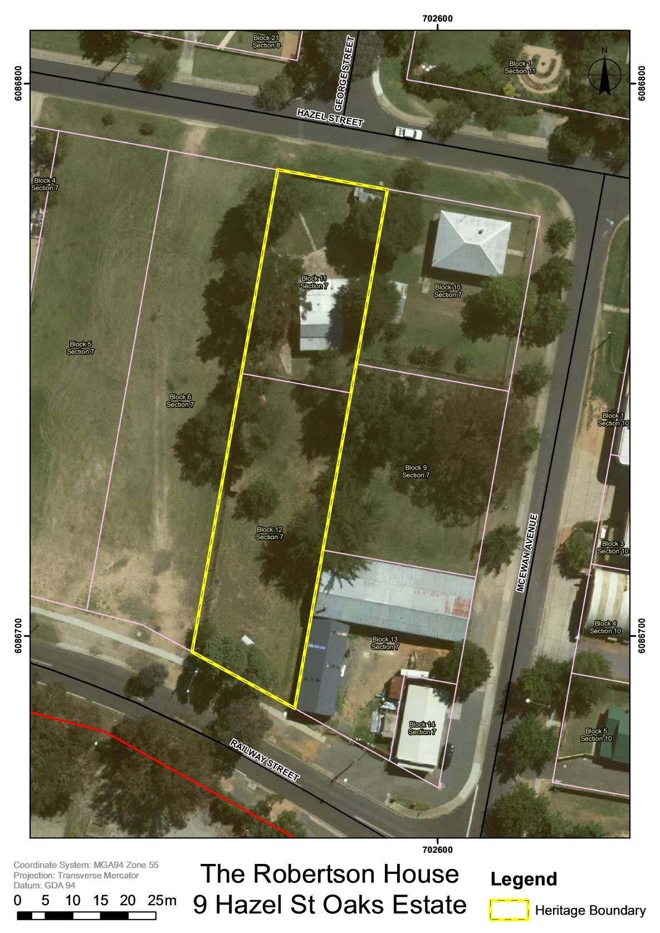

Figure 2 Robertsons’ House, registration boundary.

**images**

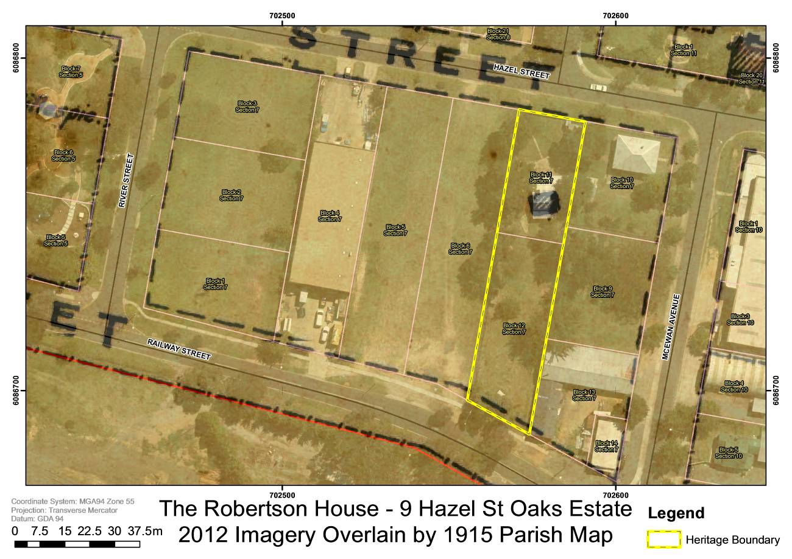

Figure 3 Cadastral map and aerial imagery of the Robertsons’ House with 1915 survey overlay

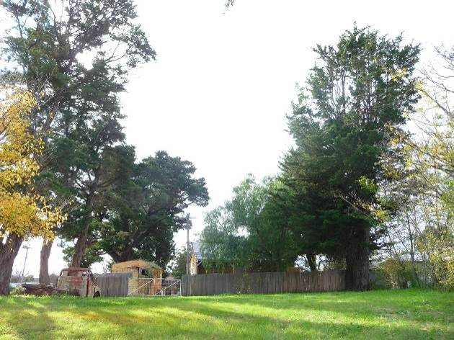

Figure 4 Overview facing north (ACT Heritage, 2014)

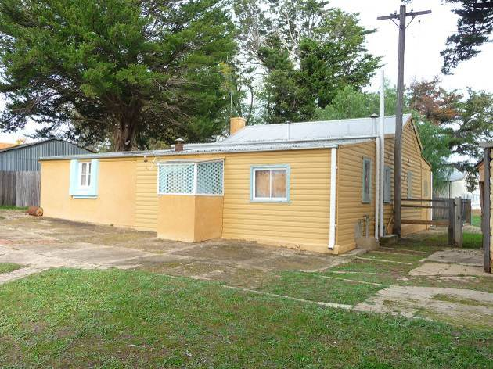

Figure 5 North and west facades (ACT Heritage, 2014)

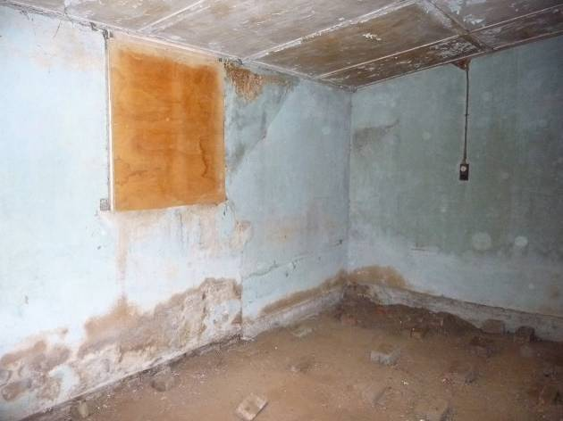

Figure 6 Bedroom 3 (ACT Heritage, 2014)

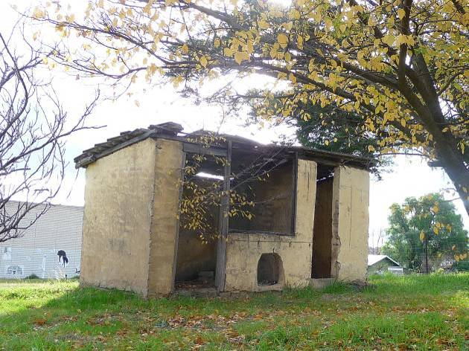

Figure 7 Fowl shed (ACT Heritage, 2014)

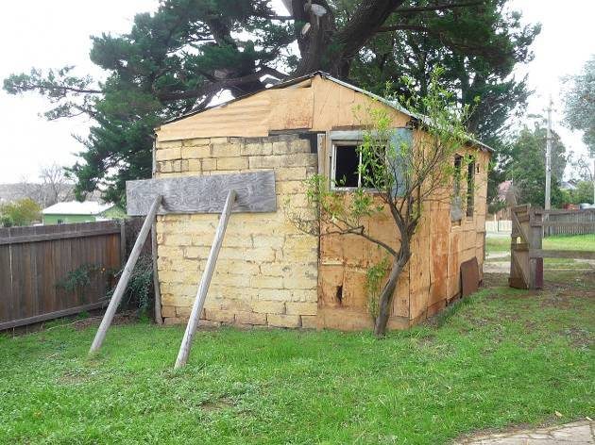

Figure 8 Southern end of western shed and laundry (ACT Heritage, 2014)

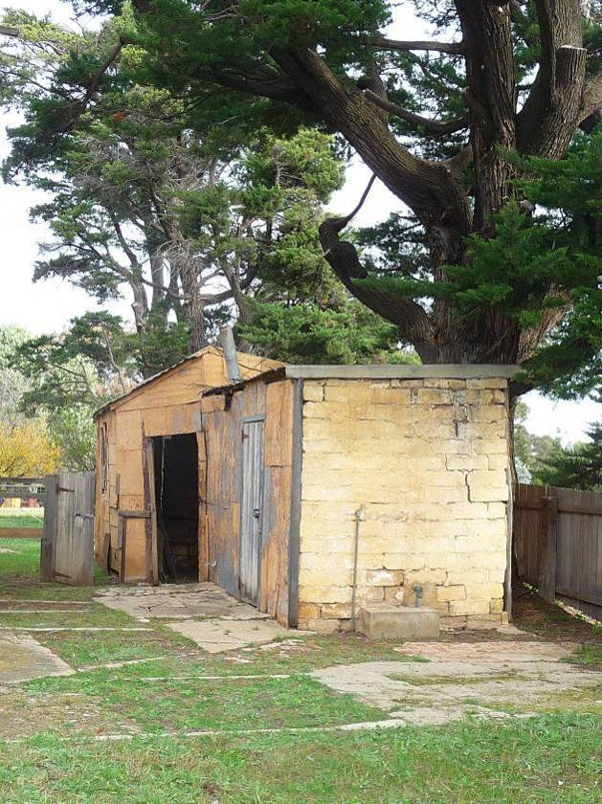

Figure 9 Northern end of western shed and laundry (ACT Heritage, 2014)

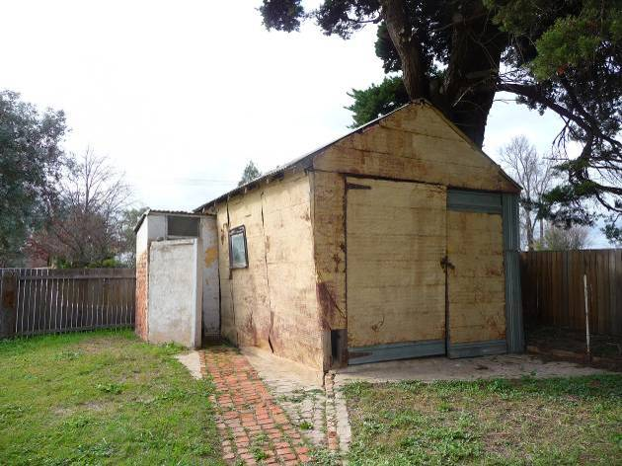

Figure 10 Northeast shed and toilet block (ACT Heritage, 2014)

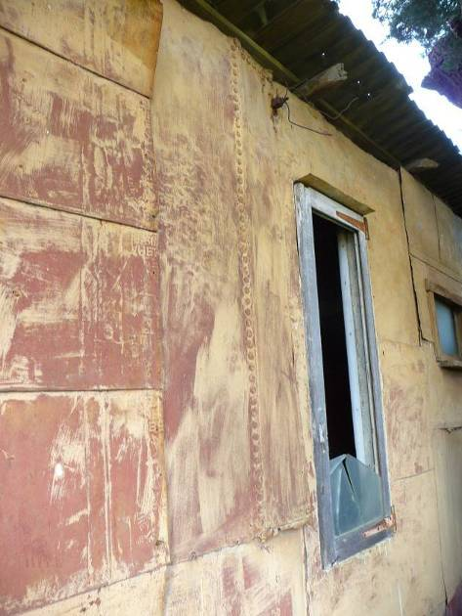

Figure 11 Tin cladding on east laundry facade (ACT Heritage, 2014)

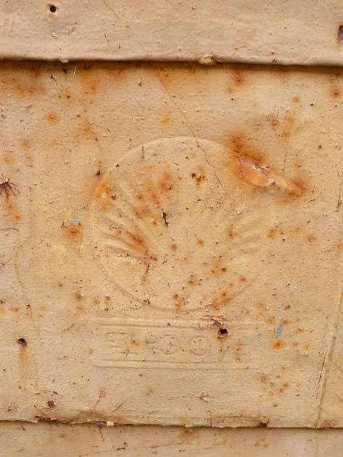

Figure 12 B.I.O. Shell kerosene tin cladding on western shed (ACT Heritage, 2014)

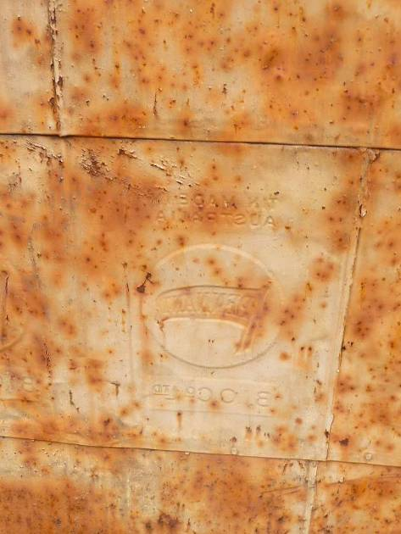

Figure 13 B.I.O. Pennant kerosene tin cladding on western shed (ACT Heritage, 2014)

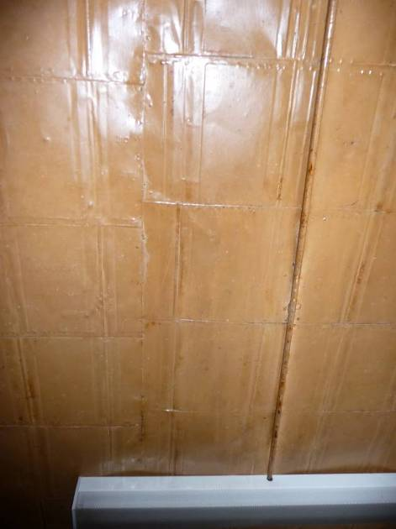

Figure 14 Vacuum Oil Company flattened kerosene tin lining on room 4/bedroom 1 ceiling (ACT Heritage, 2014)

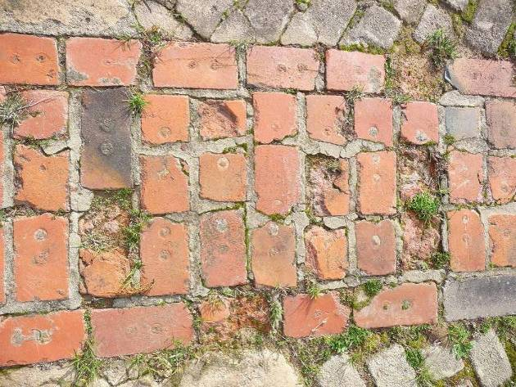

Figure 15 Brick paving (ACT Heritage, 2014)

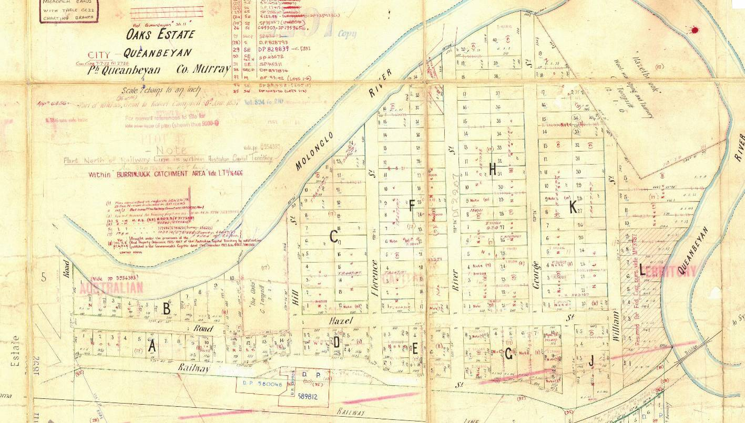

Figure 16 1888 Oaks Estate subdivision Deposited Plan 2207 (NSW Land & Property Information)

**REFERENCES**

Australian Bureau of Statistics (1931). Year book, Australia. Australian Bureau of Statistics, Canberra.

Chevron (2014). *History of Texaco.*  <http://www.texaco.com/about-timeline.aspx> accessed 17/06/2014

Flood, J. (2004) Archaeology of the Dreamtime: the Story of Prehistoric Australia and its People. J.B. Publishing, Marleston, S. Aust

Kabaila, P. (2005) High Country Footprints: Aboriginal pathways and movements in the high country of southeastern Australia. Recognising the ancient paths beside modern highways. Pirion Publishing, Canberra.

Leeson, P. (2007) *Condition report, 9 Hazel Street.* Report prepared for ACT Heritage.

Ruckschloss, J. (2008) Memo: 9 Hazel Street, Oaks Estate, Queanbeyan, NSW Structural Audit. Report prepared for ACT Heritage.

Shell (2001) *...from kero tins to LNG tankers...* Shell, Australia.

Watson, F. (1927) *A Brief History of Canberra*. Federal Capital Press of Australia, Canberra.

Williams, K (1997). Oaks Estate : no man's land. K. Williams, Oaks Estate, A.C.T.

Williams, K. Personal communication via letter 19 October 2014.