Australian Capital Territory

Emergencies (Built-Up Area and Bushfire Abatement Zone) Declaration 2016

Notifiable Instrument NI2016–15

made under the

Emergencies Act 2004, s 71 (Commissioner may declare bushfire abatement zone) and s 65 (What is a built-up area and a rural area?)

1 Name of Instrument
This instrument is the Emergencies (Built-Up Area and Bushfire Abatement Zone) Declaration 2016.

2 Commencement
This instrument commences on the day after its notification.

3 Declaration of built-up area and bushfire abatement zone
I declare the brown areas marked on the map at Schedule 1, held by the ACT Emergency Services Agency, to be a built-up area under s 65(1) of the Act. I have consulted with the Chief Officer (ACT Fire and Rescue) and the Chief Officer (ACT Rural Fire Service) before making this declaration.
I declare the purple areas marked on the map at Schedule 1, held by the ACT Emergency Services Agency, to be a bushfire abatement zone under section 71(1) of the Act. I have consulted with the conservator and the planning and land authority before making this declaration.

4 Revocation
NI2012-450 is revoked.

Dominic Lane AFSM
ACT Emergency Services Agency
Commissioner
15 January 2016
Schedule 1

DECLARATION OF A BUILT UP AREA AND BUSHFIRE ABATEMENT ZONE.

The areas shown in brown on the indicative map below comprise a bushfire Built-Up Area for the purposes of section 65(1) of the Emergencies Act 2004.

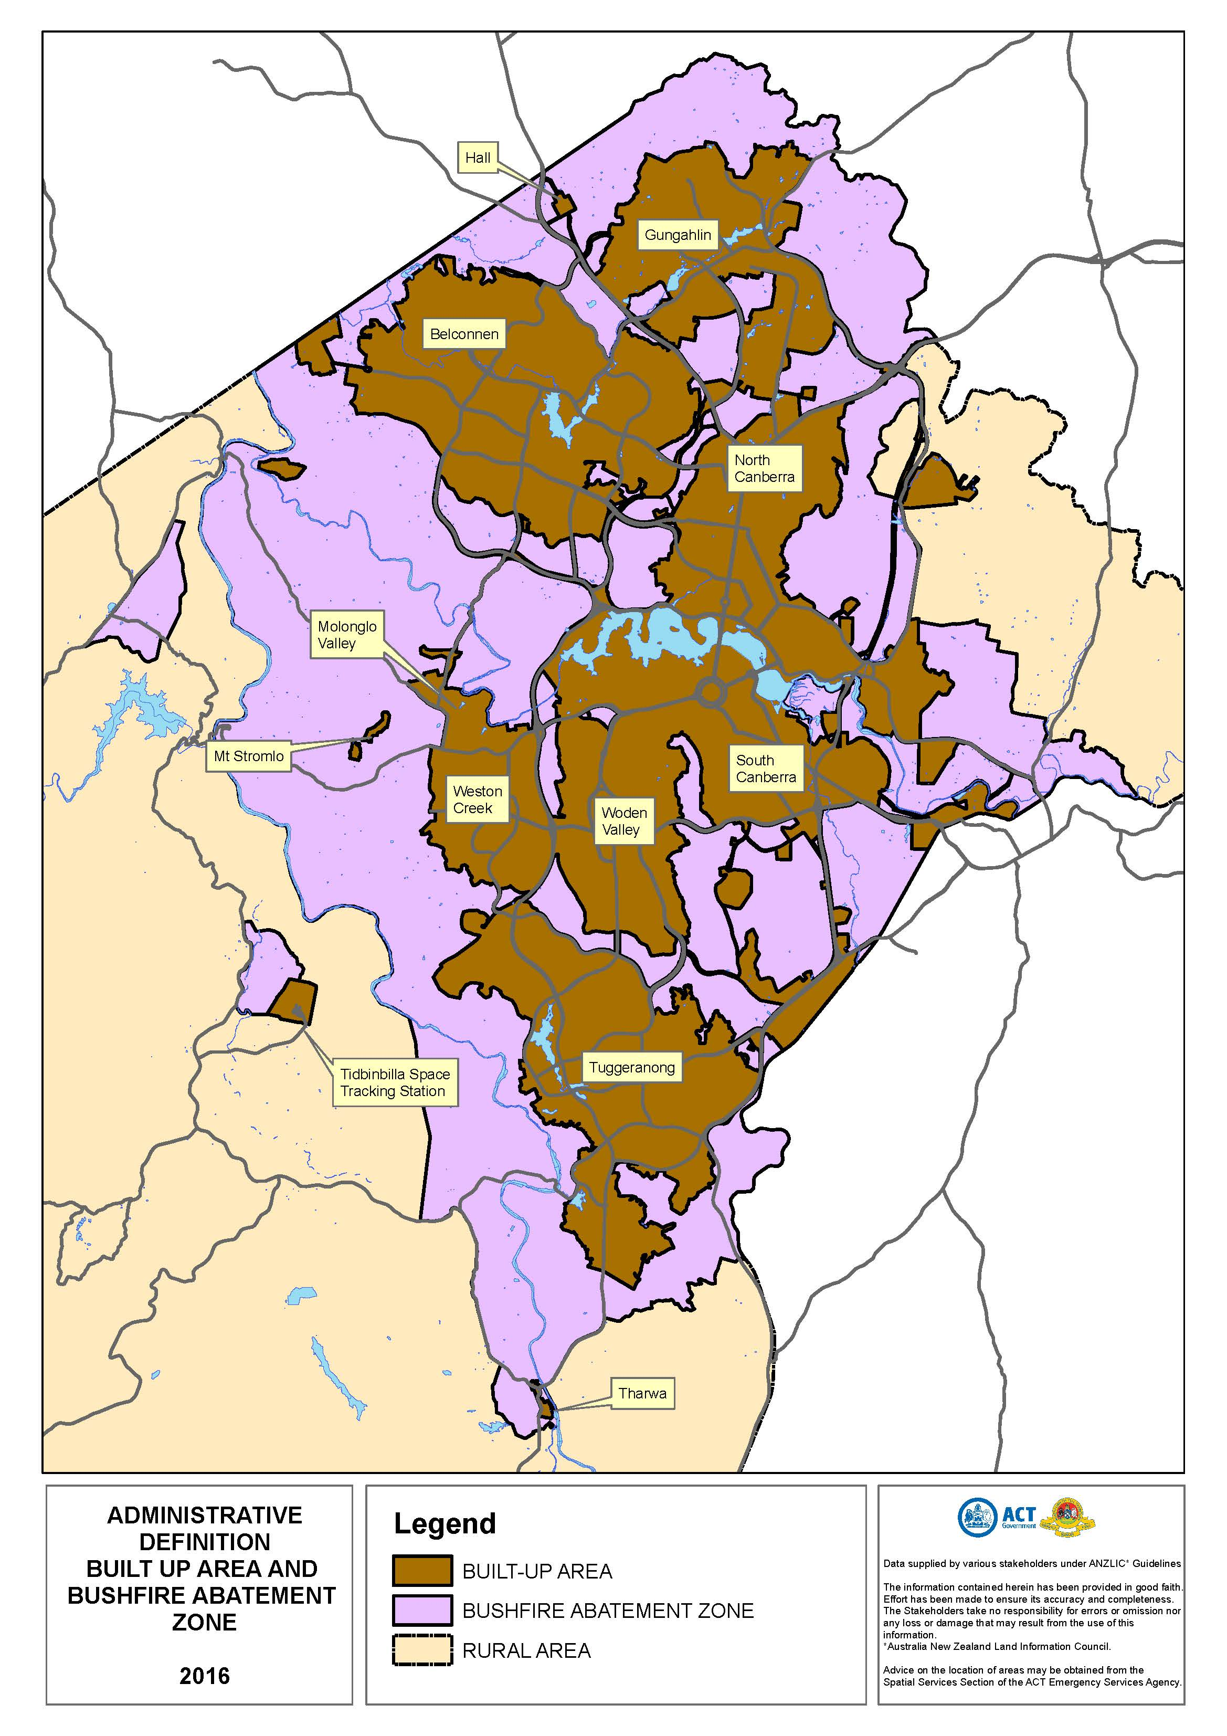
The areas shown in purple on the indicative map below comprise a Bushfire Abatement Zone for the purposes of section 71(1) of the Emergencies Act 2004.

