Australian Capital Territory
Planning and Development (Draft Variation No 349) Consultation Notice 2016
Notifiable instrument NI2016—226
made under the
Planning and Development Act 2007, s 63 (Public consultation—notification) and s 64 (Public consultation—notice of interim effect etc)

1 Name of instrument
This instrument is the Planning and Development (Draft Variation No 349) Consultation Notice 2016.
2 Draft variation to the Territory plan
The planning and land authority (the Authority) has prepared a draft plan variation No 349 – Public land overlay and zone changes (the Draft Variation) to vary the Territory plan. The Draft Variation contains proposed amendments to public land overlay and zone provisions by applying a ‘Pc’ nature reserve overlay to parts of blocks 1616 and 1370 Belconnen (Pinnacle extension) and rezoning block 7 section 72 Watson (Justice Robert Hope Park) from PRZ1 Urban Open Space to NUZ3 Hills, Ridges and Buffer with a ‘Pc’ nature reserve overlay.
3 Documents available for public inspection
(1) The Authority gives notice that the following documents are available for public inspection and purchase:
(a) the Draft Variation; and
(b) the background papers relating to the Draft Variation.
(2) Copies of the documents mentioned in section 3(1) are available for inspection and purchase at Access Canberra, Environment, Planning and Land Shopfront, Ground Floor South, Dame Pattie Menzies House, 16 Challis Street, Dickson, Monday to Friday (except public holidays) between 8:30am and 4:30pm for the period commencing on the day this notice commences and ending on 24 June 2016 (the Consultation Period).
(3) Copies of the documents mentioned in section 3(1) are also available for inspection during the Consultation Period online at www.act.gov.au/draftvariations
4 Invitation to give written comments
(1) The Authority invites written comments about the Draft Variation during the Consultation Period. Comments should include reference to the Draft Variation and be addressed to the Territory Plan Section of the Environment and Planning Directorate (EPD). Please also provide your name and contact details to assist in the assessment of the comments provided and to enable the Authority to contact you in relation to your comments, if required.
(2) Written comments should be provided to the Authority by:
(a) email to terrplan@act.gov.au; or
(b) mail to Territory Plan Section, EPD, GPO Box 158, Canberra, ACT 2601; or
(c) hand delivery to Access Canberra, Environment, Planning and Land Shopfront, Ground Floor South, Dame Pattie Menzies House, 16 Challis Street, Dickson.
5 Public inspection of written comments
(1) Copies of written comments about the Draft Variation given in response to the invitation in section 4, or otherwise, or received from the National Capital Authority will be available (unless exempted) for public inspection for a period of at least 15 working days starting 10 working days after the day the consultation period ends at Access Canberra, Environment, Planning and Land Shopfront, Ground Floor South, Dame Pattie Menzies House, 16 Challis Street, Dickson, Monday to Friday (except public holidays) between 8:30am and 4:30pm and may be published on the EPD website at www.environment.act.gov.au.
(2) You may apply under section 411 of the Planning and Development Act 2007 (the Act) for part of your consultation comments to be excluded from being made available to the public. A request for exclusion under this section must be in writing, clearly identifying what you are seeking to exclude and how the request satisfies the exclusion criteria. Please note that your name and contact details and other personal information will not be made public unless you request otherwise.
6 Effect of the draft plan variation
Section 65 of the Act does not apply in relation to the Draft Variation and therefore it does not have interim effect. The current Territory plan will continue to apply while the Draft Variation remains in draft form.
7 Obtaining further information
Further information about the Draft Variation can be obtained through email correspondence with the Territory Plan Section, EPD, at Terrplan@act.gov.au, a reference to the Draft Variation should be included in any email.
8 Meaning of draft plan variation No 349 – Public land overlay and zone changes
In this instrument:
Draft plan variation No 349 – Public land overlay and zone changes means the draft plan variation in the schedule.
Note 1: Your personal information will be managed in accordance with the Information Privacy Act 2014 and the EPD Information Privacy Policy which are available through the EPD website.

Jim Corrigan
Delegate of the planning and land authority
11 May 2016

Planning and Development Act 2007

Draft
Variation to the
Territory Plan
No 349

Public land overlay and zone changes
Parts of blocks 1616 & 1370 Belconnen (Pinnacle extension)
Block 7 section 72 Watson (Justice Robert Hope Park)

May 2016

Draft variation for public consultation prepared
under s60 of the Planning and Development Act 2007

This page is intentionally blank.

Contents

1. INTRODUCTION 3
1.1 Summary of the Proposal 3
1.2 Outline of the process 3
1.3 This document 3
1.4 Public Consultation 3
2. EXPLANATORY STATEMENT 3
2.1 Background 3
2.1.1 Parts of blocks 1616 & 1370 Belconnen 3
2.1.2 Block 7 section 72 Watson 3
2.2 Site Description 3
2.2.1 Parts of blocks 1616 & 1370 Belconnen 3
2.2.2 Block 7 section 72 Watson 3
2.3 Current Territory Plan Provisions 3
2.3.1 Parts of blocks 1616 & 1370 Belconnen 3
2.3.2 Block 7 section 72 Watson 3
2.4 Proposed Changes 3
2.4.1 Proposed Changes to the Territory Plan Map 3
2.5 Reasons for the Proposed Draft Variation 3
2.6 Planning Context 3
2.6.1 National Capital Plan 3
2.6.2 Territory Plan 3
2.7 Interim Effect 3
2.8 Consultation with Government Agencies 3
3. DRAFT VARIATION 3
3.1 Variation to the Territory Plan 3
3.1.1 Parts of blocks 1616 & 1370 Belconnen 3
3.1.2 Block 7 section 72 Watson 3

- INTRODUCTION
  - Summary of the Proposal
Draft Variation to the Territory Plan No 349 (DV349) proposes to vary the Territory Plan to incorporate two areas into Canberra’s nature reserve system. The proposed changes are to conserve two environmental offset areas that have been established to comply with approval conditions for developments impacting on Matters of National Environmental Significance (MNES) under the provision of the Commonwealth’s Environment Protection and Biodiversity Conservation Act 1999 (EPBC Act).
The draft variation proposes to make changes to public land overlay and zone provisions as follows:
- Apply a nature reserve overlay to parts of blocks 1616 and 1370 Belconnen
- Rezone block 7 section 72 Watson from PRZ1 Urban Open Space to NUZ3 Hills, Ridges and Buffer with a nature reserve overlay.

  - Outline of the process
The Commonwealth’s Australian Capital Territory (Planning and Land Management) Act 1988 allows for the Legislative Assembly to make laws to establish a Territory Planning Authority and for that Authority to prepare and administer a Territory Plan. The Planning and Development Act 2007 (the Act) establishes the planning and land authority as the Authority which prepares and administers the Territory Plan, including continually reviewing and proposing amendments as necessary. The functions of the planning and land authority are administered by the Environment and Planning Directorate (EPD).
The Territory Plan is comprised of a written statement and a map. The written statement contains a number of parts, namely governance; strategic directions; zones (including objectives and development tables and zone or centre development codes); precinct codes; general codes; overlays; definitions; structure plans, concept plans and development codes for future urban areas.
The Territory Plan Map graphically represents the applicable land use zones (under the categories of residential, commercial, industrial, community facility, urban parks and recreation, transport and services and non urban), precincts and overlays. The zone, precinct and overlay requirements are detailed in the volumes of the Territory Plan.
Draft variations to the Territory Plan are prepared in accordance with the Act. Following the release of the draft variation under section 63 of the Act, submissions from the public are invited. At the conclusion of the consultation period the EPD submits a report on consultation and a recommended final variation to the Minister responsible for planning for approval. The Minister has the discretion to determine if referral to the Legislative Assembly standing committee responsible for planning is warranted prior to approval, depending on the nature and significance of the proposal. If the draft variation is referred to the committee by the Minister or otherwise, the Minister must consider the findings of the committee before deciding whether to approve the draft variation. If the Minister approves the variation, the variation and associated documents will be tabled in the Legislative Assembly. Unless disallowed by the Legislative Assembly within five sitting days, the variation commences on a day nominated by the Minister.

  - This document
This document contains the background information in relation to the proposed variation. It comprises the following parts
Part 1 This Introduction
Part 2 An Explanatory Statement, which gives reasons for the proposed variation and describes its effect
Part 3 The Draft Variation, which details the precise changes to the Territory Plan that are proposed
  - Public Consultation
Written comments about the draft variation are invited from the public by 24 June 2016.
Comments should include reference to the draft variation and be addressed to the Territory Plan Section. Please also provide your name and contact details to assist in the assessment of the comments provided, and to enable EPD to contact you in relation to your comments, if required. Your personal information will be managed in accordance with the Information Privacy Act 2014 and the EPD Information Privacy Policy, which is available for viewing on EPD’s website.
Comments can be:
- emailed to terrplan@act.gov.au
- mailed to Territory Plan Section, GPO Box 158, Canberra, ACT 2601
- delivered to EPD’s Customer Service Centre at 16 Challis Street, Dickson
- made on the ‘Have Your Say’ website: http://haveyoursay.planning.act.gov.au
Copies of written comments will be made available for public inspection for no less than 15 working days starting 10 working days after the closing date for comment. The comments will be available at EPD’s customer service centre in Dickson and may be published on EPD’s website. Comments made available will not include personal contact details unless you request otherwise.
A request may be made for parts of a submission to be excluded under section 411 or 412 of the Act (Planning and Development Act 2007). A request for exclusion under these sections must be in writing, clearly identifying what parts of your submission you are seeking to exclude and how the request satisfies the exclusion criteria.

Further Information
The draft variation and background document are available online at www.act.gov.au/draftvariations until the closing date for written comments.
Printed copies of the draft variation (this document) and background documents are available for inspection and purchase at the Environment and Planning Customer Service Centre, 16 Challis Street, Dickson, Monday to Friday (except public holidays) between 8:30am and 4:30pm. Please call 6207 1923 to arrange a copy for purchase.

- EXPLANATORY STATEMENT
  - Background
    - Parts of blocks 1616 & 1370 Belconnen (Pinnacle Nature Reserve extension)
The development of the University of Canberra Public Hospital will result in the removal of 7.6ha of the critically endangered ecological community, White Box-Yellow Box-Blakely’s Red Gum Grassy Woodland and Derived Native Grassland (Box-Gum Grassy Woodland) listed under the EPBC Act. A range of measures will be in place to avoid or mitigate impacts on MNES. However, due to residual and unavoidable impacts on Box-Gum Grassy Woodland, an offset site was required as part of the Commonwealth approval decision. Parts of blocks 1616 and 1370 Belconnen are identified as the suitable environmental offset site.
    - Block 7 section 72 Watson (Justice Robert Hope Park)
The medium density residential development on block 9 section 64 in Watson along with the extension of Negus Crescent to Antill Street and the offsite stormwater works for Justice Robert Hope Park will significantly impact the critically endangered White Box-Yellow Box-Blakely’s Red Gum Grassy Woodland and Derived Native Grassland (Box-Gum Grassy Woodland). As part of the conditional approval from the Commonwealth Government, Justice Robert Hope Park is identified to offset these impacts and provide better protection for species listed under the EPBC Act, including the Regent Honeyeater (Anthochaera phrygia).

  - Site Description
    - Parts of blocks 1616 & 1370 Belconnen (Pinnacle Nature Reserve extension)
Pinnacle Nature Reserve is situated on the southern end of Belconnen District, adjacent to the suburbs of Hawker and Weetangera. Block 1370 Belconnen together with block 1616 Belconnen borders the Pinnacle Nature Reserve (Figure 1). The subject area has approximately 5.1ha of Box-Gum Grassy Woodland and 10.4ha of derived grasslands, with the remainder being Eucalyptus macrorhyncha Tableland Grass/Shrub Forest (4ha). It is currently zoned NUZ3 Hills, Ridges and Buffer.

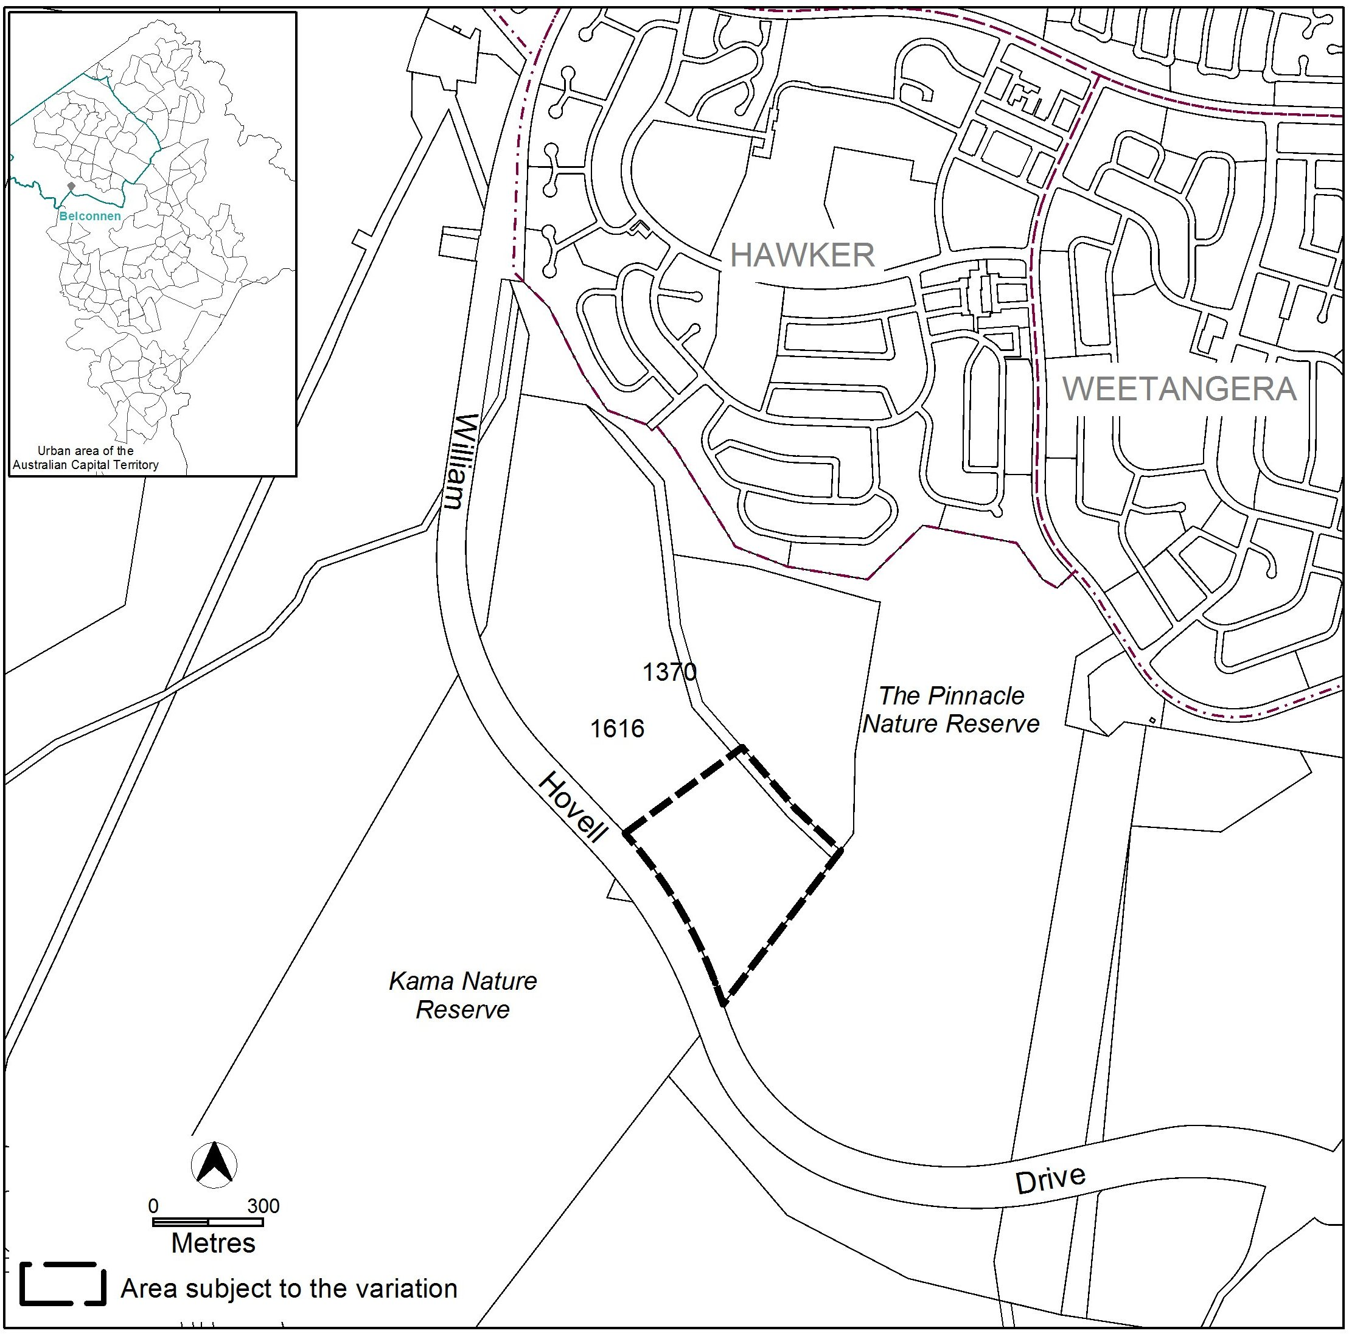
Figure 1 Site Plan

    - Block 7 section 72 Watson (Justice Robert Hope Park)
Justice Robert Hope Park is situated in the northern part of Watson (Figure 2). It is part of a well connected and diverse woodland-open forest complex extending across north-eastern ACT. It is dominated by large old, prolific trees which provide seasonal nectar and valuable foraging habitat for canopy-dwelling birds and arboreal fauna. The park is currently zoned PRZ1 Urban Open Space.
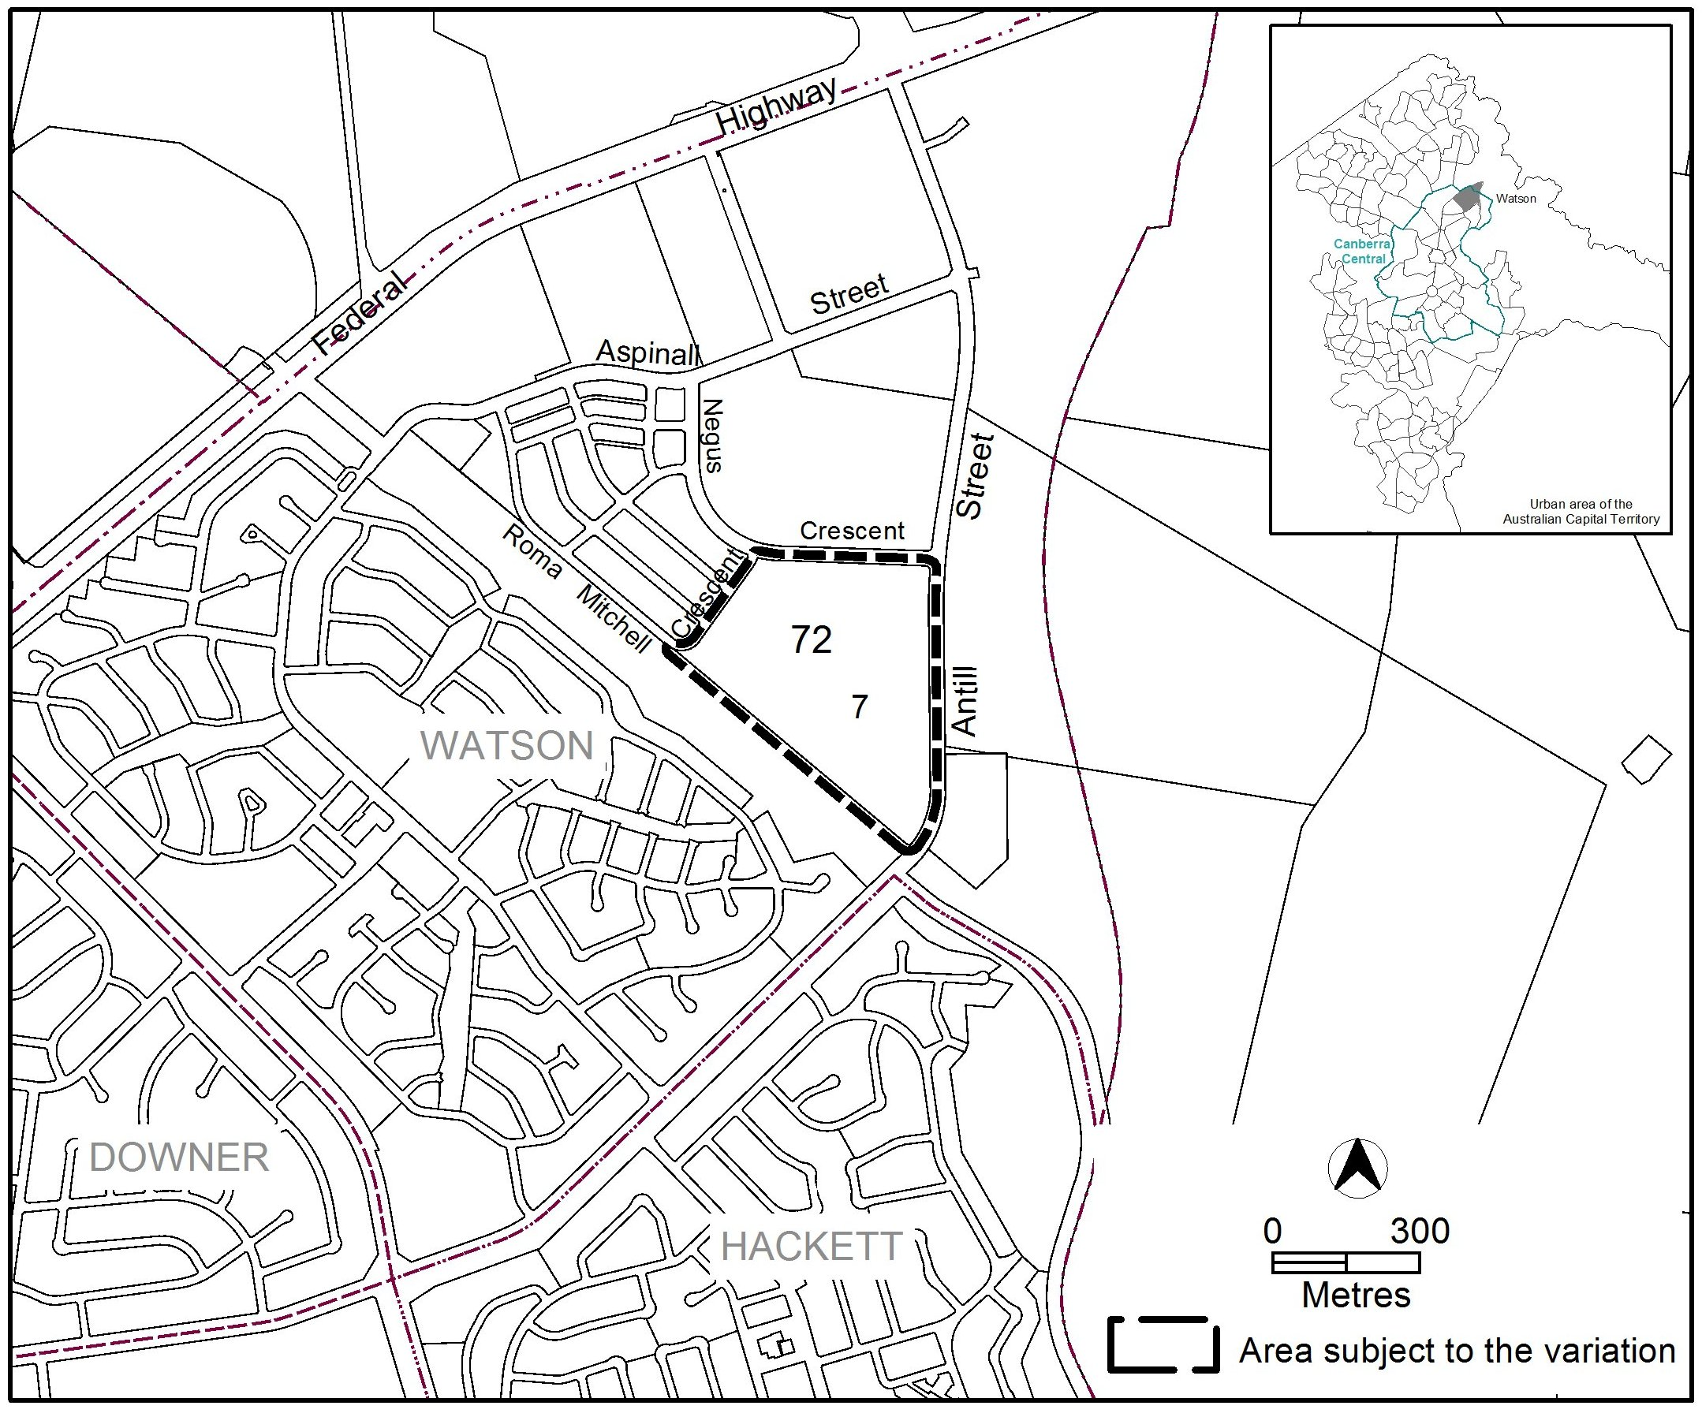
Figure 2 Site Plan

  - Current Territory Plan Provisions
    - Parts of blocks 1616 & 1370 Belconnen (Pinnacle Nature Reserve extension)
The Territory Plan map zone for the area subject to this variation is shown in Figure 3.
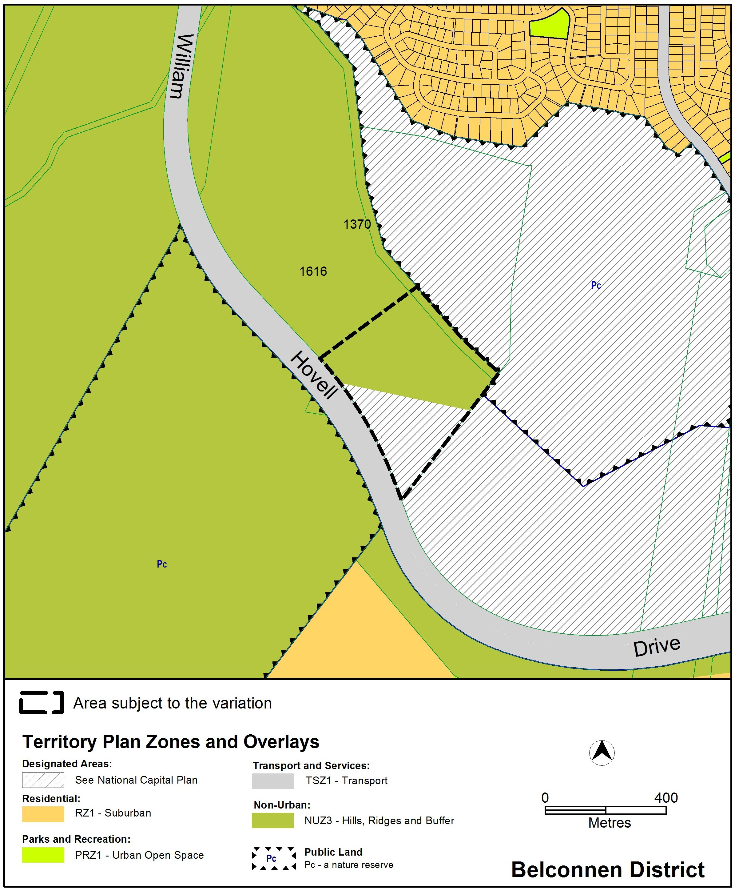
Figure 3 Territory Plan Zones Map

    - Block 7 section 72 Watson (Justice Robert Hope Park)
The Territory Plan map zone for the area subject to this variation is shown in Figure 4.
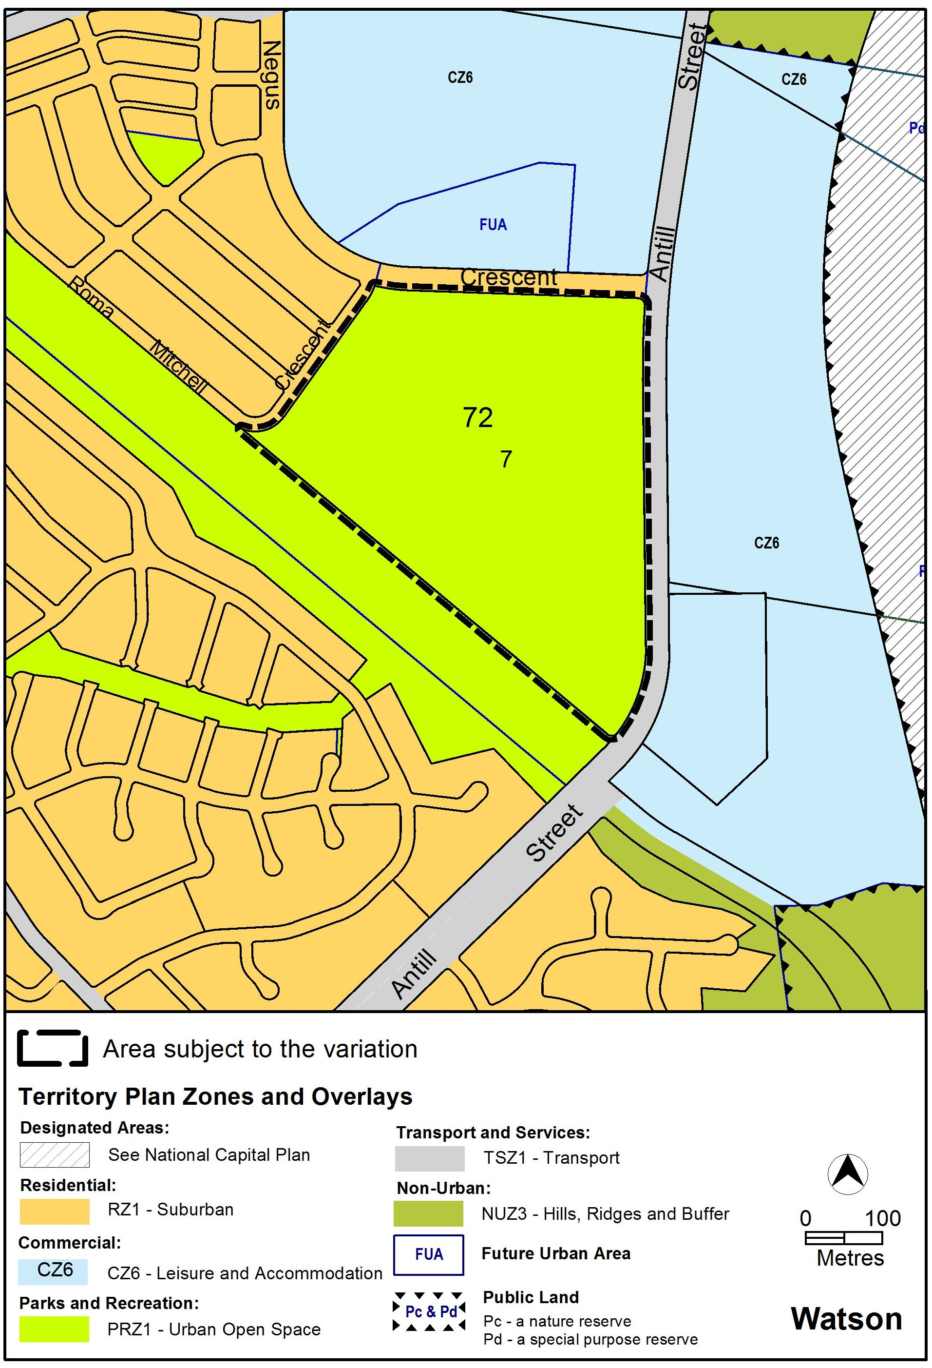
Figure 4 Territory Plan Zones Map
  - Proposed Changes
    - Proposed Changes to the Territory Plan Map
The proposed changes to the Territory Plan map are indicated in Figure 5 and 6 at Part 3 of this document and are detailed as follows:
- Parts of blocks 1616 and 1370 Belconnen to have a Pc nature reserve overlay (shown in Figure 5)
- Block 7 section 72 Watson to be rezoned from PRZ1 Urban Open Space to NUZ3 Hills, Ridges and Buffer with a Pc nature reserve overlay (shown in Figure 6)
The draft variation map indicates the proposed zone boundaries as accurately as possible but may be subject to adjustments following detailed surveys.

  - Reasons for the Proposed Draft Variation
This draft variation has been prepared to establish the environmental offsets that have been required by the Commonwealth Government under the EPBC Act approval for the development of the University of Canberra Public Hospital in Bruce and the development of a medium density residential development in Watson.

  - Planning Context
    - National Capital Plan
The Australian Capital Territory (Planning and Land Management) Act 1988 established the National Capital Authority (NCA) with two of its functions being to prepare and administer a National Capital Plan (NCP) and to keep the NCP under constant review and to propose amendments to it when necessary.
The NCP, which was published in the Commonwealth Gazette on 21 January 1990 is required to ensure that Canberra and the Territory are planned and developed in accordance with their national significance. The Planning and Land Management Act 1988 also required that the Territory Plan is not inconsistent with the NCP.

    - Territory Plan
Statement of Strategic Directions
The proposal is consistent with the Territory Plan’s statement of strategic directions in terms of environmental, economic and social sustainability and spatial planning and urban design principles.
The change will incorporate two pieces of land in perpetuity for management, protection and enhancement of MNES under the Commonwealth’s EPBC Act while developments in Bruce and Watson can occur to promote economic activities and meet community needs.

  - Interim Effect
Section 65 of the Planning and Development Act 2007 does not apply in relation to the draft variation so it does not have interim effect. The current Territory Plan will continue to apply while the variation remains in draft form.

  - Consultation with Government Agencies
The EPD is required to, in preparing a draft variation under section 61(b) consult with each of the following in relation to the proposed draft variation:
- the National Capital Authority
- the Conservator of Flora and Fauna
- the Environment Protection Authority
- the Heritage Council
- the Land Custodian, if the draft variation would, if made, be likely to affect unleased land or leased public land – each custodian for the land likely to be affected

National Capital Authority
The National Capital Authority provided the following comments on 23 February 2016:
In regard to Block 7 Section 72 Watson (Justice Robert Hope Park), the NCA has no objection to the proposed zoning change. The site is within Urban Areas under the General Policy Plan Metropolitan Canberra of the National Capital Plan, and the proposed NUZ3 zoning is not inconsistent with this.

Part of Block 1616 Belconnen subject to the variation is within Designated Areas. The NCA understands that the proposed variation in this location is to identify the full extent of the nature reserve only, rather than a change to the underlying land use category/zoning. On this basis, the NCA has no objection to the proposed change.

Response
Noted.

Conservator of Flora and Fauna
The Conservator of Flora and Fauna made the following comments on
15 February 2016:
In accordance with Section 61(b) of the Planning and Development Act 2007, I advise that I have examined Draft Variation No 349 – public land overlay and zone changes, Part Block 1616 Belconnen (Pinnacle extension), Block 7 Section 72 Watson (Justice Robert Hope Park. I have no comments to provide other than to note my support.

Response
Noted.

Environment Protection Authority
The Environment Protection Authority provided the following comments on
24 February 2016:
Thank you for the opportunity to review the proposed variation to the Territory Plan as outlined in DV349. The Environment Protection Authority has reviewed the documentation and supports the public land overlay and zone changes to part block 1616 Belconnen (Pinnacle extension) and block 7 section 72 Watson (Justice Robert Hope Park).
It should be noted that records indicate a pindone bait burial pit is located in the targeted area of block 1616 Belconnen and that part of the area (also block 1616) may also be impacted by activities undertaken within the former field firing range. Unexploded ordnance (UXO) is associated with Defence Force field firing ranges and have been associated with land contamination in the past. The location, nature and extent of any contamination associated with the field firing range activities is unknown.
Given the unknown status of the site, the site should be appropriately managed.

Response
Noted.

Heritage Council
The Heritage Council provided the following comments on 29 February 2016:
Thank you for the opportunity to provide comment on the Draft Variation to the Territory Plan 349 (DV349). From information provided, we understand that DV349 proposes the following changes to the Territory Plan:
- Rezone Block 7, Section 72, Watson from ‘PRZ1 Urban Open Space to ‘NUZ3 Hills, Ridges and Buffer’, with a nature reserve overlay; and
- Apply a nature reserve overlay to part of Block 1616, Belconnen.
Both areas are identified as environmental offsets established to comply with development approval conditions under the Environment Protection and Biodiversity Conservation Act 1999; respectively relating to the University of Canberra Public Hospital and the urban development of Block 9, Section 64, Watson.
Review of the ACT Heritage Register identifies that no heritage places or objects are registered within the two subject areas, although the ‘Molonglo River to Barton Highway Woodland’ nomination does include Block 7, Section 72, Watson. ACT Heritage also notes that both areas have the potential to contain Aboriginal places and objects, and if present, these heritage sites would be protected under Section 75 of the Heritage Act 2004.
ACT Heritage supports the proposed changes outlined in DV349, as the additional nature reserve overlays will function to protect a range of natural and cultural heritage values.

Response
Noted.

Land Custodian – Territory and Municipal Services Directorate
The land custodian provided the following comments on 29 February 2016:
TAMS have reviewed the proposed Territory Plan Variation No. 349 and supported the proposal.
Response
Noted.

- DRAFT VARIATION
  - Variation to the Territory Plan
    - Parts of blocks 1616 & 1370 Belconnen (Pinnacle Nature Reserve extension)
The Territory Plan Map is varied as shown in Figure 5 for the area shown as subject to this draft variation.
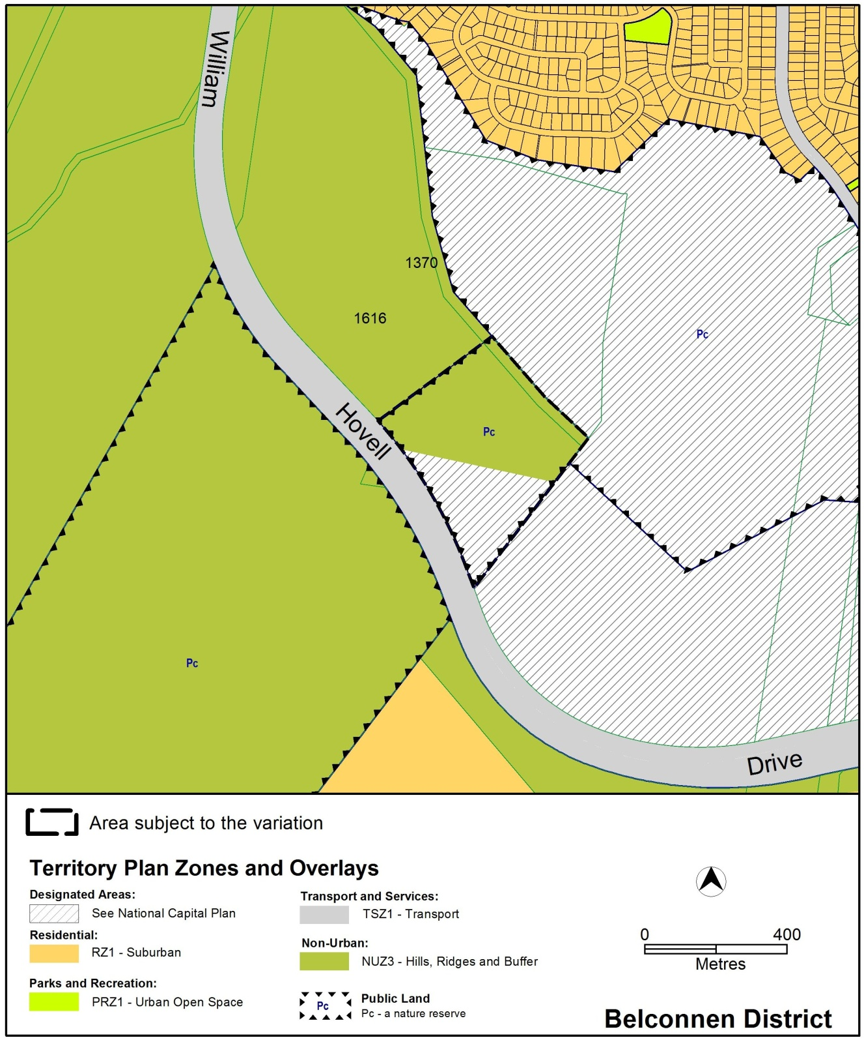
Figure 5 Proposed Territory Plan changes

    - Block 7 section 72 Watson (Justice Robert Hope Park)
The Territory Plan Map is varied as shown in Figure 6 for the area shown as subject to this draft variation.
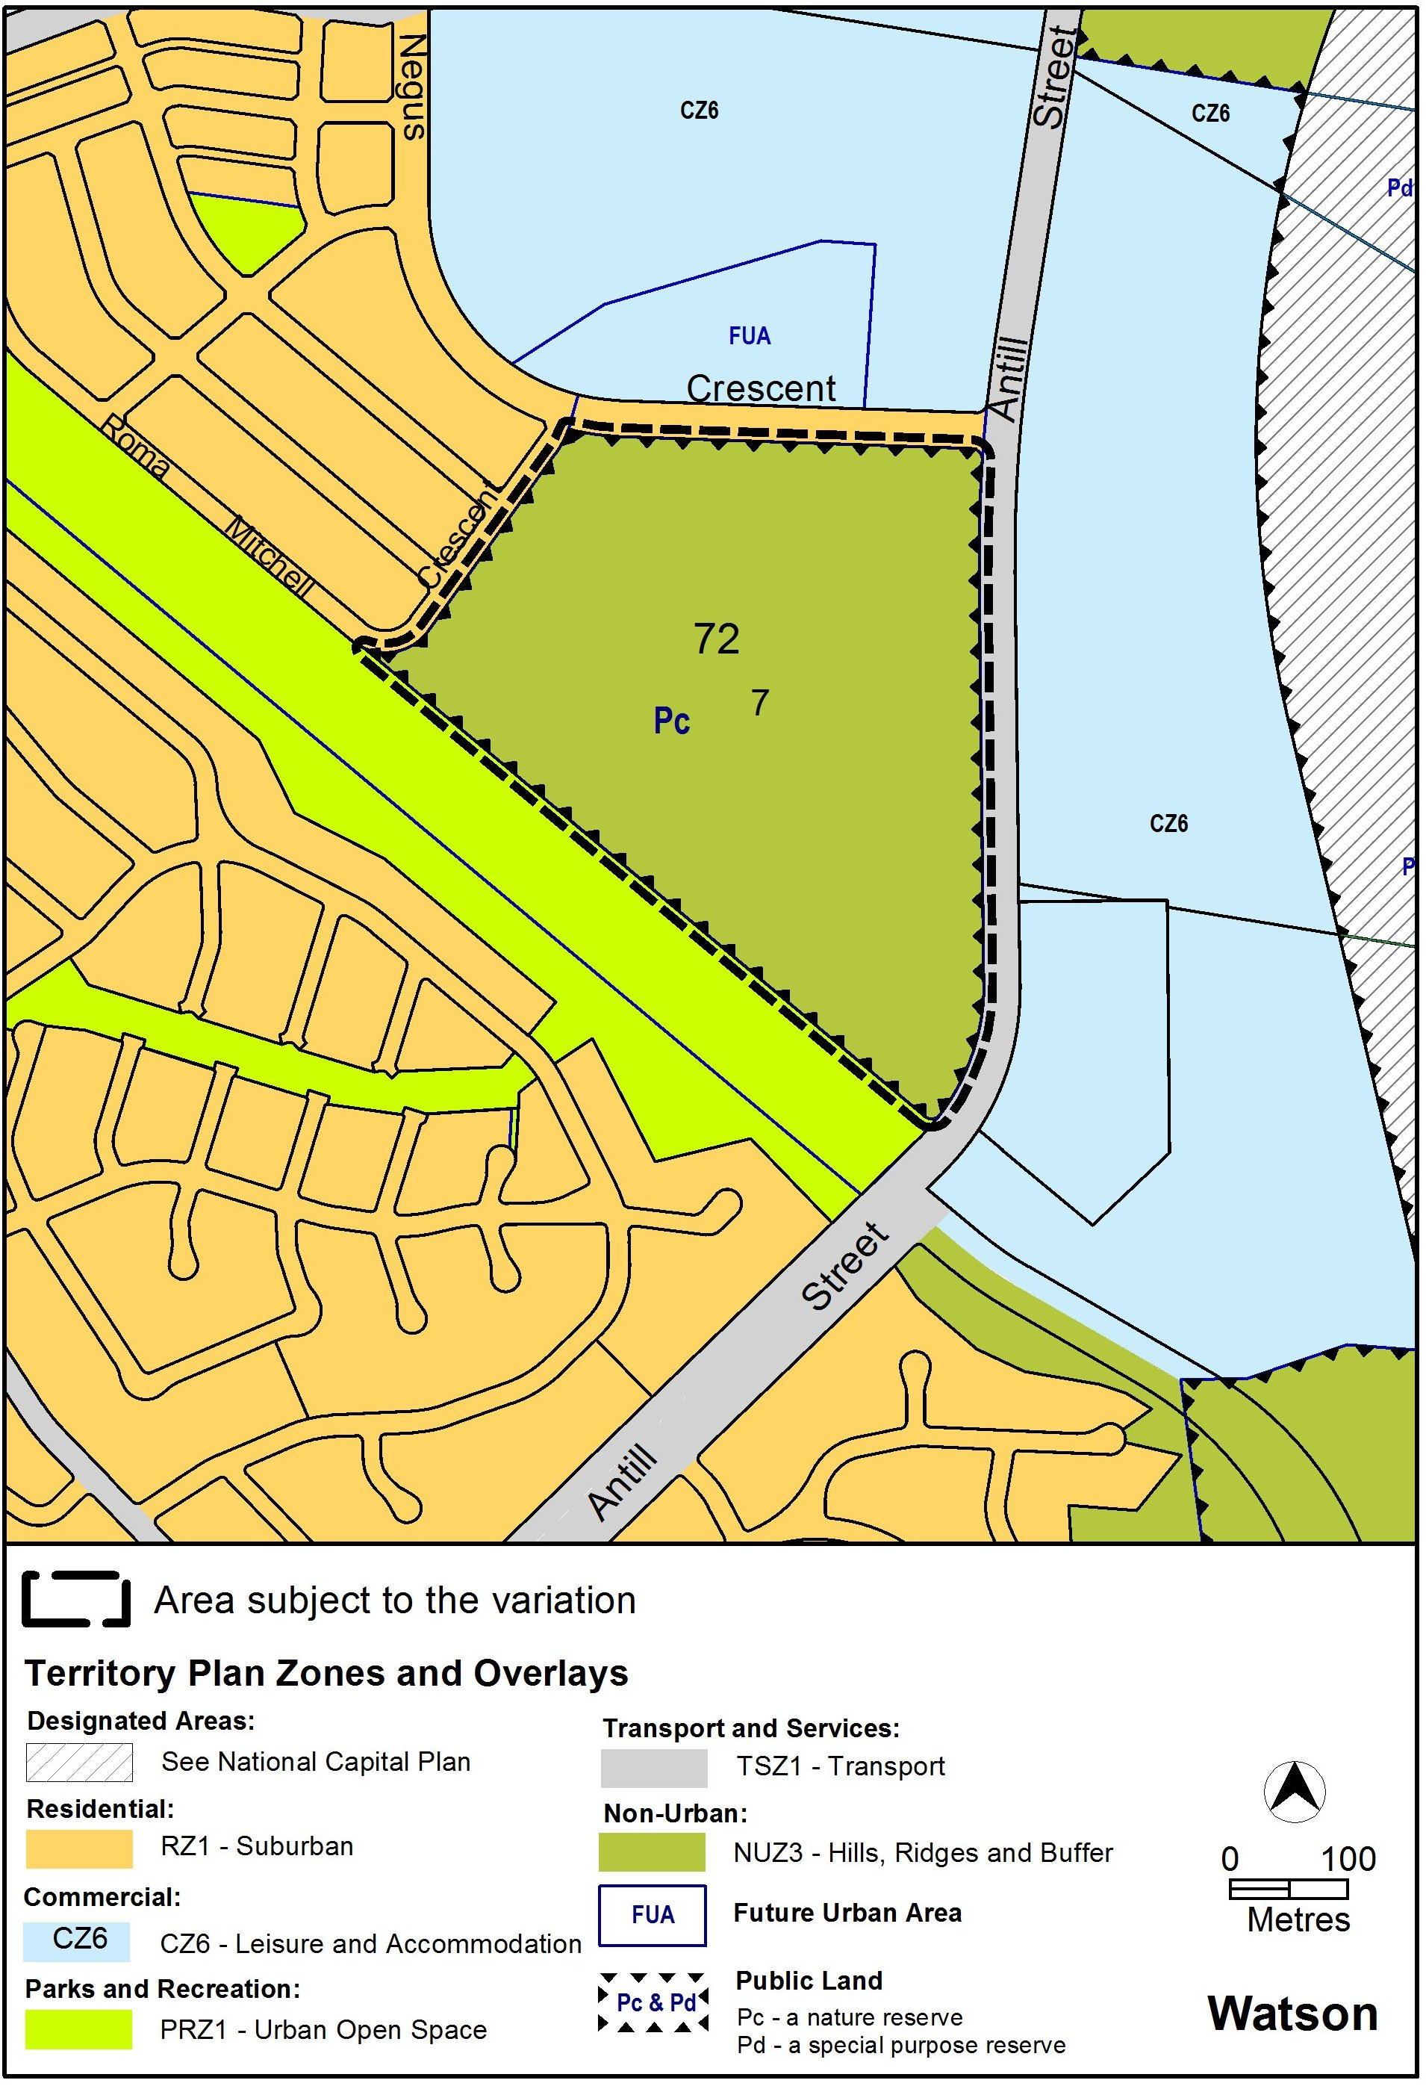
Figure 6 Proposed Territory Plan changes
Interpretation service
