Australian Capital Territory
Road Transport (Public Passenger Services) Public Vehicle Driver Authority Card Guidelines 2016 (No 1)*
Notifiable Instrument NI 2016—412
made under the
Road Transport (Public Passenger Services) Regulation 2002, section 307 (Driver authority card to be displayed or shown)

1 Name of instrument

This instrument is the Road Transport (Public Passenger Services) Public Vehicle Driver Authority Card Guidelines 2016 (No 1).

2 Revocation

This instrument revokes notifable instrument NI2010-188 dated 31 March 2010.

3 Commencement

This instrument commences on 1 August 2016.

3 Position for display of public vehicle driver authority cards – sedans and passenger vans
(1) For a sedan, a public vehicle driver authority card may be displayed within the shaded area of the diagram below so that the information on the photo-side of the card can reasonably be read by a passenger in any of the passenger seating positions in the sedan.
(2) For a passenger van, a public vehicle driver authority card may be displayed within the shaded area of the diagram below so that the information on the photo-side of the card can reasonably be seen by a passenger in any of the passenger seating positions in the van.

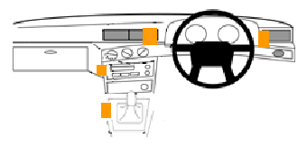

Shaded area
Position of other taxi equipment

Example of public vehicle driver authority card displayed within shaded area
The public vehicle driver authority card displayed in the following photograph is displayed within the shaded area of the diagram.
Figure 1 – Vehicle (Car) Dashboard
Note An example is part of the instrument, is not exhaustive and may extend, but does not limit, the meaning of the provision in which it appears (see Legislation Act, s 126 and s 132).

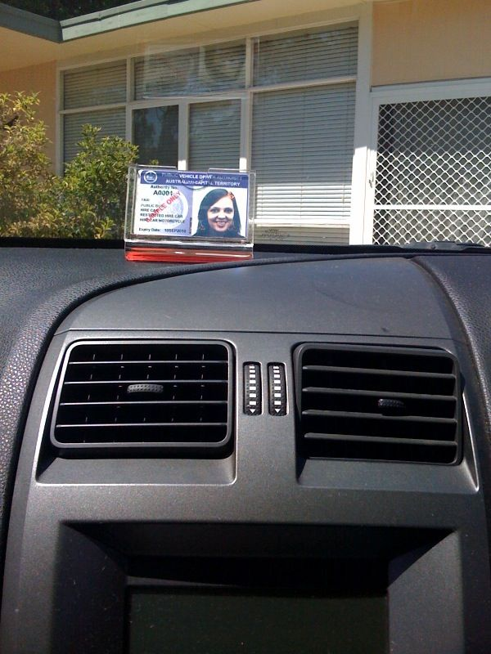

4 Position for display of public vehicle driver authority cards – buses
(1) For a bus, the photo-side side of a public vehicle driver authority card may be displayed above the bus’s windscreen in accordance with the photographs below.
(2) However, if the bus has a front-area layout similar to that of a sedan, the photo-side side of a public vehicle driver authority card may be displayed within the shaded area shown in the diagram for clause 3.
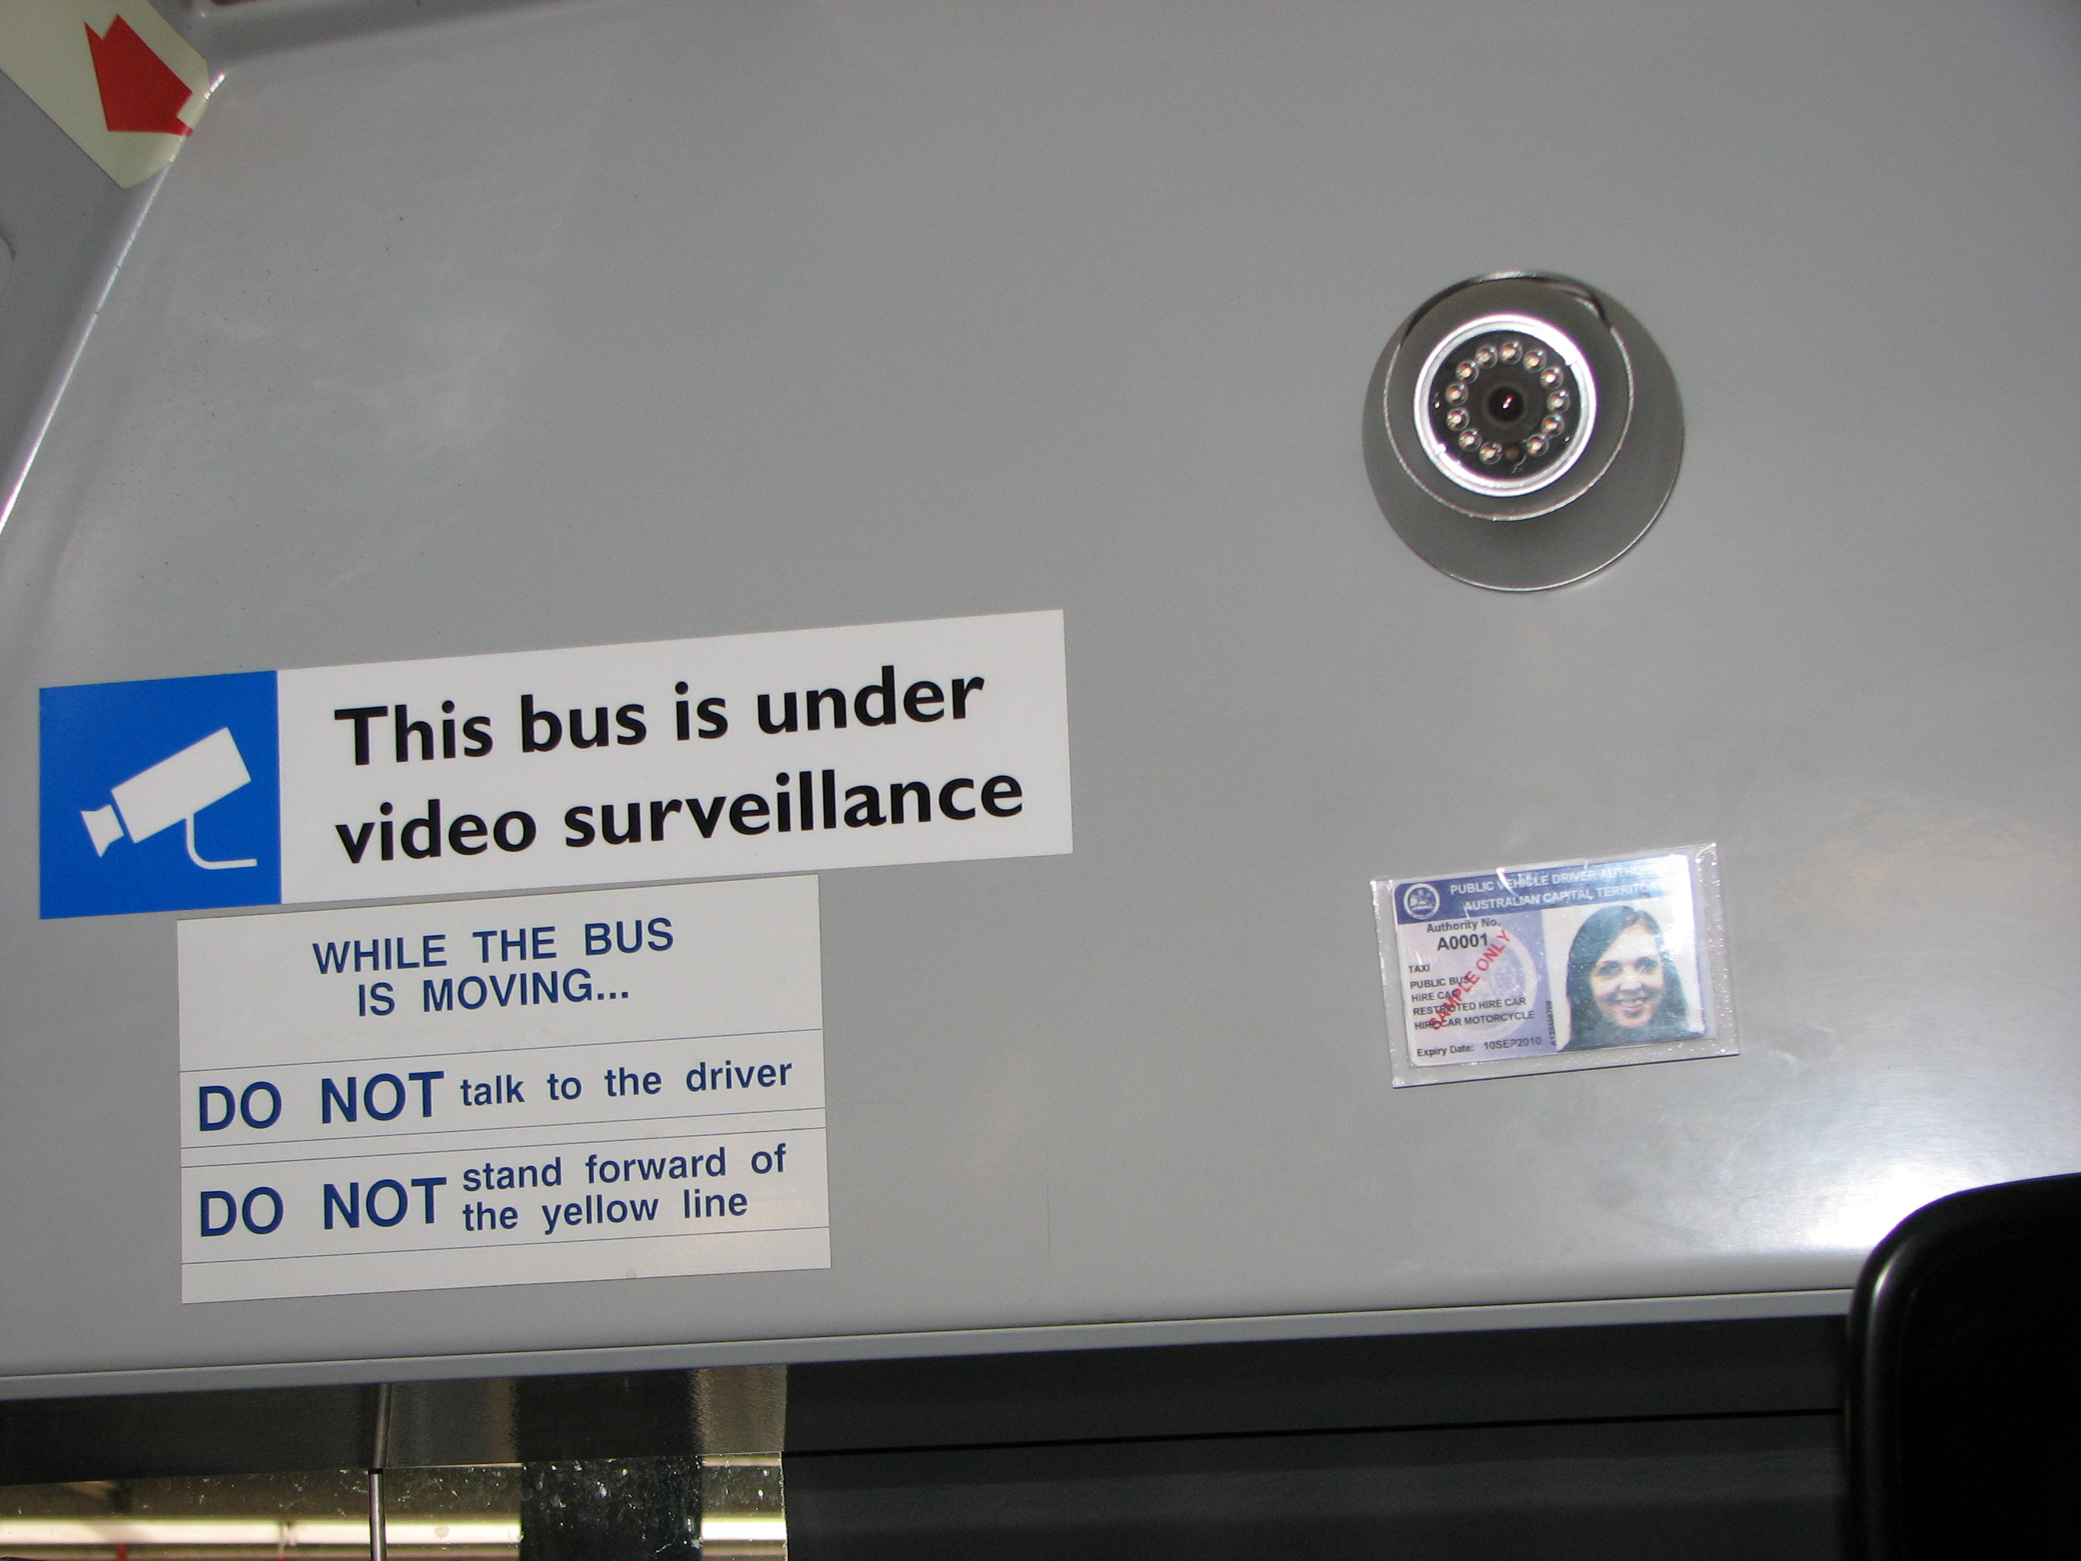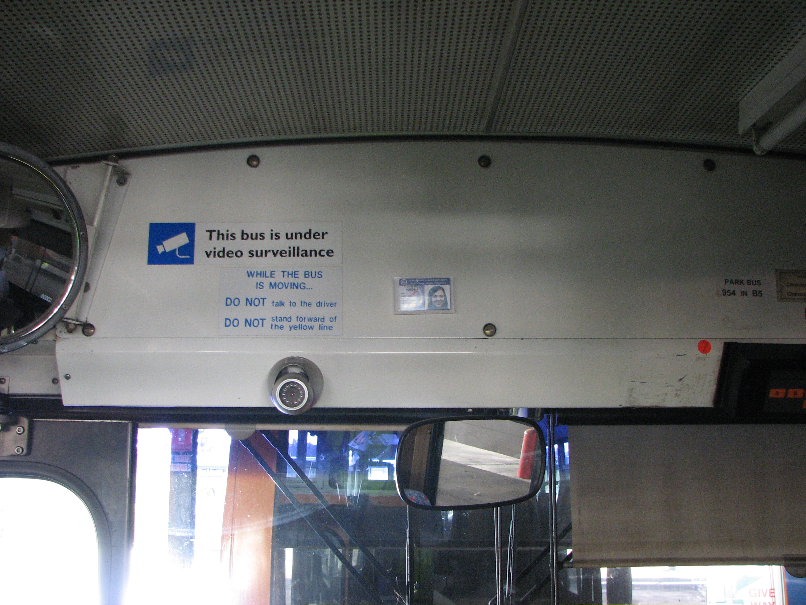

Note A driver who is authorised under a law of another jurisdiction to drive a public vehicle for hire or reward that has been issued a driver photographic identity card (however described) under that jurisdiction's law for use when operating the public vehicle may continue to display the driver’s home-jurisdiction identity card while driving in the ACT and is not required to also display an ACT-issued public vehicle driver authority card (see Road Transport (Public Passenger Services) Regulation 2002, s 306, def driver authority card, par (b)).

Kerry Bell
Delegate
Road Transport Authority, Access Canberra
29 July 2016

